**9921103163**

**Nitin Chaudhary**

**F7**

**Week 9 and 10**

Ans 1-

DELIMITER $$

CREATE FUNCTION maximum(

a INT, b INT,c INT)

RETURNS INT DETERMINISTIC

BEGIN

IF a > b && a>c THEN

return a;

ELSEIF b > a && b>c THEN

return b;

ELSE

return c;

END IF;

END $$

DELIMITER ;

SET @largest=maximum(447, 565, 554);

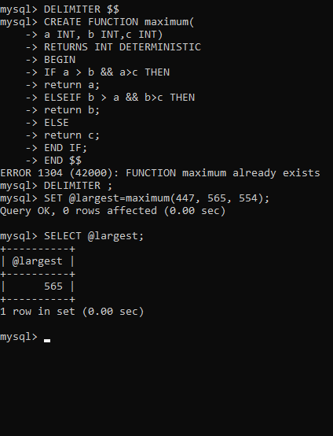SELECT @largest;

Ans 2-

DELIMITER $$

CREATE PROCEDURE LoopExample(IN c INT)

BEGIN

DECLARE str VARCHAR(255);

DECLARE st VARCHAR(225);

DECLARE x INT;

SET x = 1;

SET st="Hello World";

SET str = "";

loop_label: LOOP

  IF x > c THEN

 LEAVE loop_label;

END IF;

SET x = x + 1;

SET str = CONCAT(str,st,' ');

IF(x<=c) THEN

ITERATE loop_label;

END IF;

END LOOP;

SELECT str;

END$$

DELIMITER ;

CALL LoopExample(5);

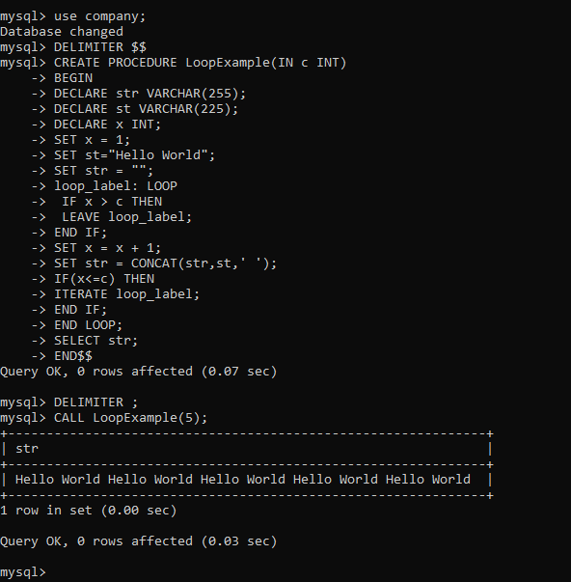

Ans 3-

DELIMITER $$

CREATE PROCEDURE LoopExample(IN c INT)

BEGIN

DECLARE str VARCHAR(255);

DECLARE st VARCHAR(225);

DECLARE msg VARCHAR(225);

DECLARE x INT;

SET x = 1;

SET st="Hello World";

SET str = "";

loop_label: LOOP

  IF x > c THEN

 LEAVE loop_label;

END IF;

SET x = x + 1;

SET str = CONCAT(str,st,' ');

IF(x<=c) THEN

ITERATE loop_label;

END IF;

END LOOP;

IF str="" THEN

SET msg="Please Enter a positive number";

END IF;

IF str!="" THEN

SET msg="You have entered a positive number";

END IF;

SELECT msg;

SELECT str;

END$$

DELIMITER ;

CALL LoopExample(-1);

CALL LoopExample(4);

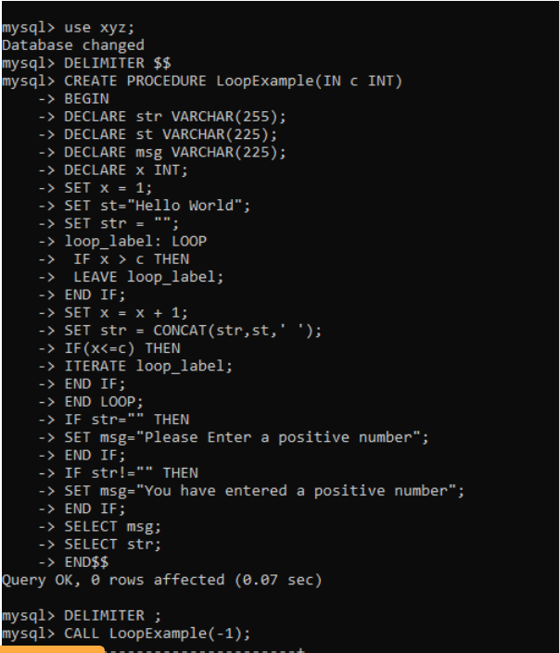

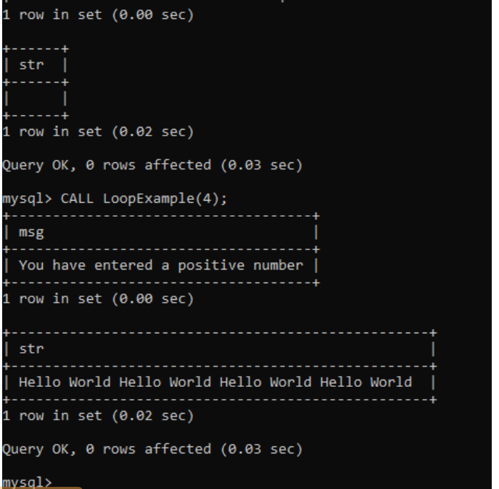

Ans 4-

DELIMITER $$

CREATE PROCEDURE circle(IN r INT)

BEGIN

DECLARE ar DECIMAL(14,2);

SET ar=3.14*r*r;

INSERT INTO AREA VALUES(r,ar);

END$$

DELIMITER ;

CALL circle(5);

select * from AREA;

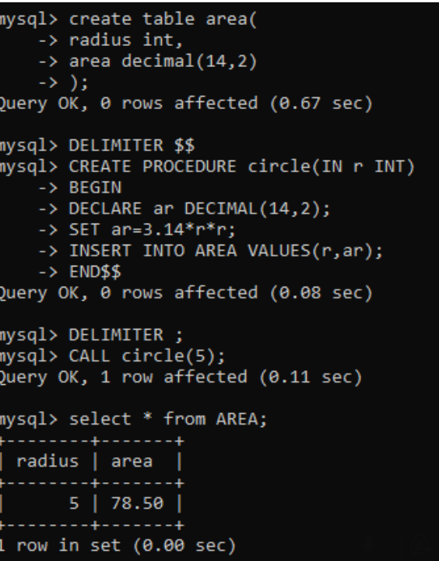

Ans 5-

DELIMITER $$

CREATE PROCEDURE POWER()

BEGIN

DECLARE s INT;

DECLARE c INT;

DECLARE n INT;

SET n=20;

loop_label:LOOP

IF n>30 THEN

LEAVE loop_label;

END IF;

SET s=n*n;

SET c=n*n*n;

INSERT INTO power values(n,s,c);

SET n=n+1;

IF(n<=30) THEN

ITERATE loop_label;

END IF;

END LOOP;

END$$

DELIMITER ;

CALL POWER();

select * from POWER;

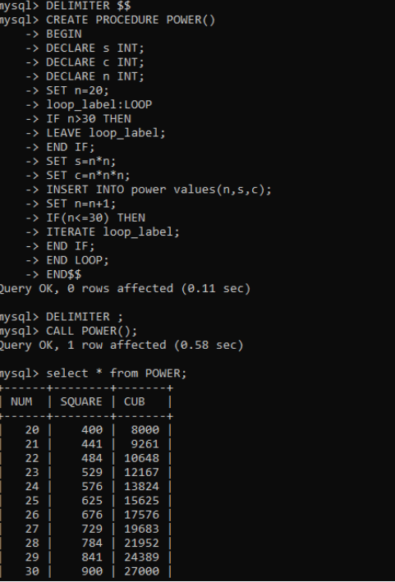

Ans 6-

//Using for loop

DELIMITER $$

CREATE PROCEDURE Example(IN str VARCHAR(20))

BEGIN

DECLARE rev VARCHAR(20);

DECLARE x INT;

SET x = LENGTH(str)+1;

SET rev='';

loop_label: LOOP

IF x =0 THEN

LEAVE loop_label;

END IF;

SET x = x - 1;

SET rev = CONCAT(rev,SUBSTR(str,x,1));

IF x>=0 THEN

ITERATE loop_label;

END IF;

END LOOP;

SELECT rev;

END$$

DELIMITER ;

CALL Example("Chaudhary");

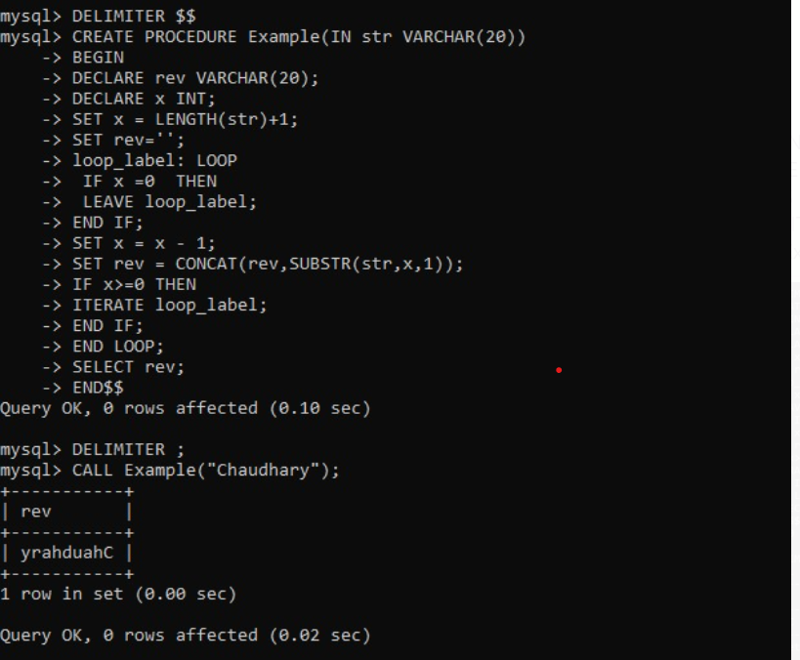

//Using while loop

DELIMITER $$

CREATE PROCEDURE Example(IN str VARCHAR(20))

BEGIN

DECLARE rev VARCHAR(20);

DECLARE x INT;

SET x = LENGTH(str);

SET rev='';

WHILE x>=0 DO

SET rev = CONCAT(rev,SUBSTR(str,x,1));

SET x = x - 1;

END WHILE;

SELECT rev;

END $$

DELIMITER ;

CALL Example("Chaudhary");

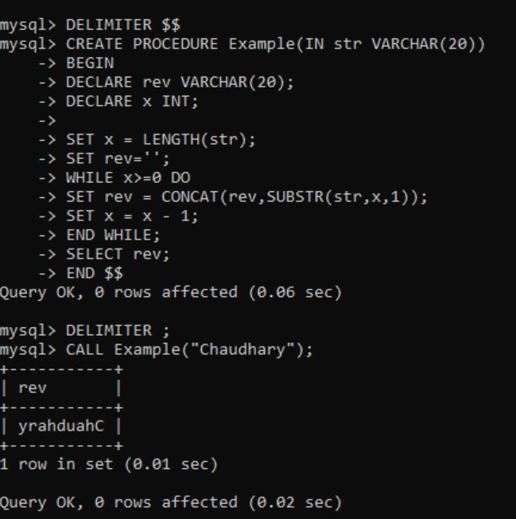

Ans 7-

delimiter $$

create procedure chang(IN s INT)

BEGIN

update employee set salary=salary+0.15*salary where ssn=s;

END$$

DELIMITER ;

CALL chang(2);

select * from employee;

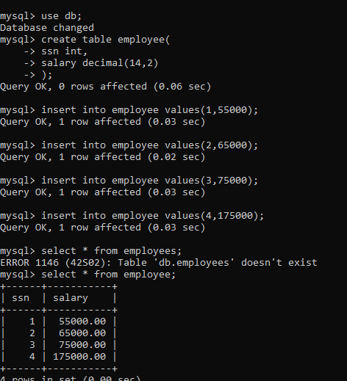

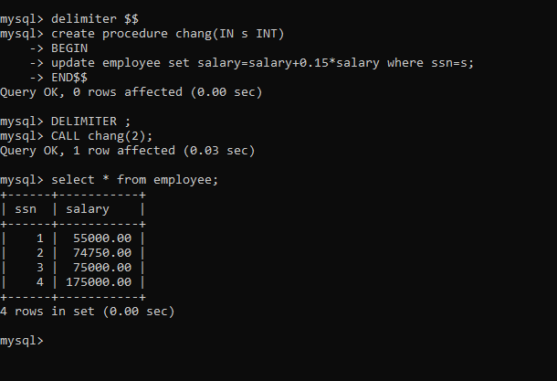

Ans 8-

Ask to maa’m about printing the message as that message is giving error when i tried to return it even with creating functoin

delimiter $$

create procedure cha(IN n varcahar(20), IN o varchar(20)

BEGIN

update employee set newjob=n where oldjob=o;

END$$

DELIMITER ;

CALL cha("A","G");

select * from employee;

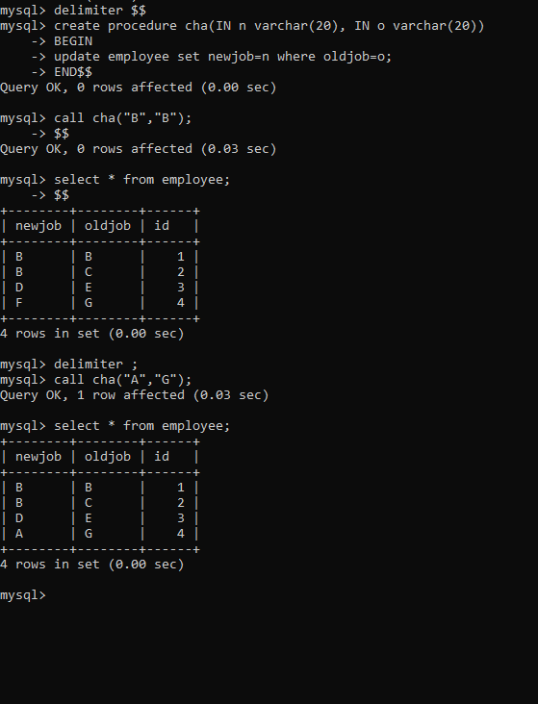

Ans 9-

DELIMITER $$

CREATE  PROCEDURE  createEmailList ( INOUT emailList  varchar(4000) )

BEGIN

DECLARE  finished  INTEGER DEFAULT 0;

DECLARE emailAddress  varchar(100) DEFAULT " " ;

DECLARE  curEmail

CURSOR FOR

SELECT email_id FROM employee;

DECLARE  CONTINUE  HANDLER FOR NOT FOUND SET finished = 1;

OPEN curEmail;

getEmail: LOOP

FETCH curEmail INTO emailAddress;

IF finished = 1 THEN

LEAVE getEmail;

END IF;

SET emailList = CONCAT(emailAddress,";",emailList); END LOOP getEmail;

CLOSE curEmail;

END$$

DELIMITER ;

SET @emailList="";

CALL createEmailList(@emailList);

SELECT @emailList;

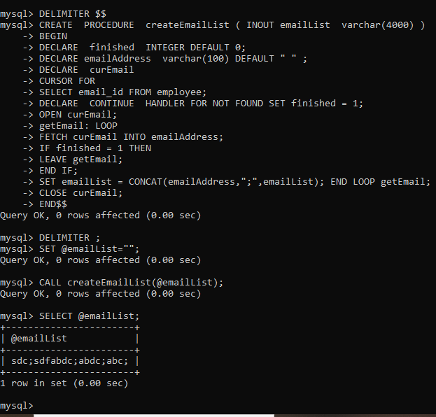

Ans 10-

DELIMITER $$

CREATE TRIGGER after_members_insert

AFTER INSERT ON members

FOR EACH ROW

BEGIN

IF NEW.dob IS NULL THEN

INSERT INTO REMINDERS(mid,message) VALUES(new.mid,"Your DOB is NULL. PLease update.");

END IF;

END $$

DELIMITER ;

insert into members values('mid1','john doe','john.doe@example.com',NULL),('mid2','kimkole','kim.kole@example.com','2000-01-01');

select * from reminders;

