Week 6 lab A

NBTG13715

Nitin Chaudhary

F8

Q1

#include<stdio.h>

int main()

{

int a[100],i,b,j,k;

float s=0,avg;

printf("enter how many numbers do you want to enter: ");

scanf("%d",&k);

printf("\nenter array numbers\n");

for(i=0;i<k;i++)

{

scanf("%d",&b);

a[i]=b;

}

for(i=0;i<k;i++)

{

s+=a[i];

}

avg=s/k;

printf("average is %f",avg);

}

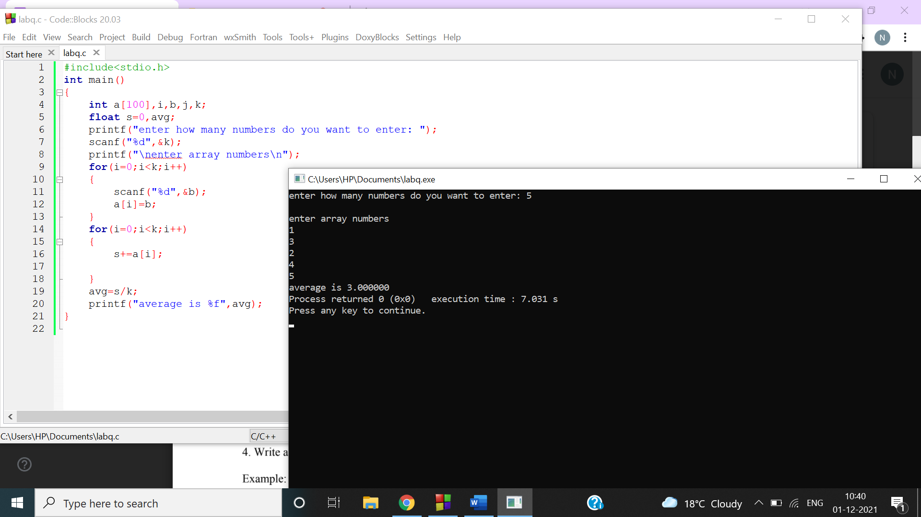

Q2

#include<stdio.h>

int main()

{

int a[100],b,i,j,c=0;

printf("enter how many numbers do you want to enter\n");

scanf("%d",&b);

printf("enter array elements from 0 to 9\n");

for(i=0;i<b;i++)

{

scanf("%d",&a[i]);

}

for(i=0;i<=9;i++)

{

c=0;

for(j=0;j<b;j++)

{

if(i==a[j])

{

c++;

}

}

if(c>0)

{

printf("%d occurs %d times\n",i,c);

}

}

}

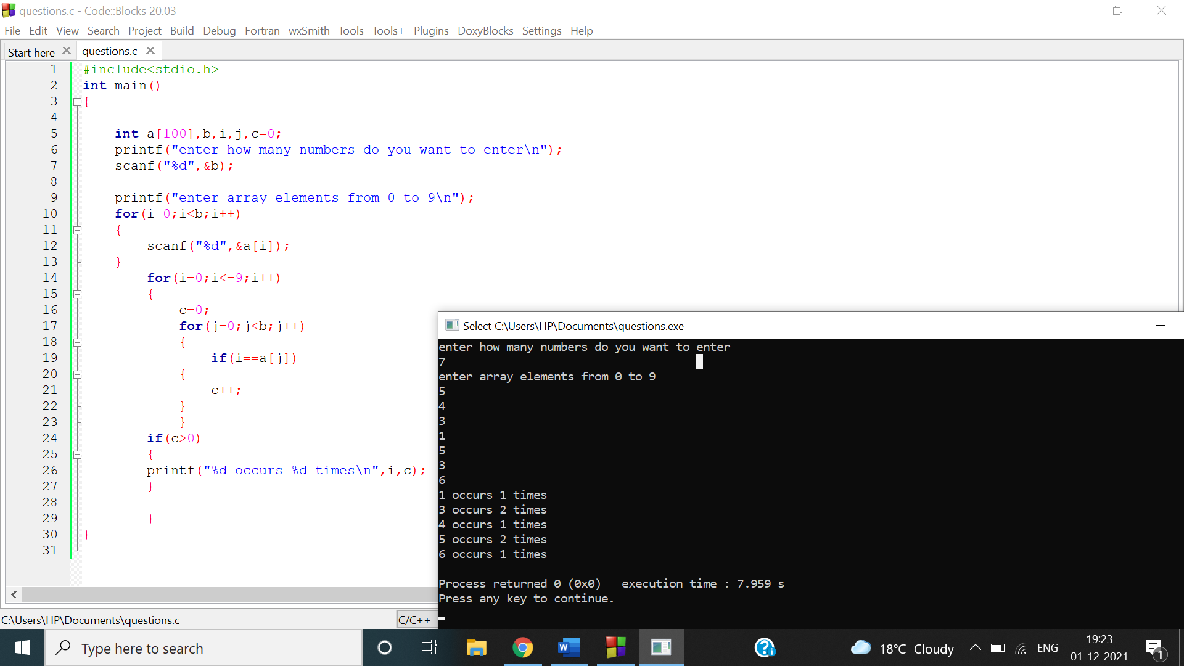

Q3

#include<stdio.h>

int main()

{

int a[7]={1,2,3,4,5,6,7},temp,i;

printf("array elements before rotating\n");

for(i=0;i<7;i++)

{

printf("%d\t",a[i]);

}

for(i=0;i<6;i++)

{

temp=a[i];

a[i]=a[i+1];

a[i+1]=temp;

}

printf("\narray elements after rotating\n");

for(i=0;i<7;i++)

{

printf("%d\t",a[i]);

}

}

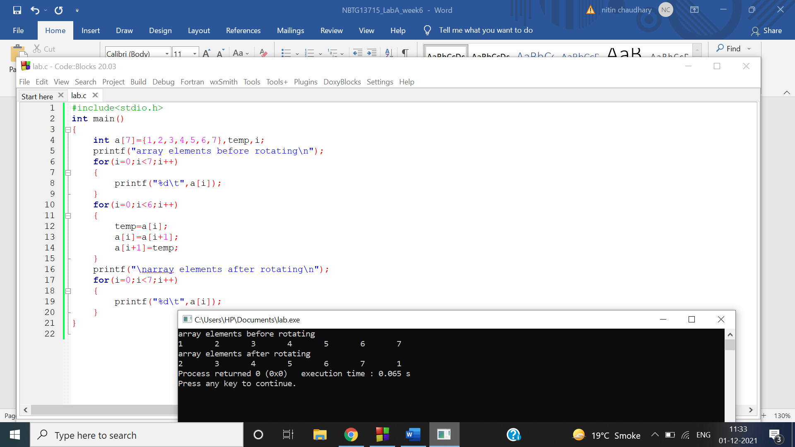

Q4

#include<stdio.h>

int main()

{

int a[4]={32,54,-6,-15},temp,i,j,k,min=0,smin;

for(i=0;i<4;i++)

{

for(j=0;j<4;j++)

{

if(a[j]<a[i])

{

min=a[j];

k=j;

}

}

}

for(i=0;i<4;i++)

{

for(j=0;j<4;j++)

{

if(a[j]<a[i]&&a[j]>a[k])

{

smin=a[j];

}

}

}

printf("\nsecond smallest element is : %d\n",smin);

}

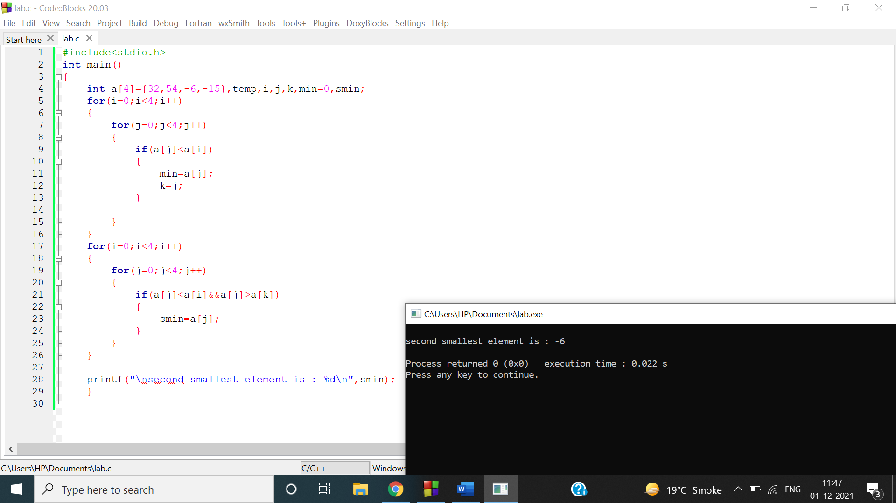

Q5)

a)

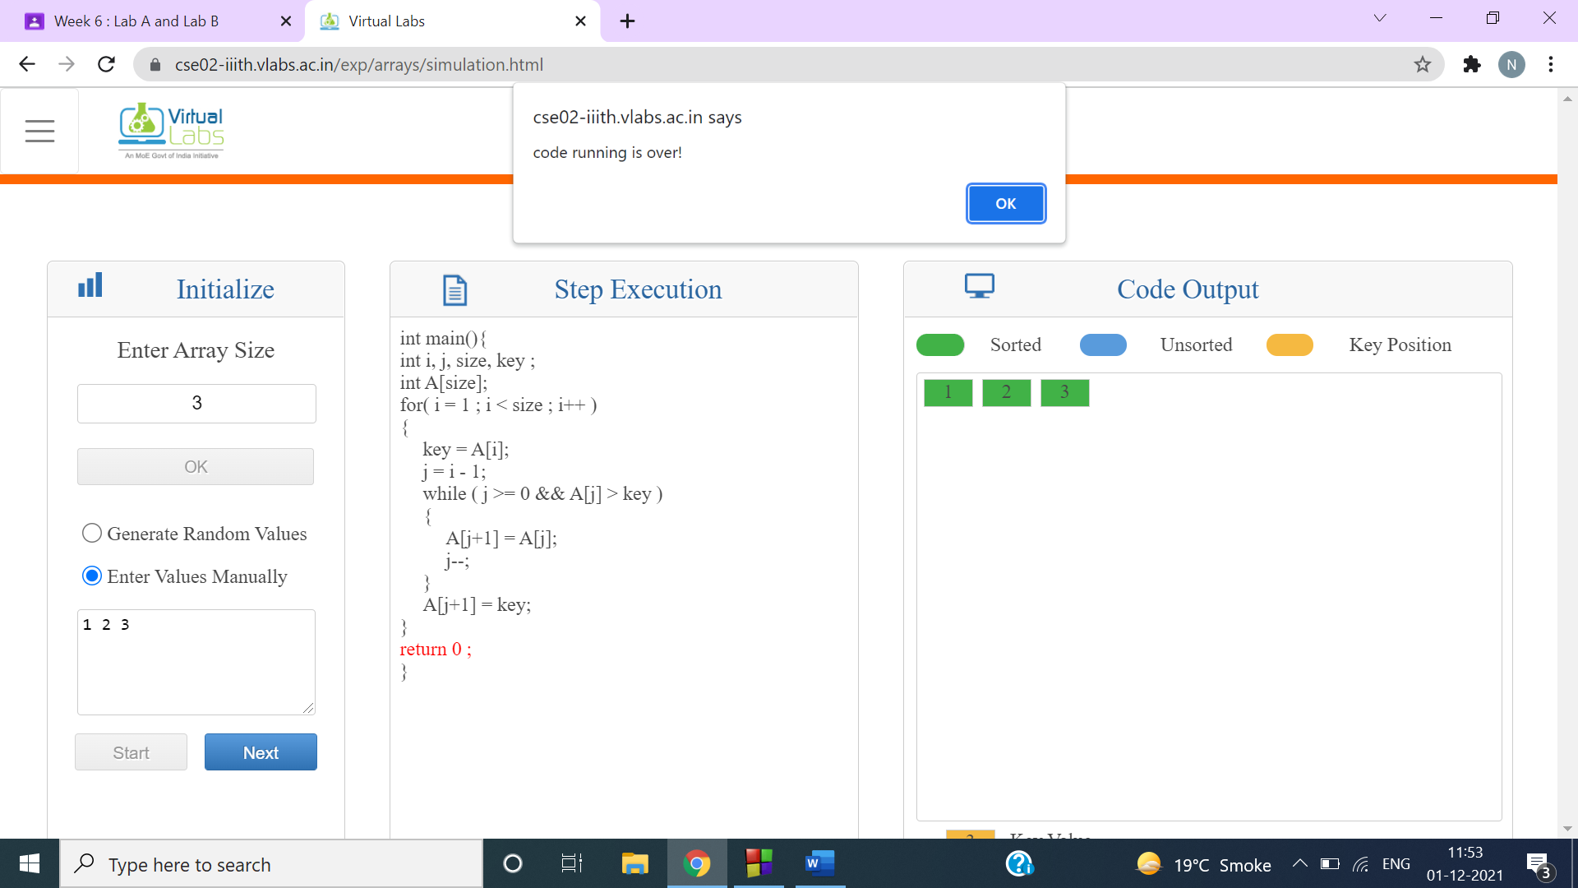

b)

