NBTG13715

Nitin chaudhary

Week 7 Lab A

Q1

#include<stdio.h>

int main()

{

int i=0,j=0;

char a[100],b[100];

printf("enter string\n");

gets(a);

while(a[i]!='\0')

{

if((a[i]>='a'&&a[i]<='z')||(a[i]>='A'&&a[i]<='Z'))

{

b[j]=a[i];

j++;

}

i++;

}

printf("string only with alphabets\n");

puts(b);

}

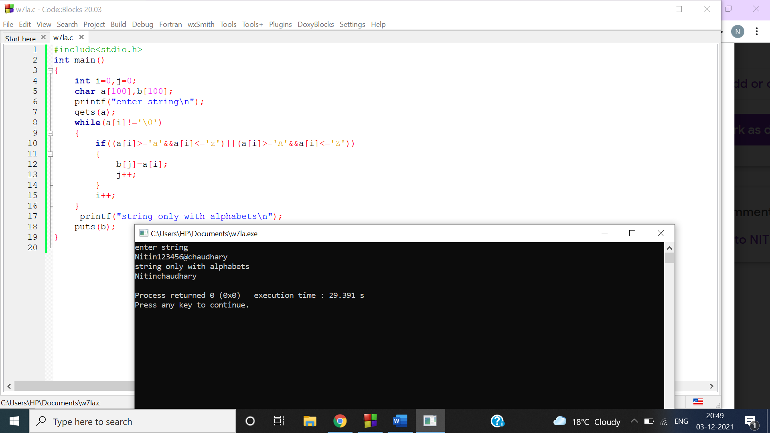

Q2

#include<stdio.h>

int main()

{

int i=0,len=0;

char a[100];

printf("enter string\n");

gets(a);

while(a[i]!='\0')

{

i++;

}

printf("length of string is %d \n",i);

}

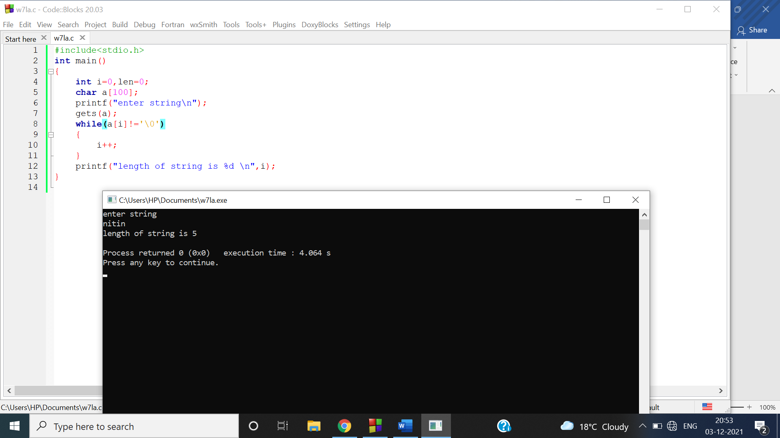

Q3

#include<stdio.h>

int main()

{

char a[100],b;

int i,c=0;

printf("enter string\n");

gets(a);

printf("enter element to be searched\n");

scanf("%c",&b);

while(a[i]!='\0')

{

if(a[i]==b)

{

c++;

}

i++;

}

printf("%c occurs %d times\n",b,c);

}

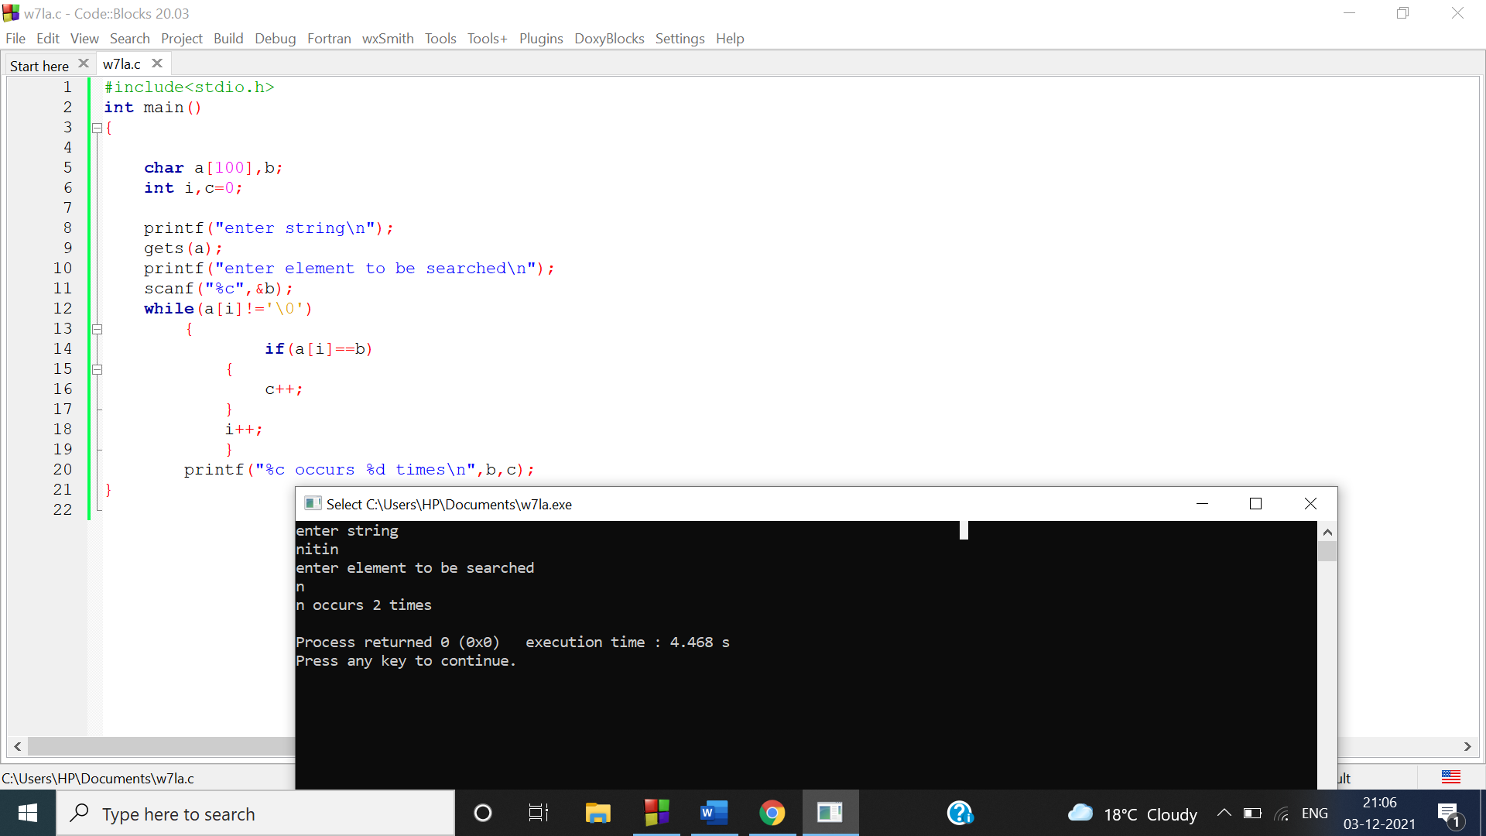

Q4

#include<stdio.h>

int main()

{

char a[100];

int i,v=0,c=0;

printf("enter alphabets string\n");

gets(a);

for(i=0;a[i]!='\0';i++)

{

if(a[i]=='a'||a[i]=='e'||a[i]=='i'||a[i]=='o'||a[i]=='u')

v++;

else

c++;

}

printf("total number of vowels are %d\n",v);

printf("total number of consonents are %d\n",c);

}

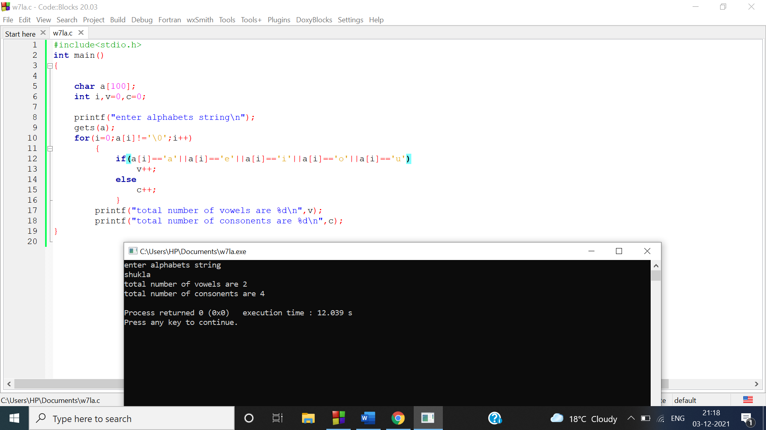

Q5

a)

#include<stdio.h>

int main()

{

char a[100],b[100];

int i;

printf("enter first string\n");

gets(a);

printf("enter second string\n");

gets(b);

i=strcmp(a,b);

if(i==0)

printf("strings are equal\n");

else

printf("strings are not equal\n");

}

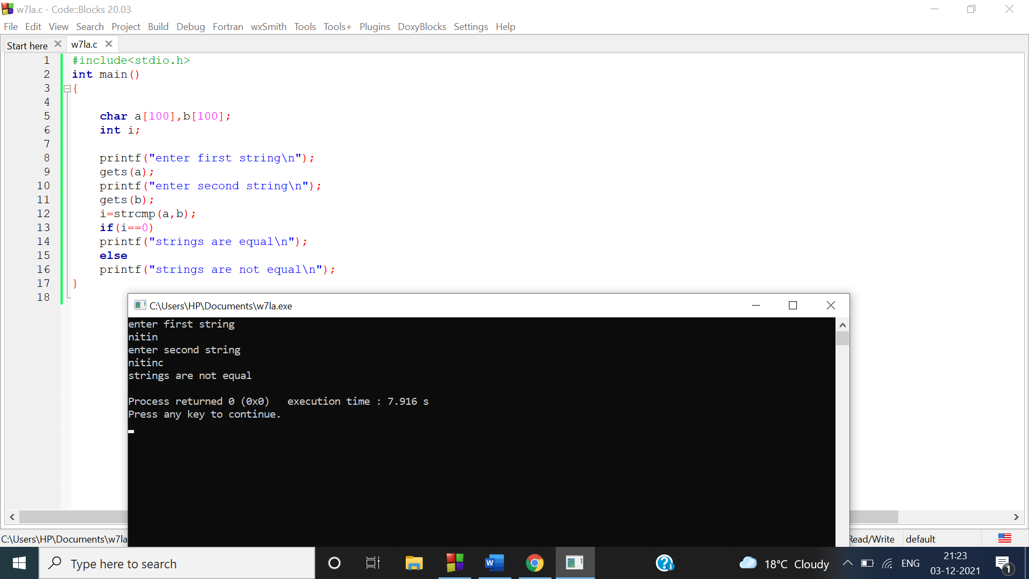

b)

#include <stdio.h>

int main()

{

char str1[80], str2[80];

int l, i, j;

printf("Enter first string: ");

gets(str1);

printf("Enter second string: ");

gets(str2);

//finding length of second string

for (l = 0; str2[l] != '\0'; l++);

for (i = 0, j = 0; str1[i] != '\0' && str2[j] != '\0'; i++)

{

if (str1[i] == str2[j])

{

j++;

}

else

{

j = 0;

}

}

if (j == l)

{

printf("Substring found at position %d", i - j + 1);

}

else

{

printf("Substring not found");

}

return 0;

}

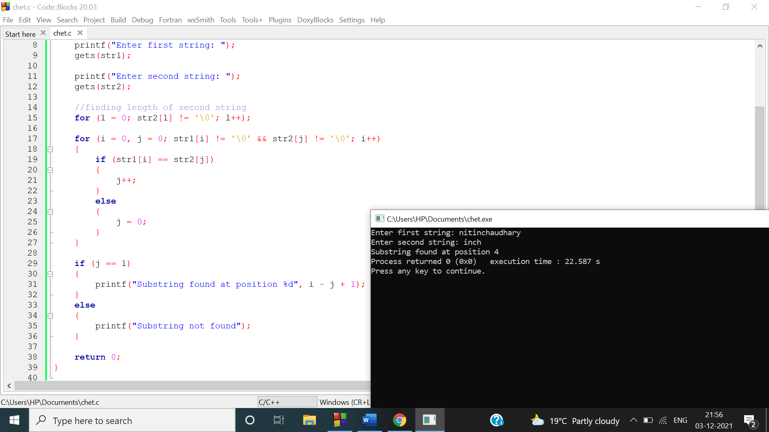

c)

#include<stdio.h>

#include<string.h>

main(){

int i,j,n;

char str[100][100],s[100];

printf("Enter number of names :\n");

scanf("%d",&n);

printf("Enter names in any order:\n");

for(i=0;i<n;i++){

scanf("%s",str[i]);

}

for(i=0;i<n;i++){

for(j=i+1;j<n;j++){

if(strcmp(str[i],str[j])>0){

strcpy(s,str[i]);

strcpy(str[i],str[j]);

strcpy(str[j],s);

}

}

}

printf("\nThe sorted order of names are:\n");

for(i=0;i<n;i++){

printf("%s\n",str[i]);

}

}

