NBTG13715

Nitin Chauhary

F8

Week 8 lab B

Q1

#include<stdio.h>

int main()

{

int a,b;

printf("enter first number");

scanf("%d",&a);

printf("enter second number");

scanf("%d",&b);

check(a,b);

}

int check(int a,int b)

{

if(b%a==0)

printf("%d is a multiple of %d",a,b);

else

printf("%d is not a multiple of %d",a,b);

}

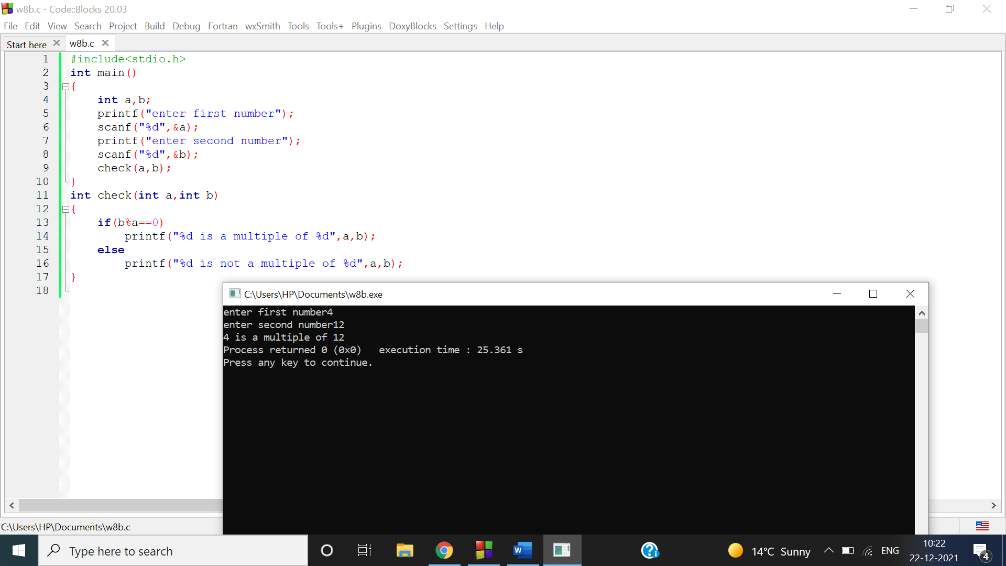

Q2

#include<stdio.h>

int main()

{

int n;

printf("enter number of elements you want to enter in array");

scanf("%d",&n);

int a[n],i;

printf("enter array numbers");

for(i=0;i<n;i++)

{

scanf("%d",&a[i]);

}

maximum(a,n);

}

int maximum(int a[],int n)

{

int max=a[0],i;

for(i=0;i<n;i++)

{

if(a[i]>max)

{

max=a[i];

}

}

printf("maximum value is %d",max);

}

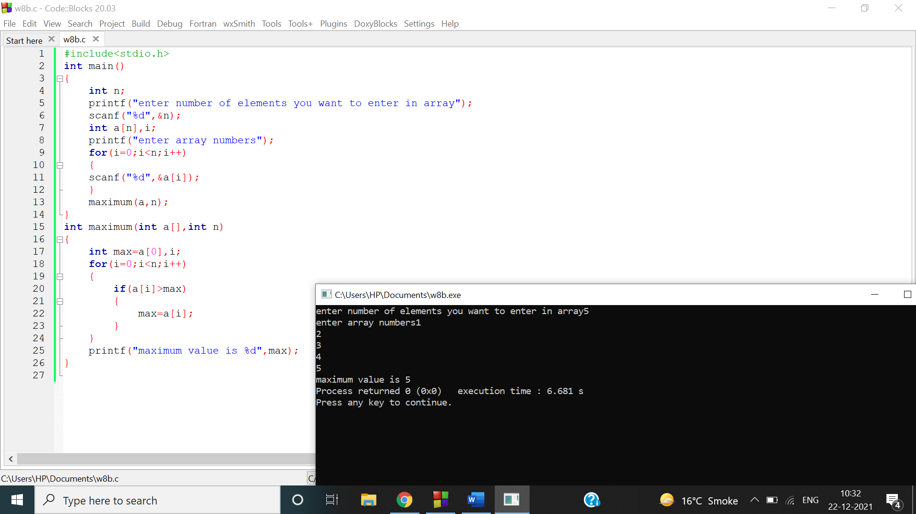

Q3

#include<stdio.h>

int main()

{

char a[100],c;

printf("enter string");

gets(a);

printf("enter character");

c=getchar();

check(a,c);

}

void check(char a[] , char c)

{

int i=0;

while(a[i]!='\0')

{

if(a[i]==c)

{

printf("character %c is present",c);

break;

}

else

i++;

}

}

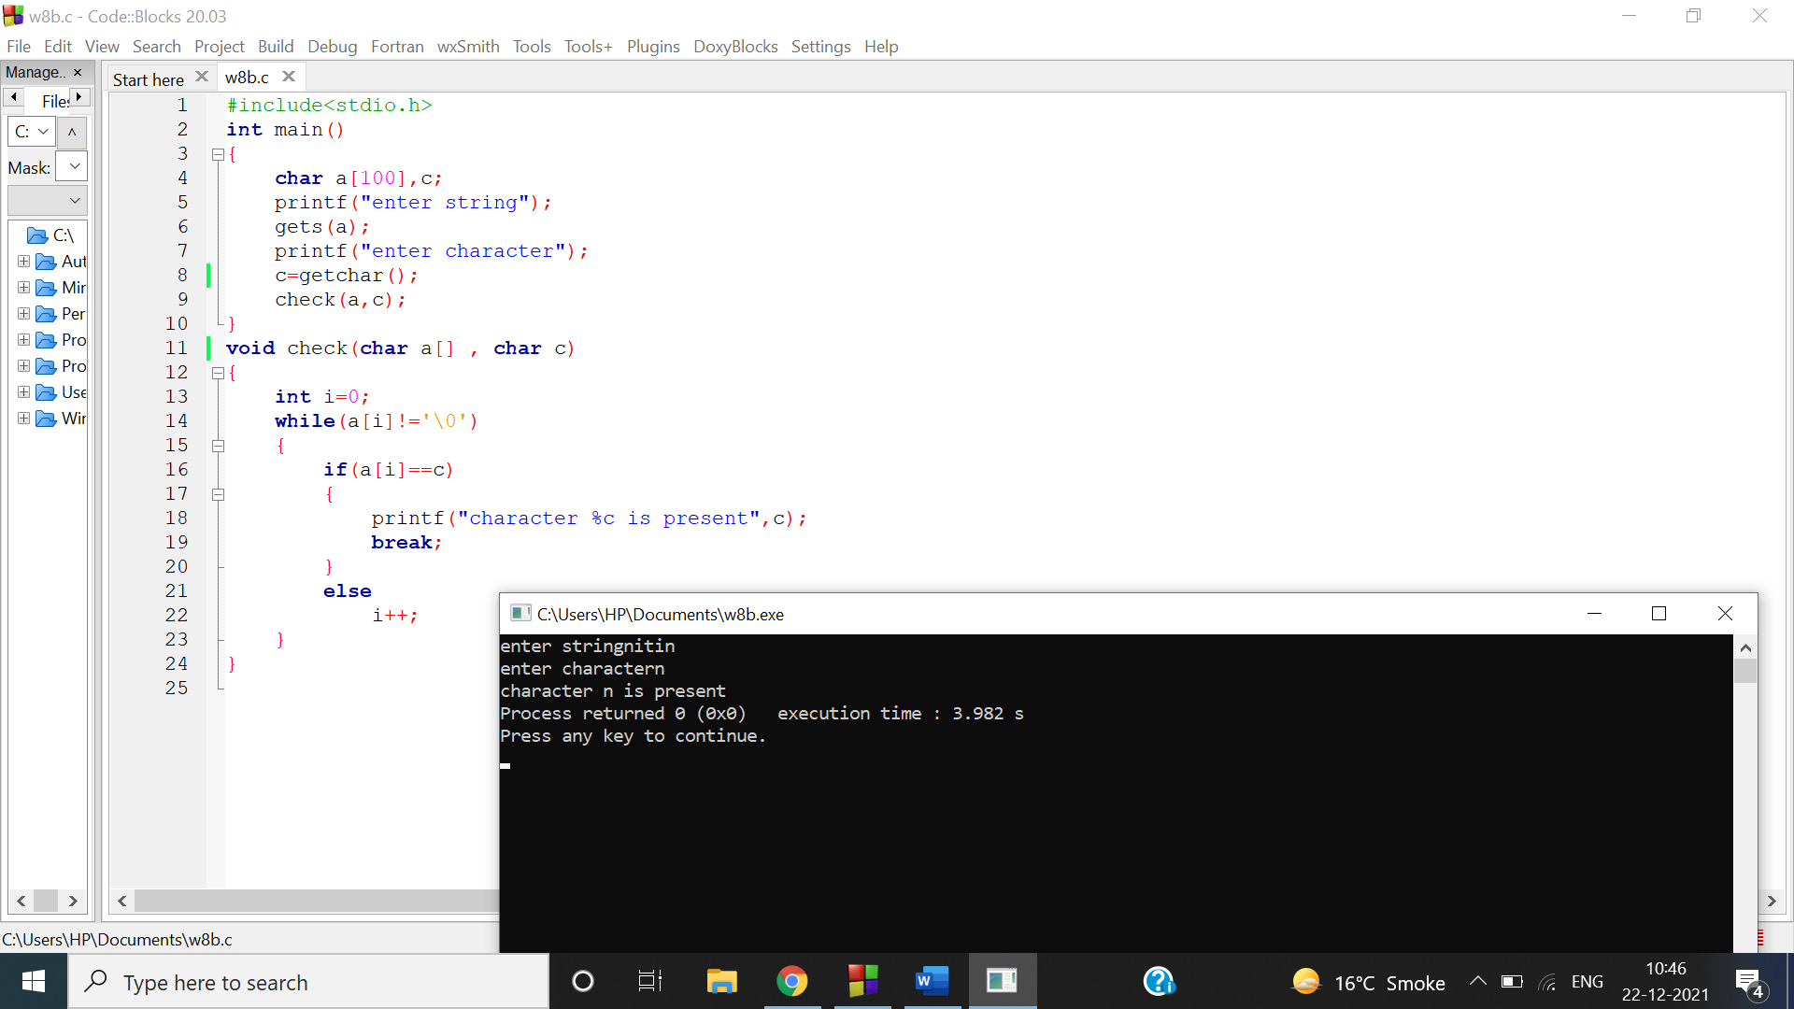

Q4

#include<stdio.h>

int main()

{

char a[100];

printf("enter string");

gets(a);

check(a);

}

void check(char a[])

{

int i=0;

while(a[i]!='\0')

{

i++;

}

printf("length of string is %d",i);

}

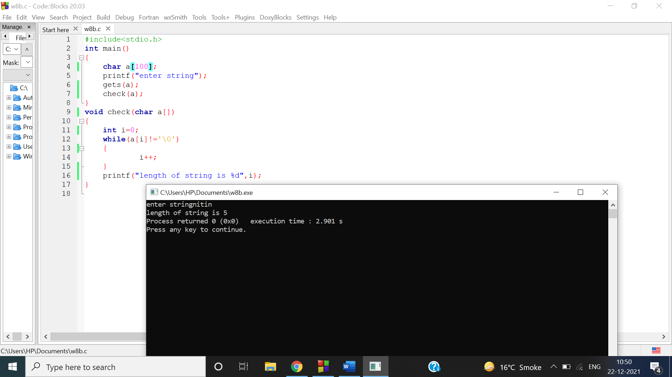

Q5

#include<stdio.h>

int main() {

int n;

printf("Enter a positive integer: ");

scanf("%d",&n);

printf("Factorial of %d = %d",n,factorial(n));

return 0;

}

int factorial(int n) {

if (n>=1)

return n\*factorial(n-1);

else

return 1;

}

