Week 5 lab A

NBTG13715

Nitin Chaudhary

F8

Q1

#include <stdio.h>

int main()

{

int a;

printf("enter from 1 to 7 considering sunday as first day of week");

scanf("%d",&a);

if(a>7||a<1)

{

printf("wrong input");

printf("\nenter from 1 to 7 considering sunday as first day of week");

scanf("%d",&a);

}

switch(a)

{

case 1:printf("its sunday");

break;

case 2:printf("its monday");

break;

case 3:printf("its tuesday");

break;

case 4:printf("its wednesday");

break;

case 5:printf("its thursday");

break;

case 6:printf("its friday");

break;

case 7:printf("its satday");

break;

}

}

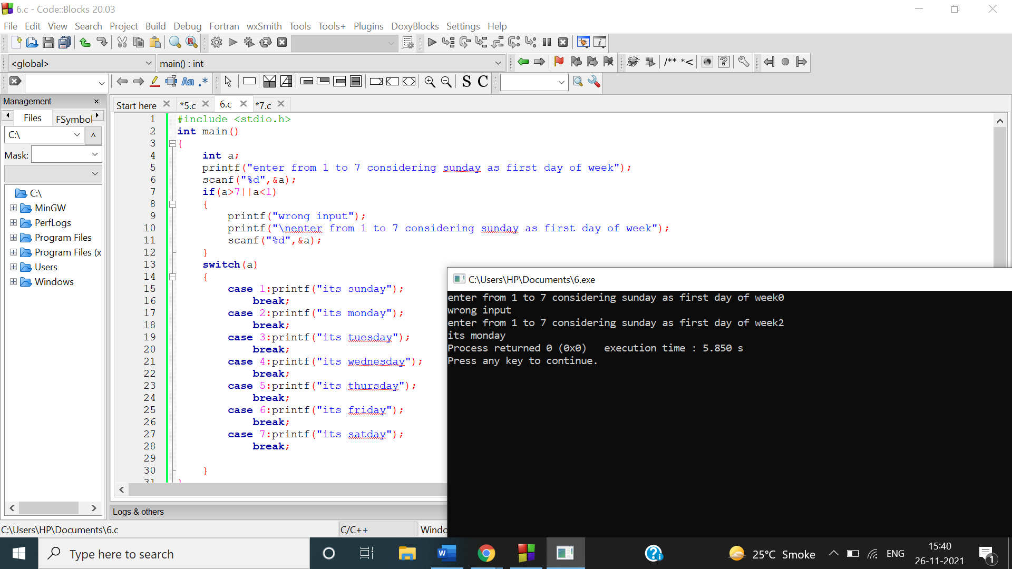

Q2

#include <stdio.h>

int main()

{

int a,b,c,d;

printf("enter first number");

scanf("%d",&a);

printf("enter second number");

scanf("%d",&b);

c=a>b;

switch(c)

{

case 1:printf("first is maximum");

break;

case 0:printf("secomd is maximum");

break;

}

}

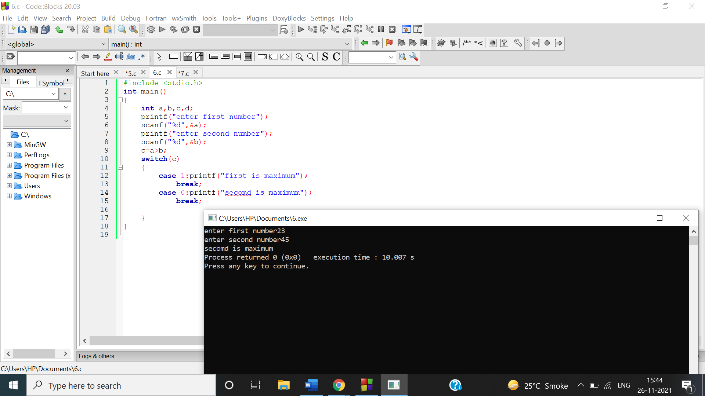

Q3

#include <stdio.h>

int main()

{

int a;

printf("enter from 1 to 12 considering january as first month");

scanf("%d",&a);

if(a>12||a<1)

{

printf("wrong input");

printf("\nenter from 1 to 12 considering january as first month");

scanf("%d",&a);

}

switch(a)

{

case 1:printf("its january having 31 days");

break;

case 2:printf("its february having 28 days");

break;

case 3:printf("its march having 31 days");

break;

case 4:printf("its april having 30 days");

break;

case 5:printf("its may having 31 days");

break;

case 6:printf("its june having 30 days");

break;

case 7:printf("its july having 31 days");

break;

case 8:printf("its august having 31 days");

break;

case 9:printf("its september having 30 days");

break;

case 10:printf("its october having 31 days");

break;

case 11:printf("its november having 30 days");

break;

case 12:printf("its december having 31 days");

break;

}

}

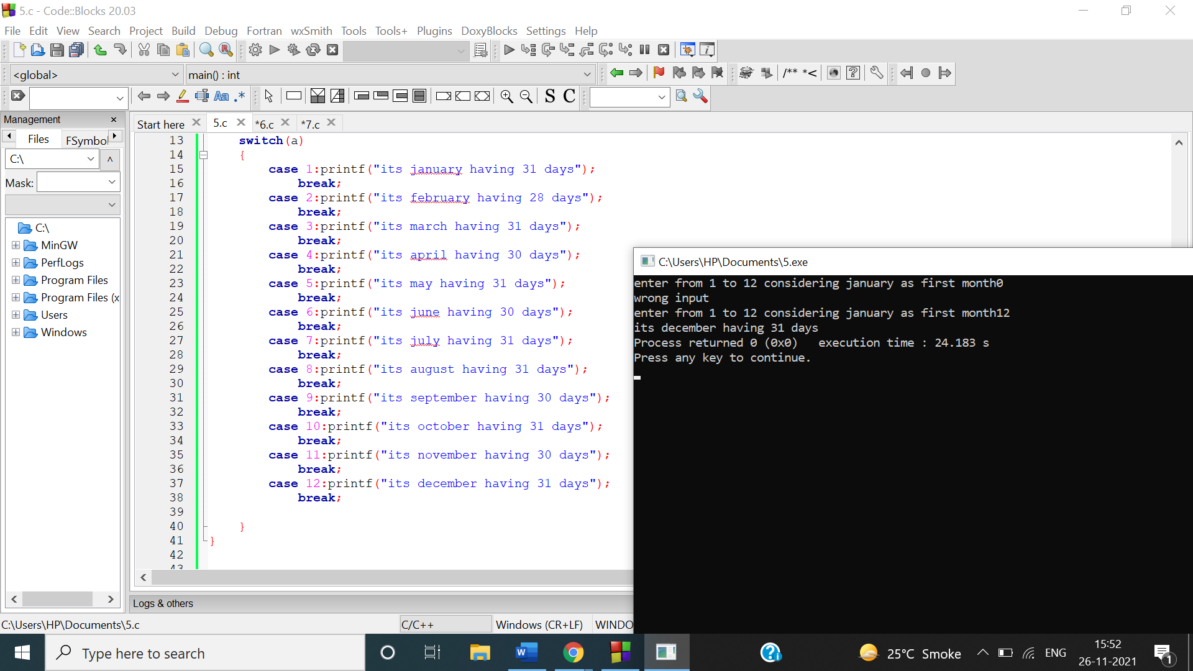

Q4

#include <stdio.h>

int main()

{

int a,b,x;

printf("enter first number");

scanf("%d",&a);

printf("\nenter second number");

scanf("%d",&b);

printf("\nenter 1 for addition, 2 for subtracton,3 for multiplication,4 for division ");

scanf("%d",&x);

if(x>4||x<1)

{

printf("wrong input");

printf("\nenter 1 for addition, 2 for subtracton,3 for multiplication,4 for division ");

scanf("%d",&x);

}

switch(x)

{

case 1:printf("result is %d",a+b);

break;

case 2:printf("result is %d",a-b);

break;

case 3:printf("result is %d",a\*b);

break;

case 4:printf("result is %d",a/b);

break;

}

}

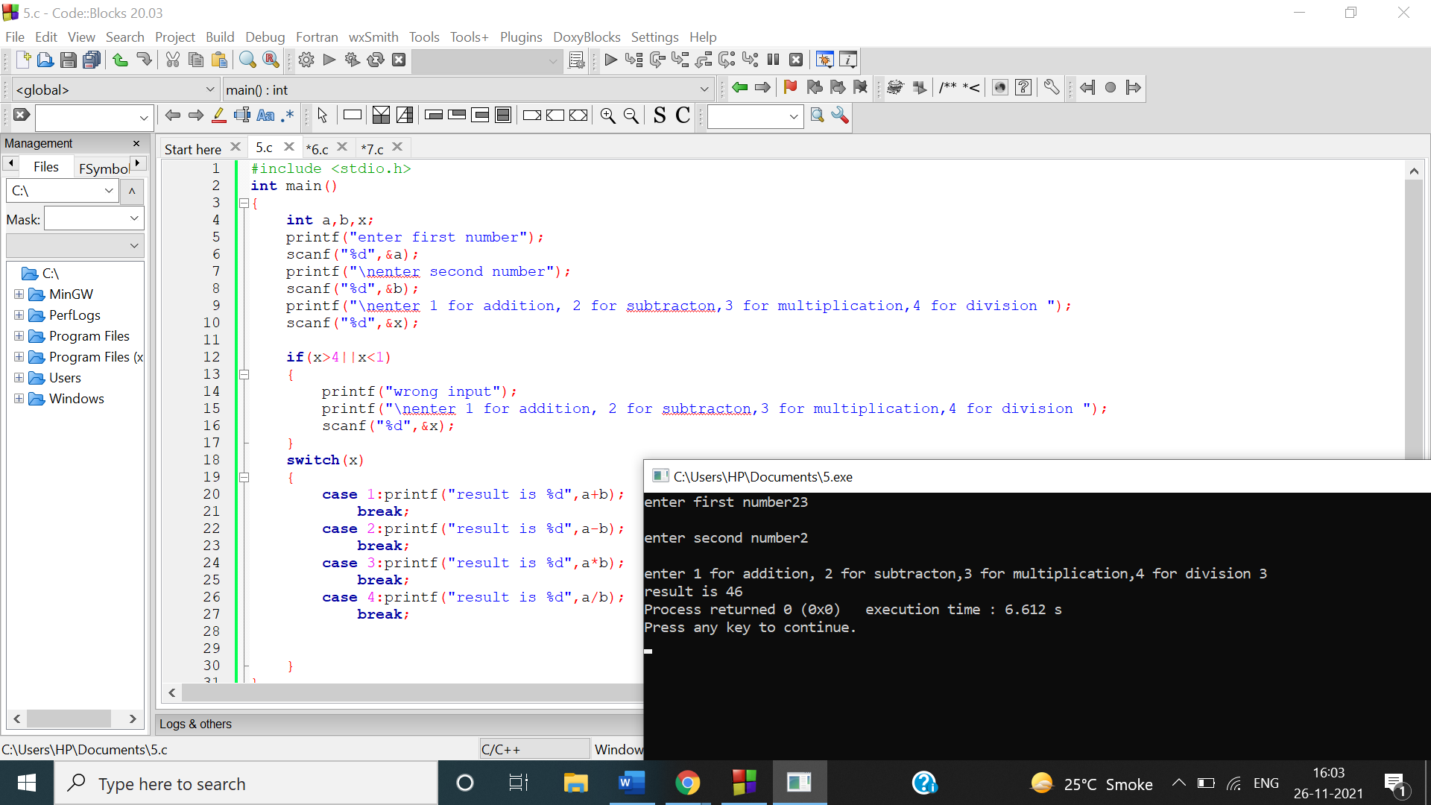

Q5

#include <stdio.h>

int main()

{

char a;

int qty,rate,total;

printf("\nenter B for Burger, F for French Fries, P for Pizza,S for Sandwiches\n");

scanf("%c",&a);

switch(a)

{

case 'B':

printf("you have selected Burger,\n enter the quantity");

scanf("%d",&qty);

rate=200;

total=qty\*rate;

printf("total amount is Rs%d",total);

break;

case 'F':

printf("you have selected french fries,\n enter the quantity");

scanf("%d",&qty);

rate=50;

total=qty\*rate;

printf("\ntotal amount is Rs%d",total);

break;

case 'P':

printf("you have selected pizza ,\n enter the quantity");

scanf("%d",&qty);

rate=500;

total=qty\*rate;

printf("\ntotal amount is Rs %d",total);

break;

case 'S':

printf("you have selected sandwich,\n enter the quantity");

scanf("%d",&qty);

rate=150;

total=qty\*rate;

printf("\ntotal amount is Rs%d",total);

break;

}

return 0;

}

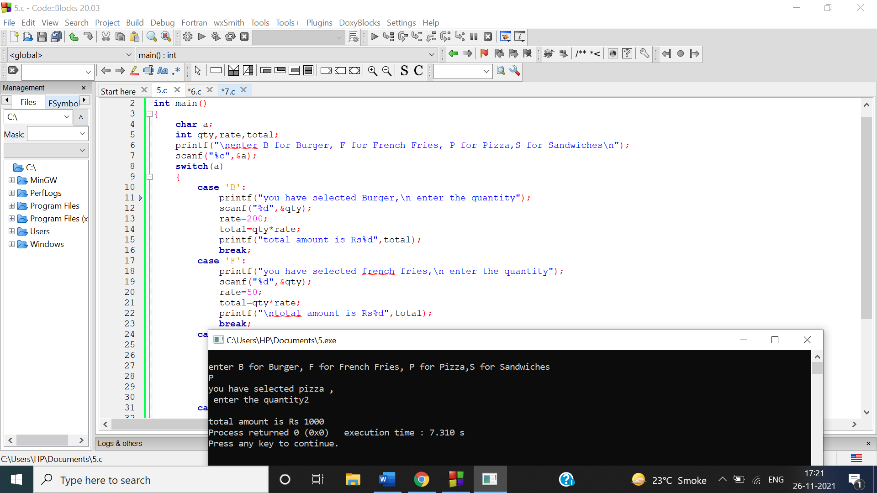

Q6

a)

#include <stdio.h>

int main()

{

int n,i=1,s=0;

printf("enter n to get sum of first n natural numbers\n");

scanf("%d",&n);

while(i<=n)

{

s+=i;

i++;

}

printf("\nsum of first %d natural numbers is %d",n,s);

return 0;

}

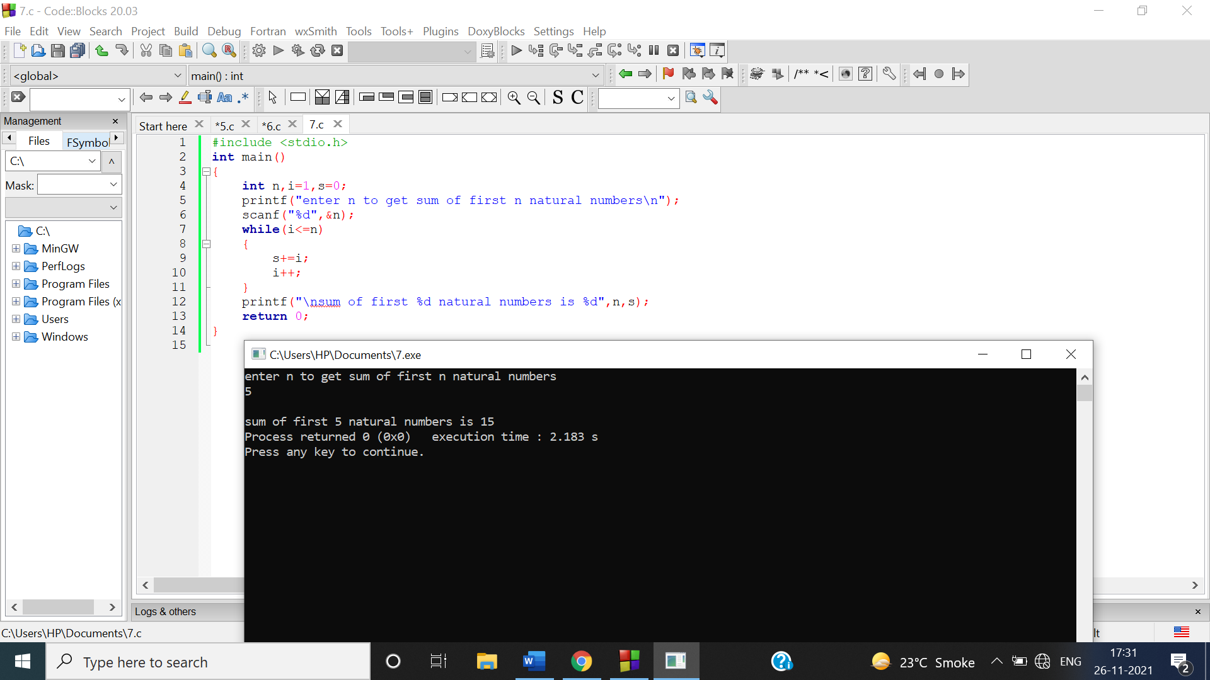

b)

#include <stdio.h>

int main()

{

int n,i=1,s=0;

printf("enter n to get sum of first n natural numbers\n");

scanf("%d",&n);

do

{

s+=i;

i++;

}while(i<=n);

printf("\nsum of first %d natural numbers is %d",n,s);

return 0;

}

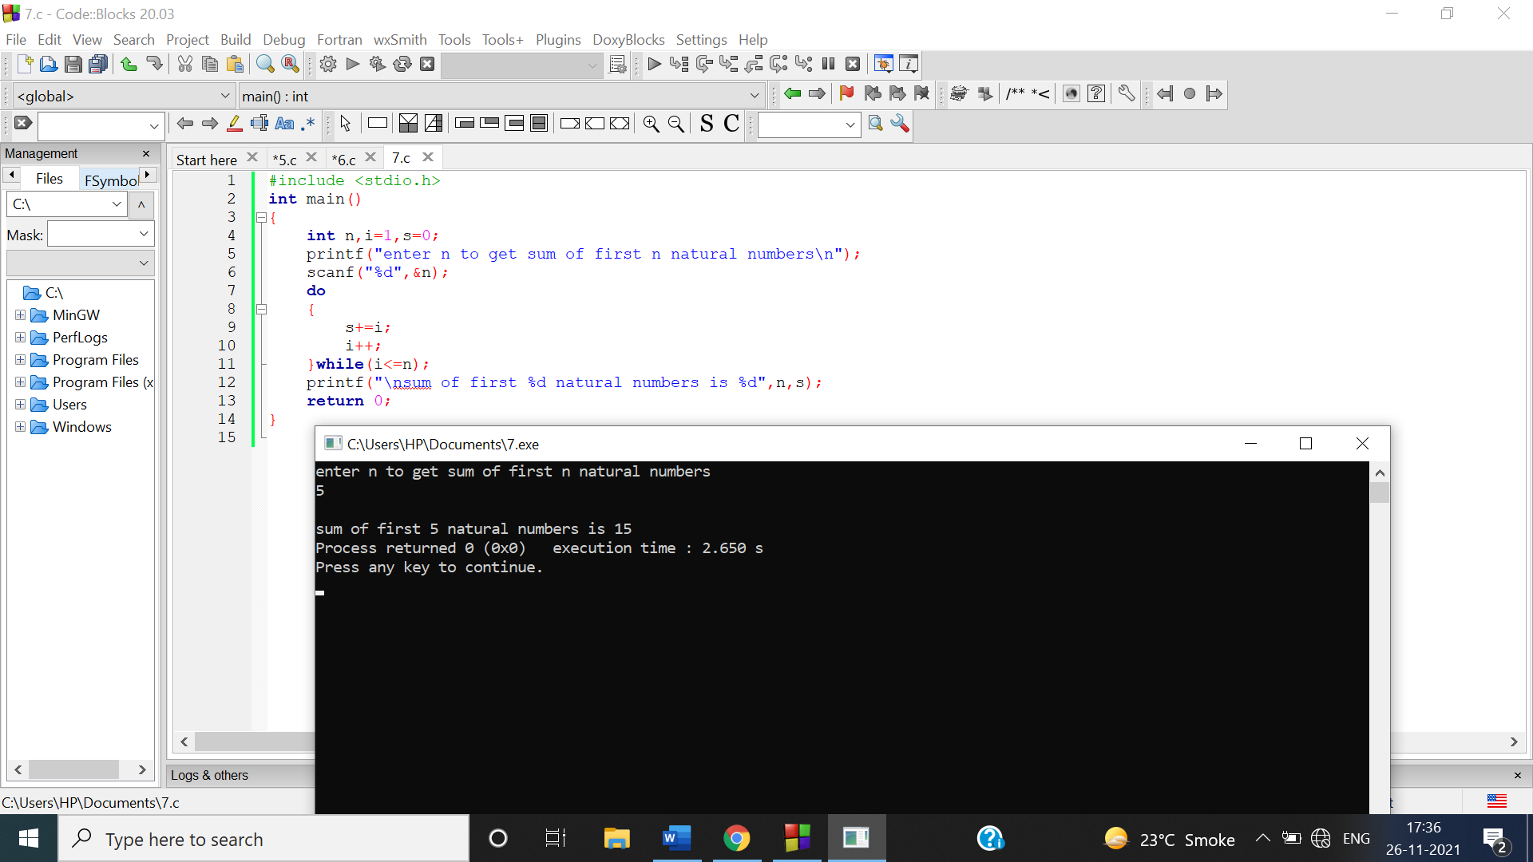

Q7

#include <stdio.h>

int main()

{

int n,i=1,s=0;

printf("enter number to get its table\n");

scanf("%d",&n);

while(i<=10)

{

printf("\n%d \* %d = %d",n,i,n\*i);

i++;

}

return 0;

}

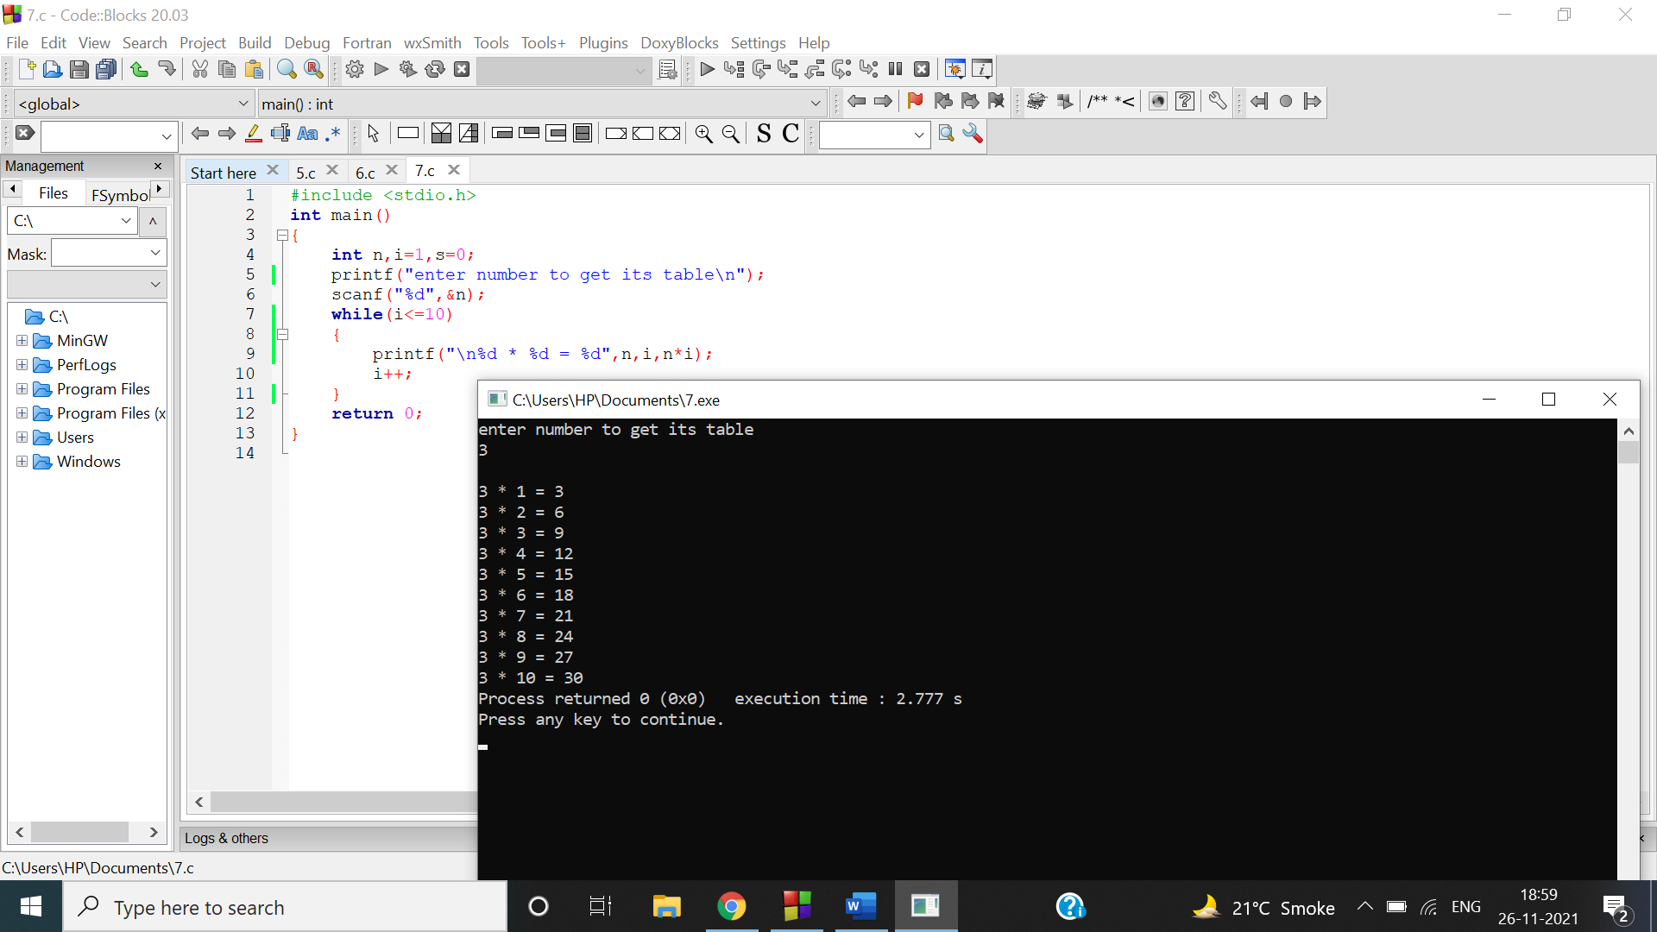

Q8

#include <stdio.h>

int main()

{

int n,i=1,p=1,r;

printf("enter number to get product of its digits\n");

scanf("%d",&n);

while(n!=0)

{

r=n%10;

p\*=r;

n/=10;

i++;

}

printf("\nproduct of digits is %d",p);

return 0;

}

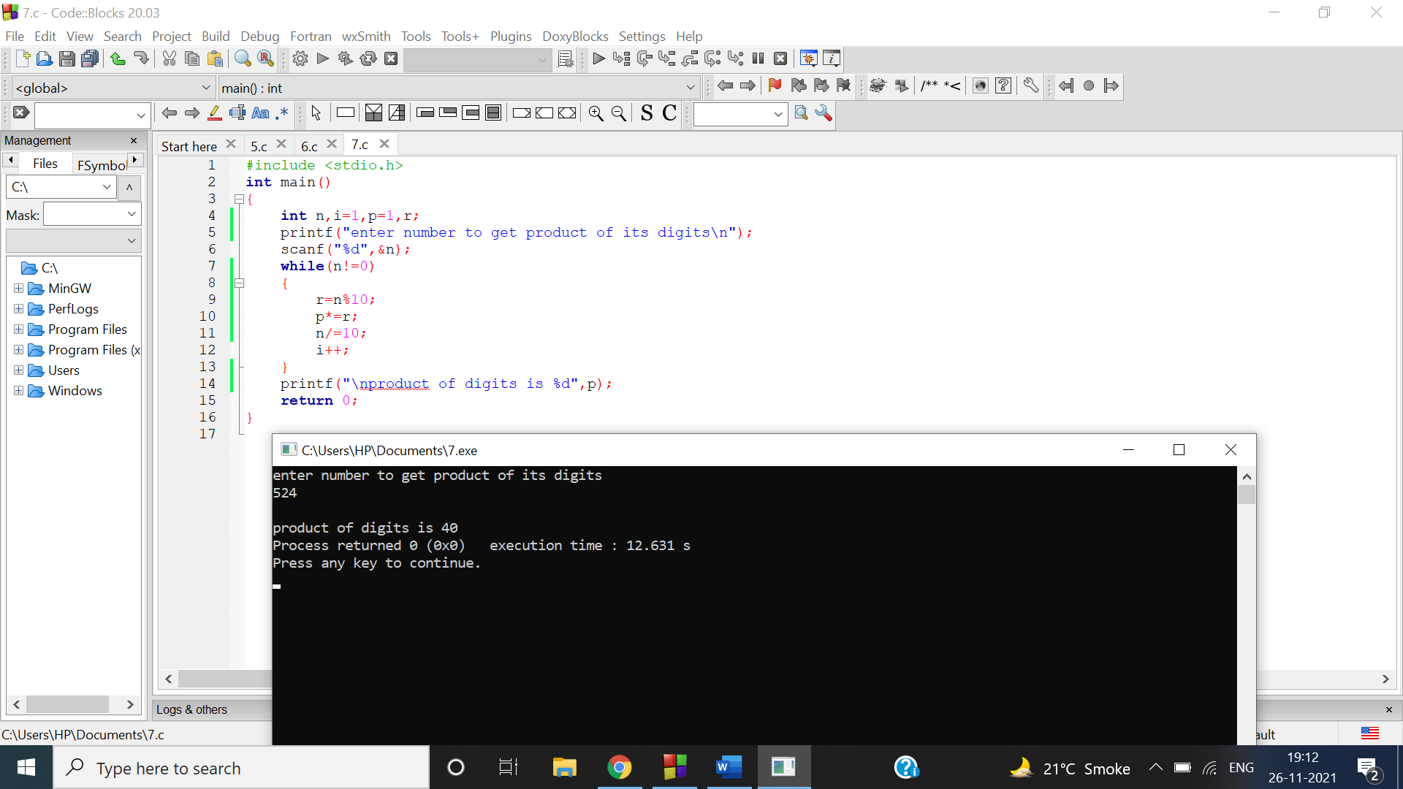

Q10

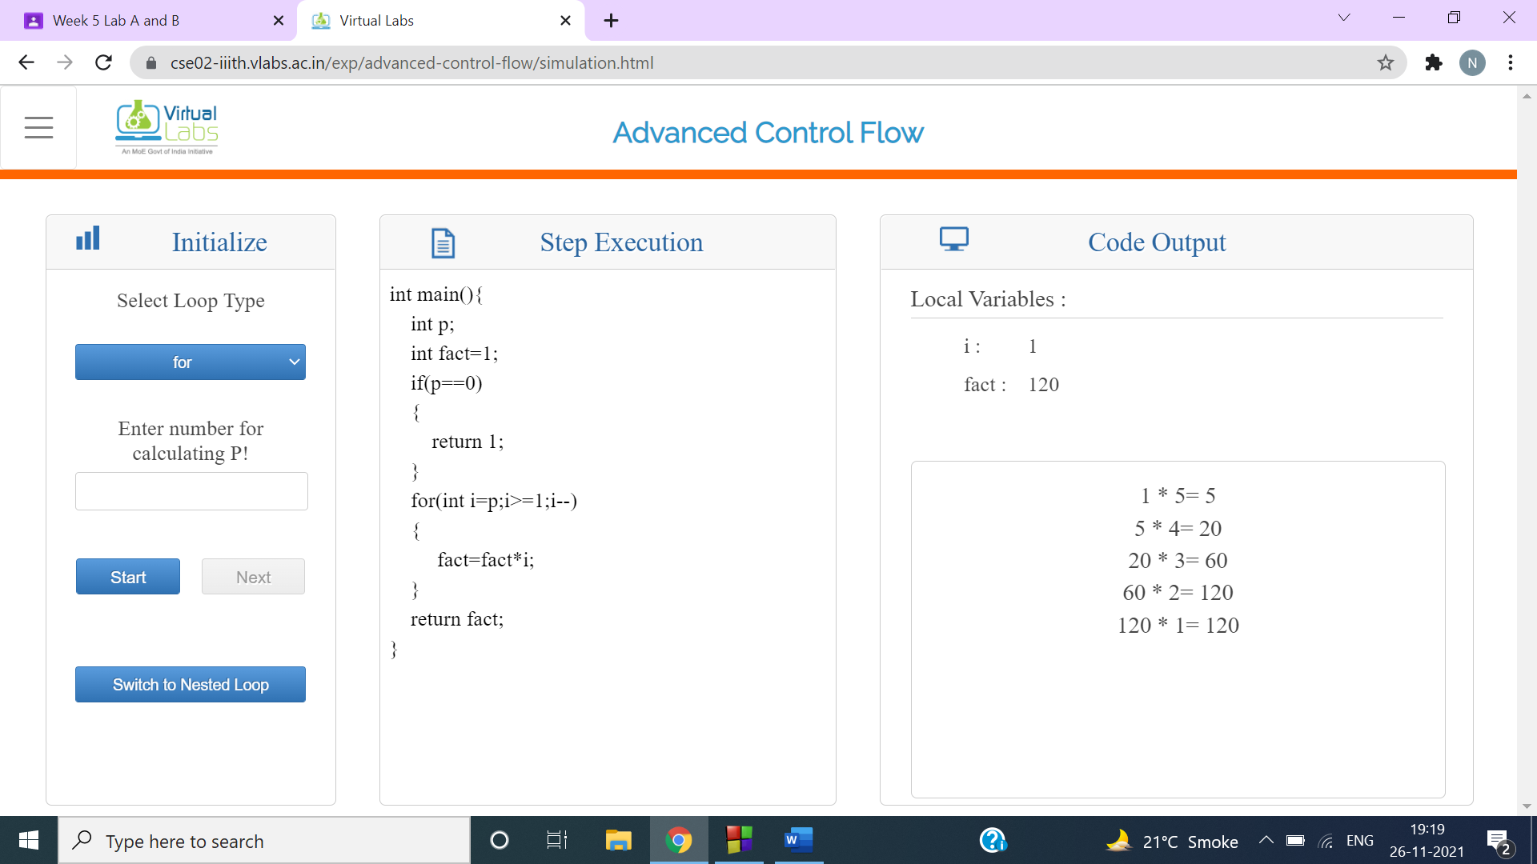

Q11

