NBTG13715

Nitin Chaudhary

Week 7

Lab B

F8

Q1

int cube(int n)

{

int c;

c=n\*n\*n;

return c;

}

int main()

{

int a,b;

printf("enter a nuber to get its cube");

scanf("%d",&a);

b=cube(a);

printf("cube of %d is %d ",a,b);

}

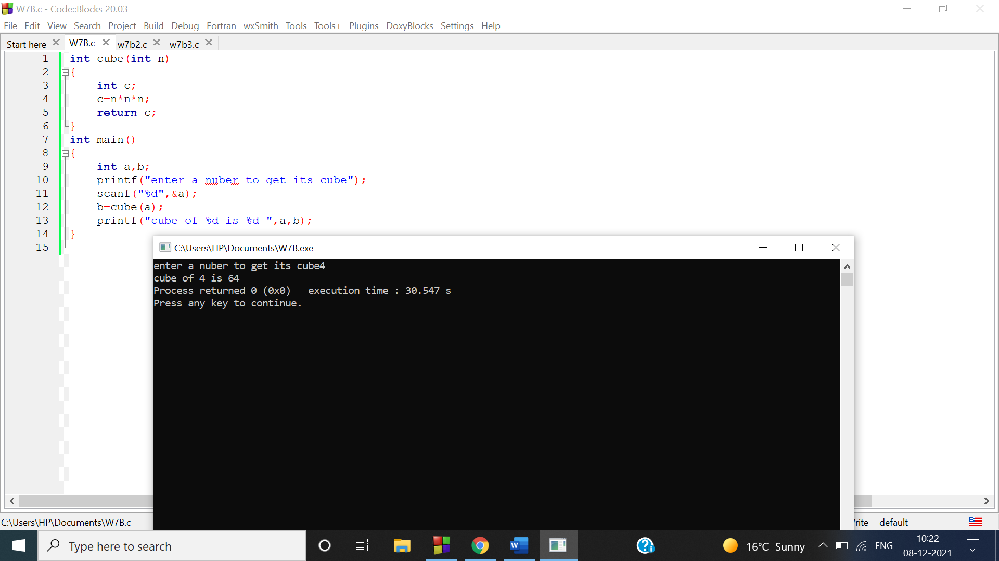

Q2

int cube(int n)

{

int c;

c=n\*n\*n;

return c;

}

int main()

{

int a,b,i;

printf("enter n to get cube of first n numbers");

scanf("%d",&a);

for(i=1;i<=a;i++)

{

b=cube(i);

printf("cube of %d is %d\n",i,b);

}

}

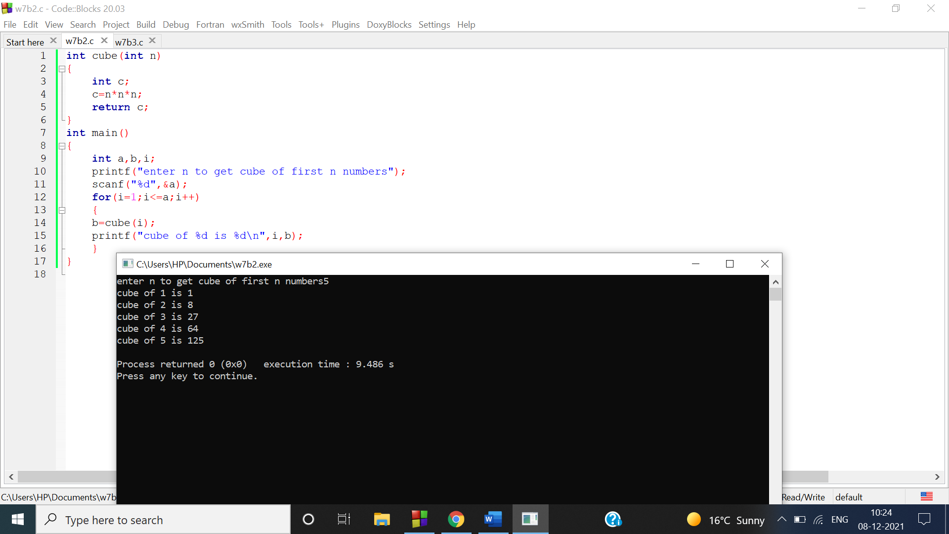

Q3

int octal(int n)

{

int a[100],r,i=0,j;

while(n>0)

{

r=n%8;

a[i]=r;

i++;

n/=8;

}

j=i-1;

printf("\noctal equivalent is\n");

for(j;j>=0;j--)

{

printf("%d",a[j]);

}

}

int main()

{

int num;

printf("enter a number to get its octal equivalent\n");

scanf("%d",&num);

octal(num);

}

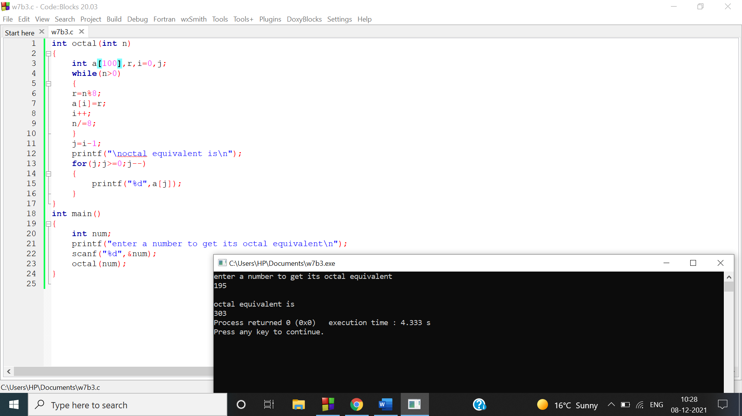

Q4

void add(int a,int b,int c,int d)

{

int x,y;

x=a+c;

y=b+d;

printf("complex nuber addition is %d+i%d",x,y);

}

int main()

{

int a,b,c,d;

printf("enter real and complex parts of first complex number separated with space");

scanf("%d%d",&a,&b);

printf("enter real and complex parts of second complex number separated with space");

scanf("%d%d",&c,&d);

add(a,b,c,d);

}

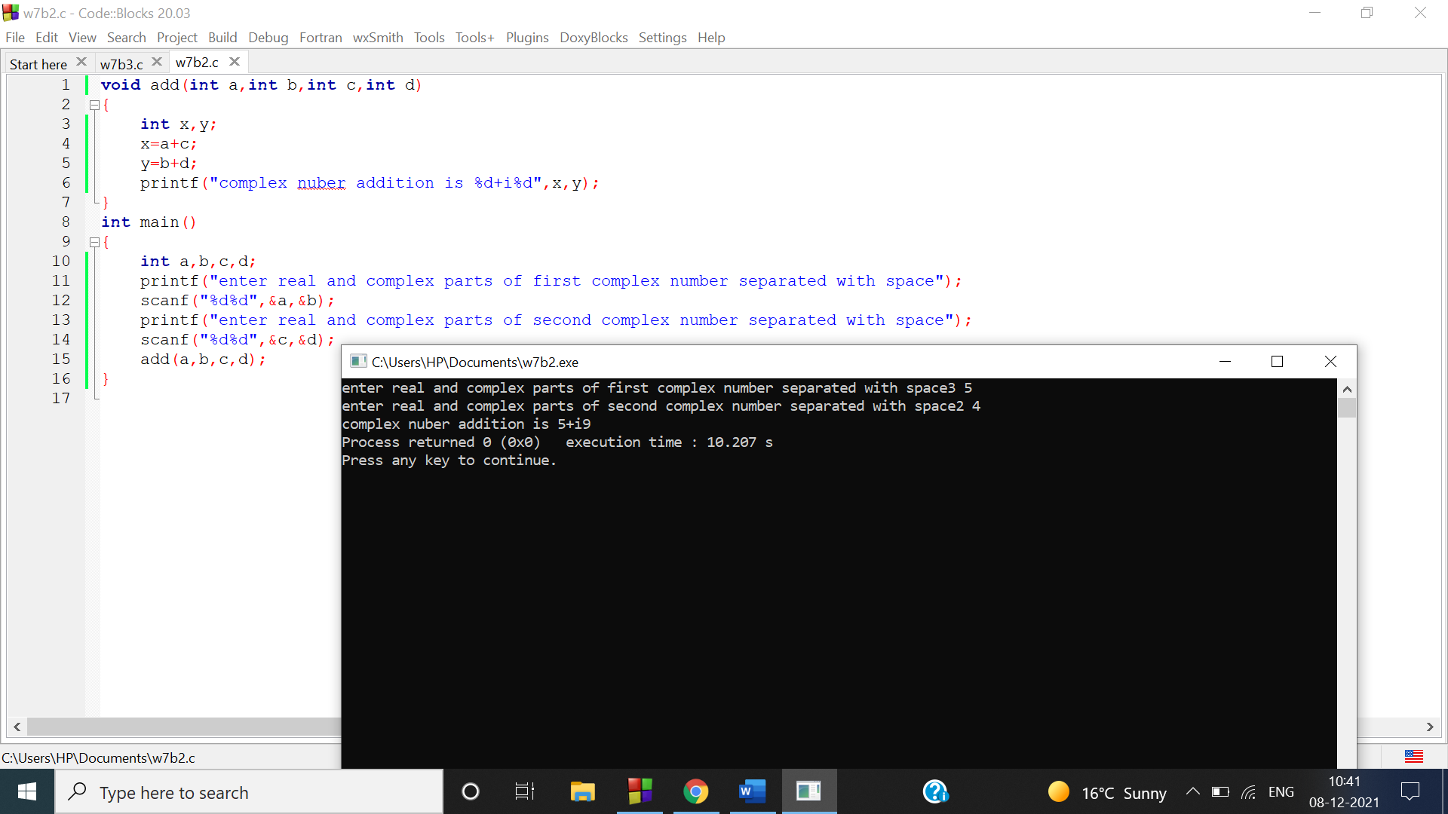

Q5

void fibo(int n)

{

int s=0,a=1,b=1,i,c;

printf("first %d terms of fibonacci series are\n",n);

printf("%d\t%d\t%d\t",c,a,b);

for(i=4;i<=n;i++)

{

c=a+b;

a=b;

b=c;

printf("%d\t",c);

}

}

int main()

{

int n;

printf("enter n to get n terms of a fibonacci series");

scanf("%d",&n);

fibo(n);

}

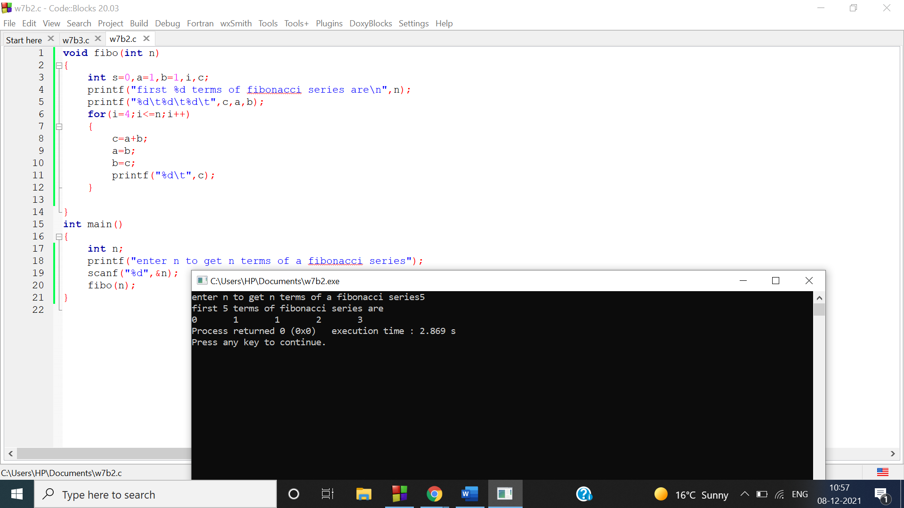

Q6

void check()

{

int a[4]={2,3,5,7};

int i,j,x=0,c;

for(i=0;i<4;i++)

{

c=8-a[i];

for(j=0;j<4;j++)

{

if(a[j]==c)

{

printf("8 can be expressed as the sum of two prime numbers %d and %d",a[i],c);

x++;

break;

}

}

if(x==1)

{

break;

}

}

if(x==0)

{

printf("8 can not be expressed as the sum of two prime numbers");

}

}

int main()

{

check();

}

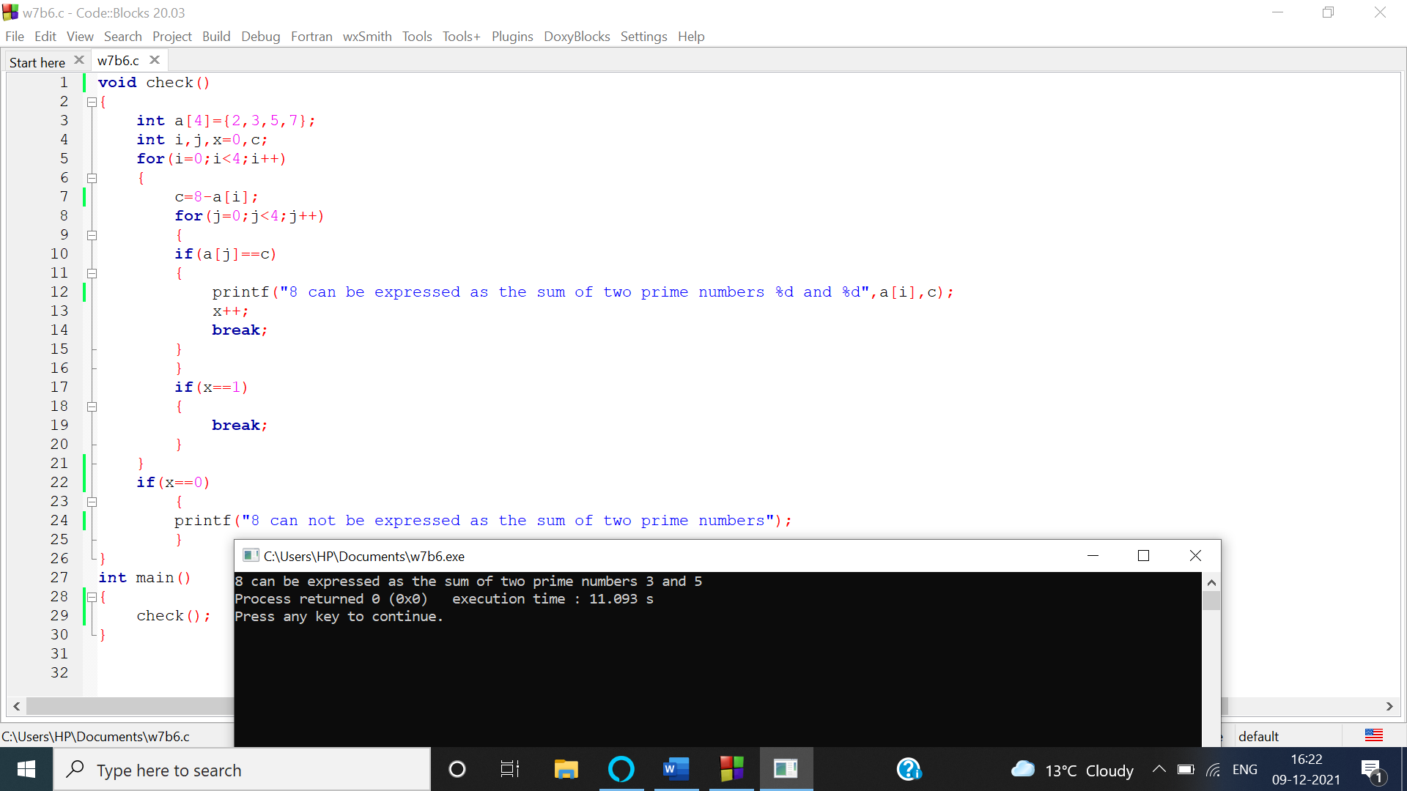

Q7

void add(float a,float b)

{

float sum;

sum=a+b;

printf("sum of %f and %f is %f\n",a,b,sum);

}

void sub(float a,float b)

{

float subtract;

subtract=a-b;

printf("subtraction of %f and %f is %f\n",a,b,subtract);

}

void mul(float a,float b)

{

float multiply ;

multiply=a\*b;

printf("multiplication of %f and %f is %f\n",a,b,multiply);

}

void div(float a,float b)

{

float division;

division=a/b;

printf("division of %f and %f is %f\n",a,b,division);

}

int main()

{

int n;

float a,b;

printf("enter two numbers separated with space");

scanf("%f%f",&a,&b);

printf("enter 1 to add,2 to subtract ,3 to multiply,4 to divide");

scanf("%d",&n);

switch(n)

{

case 1:

add(a,b);

break;

case 2:

sub(a,b);

break;

case 3:

mul(a,b);

break;

case 4:

div(a,b);

break;

}

}

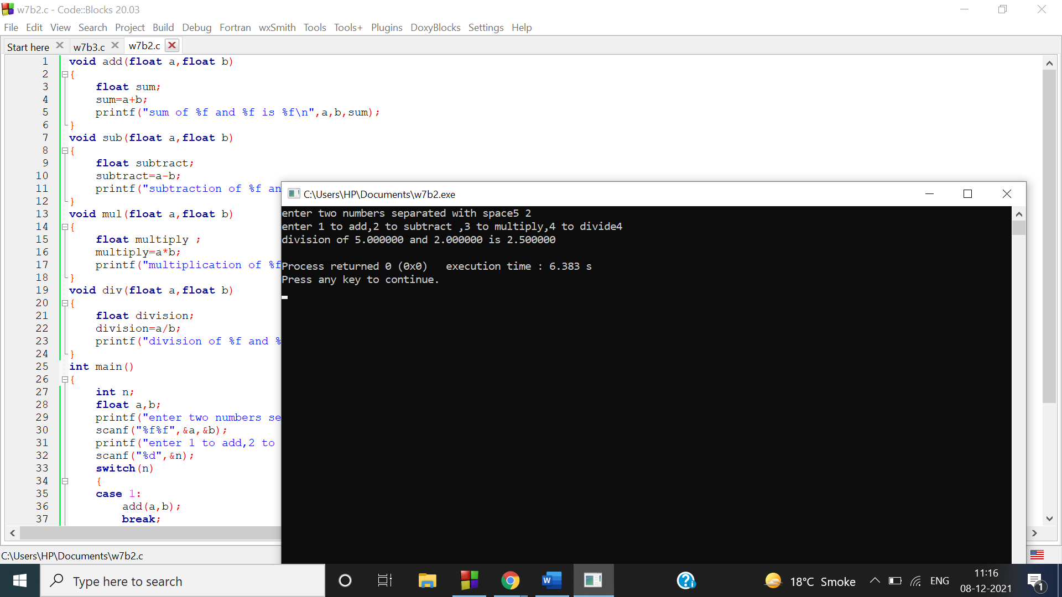

Q8

