NBTG13715

Nitin Chaudhary

Week 8

Lab A

F8

Q1

void display(int x[],int n)

{

int i,j=0;

for(i=x[0];i<x[n-1];i++)

{

if(x[j]==i)

{

j++;

continue;

}

else

{

printf("%d is missing",i);

break;

}

}

}

int main()

{

int a[]={1,2,3,4,6,7};

int i,size=6;

display(a,size);

}

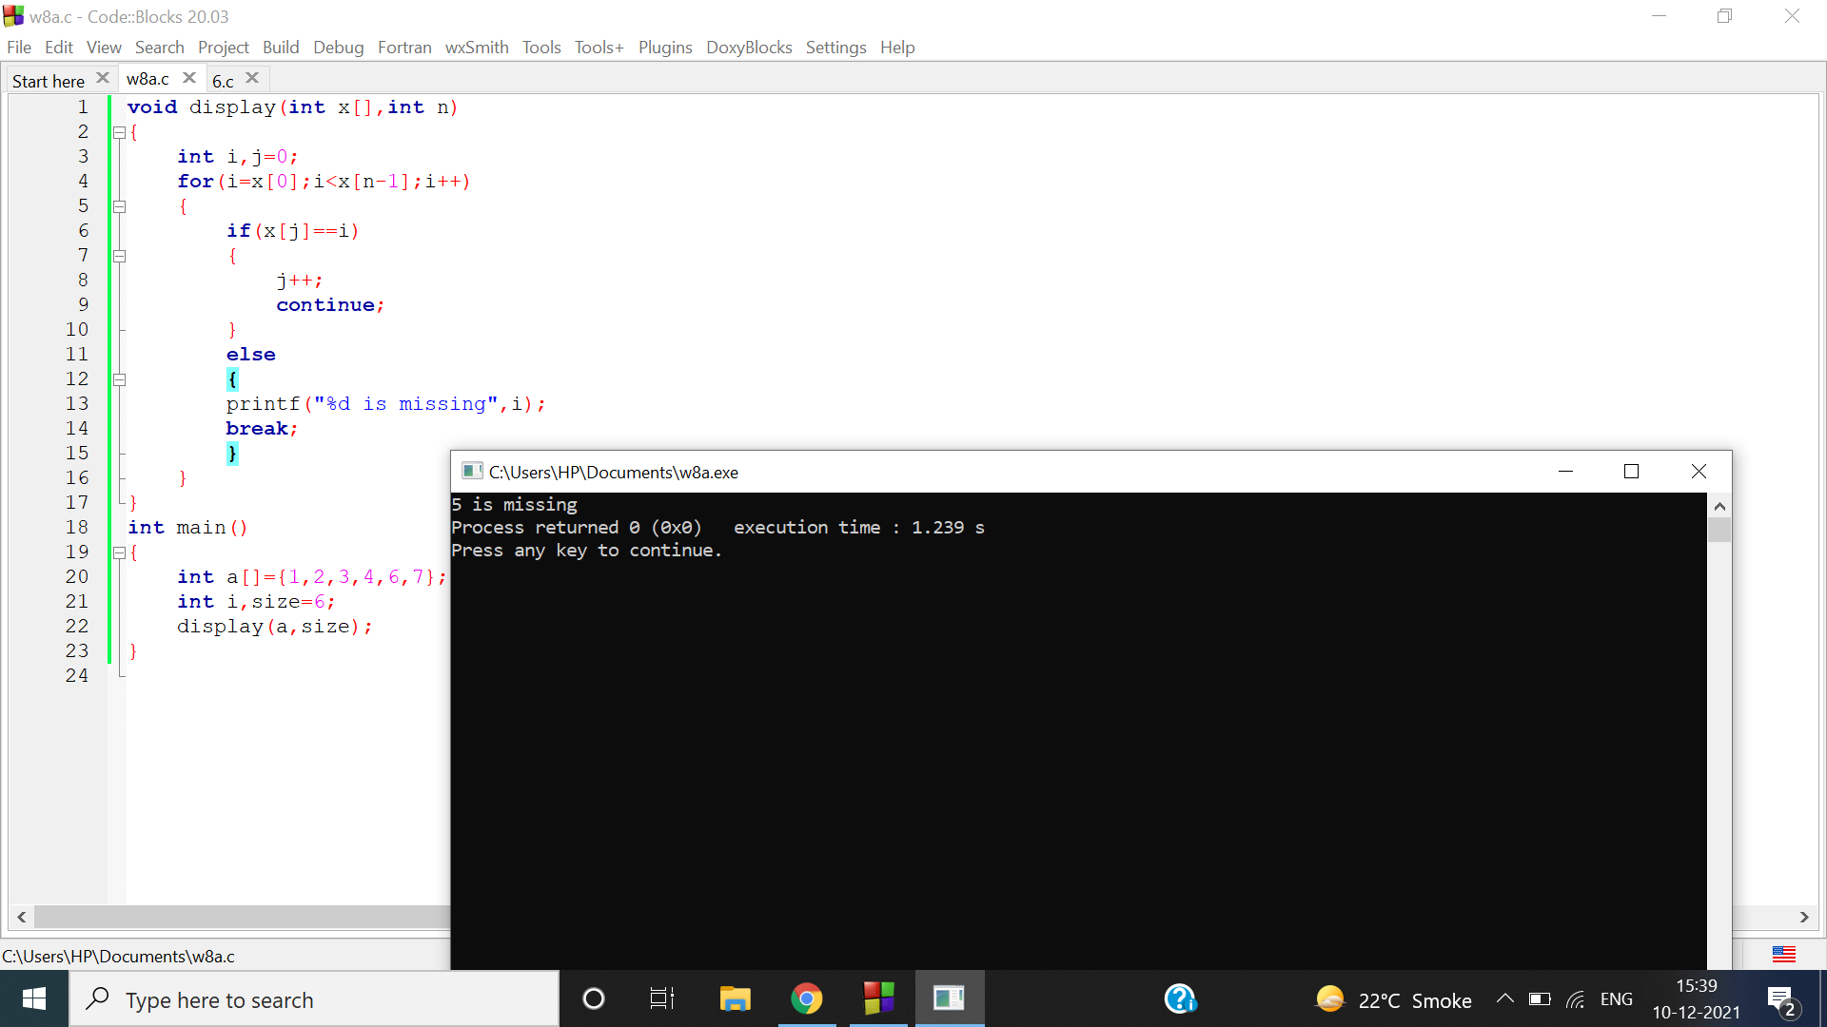

Q2

int array_sort(int x[],int size)

{

int i,j,b;

for(i=0;i<size;++i)

{

for (j=i+1;j<size;++j)

{

if(x[i]>x[j])

{

b=x[i];

x[i]=x[j];

x[j]=b;

}

}

}

printf("sorted array is\n");

for(i=0;i<size;i++)

{

printf("%d\t",x[i]);

}

}

int main()

{

int i,n,a[100];

printf("enter size of array:");

scanf("%d",&n);

printf("enter elements of array\n");

for(i=0;i<n;i++)

{

scanf("%d",&a[i]);

}

array_sort(a,n);

}

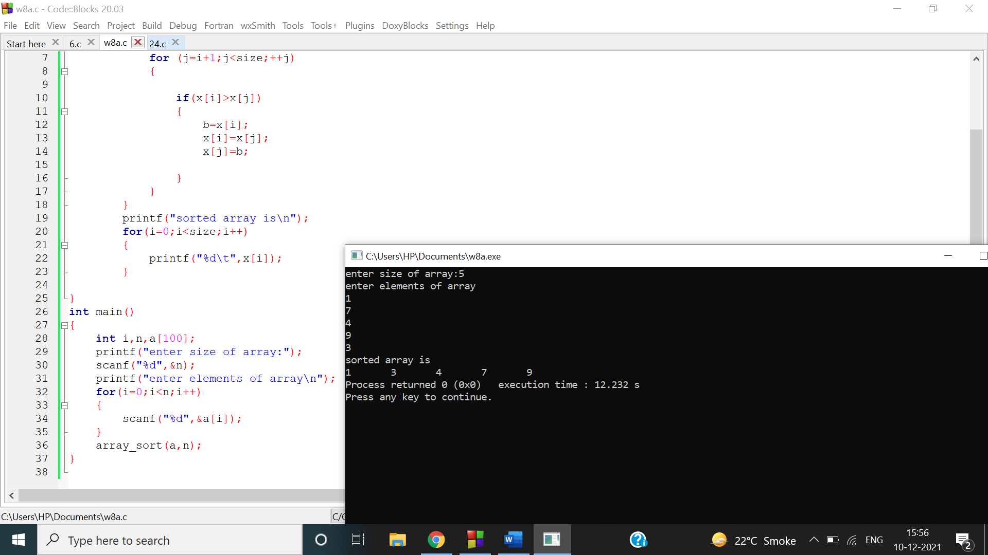

Q3

#include<stdio.h>

int s=0;

int main()

{

int a;

printf("enter any number:");

scanf("%d",&a);

sum(a);

}

int sum(int a)

{

int b=a,c,d;

d=b%10;

s+=d;

b/=10;

if(b!=0)

sum(b);

else

printf("sum is:%d",s);

}

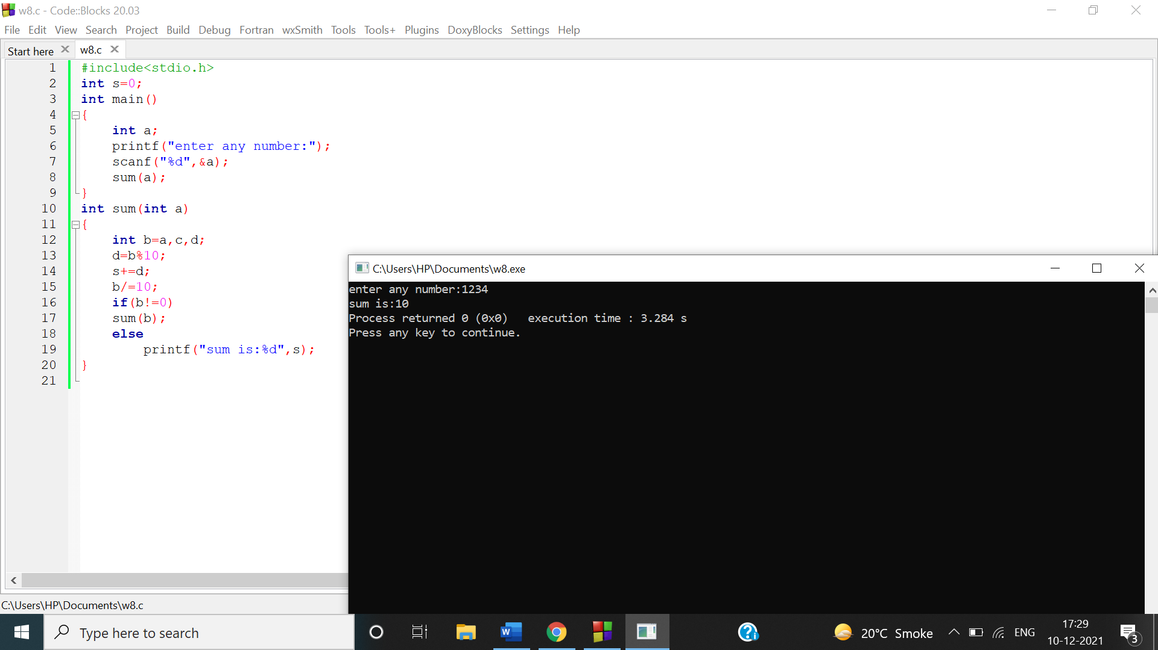

Q4

#include<stdio.h>

int main()

{

int num;

printf("enter any number\n");

scanf("%d",&num);

reverse(num);

}

int reverse(int num)

{

int b;

b=num%10;

printf("%d",b);

num/=10;

if(num!=0)

{

reverse(num);

}

}

