Question 1-

#include<stdio.h>

int main()

{

printf("my name is nitin\n");

printf("my enrollment no. is NBTG13715\n");

printf("my BATCH is F8\n");

printf("my college name is JIIT\n");

return 0;

}

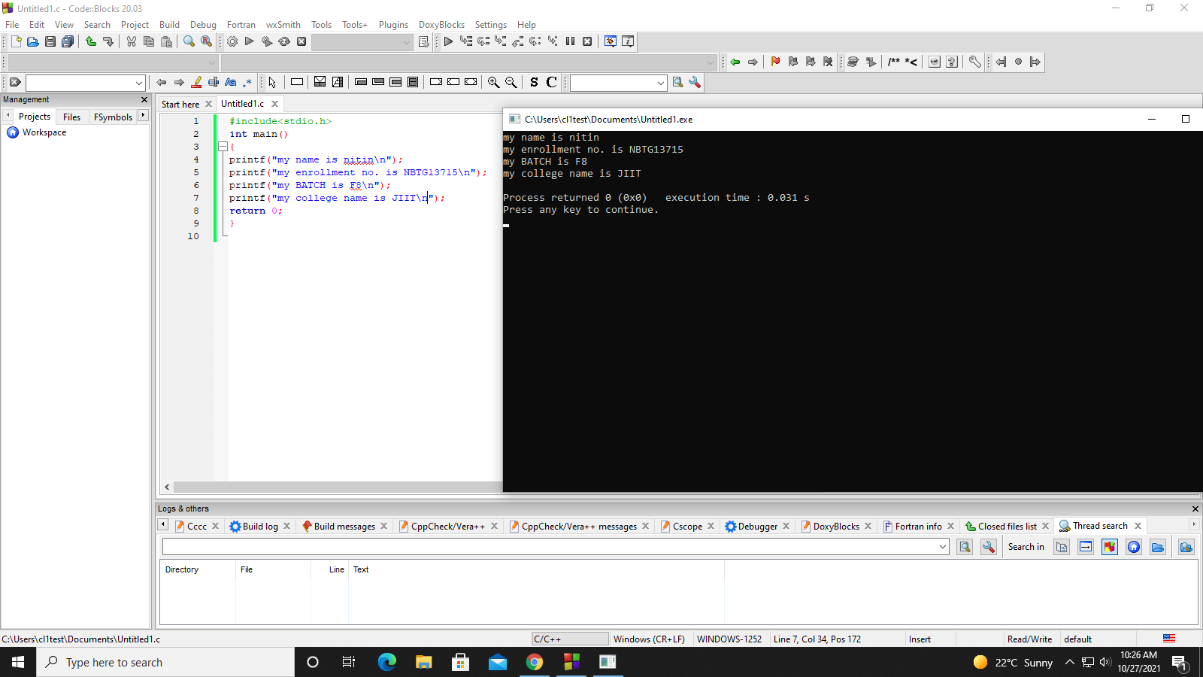

Question2-

#include<stdio.h>

int main()

{

int a;

int b;

float c;

a=10;

b=15;

c=12.6;

printf("values are:\n%d\n%d\n%f\n",a,b,c);

}

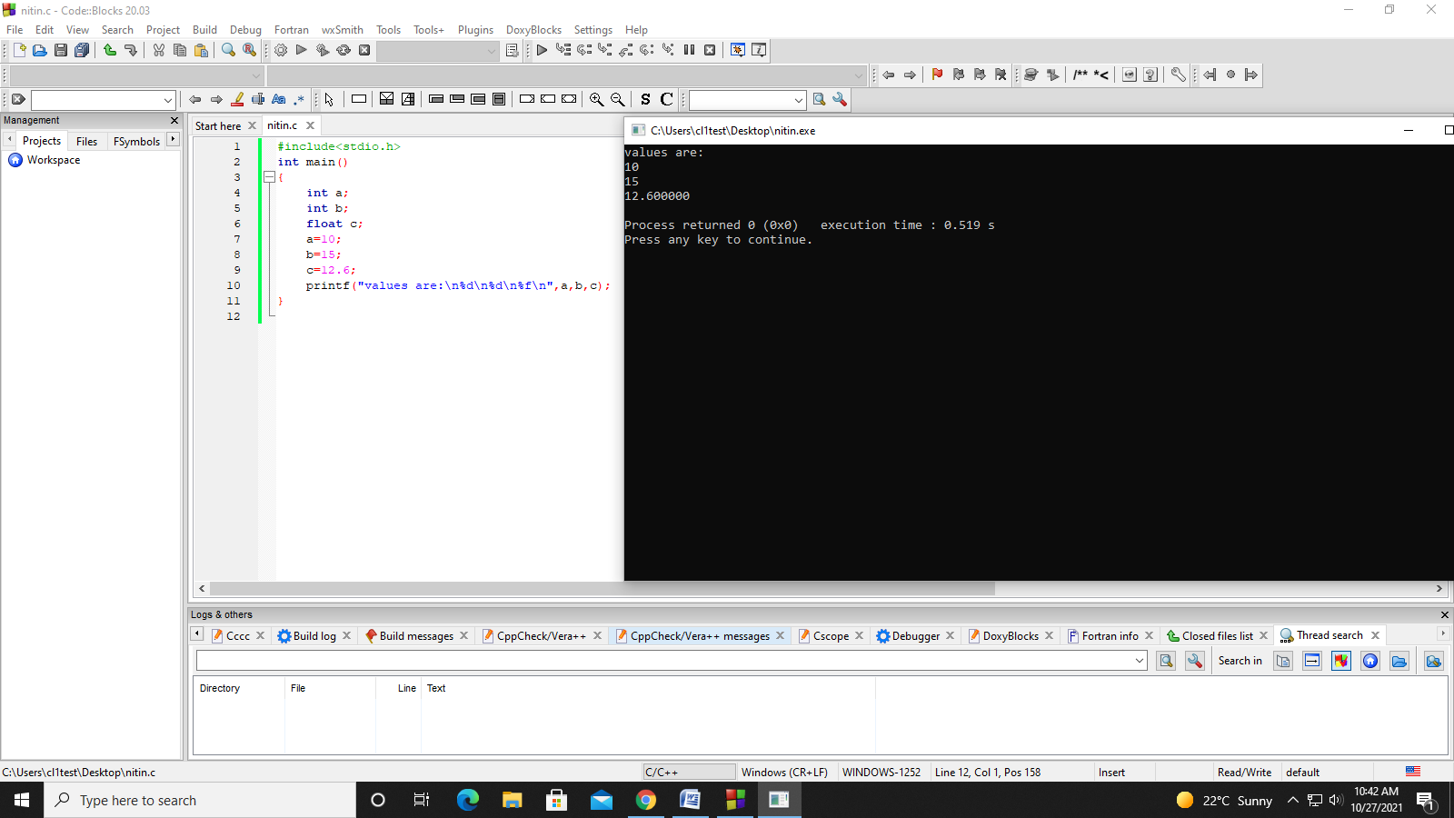

Question 3-

#include<stdio.h>

int a;//global variable

int main()

{

a=12;

int b;//local variable

b=10;

printf("value of local variable:%d\n",b);

printf("value of global variable:%d",a);

}

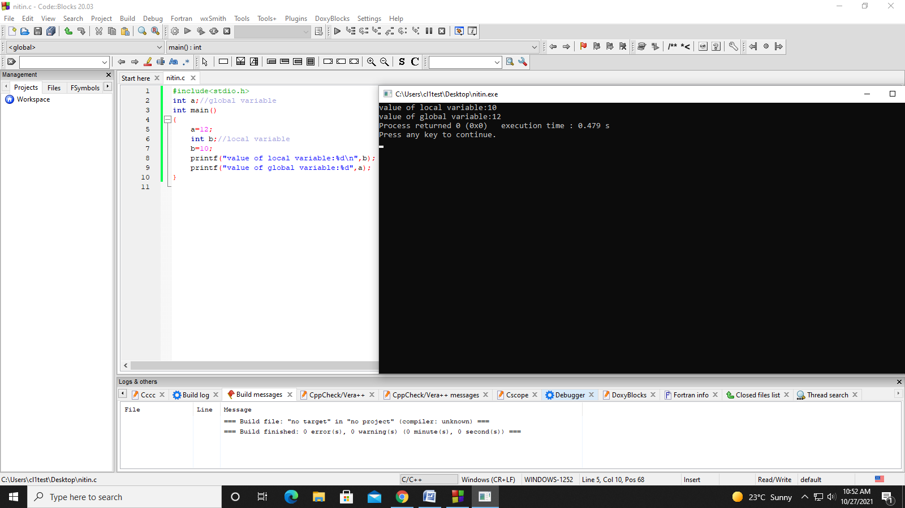

Question 4-

#include<stdio.h>

int main()

{

int a=4;

float b=6.8;

char c='n';

double d=7.5;

printf("integer value:%d\nfloat value:%0.3f\ncharacter value:%c\ndouble value:%lf",a,b,c,d);

return 0;

}

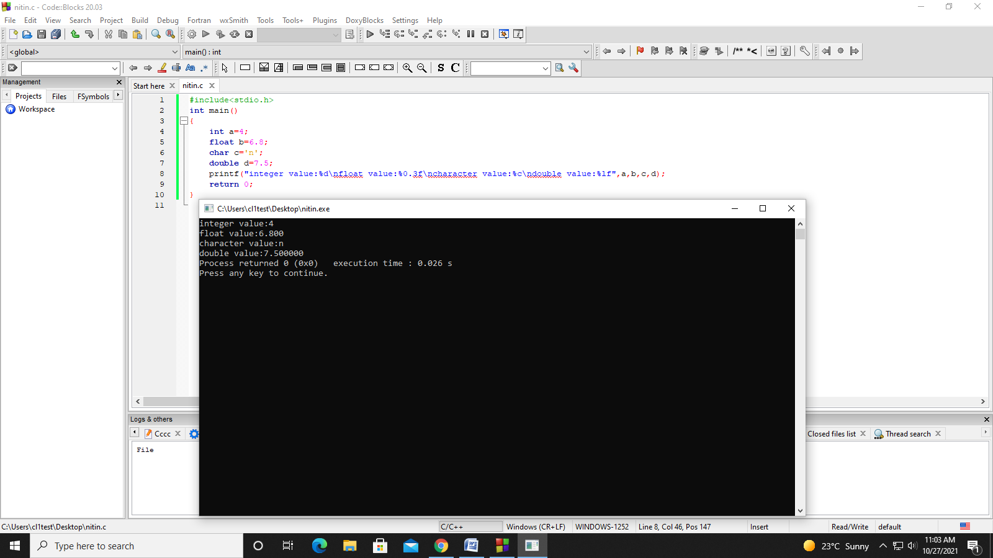

Question 5-

#include<stdio.h>

int main()

{

int a,b;

printf("enter first number:");

scanf("%d",&a);

printf("enter second number:");

scanf("%d",&b);

printf("sum=%d\ndifference=%d\nmultiplication=%d\ndivision=%d\n",a+b,a-b,a*b,a/b);

return 0;

}

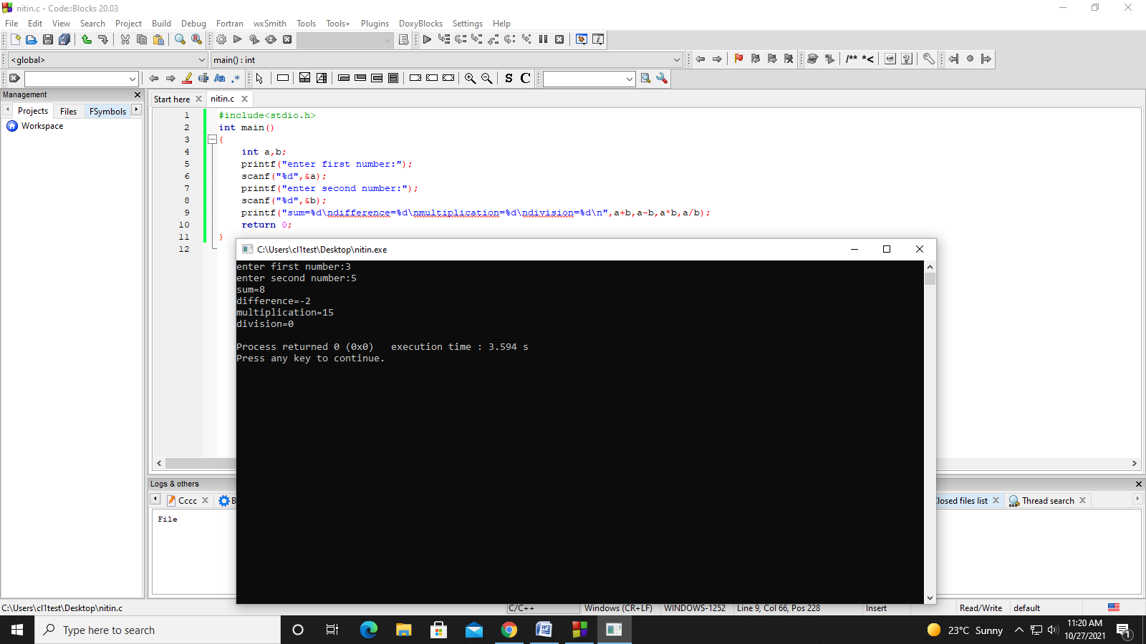

Question 6:

#include<stdio.h>

int main()

{

float a,b,product;

printf("enter first number:");

scanf("%f",&a);

printf("enter second number:");

scanf("%f",&b);

product=a*b;

printf("\nproduct is%f",product);

return 0;

}

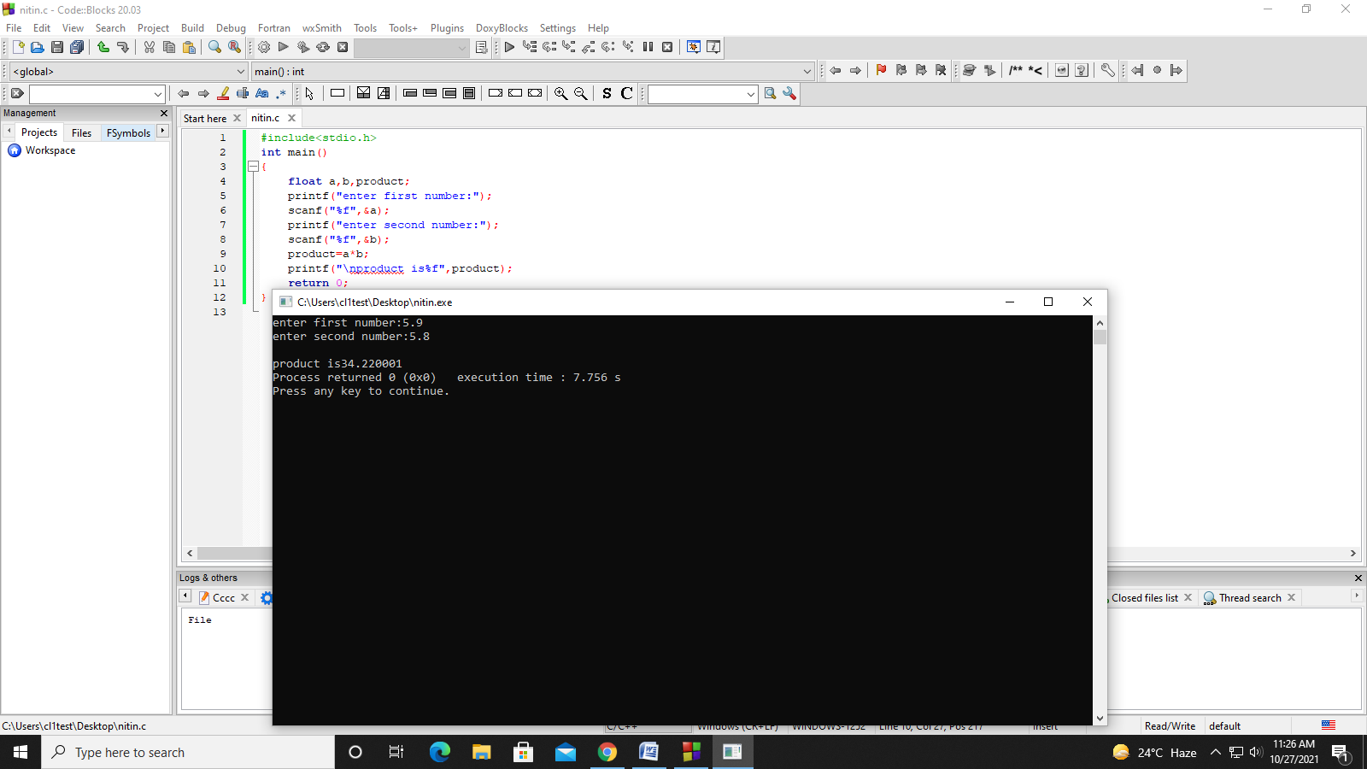

Question-7

#include<stdio.h>

int main()

{

float a;

printf("enter distance between two cities in Km:");

scanf("%f",&a);

printf("\ndistance in metres=%.1f",a*1000);

printf("\ndistance in feet=%.1f",a*3280.8);

printf("\ndistance in inches=%.1f",a*39370.1);

printf("\ndistance in centimetres=%.1f",a*100000);

return 0;

}

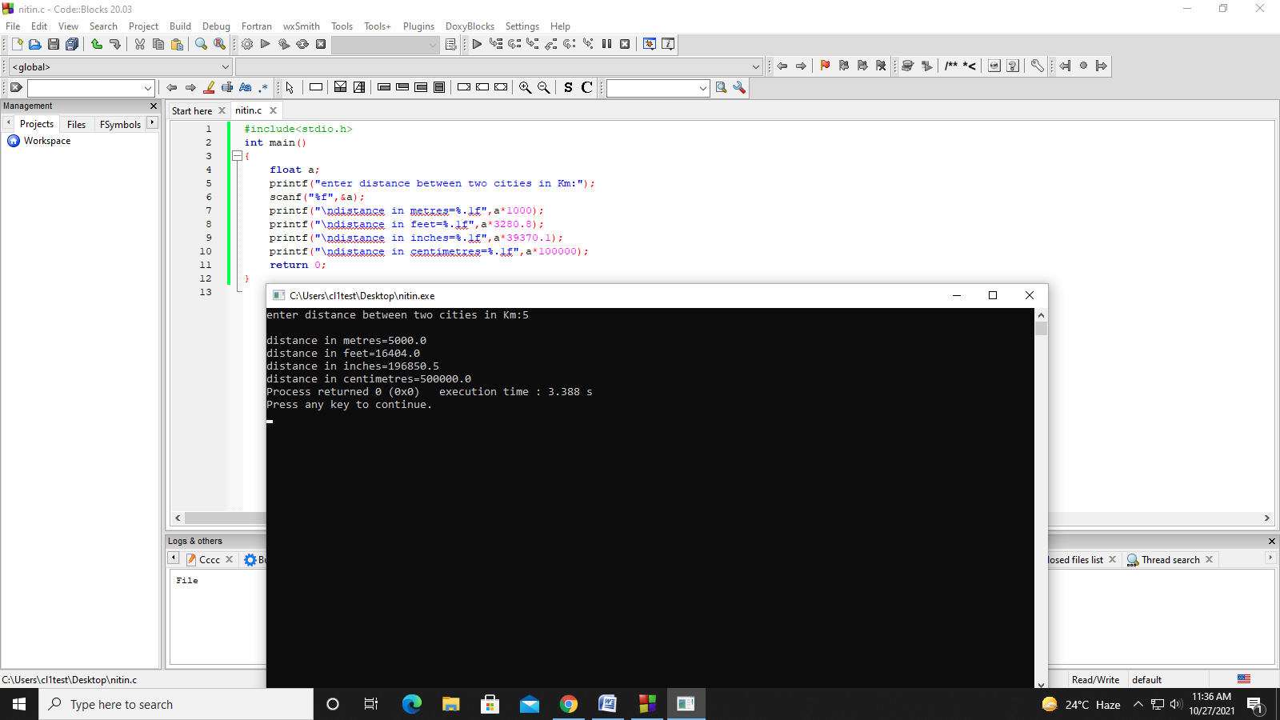

Question 8-

#include<stdio.h>

int main()

{

float a,b,c,d,e,agg_marks;

printf("enter marks of first subject:");

scanf("%f",&a);

printf("\nenter marks of second subject:");

scanf("%f",&b);

printf("\nenter marks of third subject:");

scanf("%f",&c);

printf("\nenter marks of fourth subject:");

scanf("%f",&d);

printf("\nenter marks of fifth subject:");

scanf("%f",&e);

agg_marks=a+b+c+d+e;

printf("\naggregate marks=%.1f",agg_marks);

printf("\npercentage marks=%.1f",agg_marks/5);

return 0;

}

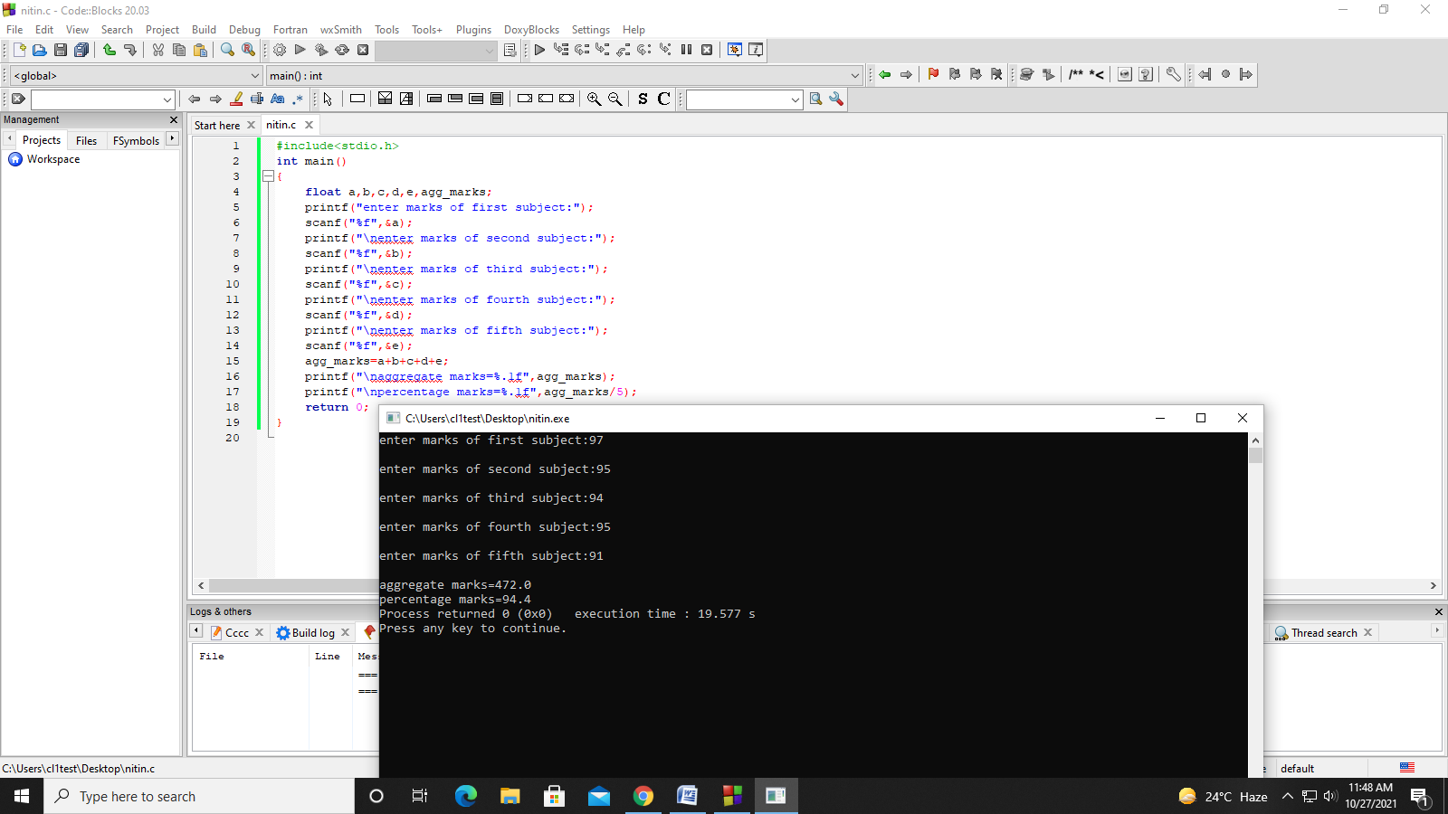

Question-9

#include<stdio.h>

int main()

{

float a,b;

printf("enter tmperature in fahrenheit degrees:");

scanf("%f",&a);

b=(a-32)*0.5556;

printf("\ntmperature in centigrade degrees:%f",b);

return 0;

}

Q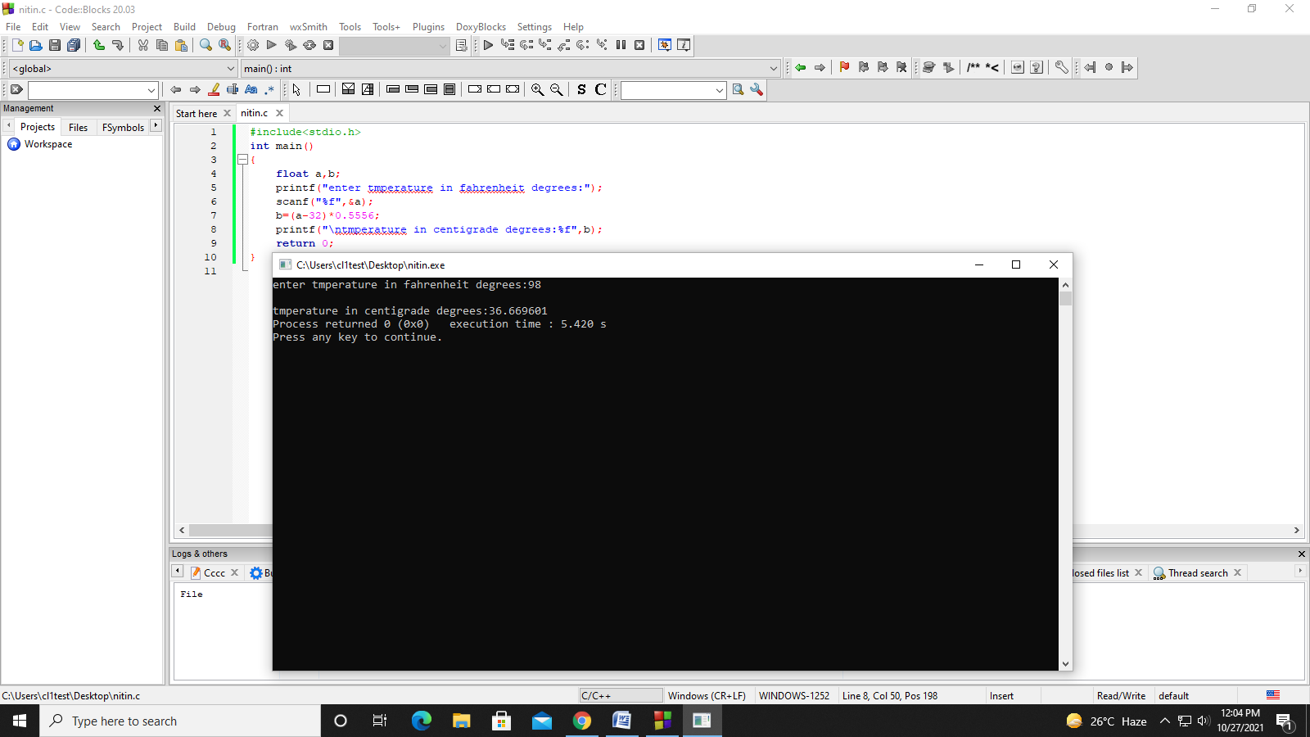

Question-10

#include<stdio.h>

int main()

{

float a,b,r;

printf("enter lenth of rectangle:");

scanf("%f",&a);

printf("enter breadth of rectangle:");

scanf("%f",&b);

printf("enter radius of circle");

scanf("%f",&r);

printf("\narea of rectangle:%f",a*b);

printf("\nperimeter of rectangle:%f",(a+b)*2);

printf("\narea of circle:%f",3.141*r*r);

printf("\nperimeter of circle%f",2*3.141*r);

return 0;

}

