NBTG13715

F8

Nitin chaudhary

Week 10 lab B

Ans 1

#include<stdio.h>

int main()

{

FILE \*fp;

fp=fopen("test.txt","w");

char a[100];

printf("Input a sentence for the file :");

gets(a);

fputs(a,fp);

if(fp!=NULL)

printf("The file test.txt created successfully...!!");

else

printf("file not created");

fclose(fp);

return 0;

}

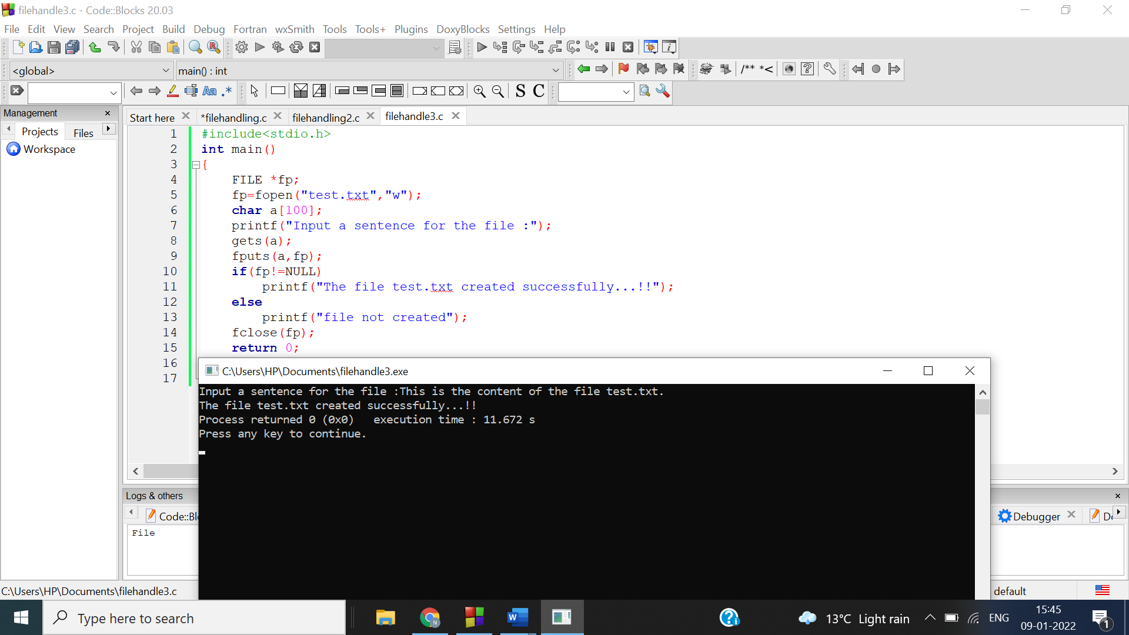

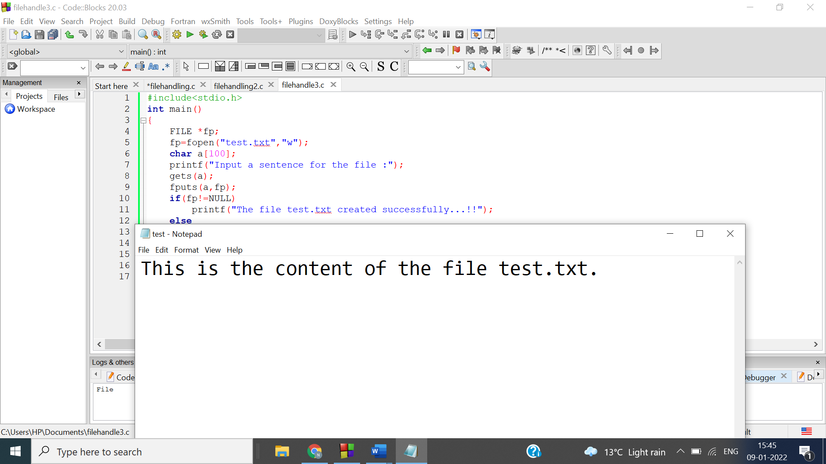

Ans 2

#include<stdio.h>

int main()

{

FILE \*fp;

char a[100],b;

printf("Input the file name to be opened :");

gets(a);

fp=fopen(a,"r");

printf("The content of the file test.txt is :\n");

while(fscanf(fp,"%c",&b)!=EOF)

printf("%c",b);

fclose(fp);

return 0;

}

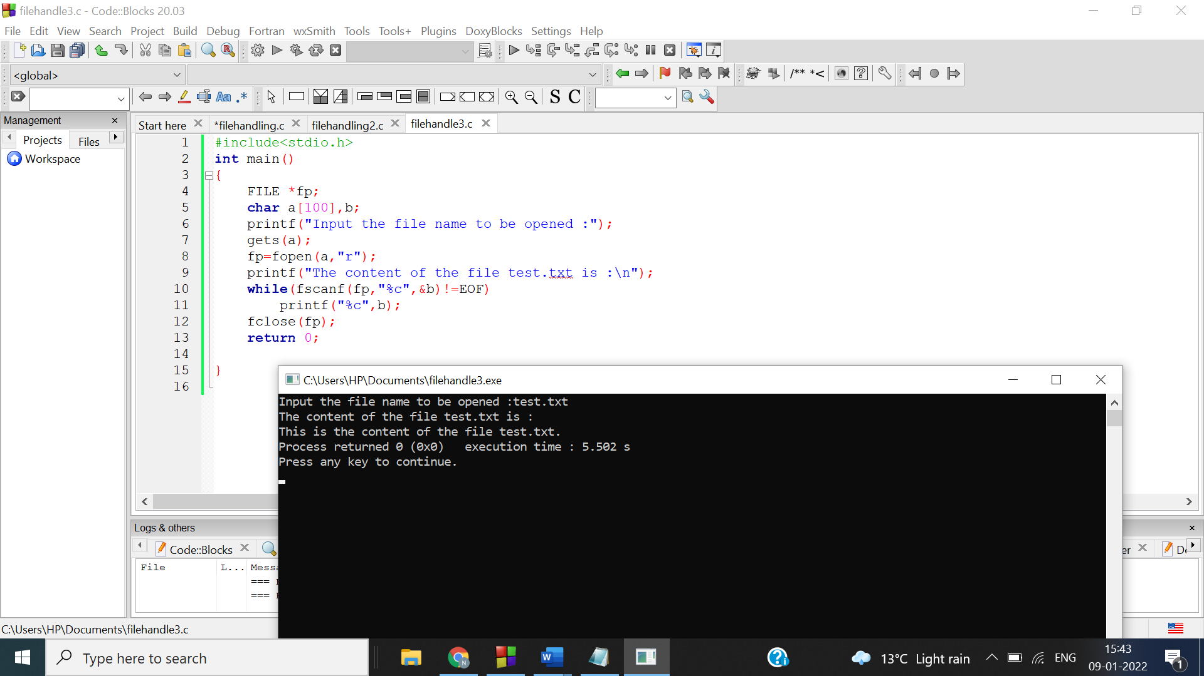

Ans 3

#include<stdio.h>

int main()

{

FILE \*fp;

fp=fopen("test.txt","w");

int k;

printf("Input the number of lines to be written :");

scanf("%d",&k);

char a[100],b;

printf("The lines are :\n");

for(int i=0;i<=k;i++)

{

gets(a);

fputs(a,fp);

putc('\n',fp);

}

fclose(fp);

fp=fopen("test.txt","r");

printf("The content of the file test.txt is :");

while(fscanf(fp,"%c",&b)!=EOF)

printf("%c",b);

fclose(fp);

return 0;

}

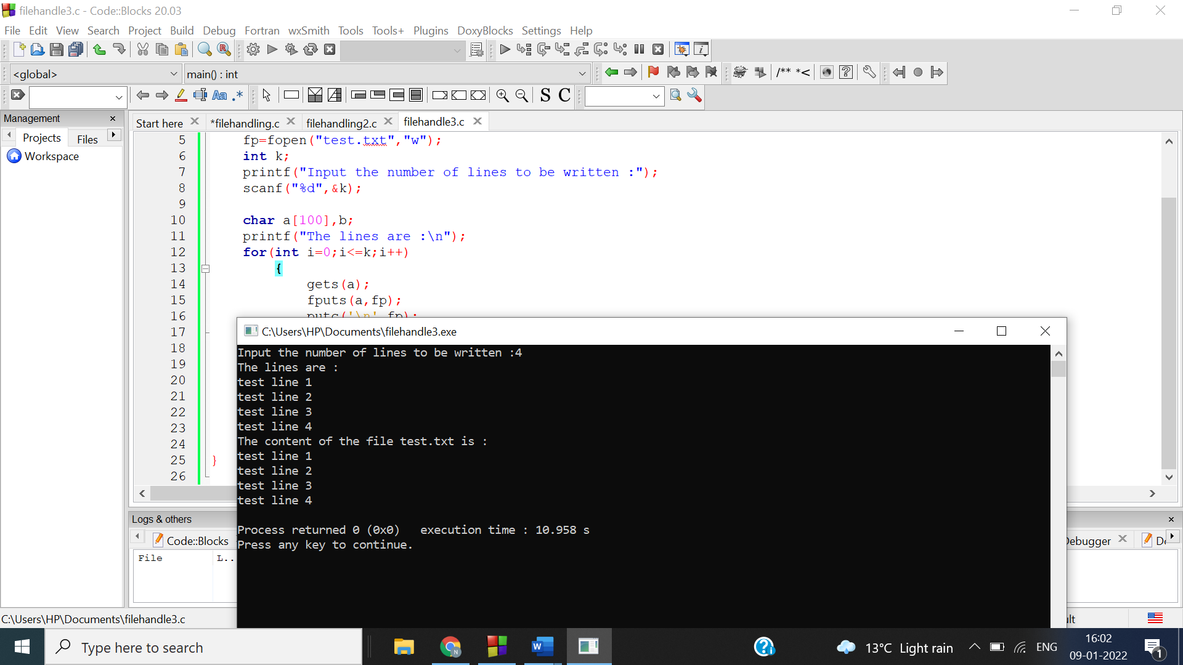

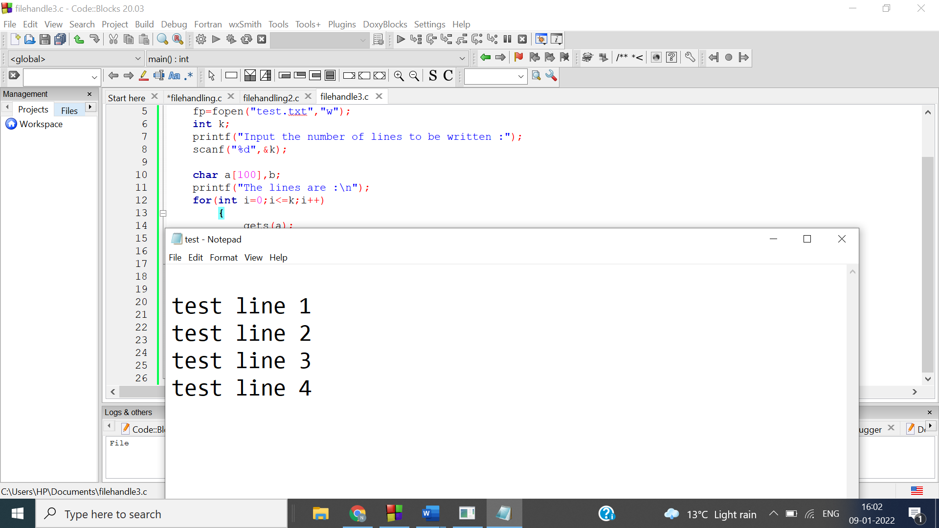

Ans 4

#include<stdio.h>

#include<stdlib.h>

int main()

{

FILE \*p1;

char c[20],x,m=0;

int a;

p1=fopen("abc.txt","r");

printf("The content is: \n");

while(fscanf(p1,"%c",&x)!=EOF)

{

if(x=='\n')

m++;

printf("%c",x);

}

printf("\nThere are %d lines in the file",m+1);

fclose(p1);

return 0;

}

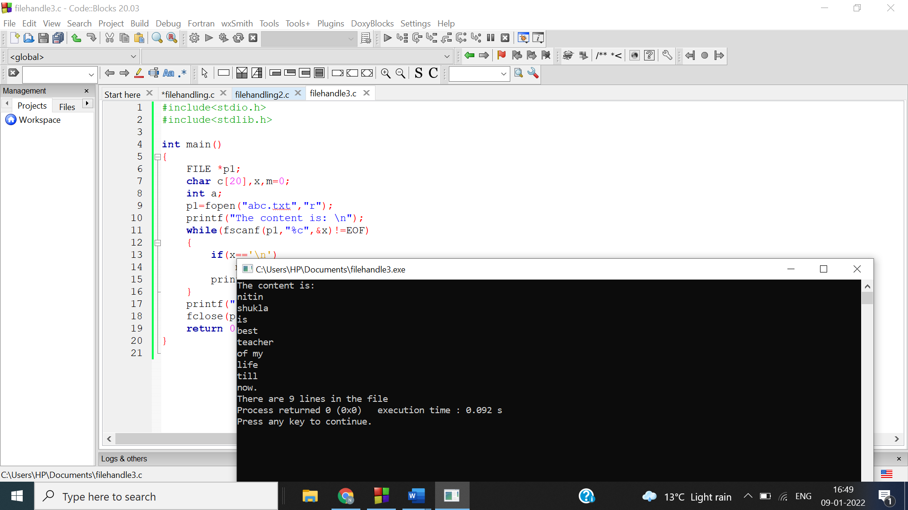

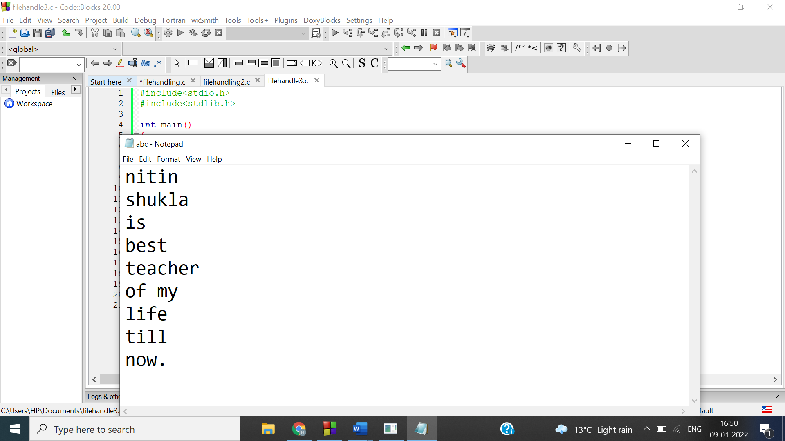

Ans 5

#include<stdio.h>

#include<stdlib.h>

int main()

{

FILE \*p,\*p1;

char x;

p=fopen("a.txt","r");

p1=fopen("b.txt","a");

printf("The merged file is: \n");

while(fscanf(p,"%c",&x)!=EOF)

{

fprintf(p1,"%c",x);

}

fclose(p);

fclose(p1);

p1=fopen("b.txt","r");

while(fscanf(p1,"%c",&x)!=EOF)

{

printf("%c",x);

}

fclose(p1);

return 0;

}

