Week 4 lab B

NBTG13715

Nitin Chaudhary

F8

Q1-

#include<stdio.h>

int main()

{

int n,r,fr;

printf("enter a four digit no.\n");

scanf("%d",&n);

r=(n+8)/3;

fr=r%5;

fr\*=5;

printf("final result is %d",fr);

return 0;

}

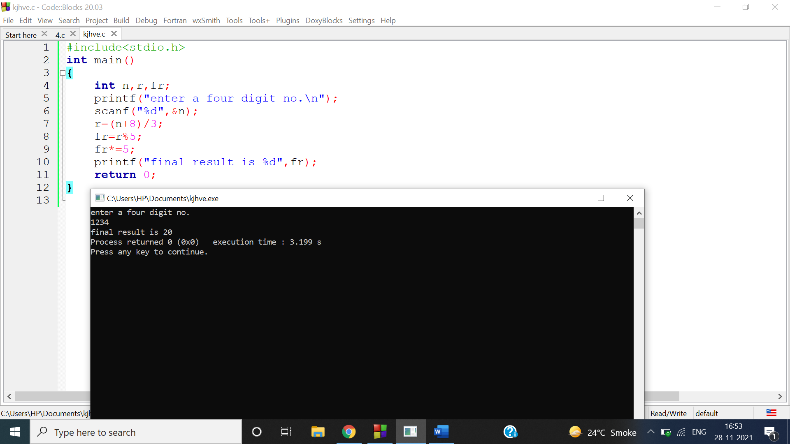

Q2

#include<stdio.h>

int main()

{

int n;

printf("enter a four digit no.\n");

scanf("%d",&n);

n+=8;

n/=3;

n%=5;

n\*=5;

printf("final result is %d",n);

return 0;

}

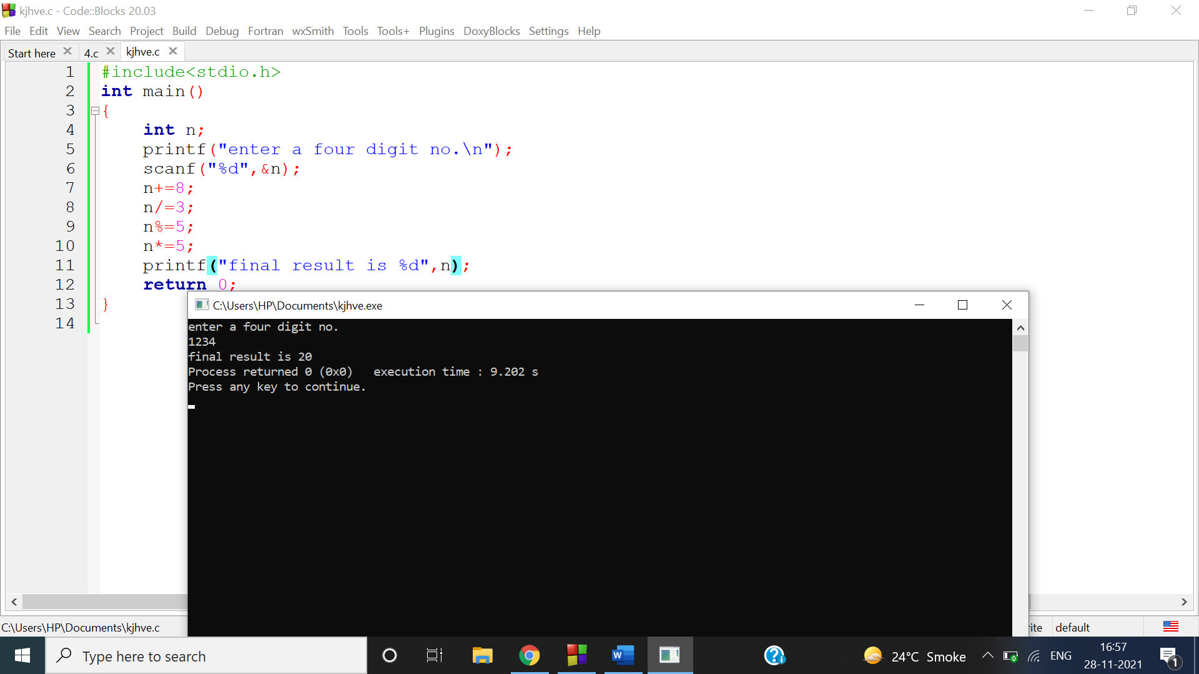

Q3

#include <stdio.h>

int main()

{

int a,b;

printf("enter first number");

scanf("%d",&a);

printf("enter second number");

scanf("%d",&b);

a=a+b;

b=a-b;

a=a-b;

printf("interchanged values are first=%d,second= %d",a,b);

return 0;

}

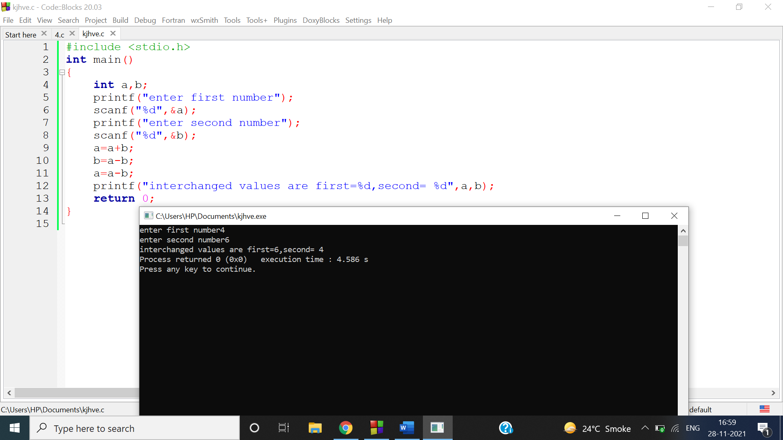

Q4  
#include <stdio.h>

int main()

{

printf("total students=45\n");

printf("total boys=25\n");

printf("total girls=20\n");

printf("80%% scores grade A means 36 students scores grade A\n");

printf("boys scoring grade A=15\n");

int A=36,b=15,g;

g=A-b;

printf("So girls getting grade A =%d",g);

}

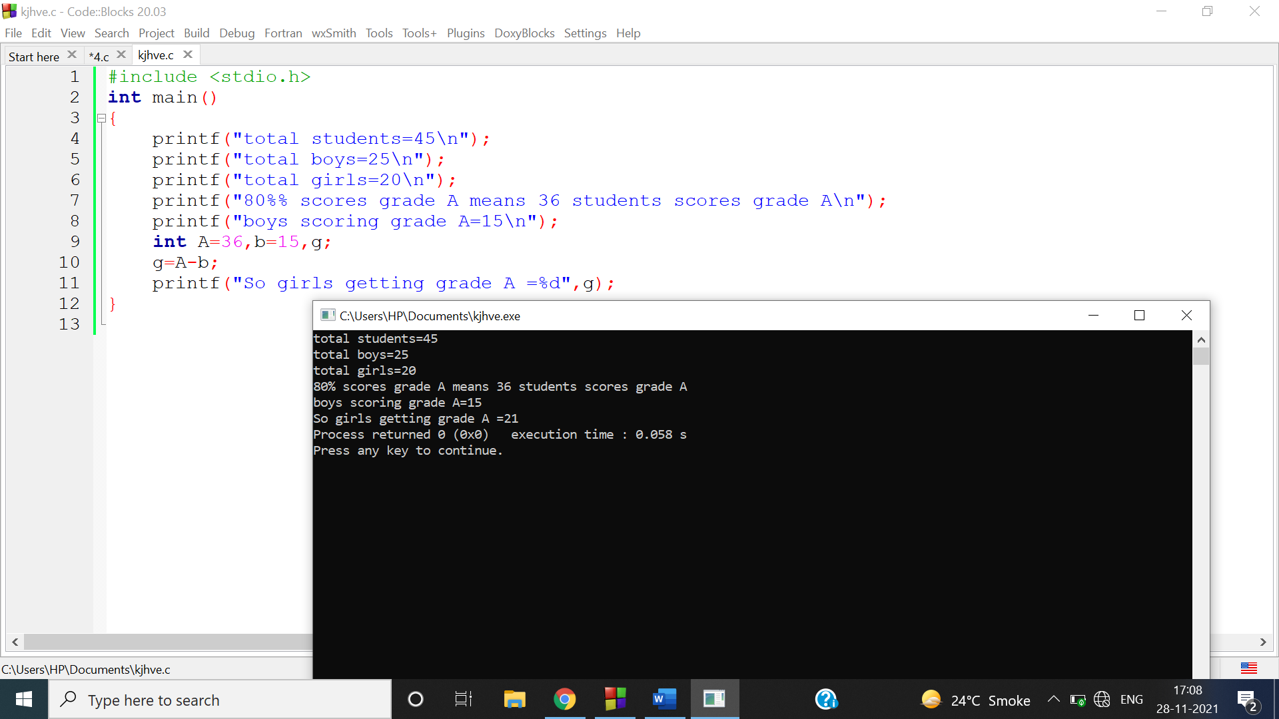

Q5

#include<stdio.h>

int main()

{

int a,n,b=1,c,i;

printf("enter any number ");

scanf("%d",&a);

printf("enter digit position from starting ");

scanf("%d",&c);

while(c>=10)

{

c/=10;

}

/\*c becomes 1st digit\*/

printf("enter digit position from last ");

scanf("%d",&n);

for(i=1;i<=n;i++)

{

b\*=10;

}

a=(a-((a/b)\*b))/(b/10);

printf("\nrequired digit sum is %d",a+c);

return 0;

}

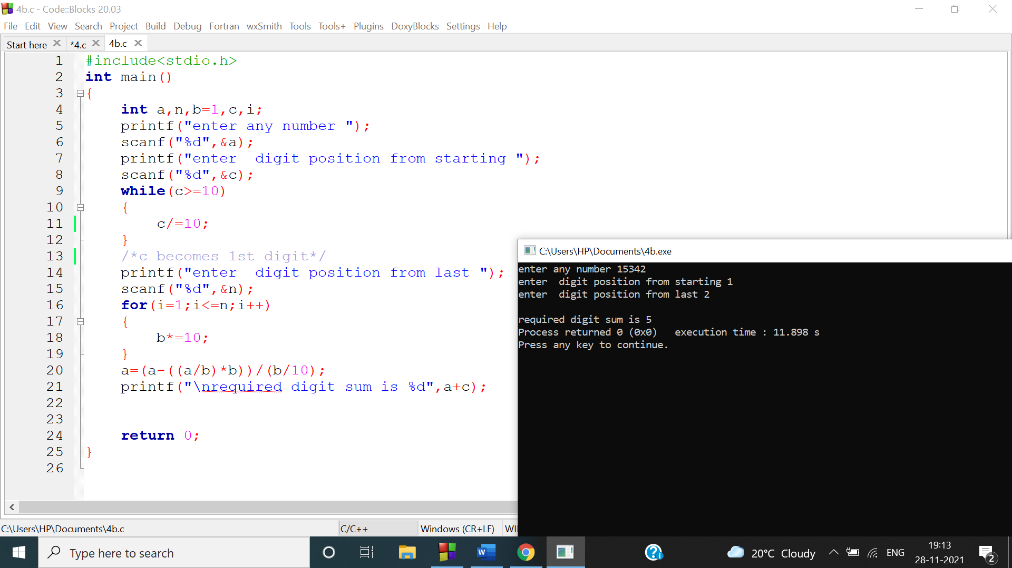

Q6-

#include<stdio.h>

int main()

{

int a,b,c,n1,n2,n3,n4,n;

printf("enter a four digit number to increase all its digits by 2\n");

scanf("%d",&a);

b=a;

b/=1000;

n1=b+2;

b=a;

b%=1000;

b/=100;

n2=b+2;

b=a;

b%=100;

b/=10;

n3=b+2;

b=a;

b%=10;

n4=b+2;

n=(n1\*1000)+(n2\*100)+(n3\*10)+n4;

printf("final number is %d",n);

return 0;

}

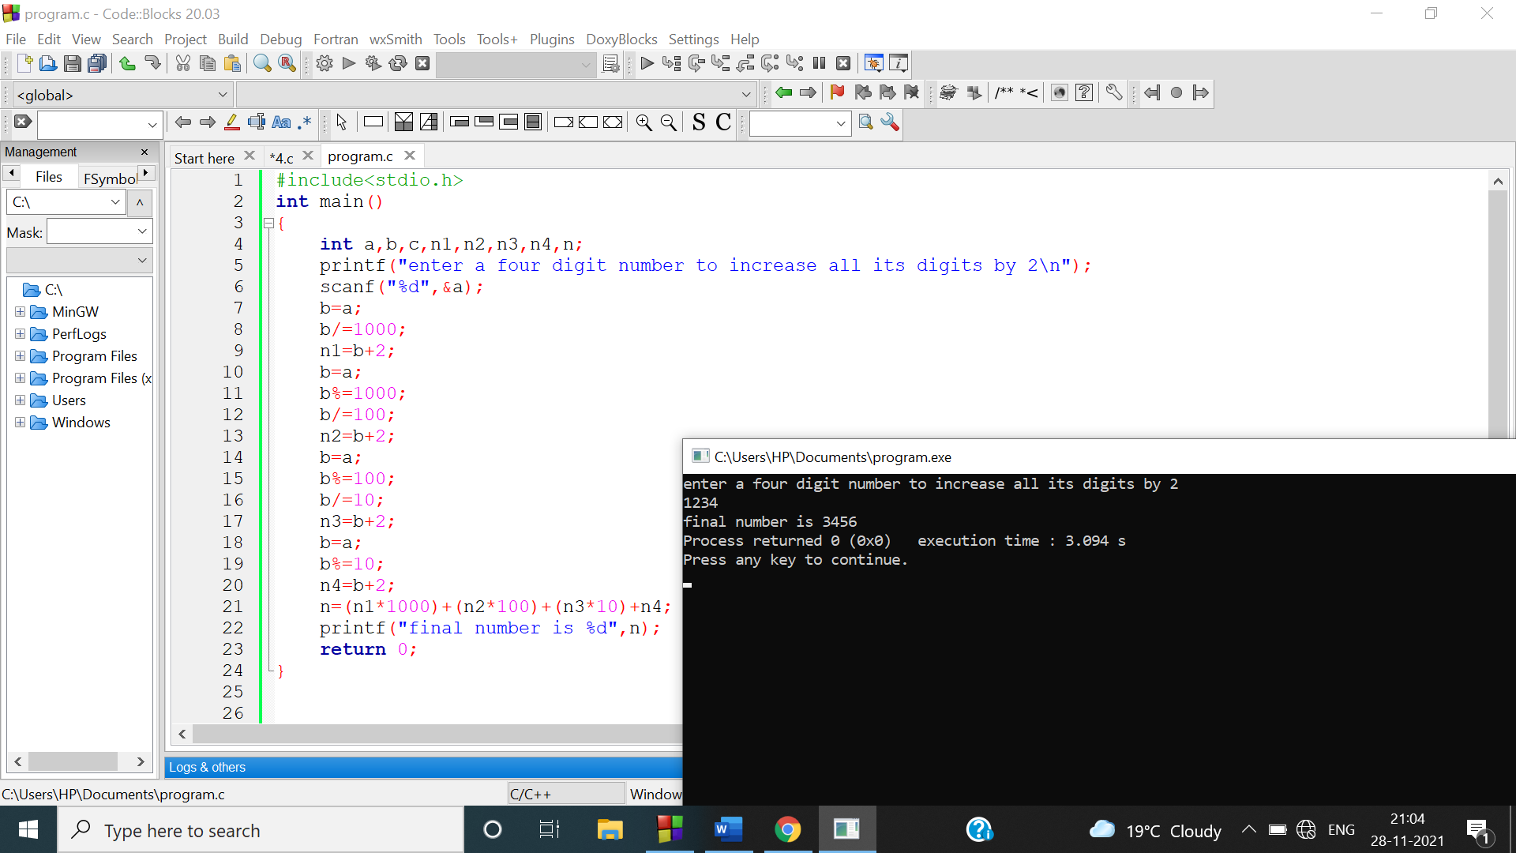

Q7

#include<stdio.h>

int main()

{

int a,b,d,c=0,i,n;

printf("enter a four digit number to increase all its digits by 2\n");

scanf("%d",&a);

for(b=1000;b>1;b/=10)

{

d=a;

d=(d-((d/b)\*b))/(b/10);

c+=d;

}

printf("final number is %d",c);

return 0;

}

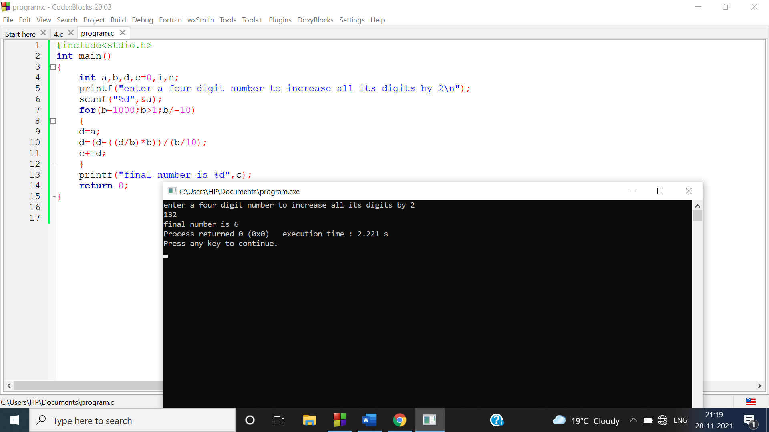

Q8

#include<stdio.h>

int main()

{

int a,b,c,n1,n2,n3,n4,n;

printf("enter a three digit number to reverse its digits\n");

scanf("%d",&a);

b=a;

b/=100;

n1=b;

b=a;

b%=100;

b/=10;

n2=b;

b=a;

b%=10;

n3=b;

n=(n3\*100)+(n2\*10)+n1;

printf("reversed number is %d",n);

return 0;

}

