NBTG13715

Week 9 Lab B

Nitin Chaudhary

F8

Ans1-

#include <stdio.h>

int main()

{

int var=20,\*ptr;

ptr=&var;

printf("var=%d\nptr=%u\n\*ptr=%u",var,ptr,\*ptr);

return 0;

}

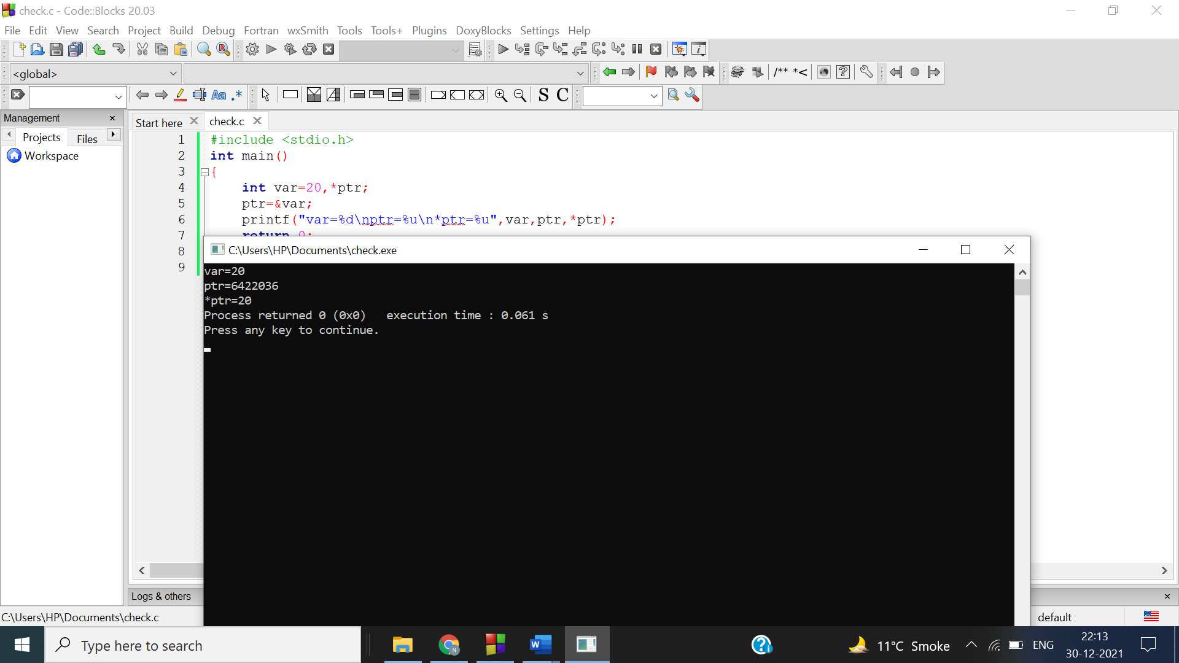

Ans2-

#include <stdio.h>

int main()

{

int a[5];

printf("Enter 5 numbers\n");

for(int i=0;i<5;i++)

{

scanf("%d",(a+i));

}

int min=\*a;

for(int i=0;i<5;i++)

{

if(\*(a+i)<min)

min=\*(a+i);

}

printf("smallest number is %d",min);

return 0;

}

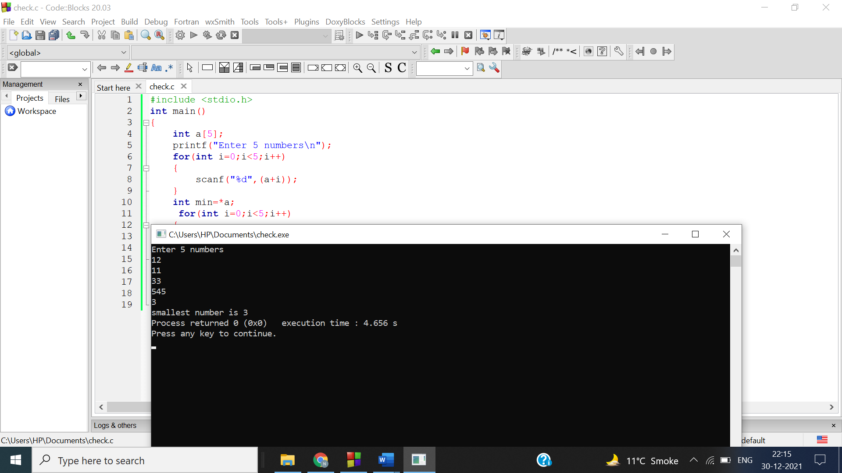

Ans 3-

#include <stdio.h>

int main()

{

int m,n;

int \*\*arr;

printf("Enter number of rows and columns\n");

scanf("%d%d",&m,&n);

arr=(int \*\*)malloc(m\*sizeof(int));

for(int i=0;i<m;i++)

{

arr[i]=(int \*)malloc(n\*sizeof(int));

}

printf("Enter the matrix\n");

for(int i=0;i<m;i++)

{

for(int j=0;j<n;j++)

{

scanf("%d",&arr[i][j]);

}

}

int min=arr[0][0],max=arr[0][0];

for(int i=0;i<m;i++)

{

for(int j=0;j<n;j++)

{

if(arr[i][j]>max)

max=arr[i][j];

if(arr[i][j]<min)

min=arr[i][j];

}

}

printf("Smallest number : %d\nLargest number : %d",min,max);

return 0;

}

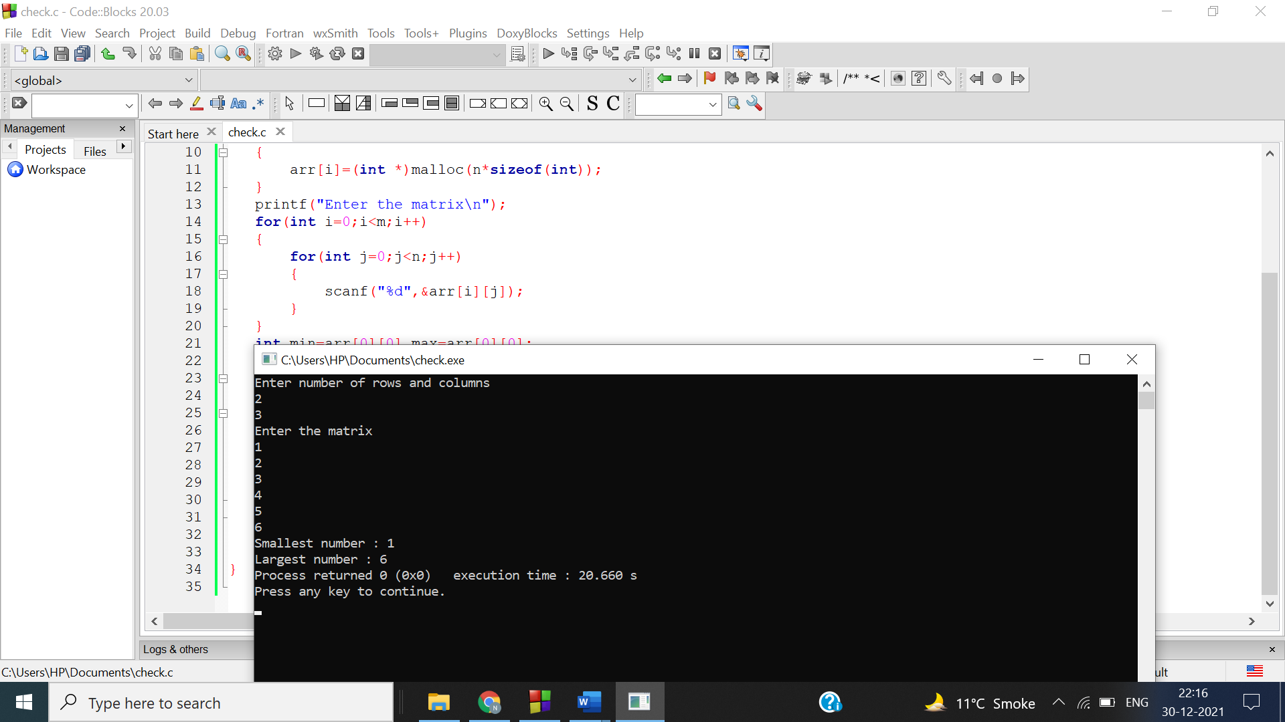

Ans 4-

#include<stdio.h>

int main()

{

int \*p,n,i;

printf("How many numbers you want to enter: ");

scanf("%d",&n);

p=(int\*)malloc(n \* sizeof(int));

printf("\nEnter %d Numbers:\n\n",n);

for(i=0;i<n;i++)

{

scanf("%d",p+i);

}

printf("\nArray in Reverse Order: \n\n");

for(i=n-1;i>=0;i--)

{

printf(" %d",\*(p+i));

}}

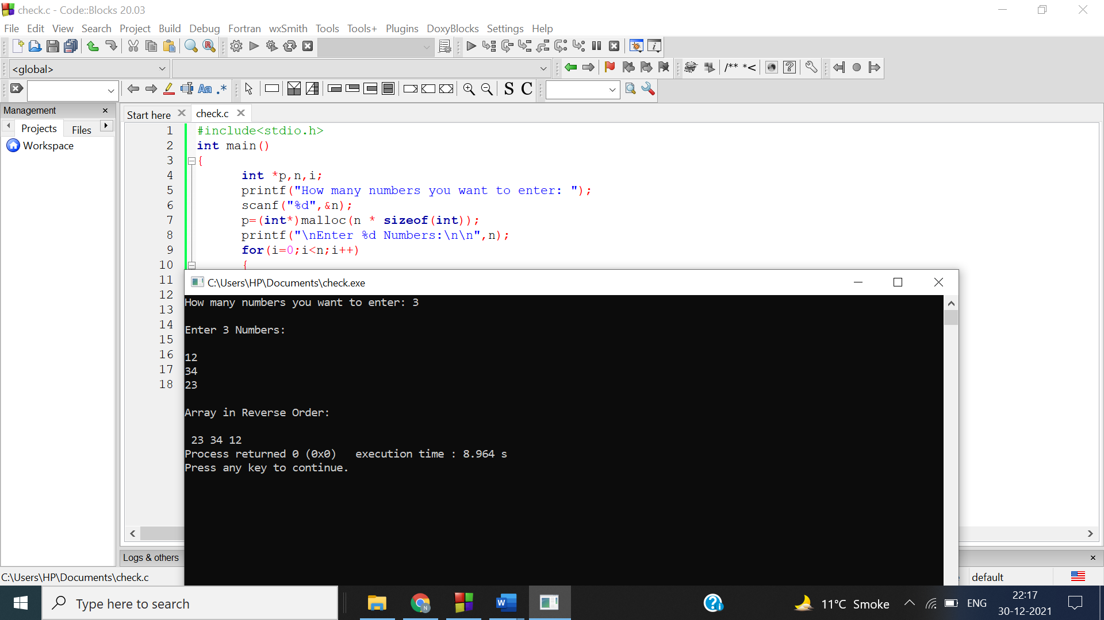

Ans 5-

#include <stdio.h>

int main()

{

char s[]="Garvit";

char \*p=s;

int v=0,c=0;

while(\*p!='\0')

{

if(\*p=='a' || \*p=='e' || \*p=='i' || \*p=='o' || \*p=='u' || \*p=='A' || \*p=='E' || \*p=='I' || \*p=='O' || \*p=='U')

v++;

else

c++;

p++;

}

printf("vowels=%d\nconsonants=%d",v,c);

return 0;

}

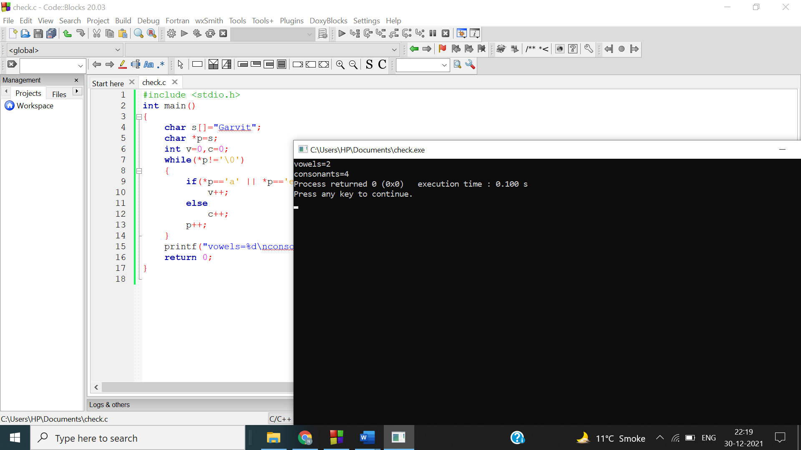

Ans 6-

#include <stdio.h>

int main()

{

int a=5,b=3,temp;

printf("Before swapping a=%d\tb=%d\n",a,b);

int \*pa,\*pb;

pa=&a;

pb=&b;

temp=\*pa;

\*pa=\*pb;

\*pb=temp;

printf("After swapping a=%d\tb=%d",a,b);

return 0;

}

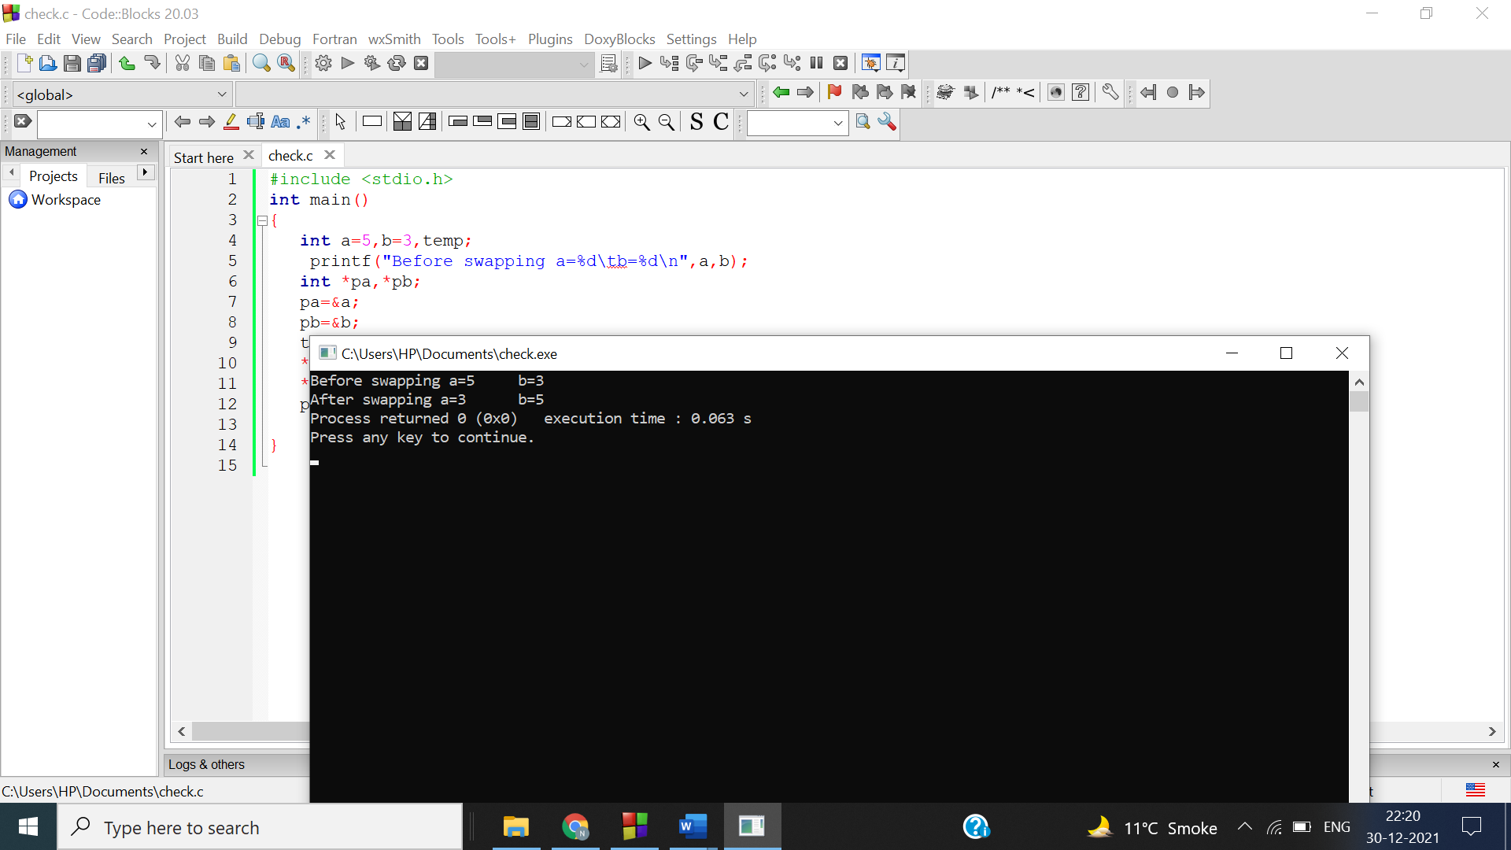

Ans 7-

#include <stdio.h>

int main()

{

const int a=5;

int \*p;

p=&a;

\*p=100;

printf("a=%d",a);

return 0;

}

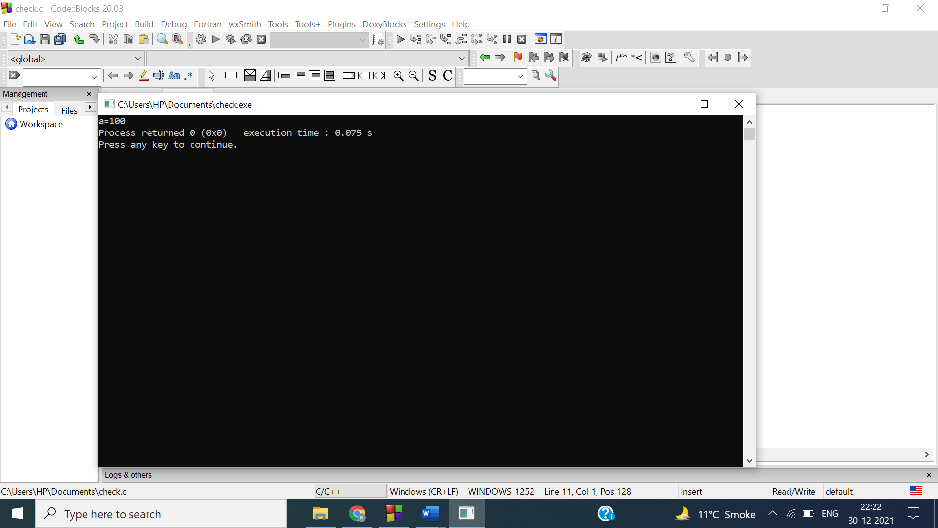

Ans 8-

#include <stdio.h>

struct student

{

char name[30];

int roll;

float perc;

};

int main()

{

struct student std;

struct student \*ptr;

ptr= &std;

printf("Enter details of student: ");

printf("\nName :"); gets(ptr->name);

printf("Roll No :"); scanf("%d",&ptr->roll);

printf("Percentage :"); scanf("%f",&ptr->perc);

printf("\nEntered details: ");

printf("\nName:%s\nRollNo: %d\nPercentage: %.02f\n",ptr->name,ptr->roll,ptr->perc);

return 0;

}

