NBTG13715

Week9 Lab A

Nitin Chaudhary

F8

Ans1-

#include<stdio.h>

struct add

{

int inch,feet;

};

int main()

{

struct add n1,n2,n3;

printf("Measurement 1 is\n") ;

printf(" enter Inches: ");

scanf("%d",&n1.inch);

printf("enter feet: ");

scanf("%d",&n1.feet);

printf("Measurement 2 is\n");

printf("Inches: ");

scanf("%d",&n2.inch);

printf("enter feet: ");

scanf("%d",&n2.feet);n3.inch=n1.inch+n2.inch;

n3.feet=n1.feet+n2.feet;

if(n3.feet>=12)

{

n3.inch+=1;

n3.feet-=12;

}

printf("Addition is\n");

printf("Inches : %d\nFeet: %d",n3.inch,n3.feet);

return 0;

}

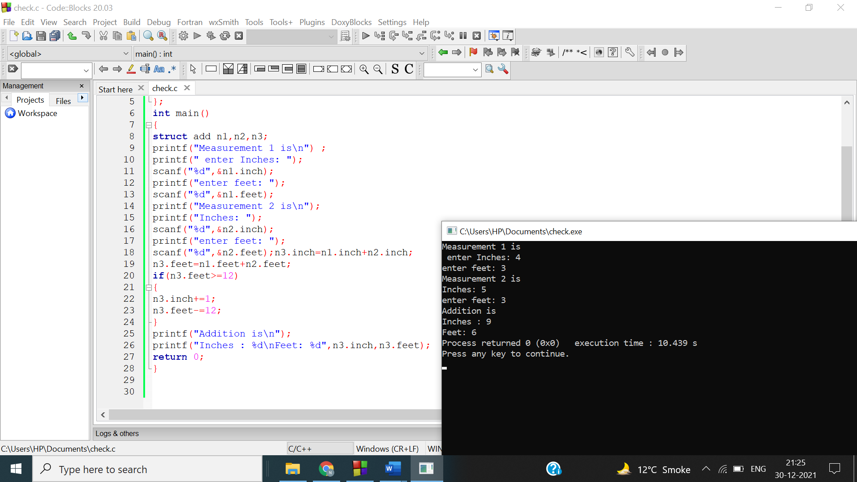

Ans 2-

#include <stdio.h>

struct detail

{char name[25],branch[25],batch[10],clg[10];

int rol;

};

int main()

{

int n,i;

printf("NUMBER OF STUDENT: ");

scanf("%d",&n);

struct detail info[n];

for(i=0;i<n;i++)

{

printf("\n Student %d \n",i+1);

printf("Name: ");

scanf("%s",info[i].name);

printf("College : ");

scanf("%s",info[i].clg);

printf("Roll no : ");

scanf("%d",&info[i].rol);

printf("Branch : ");

scanf("%s",info[i].branch);

printf("Batch\: ");

scanf("%s",info[i].batch);printf("\n");}

printf("\n\nPrinting students information.");

for(i=0;i<n;i++)

{

printf("\n Student %d \n",i+1);

printf("Name:%s \n",info[i].name);

printf("College :%s \n",info[i].clg);

printf("Roll no :%d \n",info[i].rol);

printf("Branch :%s \n",info[i].branch);

printf("Batch:%s \n",info[i].batch);

}

printf("Thank You");

return 0;

}

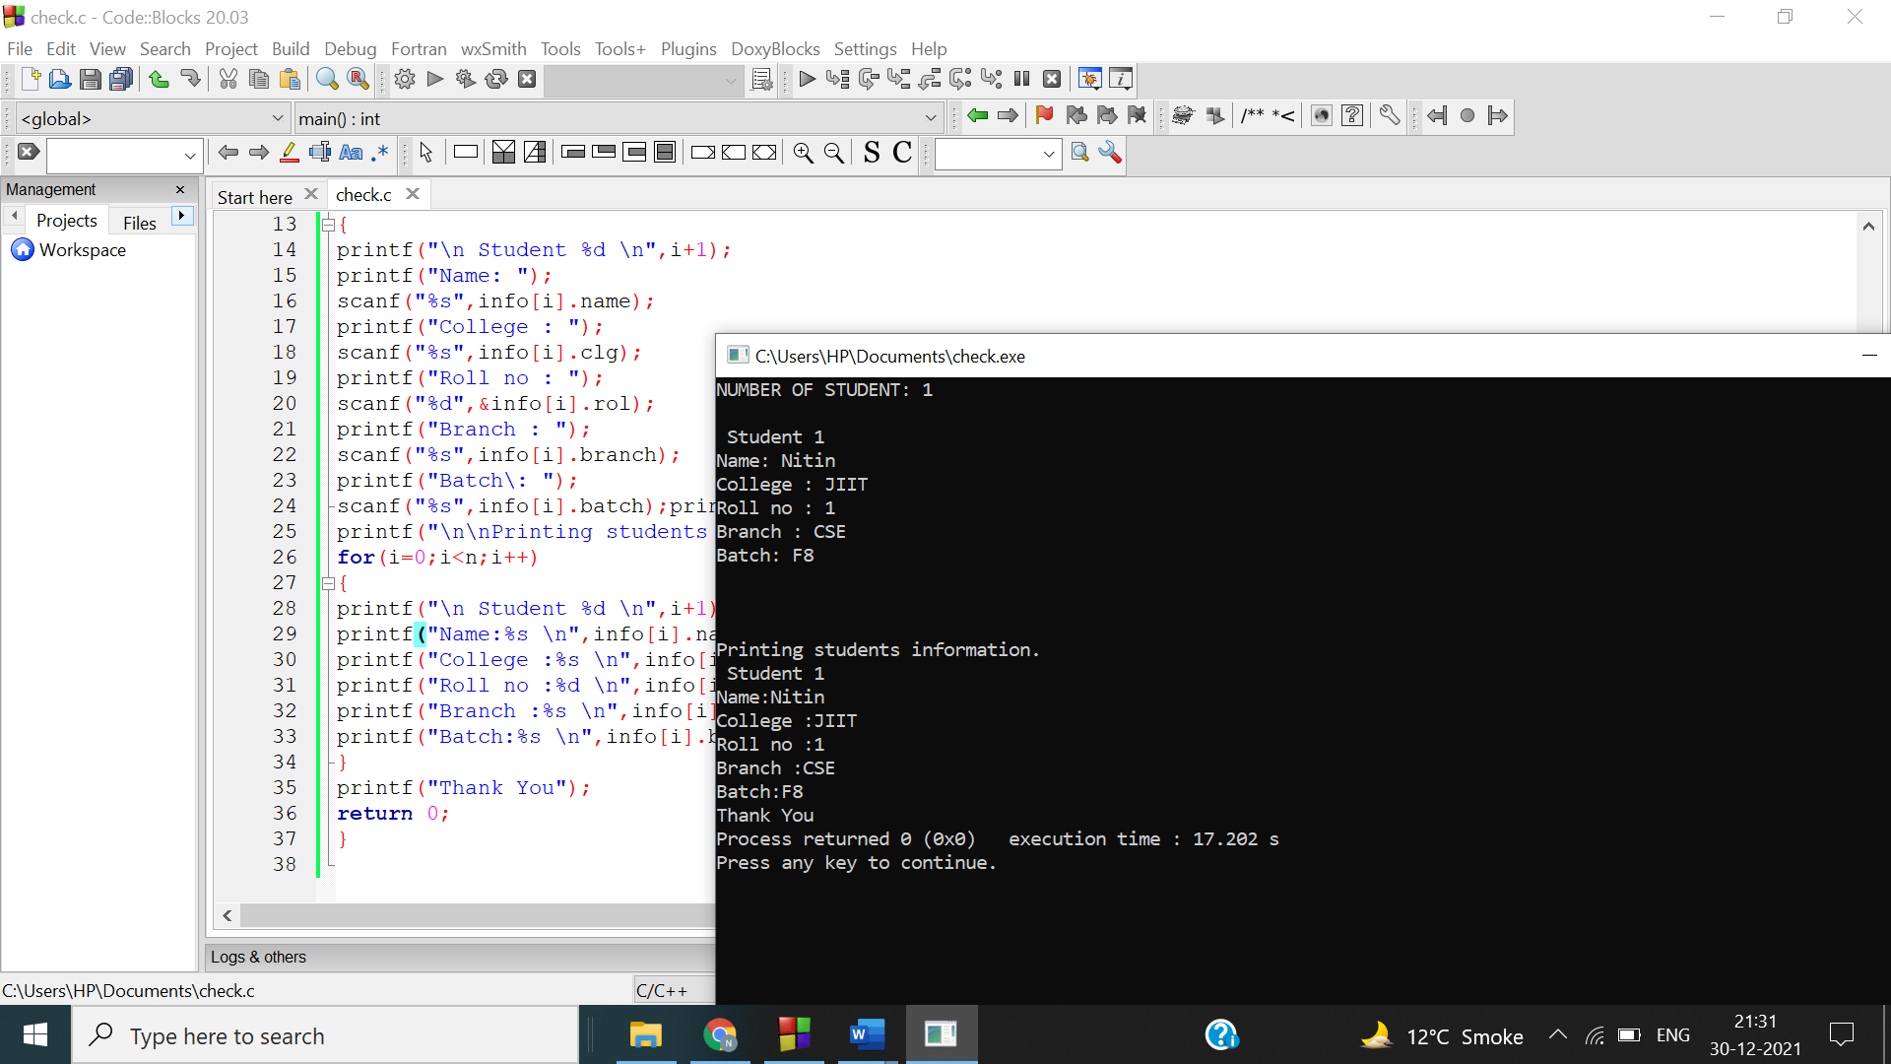

Ans3-

#include <stdio.h>

struct Marks

{

int roll_no;

char name[15];

float chem_marks, maths_marks, phy_marks;

}m[5];

int main()

{

for(int x=0; x<5; x++)

{

printf("Student %d\n",x+1);

printf("Enter roll no. : ");

scanf("%d", &m[x].roll_no);

printf("Enter name : ");

scanf("%s",&m[x].name);

printf("Enter Chemistry marks : ");

scanf("%f", &m[x].chem_marks);

printf("Enter Maths marks : ");

scanf("%f", &m[x].maths_marks);

printf("Enter Physics marks : ");

scanf("%f", &m[x].phy_marks);

}

for(int x=0; x<5; x++)

{

printf("\n\nStudent %d\n",x+1); printf("Roll no. : %d\t",m[x].roll_no);

printf("Name : %s\t",m[x].name);

printf("Chemistry marks : %f\t", m[x].chem_marks);

printf("Maths marks : %f\t", m[x].maths_marks);

printf("Physics marks : %f\t", m[x].phy_marks);

float percentage = (m[x].chem_marks + m[x].maths_marks +

m[x].phy_marks)/300.0*100;

printf("Percentage : %f\t", percentage);

}

return 0;

}

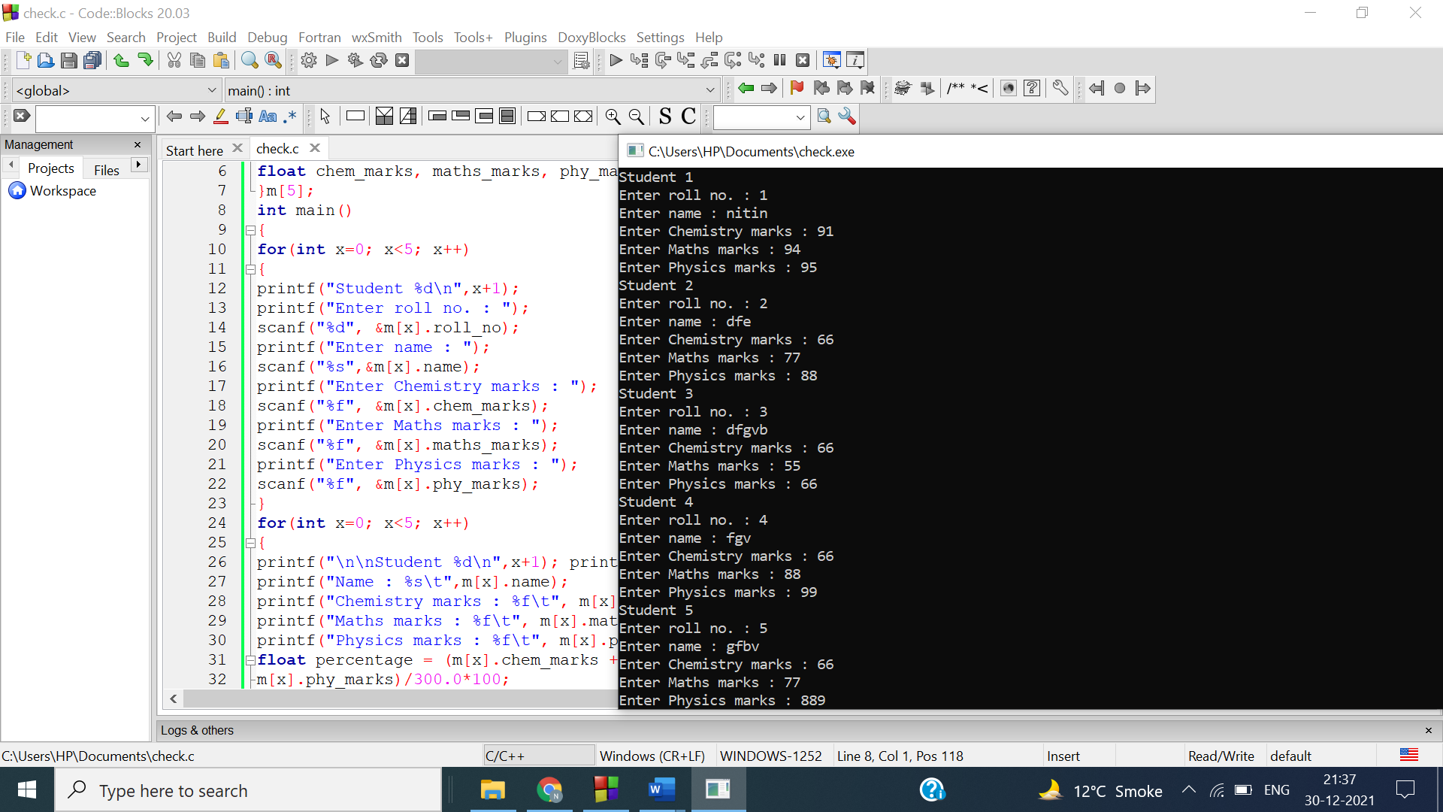

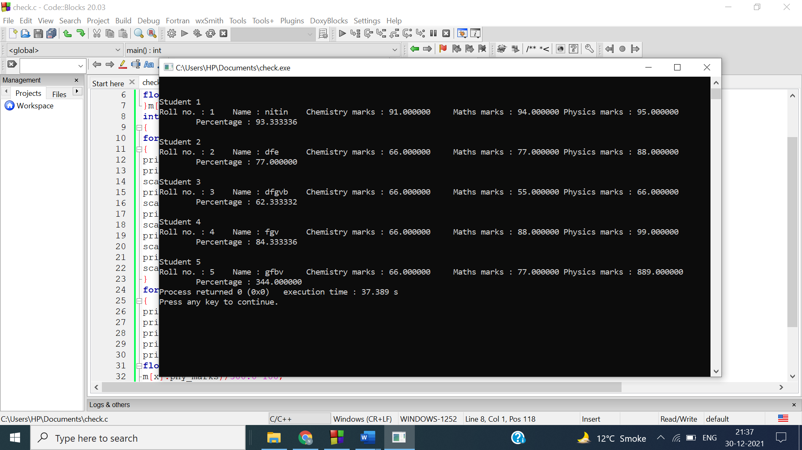

Ans 4-

#include <stdio.h>

struct student

{

char n[100];

int r;

float m1,m2;

} s;

int main()

{ printf("Enter information:\n");

printf("Enter name: ");

gets(s.n);

printf("Enter roll number: ");

scanf("%d", &s.r);

printf("Enter marks of First Year : ");

scanf("%f", &s.m1);

printf("Enter marks of Second Year : ");

scanf("%f", &s.m2);

printf("\n\nDisplaying Information :[ELIGIBILITY CRITERIA(PERCENTAGE >=95)]\n\n");

printf("Name: ");

printf("%s\n", s.n);

printf("Roll number: %d\n", s.r);

printf("Marks of First Year : %f\n", s.m1);

printf("Marks of Second Year : %f\n", s.m2);

printf("Percentage : %f\n", (s.m1+s.m2)/2.0);

if((s.m1+s.m2)>=95)

{

printf("Eligible for scholarship"); }

else

{

printf("Not Eligible for scholarship");

}

return 0;

}

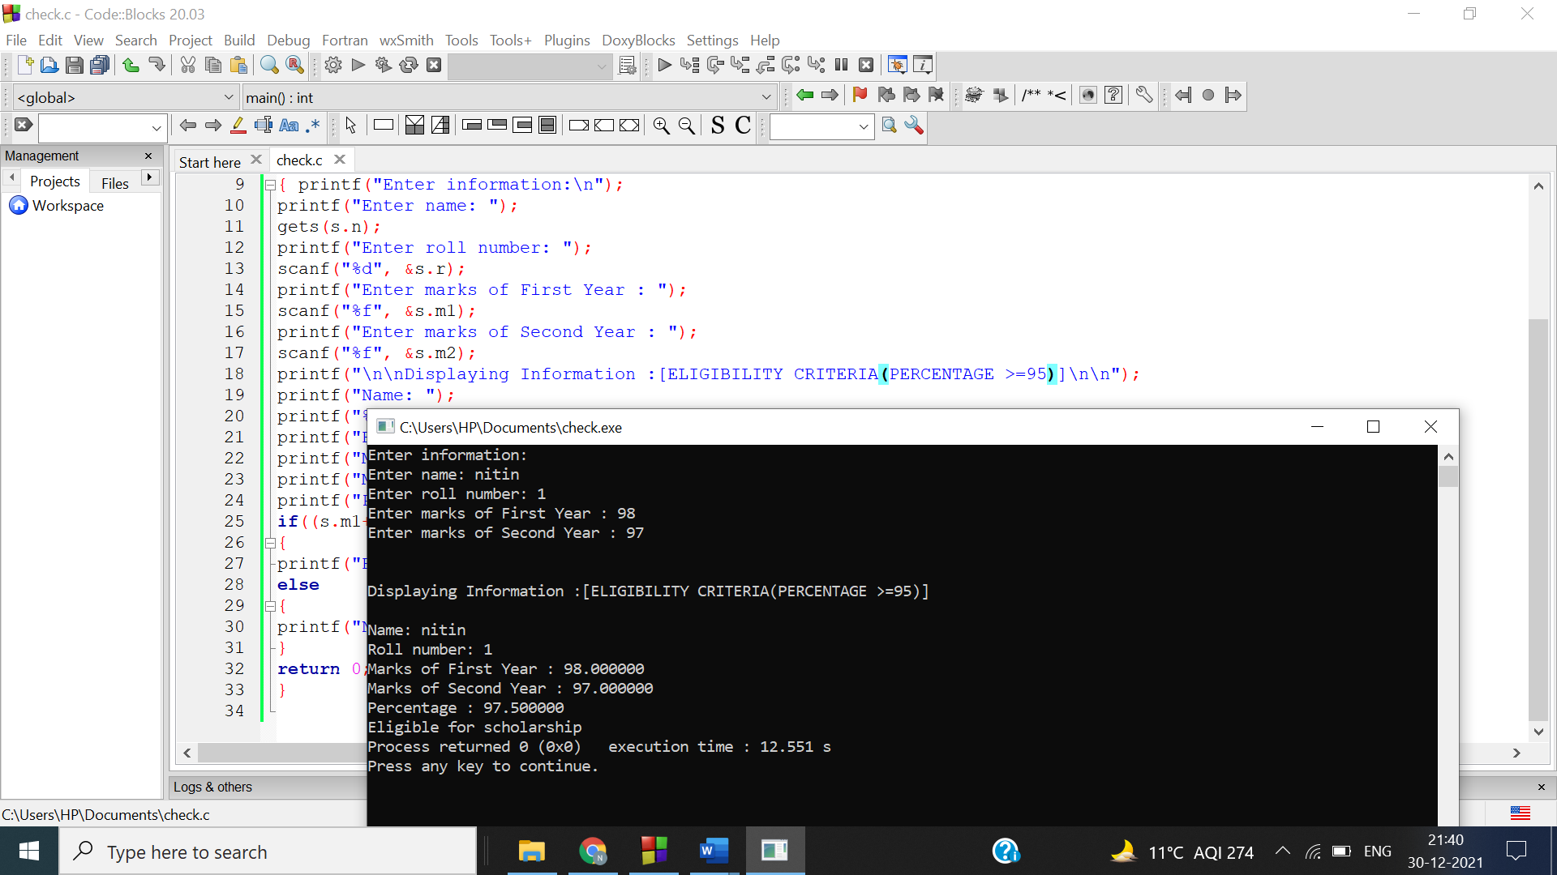

Ans 5-

#include <stdio.h>

union Student

{

long int roll_no;

char name[33];

int age;

}s;int main()

{

printf("Size of union = %ld bytes.",sizeof(s));

return 0;

}

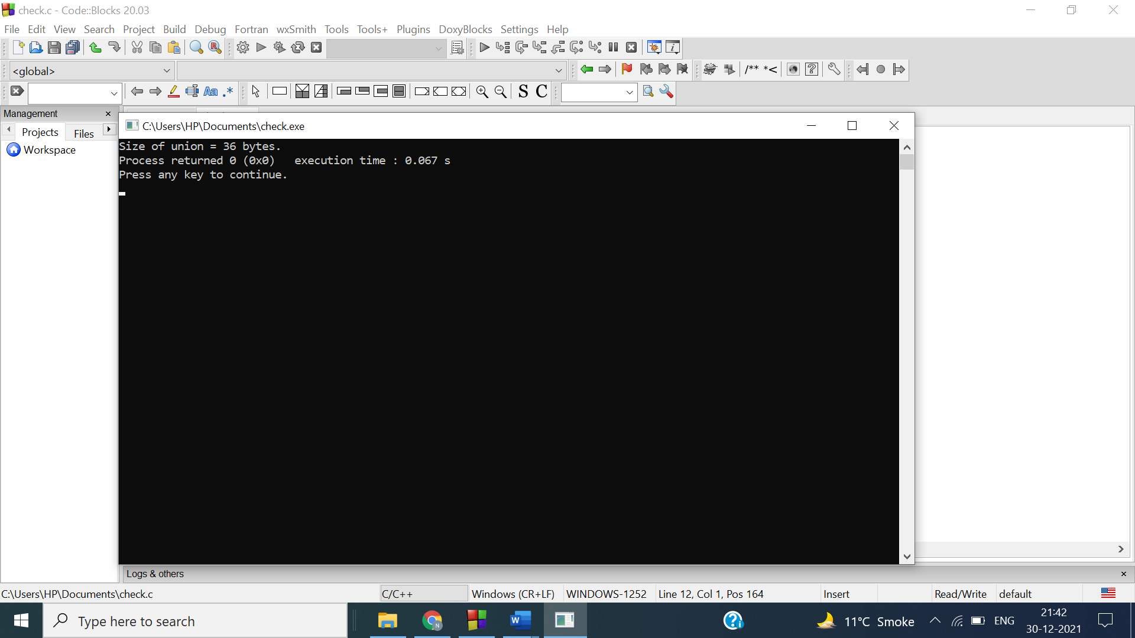

Reason :

Since we know that padding is present in union. So the size of a union will be the smallest multiple of the largest alignment required by any member that is not smaller than the largest member. Here largest alignment is long long which has 8 bytes there size of union student{}; is 40 instead of 33

Ans 6-

#include<stdio.h>

union student

{

char phy[20]; char chem[20];

char math[20];

char eng[20];

char opt[20];

};

int main()

{

printf("Size of union is %d",sizeof(union student));

return 0;

}

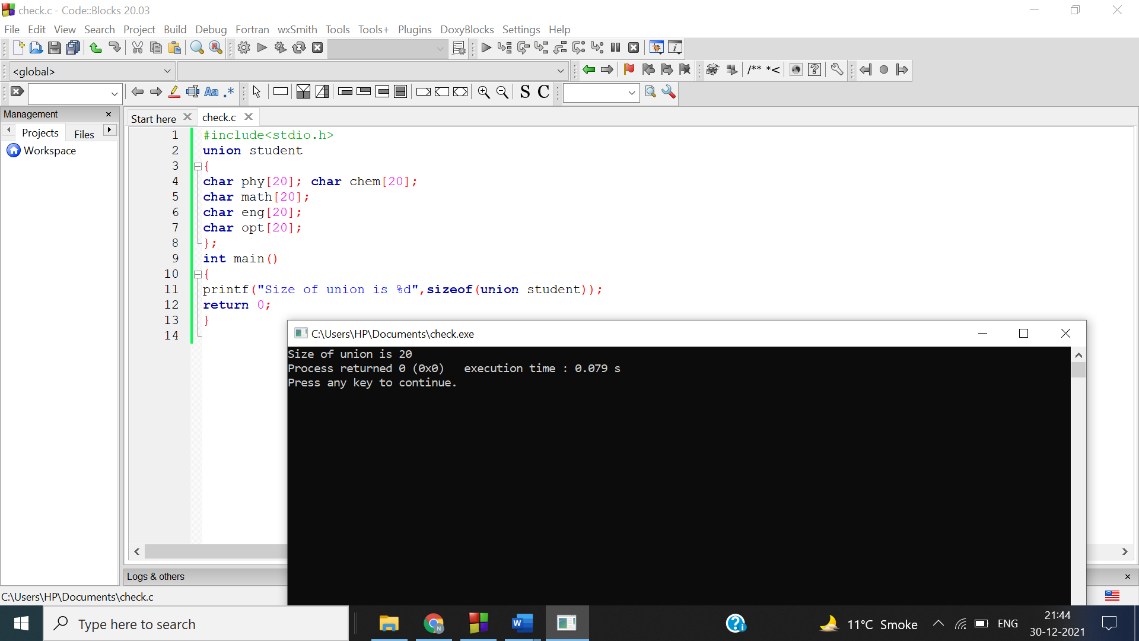

Reason : Only char is present in the union therefore it show the size of the largest char array. i.e. 20.

Ans 7-

#include<stdio.h>

union student{

struct detail

{

char nam[25],branch[25],batch[10],clg[10];

int rol;

}s;

};

int main()

{

int n,i;

printf("NUMBER OF STUDENT: ");

scanf("%d",&n);

union student info[n];

for(i=0;i<n;i++)

{

printf("\n Student %d \n",i+1);

printf("Name: ");

scanf("%s",info[i].s.nam);

printf("College : ");

scanf("%s",info[i].s.clg);

printf("Roll no : ");

scanf("%d",&info[i].s.rol);printf("Branch : ");

scanf("%s",info[i].s.branch);

printf("Batch: ");

scanf("%s",info[i].s.batch);

printf("\n");

}

printf("\n\nPrinting students information.");

for(i=0;i<n;i++)

{

printf("\n Student %d \n",i+1);

printf("Name:%s \n",info[i].s.nam);

printf("College :%s \n",info[i].s.clg);

printf("Roll no :%d \n",info[i].s.rol);

printf("Branch :%s \n",info[i].s.branch);

printf("Batch:%s \n",info[i].s.batch);

}

printf("*********");

return 0;

}

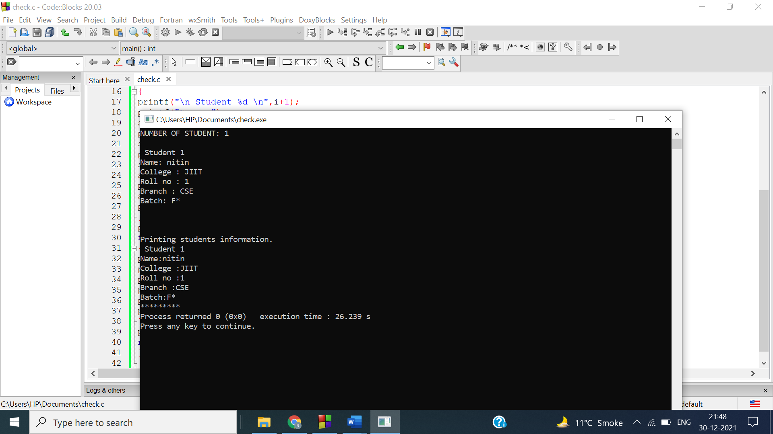

Ans 8

#include<stdio.h>

union numchar

{

int num;

char ch;

};

int main(){

union numchar* X = NULL;

X= (union numchar*)

malloc(sizeof(union numchar));

printf("Enter number : ");

scanf("%d", &(X->num));

printf("\nNumber: %d",X->num);

printf("\nCharacter: %c",X->ch);

return 0;

}

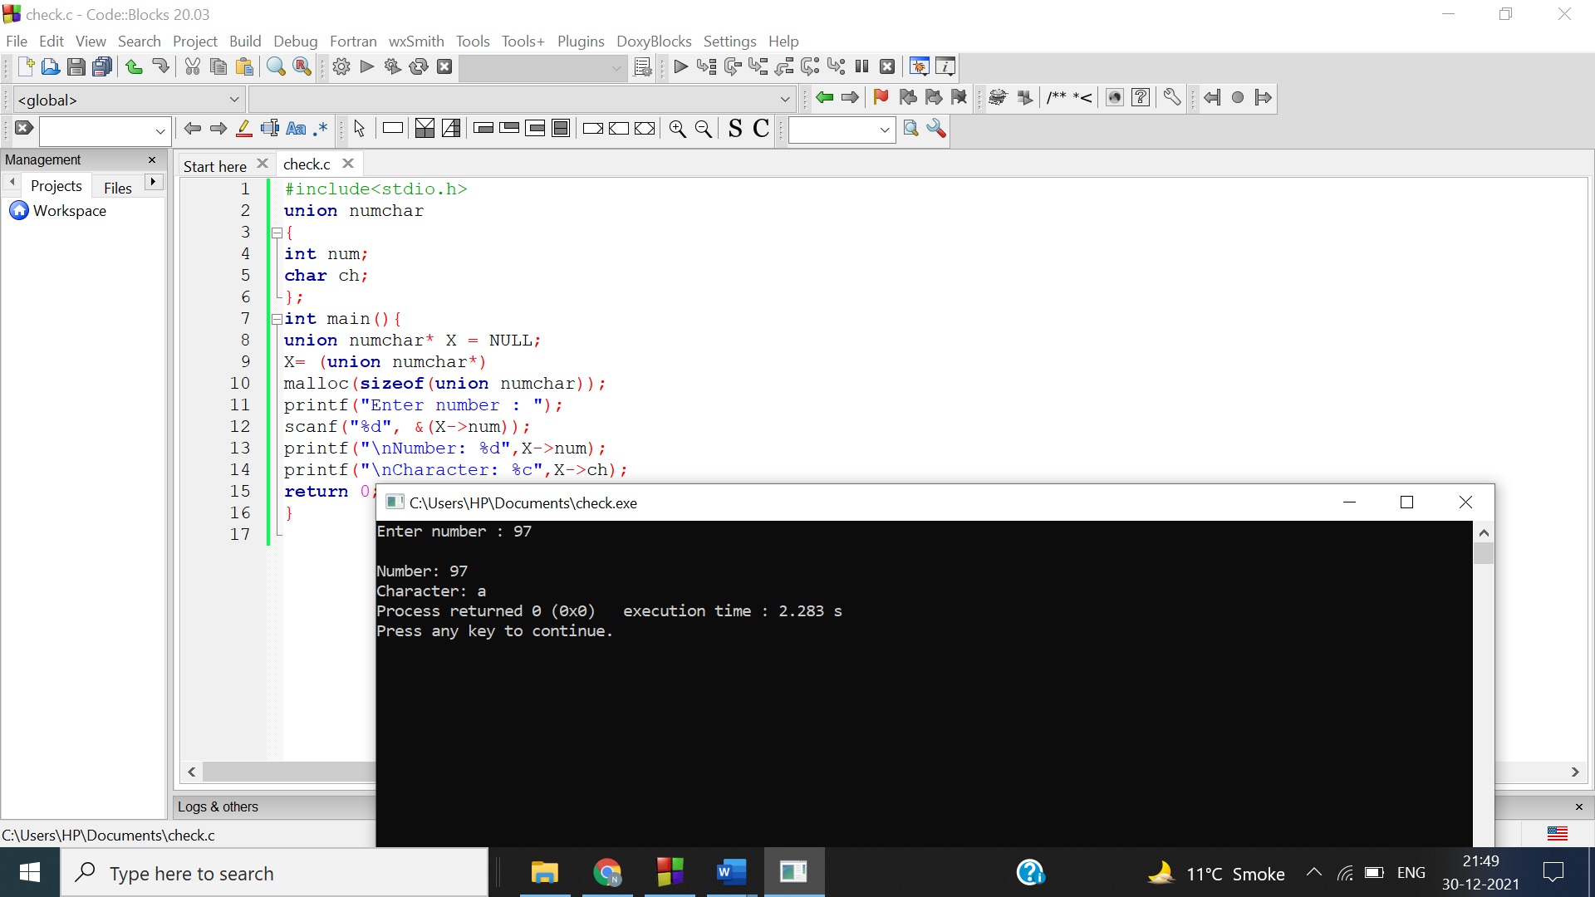

Ans 9-

#include<stdio.h>

union employ

{

struct detail{ int id;

char name[30]; int age;

int salary;

}d;};

int main(){

union employ emp[5]; int i;

for(i=0;i<5;i++)

{

printf("Enter details of employee %d \n",i+1);

printf("Enter ID:");

scanf("%d", &emp[i].d.id);

printf("Enter name:");

fflush(stdin);

scanf("%s",emp[i].d.name);

printf("Enter Age: ");

scanf("%d", &emp[i].d.age);

printf("Enter Salary:");

scanf("%d", &emp[i].d.salary);

}

for(i=0;i<5;i++){

printf("%d \t %s \t %d \t %d \n", emp[i].d.id, emp[i].d.name ,

emp[i].d.age , emp[i].d.salary);

}

return 0;

}

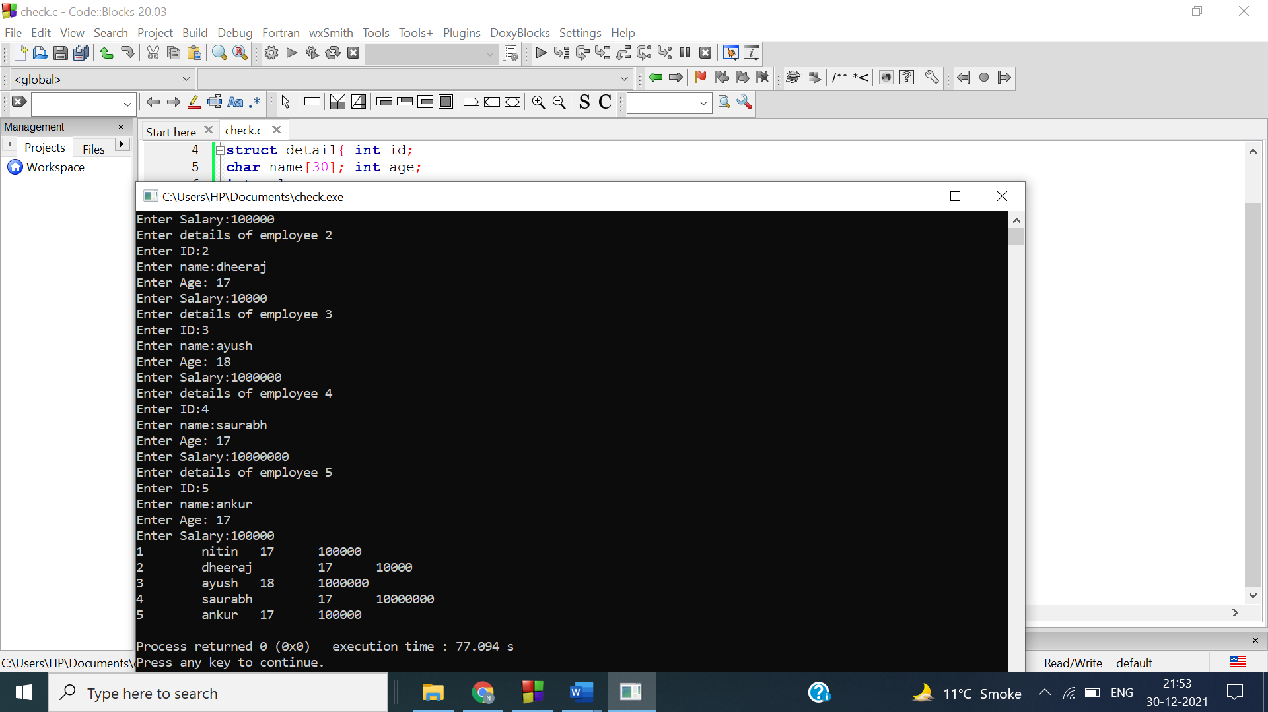

Ans 10-

#include<stdio.h>

union exp

{

char name[10];

int age;

float percentage;

};int main()

{

union exp var1,var2;

printf("Enter your name:");

scanf("%s", var1.name);

printf("Enter your age:");

scanf("%d", &var1.age);

printf("Enter your percentage:");

scanf("%f", &var1.percentage);

printf("\nName: %s", var1.name);

printf("\nAge: %d", var1.age);

printf("\nPercentage: %f", var1.percentage);

printf("\n Ques10 b \n");

printf("Enter your name:");

fflush(stdin);

scanf("%s", var2.name);

printf("Name: %s\n", var2.name);

printf("Enter your age:");

scanf("%d", &var2.age);

printf("Age: %d \n", var2.age);

printf("Enter your percentage:");

scanf("%f", &var2.percentage);printf("Percentage: %f\n", var2.percentage);

printf("size of variable 1:%d\n",sizeof(var1));

printf("size of variable 1:%d",sizeof(var2));

}

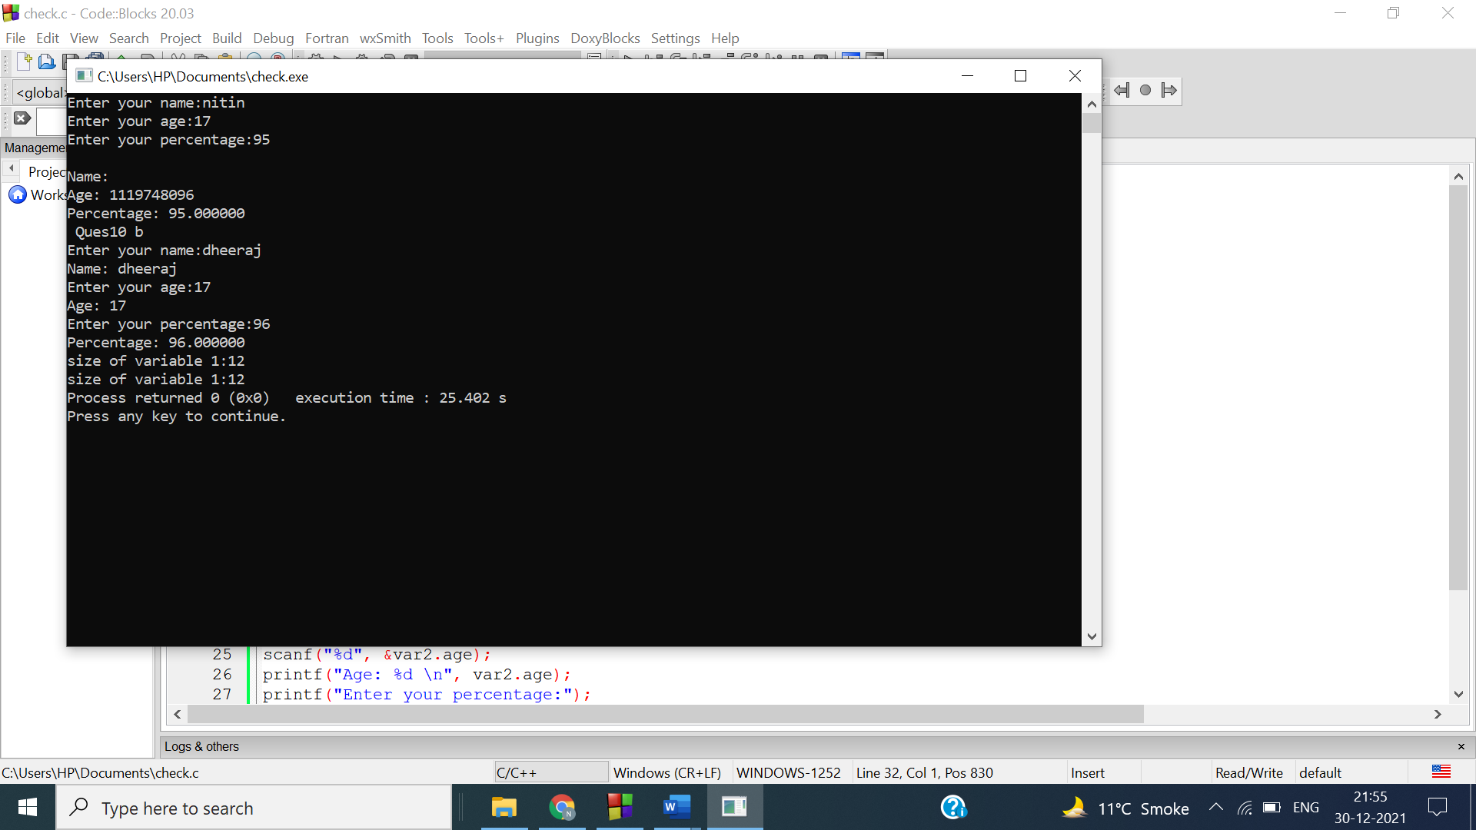

Reason :

In a part of the question output is correct only for percentage it is because last input input in union is for percentage. In b part of the question all outputs are correct because we print the variable value before we take another input in union, that is why none of the value was distorted.

Ans 11-

#include<stdio.h>

struct s

{int a; char b; float c;

};

union u

{

int a; char b; float c;

};

int main(){ struct s st; union u un;

printf("Enter int for struct");

scanf("%d",&st.a);

printf("Enter char for struct");

fflush(stdin); scanf("%c",&st.b);

printf("Enter float for struct");

scanf("%f",&st.c);

printf("Enter int for union");

scanf("%d",&un.a);

printf("Enter char for union");

fflush(stdin);

scanf("%c",&un.b);

printf("Enter float for union");

scanf("%f",&un.c);

printf("\nStructure: int %d char %c float %f",st.a,st.b,st.c);

printf("\nUnion: int %d char %c float %f",un.a,un.b,un.c);printf("\nUnion size : %d\nStructure size : %d",sizeof(union

u),sizeof(struct s));

return 0;

}

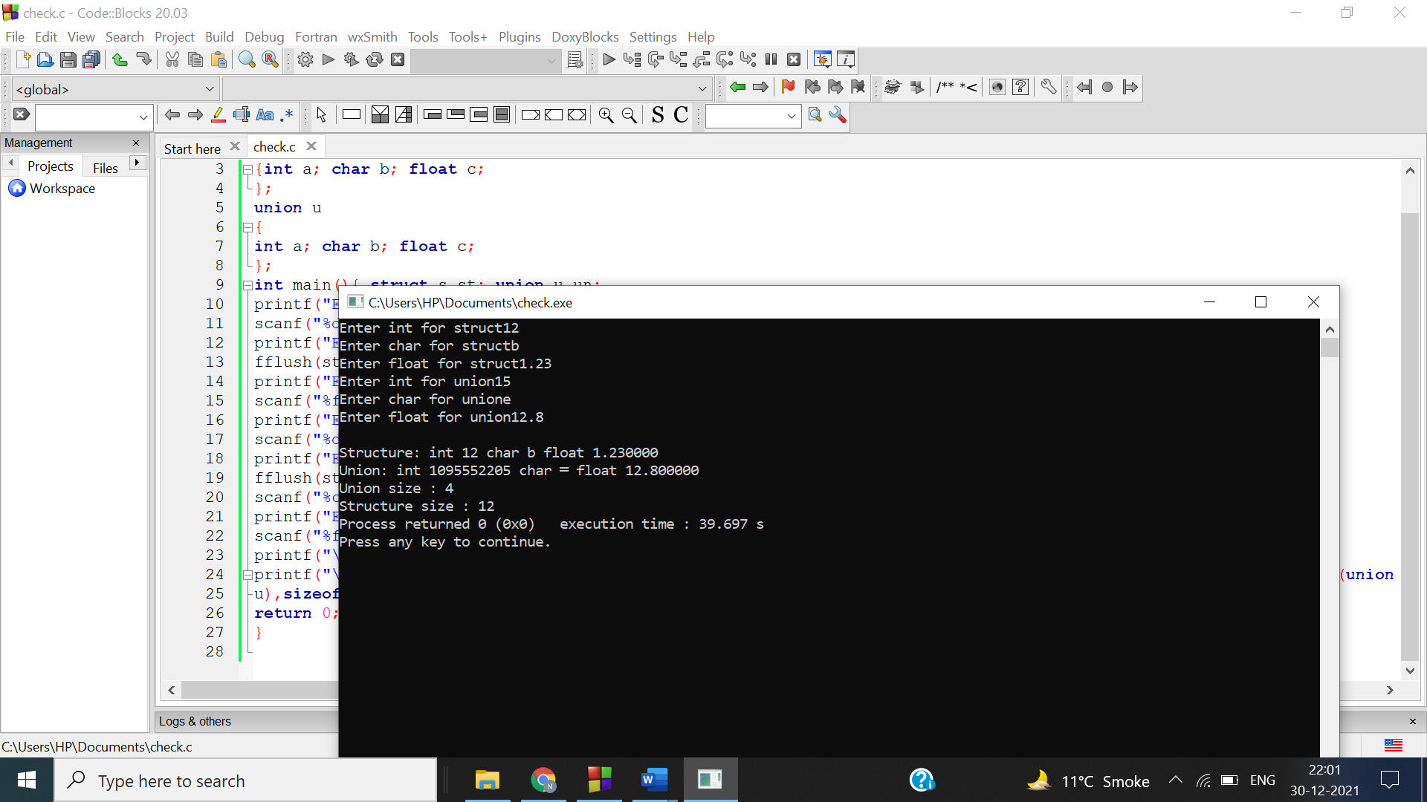

Ans 12-symtab[0].u.*sval