NBTG13715

W10 Lab A

Nitin Chaudhary

Ans 1

#include <stdio.h>

struct student {

char name[50];

int roll_no;

int rank;

} s;

int main() {

printf("Enter information:\n");

printf("Enter name: ");

fgets(s.name, sizeof(s.name), stdin);

printf("Enter roll number: ");

scanf("%d", &s.roll_no);

printf("Enter rank: ");

scanf("%d", &s.rank);

printf("Displaying Information:\n");

printf("Name: ");

printf("%s", s.name);

printf("Roll number: %d\n", s.roll_no);

printf("rank: %d\n", s.rank);

return 0;

}

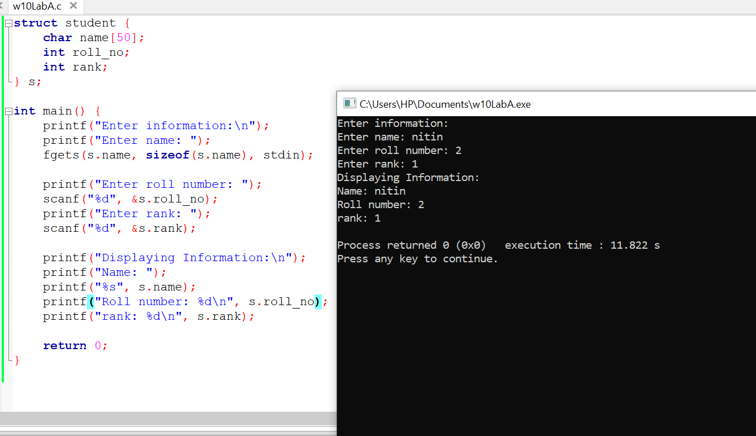

Ans 2

#include <stdio.h>

int main(){

int a,b;

int *pa,*pb;

pa=&a; pb=&b;

printf("Enter first integer: ");

scanf("%d",pa);

printf("Enter second integer: ");

scanf("%d",pb);

if(*pa==*pb)

printf("Integers are equal.\n");

else

printf("Integers are not equal.\n");

return 0;

}

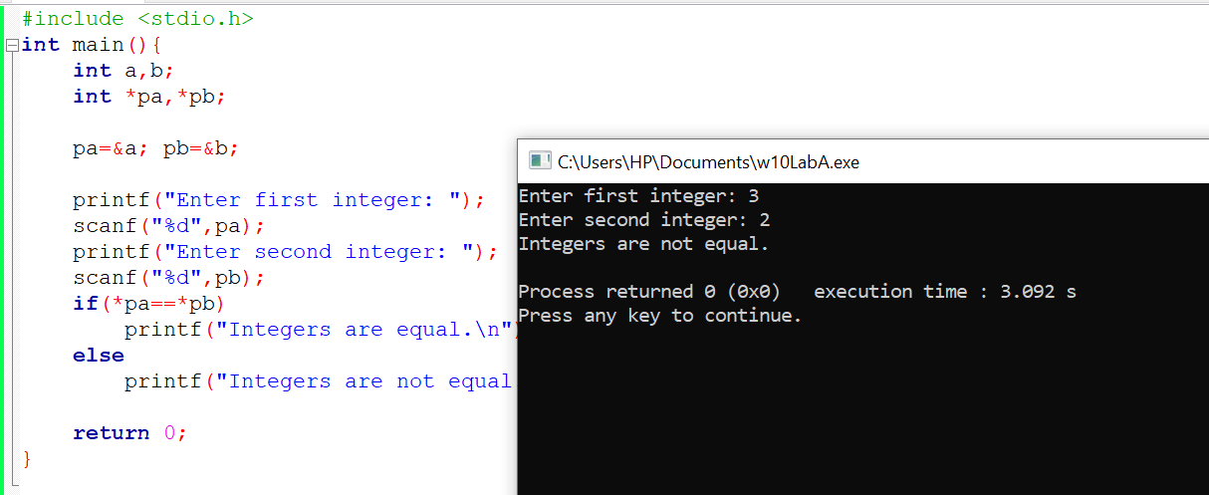

Ans 3

#include <stdio.h>

void SortArray(int Size, int* parr)

{

int i, j, temp;

for (i = 0; i < Size; i++)

{

for (j = i + 1; j < Size; j++)

{

if(*(parr + j) < *(parr + i))

{

temp = *(parr + i);

*(parr + i) = *(parr + j);

*(parr + j) = temp;

}

}

}

printf("Sorted Array Elements = ");

for(i = 0; i < Size; i++)

{

printf("%d ", *(parr + i));

}

}

int main()

{

int Size;

printf("\nEnter Array Size to Sort ");

scanf("%d", &Size);

int arr[Size];

printf("\nPlease Enter %d elements of an Array = ", Size);

for (int i = 0; i < Size; i++)

{

scanf("%d", &arr[i]);

}

SortArray(Size, arr);

printf("\n");

}

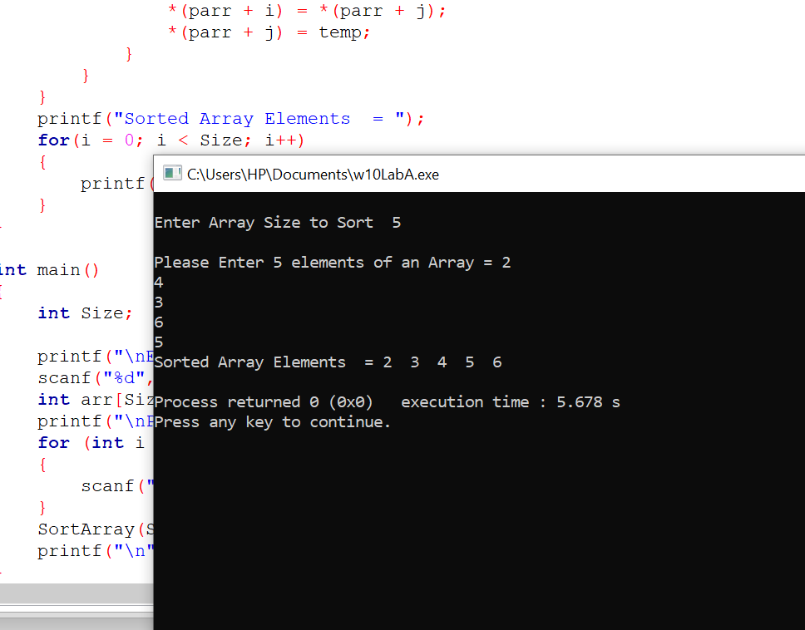

Ans 4

#include <stdio.h>

int main()

{

int n;

printf("How many items you want to enter: ");

scanf("%d",&n);

getchar();

char *list[n][100];

printf("Enter the items: \n");

for(int i=0;i<n;i++)

{

printf("a[%d]=",i);

gets(&list[i]);

fflush(stdin);

}

printf("The items are: \n");

for(int i=0;i<n;i++)

{

printf("a[%d]=",i);

puts(list[i]);

printf("\n");

}

return 0;

}

