Week 5 lab B

NBTG13715

Nitin Chaudhary

F8

Q1

a)

#include <stdio.h>

int main()

{

int a,b,i=1,j;

printf("enter smaller number a\n");

scanf("%d",&a);

printf("enter greater number b\n");

scanf("%d",&b);

for(a;a<=b;a++)

{

j=1;

for(i;i<=(a/2);i++)

{

if(a%i==0)

{

j++;

}

}

if(j==1&&a!=1)

printf("\n%d is prime\n",a);

}

return 0;

}

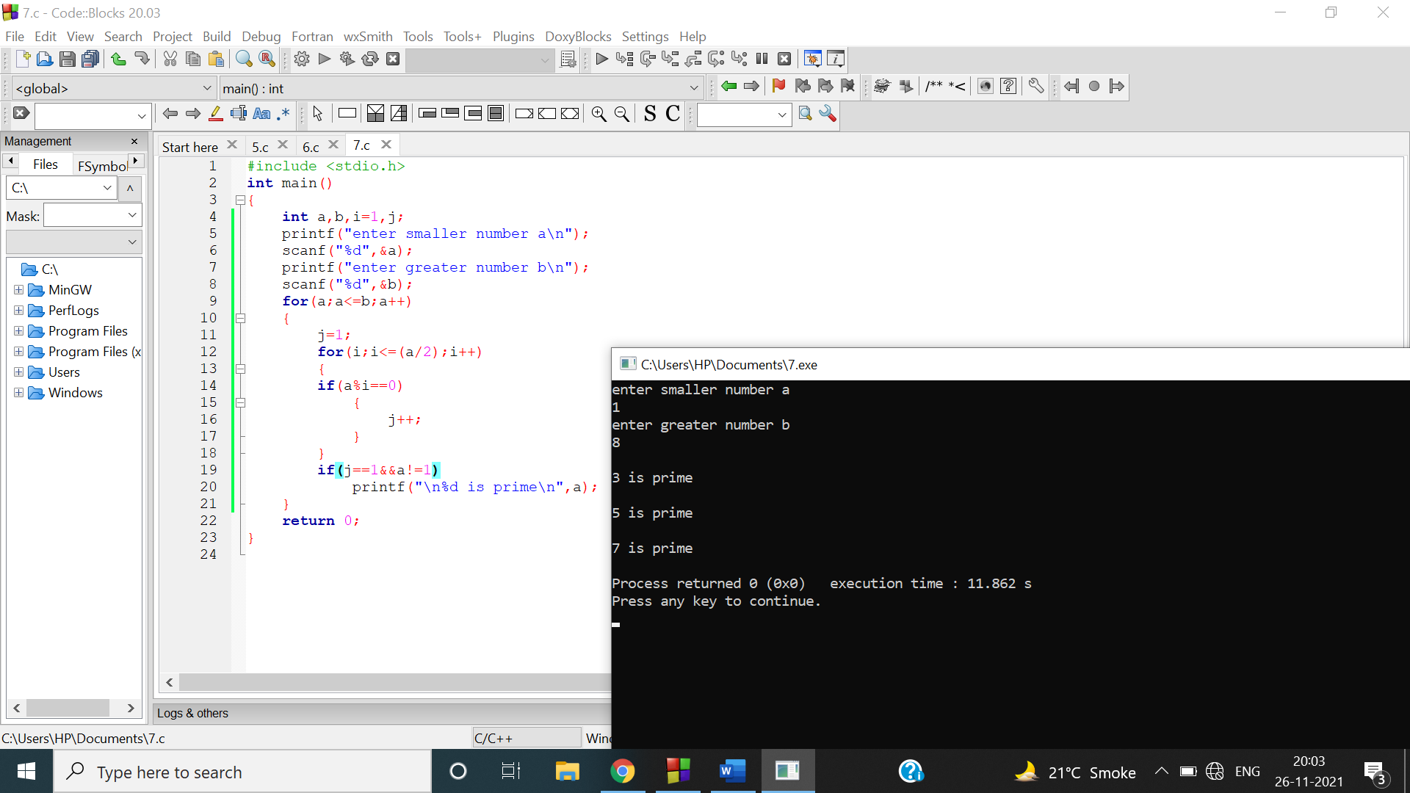

b)

#include <stdio.h>

int main()

{

int a,b,s=0;

printf("enter smaller number a\n");

scanf("%d",&a);

printf("enter greater number b\n");

scanf("%d",&b);

for(a;a<=b;a++)

{

if(a%2!=0)

s+=a;

}

printf("\nodd no. sum is %d\n",s);

return 0;

}

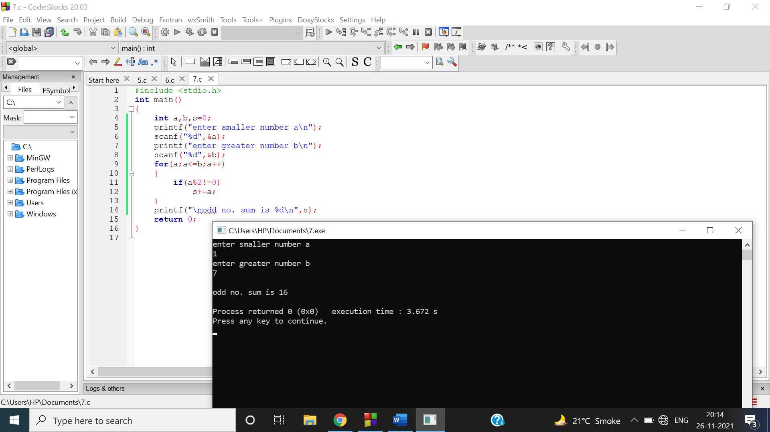

Q2

#include<stdio.h>

int main()

{

int a[100],b,i,j,c=0;

printf("enter how many digit number do you want to enter\n");

scanf("%d",&b);

printf("enter number having digits separated by space\n");

for(i=0;i<b;i++)

{

scanf("%d",&a[i]);

}

for(i=0;i<=9;i++)

{

c=0;

for(j=0;j<b;j++)

{

if(i==a[j])

{

c++;

}

}

if(c>0)

{

printf("%d occurs %d times\n",i,c);

}

}

}

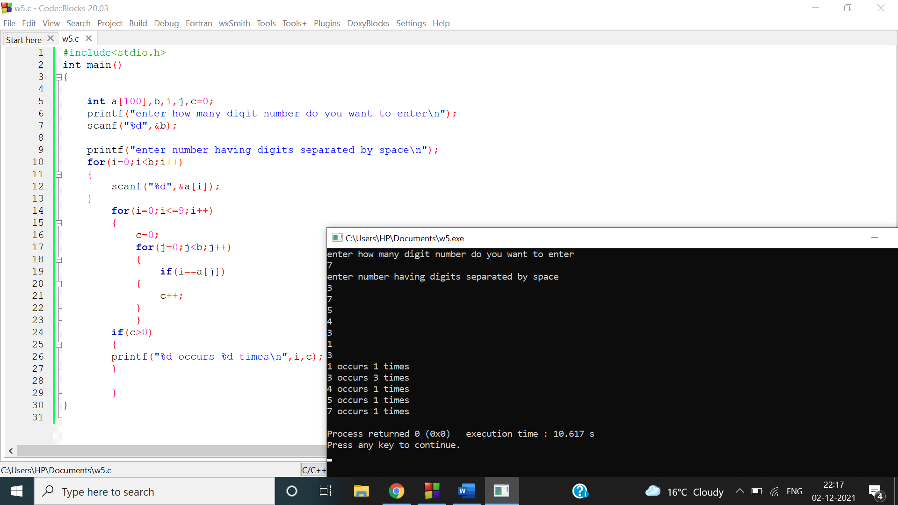

FLOW CHART-

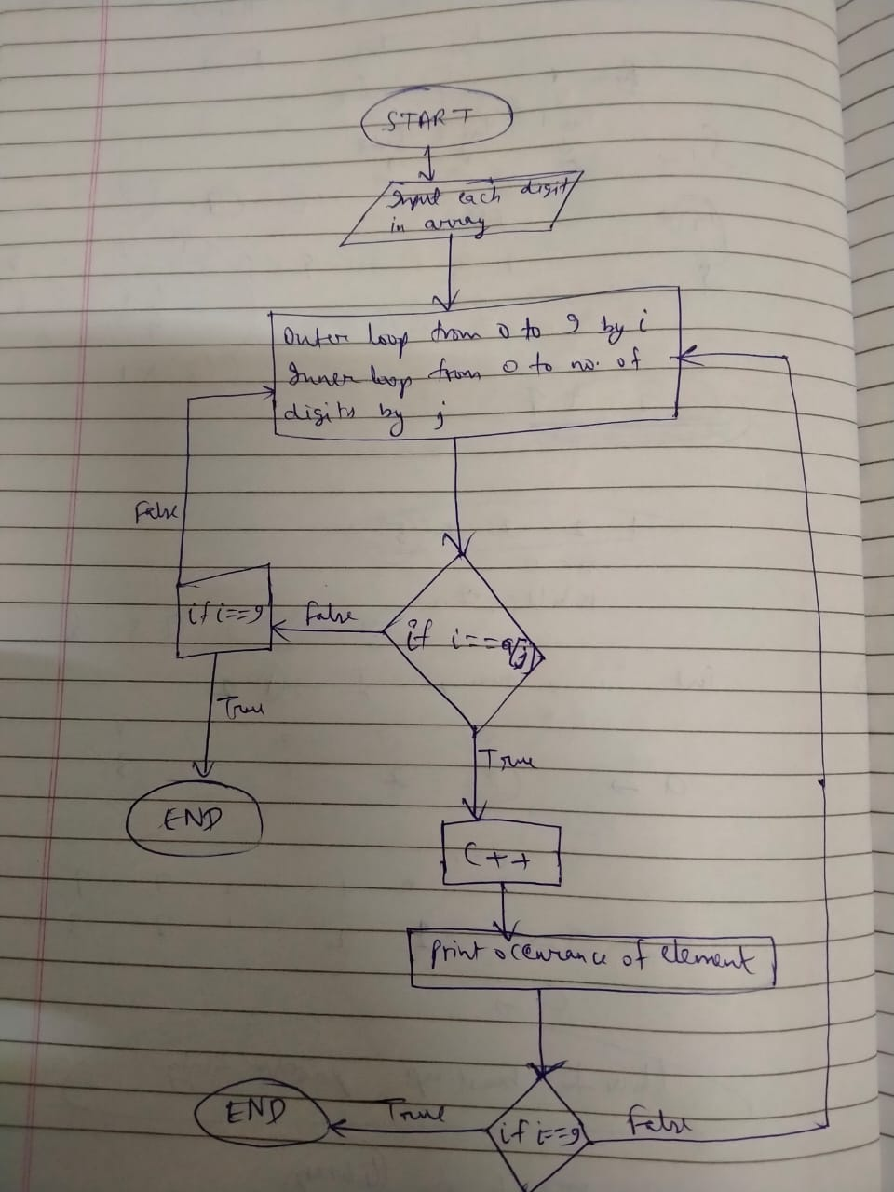

Q3

int reversDigits(int num)

{

int rev_num = 0;

while (num > 0) {

rev_num = rev_num * 10 + num % 10;

num = num / 10;

}

return rev_num;

}

int main()

{

int num;

printf("enter number");

scanf("%d",&num);

printf("Reverse of no. is %d", reversDigits(num));

getchar();

return 0;

}

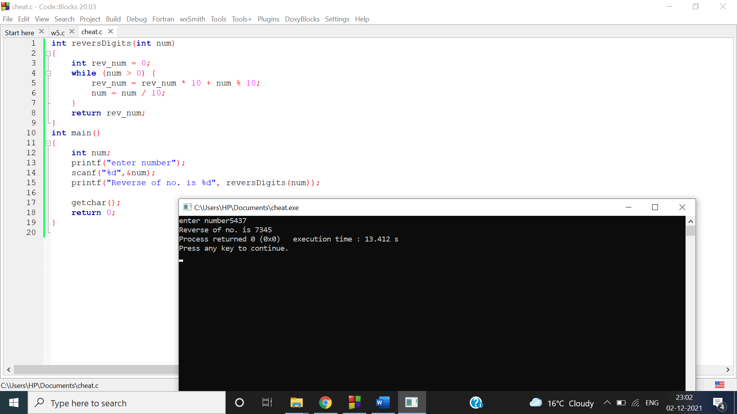

FLOW CHART

~~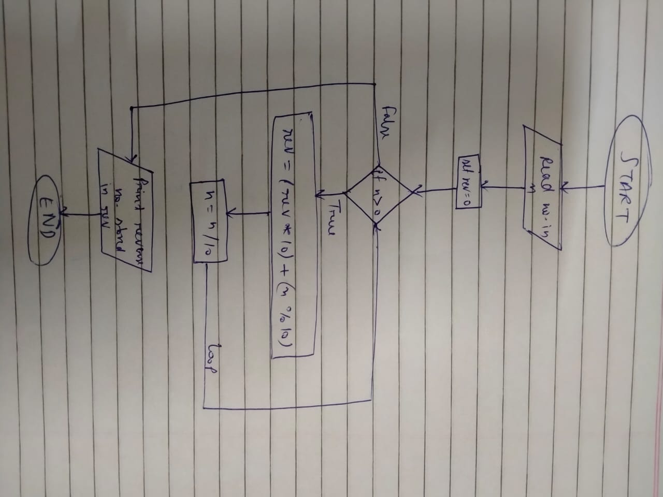~~

Q4

#include <stdio.h>

void main(){

int num,r,sum=0,t;

printf("Input a number: ");

scanf("%d",&num);

for(t=num;num!=0;num=num/10){

r=num % 10;

sum=sum*10+r;

}

if(t==sum)

printf("%d is a palindrome number.\n",t);

else

printf("%d is not a palindrome number.\n",t);

}

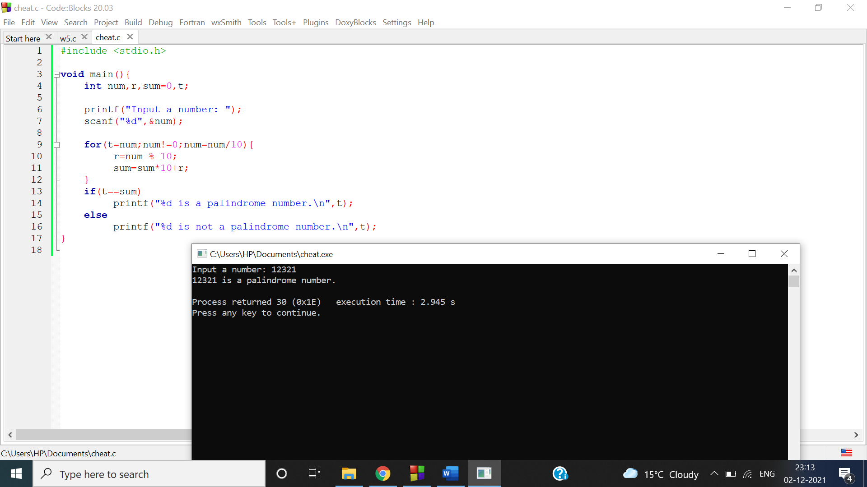

FLOW CHART

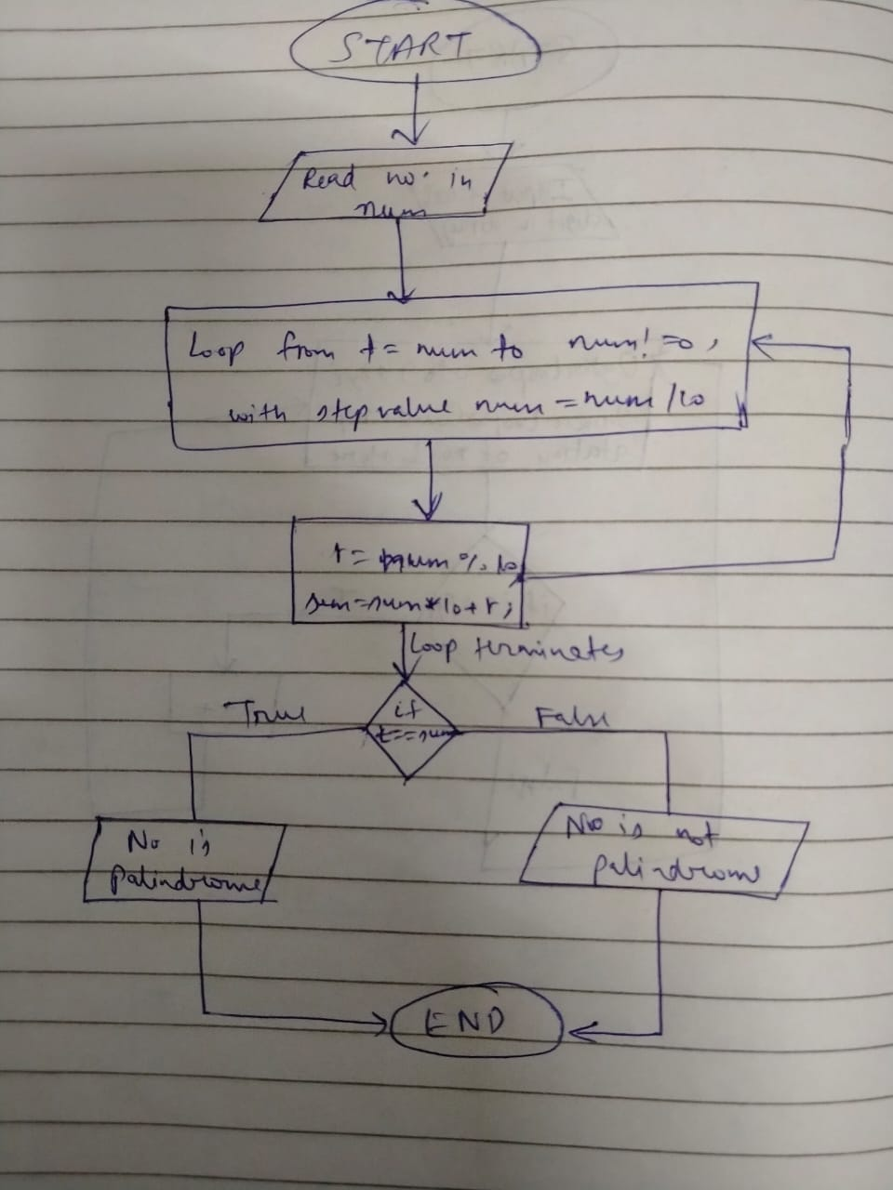

Q5

#include <stdio.h>

int main()

{

int a,n,i,res=1;

printf("\n Enter any no : ");

scanf("%d",&a);

printf("\n Enter power for the no : ");

scanf("%d",&n);

for(i=1;i<=n;i++){

res*=a;

}

printf(" Result is %d",res);

return 0;

}

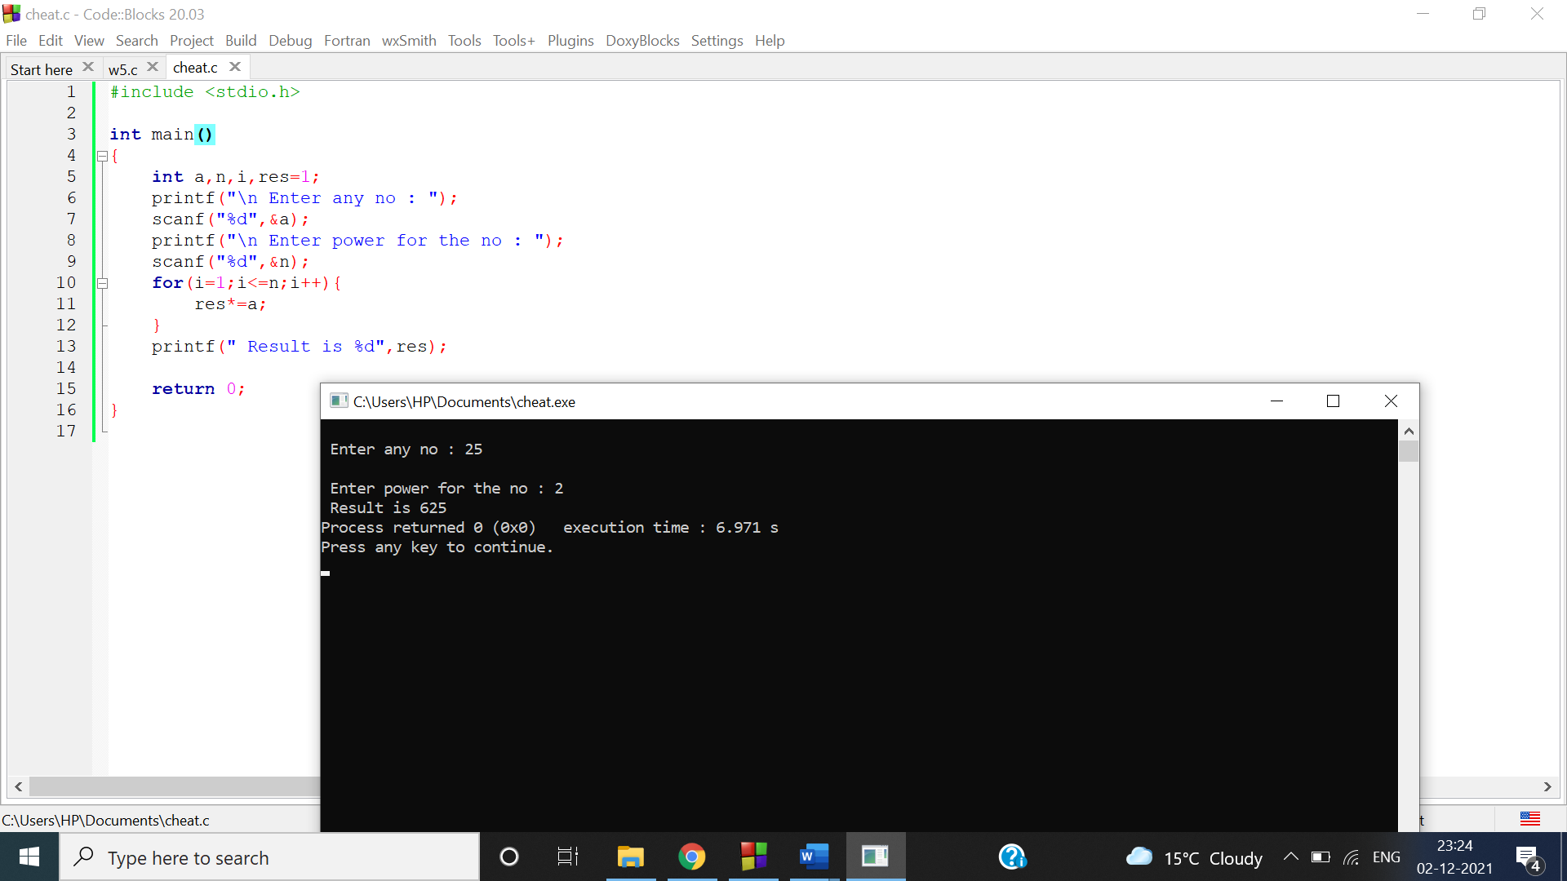

Q6

#include <stdio.h>

int main()

{

int n;

printf("\n Enter the no of rows : ");

scanf("%d",&n);

printf("\n");

for(int i=1;i<=n;i++){

for(int j=1;j<=n;j++){

if(i>j){

printf(" ");

}

else{

if(i==1 || i==j || j==n){

printf("*");

}

else{

printf(" ");

}

}

}

printf("\n");

}

return 0;

}

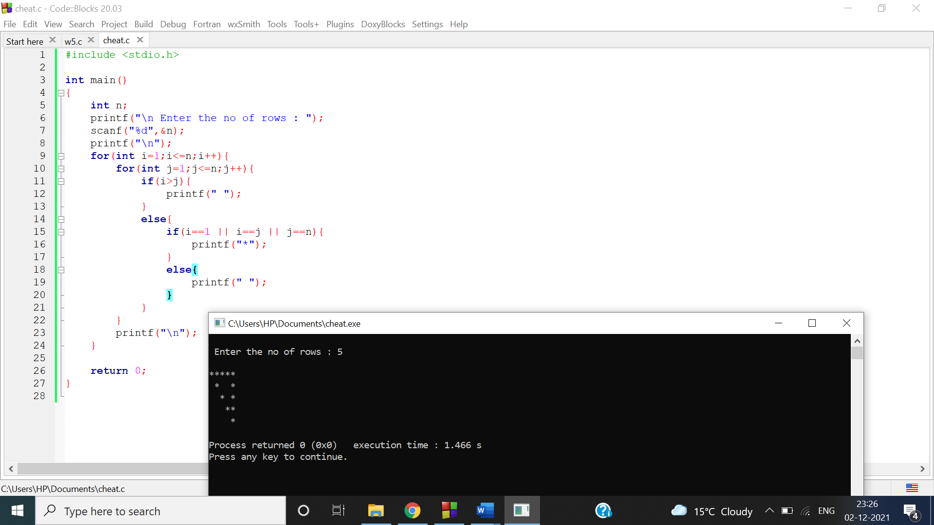

Q7

#include <stdio.h>

int main()

{

int n,i,j,c,c1;

printf("\n Enter the no of rows :");

scanf("%d",&n);

for(i=1;i<=n;i++){

c=i;

for(j=1;j<=(4*n-3);j++){

if(j>=((2*n-1)-2*(i-1)) && j<=((2*n-1)+2*(i-1))){

if(j%2==0){

printf(" ");

}

else if(j<=2*n-1){

printf("%d",11*c);

c++;

c1=c-2;

}

else{

printf("%d",11*c1);

c1--;

}

}

else{

printf(" ");

}

}

printf("\n");

}

return 0;

}

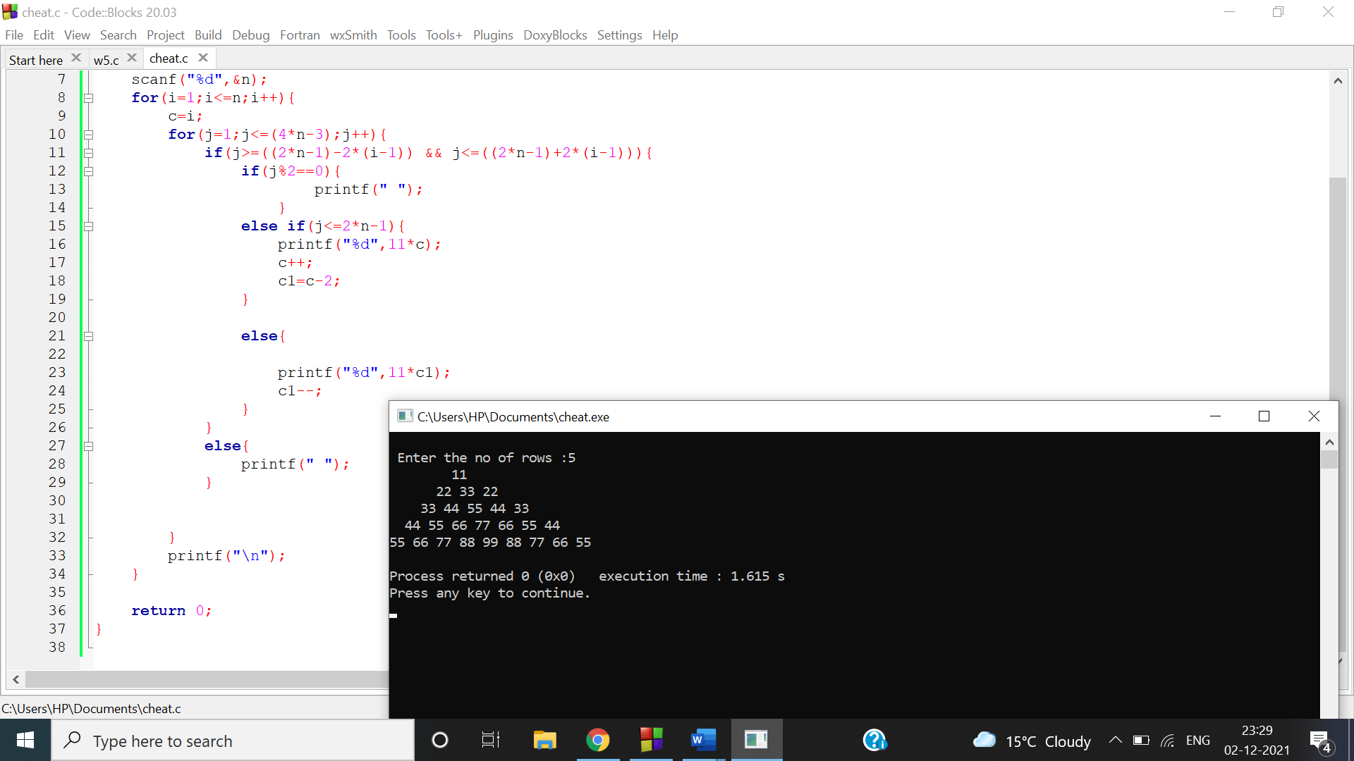

Q8

#include <stdio.h>

int main()

{

int n;

printf("\n Enter the no of rows : ");

scanf("%d",&n);

printf("\n");

for(int i=1;i<=n;i++){

for(int j=1;j<=(2*n+1);j++){

if(j>=(n+1-(i-1)) && j<=n+i){

printf(" ");

}

else{

printf("*");

}

}

printf("\n");

}

for(int i=n-1;i>=1;i--){

for(int j=1;j<=(2*n+1);j++){

if(j>=(n+1-(i-1)) && j<=n+i){

printf(" ");

}

else{

printf("*");

}

}

printf("\n");

}

return 0;

}

