Tut 7

NBTG13715

Nitin Chaudhary

F8

Q1-

#include <stdio.h>

int main()

{

int a[]={5,7,9,10,-4,8,-6,-9};

int pos=0,neg=0;

for(int i=0;i<8;i++)

{

if(a[i]>=0)

pos++;

else

neg++;

}

printf("array contains %d positive elements\n",pos);

printf("array contains %d negative elements\n",neg);

return 0;

}

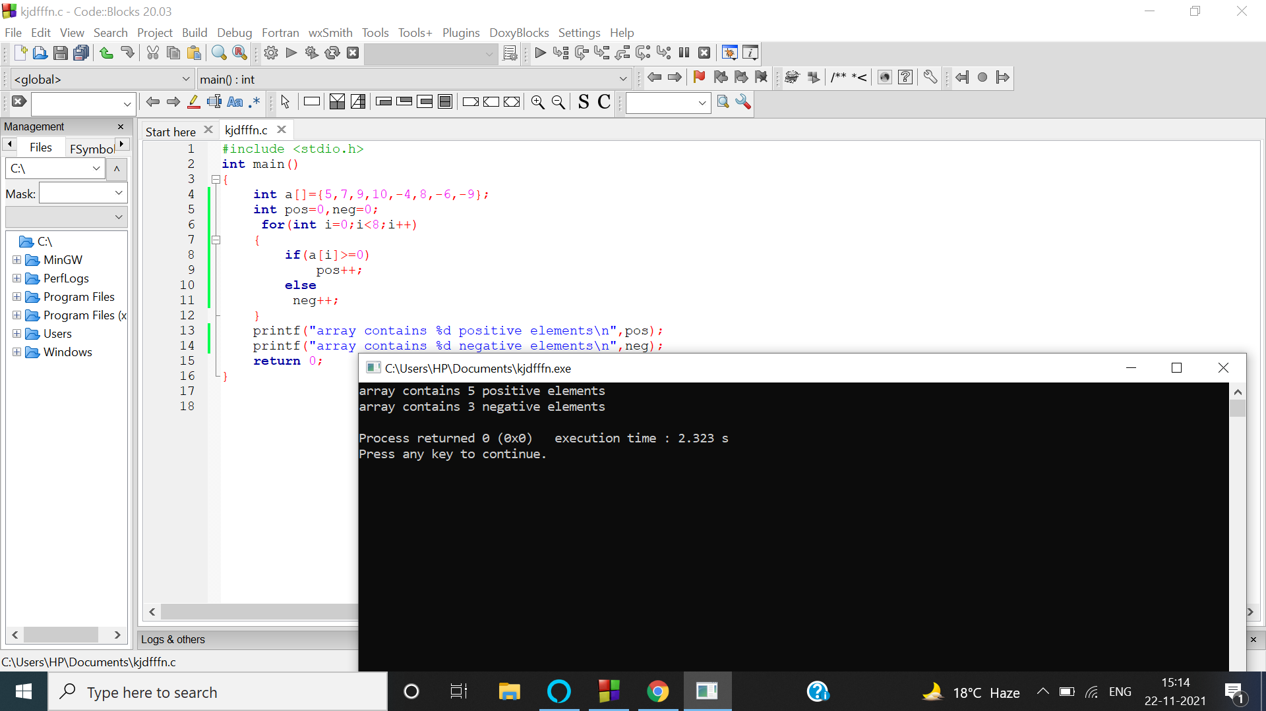

Q2-

#include <stdio.h>

int main()

{

int arr[]={5,7,9,10,-4,8,-6,-9};

int i, size=8, num, pos;

printf("Available array is:");

for(int i=0;i<8;i++)

{

printf("%d\t",arr[i]);

}

printf("\nEnter element to insert : ");

scanf("%d", &num);

printf("array size is 8, Enter the element position from 0 to 7 : ");

scanf("%d", &pos);

for(i=size; i>=pos; i--)

{

arr[i] = arr[i-1];

}

arr[pos-1] = num;

size++;

printf("\nArray elements after insertion : ");

for(i=0; i<size; i++)

{

printf("%d\t", arr[i]);

}

return 0;

}

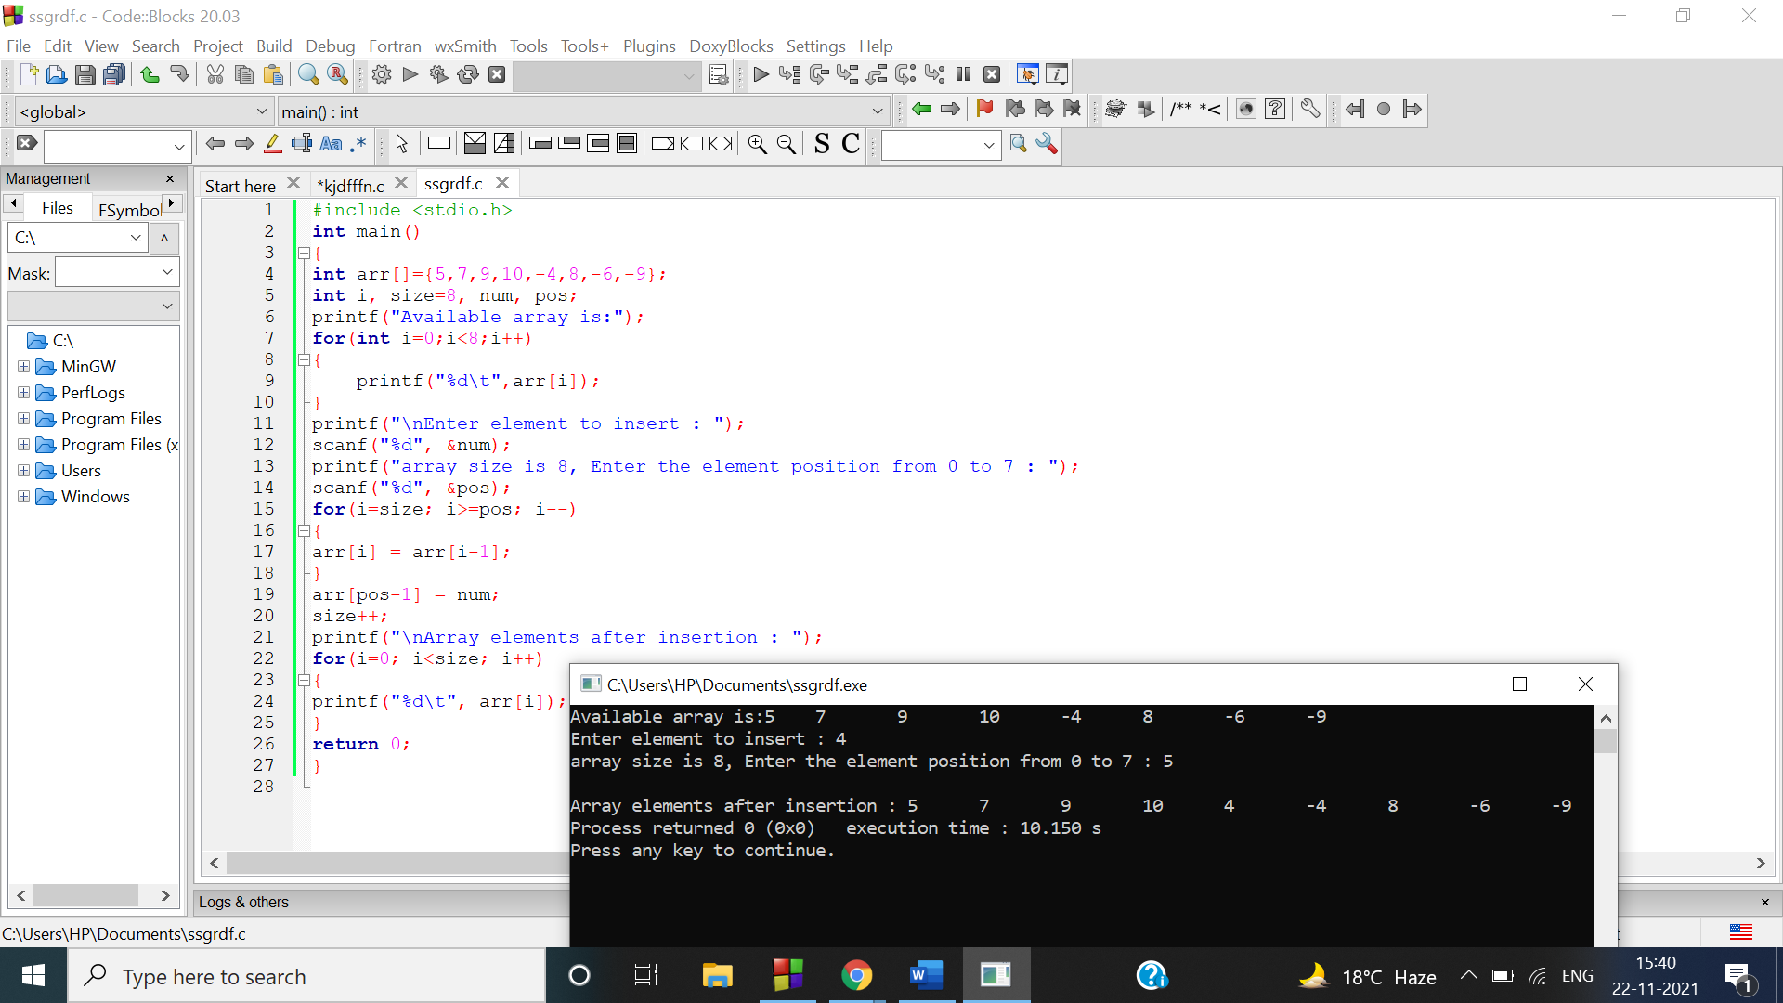

Q3

#include<stdio.h>

int main()

{

int arr[]={5,7,9,10,-4,8,-6,-9};

int i, size=8, num, pos;

printf("Avalable array is:\n");

for(int i=0;i<8;i++)

{

printf("%d\t",arr[i]);

}

printf("\nEnter the element position to delete from 1 to 8: ");

scanf("%d",&pos);

for(i=pos-1;i<size-1;i++)

{

arr[i]=arr[i+1];

}

size--;

printf("\nElements of array after delete are : ");

for(i=o;i<size;i++)

{

printf("%d\t", arr[i]);

}

return 0;

}

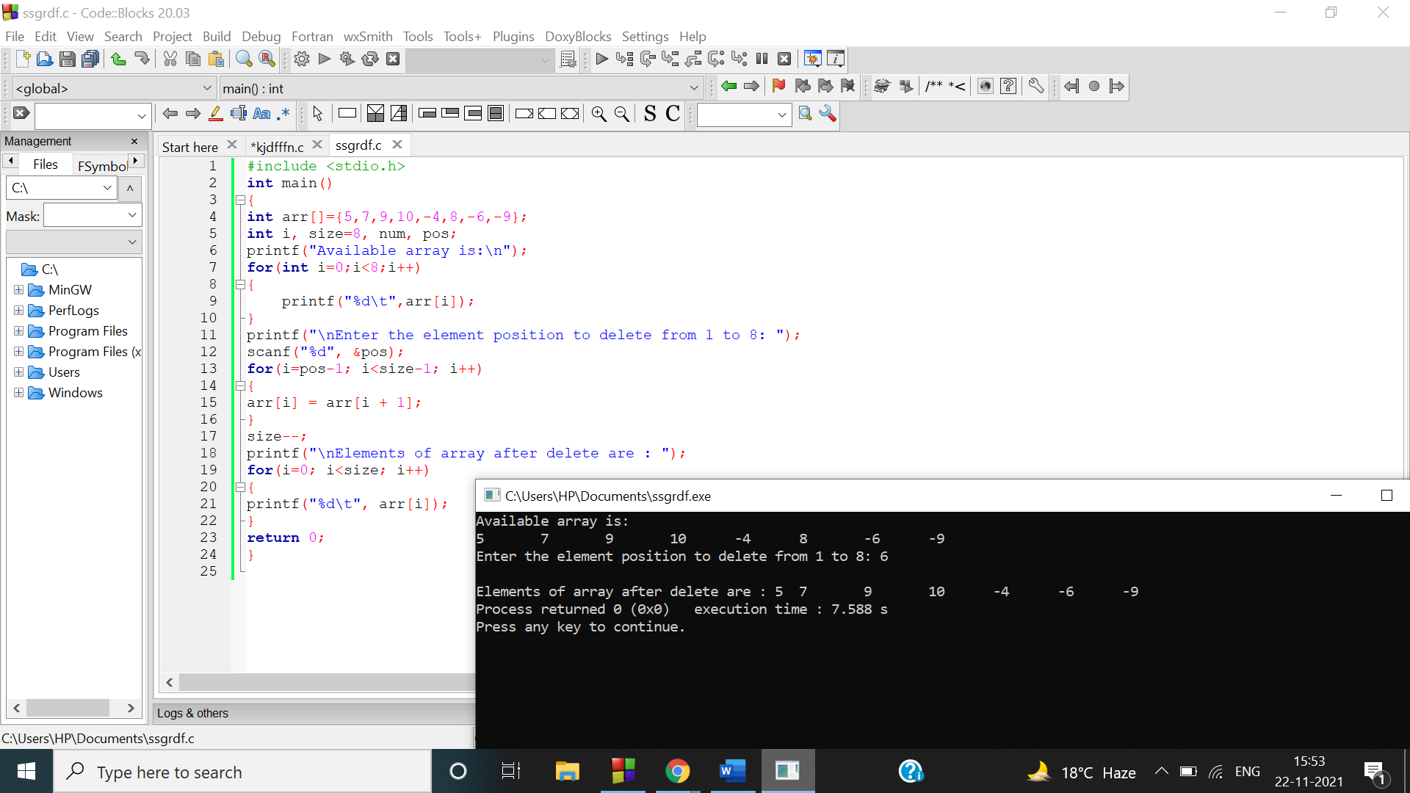

Q4

a)

#include<stdio.h>

int main()

{

int arr[]={5,7,9,10,-4,8,-6,-9};

int i,j, size=8,num, pos;

printf("Avalable array is:\n");

for(int i=0;i<8;i++)

{

printf("%d\t",arr[i]);

}

for(int j=0;j<4;j++)

{

num=arr[j];

arr[j]=arr[7-j];

arr[7-j]=num;

}

printf("\nreversed array is:\n");

for(int i=0;i<8;i++)

{

printf("%d\t",arr[i]);

}

return 0;

}

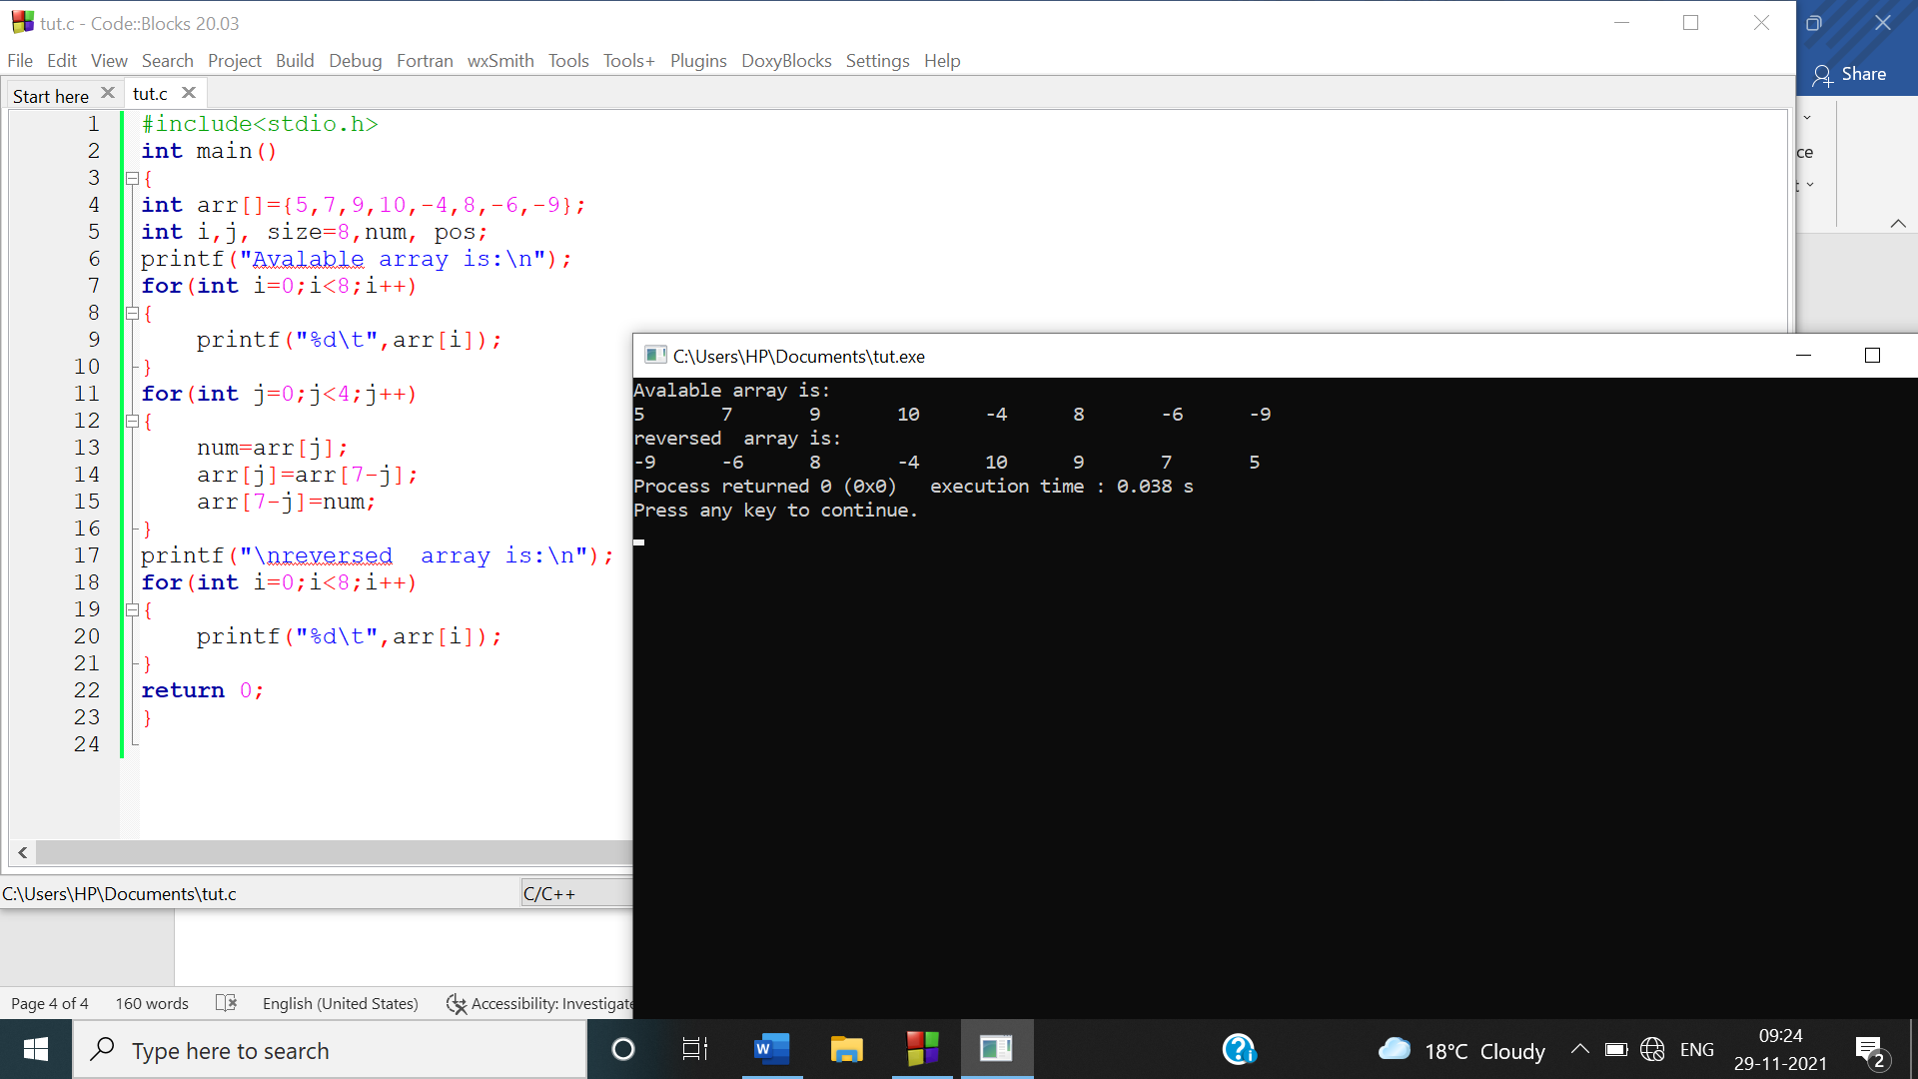

Q4 -b)

#include<stdio.h>

int main()

{

int arr[]={5,7,9,10,-4,8,-6,-9};

int i,j, size=8,arr2[100];

printf("Avalable array is:\n");

for(int i=0;i<8;i++)

{

printf("%d\t",arr[i]);

}

for(int j=0;j<8;j++)

{

arr2[j]=arr[7-j];

}

printf("\nreversed array is:\n");

for(int i=0;i<8;i++)

{

printf("%d\t",arr2[i]);

}

return 0;

}

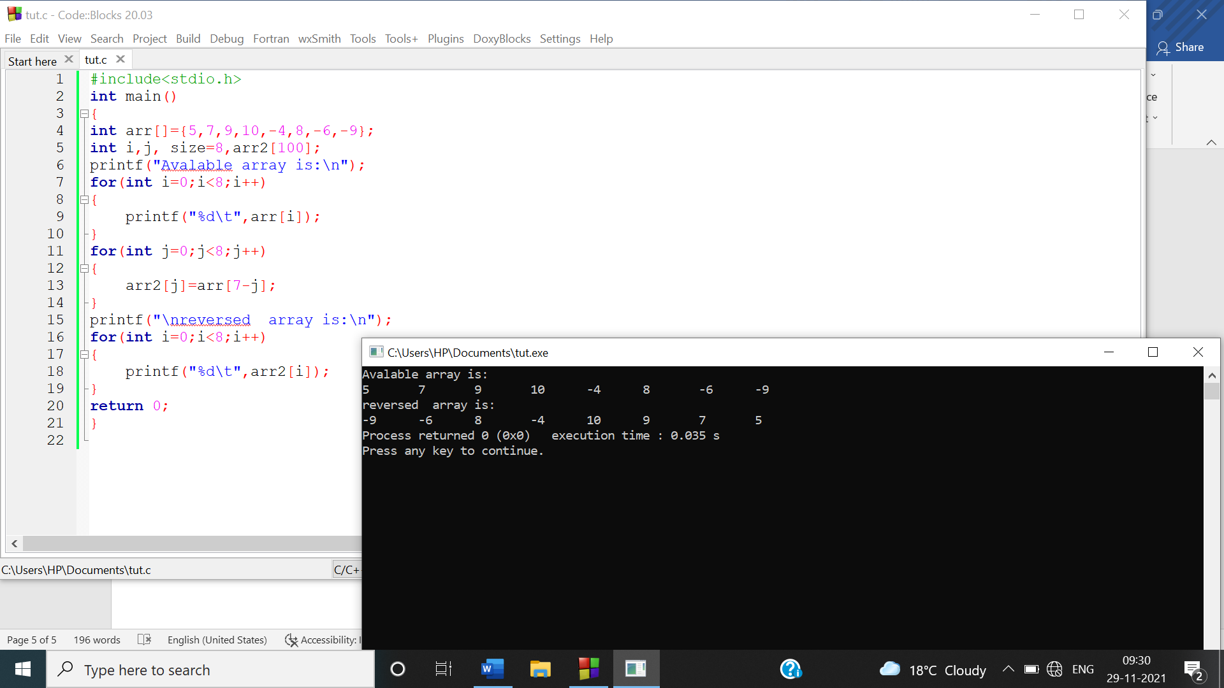

Q4-c)

#include<stdio.h>

int main()

{

int arr[]={5,7,9,10,-4,8,-6,-9};

int i,j, size=8,arr2[100],num;

printf("Avalable array is:\n");

for(int i=0;i<8;i++)

{

printf("%d\t",arr[i]);

}

for(int j=0;j<8;j++)

{

num=arr[j];

arr[j]=arr[7-j];

arr[7-j]=num;

}

printf("\nreversed array is:\n");

for(int i=0;i<8;i++)

{

printf("%d\t",arr[i]);

}

return 0;

}

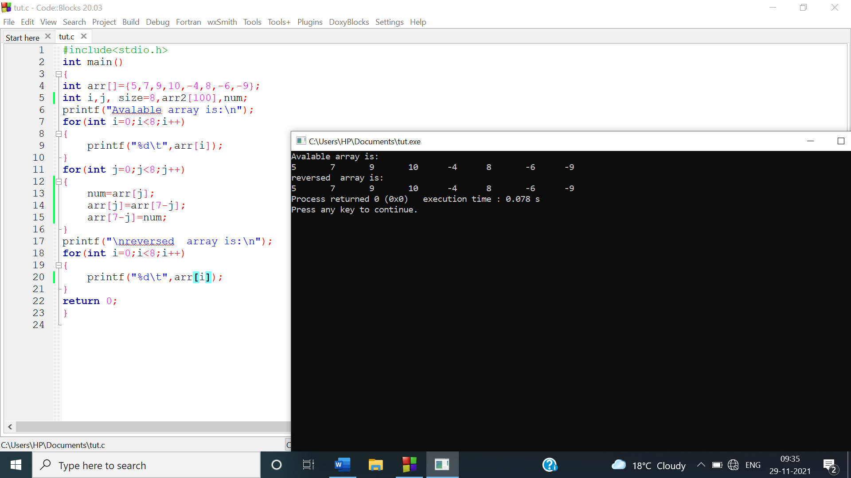

Q5

a)

#include<stdio.h>

int main()

{

int marks[100],b,m,i;

printf("enter no. of students :\n");

scanf("%d",&b);

printf("enter students marks:\n");

for(i=0;i<b;i++)

{

scanf("%d",&m);

marks[i]=m;

}

printf("marks of students are:\n");

for(int i=0;i<b;i++)

{

printf("marks of student %d are %d\n",i+1,marks[i]);

}

return 0;

}

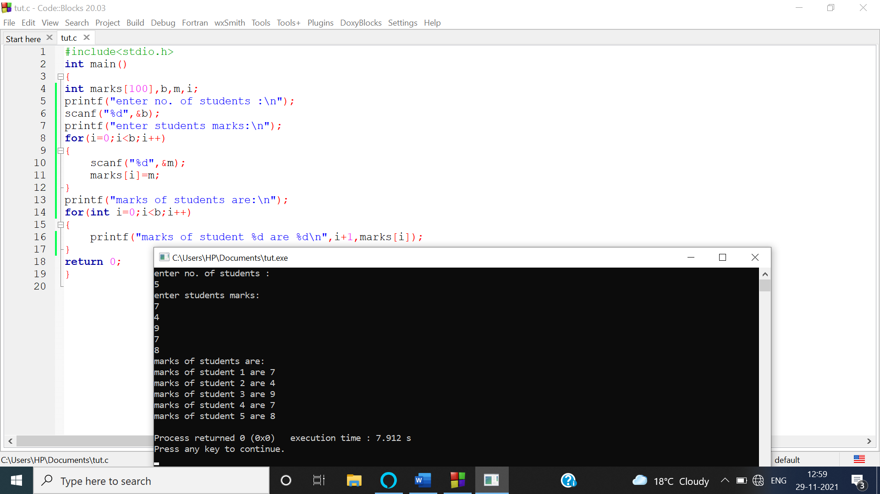

b)

#include<stdio.h>

int main()

{

int marks[100],b,m,i,max,min;

printf("enter no. of students :\n");

scanf("%d",&b);

printf("enter students marks:\n");

for(i=0;i<b;i++)

{

scanf("%d",&m);

marks[i]=m;

}

min=max=marks[0];

for(int i=0;i<b;i++)

{

if(marks[i]>max)

max=marks[i];

if(marks[i]<min)

min=marks[i];

}

printf("highest marks are: %d\n",max);

printf("lowest marks are: %d\n",min);

return 0;

}

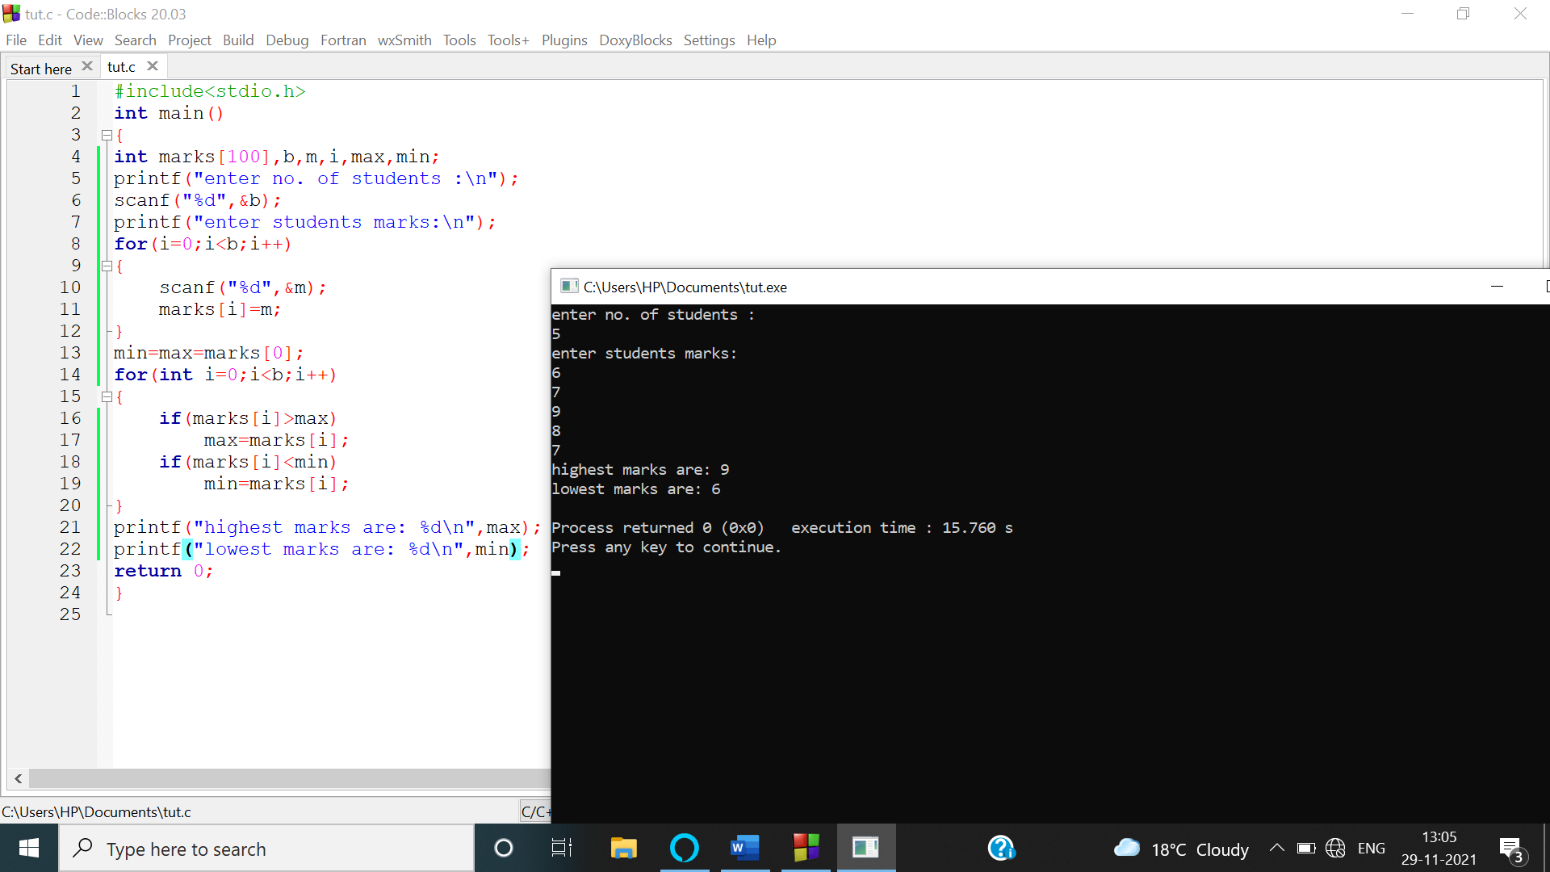

c)

#include<stdio.h>

int main()

{

int marks[100],b,m,i;

float avg,s=0;

printf("enter no. of students :\n");

scanf("%d",&b);

printf("enter students marks:\n");

for(i=0;i<b;i++)

{

scanf("%d",&m);

marks[i]=m;

}

for(int i=0;i<b;i++)

{

s+=marks[i];

}

avg=s/b;

printf("average marks are: %f\n",avg);

return 0;

}

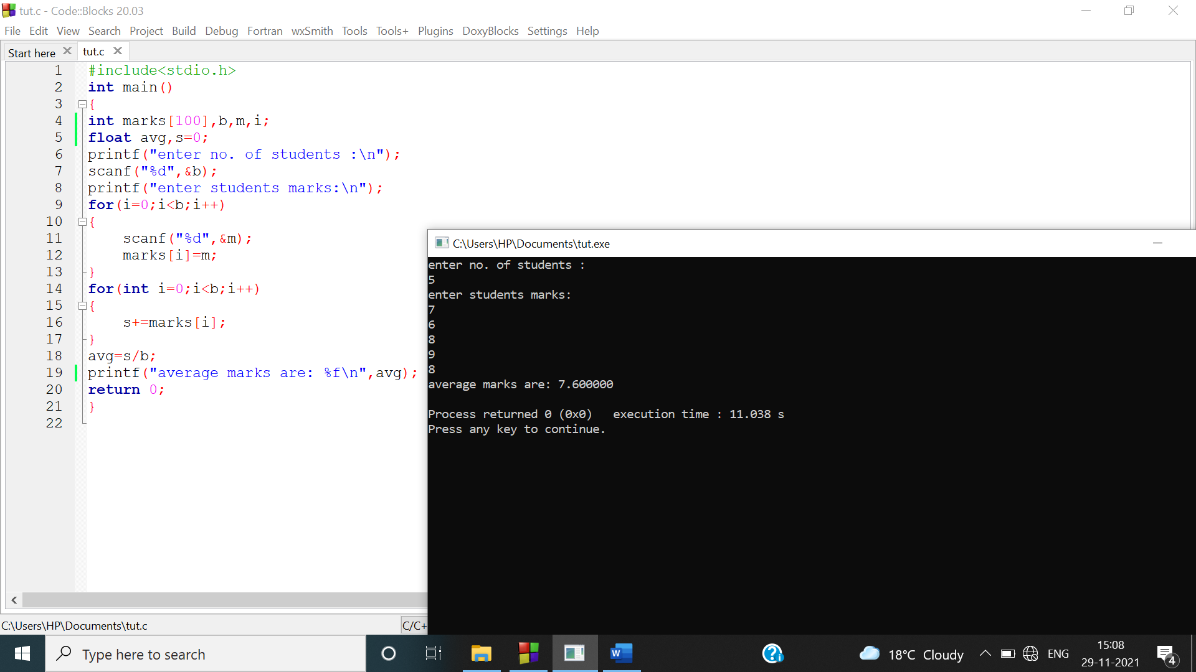

d)

#include<stdio.h>

int main()

{

int marks[100],b,m,i,j,temp,median;

printf("enter no. of students :\n");

scanf("%d",&b);

printf("enter students marks:\n");

for(i=0;i<b;i++)

{

scanf("%d",&m);

marks[i]=m;

}

for(i=0;i<b;i++)

{

for(j=0;j<b;j++)

{

if(marks[i]<marks[j])

{

temp=marks[i];

marks[i]=marks[j];

marks[j]=temp;

}

}

}

if(b%2!=0)

{

median=marks[(b-1)/2];

}

else

{

median=marks[b/2];

}

printf("median is:%d",median);

return 0;

}

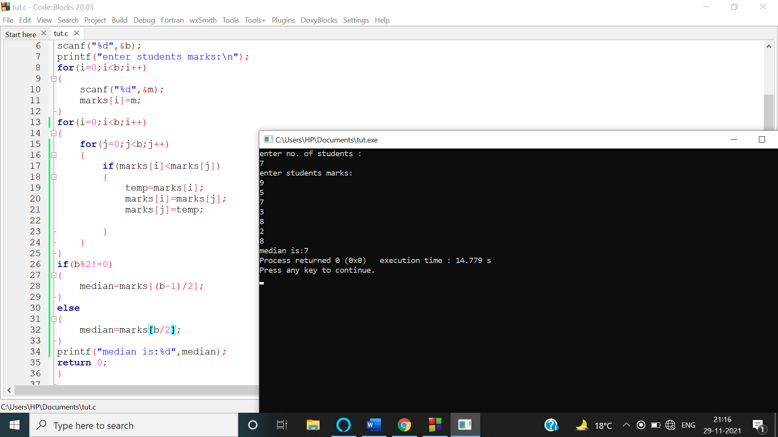

e)

#include<stdio.h>

int main()

{

int marks[100],b,m,i,j,count=0,arr[100],max=0,index;

printf("enter no. of students :\n");

scanf("%d",&b);

printf("enter students marks:\n");

for(i=0;i<b;i++)

{

scanf("%d",&m);

marks[i]=m;

}

for(i=0;i<b;i++)

{

for(j=0;j<b;j++)

{

if(marks[i]==marks[j])

{

count++;

}

}

arr[i]=count;

count=0;

}

for(i=0;i<b;i++)

{

if(arr[i]>max)

{

max=arr[i];

index=i;

}

}

printf("\nmode is : %d",marks[index]);

return 0;

}

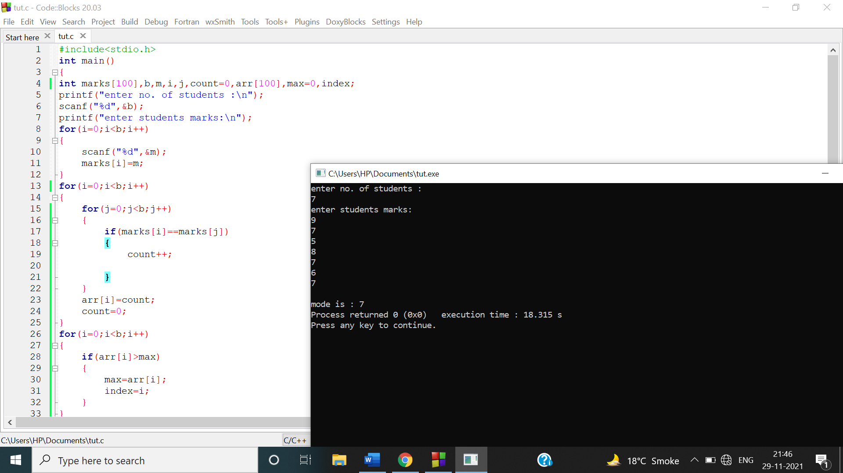

f)

#include<stdio.h>

int main()

{

int marks[100],marks2[100],b,m,i,j,temp;

printf("enter no. of students :\n");

scanf("%d",&b);

printf("enter students marks:\n");

for(i=0;i<b;i++)

{

scanf("%d",&m);

marks[i]=m;

marks2[i]=m;

}

for(i=0;i<b;i++)

{

for(j=0;j<b;j++)

{

if(marks2[i]<marks2[j])

{

temp=marks2[i];

marks2[i]=marks2[j];

marks2[j]=temp;

}

}

}

printf("\nIncreasing order of marks is:\n");

for(i=0;i<b;i++)

{

printf("%d\t",marks2[i]);

}

return 0;

} 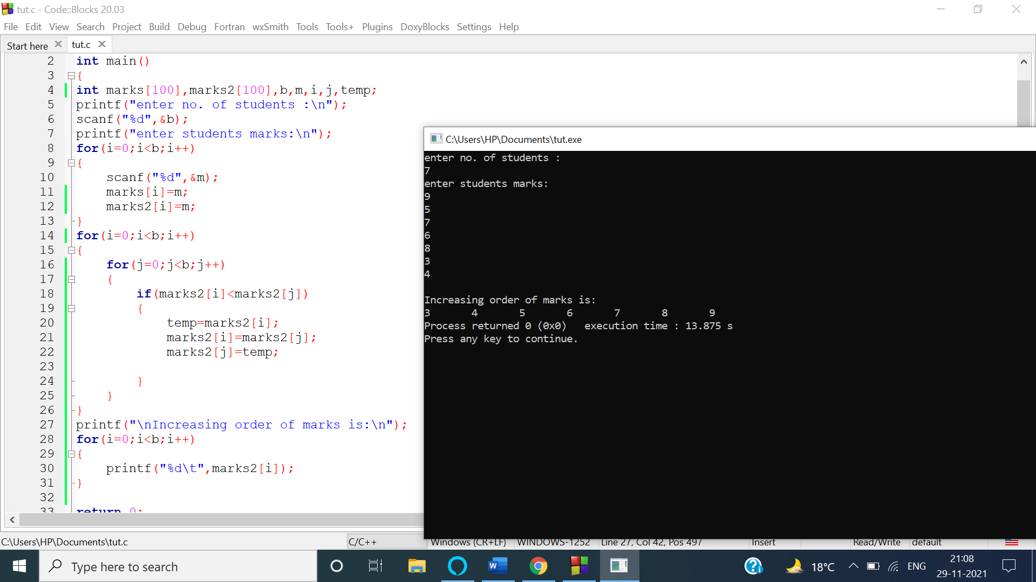

g)

#include<stdio.h>

int main()

{

int marks[100],b,m,i,j,count=0,arr[100],marks3[100],d=0;

printf("enter no. of students :\n");

scanf("%d",&b);

printf("enter students marks:\n");

for(i=0;i<b;i++)

{

scanf("%d",&m);

marks[i]=m;

}

for(i=0;i<b;i++)

{

for(j=0;j<b;j++)

{

if(marks[i]==marks[j])

{

count++;

}

}

arr[i]=count;

if(count==1)

{

d++;

}

count=0;

}

j=0;

for(i=0;i<b;i++)

{

if(arr[i]==1)

{

marks3[j]=marks[i];

j++;

}

}

printf("\nmarks3 containing unique elements is:\n");

for(i=0;i<d;i++)

printf("%d\t",marks3[i]);

return 0;

}

