**NITIN CHAUDHARY**

**F8**

**9921103163**

**WEEK 6B**

**Ans 1-**

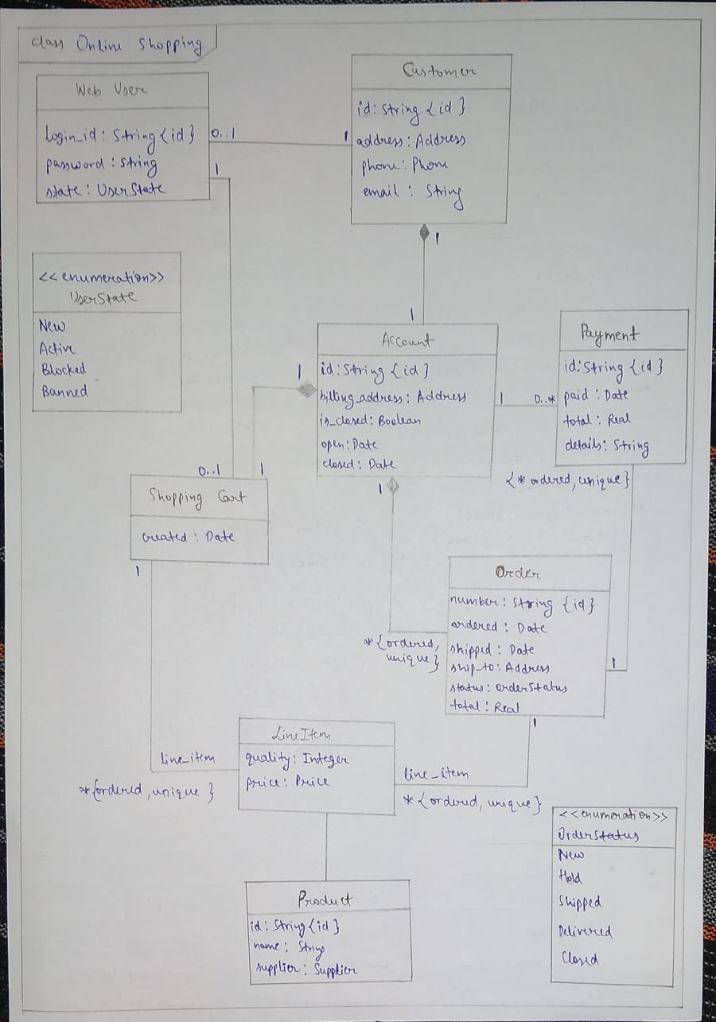

**Ans 2-**

**i)&ii)**

#include<iostream>

using namespace **std**;

class **CPU**

{

  double clock_speed;

  public :

**CPU**()

  {

      clock_speed=0;

  }

**CPU**(double b)

  {

    clock_speed=b;

  }

  void **get_clockspeed**()

  {

    cout**<<**"The clock speed of CPU is "**<<**clock_speed**<<endl**;

  }

  void **set_clockspeed**(double c)

  {

     clock_speed=c;

  }

};

class **computer**

{

**CPU** processor;

  public:

**computer**(){}

**computer**(**CPU** a)

  {

    a.**get_clockspeed**();

  }

  void **getCpu**()

  {

     processor.**get_clockspeed**();

  }

  void **setcpu**(**CPU** x)

  {

     x.**get_clockspeed**();

  }

};

class **PC** : public **computer**

{

**string** pc_name;

  public :

**PC**(**CPU** a):**computer**(a)

  {

    cout**<<**"PC started"**<<endl**;

  }

};

int **main**()

{

**CPU** **c**(3.5);

**PC** **p**(c);

*// p.getCpu();*

return 0;

}

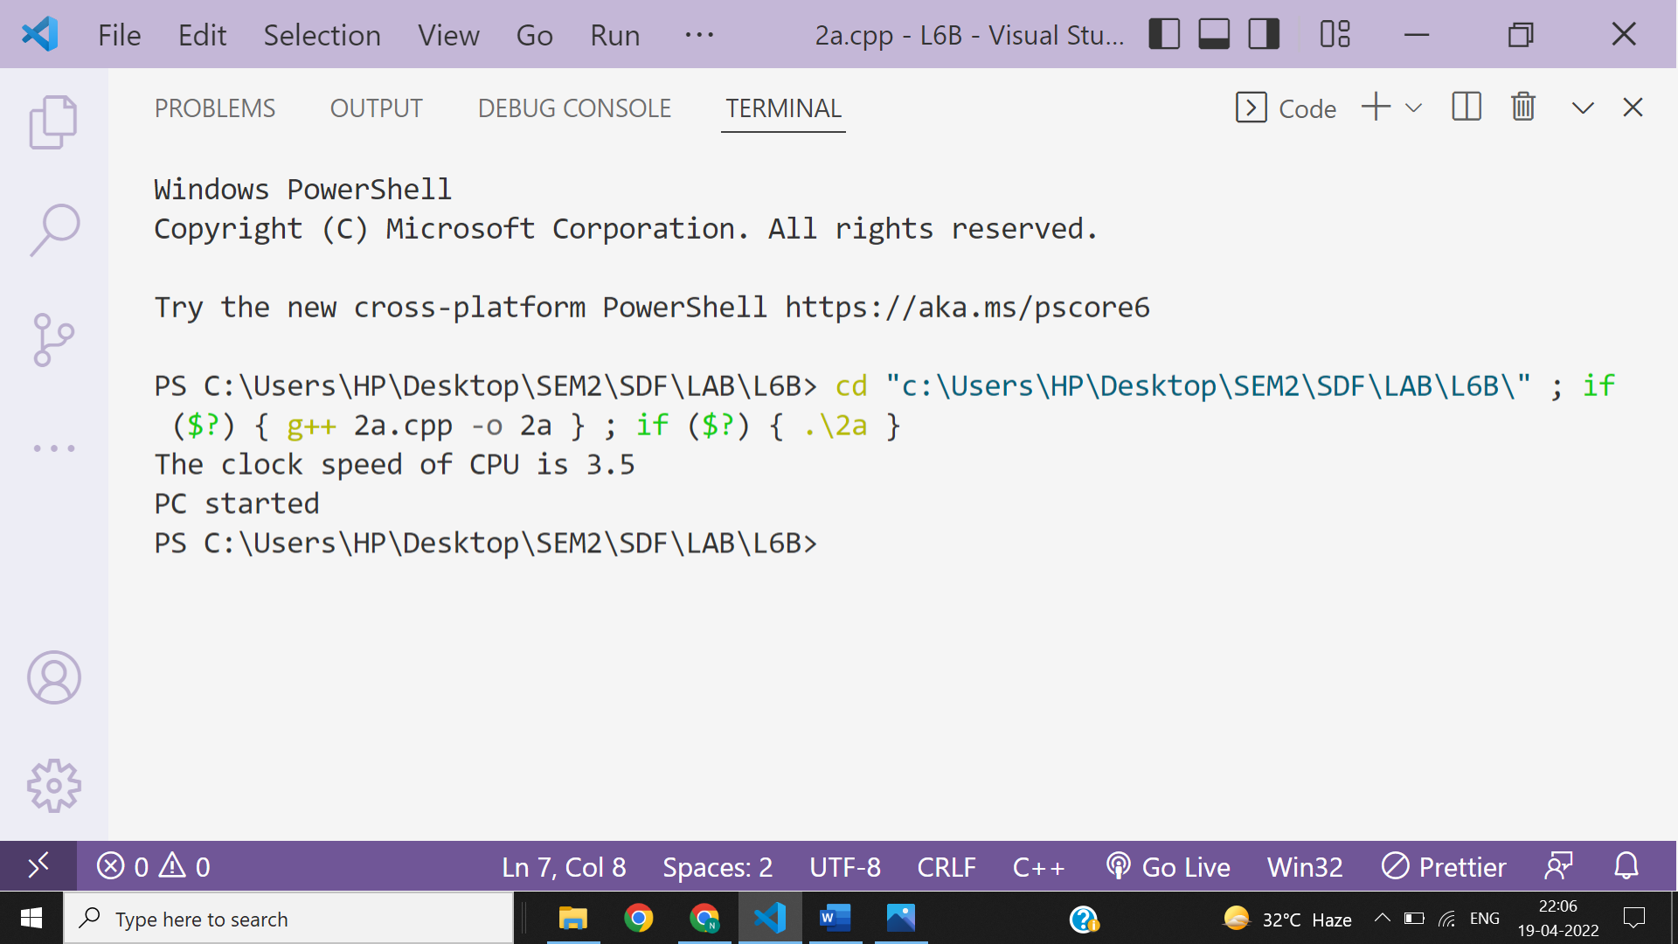

**iii)**

#include<iostream>

using namespace **std**;

class **Engine**

{

    float mPower;

    public:

**Engine**()

    {

        cout**<<**"Engine installed in Car"**<<endl**;

    }

**~Engine**()

    {

        cout**<<**"Engine destroyed with Car"**<<endl**;

    }

};

class **Car**

{

**string** mColor;

**string** mModel;

       int mEngine;

**Engine** * e;

       public:

**Car**()

       {

           cout**<<**"Car created"**<<endl**;

           e=new **Engine**;

       }

**~Car**()

       {

           cout**<<**"Car destroyed"**<<endl**;

           delete (e);

       }

};

int **main**()

{

**Car** Bugati_veyron;

return 0;

}

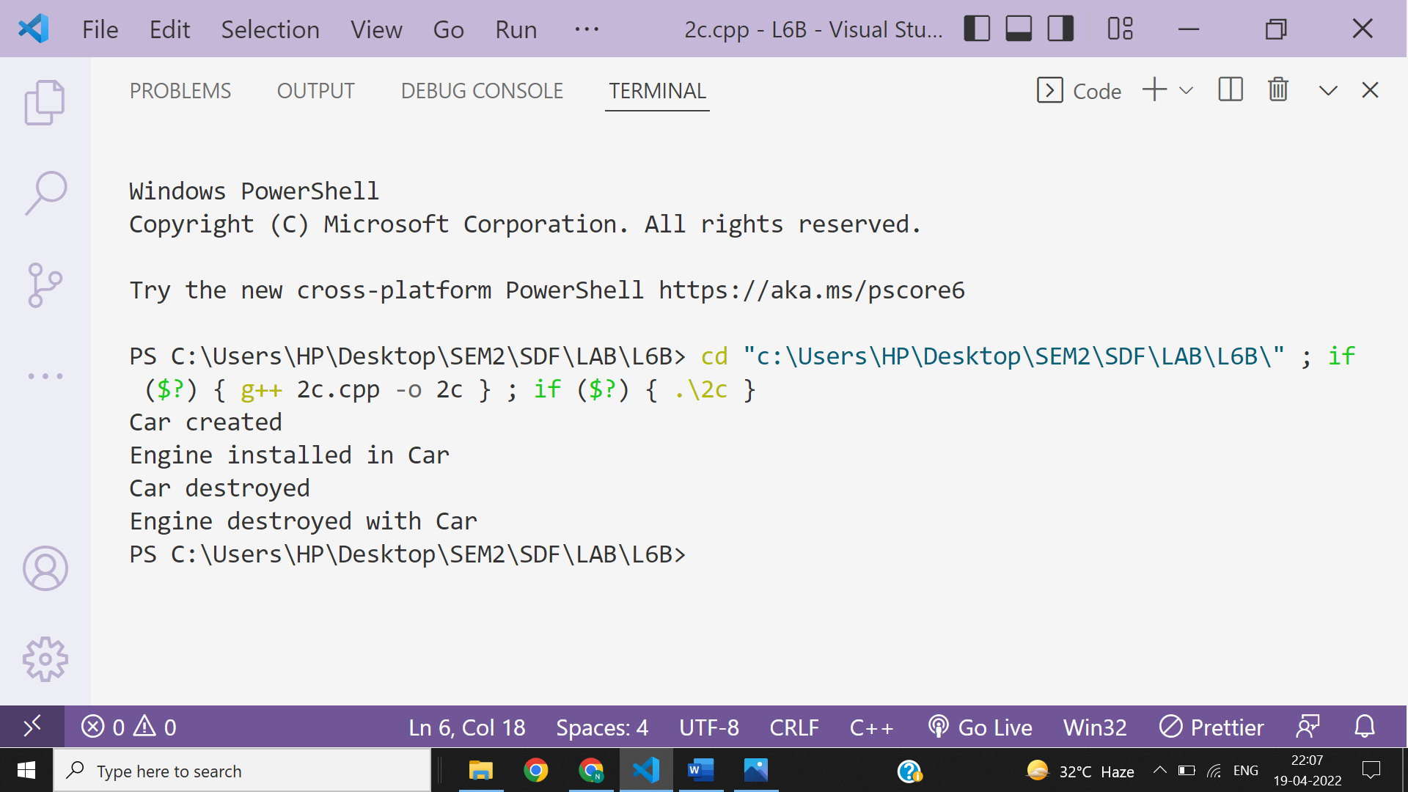

**Ans 3-**

