**WEEK 3 LAB A**

**9921103163**

**NITIN CHAUDHARY**

**F8**

**Ans 1-**

#include<iostream>

using namespace **std**;

class **Triangle**

{

public:

    void **fun**(int a,int b,int c)

    {

        cout**<<**"Perimeter of triangle is "**<<**a+b+c**<<**" units";

        cout**<<**"\n Area of triangle is "**<<**0.5*a*b**<<**" square units";

    }

};

int **main**()

{

int p,q,r;

**Triangle** t1;

cout**<<**"Enter sides of triangle";

cin**>>**p**>>**q**>>**r;

t1.**fun**(p,q,r);

}

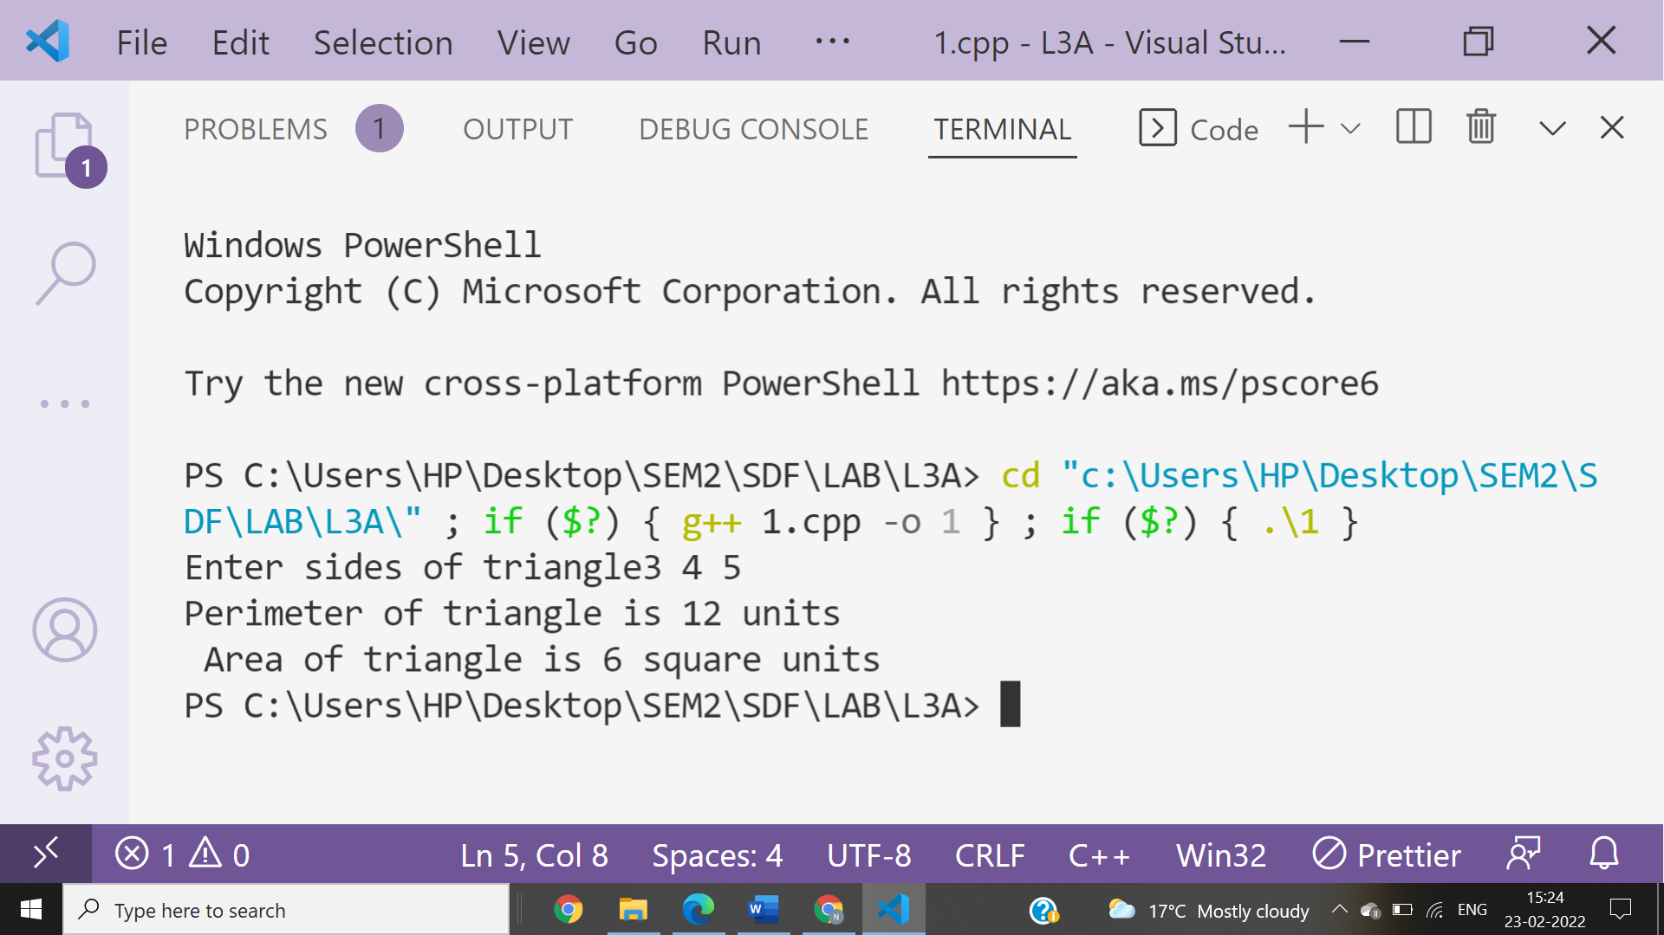

**Ans 2-**

#include <iostream>

#include<math.h>

using namespace **std**;

class **triangle**

{

  float a;

  float b;

  float c;

  public:

**triangle**(int x,int y,int z)

  {

    a=x;

    b=y;

    c=z;

  }

  void **area**()

  {

    float p,s;

    s=((a+b+c)/2.0);

    p=**sqrt**(s*(s-a)*(s-b)*(s-c));

    cout**<<**"Area Of Triangle Is " **<<** p **<<** " Square Units"**<<**"\n";

  }

  void **perimeter**()

  {

        cout**<<**"Perimeter Of The Triangle Is " **<<** a+b+c **<<** " units";

  }

};

int **main**()

{

**triangle** **b1**(3,4,5);

  b1.**area**();

  b1.**perimeter**();

  return 0;

}

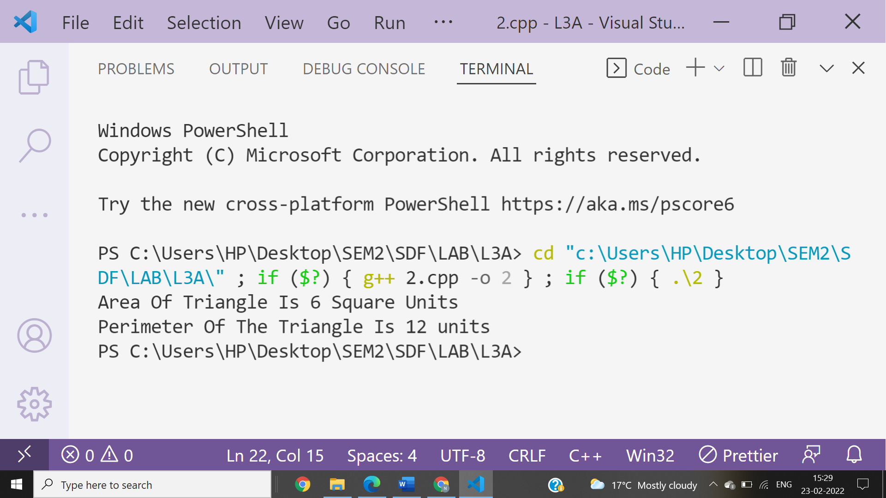

**Ans 3-**

#include<iostream>

using namespace **std**;

class **Complex**

{

public:

    int a,b;

    void **real**(**Complex** z)

    {

        cout**<<**"\nReal part is:"**<<**z.a;

    }

    void **complex**(**Complex** y)

    {

        cout**<<**"\nComplex part is:"**<<**y.b;

    }

    void **sum**(**Complex** p, **Complex** q)

    {

        cout**<<**"\nsum is:"**<<**p.a+q.a**<<**"+i"**<<**p.b+q.b;

    }

    void **difference**(**Complex** p, **Complex** q)

    {

        cout**<<**"\ndifference is:"**<<**p.a-q.a**<<**"+i"**<<**p.b-q.b;

    }

    void **product**(**Complex** p, **Complex** q)

    {

        cout**<<**"\nproduct is:"**<<**(p.a*q.a)-(p.b*q.b)**<<**"+i"**<<**(p.a*q.b)+(p.b*q.a);

    }

};

int **main**()

{

**Complex** c1,c2,c3;

cout**<<**"Enter real and imagenary part of  first complex number ";

cin**>>**c1.a**>>**c1.b;

cout**<<**"Enter real and imagenary part of  second complex number ";

cin**>>**c2.a**>>**c2.b;

c3.**real**(c1);

c3.**complex**(c1);

c3.**real**(c2);

c3.**complex**(c2);

c3.**sum**(c1,c2);

c3.**difference**(c1,c2);

c3.**product**(c1,c2);

}

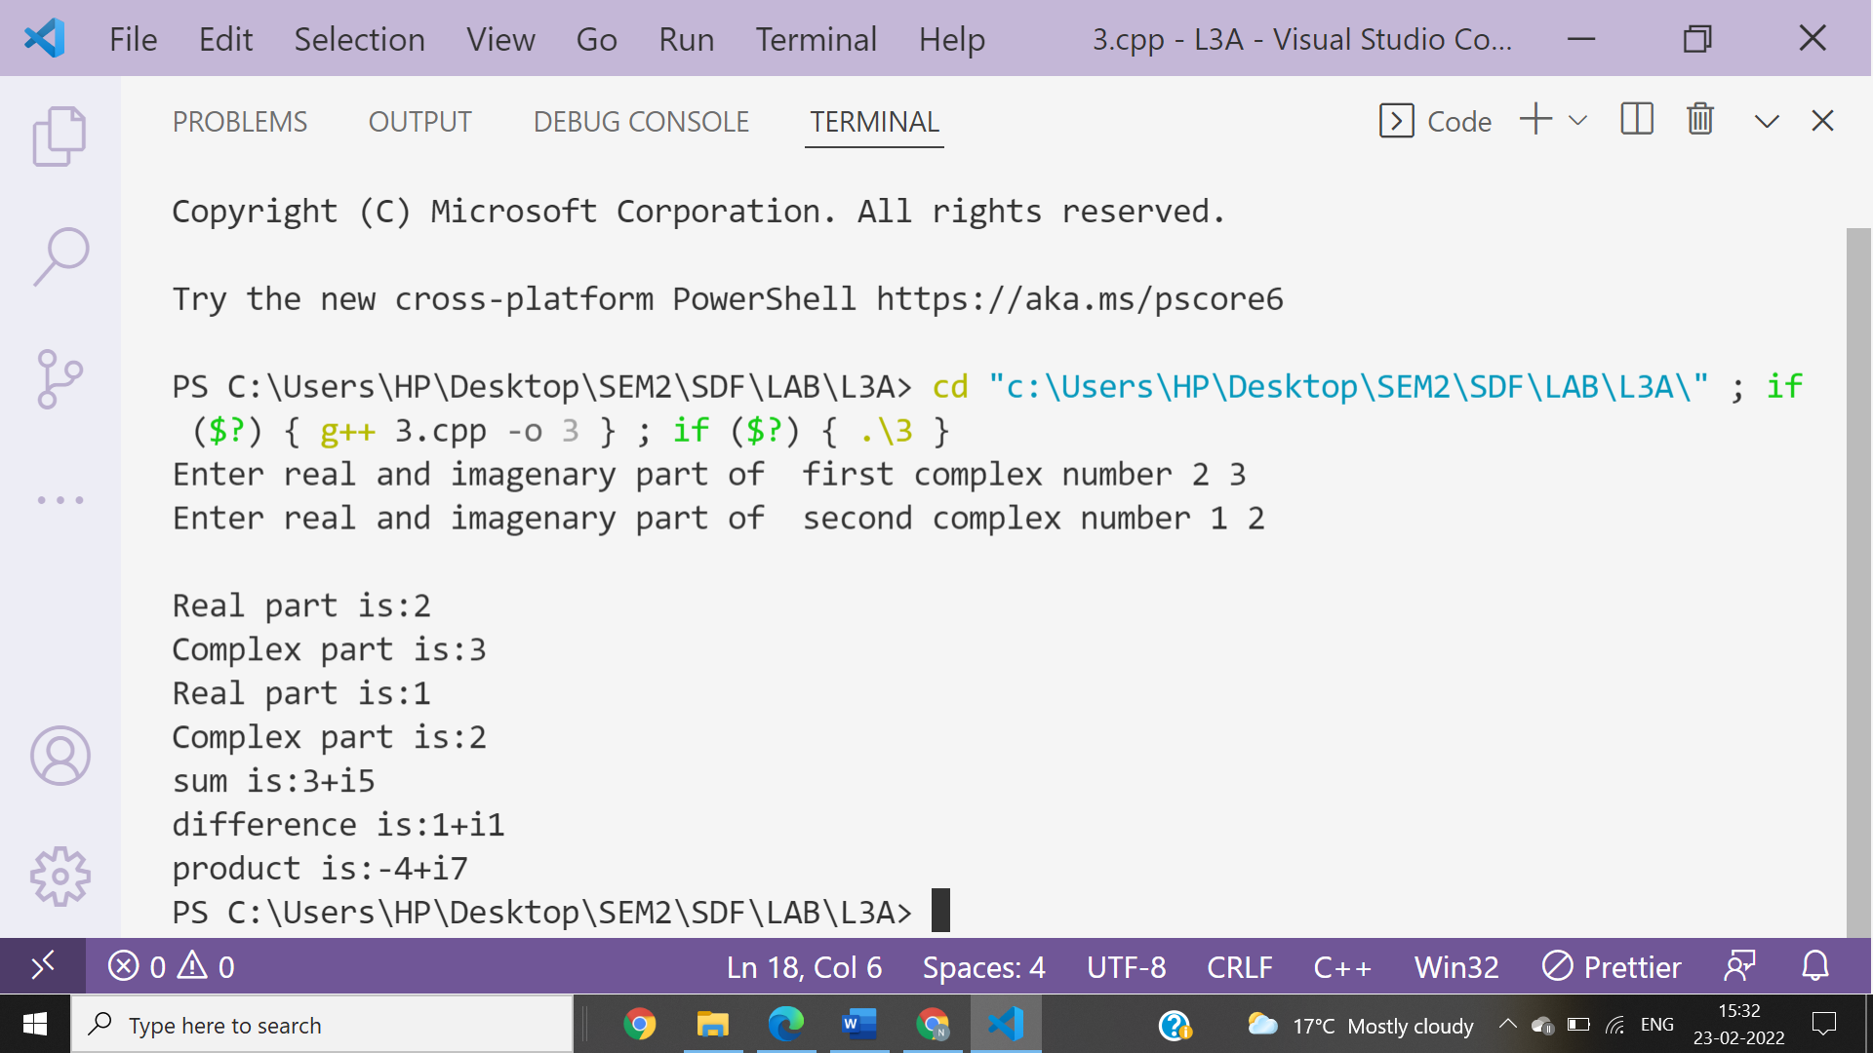

**Ans 4-**

#include<iostream>

using namespace **std**;

class **First**

{

char studentname[20];

public:

    void **printname**()

    {

        cout**<<**"Enter Student name:";

**gets**(studentname);

        cout**<<**"Student name is "**<<**studentname;

    }

};

int **main**()

{

**First** n1;

n1.**printname**();

}

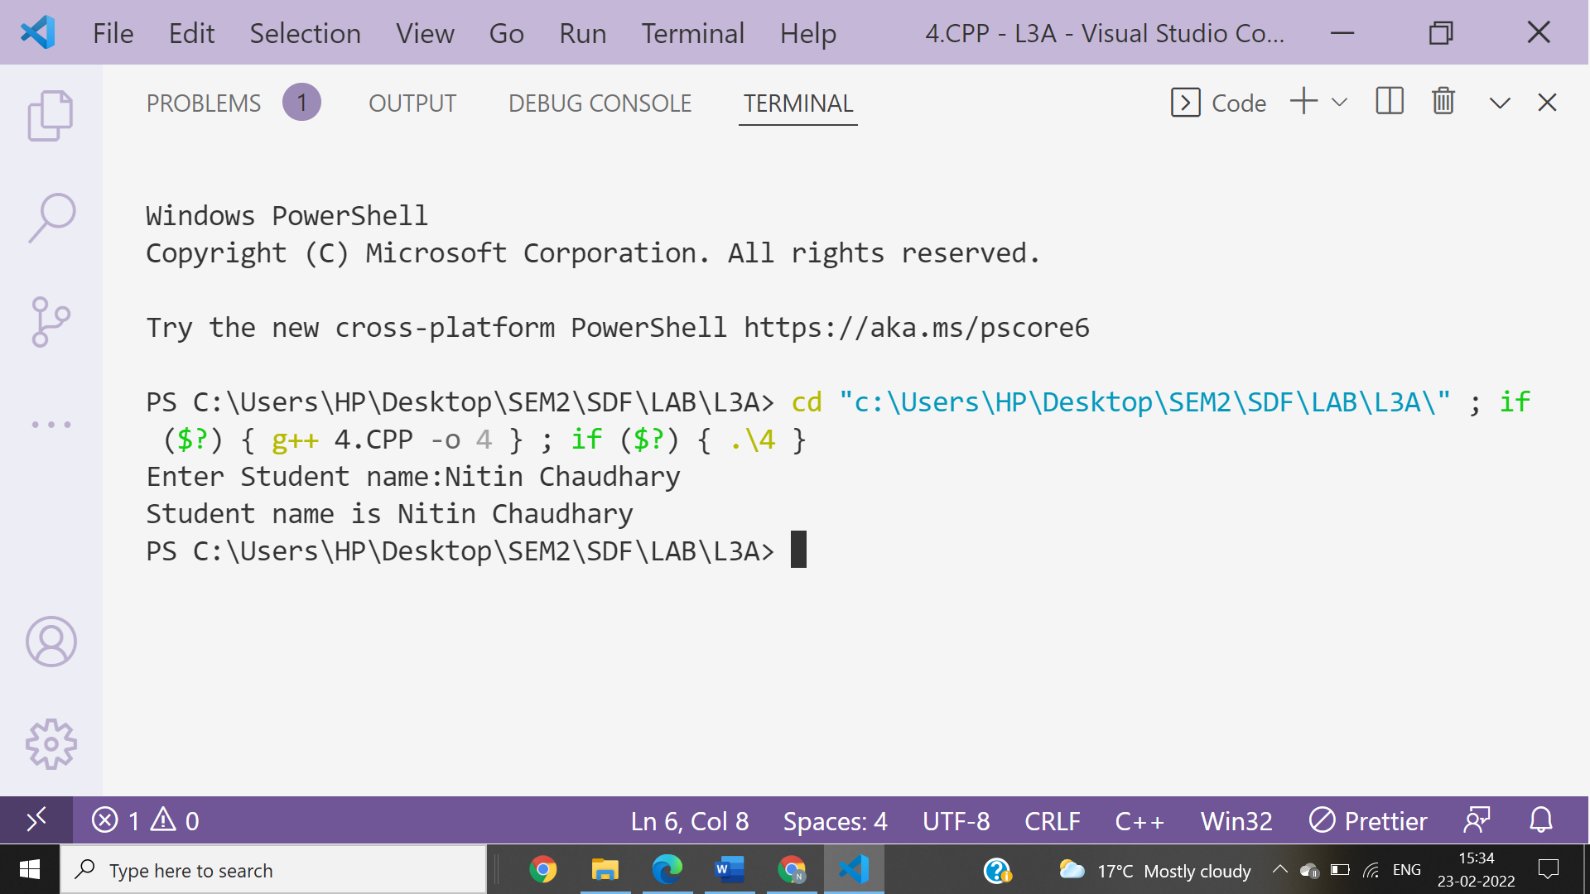

**Ans 5-**

#include<iostream>

using namespace **std**;

class **Second**

{

   int personid;

   public:

**Second**()

   {

       personid=50;

       cout**<<**"The person id is : "**<<**personid**<<endl**;

   }

**Second**(int id)

   {

       personid=id;

     cout**<<**"The person id is : "**<<**personid**<<endl**;

   }

};

int **main**()

{

**Second** obj1;

**Second** **obj2**(50);

    return 0;

}

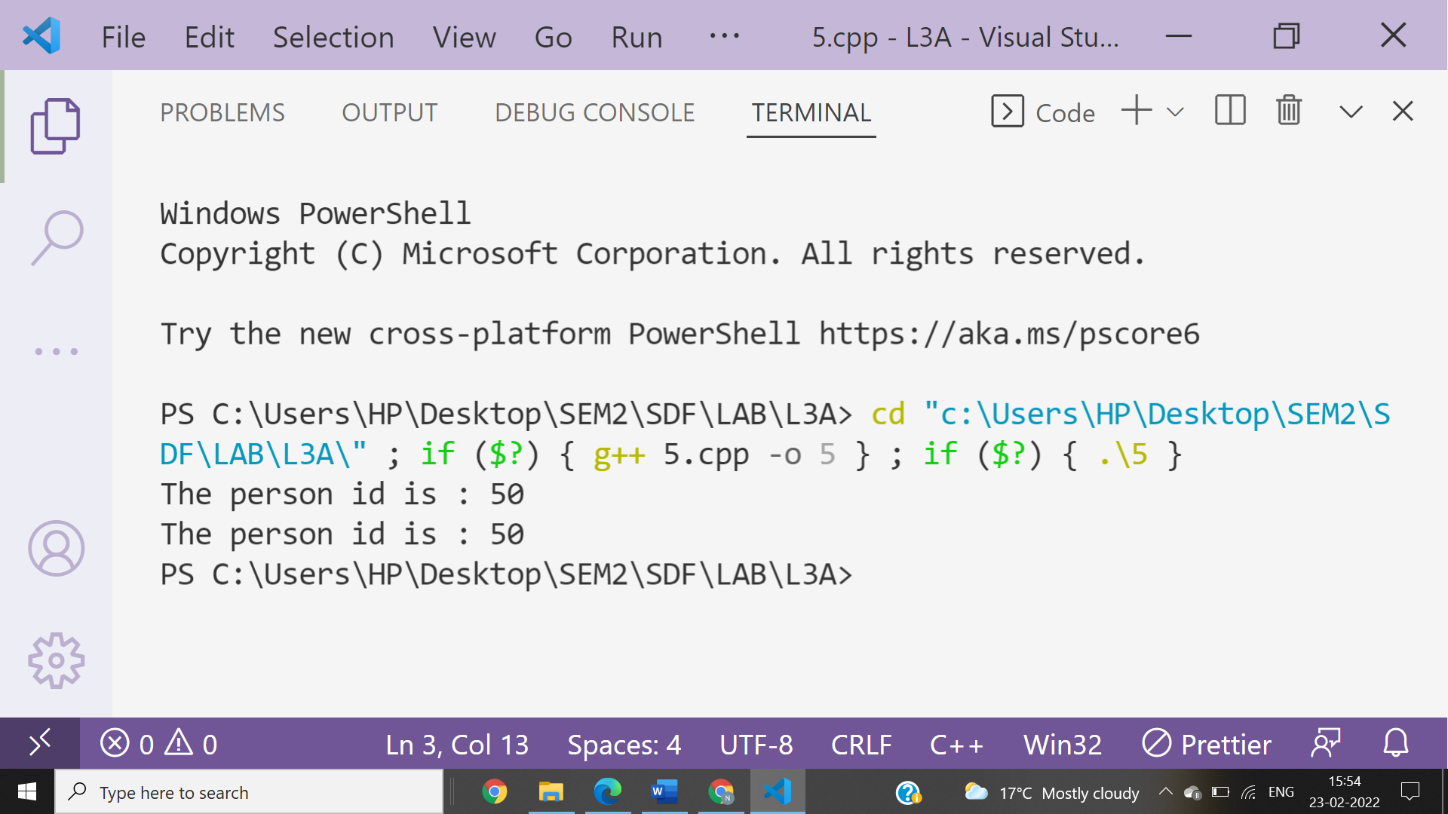

**Ans 6-**

#include<iostream>

using namespace **std**;

class **Area**

{

float l,b;

public:

    void **setDim**()

    {

        cout<<"Enter length of rectangle";

        cin>>l;

        cout<<"Enter breath of rectangle";

        cin>>b;

    }

    void **getArea**()

    {

        cout<<"Area of rectangle is "<<l*b<<" square units";

    }

};

int **main**()

{

Area a;

a.**setDim**();

a.**getArea**();

}

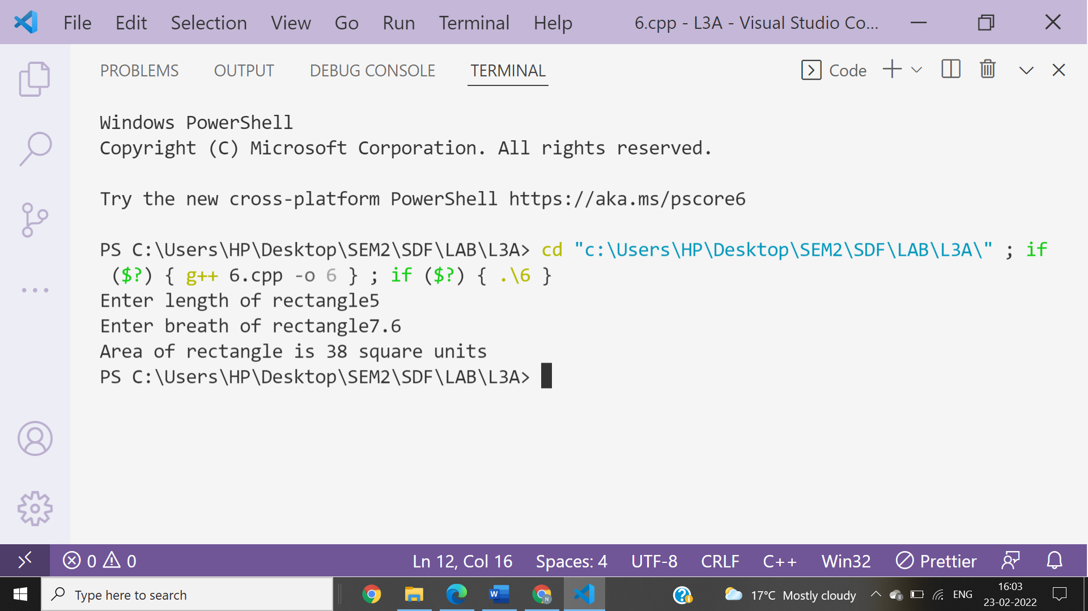

**Ans 7-**

#include <iostream>

using namespace **std**;

class **Student**

{

float physics, computer, maths;

public:

**Student**(float a, float b, float c)

    {

        physics = a;

        computer = b;

        maths = c;

        cout **<<** "Physics marks = " **<<** physics **<<** **endl**;

        cout **<<** "Chemistry marks = " **<<** computer **<<** **endl**;

        cout **<<** "Maths marks = " **<<** maths **<<** **endl**;

    }

    void **calculateAverage**(**Student** s)

    {

        float average;

        average = (physics+computer+maths)/3;

        cout **<<** "The average marks of the student is : " **<<** average **<<** **endl**;

    }

};

int **main**()

{

    cout **<<** "Student 1 : \n";

**Student** **s1**(90, 34, 77);

    s1.**calculateAverage**(s1);

    cout **<<** "Student 2 : \n";

**Student** **s2**(99, 88, 98);

    s2.**calculateAverage**(s2);

    return 0;

}

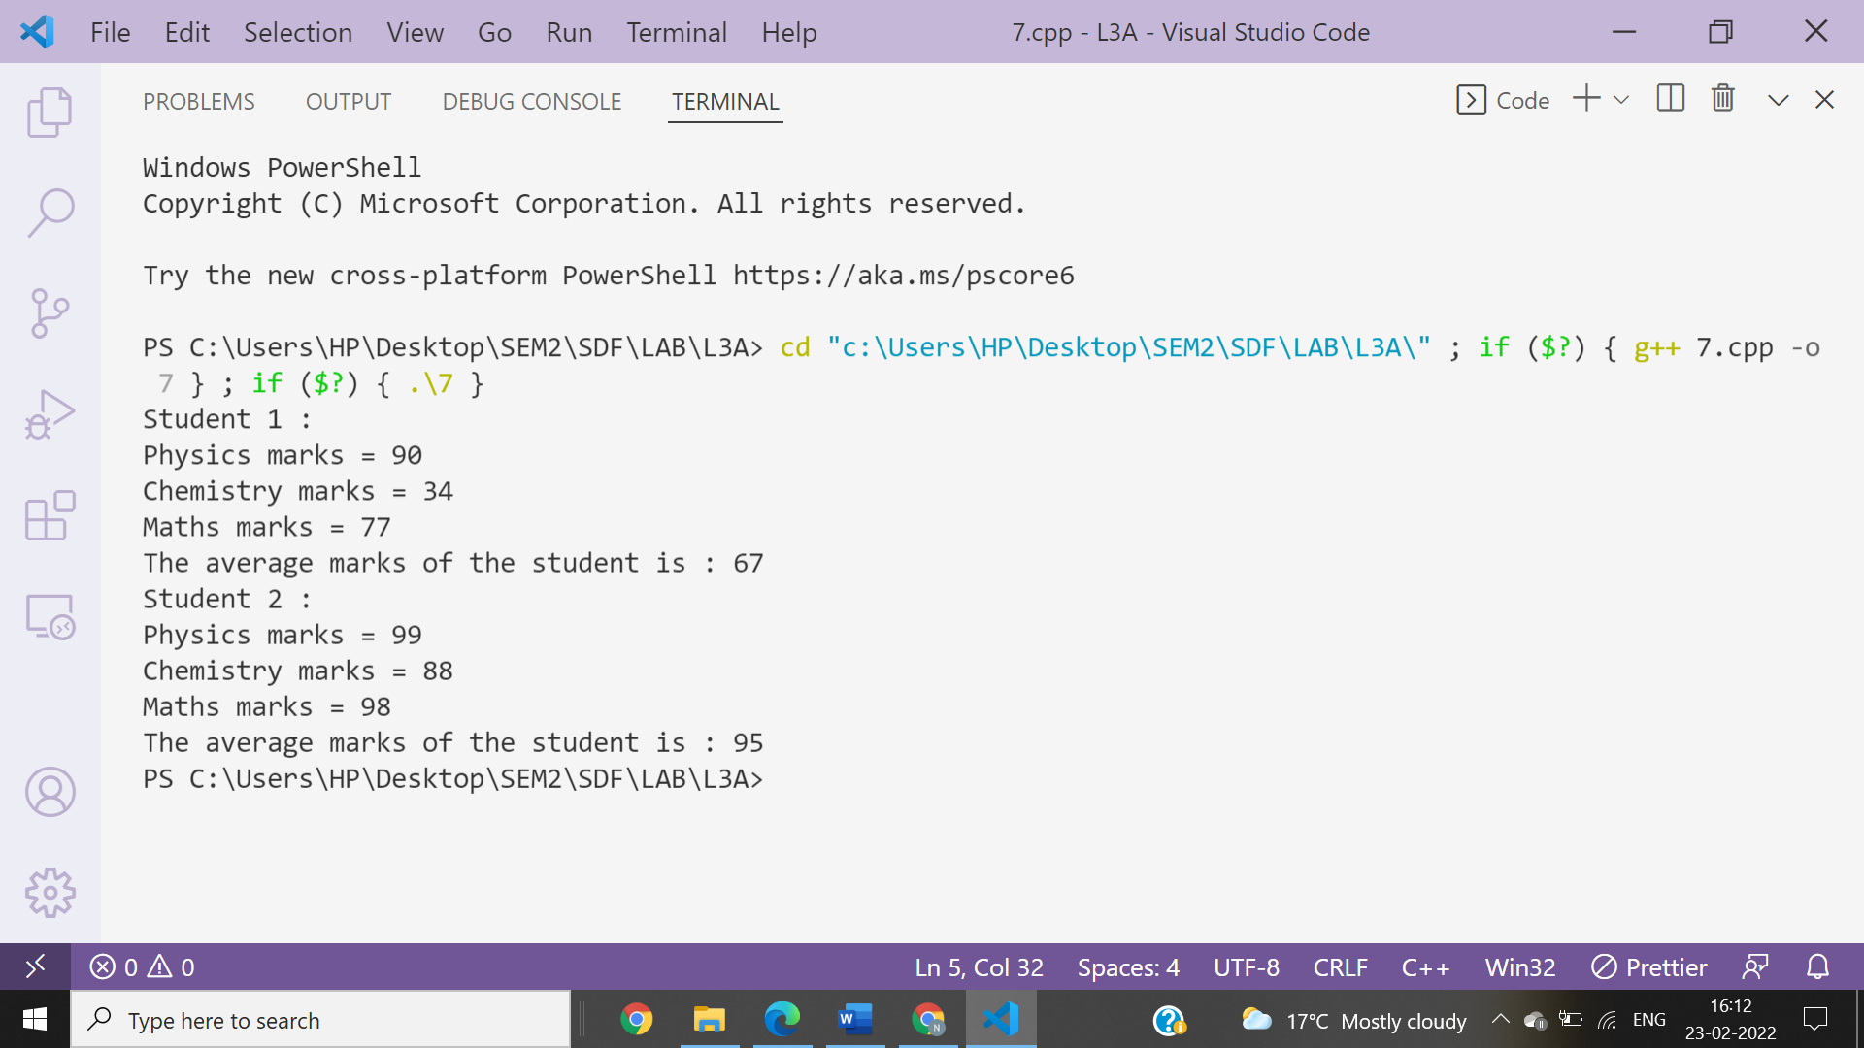

**Ans 8-**

#include<iostream>

using namespace **std**;

class **details**

{

private:

int Enrolment_number;

**string** Name,Branch;

float CGPA;

public:

**details**(int a,**string** b,**string** c,float d)

    {

        Enrolment_number=a;

        Name**=**b;

        Branch**=**c;

        CGPA=d;

    }

**details**(int a,**string** b,float d)

    {

        Enrolment_number=a;

        Name**=**b;

        Branch**=**"CSE";

        CGPA=d;

    }

**details**()

    {

        Enrolment_number=1;

        Name**=**"Unknown";

        Branch**=**"CSE";

        CGPA=6;

    }

    void **get**(**details** obj)

    {

        cout**<<**"\nEnrollment number: "**<<**obj.Enrolment_number;

        cout**<<**"\nName: "**<<**obj.Name;

        cout**<<**"\nBranch: "**<<**obj.Branch;

        cout**<<**"\nCGPA: "**<<**obj.CGPA;

    }

    void **set**(int a,**string** b,**string** c,float d)

    {

        Enrolment_number=a;

        Name**=**b;

        Branch**=**c;

        CGPA=d;

    }

};

int **main**()

{

**details** **obj1**(3163,"Nitin chaudhary","CSE",8.8),**obj2**(3151,"Ankur chaudhary",8.7),obj3,obj4;

cout**<<**"\nDETAILS FOR OBJECT 1\n";

obj4.**get**(obj1);

cout**<<**"\nDETAILS FOR OBJECT 2\n";

obj4.**get**(obj2);

cout**<<**"\nDETAILS FOR OBJECT 3\n";

obj4.**get**(obj3);

obj3.**set**(3169,"Divya mishra","CSE",8.5);

cout**<<**"\nUPDATED DETAILS FOR OBJECT 3\n";

obj4.**get**(obj3);

}

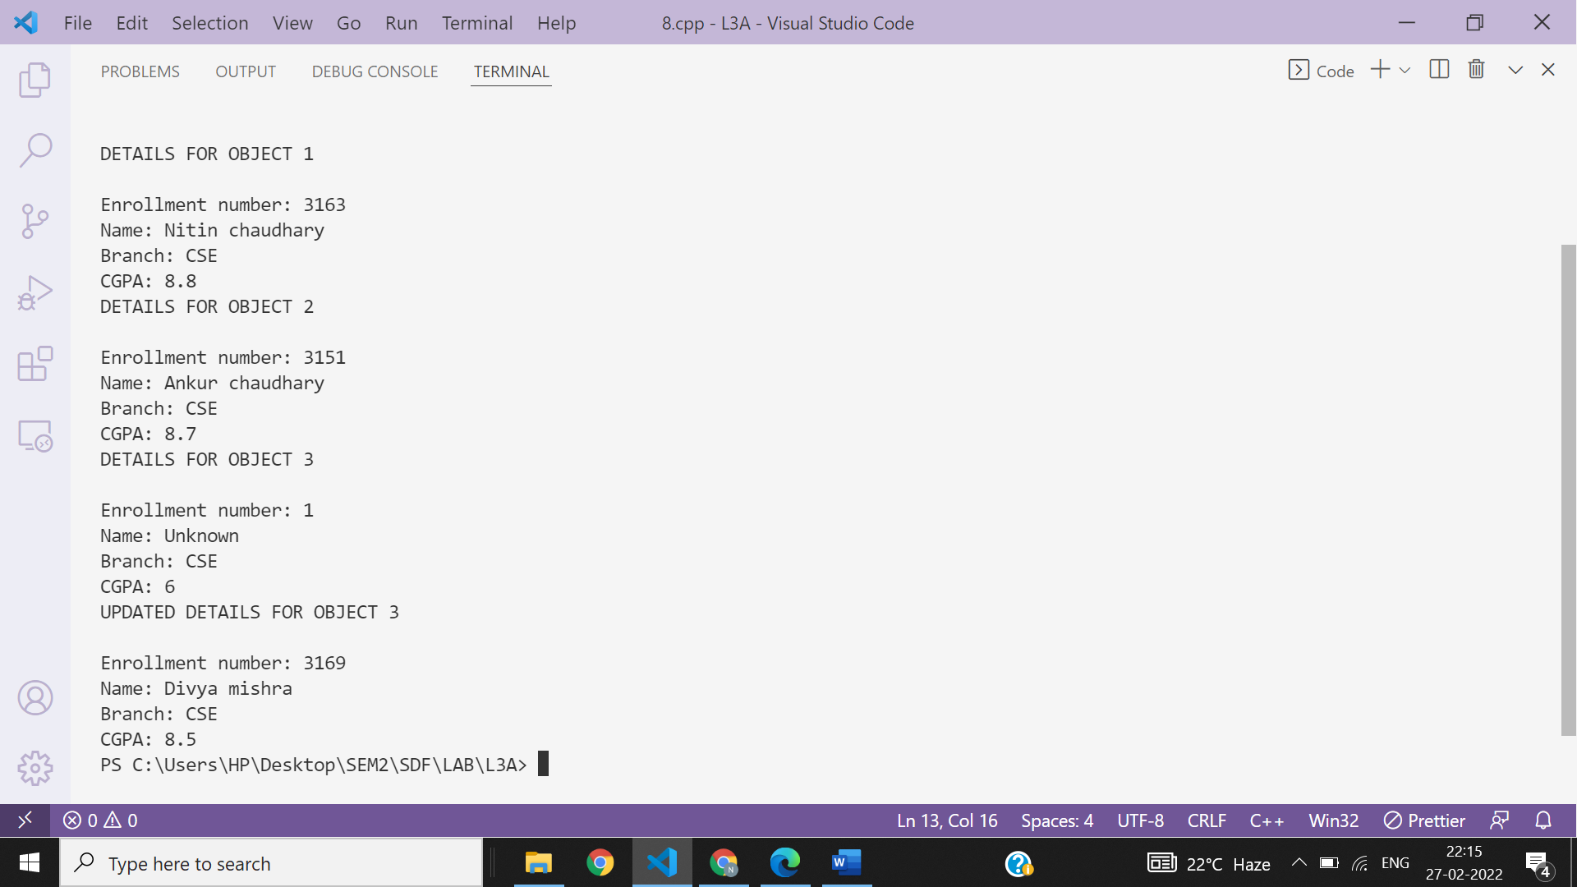

**Ans 9-**

#include<iostream>

using namespace **std**;

class **bill**

{

     private:

         int number;

         char name[50];

         float unit;

         float netbill;

     public:

        void **get**()

        {

                 cout**<<**"Enter Details of Customer Below :- \n" **<<endl**;

                 cout**<<**"Enter Bill Number : ";

                 cin**>>**number;

                 cout**<<**"\nEnter Customer Name :\n";

**getchar**();

**gets**(name);

                 cout**<<**"\nEnter No. of Units used : ";

                 cin**>>**unit;

         }

        void **calc_bill**()

        {

                if(unit<=100)

                       netbill=unit*8;

               else if(unit<=200)

                       netbill=800+(unit-100)*9;

               else

                       netbill=100*8+100*9+(unit-200)*10;

         }

        void **put**()

         {

                cout**<<**"\n\n\nBill Number is : "**<<**number;

                cout**<<**"\n\nCustomer Name is : "**<<**name;

                cout**<<**"\n\nNumber of Units Consumed : "**<<**unit;

                cout**<<**"\n\nBill of Customer : "**<<**netbill;

         }

};

int **main**()

{

**bill** b1;

    b1.**get**();

    b1.**calc_bill**();

    b1.**put**();

    cout**<<**"\n";

    return 0;

}

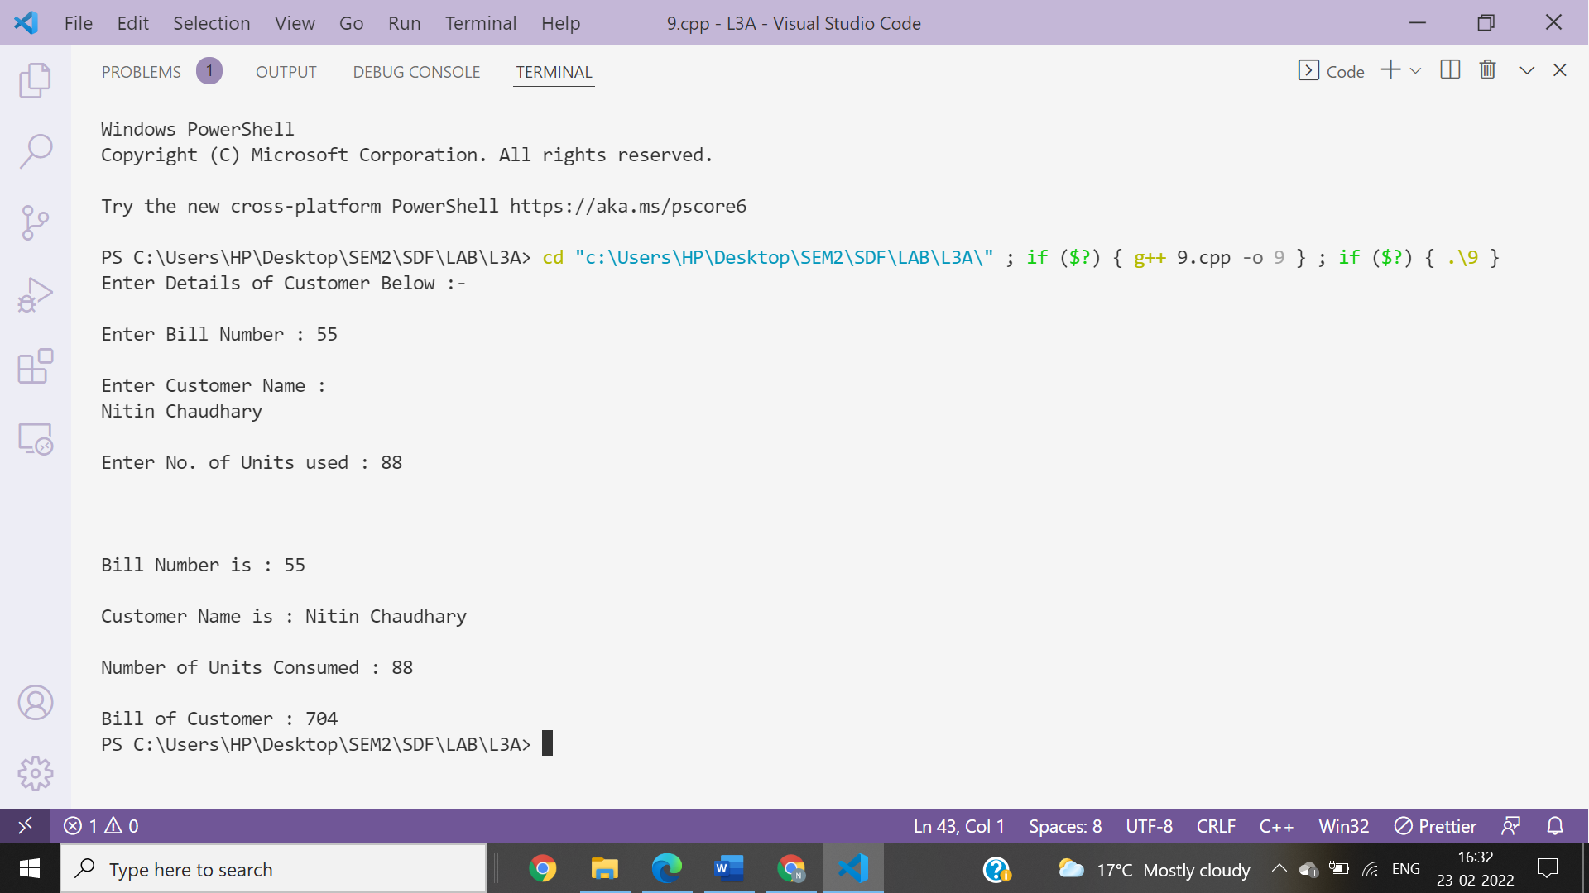

**Ans 10-**

**Output of the code will be-**

**l1.a = 10, l1.b = 15**

**p2.a = 10, l2.b = 15**