**9921103163**

**NITIN CHAUDHARY**

**F8**

**Week 9**

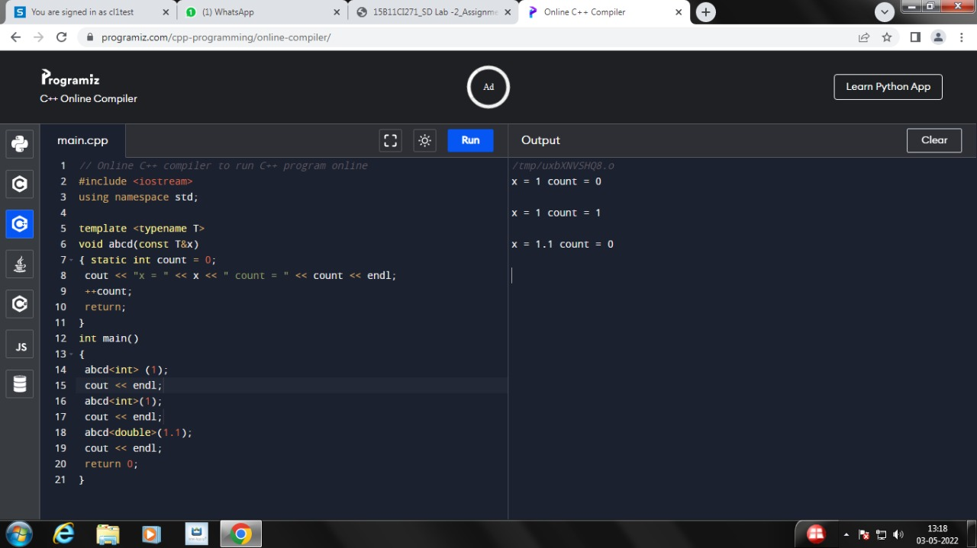**ANS-1-**

**Ans 2-**

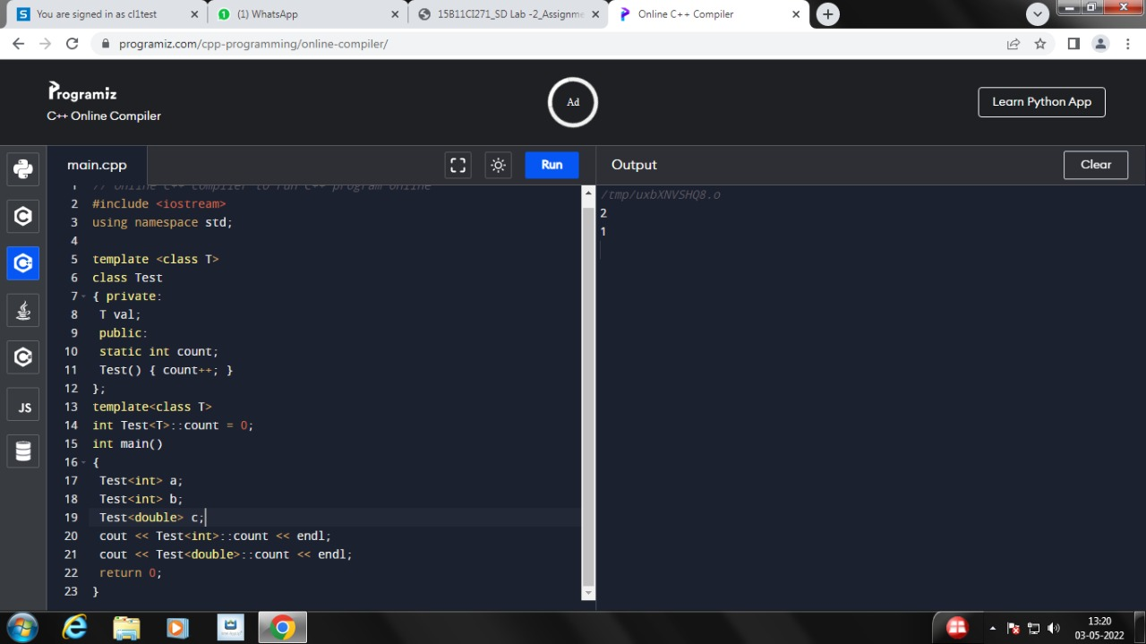

**Ans 3-**

**#include<iostream>**

**using namespace std;**

**template <class calculator>**

**class X {**

**calculator a,b;**

**public:**

**X(calculator a, calculator b){**

**this->a=a;**

**this->b=b;}**

**calculator add(){**

**cout<<"addition of two numbers:"<<a+b<<endl;**

**return a+b;**

**}**

**calculator sub(){**

**cout<<"subtration of two numbers:"<<a-b<<endl;**

**return a-b;**

**}**

**calculator mul(){**

**cout<<"Multiplication of two numbers:"<<a*b<<endl;**

**}**

**calculator div(){**

**cout<<"division of two numbers:"<<a/b<<endl;**

**}**

**};**

**int main(){**

**X<int> obj(7,8);**

**obj.add();**

**obj.sub();**

**obj.mul();**

**obj.div();**

**X<float> obj1(7.1,8.1);**

**obj1.add();**

**obj1.sub();**

**obj1.mul();**

**obj1.div();**

**X<double> obj2(7,8);**

**obj2.add();**

**obj2.sub();**

**obj2.mul();**

**obj2.div();**

**}**

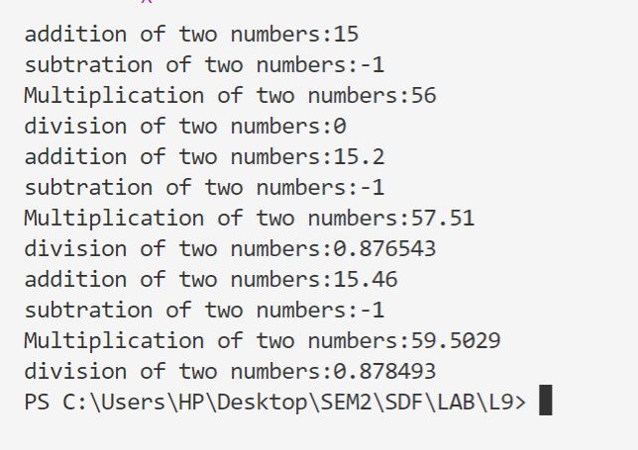

**Ans 4-**

**#include<iostream>**

**using namespace std;**

**template<class x>**

**x Minimum(x a,x b){**

**if(a<b)**

**return a;**

**return b;**

**};**

**template<class x>**

**x Maximum(x a, x b){**

**if(a>b)**

**return a;**

**return b;**

**}**

**int main(){**

**int var,var1;**

**cout<<"Enter two values of int type: ";**

**cin>>var>>var1;**

**cout<<"Minimum value is:"<<Minimum(var,var1);**

**cout<<endl<<"Maxumum value is:"<<Maximum(var,var1);**

**cout<<"\nEnter two values of float type: ";**

**float var2,var3;**

**cin>>var2>>var3;**

**cout<<"Minimum value is:"<<Minimum(var2,var3);**

**cout<<endl<<"Maxumum value is:"<<Maximum(var2,var3);**

**cout<<"\nEnter two values of double type: ";**

**double var4,var5;**

**cin>>var4>>var5;**

**cout<<"Minimum value is:"<<Minimum(var4,var5);**

**cout<<endl<<"Maxumum value is:"<<Maximum(var4,var5);**

**}**

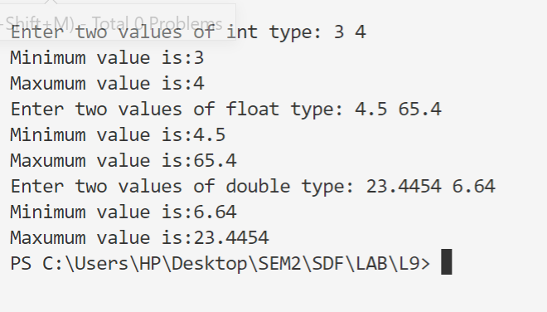

**Ans 5-**

#include<iostream>

using namespace **std**;

class **MyVector**{

int availableSize = 1;

int currSize = 0;

int *arr;

public:

**MyVector**(){

arr = new int;

}

void **pushBack**(int num){

if(currSize == availableSize){

int *newarr = new int[2*currSize];

for(int i = 0 ; i < currSize ; i++){

newarr[i] = arr[i];

}

arr = newarr;

availableSize = availableSize * 2;

arr[currSize] = num;

currSize++;

}

else{

arr[currSize] = num;

currSize++;

}

}

int **size**(){

return currSize;

}

void **popBack**(){

currSize--;

}

void **showVector**(){

for(int i = 0;i<currSize;i++){

cout**<<**arr[i]**<<**" ";

}

}

};

int **main**(){

int i=1,n;

**MyVector** V;

while(i){

cout**<<**"\n\tTo push enter 1 \n\tTo pop enter 2\n\tEnter any other to quit \n\tYour Choice : ";

cin**>>**i;

if(i==1){

cout**<<**"\tEnter the number : ";

cin**>>**n;

V.**pushBack**(n);

cout**<<**"\tPushed Successfully"**<<endl**;

cout**<<**"\tThe vector is : ";

V.**showVector**();

cout**<<endl**;

}

if(i==2){

V.**popBack**();

cout**<<**"\tPopped successfully"**<<endl**;

cout**<<**"\tThe vector is : ";

V.**showVector**();

cout**<<endl**;

}

}

cout**<<**"The vector is : ";

V.**showVector**();

return 0;

}

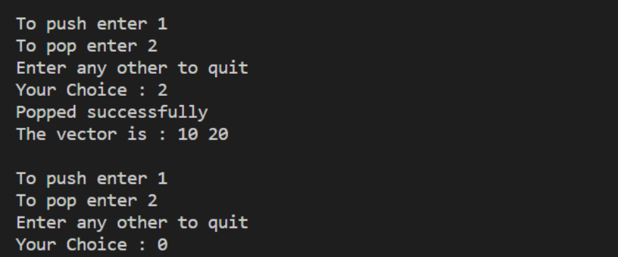

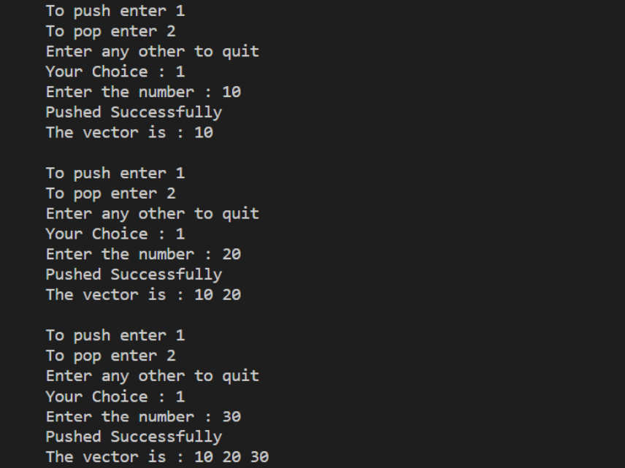

**Ans 6-**#include<bits/stdc++.h>

#include<iostream>

#include<vector>

using namespace **std**;

int **main**(){

vector<int> v1;

vector<int> v2;

int input = 1;

cout<<"\n\tInput for vector 1"<<endl;

while(input>=0){

cout<<"\tEnter input : ";

cin>>input;

if(input>=0)

v1.**push_back**(input);

}

input = 1;

cout<<"\n\tInput for vector 2"<<endl;

while(input>=0){

cout<<"\tEnter input : ";

cin>>input;

if(input>=0)

v2.**push_back**(input);

}

int flag = 0;

for(int i = 0;i<v2.**size**();i++){

flag = 0;

for(int j = 0;j < v1.**size**();j++){

if(v2[i]==v1[j])

flag = 1;

}

if(flag == 0)

v1.**push_back**(v2[i]);

}

**sort**(v1.**begin**(),v1.**end**());

for(int j = 0;j < v1.**size**();j++){

cout<<v1[j]<<" ";

}

return 0;

}

