**9921103163**

**Nitin Chaudhary**

**F8**

**Week 8 Assignment.**

**Ans 1-**

#include<iostream>

#include<string.h>

using namespace **std**;

int **isint**(char a[])

{

    int len=**strlen**(a);

    int minus=0;

    int dsum=0;

    for(int i=0;i<len;i++)

    {

        if(**isdigit**(a[i])!=0)

            dsum++;

        else if(a[i]=='-')

            minus++;

    }

    if(dsum+minus==len)

        return 1;

    else

        return 0;

}

int **isdouble**(char a[])

{

    int len=**strlen**(a);

    int dsum=0;

    int dot=0;

    int minus=0;

    for(int i=0;i<len;i++)

    {

        if(**isdigit**(a[i])!=0)

        {

            dsum++;

        }

        else if(a[i]=='.')

        {

            dot++;

        }

        else if(a[i]=='-')

        {

            minus++;

        }

    }

    if(dsum+dot+minus==len)

        return 1;

    else

        return 0;

}

void **check**(char a[],int x){

    if(x==1){

    if(**isint**(a)==1){}

    else if(**isdouble**(a)==1)

    {

        throw 5.5;

    }

    else

    {

        throw 'c';

    }

    }

    if(x==2){

        if(**isint**(a)==1){

            throw 5;

        }

    else if(**isdouble**(a)==1)

    {

        throw 5.5;

    }

    }

    if(x==3){

        if(**isint**(a)==1){

            throw 5;

        }

    else if(**isdouble**(a)==1){}

    else

    throw 'd';

    }

}

int **main**()

{

    char a[10];

    char b[10];

    char c[10];

    try{

    cout**<<**"Enter integer ";

    cin**>>**a;

**check**(a,1);

    cout**<<**"Enter character";

    cin**>>**b;

**check**(b,2);

    cout**<<**"Enter double value";

    cin**>>**c;

**check**(c,3);

    }

    catch(int){

        cout**<<**"\nWrong input";

        cout**<<**"\nInteger caught";

    }

    catch(char){

        cout**<<**"\nWrong input";

        cout**<<**"\nCharacter caught";

    }

    catch(double){

        cout**<<**"\nWrong input";

        cout**<<**"\nDouble caught";

    }

}

**Output-**

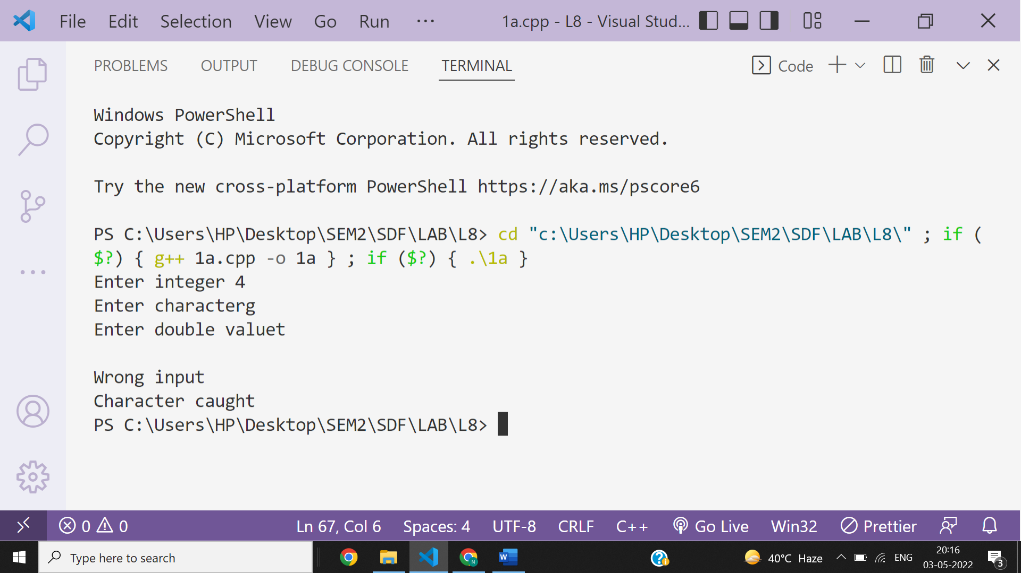

**Ans 2-**

**Output**

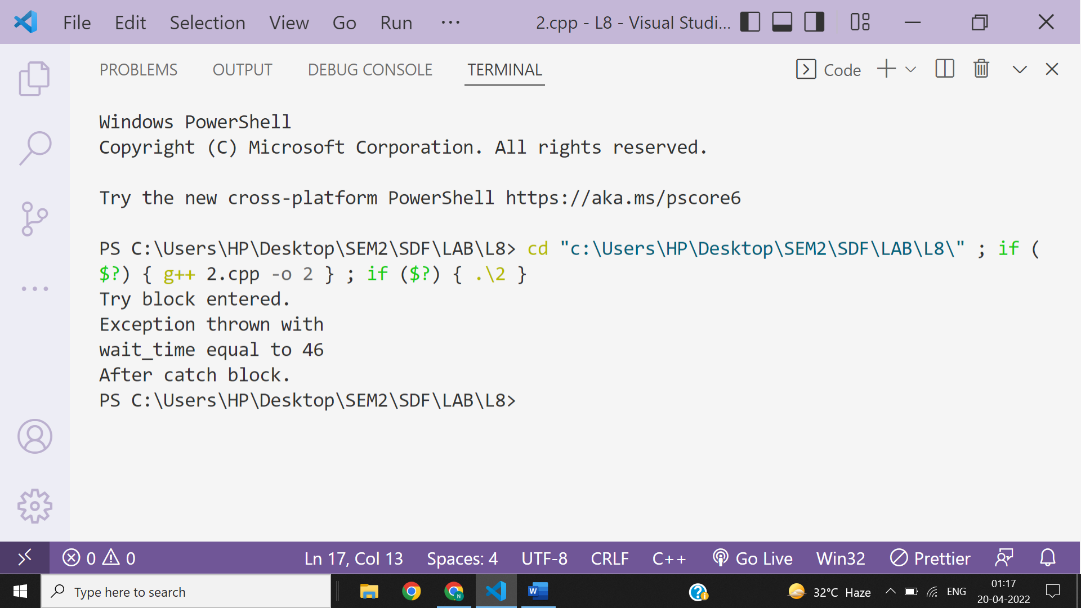

**Ans 3-**

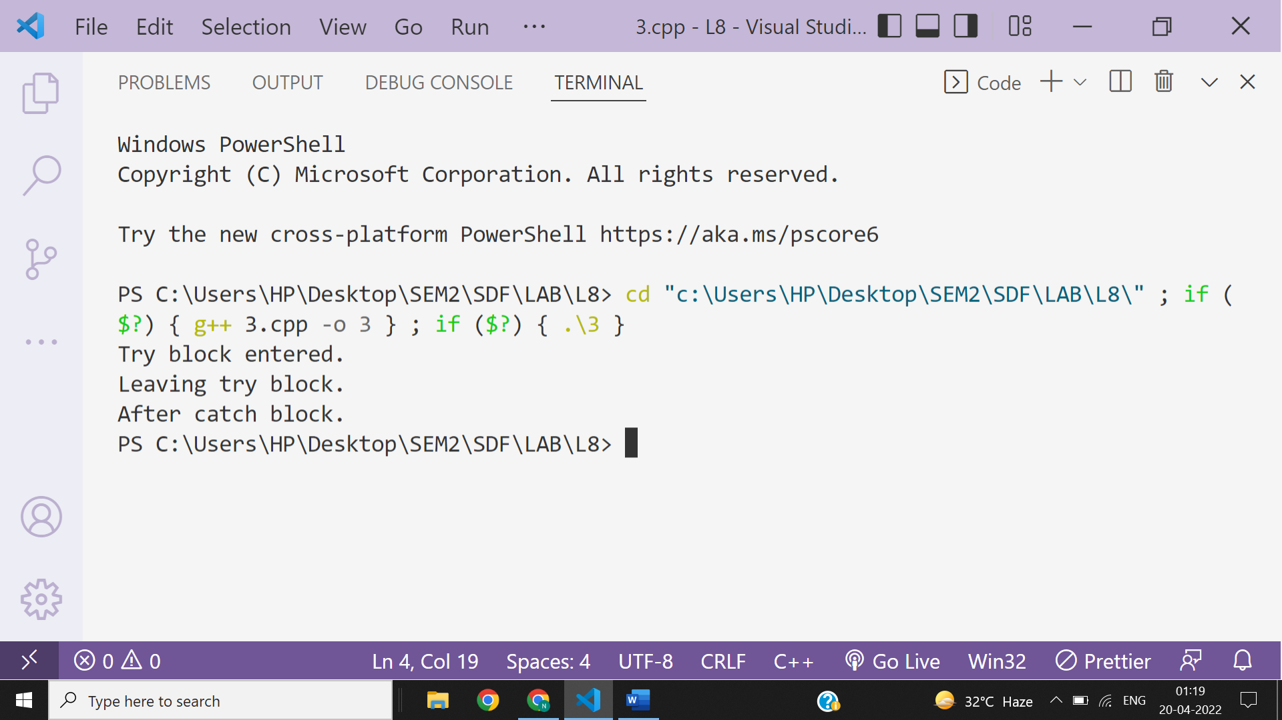

**Ans 4-**

When a throw statement is executed then it will basically go upto the stack and destroys all local variables in the try block until it finds an suitable exception handler or catch . And it does not find any suitable catch then your program will be crashed.

So , the throw keyword throws an exception when a problem is detected which lets us create a custom error handler.

General syntax-

try{

throw value;

}

catch(datatype var){}

**Ans 5-**

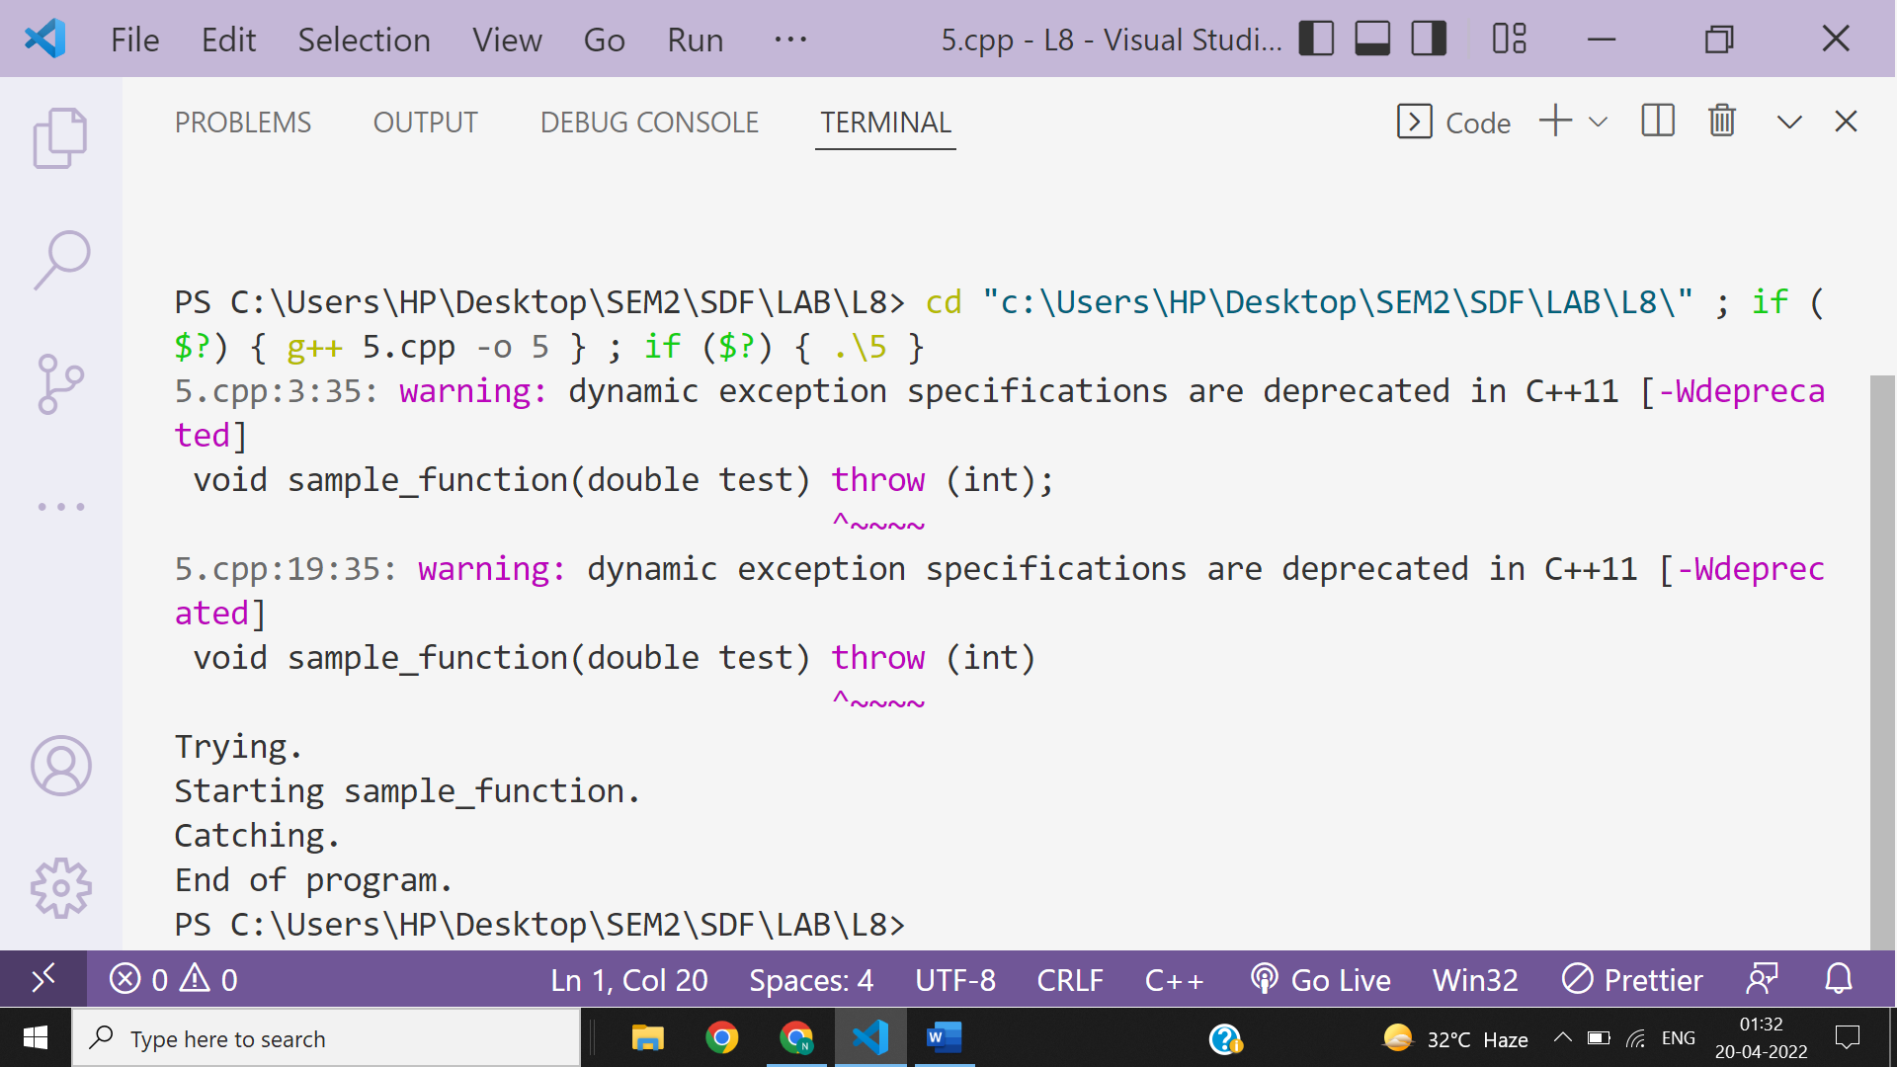

**Ans 6-**

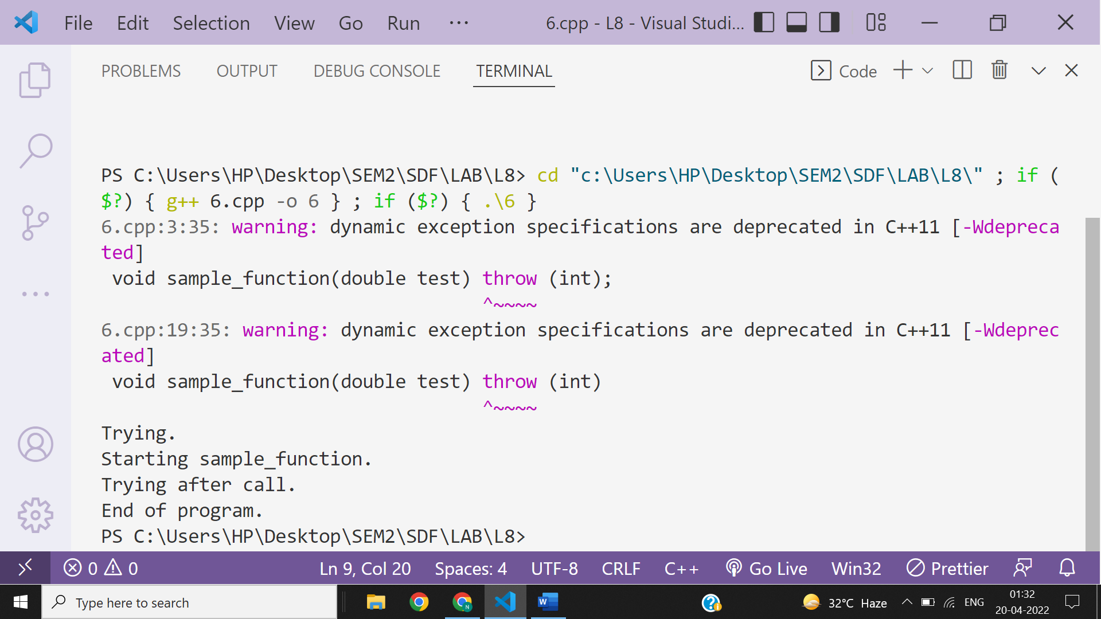

**Ans 7-**

If an exception is never caught then your program will crash at rum time and an default exception message will be printed to the terminal .

So, if an exception is throw and not caught anywhere then the program terminates abnormally.

**Ans 8-**

**Yes , we can nest a try block inside another try block.**

**Ans 9-**

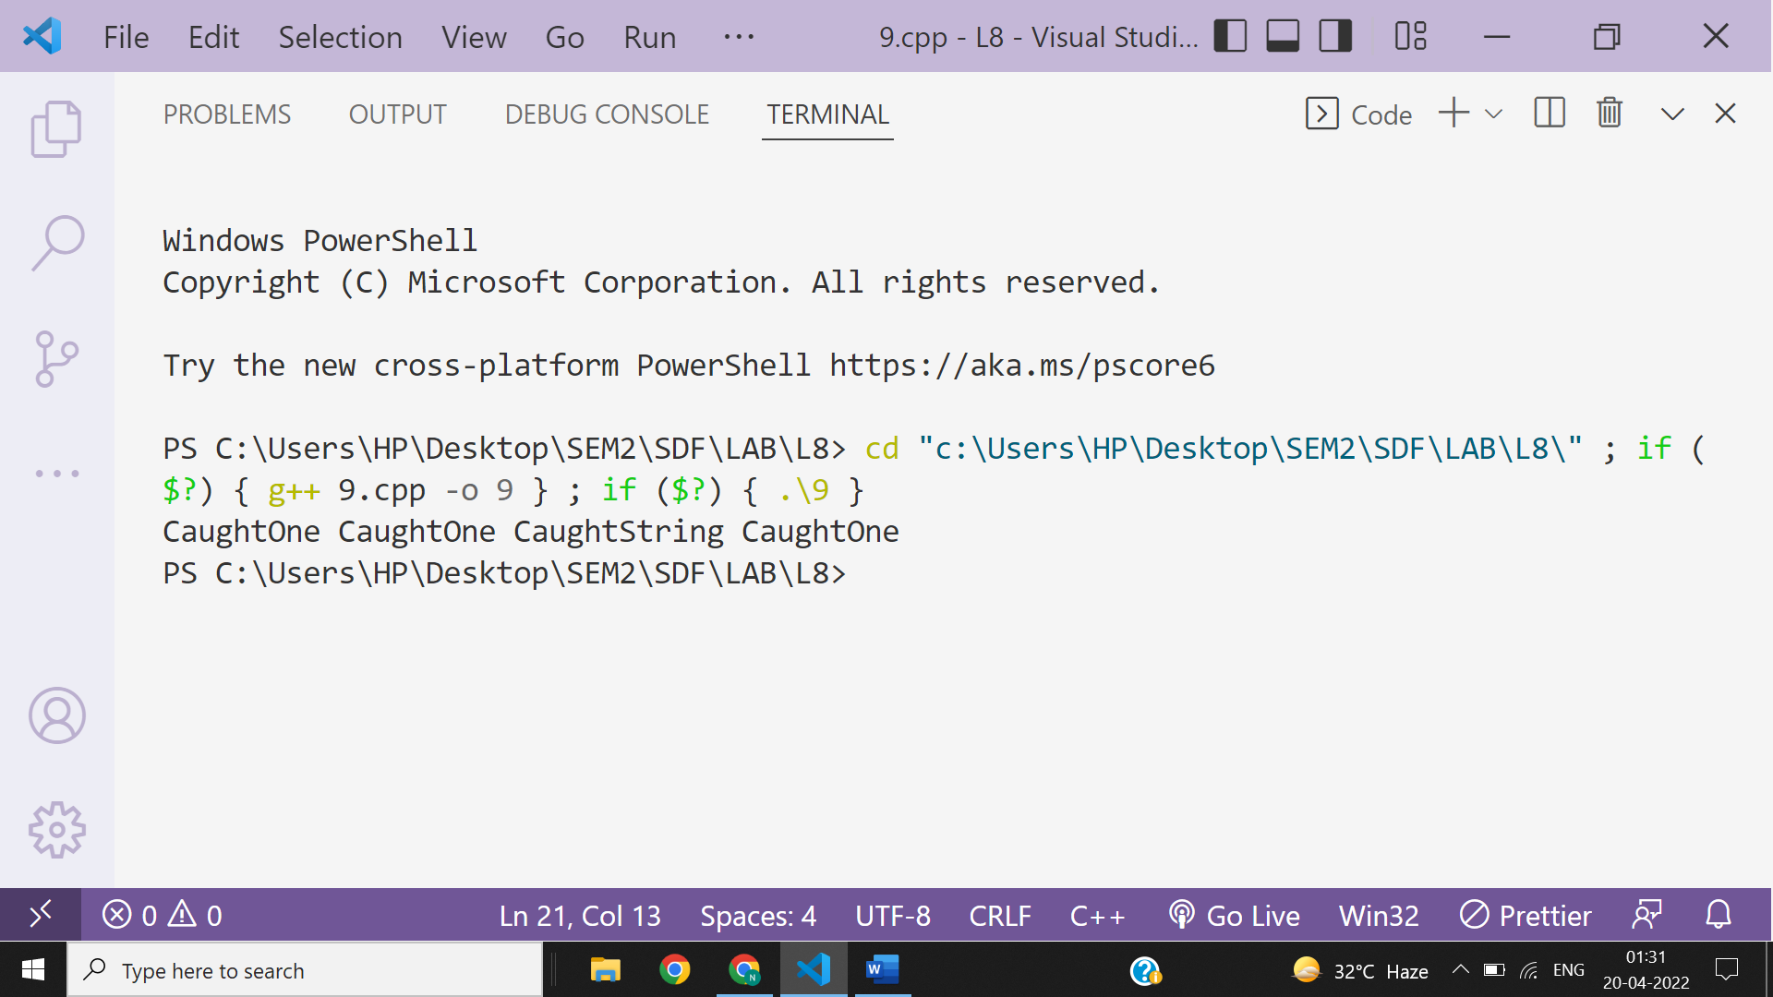

**Ans 10-**

