**NBTG13715**

**Nitin Chaudhary**

**F8**

**Ans 1-**

#include<iostream>

using namespace **std**;

int **main**()

{

    int *a=new int;

    float *b=new float;

    cout**<<**"Enter values";

    cin**>>**\*a**>>**\*b;

    cout**<<**"\nvalues are:";

    cout**<<**\*a**<<**" "**<<**\*b;

    delete a;

    delete b;

    return 0;

}

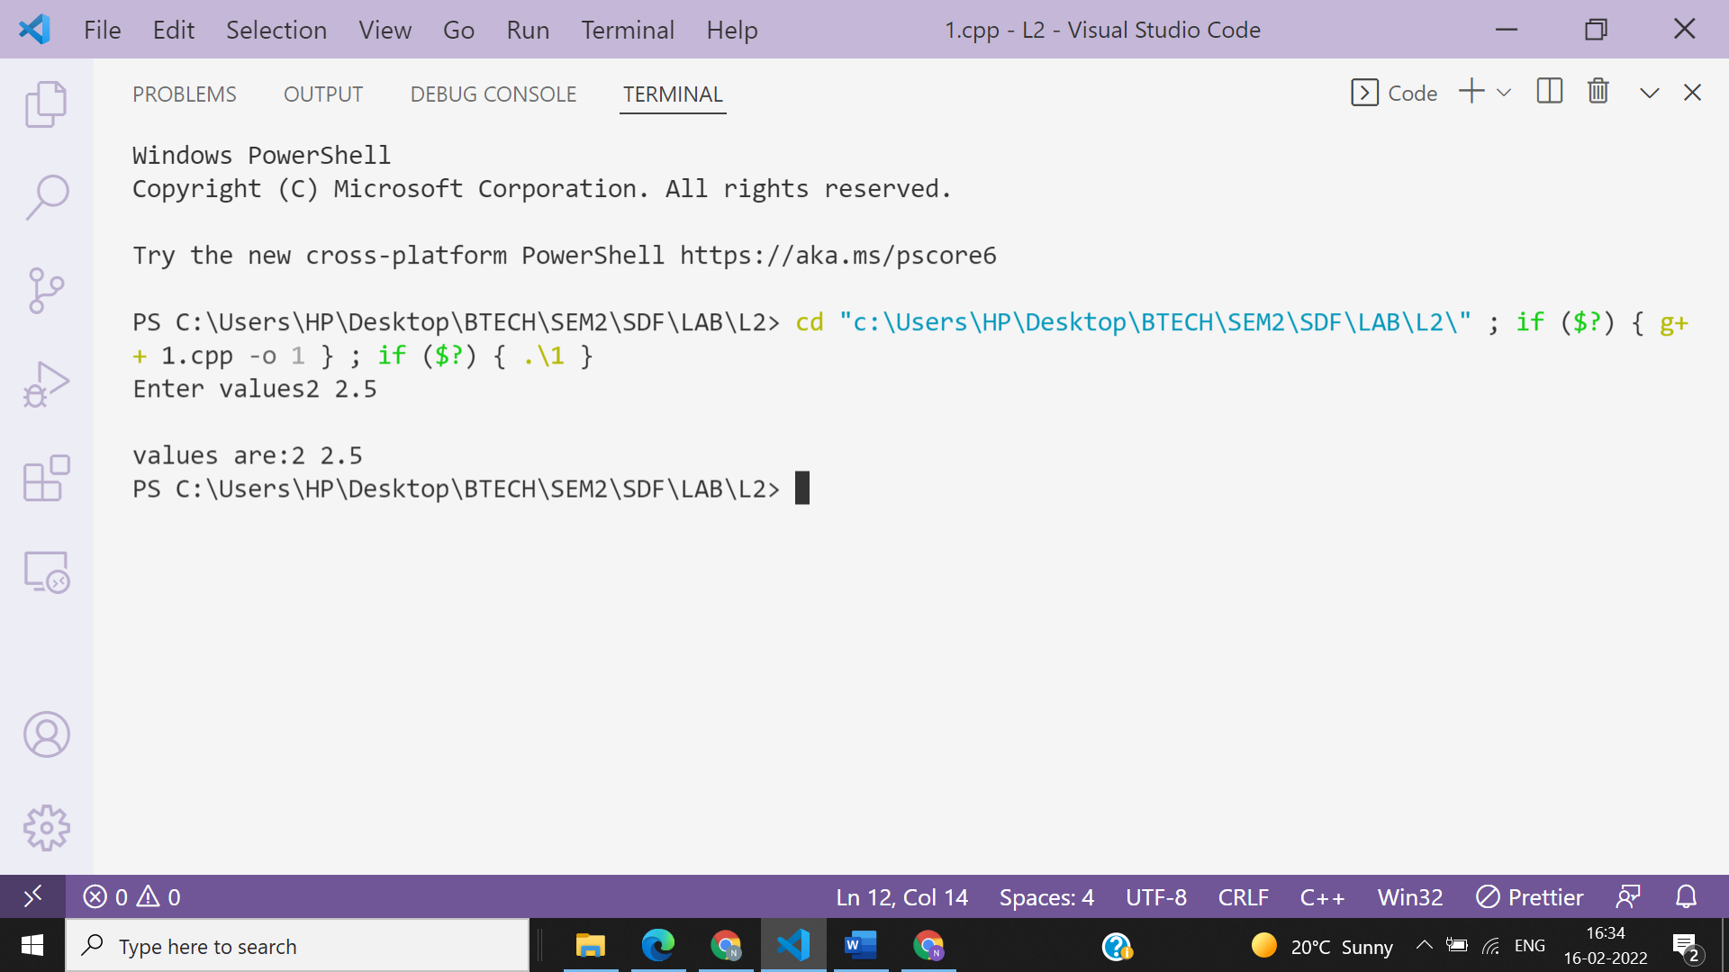

**Ans 2.1-**

#include <iostream>

using namespace **std**;

const int MAX = 3;

int **main** () {

 int var[MAX]={10,100,200};

 int *ptr;

ptr = var;

for (int i = 0; i < MAX; i++){

 cout **<<** "Address of var[" **<<** i **<<** "] = ";

 cout **<<** ptr **<<** **endl**;

 cout **<<** "Value of var[" **<<** i **<<** "] = ";

 cout **<<** *ptr **<<** **endl**;

 ptr++;

 }

 return 0;

}

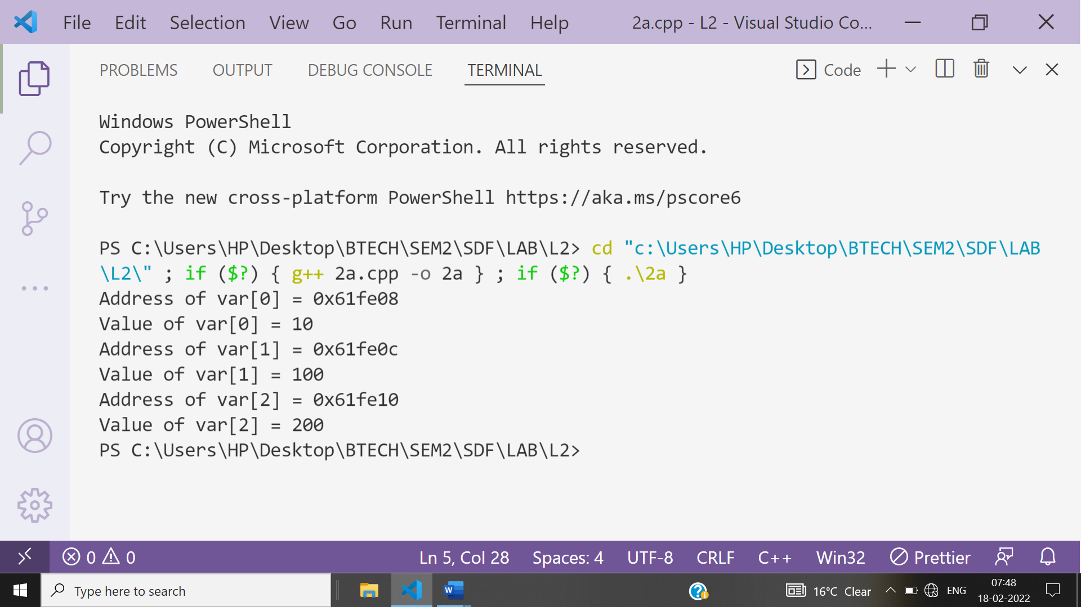

**Ans 2.2-**

#include <iostream>

using namespace **std**;

const int MAX = 3;

int **main** () {

 int var[MAX] = {10, 100, 200};

 int *ptr;

*// let us have address of the last element in pointer.*

 ptr = &var[MAX-1];

 for (int i = MAX; i > 0; i--) {

 cout **<<** "Address of var[" **<<** i **<<** "] = ";

 cout **<<** ptr **<<** **endl**;

 cout **<<** "Value of var[" **<<** i **<<** "] = ";

 cout **<<** *ptr **<<** **endl**;

*// point to the previous location*

 ptr--;

 }

 return 0;

}

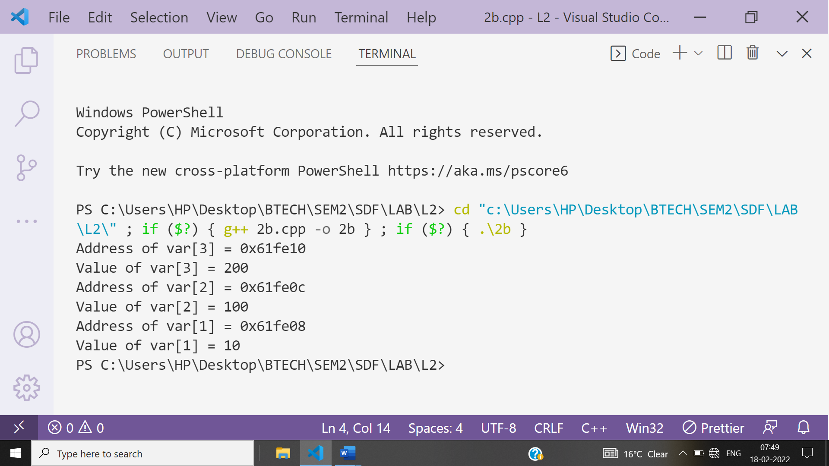

**Ans 3-**

#include <iostream>

using namespace **std**;

int **main**()

{

    int n;

    cout **<<** "Enter the number of students\n";

    cin **>>** n;

    float *ptr = **NULL**;

    ptr = new float[n];

    cout**<<**"Enter CGPA of "**<<**n**<<**" students:";

    for (int i = 0; i < n; i++)

    {

        cout **<<** "\nStudent " **<<** i + 1 **<<** ": ";

        cin **>>** *(ptr + i);

    }

    cout **<<** "\nDETAILS :\n";

    for (int i = 0; i < n; i++)

    {

        cout **<<** "\nCGPA of student " **<<** i + 1 **<<** " is " **<<** *(ptr + i);

    }

    delete ptr;

    return 0;

}

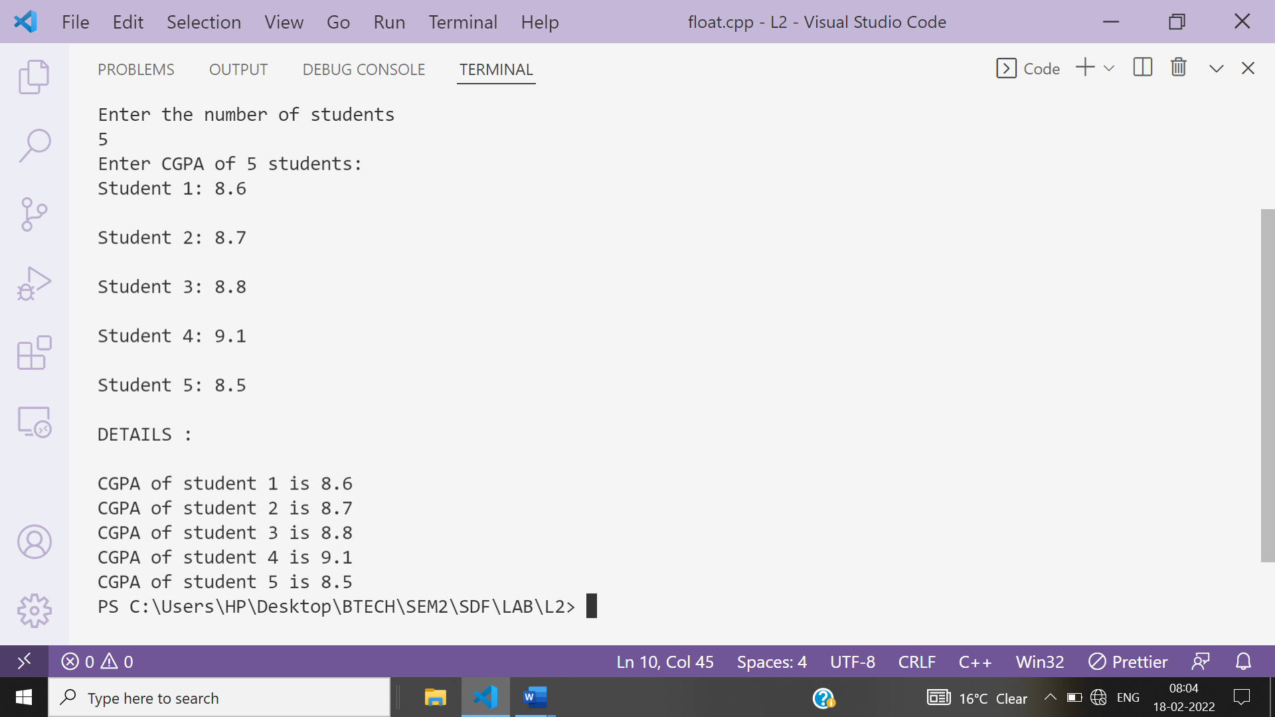

**Ans 4-**

A.

**The output is : ABCDEFGHIJ**

**Explanation: As the type of lfc is char type hence it will result int to character conversion of corresponding ASCII value.**

**B.**

**The output is : fg**

**Explanation:As the pointer is reached to f place after increment of 5 indexes , hence it will print fg as output.**

**Ans 5-**

#include<iostream>

using namespace **std**;

int **main**()

{

    int n,max=0;

    cout**<<**"Enter how many integers you want to enter:";

    cin**>>**n;

    int *a=new int[n];

    cout**<<**"Enter "**<<**n**<<**" integers to get largest integer from them:";

    for(int i=0;i<n;i++)

    {

        cin**>>**\*(a+i);

    }

    for(int i=0;i<n;i++)

    {

        if(max<*(a+i))

        {

            max=*(a+i);

        }

    }

    cout**<<**"Largest integer is:"**<<**max;

    return 0;

}

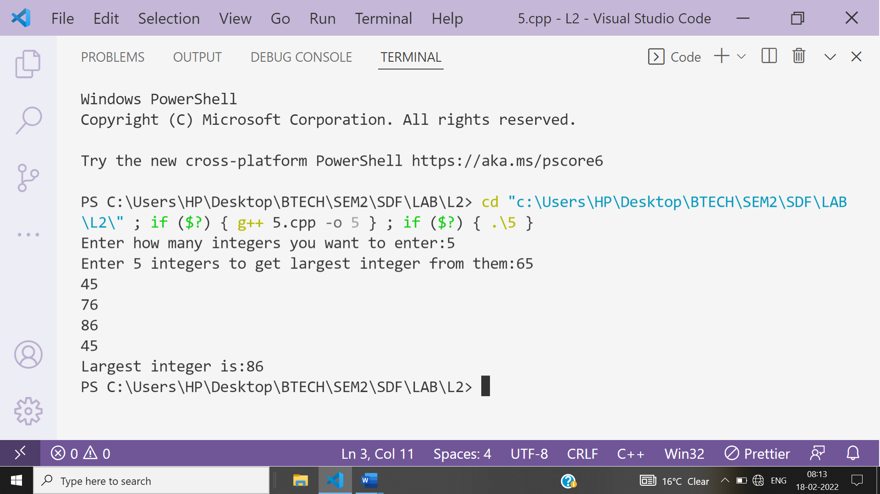

**Ans 6-**

#include<iostream>

using namespace **std**;

int **main**()

{

    int n,sum=0;

    cout**<<**"Enter how many integers you want to enter:";

    cin**>>**n;

    int *a=new int[n];

    cout**<<**"Enter "**<<**n**<<**" integers to get sum of all:";

    for(int i=0;i<n;i++)

    {

        cin**>>**\*(a+i);

    }

    for(int i=0;i<n;i++)

    {

        sum+=*(a+i);

    }

    cout**<<**"Sum of"**<<**n**<<**"entered integers is:"**<<**sum;

    return 0;

}

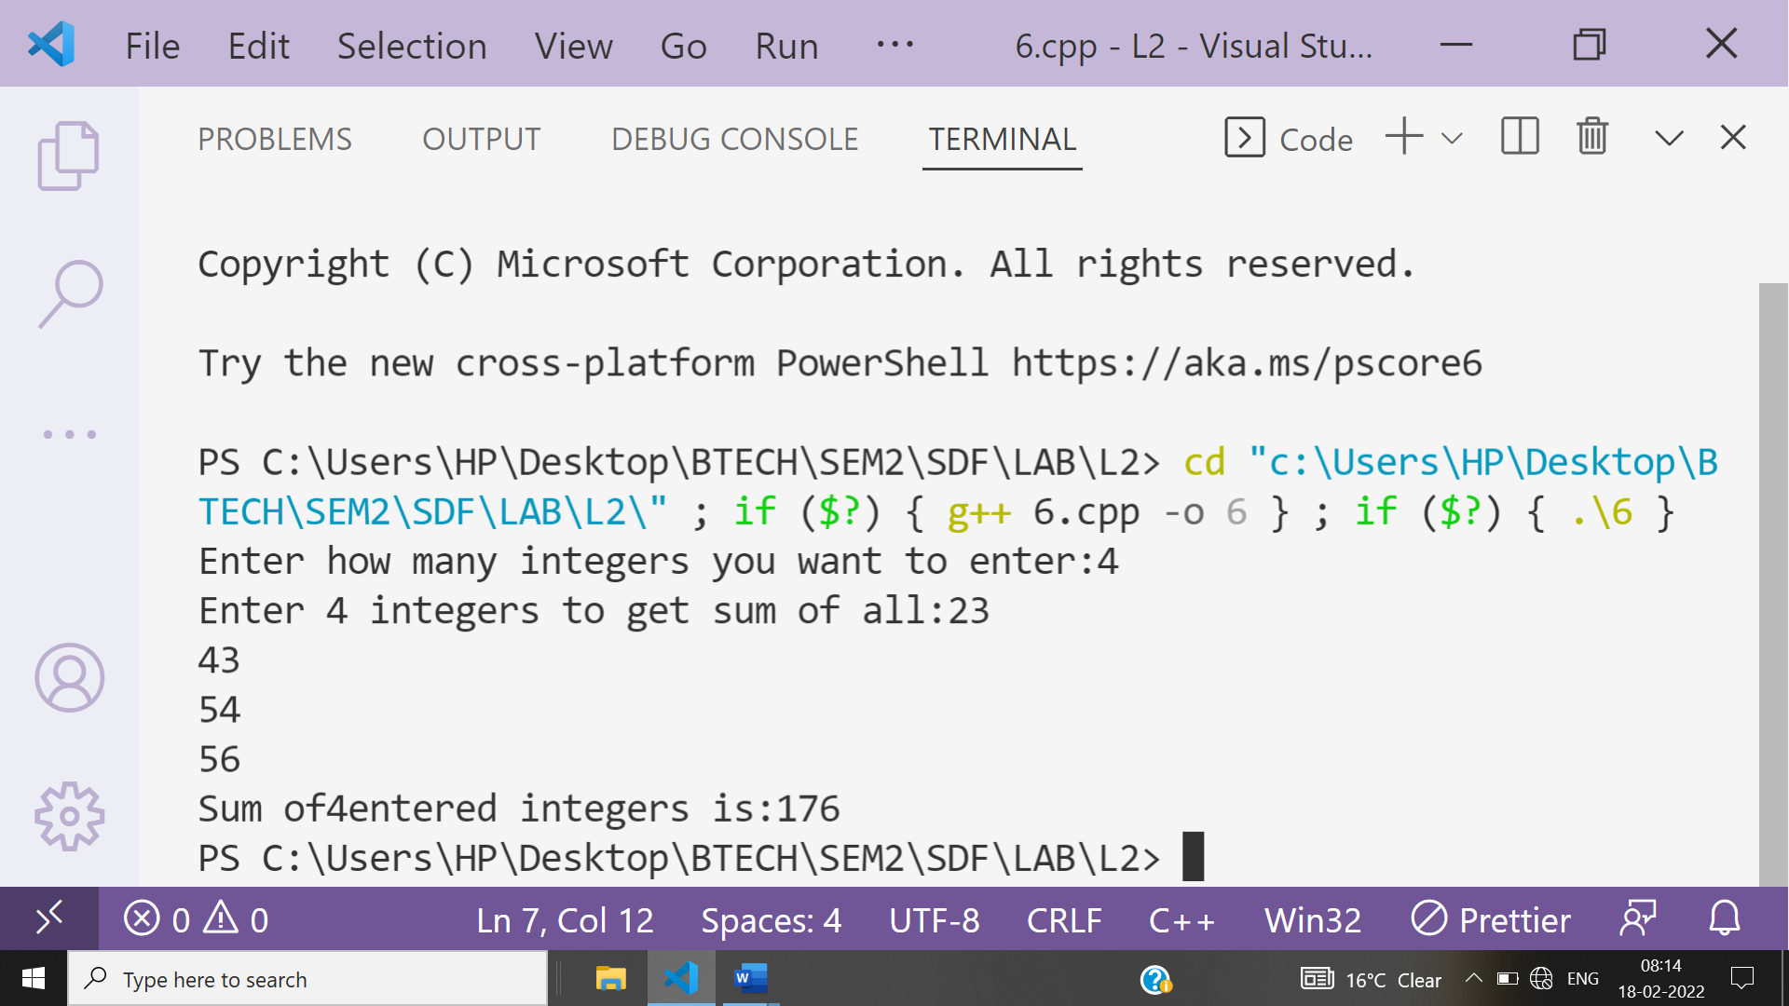

**Ans 7-**

#include<iostream>

using namespace **std**;

int **main**()

{

    int a[5]={1,2,3,4,1},n;

    int check=0;

    cout**<<**"Enter an element to check whether it is present or not in array:";

    cin**>>**n;

    cout**<<**"The array is:\n";

    for(int i=0;i<5;i++)

    {

        cout**<<**a[i]**<<**" ";

    }

    for(int i=0;i<5;i++)

    {

        if(a[i]==n)

        {

            cout**<<**"\n"**<<**n**<<**" is present in array at index :"**<<**i;

            check++;

        }

    }

    if(check==0)

    {

        cout**<<**n**<<**" is not present in array";

    }

    return 0;

}

**Ans 8-**

#include<iostream>

using namespace **std**;

int **main**()

{

    int n;

    cout**<<**"Enter value of n:";

    cin**>>**n;

    int *a=new int[n];

    cout**<<**"Enter "**<<**n**<<**" integers:";

    for(int i=0;i<n;i++)

    {

        cin**>>**\*(a+i);

    }

    cout**<<**"\nEntered "**<<**n**<<**" integers are:\n";

    for(int i=0;i<n;i++)

    {

        cout**<<**\*(a+i)**<<**"\n";

    }

    return 0;

}

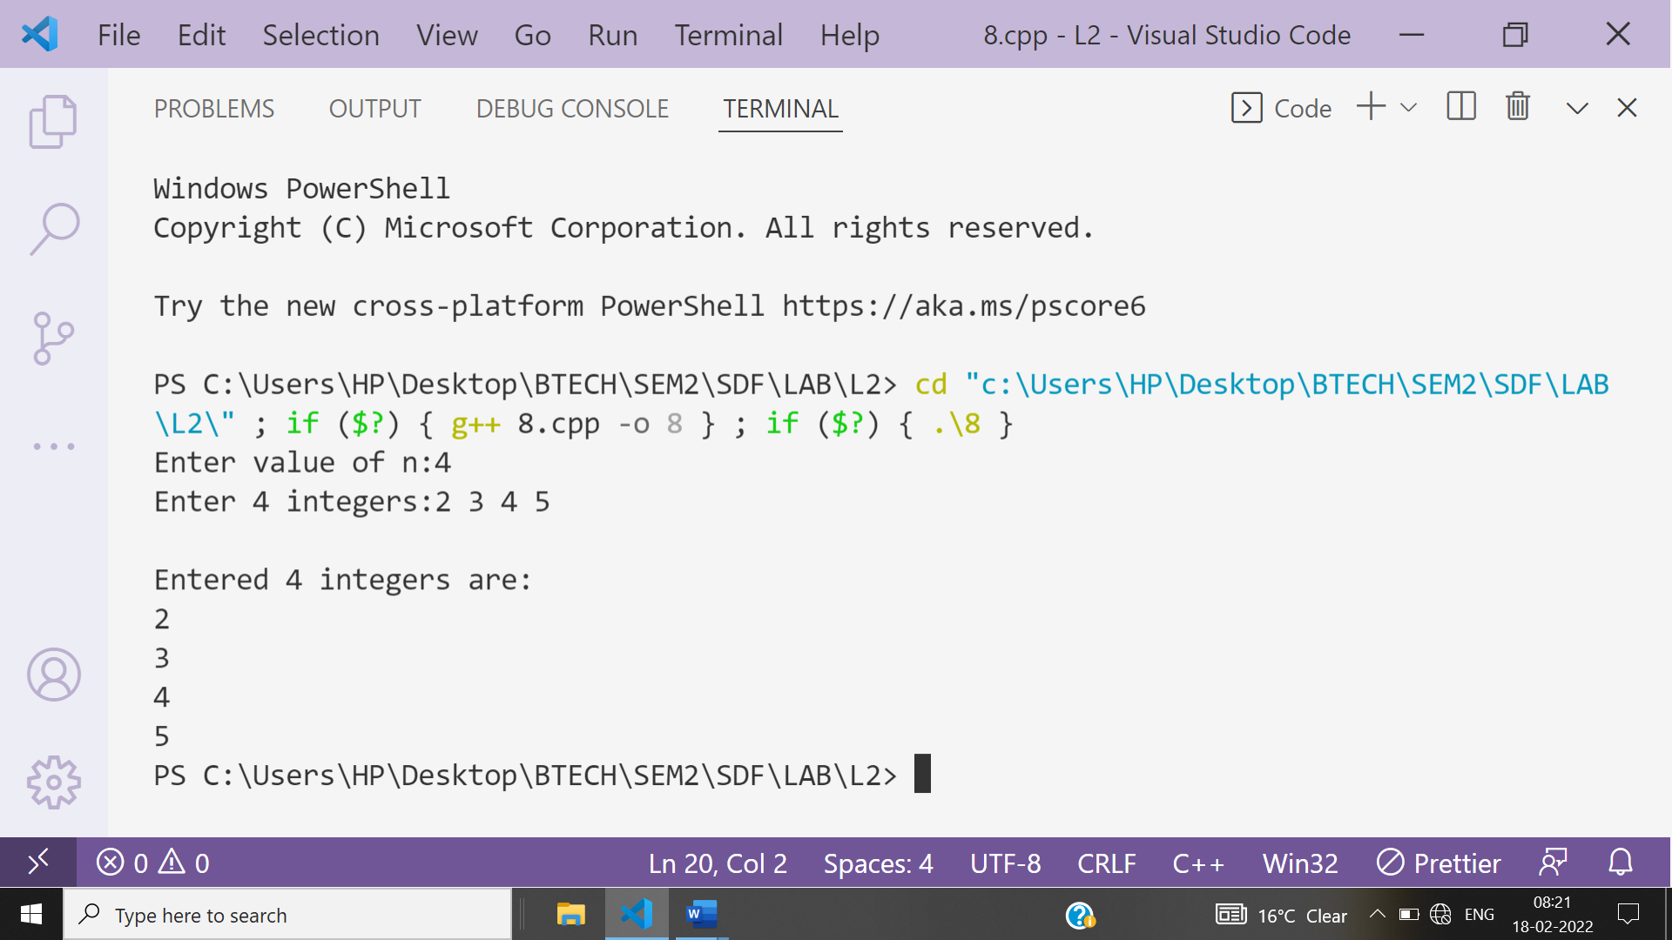

**Ans 9-**

#include<iostream>

using namespace **std**;

int **main**()

{

    int arr[]={34,67,88,3,5,9,55};

    int *ptr = arr;

    int temp;

    cout**<<**"The orriginal array is :\n";

    for (int i = 0; i < 7; i++)

    {

        cout**<<**\*(ptr+i)**<<**" ";

    }

    for (int i = 0; i < 6 ; i++)

    {

        for (int j = 0; j < 6-i; j++)

        {

            if(*(ptr+j) > *(ptr+j+1))

            {

                temp = *(ptr+j);

                *(ptr+j)= *(ptr+j+1);

                *(ptr+j+1)= temp;

            }

        }

    }

    cout**<<**"\n\nThe array in accending order is \n";

    for (int i = 0; i < 7; i++)

    {

        cout**<<** *(ptr+i) **<<**" ";

    }

    for (int i = 0; i < 3; i++)

    {

        temp=*(ptr+i);

        *(ptr+i)=*(ptr+6-i);

        *(ptr+6-i)=temp;

    }

    cout**<<**"\n\nThe reversed array is \n";

    for (int i = 0; i < 7; i++)

    {

        cout**<<**\*(ptr+i)**<<**" ";

    }

    return 0;

}

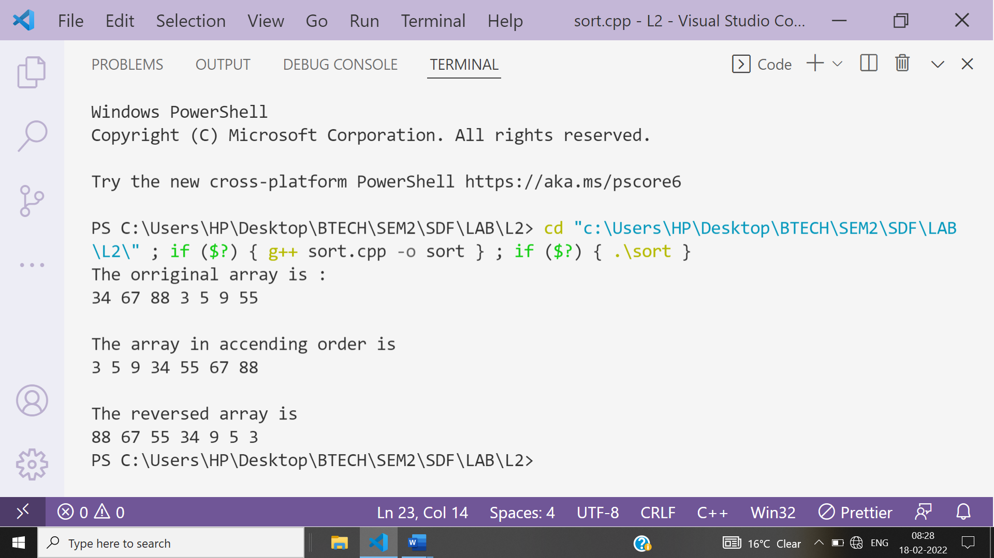

**Ans 10-**

**Output is-**

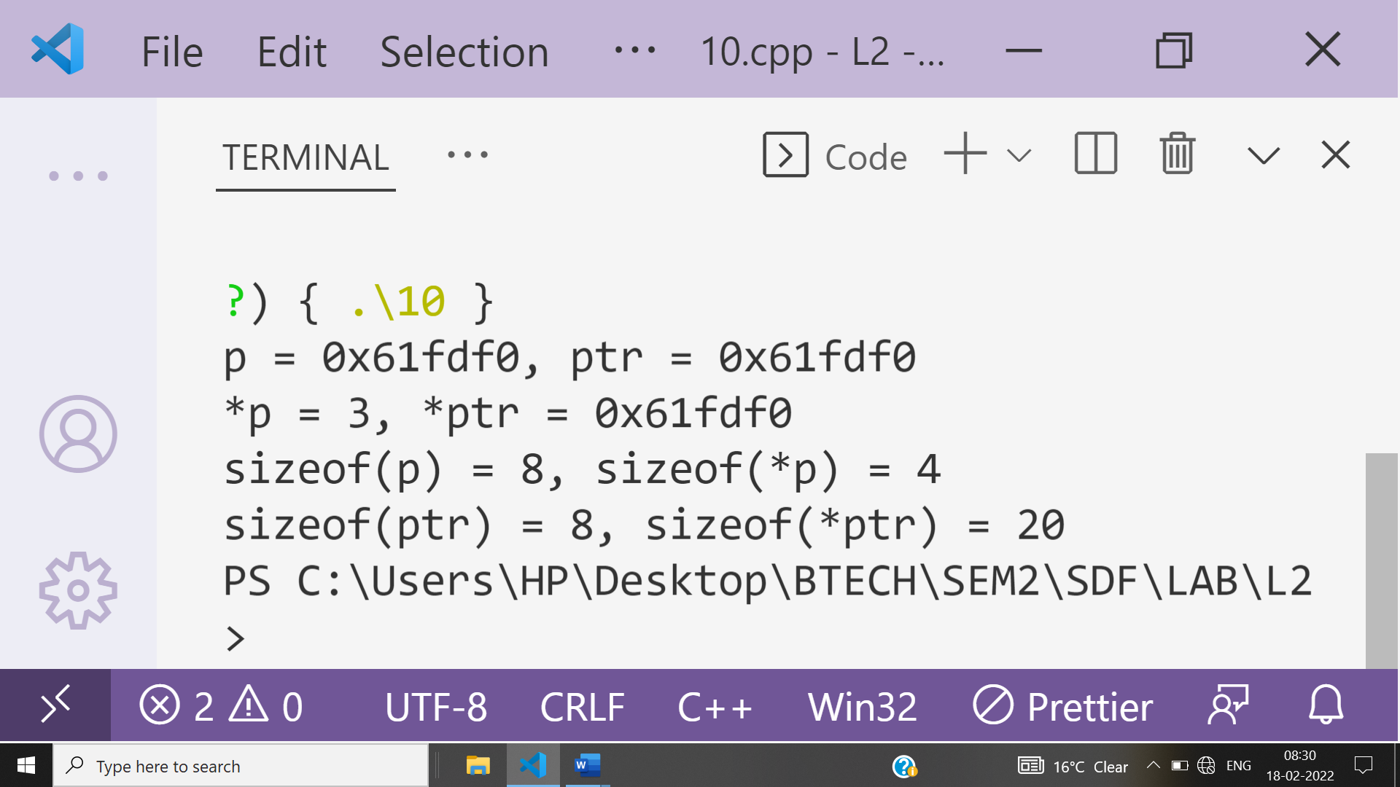

**Explanation:**

**p points to the first element of array while ptr is an pointer to array.**

**p and ptr both contains base address of array hence showing same output for address.**

**The sizeof shows a couple of things: 1) the sizeof for both p and ptr shows 8 bytes - the amount of memory necessary to store an address; 2) the sizeof(*p) is 4, because this pointer points to a single integer value; 3) the sizeof(*ptr) is 20 because it points to the entire array of 5 integer values, or 20 bytes.**

**Ans 11-**

#include<iostream>

using namespace **std**;

int **main**()

{

    int m,n;

    cout**<<**"Enter the values of the no. of rows and collumn for 2D array\n";

    cin**>>**m**>>**n;

    int **ptr;

    ptr = new int*[m];

    for (int i = 0; i < m; i++)

    {

        ptr[i]= new int[n];

    }

    cout**<<**"Enter the values for the array\n";

    for (int i = 0; i < m ; i++)

    {

        for (int j = 0; j < n; j++)

        {

            cin**>>**ptr[i][j];

        }

    }

    cout**<<**"The values in 2D array are \n";

    for (int i = 0; i < m ; i++)

    {

        cout**<<**"\n";

        for (int j = 0; j < n; j++)

        {

           cout**<<**"\t"**<<**ptr[i][j];

        }

    }

    return 0;

}

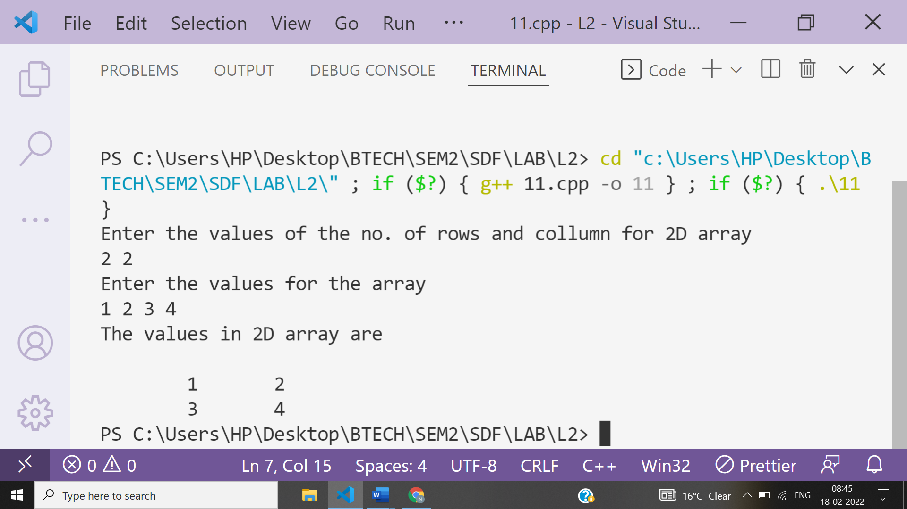

**Ans 12-**

#include<iostream>

using namespace **std**;

int **main**()

{

    int m,n;

    cout**<<**"Enter the no. of rows and collumn\n";

    cin**>>**m**>>**n;

    int arr[m][n];

    cout**<<**"Enter the values for Array ";

        for (int j = 0; j < m; j++)

        {

            for (int k = 0; k < n; k++)

            {

                cin>>arr[j][k];

            }

        }

        int (*ptr)[n];

        ptr=arr;

        cout**<<**"The array is \n";

        for (int j = 0; j < m; j++)

        {

            cout**<<**"\n";

            for (int k = 0; k < n; k++)

            {

                cout**<<**"\t"<<*(*(ptr+j)+k);

            }

        }

            return 0;

        }

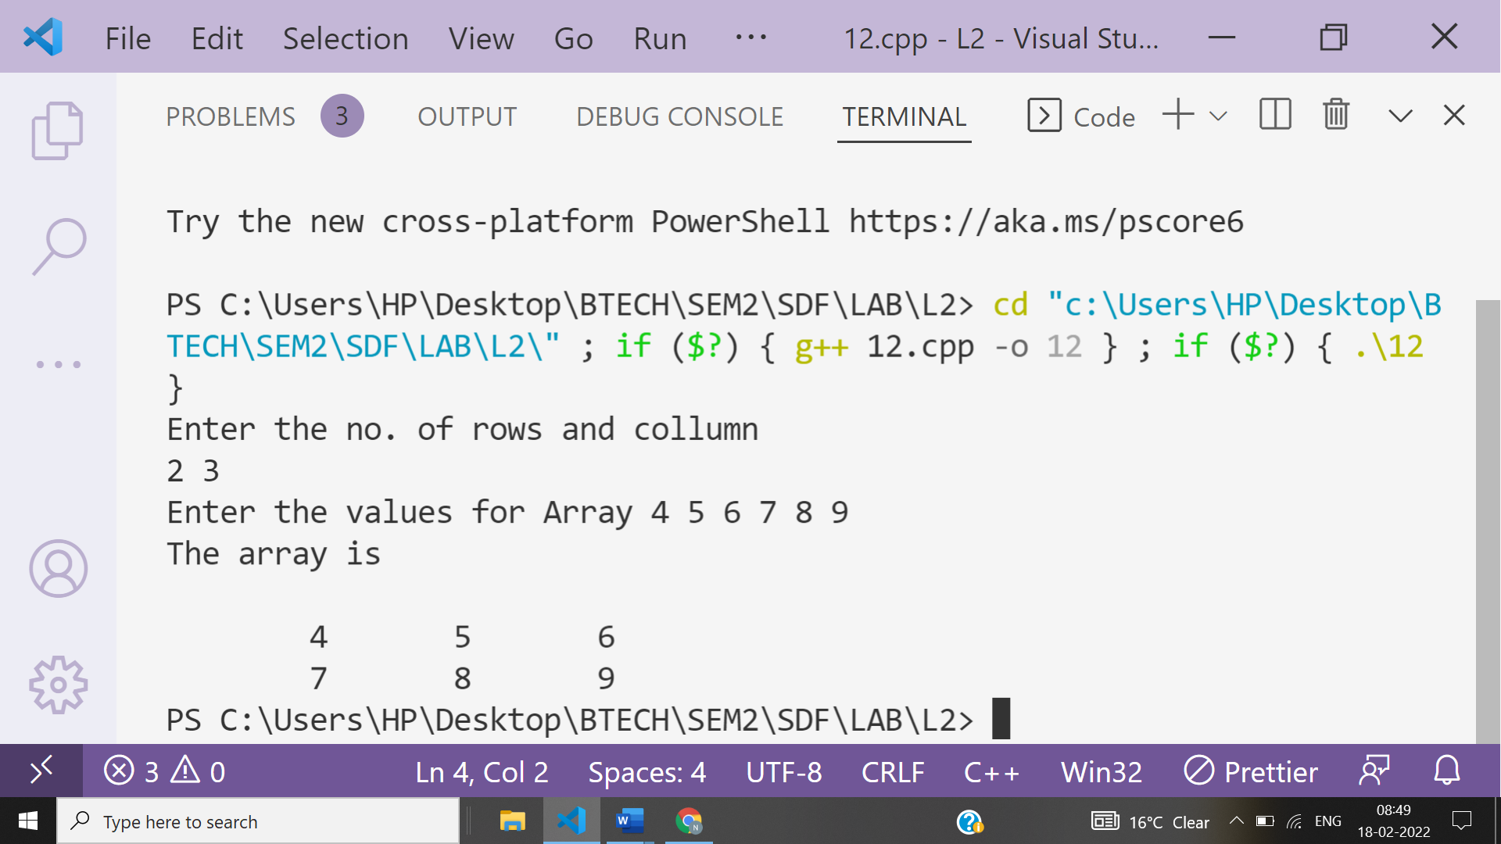

**Ans 13-**

#include<iostream>

using namespace **std**;

int **main**()

{

    int m,r,c;

    cout**<<**"Enter the value of no. of 2d arrays you want\n";

    cin**>>**m;

    cout**<<**"Enter the no. of rows and collumn for the arrays\n";

    cin**>>**r**>>**c;

    int arr[m][r][c];

    for (int i = 0; i < m; i++)

    {

        cout**<<**"Enter the values for Array "**<<**i+1**<<**"\n";

        for (int j = 0; j < r; j++)

        {

            for (int k = 0; k < c; k++)

            {

                cin>>arr[i][j][k];

            }

        }

    }

    cout**<<**"The values in the 3D array are";

    for (int i = 0; i < m; i++)

    {

        for (int j = 0; j < r; j++)

        {

            cout**<<**"\n";

            for (int k = 0; k < c; k++)

            {

                cout**<<**"\n"<<arr[i][j][k]<<"  "<<&arr[i][j][k];

            }

        }

    }

    return 0;

}

