**9921103163**

**NITIN Chaudhary**

**W3B**

**F8**

**Home Assignment**

**Q1-**

**Ans-**

#include <iostream>

using namespace **std**;

class **wall**

{

private:

    float length;

    float height;

public:

*//parameterised constructor*

**wall**(float a, float b)

    {

        length = a;

        height = b;

    }

*//copy constructor*

**wall**(const **wall** &obj2)

    {

        length=obj2.length;

        height=obj2.height;

    }

*//member function*

float **area**(**wall** obj)

{

    cout**<<**"Value of length is :"**<<**obj.length;

    cout**<<**"\nValue of height is :"**<<**obj.height;

    float ar=obj.length*obj.height;

    cout**<<**"\nArea of wall is:";

    return ar;

}

};

 int **main**()

{

**wall** **obj1**(52,23);*//this will call parameterised constructor and it will assign values to length and height as 52 and 23 respectively.*

**wall** obj2=obj1;*//this will call copy constructor and assign same values to the obj2 variables as assigned to obj1 variables.*

    cout**<<**obj1.**area**(obj2);*//this class function will calcute the area of the wall*

}

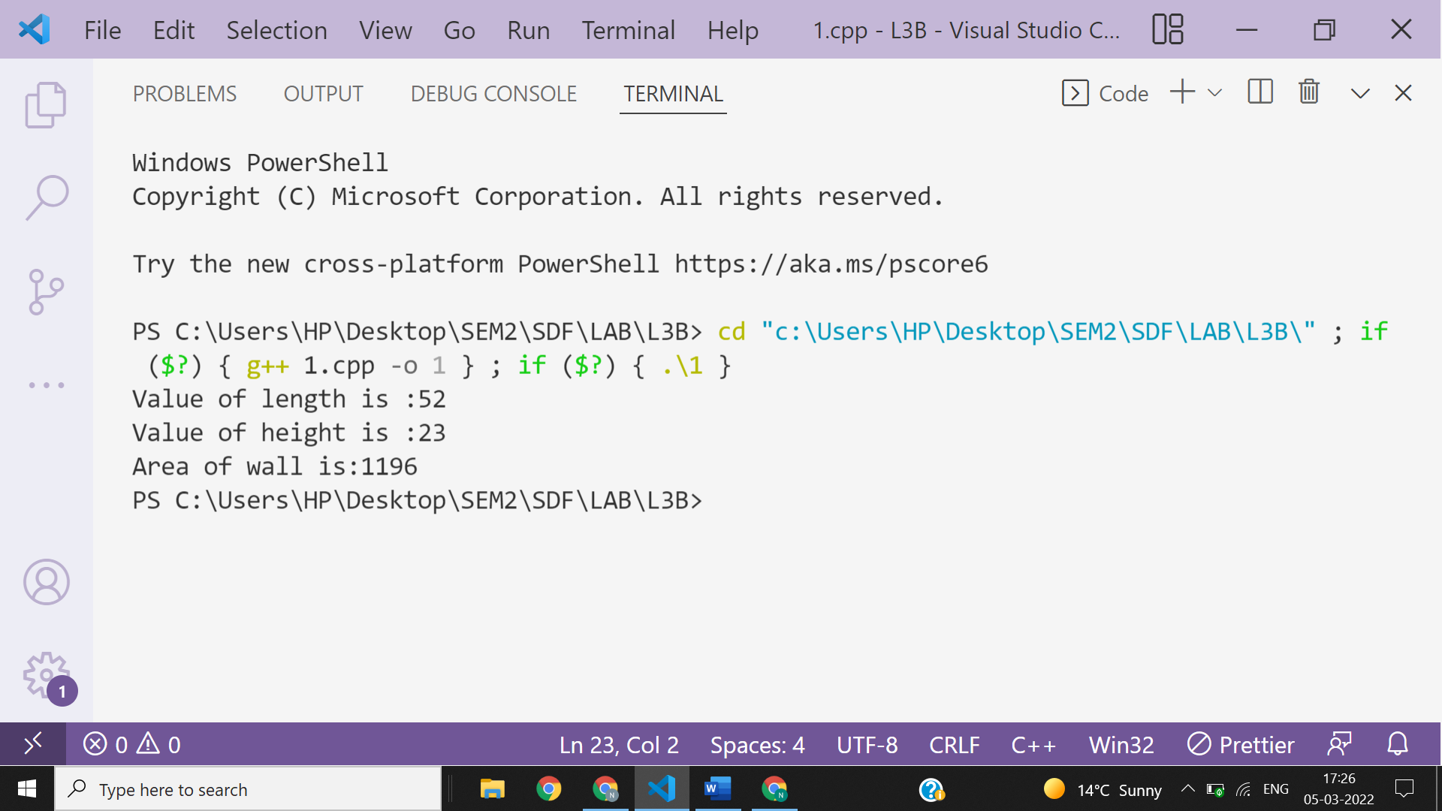

**Ans 2-**

#include <iostream>

using namespace **std**;

class **String**

{

private:

    char *s;

    int size;

public:

**String**(char *a,int l)

    {

        cout**<<**"constructor called\n";

        s=a;

        size=l;

    }

**String**(const **String** &obj)

    {

        cout**<<**"Copy constructor called\n";

        s=obj.s;

        size=obj.size;

    }

**~String**()

    {

        cout**<<**"Destructor called\n";

    }

    void **fun**(int l)

    {

        cout**<<**"string is :";

        for(int i=0;i<l;i++)

        {

            cout**<<**\*(s+i);

        }

        cout**<<endl**;

    }

};

int **main**()

{

    char a[20];

    int len=0;

    cout**<<**"Enter the string:";

**gets**(a);

    for(int i=0;a[i]!='\0';i++)

        len++;

**String** **obj1**(a,len);

**String** **obj2**(obj1);*//this will call copy constructor and assign same values to the obj2 variables as assigned to obj1 variables.*

    obj2.**fun**(len);*//this function will print inputted strings*

    return 0;

}

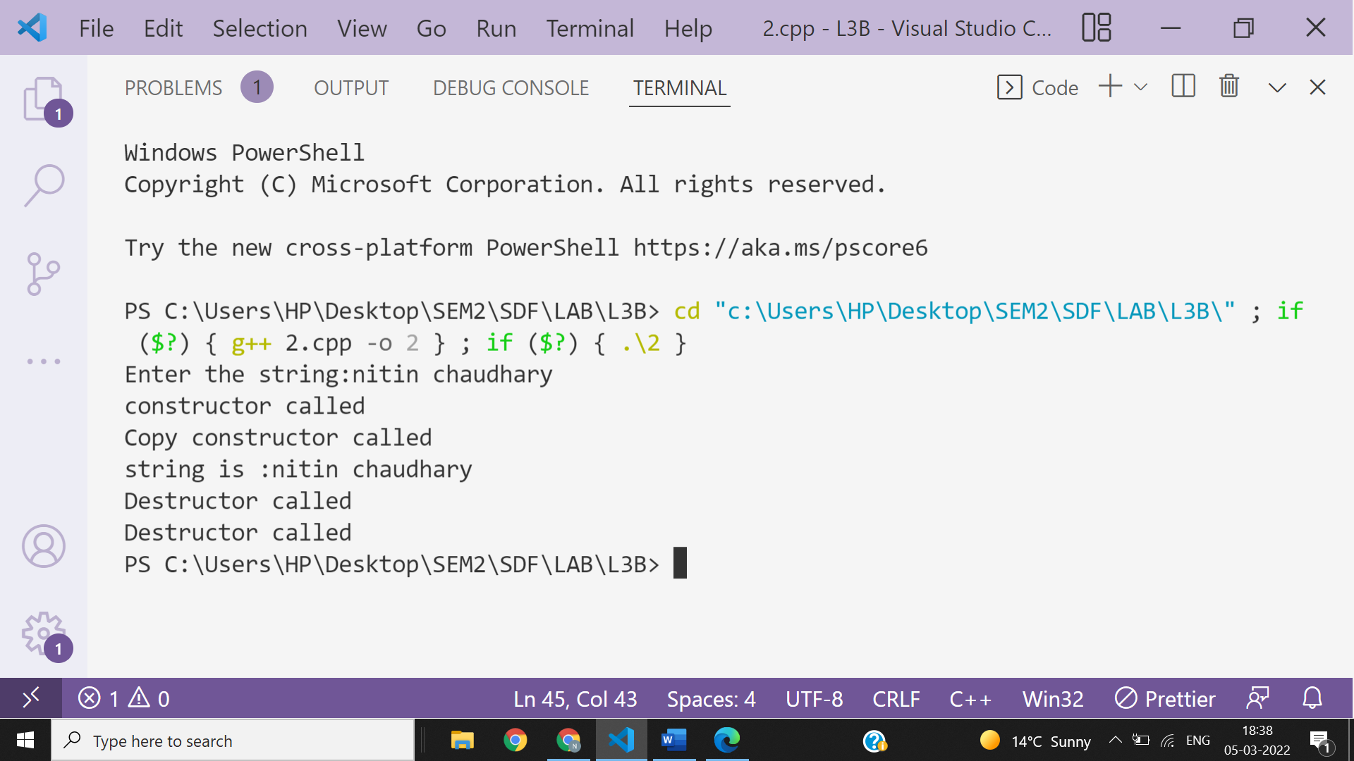

**Ans 3-**

**Output of the given code is-**

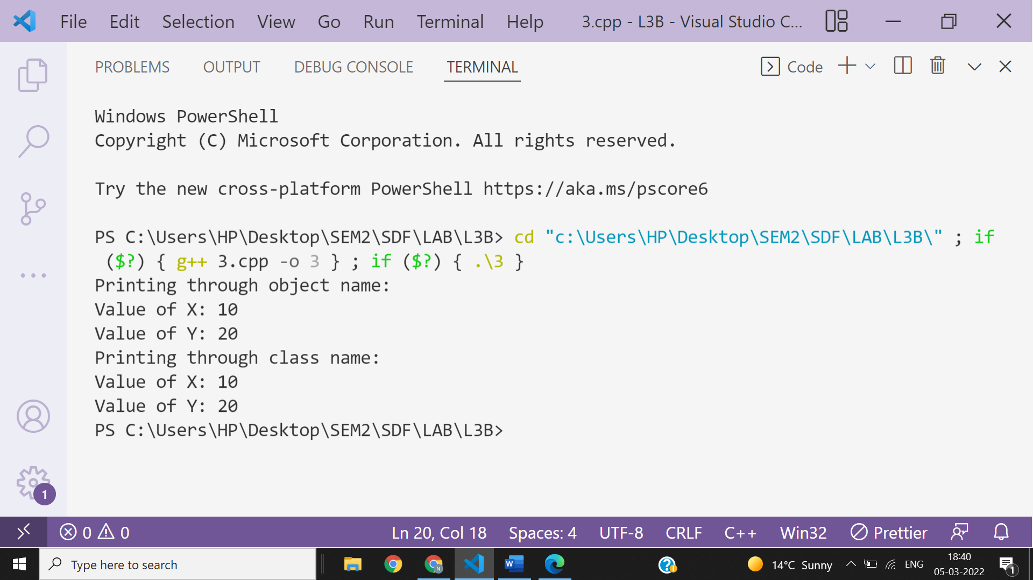

**Ans 4-**

#include<iostream>

using namespace **std**;

class **A**{

private:

int numA=8;

public:

friend void **add**();

};

class **B**{

private:

int numB=12;

public:

friend void **add**();

};

void **add**()

{

int sum;

**A** o1;

**B** o2;

sum=o1.numA+o2.numB;

cout**<<**"sum of private integers of two classes is:"**<<**sum;

}

int **main**()

{cout**<<**"Calling friend function\n";

**add**();

}

