**9921103163**

**NITIN Chaudhary**

**W4**

**F8**

**Ans 1-**

#include <iostream>

using namespace **std**;

class **complex**

{

    int real;

    int imag;

public:

**complex**() {}

**complex**(int a, int b)

    {

        real = a;

        imag = b;

    }

**complex** **operator+**(**complex** obj1)

    {

**complex** temp;

        temp.real = real + obj1.real;

        temp.imag = imag + obj1.imag;

        return temp;

    }

    void **out**()

    {

        cout **<<** "Complex number is" **<<** real **<<** "+i" **<<** imag;

    }

};

int **main**()

{

**complex** **object1**(2, 3), **object2**(4, 5), object3;

    object3 **=** object1.**operator+**(object2);

    object3.**out**();

}

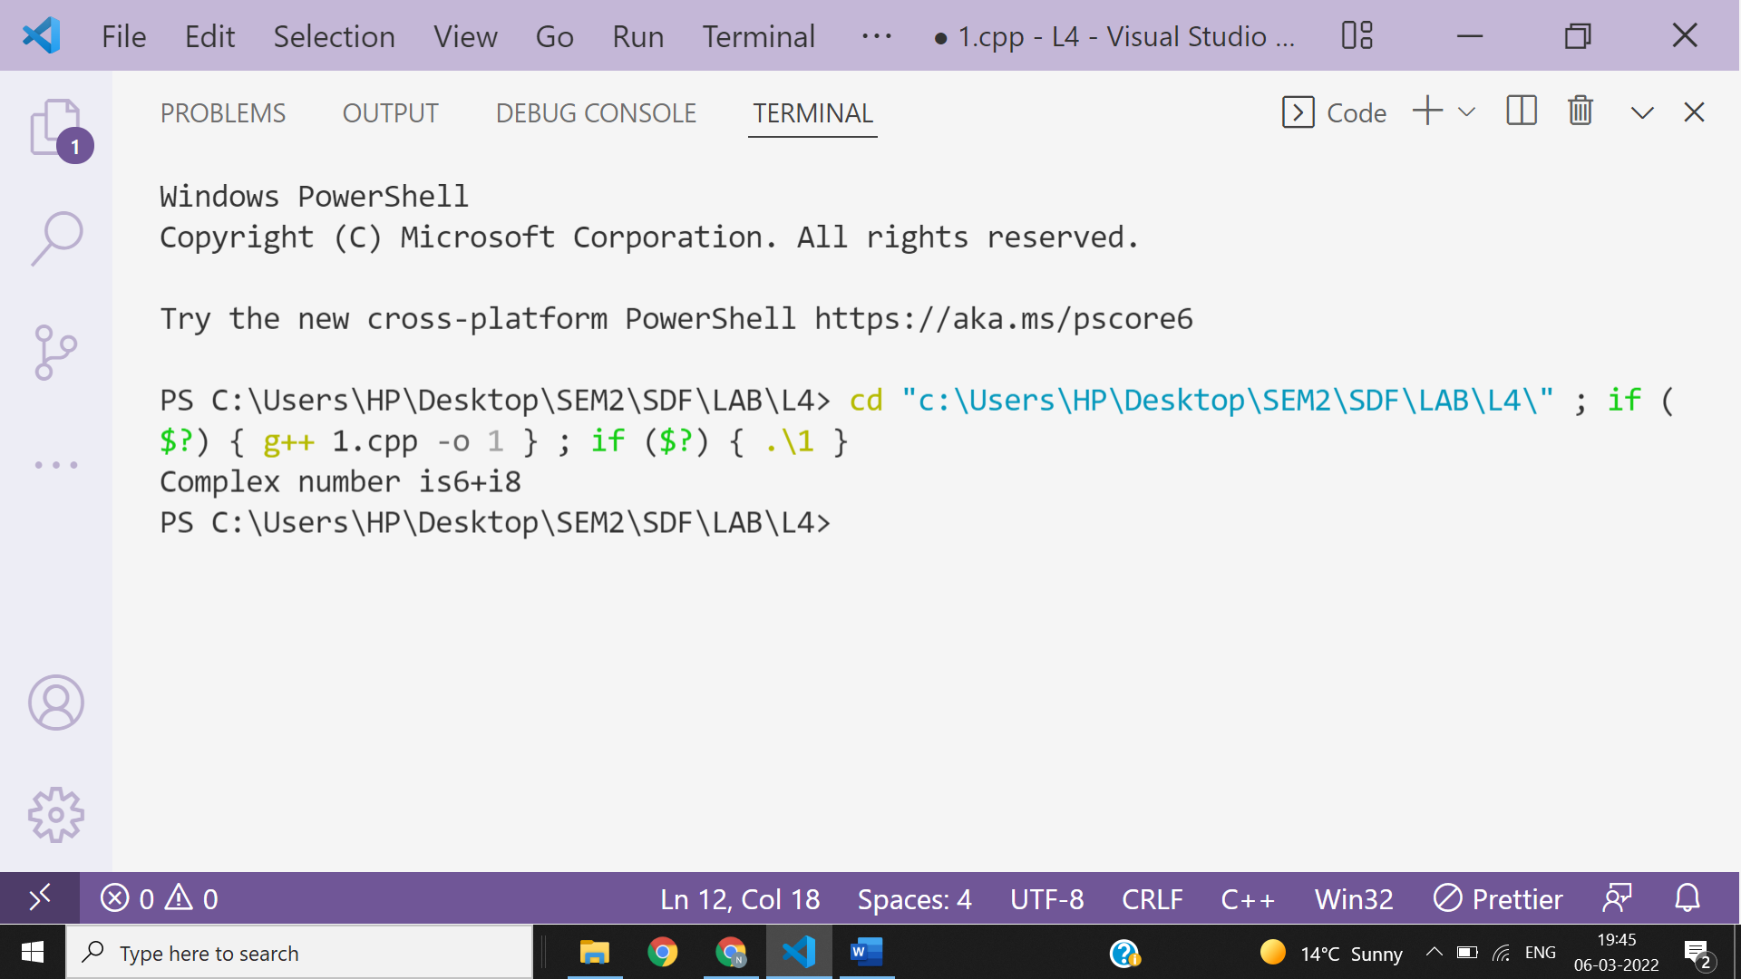

**Ans 2-**

#include<string>

#include<iostream>

using namespace **std**;

class **Box**

{

int capacity;

public:

**Box**(){}

**Box**(double capacity){

this->capacity = capacity;

}

*//defining '<' operator for comparision*

int **operator<**(**Box** obj)

{

    if(capacity<obj.capacity)

    {

        return 1;

    }

    else{

        return 0;

    }

}

};

int **main**(int argc, char const *argv[])

{

**Box** **b1**(10);

**Box** b2=**Box**(14);

if(b1**<**b2){

cout**<<**"Box 2 has large capacity.";

}

else{

cout**<<**"Box 1 has large capacity.";

}

return 0;

}

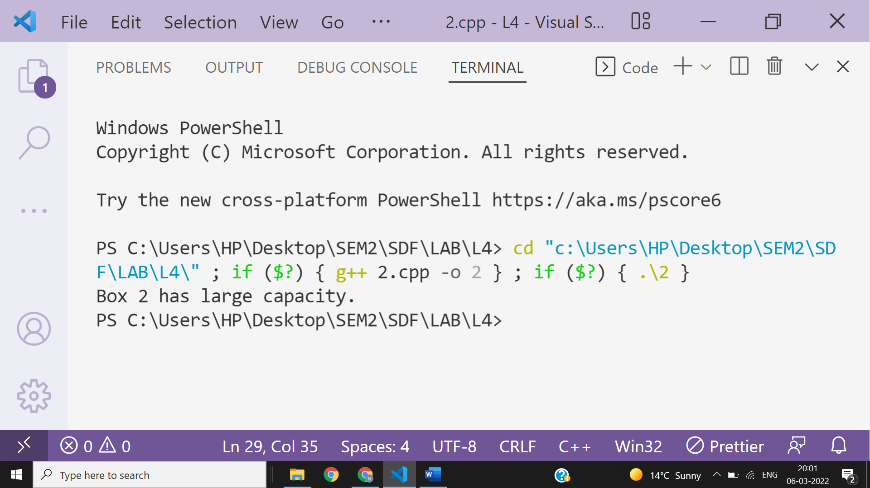

**Ans 3-**

#include <iostream>

using namespace **std**;

class **nitin**

{

    int a;

public:

**nitin**(int n)

    {

        a = n;

    }

    int **operator++**()

    {

        return ++a;

    }

    int **operator++**(int)

    {

        return a++;

    }

};

int **main**()

{

**nitin** **o1**(5);

    cout **<<** o1.**operator++**()**<<endl**;

    cout **<<** **++**o1**<<endl**;

    cout **<<** o1**++<<endl**;

    return 0;

}

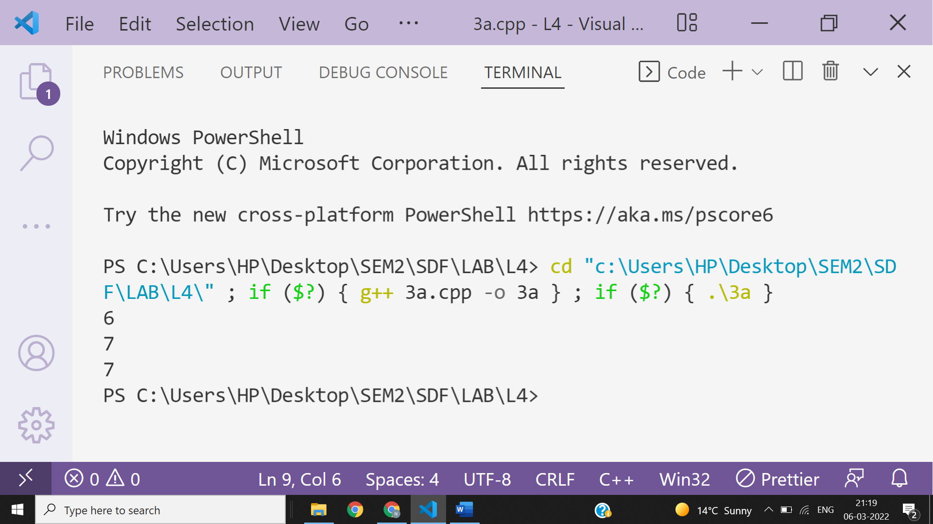

**Ans 4-**

#include <iostream>

using namespace **std**;

class **Teacher** {

public:

**Teacher**(){

 cout**<<**"Hey Guys, I am a teacher"**<<endl**;

 }

**string** collegeName = "Beginnersbook";

};

*//This class inherits Teacher class*

class **MathTeacher**: public **Teacher** {

public:

**MathTeacher**(){

 cout**<<**"I am a Math Teacher"**<<endl**;

 }

**string** mainSub = "Math";

**string** name = "Negan";

};

int **main**() {

**MathTeacher** obj;

 cout**<<**"Name: "**<<**obj.name**<<endl**;

 cout**<<**"College Name: "**<<**obj.collegeName**<<endl**;

 cout**<<**"Main Subject: "**<<**obj.mainSub**<<endl**;

 return 0;

}

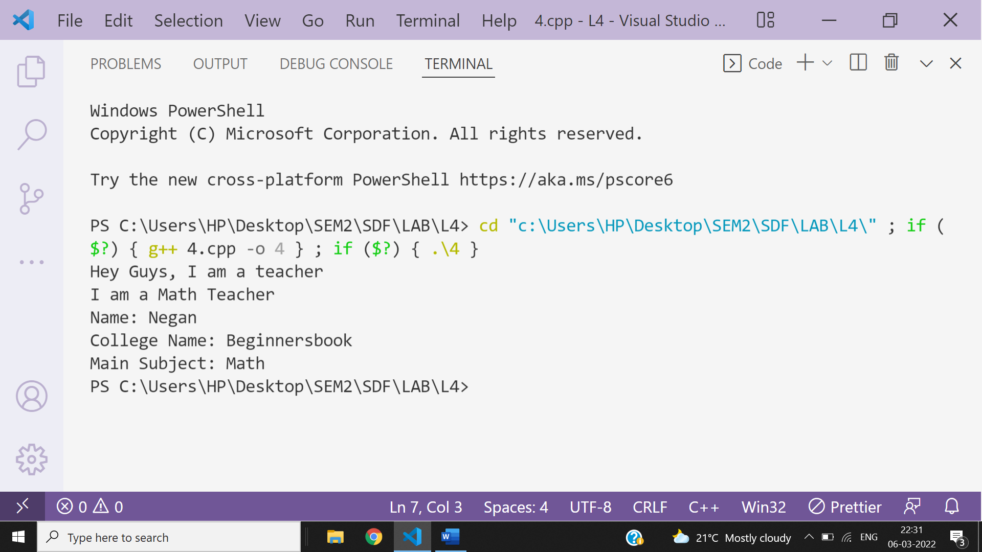

**Ans-5-**

**Ans-9-**

#include<iostream>

using namespace **std**;

class **base** {

int arr[10];

int f;

};

class **b1**: private **base** {int c; };

class **b2**: private **base** {int d; };

class **derived**: public **b1**, public **b2** {};

int **main**(void)

{

**derived** d;

cout **<<** sizeof(d);

return 0;

}

