**NBTG13715**

**Nitin Chaudhary**

**F8**

**Ans 1-**

#include <iostream>

using namespace std;

int main()

{

    int a,s,d;

    cout<<"enter three numbers";

    cin>>a>>s>>d;

    int sum=a+s+d;

    cout<<"SUM:"<<sum<<endl;

    cout<<"AVERAGE:"<<sum/3;

    return 0;

}

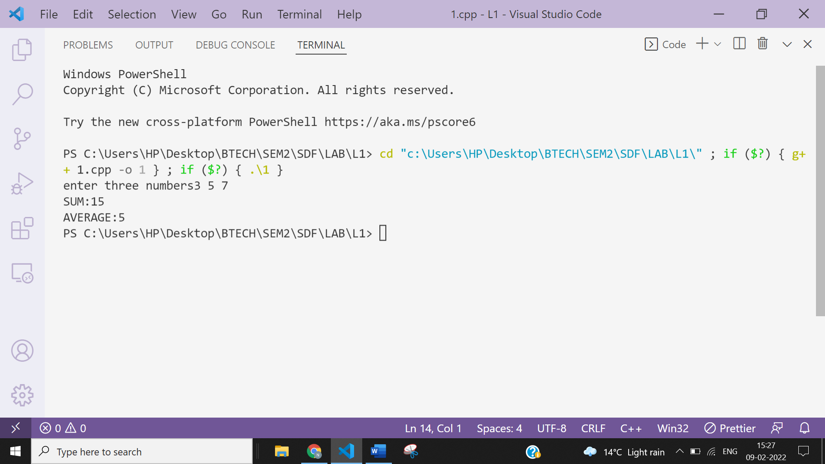

**Ans 2-**

#include <iostream>

using namespace **std**;

int **main**()

{

    int a,s;

    cout<<"enter two numbers";

    cin>>a>>s;

    if(a>s)

    cout<<"Larger "<<a<<endl;

    else

    cout<<"Larger "<<s<<endl;

    return 0;

}

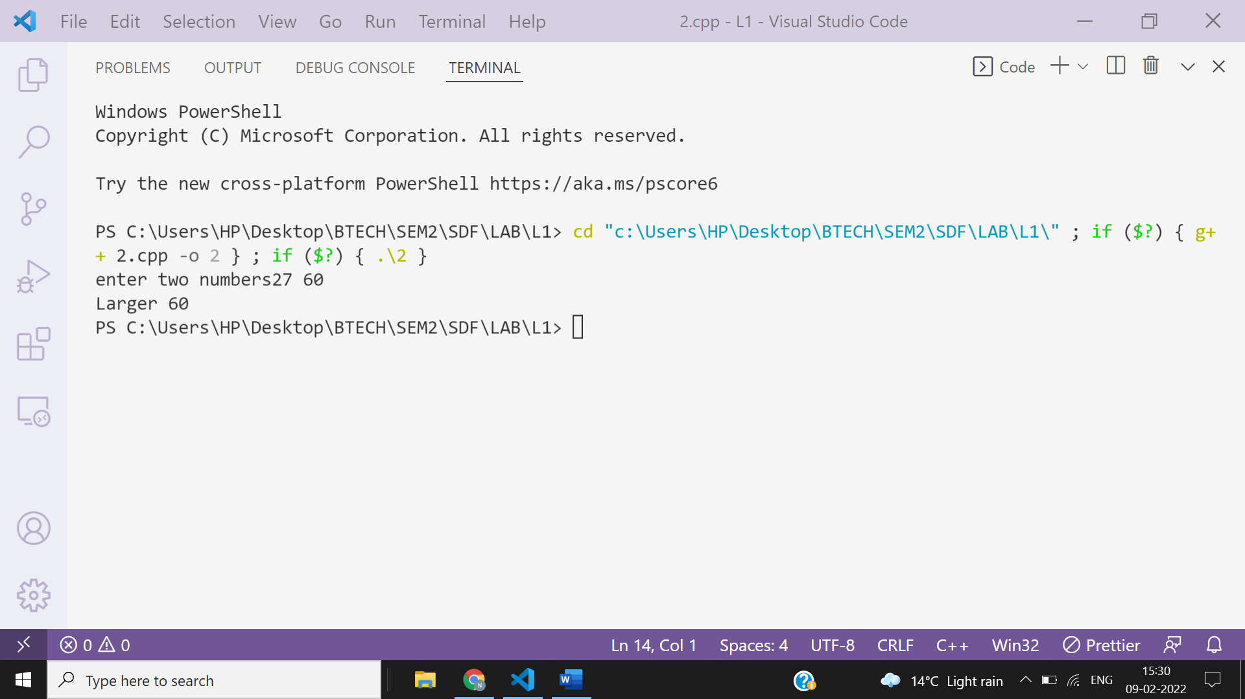

**Ans 3-**

#include <iostream>

using namespace std;

int main()

{

    float a,b,c,d;

    cout<<"enter the values of a,b,c&d";

    cin>>a>>b>>c>>d;

    if(b==c)

    cout<<"division with zero is not possible, try with different input"<<endl;

    else

    {

        float x=a/(b-c)+d;

        cout<<"x=a/(b-c)+d="<<x<<endl;

    }

    return 0;

}

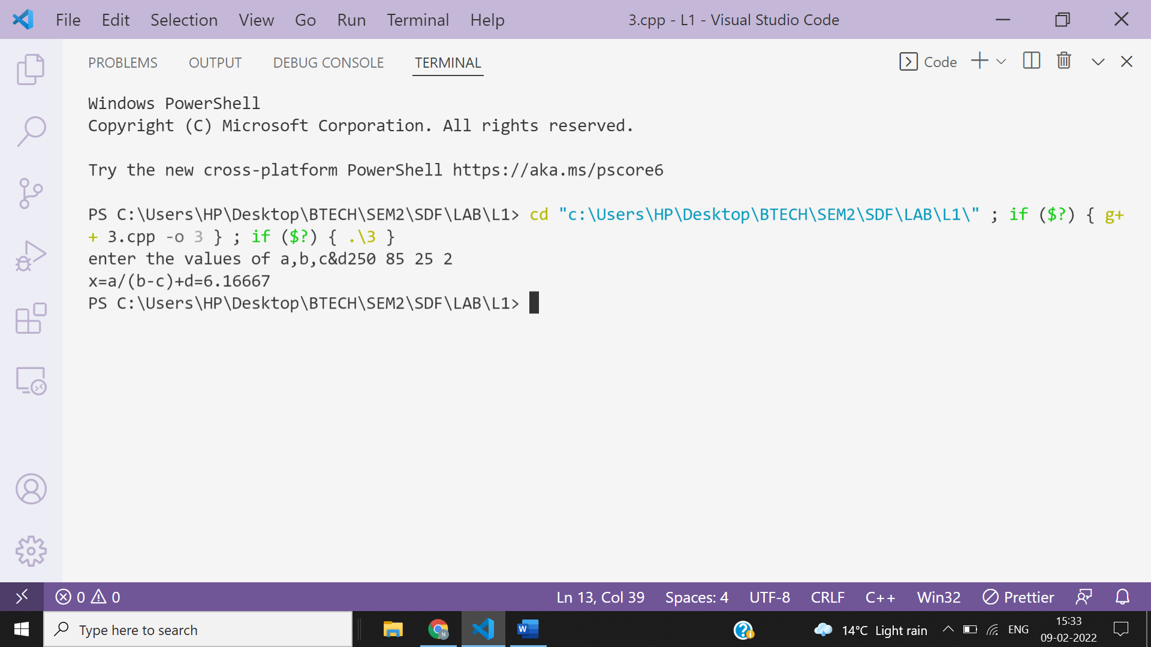

**Ans 4-**

#include<iostream>

using namespace **std**;

int **main**()

{

    int n,ans;

    cout<<"enter how many elements do you want to enter in array";

    cin>>n;

    int a[n];

    cout<<"enter  array elements";

    for(int i=0;i<n;i++)

        cin>>a[i];

     int i=1;

    int count;

    while(true)

    {

        count=0;

        for(int j=0;j<n;j++)

        {

            if(a[j]==i)

            {

                count++;

            }

        }

        if(count==0)

        {

            cout<<i;

            break;

        }

        else

        {

            i++;

        }

    }

}

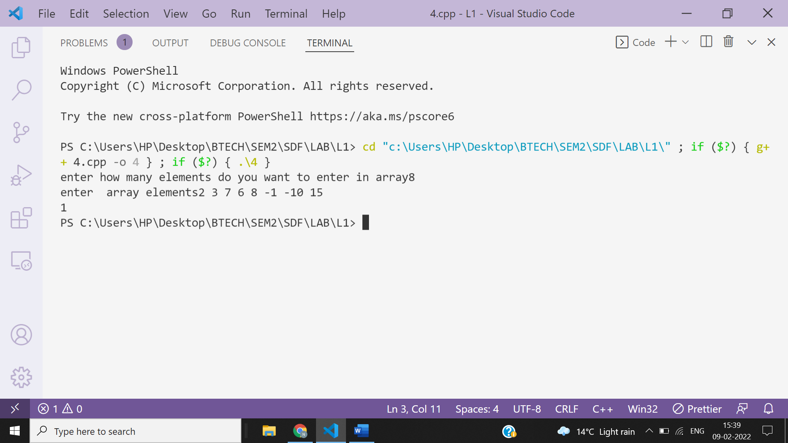

**Ans 5**

#include<iostream>

using namespace **std**;

int **main**()

{

    int n;

    cout<<"enter how many elements do you want to enter in array";

    cin>>n;

    int a[n];

    cout<<"enter  array elements";

    int max=0;

    for(int i=0;i<n;i++)

    {

       cin>>a[i];

       if(max<a[i])

       {

           max=a[i];

       }

    }

    for(int i=2;i<=max;i++)

    {

        int f=0;

        for(int j=2;j<i;j++)

        {

            if(i%j==0)

            {

                f++;

            }

        }

        if(f==0)

        {

            int count=0;

            for(int k=0;k<n;k++)

            {

                if(a[k]==i)

                {

                    count++;

                }

            }

            if(count==0)

            {

                cout<<i<<" is the smallest prime no. which is not present in array";

                break;

            }

            else

            {

                if(i==max)

                {

                    cout<<"No prime no. missing"<<endl<<"As "<<max<<" is the maximum element and all prime numbers upto "<<max<<" are present in the array";

                }

            }

        }

    }

}

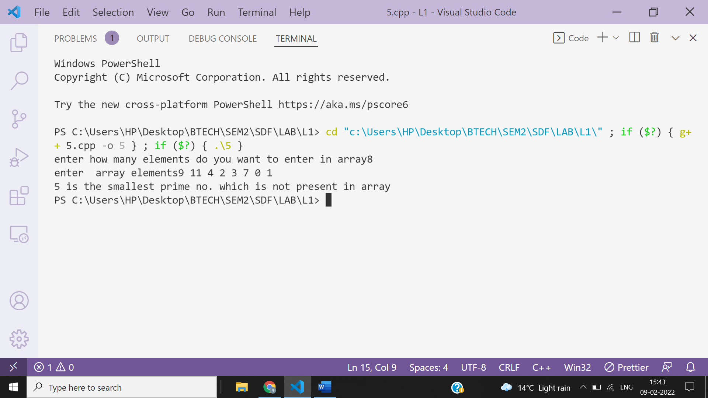

**Ans 6-**

#include<iostream>

using namespace **std**;

int **main**()

{

    int r,c;

    cout<<"enter number of rows";

    cin>>r;

    cout<<"enter number of columns";

    cin>>c;

    int a[r][c],b[r][c];

    cout<<"enter binary array elements";

    for(int i=0;i<r;i++)

    {

        for(int j=0;j<c;j++)

        {

            b[i][j]=0;

        }

    }

    for(int i=0;i<r;i++)

    {

        for(int j=0;j<c;j++)

        {

            cin>>a[i][j];

            if(a[i][j]==1)

            {

                for(int k=0;k<r;k++)

                {

                    b[k][j]=1;

                }

                for(int k=0;k<c;k++)

                {

                    b[i][k]=1;

                }

            }

        }

    }

    cout<<"\ninputted array is\n";

    for(int i=0;i<r;i++)

    {

        for(int j=0;j<c;j++)

        {

            cout<<a[i][j]<<" ";

        }

        cout<<"\n";

    }

    cout<<"\noutput array is\n";

    for(int i=0;i<r;i++)

    {

        for(int j=0;j<c;j++)

        {

            cout<<b[i][j]<<" ";

        }

        cout<<"\n";

    }

}

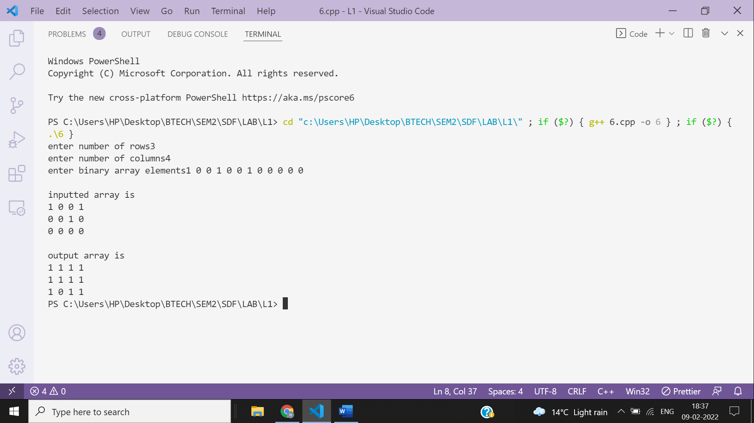

**Ans 7-**

#include<iostream>

using namespace **std**;

struct **details**{

    char name[100];

    int age;

    float salary;

}var;

int **main**()

{

cout<<"Enter full name";

**gets**(var.name);

cout<<"Enter age";

cin>>var.age;

cout<<"Enter salary";

cin>>var.salary;

cout<<"Displaying information\n";

cout<<"Name:"<<var.name;

cout<<"\nAge:"<<var.age;

cout<<"\nSalary:"<<var.salary;

}

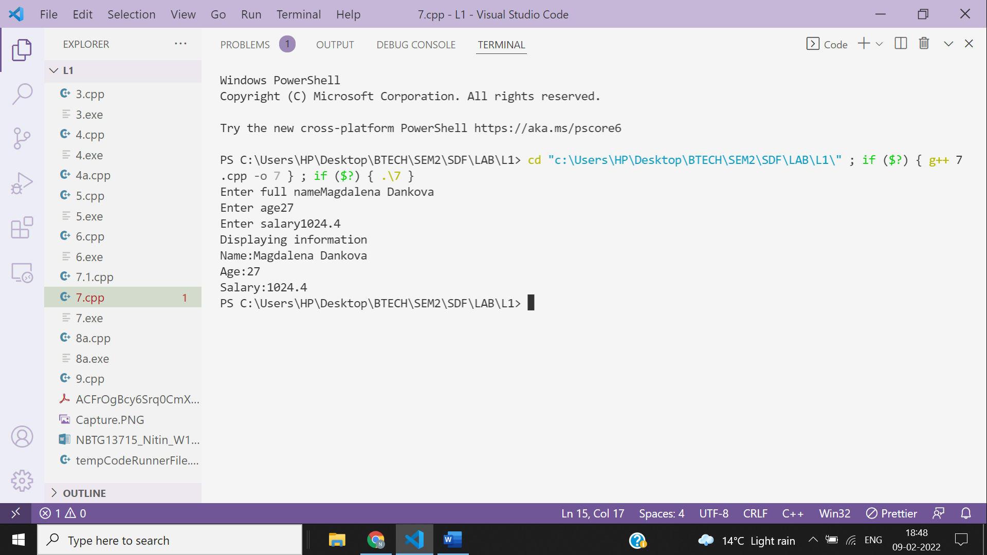

**MODIFIED PROGRAM 7.1-**

#include <iostream>

using namespace **std**;

struct **details**

{

        float basicpay;

        float hra;

        float book_allow;

        float house_allow;

        float spcal_allow;

};

struct **information**

{

        char name[20];

        int age;

        float salary;

        struct **details** income;

}emp;

int **main**()

{

    int total_salary;

            cout**<<**"Enter The Name Of Employee";

**gets**(emp.name);

            cout**<<**"Enter The Age Of Employee";

            cin**>>**emp.age;

            struct **information** *ptr=&emp;

            cout**<<**"Enter The Salary details Of Employee\n";

            cout**<<**"Enter The Basic Of Employee";

            cin**>>**emp.income.basicpay;

            cout**<<**"Enter The HRA Of Employee";

            cin**>>**emp.income.hra;

            cout**<<**"Enter The Book Allowance Of Employee";

            cin**>>**emp.income.book_allow;

            cout**<<**"Enter The House Allowance Of Employee";

            cin**>>**emp.income.house_allow;

            cout**<<**"Enter The Special Allowance Of Employee";

            cin**>>**emp.income.spcal_allow;

            total_salary=(emp.income.basicpay+emp.income.hra+emp.income.book_allow+emp.income.house_allow+emp.income.spcal_allow);

            cout**<<**ptr->name**<<**"\n";

            cout**<<**ptr->age**<<**"\n";

            cout**<<**"Total Salary"**<<**total_salary**<<endl**;

    return 0;

}

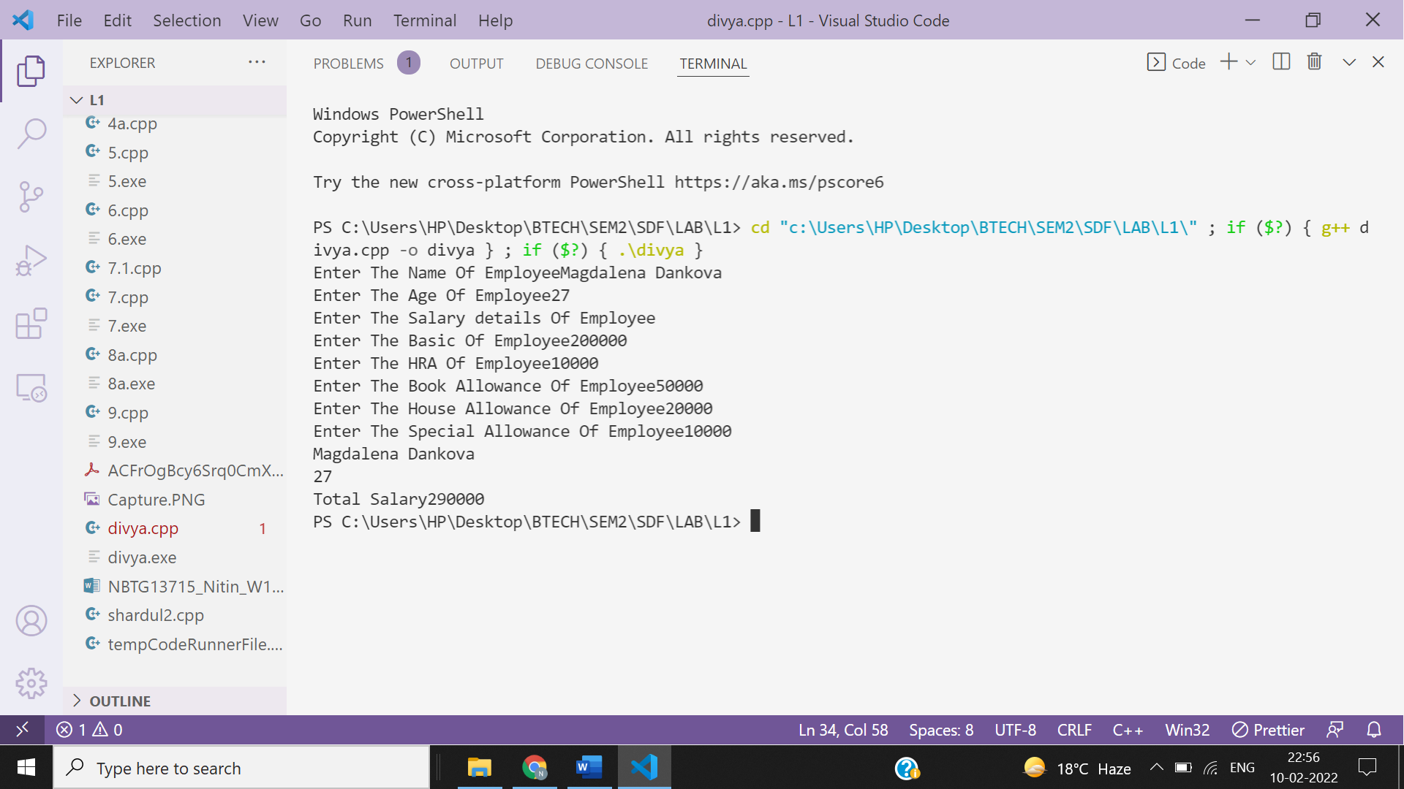

**Ans 8-**

#include<iostream>

using namespace **std**;

struct **phone**{

    int price;

    float battery_power;

    float rating;

};

int **main**()

{

    struct **phone** p1,p2;

    cout<<"enter details of phone 1\n";

    cout<<"Enter Price";

    cin>>p1.price;

    cout<<"\nEnter battery power in mAH";

    cin>>p1.battery_power;

    cout<<"\nEnter rating (0-5)";

    cin>>p1.rating;

    cout<<"\nenter details of phone 2\n";

    cout<<"Enter Price";

    cin>>p2.price;

    cout<<"\nEnter battery power in mAH";

    cin>>p2.battery_power;

    cout<<"\nEnter rating (0-5)";

    cin>>p2.rating;

    if(p1.price<p2.price)

    {

        cout<<"Phone better w.r.t Price is Phone1\n";

    }

    else{

        cout<<"Phone better w.r.t Price is Phone2\n";

    }

    if(p1.battery_power>p2.battery_power)

    {

        cout<<"Phone better w.r.t Battery Power is Phone1\n";

    }

    else{

        cout<<"Phone better w.r.t Battery Power is Phone2\n";

    }

    if(p1.rating>p2.rating)

    {

        cout<<"Phone better w.r.t Rating is Phone1\n";

    }

    else{

        cout<<"Phone better w.r.t Rating is Phone2\n";

    }

}

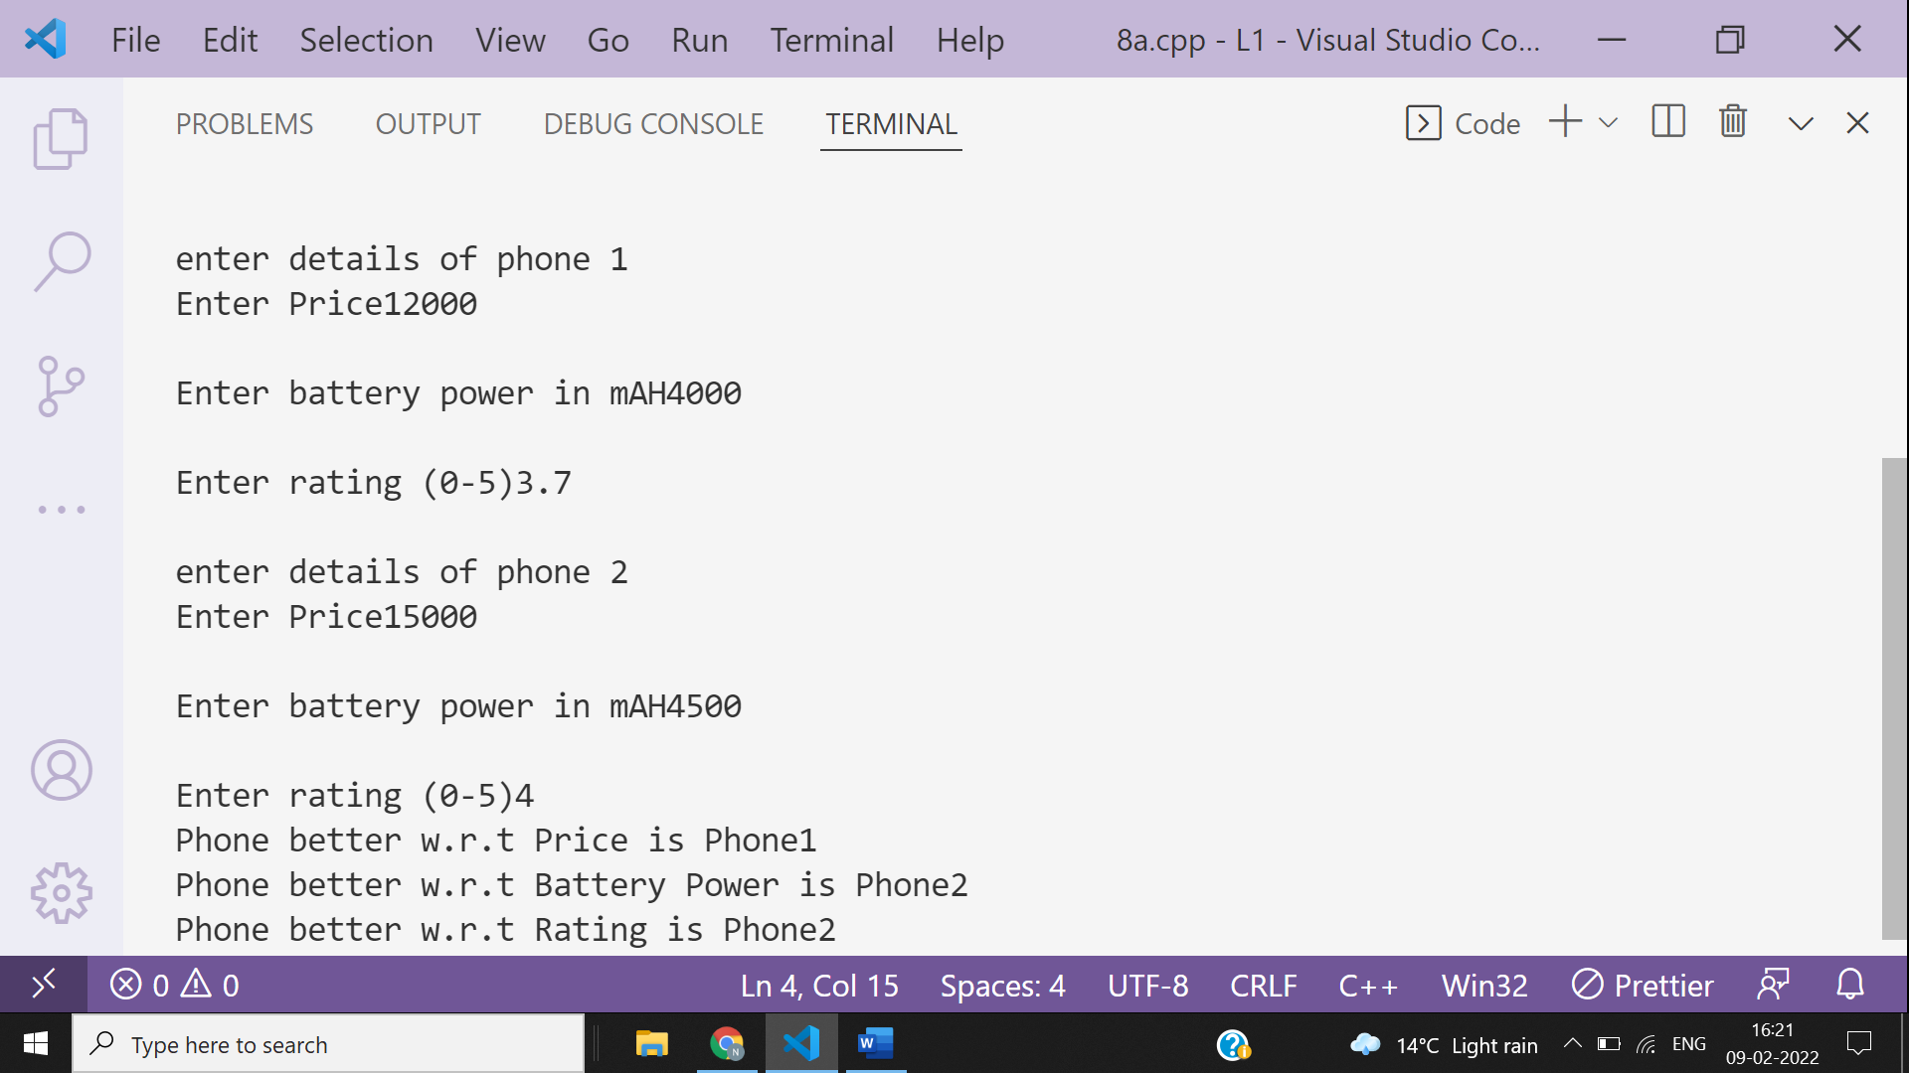

**Ans 9-**

#include <iostream>

using namespace **std**;

int **main**()

{

int n,m;

cout **<<** "\nInput the number of rows : ";

cin **>>** m;

cout **<<** "\nInput the number of columns : ";

cin **>>** n;

int arr[m][n];

int i,j;

cout **<<** "\nInput the matrix \n";

for(i = 0; i < m; i++)

{

for(j = 0; j < n; j++)

{

cin >> arr[i][j];

}

}

cout **<<** "\nThe Matrix is \n";

for(i = 0; i < m; i++)

{

for(j = 0; j < n; j++)

{

cout << arr[i][j] <<" ";

}

cout **<<** **endl**;

}

cout **<<** "\nSpiral Matrix :";

int k = 0, l = 0;

while(k < m && l < n)

{

for(i = l; i < n; i++)

{

cout << arr[k][i] <<" ";

}

k++;

for(i = k; i < m; i++)

{

cout << arr[i][n-1] <<" ";

}

n--;

if(k < m)

{

for(i = n - 1; i >= 0; --i)

{

cout << arr[m-1][i] <<" ";

}

m--;

}

if(l < n)

{

for(i = m - 1; i >= k; i--)

{

cout << arr[i][l] <<" ";

}

l++;

}

}

cout **<<** **endl**;

return 0;

}

