ACL
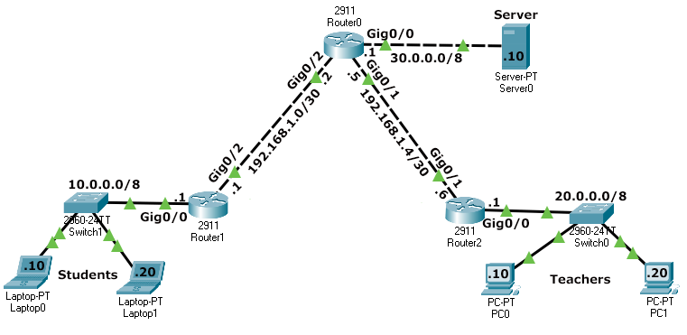
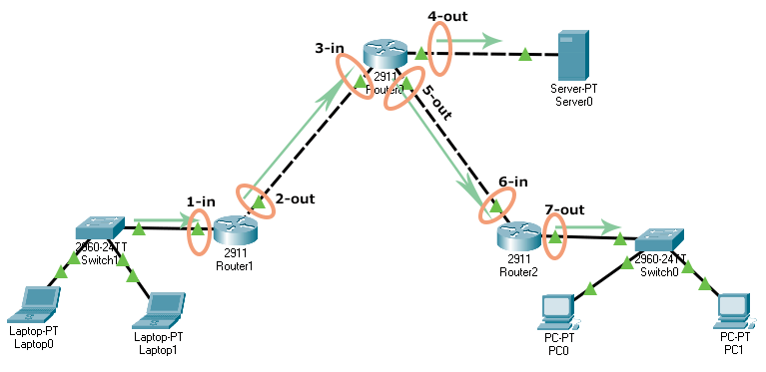
The 'ip access-list' is a global configuration mode command. To create a standard access list, it uses the following syntax.
Router(config)# ip access-list standard ACL_#

In the above syntax, the ACL_# is the name or number of the standard ACL. When you hit the enter key after entering this command, the command prompt changes and you enter standard ACL configuration mode.
Router(config-std-acl)#

In standard ACL configuration mode, you can use the following syntax to create statements.
Router(config)# ip access-list standard ACL_name
Router(config-std-acl)# permit|deny source_IP_address [wildcard_mask]

An ACL does nothing until it is applied to an interface. To apply a standard ACL to an interface, enter the interface configuration mode of the interface and use the following command.

Creating a standard ACL
Access the command prompt of Router0 and run the following commands.
Router(config)# interface type [slot_#]port_#
Router(config-if)# ip access-group ACL_# in|out
Router>
Router>enable
Router#configure terminal
Enter configuration commands, one per line. End with CNTL/Z.
Router(config)#ip access-list standard BlockStudents
Router(config-std-nacl)#deny 10.0.0.0 0.255.255.255
Router(config-std-nacl)#permit any
Router(config-std-nacl)#exit
Router(config)#interface gigabitethernet 0/0
Router(config-if)#ip access-group BlockStudents out
Router(config-if)#exit
Router(config)#exit
Router#

Deleting a standard ACL
To delete a standard ACL, use the following command in global configuration mode.
Router(config)no ip access-list standard ACL_#

