МИНИСТЕРСТВО НАУКИ И ВЫСШЕГО ОБРАЗОВАНИЯ РОССИЙСКОЙ ФЕДЕРАЦИИ

ФЕДЕРАЛЬНОЕ ГОСУДАРСТВЕННОЕ БЮДЖЕТНОЕ ОБРАЗОВАТЕЛЬНОЕ УЧРЕЖДЕНИЕ ВЫСШЕГО ОБРАЗОВАНИЯ

**«БЕЛГОРОДСКИЙ ГОСУДАРСТВЕННЫЙ ТЕХНОЛОГИЧЕСКИЙ УНИВЕРСИТЕТ им. В. Г. ШУХОВА»**

**(БГТУ им. В.Г. Шухова)**

Кафедра программного обеспечения вычислительной техники и автоматизированных систем

**Лабораторная работа №14**

по дисциплине: Объектно-ориентированное программирование Тема: Тестирование. Знакомство с TDD. Тесты как способ формирования архитектуры

Выполнил: студент группы ПВ-223

Дмитриев А.А.

Проверил:

Черников С.В.

Белгород 2024 г.

**Цель работы:** знакомство с понятием тестирования. Получение практических навыков для написания модульных тестов.

**Задание:**

Разработать программу на языке программирования Python и

модульные тесты с использованием библиотеки pytest в соответствии с

вариантом задания.

Задание на разработку ПО в лабораторной состоит из двух частей

(начальные условия задачи, финальные условия задачи). В Таблице 1

приведены условия задач.

**Вариант 2:**

|  |  |
| --- | --- |
| Разработать подсистему для стрельбы из игрового оружия. «Игровое оружие» может выполнять стрельбу, и имеет возможность отображать себя на экран | Теперь оружие получает  способность перезарядки.  Появляется такой вид оружие, как  нож. |

Код (Тесты 1):

from pytest import *  
  
from begin.item import *  
from begin.player import Player  
from begin.window import *  
  
  
@mark.parametrize("players_team_first, players_team_second",  
 [  
 (  
 [Player("C", 150, AK74(), (6, 7))],  
 [Player("A", 90, AK74(), (0, 0)),  
 Player("B", 100, TT(), (0, 2))]  
 )  
 ], )  
def test_add_players(players_team_first, players_team_second):  
 window = Window()  
 env = window.get_environment()  
  
 for player in players_team_first:  
 env.add_player_to_team_first(player)  
  
 for player in players_team_second:  
 env.add_player_to_team_second(player)  
  
 assert env.team_first == players_team_first  
 assert env.team_second == players_team_second  
  
  
@mark.parametrize("player, result",  
 [  
 (  
 Player("C", 150, AK74(), (6, 7)),  
 f"Pl: C HP: 150",  
 ),  
 (  
 Player("E", 100, TT(), (6, 7)),  
 f"Pl: E HP: 100",  
 )  
 ])  
def test_display_player(player, result):  
 assert player.display() == result  
  
  
@mark.parametrize("player, result",  
 [  
 (  
 Player("C", 150, AK74(), (6, 7)),  
 "AK74",  
 ),  
 (  
 Player("E", 100, TT(), (6, 7)),  
 "TT",  
 )  
 ])  
def test_display_item_of_player(player, result):  
 assert player.item.display() == result  
  
  
@mark.parametrize("attacker, defender, result",  
 [  
 (  
 Player("C", 150, AK74(), (6, 7)),  
 Player("E", 100, TT(), (6, 7)),  
 60,  
 ),  
 (  
 Player("C", 150, AK74(), (6, 7)),  
 Player("E", 10, TT(), (6, 7)),  
 0,  
 )  
 ])  
def test_attack(attacker, defender, result):  
 attacker.use_on(defender)  
 assert defender.hp == result

Код (Исходник 1):

class DisplayBehavior:  
 def display(self) -> str: pass  
  
  
class DisplayAK74(DisplayBehavior):  
 def display(self):  
 return "AK74"  
  
  
class DisplayTT(DisplayBehavior):  
 def display(self):  
 return "TT"  
  
class Environment:  
 def __init__(self):  
 self.team_first = []  
 self.team_second = []  
  
 self.battleMap = []  
  
 @staticmethod  
 def distance_to(player, target):  
 return math.sqrt((player.coord[0] - target.coord[0]) ** 2 + (player.coord[1] - target.coord[1]) ** 2)  
  
 @staticmethod  
 def comp_hp(player, delta_hp):  
 player.hp += delta_hp  
  
 def add_player_to_team_first(self, player):  
 self.add_player_to_team(player, self.team_first)  
  
 def add_player_to_team_second(self, player):  
 self.add_player_to_team(player, self.team_second)  
  
 @staticmethod  
 def add_player_to_team(player, team: list):  
 team.append(player)  
  
 def remove_player_from_team_first(self, player):  
 self.remove_player_from_team(player, self.team_first)  
  
 def remove_player_from_team_second(self, player):  
 self.remove_player_from_team(player, self.team_second)  
  
 @staticmethod  
 def remove_player_from_team(player, team: list):  
 team.remove(player)  
  
 def move_player(self, player, coord: tuple):  
 pass  
  
class Item(UseBehavior, DisplayBehavior):  
 def __init__(self, use_behavior, display_behavior):  
 self.use_behavior = use_behavior  
 self.display_behavior = display_behavior  
  
 def use_on(self, player, target):  
 self.use_behavior.use_on(player, target)  
  
 def display(self):  
 return self.display_behavior.display()  
  
  
class AK74(Item):  
 def __init__(self):  
 super().__init__(DistanceAttack(), DisplayAK74())  
  
  
class TT(Item):  
 def __init__(self):  
 super().__init__(DistanceAttack(), DisplayTT())

class Direction:  
 UP = (0, -1)  
 DOWN = (0, 1)  
 LEFT = (-1, 0)  
 RIGHT = (1, 0)  
  
  
class Player(DisplayBehavior):  
 def __init__(self, name: str, hp: int, item: Item, coord: tuple):  
 self.name = name  
 self.hp = hp  
 self.item = item  
 self.coord = coord  
  
 def display(self):  
 return f"Pl: {self.name} HP: {self.hp}"  
  
 def use_on(self, target):  
 self.item.use_on(self, target)  
  
 def move(self, direction: Direction, steps):  
 pass

class UseBehavior:  
  
 def use_on(self, player, target): pass  
  
  
class DistanceAttack(UseBehavior):  
 def use_on(self, player, target):  
 if Environment.distance_to(player, target) < 10:  
 Environment.comp_hp(target, -40 if target.hp > 40 else -target.hp)

from begin.environment import Environment  
  
  
class Window:  
 def __init__(self):  
 self.environment = Environment()  
 # some logic for displaying  
  
 def get_environment(self):  
 return self.environment  
  
 def display_to_window(self, object):  
 pass

Код (Тесты 2):

from pytest import *  
  
from finish.item import *  
from finish.player import Player  
from finish.window import *  
  
  
@mark.parametrize("players_team_first, players_team_second",  
 [  
 (  
 [Player("C", 150, AK74(), (6, 7))],  
 [Player("A", 90, AK74(), (0, 0)),  
 Player("B", 100, TT(), (0, 2))]  
 )  
 ], )  
def test_add_players(players_team_first, players_team_second):  
 window = Window()  
 env = window.get_environment()  
  
 for player in players_team_first:  
 env.add_player_to_team_first(player)  
  
 for player in players_team_second:  
 env.add_player_to_team_second(player)  
  
 assert env.team_first == players_team_first  
 assert env.team_second == players_team_second  
  
  
@mark.parametrize("player, result",  
 [  
 (  
 Player("C", 150, AK74(), (6, 7)),  
 f"Pl: C HP: 150",  
 ),  
 (  
 Player("E", 100, TT(), (6, 7)),  
 f"Pl: E HP: 100",  
 )  
 ])  
def test_display_player(player, result):  
 assert player.display() == result  
  
  
@mark.parametrize("player, result",  
 [  
 (  
 Player("C", 150, AK74(), (6, 7)),  
 "AK74",  
 ),  
 (  
 Player("E", 100, TT(), (6, 7)),  
 "TT",  
 )  
 ])  
def test_display_item_of_player(player, result):  
 assert player.item.display() == result  
  
  
@mark.parametrize("player, target, result",  
 [  
 (  
 Player("C", 150, AK74(), (6, 7)),  
 Player("E", 100, TT(), (6, 7)),  
 60,  
 ),  
 (  
 Player("C", 150, AK74(), (6, 7)),  
 Player("E", 10, TT(), (6, 7)),  
 0,  
 ),  
 (  
 Player("C", 150, AK74(), (0, 0)),  
 Player("E", 10, TT(), (20, 20)),  
 10,  
 )  
 ])  
def test_attack(player, target, result):  
 player.use_on(target)  
 assert target.hp == result  
  
  
@mark.parametrize("player, target, result",  
 [(  
 Player("C", 150, Knife(), (7, 7)),  
 Player("E", 100, AK74(), (7, 7)),  
 0  
 )]  
 )  
def test_knife_attack(player, target, result):  
 player.use_on(target)  
 assert target.hp == result  
  
  
@mark.parametrize("player, result",  
 [(  
 Player("C", 150, Knife(), (6, 7)),  
 "Knife"  
 )]  
 )  
def test_knife_display(player, result):  
 assert player.item.display() == result  
  
  
@mark.parametrize("player",  
 [(  
 Player("A", 150, AK74(), (6, 7))  
 )]  
 )  
def test_reload(player):  
 temp_player = Player("C", 100, AK74(), (6, 7))  
 while player.item.ammunition_behavior.curr_ammo > 0:  
 player.use_on(temp_player)  
  
 other_player = Player("D", 100, Knife(), (6, 7))  
 player.use_on(other_player)  
  
 assert player.item.ammunition_behavior.curr_ammo == 0  
 assert other_player.hp == 100  
  
 player.reload()  
 player.use_on(other_player)  
  
 assert player.item.ammunition_behavior.curr_ammo == player.item.ammunition_behavior.max_ammo - 1  
 assert other_player.hp != 100

Код (Исходник 2):

class AmmunitionBehavior:

def spend_ammo(self) -> bool: pass  
  
 def reload(self): pass  
  
  
class AmmunitionOn30(AmmunitionBehavior):  
 curr_ammo = 30  
 max_ammo = 30  
  
 def spend_ammo(self):  
 if self.curr_ammo > 0:  
 self.curr_ammo -= 1  
 return True  
  
 return False  
  
 def reload(self):  
 self.curr_ammo = self.max_ammo  
  
  
class AmmunitionOn8(AmmunitionBehavior):  
 curr_ammo = 8  
 max_ammo = 8  
  
 def spend_ammo(self):  
 if self.curr_ammo > 0:  
 self.curr_ammo -= 1  
 return True  
  
 return False  
  
 def reload(self):  
 self.curr_ammo = self.max_ammo  
  
  
class NoAmmunition(AmmunitionBehavior):  
 def spend_ammo(self):  
 return True  
  
 def reload(self):  
 pass

class DisplayBehavior:  
 def display(self) -> str: pass  
  
  
class DisplayAK74(DisplayBehavior):  
 def display(self):  
 return "AK74"  
  
  
class DisplayTT(DisplayBehavior):  
 def display(self):  
 return "TT"  
  
  
class DisplayKnife(DisplayBehavior):  
 def display(self):  
 return "Knife"  
  
  
class Environment:  
 def __init__(self):  
 self.team_first = []  
 self.team_second = []  
  
 self.battleMap = []  
  
 @staticmethod  
 def distance_to(player, target):  
 return math.sqrt((player.coord[0] - target.coord[0]) ** 2 + (player.coord[1] - target.coord[1]) ** 2)  
  
 @staticmethod  
 def comp_hp(player, delta_hp):  
 player.hp += delta_hp  
  
 def add_player_to_team_first(self, player):  
 self.add_player_to_team(player, self.team_first)  
  
 def add_player_to_team_second(self, player):  
 self.add_player_to_team(player, self.team_second)  
  
 @staticmethod  
 def add_player_to_team(player, team: list):  
 team.append(player)  
  
 def remove_player_from_team_first(self, player):  
 self.remove_player_from_team(player, self.team_first)  
  
 def remove_player_from_team_second(self, player):  
 self.remove_player_from_team(player, self.team_second)  
  
 @staticmethod  
 def remove_player_from_team(player, team: list):  
 team.remove(player)  
  
 def move_player(self, player, coord: tuple):  
 pass

from finish.ammunition_behavior import AmmunitionBehavior, AmmunitionOn30, AmmunitionOn8, NoAmmunition  
from finish.use_behavior import DistanceAttack, UseBehavior, MeleeAttack  
from finish.display_behavior import DisplayAK74, DisplayTT, DisplayBehavior, DisplayKnife  
  
  
class Item(UseBehavior, DisplayBehavior, AmmunitionBehavior):  
 def __init__(self, use_behavior, display_behavior, ammunition_behavior):  
 self.use_behavior = use_behavior  
 self.display_behavior = display_behavior  
 self.ammunition_behavior = ammunition_behavior  
  
 def use_on(self, player, target):  
 if self.ammunition_behavior.spend_ammo():  
 self.use_behavior.use_on(player, target)  
  
 def display(self):  
 return self.display_behavior.display()  
  
 def reload(self):  
 self.ammunition_behavior.reload()  
  
  
class AK74(Item):  
 def __init__(self):  
 super().__init__(DistanceAttack(), DisplayAK74(), AmmunitionOn30())  
  
  
class TT(Item):  
 def __init__(self):  
 super().__init__(DistanceAttack(), DisplayTT(), AmmunitionOn8())  
  
  
class Knife(Item):  
 def __init__(self):  
 super().__init__(MeleeAttack(), DisplayKnife(), NoAmmunition())

class Direction:  
 UP = (0, -1)  
 DOWN = (0, 1)  
 LEFT = (-1, 0)  
 RIGHT = (1, 0)  
  
  
class Player(DisplayBehavior):  
 def __init__(self, name: str, hp: int, item: Item, coord: tuple):  
 self.name = name  
 self.hp = hp  
 self.item = item  
 self.coord = coord  
  
 def display(self):  
 return f"Pl: {self.name} HP: {self.hp}"  
  
 def use_on(self, target):  
 self.item.use_on(self, target)  
  
 def reload(self):  
 self.item.reload()  
  
 def move(self, direction: Direction, steps):  
 pass

class UseBehavior:  
  
 def use_on(self, player, target): pass  
  
  
class DistanceAttack(UseBehavior):  
 def use_on(self, player, target):  
 if Environment.distance_to(player, target) < 10:  
 Environment.comp_hp(target, -40 if target.hp > 40 else -target.hp)  
  
  
class MeleeAttack(UseBehavior):  
 def use_on(self, player, target):  
 if Environment.distance_to(player, target) <= 1:  
 Environment.comp_hp(target, -200 if target.hp > 200 else -target.hp)

Пример работы:

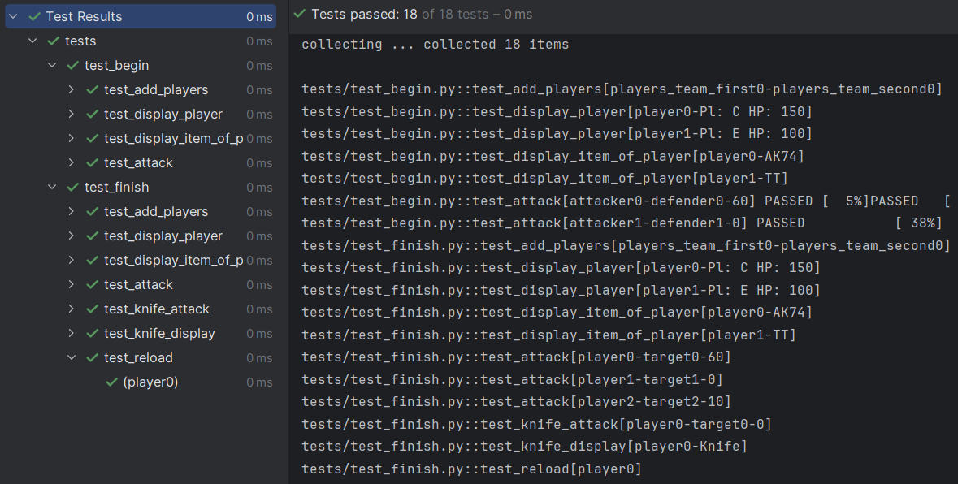

**Вывод:** В ходе лабораторной работы познакомились с понятием тестирования. Получили практические навыки для написания модульных тестов.