SWE 574 Software Development as a Team, Fall 2014
Instructor: Suzan Uskudarlı

WBLH: Web Based Living History Application
Requirements Specifications Document

10.10.2014
Revision 1.0

By: Eser Gökçe Karaca
Student Id: 2013719078

Revision | Date | Explanation
1.0 | 10.10.2014 | Initial Requirements

Table of Contents

Table of Contents 3
1. Introduction 4
2. Requirements List 4
2.1 Functional Requirements 4
2.1.1 Functional Requirements for User 4
2.2 Data Requirements 4
2.3 Non-Functional Requirements 5
2.3.1 Security 5
2.3.2 Configuration 5
2.3.4 Environment 5
3. Actors & Use Cases (Function Groups) 5
4. Function Definitions 6
4.1 Participant Functions 6
4.2 Administrator Functions 7
5. Glossary 7
6. Initial Structure 8
7. References 8

1. Introduction

This software specifications document is a guideline for designers and developers regarding the functions served by the system. The purpose of this software project is to develop a web based system regarding people’s memories using the programming language Java, and MySQL environment, to do mainly the following:

- Users should be able to describe a location and time based memory. The descriptions will include a place (or several places if appropriate), the time, and the exact description of the memory.
- Memories should be able to be located via searching and browsing. Search by location, time and person should be supported by the application.
- Users should be able to make comments on the memories.

The Web based system functions and user interface details are given in the following sections of this document.

2. Requirements List

2.1 Functional Requirements

2.1.1 Functional Requirements for User
No Use Cases(s) Requirement
1. DisplayMemories Use Case To display memories for a selected time and place
2. EnterMemory Use Case To enter a new memory for a specific time and place
3. UpdateMemory Use Case To display & update/modify information entered for a special memory
4. SearchMemory Use Case To search for other people’s memories based on location, time or person
5. CommentMemory Use Case To make comments on a specific memory

2.2 Data Requirements

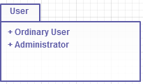
Package Diagram of “User” Class

The class “Ordinary User” that exist in the system is illustrated below.
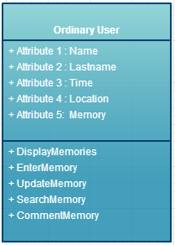

2.3 Non-Functional Requirements

2.3.1 Security
No security requirements have been provided by the customer yet.

2.3.2 Configuration
All relevant information should be able to be exported in RDF for interoperability purposes.
The application should have a web and an Android based mobile client.

2.3.4 Environment
Server side: Java
Database: MySQL
The hosting will be provided by the customer.

3. Actors & Use Cases (Function Groups)

Actor Description
Ordinary User Any person that uses the system by entering new memories or viewing existing memories
Administrator The administrator of the system that manages the web based database and has additional privileges compared to an ordinary user

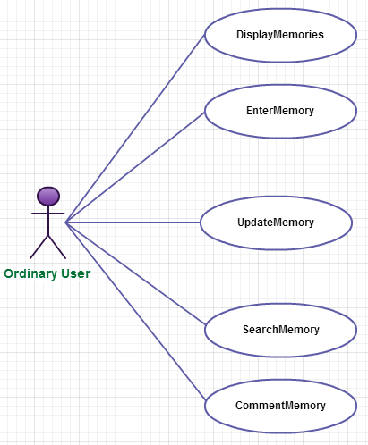

4. Function Definitions

4.1 Participant Functions

No Use Case Description
1. DisplayMemories
- This function displays memories.
- Any user may invoke this functio.
- The memory categorization is based on 2 aspects: time & location. Advanced search by location, time and person is supported.
- There are buttons to display previous and next memories for each location and to return to main menu.

2. EnterMemory
- This function enables the user to describe a location and time based memory.
- For each location, different memories can be entered according to the person and time criteria.
- The user should enter a place, time and description for the memory.
- Several places can be entered for the same memory.
- The user is able to enter a memory description using multimedia elements (text, pictures, videos, sound recordings)

3. UpdateMemory
- The user of a memory is able to update the information related to his/her memory.

- SearchMemory
- This function enables the users to search for memories with specific features.
- The memories can be located via searching and browsing.
- Advanced search by location, time and person are supported by the application.
- A map showing the location of the memory is presented using Openstreetmap at the time of viewing a memory.

5. CommentMemory
- This function enables the users to respond to or comment on the existing memories.

4.2 Administrator Functions
The administrator functions are not yet described by the customer.

- Glossary
Term Description
Memory In psychology, memory is the process in which information is encoded, stored, and retrieved.

- Initial Structure
Initial structure of the system depends on packages that include related use cases.
In this system, these are ordinary user and administrator subsystem packages, both of which access the memory application’s database system.

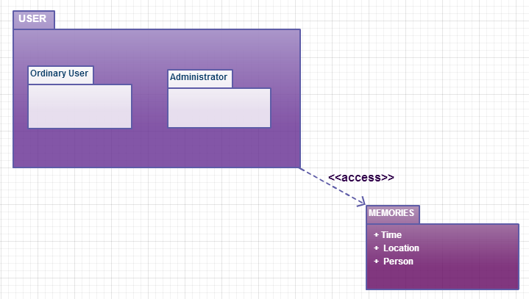

- References
Suzan Uskudarlı’s Problem Definition document on http://moodle.cmpe.boun.edu.tr/mod/page/view.php?id=302 is used as a reference.

