SWE 574 Software Development As A Team, Fall 2014
Instructor: Suzan Üsküdarlı

Living History
Milestone II Summary

01.12.2014

Revision History

Revision | Date | Explanation
1.0 | 01.12.2014 | Initial Milestone Contents

Table of Contents

Revision History 2
Table of Contents 3
1. Introduction 4
2. Signing Up (registration) Functionality 4
3. Signing In (login) Functionality 6

1. Introduction

The purpose of this documentation is to explain the contents of the 2nd milestone of “Living History” project.

2nd milestone is focused on "Signing-up (Register) and Signing-in (Login) on Client"

- Signup forms have been created on the client demo.
- Signin forms have been created on the client demo.

Additionally, there have been some developments on the Android and backend sides of the application.
- The Android version of the client (currently available only on emulator) has been developed.
- Resolution problems on the Android client have been resolved.
- Code has been developed for responding to Json requests.

2. Signing Up (registration) Functionality

When the user clicks Login button, the following form comes up.

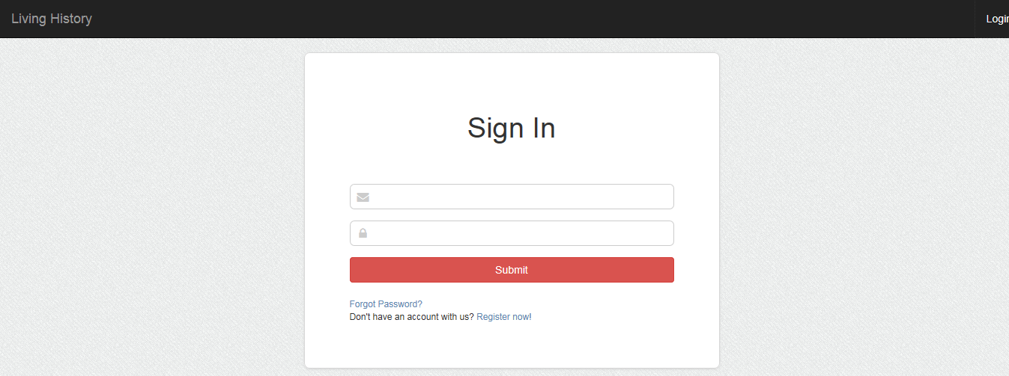
Figure 1: The Sign In (Login) Form

If the user does not have an account on the system, he/she has to click “Register now”.
Afterwards, the registration form shown below comes up.

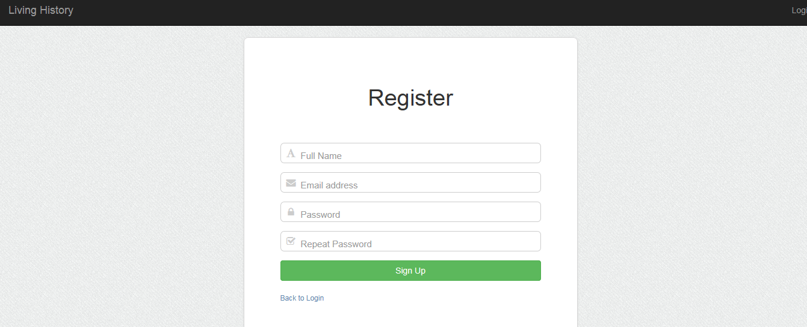

Figure 2: The Sign Up (Register) Form

On this form, the user has to enter the needed credentials on the 4 mandatory fields and then click the “Sign Up” button.

The following message will pop up.

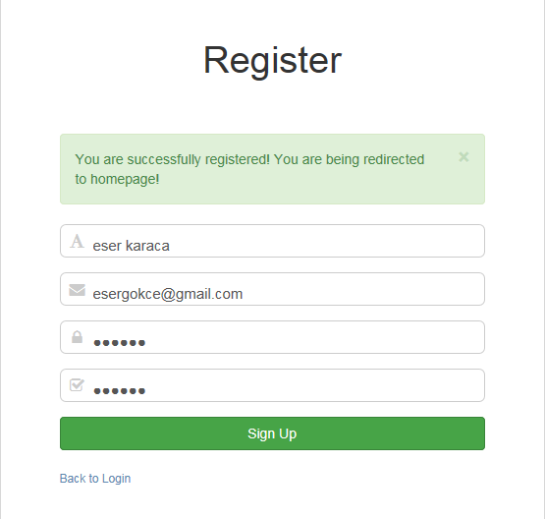
Figure 3

And then the user is redirected to the home page as below.

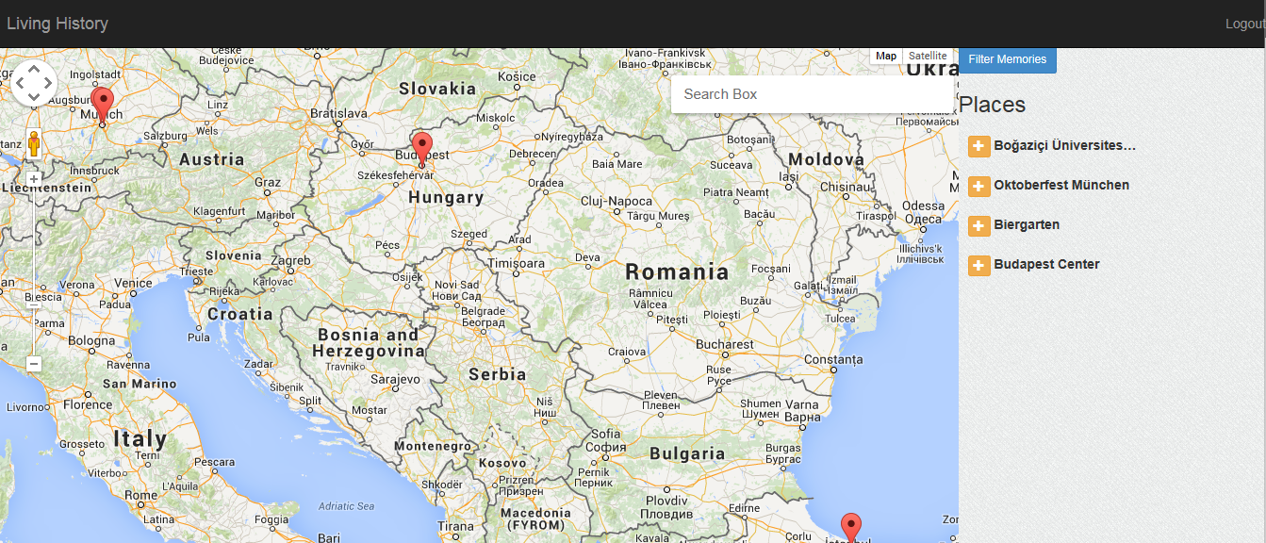

Figure 4: Home Page

3. Signing In (login) Functionality

In order to login, user should click the “Login” button on the right hand side. On the sign in screen that comes up, (Figure 2), user should write down the necessary credentials – which are email address and password - and press the “Submit” button.

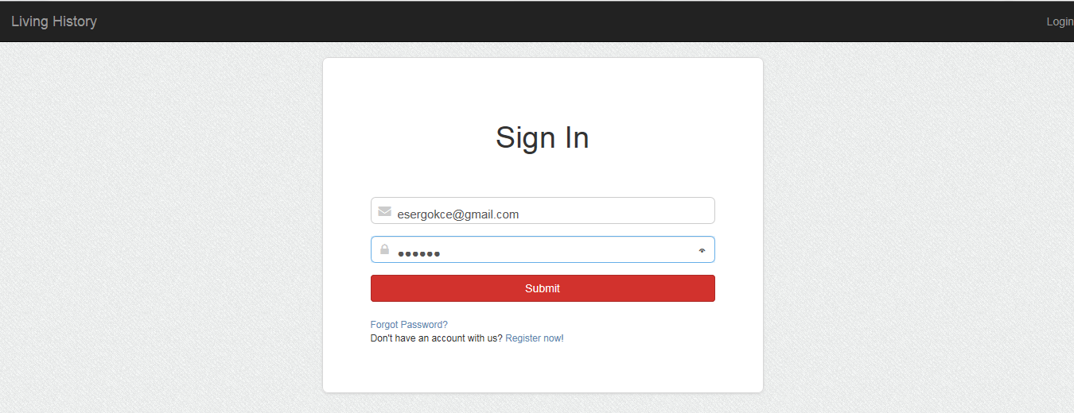
Figure 5:
Sign In (Login) form

Currently, the Sign In function is not operational.
This document will be updated with a new version when the Login functionality starts to operate.

