Auto-generated report from BCEA

Version: 13 December, 2018

## Cost-effectiveness analysis

The cost-effectiveness analysis is based on the maximisation of the expected utility, defined as the *monetary net benefit $nb_{t}=ke_{t}−c_{t}$* . Here $t$ indicates one of the interventions (treatments) being assessed, while $(e,c)$ indicate the relevant measures of *effectiveness* and *cost*. For each intervention, the expected utility is computed as ${NB}_{t}=kE[e_{t}]−E[c_{t}]$. When comparing two interventions (say, $t=1$ vs $t=0$), or using a pairwise comparison, we can determine the ``best’’ alternative by considering the difference in the expected utilities $EIB={NB}_{1}−{NB}_{0}$. This can also be expressed in terms of the *population effectiveness and cost differentials $EIB=kE[Δ_{e}]−E[Δ_{c}]$* , where $Δ_{e}=E[e∣θ_{1}]−E[e∣θ_{0}]$ and $Δ_{c}=E[c∣θ_{1}]−E[c∣θ_{0}]$ are the average effectiveness and cost, as function of the relevant model parameters $θ=(θ_{0},θ_{1})$.

This sub-section presents a summary table reporting basic economic results as well as the optimal decision, given the selected willingness-to-pay threshold $k=20100$. The table below presents a summary of the optimal decision, as well as the values of the Expected Incremental Benefit $EIB=kE[Δ_{e}]−E[Δ_{c}]$, Cost-Effectiveness Acceptability Curve $CEAC=Pr(kΔ_{e}−Δ_{c})$ and Incremental Cost-Effectiveness Ratio $ICER=\frac{E[Δ_{c}]}{E[Δ_{e}]}$, for the set willingness-to-pay value.

Cost-effectiveness analysis summary   
  
Reference intervention: intervention 2  
Comparator intervention: intervention 1  
  
Optimal decision: choose intervention 1 for k<20100 and intervention 2 for k>=20100  
  
  
Analysis for willingness to pay parameter k = 20100  
  
 Expected utility  
intervention 1 -30.880  
intervention 2 -30.879  
  
 EIB CEAC ICER  
intervention 2 vs intervention 1 0.00060352 0.46 20098  
  
Optimal intervention (max expected utility) for k=20100: intervention 2  
   
EVPI 2.5268

## Cost-effectiveness plane

The following graph shows the cost-effectiveness plane. This presents the joint distribution of the population average benefit and cost differential, $(Δ_{e},Δ_{c})$ and can be used to assess the uncertainty underlying the decision-making problem.

Each point in the graph represents a ‘potential future’ in terms of expected incremental economic outcomes. The shaded portion of the plane is the ‘*sustainability area*’. The more points lay in the sustainability area, the more likely that the reference intervention will turn out to be cost-effective, at a given willingness to pay threshold, $k$ (in this case selected at $k=$ 20100).

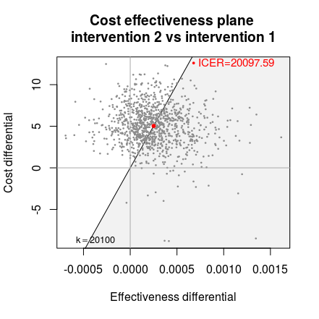

## Expected Incremental Benefit

The following graph shows the Expected Incremental Benefit (EIB), as a function of a grid of values for the willingness to pay $k$ (in this case in the interval 0 - 50000).

The EIB can be directly linked with the decision rule applied to the ICER. If a willingness to pay value $k^{*}$ exists in correspondence of which $EIB=0$ this value of $k$ is called the *break-even point*. It corresponds to the maximum uncertainty associated with the decision between the two comparators, with equal expected utilities for the two interventions. In other terms, for two willingness to pay values, one greater and one less than $k^{*}$, there will be two different optimal decisions. The graph also reports the 95% credible limits around the EIB.

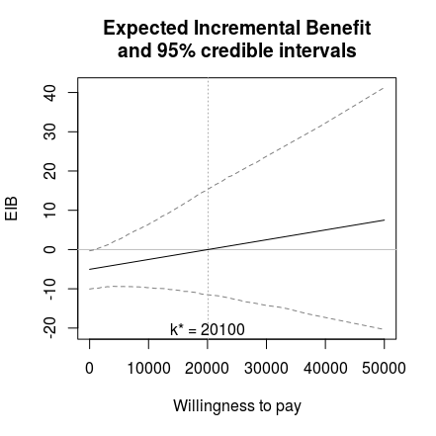

## Cost-effectiveness acceptability curve

The Cost-Effectiveness Acceptability Curve estimates the probability of cost-effectiveness, for different willingness to pay thresholds. The CEAC is used to evaluate the uncertainty associated with the decision-making process, since it quantifies the degree to which a treatment is preferred. This is measured in terms of the difference in utilities, normally the incremental benefit. Effectively, the CEAC represents the proportion of simulations in which $t=1$ is associated with a higher utility than $t=0$.

The following graph shows the cost-effectiveness acceptability curve (CEAC). The CEAC represents the proportion of ‘potential futures’ in which the reference intervention is estimated to be more cost-effective than the comparator. Thus, it can be interpreted as the ‘probability of cost-effectiveness’.

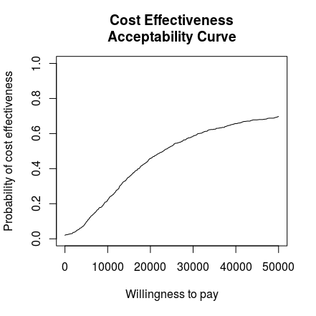

## Cost-effectiveness acceptability frontier

In addition to the CEAC, we can also visualise the uncertainty in the decision-making process using the Cost-Effectiveness Acceptability Frontier. The frontier is defined as the maximum value of the probability of cost-effectiveness among all comparators. It is an indication of the uncertainty associated with choosing the cost effective intervention. In other terms, higher frontier values correspond to lower decision uncertainty.

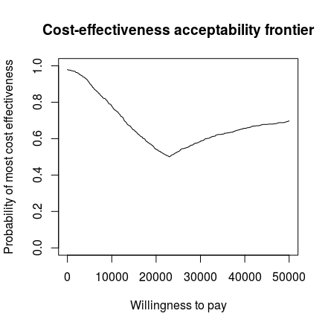

## Cost-effectiveness efficiency frontier

The Cost-Effectiveness Efficiency Frontier (CEEF) compares the net costs and benefits of different interventions in a given therapeutic area. It is different from the comon differential approach (e.g. based on the Cost-Effectiveness plane), beacuse it is based on the *net* measures. The predicted costs and effectiveness for the interventions under consideration are compared directly to the costs and effectiveness for the treatments that are currently available. The frontier in itself defines the set of interventions for which cost is at an acceptable level for the benefits given by the treatment. A new intervention is *efficient* if its average effectiveness is greater than any of the currently available alternatives, or its cost are lower than that associated with other interventions of the same effectiveness.

In the following plot, the circles indicate the mean for the cost and effectiveness distributions for each treatment option. The number in each circle corresponds to the order of the treatments in the legend. If the number is black then the intervention is on the efficiency frontier. Grey numbers indicate dominated treatments.

Cost-effectiveness efficiency frontier summary   
  
Interventions on the efficiency frontier:  
 Effectiveness Costs Increase slope Increase angle  
intervention 1 -0.00105595 9.6555 NA NA  
intervention 2 -0.00080537 14.6914 20098 1.5707

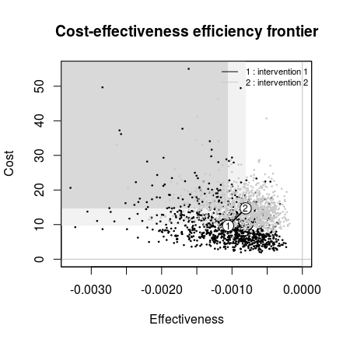

The summary is composed of two tables, reporting information for the comparators included on the frontier. It also details the average health effects and costs for the comparators not on the frontier, if any. For the interventions included on the frontier, the slope of the frontier segment connecting the intervention to the previous efficient one and the angle inclination of the segment (with respect to the $x−$ axis), measured in radians, are also reported. In particular, the slope can be interpreted as the increase in costs for an additional unit in effectiveness, i.e. the ICER for the comparison against the previous treatment.

The dominance type for comparators not on the efficiency frontier is reported in the output table. This can be of two types: absolute or extended dominance. An intervention is absolutely dominated if another comparator has both lower costs and greater health benefits, i.e. the ICER for at least one pairwise comparison is negative. Comparators in a situation of extended dominance are not wholly inefficient, but are dominated because a combination of two other interventions will provide more benefits for lower costs.

## Expected value of perfect information

One measure to quantify the value of additional information is known as the *Expected Value of Perfect Information* (EVPI). This measure translates the uncertainty associated with the cost-effectiveness evaluation in the model into an economic quantity. This quantification is based on the *Opportunity Loss* (OL), which is a measure of the potential losses caused by choosing the most cost-effective intervention *on average* when it does not result in the intervention with the highest utility in a ‘possible future’. A future can be thought of as obtaining enough data to know the exact value of the utilities for the different interventions. This would allow the decision makers to known the optimal treatment with certainty. The opportunity loss occurs when the optimal treatment on average is non-optimal for a specific point in the distribution for the utilities.

To calculate the EVPI practically, possible futures for the different utilities are represented by the simulations. The utility values in each simulation are assumed to be known, corresponding to a possible future, which could happen with a probability based on the current available knowledge included in and represented by the model. The opportunity loss is the difference between the maximum value of the simulation-specific (known-distribution) utility ${NB}^{*}(θ)=kΔ_{e}−Δ_{c}$ and the utility for the intervention resulting in the overall maximum expected utility $NB(θ^{τ})$, where $τ={arg max}_{t} {NB}^{t}$.

Usually, for a large number simulations the OL will be 0 as the optimal treatment on average will also be the optimal treatment for the majority of simulations. This means that the opportunity loss is always positive as either we choose the current optimal treatment or the treatment with a higher utility value for that specific simulation. The EVPI is then defined as the average of the opportunity loss. This measures the average potential losses in utility caused by the simulation specific optimal decision being non-optimal in reality.

If the probability of cost-effectiveness is low then more simulations will give a non-zero opportunity loss and consequently the EVPI will be higher. This means that if the probability of cost-effectiveness is very high, it is unlikely that more information would be worthwhile, as the most cost-effective treatment is already evident. However, the EVPI gives additional information over the EVPI as it takes into account the opportunity lost as well as simply the probability of cost-effectiveness.

For example, there may be a setting where the probability of cost-effectiveness is low, so the decision maker believes that decision uncertainty is important. However, this is simply because the two treatments are very similar in both costs and effectiveness. In this case the OL will be low as the utilities will be similar for both treatments for all simulations. Therefore, the cost of making the incorrect decision is very low. This will be reflected in the EVPI but not in the CEAC and implies that the optimal treatment can be chosen with little financial risk, even with a low probability of cost-effectiveness.

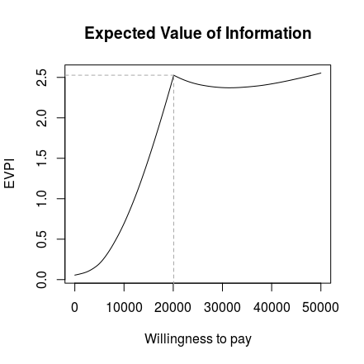

## References

Baio, G, A Berardi, and A Heath. 2017. *Bayesian Cost-Effectiveness Analysis with the R package BCEA*. New York, NY: Springer. <https://doi.org/10.1007/978-3-319-55718-2>.