Power Electronics

Boost Converter Circuit

Hyunui Park&Gyeonheal An, Automotive Mania Group (AMG)

05/08/23

1. **Problem solving.**
2. From the PSIM Circuit of Boost Converter shown in Figure 1(a), the inductor current has . It is operating in dc steady state under the following conditions: , , , and .

(a) Assuming ideal components, calculate L and draw the waveforms of duty, MOSFET voltage, inductor voltage, inductor current, diode current and capacitor current.



**Figure 1. Circuit of Boost Converter (PSIM)**



**Figure 1-(a). waveform and measured values**

**Figure 1-(b). waveform and measured values**

**Figure 1-(c). waveform and measured values**

**Figure 1-(d). waveform and measured values**

**Figure 1-(e). waveform and measured values**

**Figure 1-(f). waveform and measured values**

1. In a Boost converter, . It is operating in dc steady state under the following conditions: , , , and . Assume ideal components. Calculate the critical value of the output load and below which the converter will enter the discontinuous conduction mode of operation.
2. In the Boost converter from problem 2, the input voltage is varying in a range from 9[V] to 15[V]. For each input value, the duty-ratio is controlled to keep the output voltage constant at its nominal value (with and D = 0.4). Calculate the critical value of the inductance L such that this Boost converter remains in the continuous conduction mode at and above under all values of the input voltage .

**Figure 2. MATALB Problem 3 Code**



**Figure 3. MATLAB Result Problem 3**

1. A Boost converter is to be designed with the following values: , , and the maximum output power . The switching frequency is selected to be . Assume ideal components, Estimate the value of L if the converter is to remain in CCM at one-third the maximum output power.

Experiment

1) Following values are given: f = 150[kHz], R_Load = 20[Ω], Vin = 5[V], Pout,max = 10[W], L = 150[μH], C = 1,800[μF], ΔVout ≤ 0.1%∙Vout. With these, find following values before further procedures: V_out,max, D_max, L_crit, and ΔVout,max. Are L and C suitable for the design?

We need to find value of L and C are suitable for the design of Boost Converter before start experiment. In Boost Converter, we know that . So, we need to find the maximum duty value that does not exceed the

For the boost converter to operate in the CCM interval, must bigger than . Then calculate and .

1) calculate

2) calculate

Using the equation 1) and 2),

Next, use the conditions of the capacitor to obtain the required values. In given conditions, .

Therefore, now we know that the given values are suitable for use in this experiment.

However, if duty over the , will be over the . It can cause damage to the circuit, so circuit must be operated within a safe range of duty. Therefore, this experiment was conducted under .

2) One must create the Boost converter circuit and have a clear picture of the circuit.

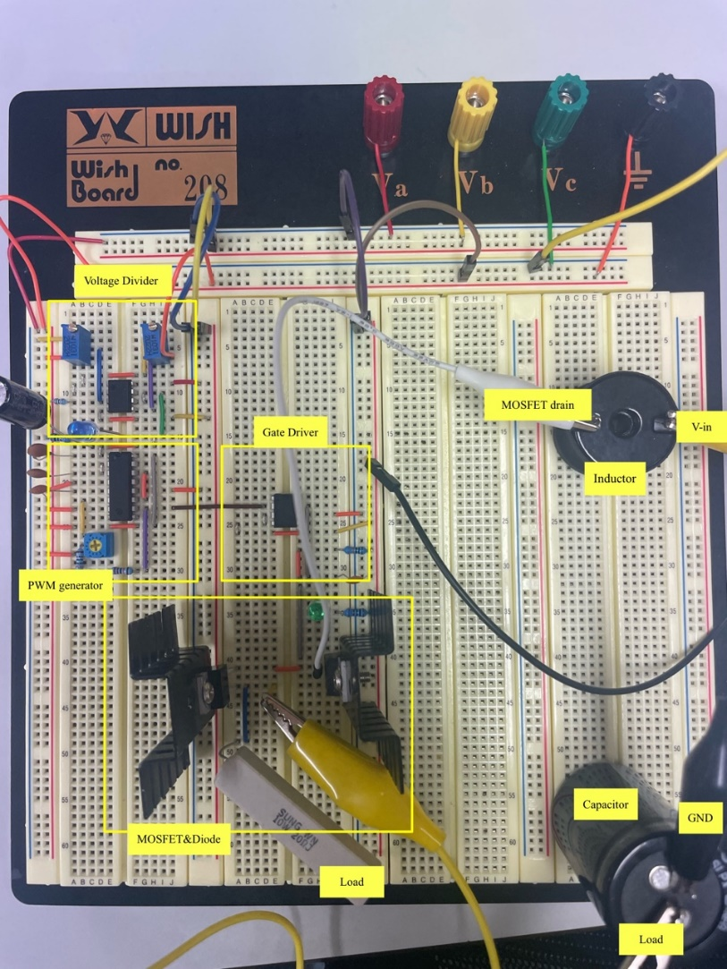

Figure 4. Boost Converter Circuit

3) One must show duty – output voltage curve when input voltage is set to 5[V] and Switching frequency is set to 150[*k*Hz] (Don’t go over the Pout,max).



Figure 5. Duty-Output Voltage (Duty = 0.5)



Figure 6. Duty-Output Voltage (Duty = 0.1)

|  |  |  |
| --- | --- | --- |
|  | Duty(0.1) | Duty(0.5) |
| Theorical | 5.55[V] | 10[V] |
| Experimental | 4.8[V] | 7.8[V] |

Table 1. Comparison of Experimental and Actual Values

In fact, when the duty is 0.5, the power voltage should be 10[V], but the experimental value is lower than that, which can be seen as a low value due to energy loss generated by the inductor and the capacitor.