|  |  |  |
| --- | --- | --- |
| **CAE**  **Simulation #3** | **2D Structure: Safety Device** | *21900416 Gyeonheal An* |
|  |

# **Introduction**

Figure 1. Summary Figure of Protection Device

The machine shown is an overload protection device that the load when the shear pin S fails. Determine the maximum von Mises stress in the upper part ABE if the pin shears when its s shear stress is 40 MPa. Assume the upper part to have a uniform thickness of 6mm. Assume plane stress conditions for the upper part. The part is made of 6061 aluminum alloy. Is the thickness sufficient to prevent failure based on the maximum distortion energy theory? If not, suggest a better thickness. (Scale all dimensions as needed.)

# **Geometry Design (DesignModeler)**

Figure 2. Making Imprinted Design in Geometry (Design Modeler)

# **Material (Aluminum Alloy)**

Table 1. Material Settings

# **Experimental Condition**

|  |  |
| --- | --- |
| **Used Material** | Aluminum Alloy |
| **Mesh** | 1mm |
| **Force** | Pin C: 1006.4N, Pin D: 929N |
| **Solution** | Total Deformation |
| Equivalent Stress |
| Safety Factor (stress) |
| Force Reaction at pin A |
| Force Reaction at pin B |

Table 2. Simulation Conditions

# **Boundary Conditions & Load Conditions**

Figure 3. BC & LC

# **Result**

|  |
| --- |
| Figure 4. Total Deformation |
|  |
| Figure 5. Equivalent stress |
|  |
| Figure 6. Safety Factor |
|  |
| **Figure 7. Force Reaction at pin A** |
|  |
| Figure 8. Force Reaction at pin B |

# **Analysis**

1. **Investigate the reaction force of the support to see if it is the same as the theoretical reaction force (static analysis).**

Figure 9. Static Analysis

Therefore, it can be confirmed that the simulation values of figure 6 and figure 7 match the theoretical values.

1. **Through the Mesh Convergence test, the convergence of the solution is examined and the appropriate element size is selected.**

Figure 10. Mesh Convergence test (Equivalent Stress : E=5%)

The number of nodes and elements is 71862 and 34831, respectively, when set to 5% allowable changes in Equivalent stress. When interpreted as the corresponding number of elements, an equivalent stress of 105.1 Mpa is generated.

Figure 11. Mesh Convergence test (Total Deformation : E=5%)

The number of nodes and elements is 68079 and 32597, respectively, when set to 5% allowable changes in Total Deformation. When interpreted as the corresponding number of elements, deformation is generated by -0.15243mm.

1. **Solve the areas where damage is predicted by theoretical analysis and compare them with simulation solutions.**

The part with the largest stress concentration is predicted to be the part that is bent to the right of the part with the smallest polarity moment I, and the part is likely to be damaged. So if we calculate the stress in the center

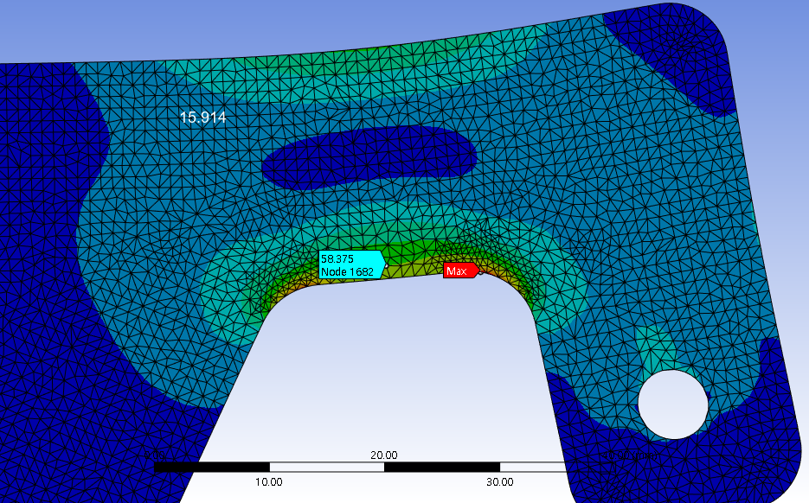

Figure 12. Area where damage is expected

It can be seen that it appears almost similar to the above simulation value.

Find the stress concentration factor on the right through the stress concentration graph below

Figure 13. Stress Concentration Coefficient Graph

**[Mpa]**

Therefore, it can be seen that the theoretical solution of the area where damage is predicted and the simulation solution almost coincide.

1. **What is the thickness of the device to secure the safety factor of 3?**

To confirm this, the design modeler of Ansys set the Thickness to 6.7mm using the Thin function and obtained the Safety Factor again.

Figure 14. Setting 6.7mm thickness in Design Modeler

Figure 15. Ansys Simulation Result (Safety Factor)

When the thickness was increased from 6mm to 6.7mm, the simulation also shows that the safety factor exceeded 3. Therefore, in order to secure the Safety Factor 3, the thickness of the object must be 6.7 mm or more.