|  |  |  |
| --- | --- | --- |
| **CAE**  **Simulation #3** | **Gantry Crane** | *21900416 Gyeonheal An* |
|  |

# **Introduction**

(Use SI unit by conversion) A gantry crane is designed that must be able to lift 10 tons(use 100KN) as it must lift compressors, motors, heat exchangers, and controls. This load should be placed at the center of one of the main 12-ft-long beams(use 1ft=0.3m) as shown below by the hoisting device location. Weight of the structure is ignored in the analysis. Assume you are using ASTM A36 structural steel(SS400). The crane must be 12 feet long, 8 feet wide, and 15 feet high. The beams should all be the same size, the columns all the same size, and the bracing all the same size. Their cross sections are selected from Appedix F(4th ed.) and shown below. You must verify that the structure is safe by checking the beam's bending strength and allowable deflection. A required safety factor against material yielding of the beam is 3. Verify that the beam deflection is less than L/360 (12/360ft=10mm, downward deflection of the beam center with respect to the ground), where L is the span of the beam. Check yielding and Euler buckling of the long columns. A required factor of safety is 3 against yielding of the column and 5 against buckling of the column.(Ignore local buckling of the horizontal beam) Assume the column-to-beam joints to be rigid while the bracing (a total of eight braces) is pinned to the column and beam at each of the four corners. Use appropriate boundary conditions for the four supports of the gantry crane.

# **Geometry Design (DesignModeler)**

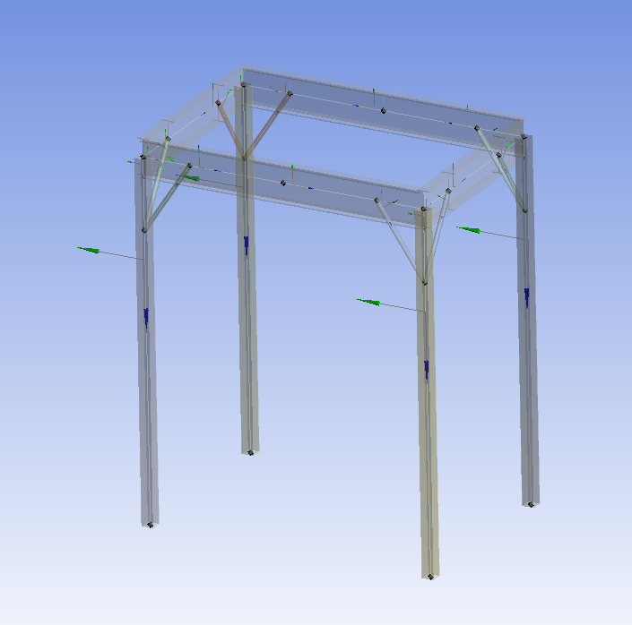

Figure . Gantry Crane by DesignModeler

# **Material (Structural Steel)**

Figure . Material Settings

# **Experimental Condition**

|  |  |  |  |
| --- | --- | --- | --- |
| **Used Material** | Structual Steel | | |
| **Mesh** | 100mm | | |
| **Force** | 100KN | | |
| **Solution** | Total Deformation | | |
| Directional Deformation | | |
| Torsional Moment | | |
| Total Bending Moment | | |
| Total Shear Force | | |
| **Beam Tool** | Direct Stress | |
| Minimum Combined Stress | |
| Maximum Combined Stress | |
| Maximum Bending Stress | |
| **Eigenvalue**  **Buckling** | Total Deformation | Mode 1 |
| Mode 2 |
| Mode 3 |
| Mode 4 |
| Mode 5 |
| Mode 6 |

Table 1. Simulation Conditions

# **Result**

|  |  |
| --- | --- |
|  | |
| Figure 3. Total Deformation | |
|  | |
| Figure 4. Directional Deformation | |
|  | |
| Figure 5. Torsional Moment | |
|  | |
| Figure 6. Total Bending Moment | |
|  | |
| Figure 7. Total Sheer Force | |
|  | |
| Figure 8. Direct Stress | |
|  | |
| Figure 9. Minimum Combined Stress | |
|  | |
| Figure 10. Maximum Combined Stress | |
|  | |
| Figure 11. Maximum Bending Stress | |
| 1 | 2 |
| 3 | 4 |
| 5 | 6 |
| Figure 12. Eigenvalue Buckling (1~6) | |

# **Analysis**

1. **Generate an ANSYS beam model and get safety factors and deflections**
2. **Compare simulation results with appropriate theoretical results (stresses and downward deflections of the horizontal beam, critical buckling load of the columns)**

**Bending stress of the horizontal beam**

1. **Discuss on boundary conditions of the four supports**
2. **What do you think the function of the braces are?**
3. Load Distribution: Bracing serves to distribute the load and transmit it to various parts of the structure. This allows the structure to evenly bear the load and maintain stability. This is particularly important when lifting heavy objects, such as cranes.
4. Motion Control: It contributes to controlling the motion (deformation or sway) of the structure. Large structures may experience motion when subjected to wind, earthquakes, or when lifting and moving objects. Bracing restricts such motion and ensures stability.
5. Buckling Prevention: Bracing prevents the buckling of columns and enhances their safety. When using tall columns, as in the case of cranes, column buckling can be a critical safety concern. Bracing limits column buckling, preventing the column from bending or collapsing.
6. Wind Resistance: Tall structures like cranes are exposed to the force of the wind. Bracing helps control wind-induced swaying and maintains the stability of the structure.
7. Overall Structural Strength Improvement: Bracing contributes to improving the overall strength of the structure. By transferring and distributing loads among various parts of the structure, it enables the structure to support heavier loads.
8. **How many number of elements is required to accurately solve this problem?**

# **Comparison of Theory and Simulation Values**

|  |  |  |
| --- | --- | --- |
| **SF** | **Simulation (Ansys)** | **Theory** |
| **Fully Reversed** | 0.92215 | 0.966 |
| **Zero Based** | 1.4754 | 1.546 |
| **Ratio Based** | 1.135 | 1.189 |
| **History Data** | 1.7761E-3 | X |

Table 2. Results of Ansys and Theory