**ASSIGNMENT: 2nd order ODE-IVP**

**What you need to submit**

* Submit the report+source files as a zip file online (LMS)
* **Report:** including pseudocode, output results, and source codes as instructed
* **Src Code:** (1) **Assignment_ode2_Name_ID.cpp, (2) myNP.h, (3) myNP.cpp**
* All the functions you have created should be updated in myNP.h and myNP.cpp

**2nd order ODE**

**Problem**

A mass-spring-damper (m-c-k) system is a 2nd order ODE



where F(t) is the input force, y(t) is the displacement.

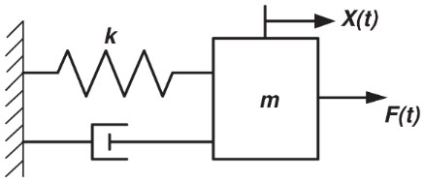

Create a program that gives the values of y(t), dy/dt(t) for the following response

1. Harmonic Response (F(t)=Acos(2*pi*f*t)
2. Free vibration (i.e. F(t)=0) from the initial condition
3. Step Response (F(t)=A)

• Parameters/Initial condition m=1kg, k=6.9N/m, c=7 N/m/s, A=2 N, f=5Hz,

t=0 to 1 sec, h=0.01 sec

Initial Condition: y(0)=0.0 m, dy/dt |t=0=0.2 m/s

**Exercise**

• Write a function for the governing equation for m-c-k system.

void mckfunc (const double t, const double Y[], double dYdt[])

{ double m = 1; double c = 7; double k = 6.9; double f = 5;

double Fin = 2 * cos(2 * PI * f * t);

dYdt[0] = Y[1];

// EXERCISE: MODIFY HERE

dYdt[1] =

(-k * Y[0] - c * Y[1] + Fin) / m;

}



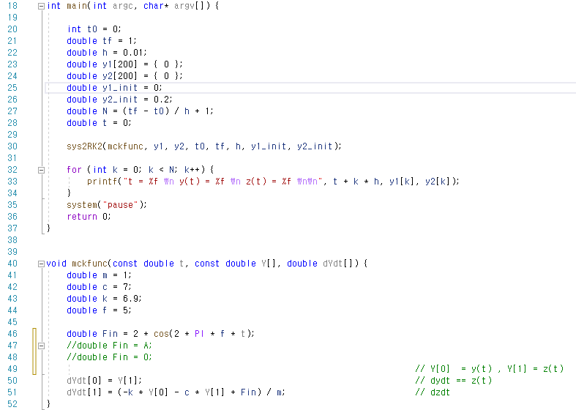

* Write a pseudocode of RK2 for 2nd order system

|  |
| --- |
| For (i to N-1 i++)  tempY = y1[i]  tempY = y2[i]  mckfunc(t, tempY, K1)  tempY[0] += K1[0]*h  tempY[1] += K1[1]*h  mckfunc(t+h, tempY, K2)  y1[i+1] = y1[i] + 0.5*(K1[0]+K2[0])*h  y2[i+1] = y2[i] + 0.5*(K1[1]+K2[1])*h  t+=th  end |

* Create a function of RK2 for 2nd order system

void sys2RK2(void func(const double t, const double Y[], double dYdt[]),double y1[], double y2[], double t0, double tf, double h, double y1_init, double y2_init);

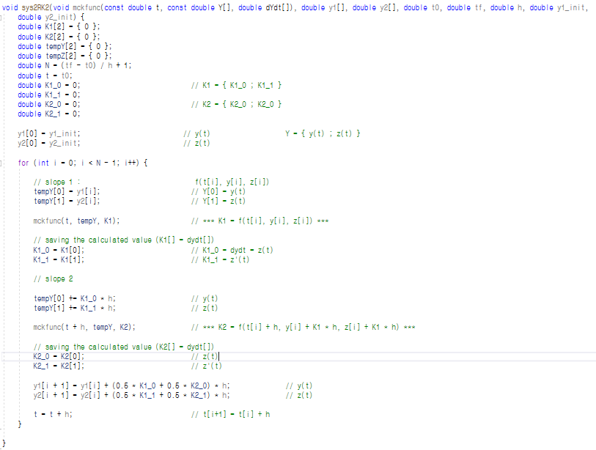

* Compare the answer with MATLAB’s ODE solver by copy-pasting your outputs in MATLAB and plotting results on the same graph.
* 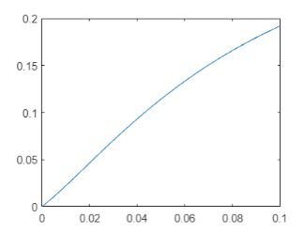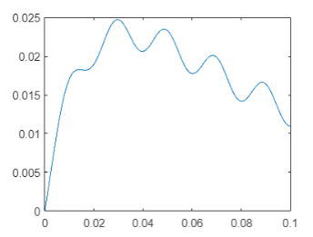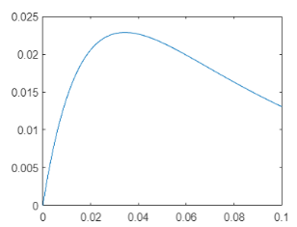텍스트, 실외, 검은색, 명판이(가) 표시된 사진

  자동 생성된 설명텍스트이(가) 표시된 사진

  자동 생성된 설명

F=A

F=Acos(2*pi*f*t)

Matlab ODE solver

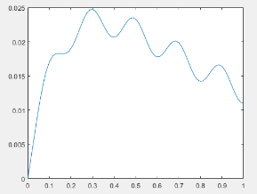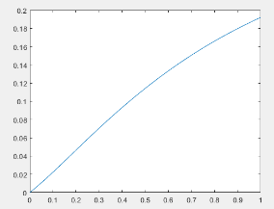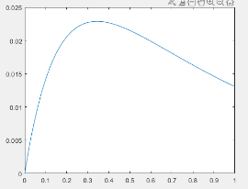

F=0

F=Acos(2*pi*f*t)

F=0

My Result

F=A

F=Acos(2*pi*f*t)