Table of Contents

University of Science and Technology of Hanoi
Department of Information and Communication Technology (ICT)

Few-Shot Open-Set
Keyword Spotting at Vocabulary Scale
A Metric-Learning Study of Feature Front-Ends, Encoders,
and Open-Set Rejection
Bachelor Thesis — Internship Report
Academic year 2025–2026
Author: | $⟨$Student name$⟩$ (ID: $⟨$student ID$⟩$)
Supervisor: | Dr. Tran Hoang Tung
Infrastructure: | Dr. Tran Giang Son (ICTLab server)

Hanoi, 2026-06-29
To whom it may concern,
I, (supervisor’s name), certify that the thesis / internship report of Mr/Ms (student’s name) is qualified for submission and defence. The work reported here was carried out by the student under my supervision during the internship period, and the results, analyses, and conclusions presented are, to the best of my knowledge, the student’s own and accurately reported.
Hanoi, 2026-06-29
Supervisor’s signature

Acknowledgements
First and foremost, I would like to express my support and appreciation for my supportive and insightful supervisor, Dr. Tran Hoang Tung, for insightful feedback and guidance throughout the three months of internship. I would also like to extend my thanks to Dr. Tran Giang Son for providing full access to the ICTLab server, which made the computational part of this project a success.
For my family, thank you for the encouragement and supportive emotion, which kept me motivated and encouraged me to complete this project. Finally, thanks to those who take the time to read this entire report — thank you, and I hope you have a wonderful time reading it.

List of Abbreviations
̄ AUCArea Under the ROC Curve
BC-ResNetBroadcasted-Residual Network
DCTDiscrete Cosine Transform
DETDetection-Error-Tradeoff (curve)
DSCNNDepthwise-Separable Convolutional Neural Network
EEREqual-Error Rate
FARFalse-Accept Rate
FRRFalse-Reject Rate
GE2EGeneralized End-to-End (loss)
GSCGoogle Speech Commands (v2)
ICTInformation and Communication Technology
IIRInfinite Impulse Response
KDKnowledge Distillation
KWSKeyword Spotting
MFCCMel-Frequency Cepstral Coefficients
MSWCMultilingual Spoken Words Corpus
NCMNearest-Class-Mean
PCENPer-Channel Energy Normalization
ROCReceiver Operating Characteristic
SCAFSub-Center ArcFace
SNRSignal-to-Noise Ratio
STFTShort-Time Fourier Transform
t-SNEt-distributed Stochastic Neighbour Embedding
VADVoice Activity Detection

Abstract
We study few-shot, open-set keyword spotting (KWS): a single embedding encoder is trained once on a large word vocabulary and then deployed to recognise an arbitrary, user-defined keyword set from only a handful of enrolment examples, while rejecting out-of-vocabulary speech and silence. We build a reproducible pipeline around two compact encoders — a depthwise-separable CNN (DSCNN-L, $≈$0.41 M parameters) and a temporal-attention edge model (EdgeSpot-Full, $≈$0.13 M) — three feature front-ends (MFCC, log-mel, and a trainable per-channel PCEN) and four metric-learning objectives (Triplet, Sub-center ArcFace, GE2E, and cosine knowledge distillation from a frozen Wav2Vec 2.0 teacher). All systems are trained on Multilingual Spoken Words Corpus (MSWC) English and evaluated cross-corpus on Google Speech Commands v2 under a strict 10-shot open-set protocol (100 randomised runs). A 16-configuration factorial screen shows that (i) the trainable PCEN front-end is the most reliable single improvement (up to $+9.2$ accuracy points at 1% false-accept rate for the edge encoder); (ii) the centroid GE2E objective dominates classification losses for open-set generalisation; and (iii) Sub-center ArcFace collapses at $37,387$ classes unless its loss weight is cut by four orders of magnitude. Accuracy saturates near two million clips, and distillation reaches GE2E-level accuracy with roughly half the data. The best system (DSCNN-L + PCEN + GE2E) attains $86.36\%$ accuracy at $1\%$ false-accept rate; the best compact model (EdgeSpot-Full + PCEN + GE2E) reaches $82.87\%$ at one third the parameters.
Key words: keyword spotting; few-shot learning; open-set recognition; metric learning; per-channel energy normalization; knowledge distillation.

1 Introduction

1.1 Global context and motivation
Keyword spotting (KWS) — the task of detecting a small set of spoken commands in a continuous audio stream — is the always-on entry point of nearly every modern voice interface. Classical KWS systems are trained as closed-set classifiers over a fixed vocabulary (e.g., the ten Google Speech Commands words). This design has two structural limitations. First, the keyword set is frozen at training time: supporting a new wake word or command requires collecting data and retraining the model. Second, a softmax classifier is, by construction, not open-set: every input is forced into one of the known classes, so unseen words and background noise are silently misclassified as commands, producing false activations.
This work targets the more realistic and more difficult few-shot, open-set formulation. We train a single embedding encoder on a very large and diverse word vocabulary, and at deployment time the end user defines an arbitrary keyword set by providing only a few ($k$) enrolment utterances per word. Each keyword is represented by a prototype (the mean embedding of its enrolment shots); recognition is performed by nearest-prototype matching in embedding space, and an explicit open-set decision rejects anything that is too far from all prototypes. Because the encoder is never retrained for a particular keyword, the same model serves unlimited downstream vocabularies; because rejection is distance-based, the system can abstain on out-of-vocabulary speech and silence.
The central scientific question we pursue is what makes such an encoder generalize, and in particular how the design choices interact with the scale of the training vocabulary. We perform a controlled factorial study over three axes — feature front-end, encoder backbone, and metric-learning objective — and we deliberately push the training vocabulary from a 31-word “micro-set” up to the full $37,387$-word MSWC English corpus. This scaling exposes a phenomenon that is invisible at small scale: a classification-style angular-margin loss that is competitive on a few hundred classes catastrophically collapses on tens of thousands of classes.

1.2 The problem in plain language
Imagine talking to a device — a smart speaker, a pair of earbuds, a car, a washing machine — and having it react the instant you say a short command such as “stop”, “next”, or a custom wake word you chose yourself. The piece of software that constantly listens for those few words, and only those words, is called a keyword-spotting system. It is deliberately small and always running, so that the big, power-hungry speech recogniser only wakes up after the keyword is heard. KWS is therefore the gatekeeper of almost every voice interface in daily use.

1.2.0.1 Why the usual approach is limiting.
Most commercial KWS systems are trained like a multiple-choice exam: the model is shown thousands of examples of a fixed list of words and learns to pick exactly one of them for any sound it hears. This works, but it has two practical headaches. (1) You cannot add a new command without going back to the factory: if a customer wants the wake word “Hey Aurora” instead of “Hey Google”, the manufacturer must collect a new dataset and retrain. The vocabulary is literally baked into the network. (2) It cannot say “I don’t know”: a multiple-choice model is forced to choose one of its known words for every sound, including a cough, a song on the radio, or a word it has never heard — the familiar annoyance of a device that activates when nobody addressed it.

1.2.0.2 What we build instead.
This thesis builds a KWS system that behaves more like a helpful human assistant. Instead of memorising a fixed word list, the system learns a general skill: how to tell whether two short audio clips are the same word or different words. We train this skill once, on a very large and varied collection of spoken words. After that, an end user can define their own commands simply by recording a few examples of each — no retraining required. Internally, each command is summarised as a single point in a “meaning map” (an embedding); to recognise speech, the system places the new sound on the same map and checks which command it lands closest to. Crucially, if the new sound lands far from every command, the system answers “none of them” — the open-set ability that lets it ignore unrelated speech and noise.

1.2.0.3 Why this is genuinely useful, and why it is hard.
The payoff is threefold: personalisation without retraining (one shipped model serves unlimited user-chosen vocabularies), robustness to the unexpected (the system can decline to answer, producing far fewer false activations), and a tiny footprint ($∼$0.1–0.4 M parameters, small enough to run offline on a phone or microcontroller, which protects privacy). Three difficulties make it more than a toy problem and run through the whole thesis. First, generalisation: the model must work on words, devices, and accents it never saw, so we train on one corpus and test on a completely different one. Second, the open-set boundary: confidently rejecting the infinite space of “everything that is not a command” is much harder than separating a few known words, and we must quantify this trade-off honestly. Third, and most surprising, scale: as the training vocabulary grows from a few dozen to nearly forty thousand words, some techniques that look excellent on small vocabularies break down completely.

1.3 Background: from sound to data
Sound is a continuous pressure wave. To process it on a computer we sample the wave at a fixed rate; throughout this work we use $16,000$ samples per second (16 kHz), the de-facto standard for speech, which captures all frequencies relevant to spoken words (up to 8 kHz by the Nyquist limit). Each spoken-command clip is standardised to exactly one second, i.e. a vector of $16,000$ numbers (the raw waveform); shorter clips are zero-padded and longer clips are trimmed. Figure 1(a) shows such a waveform for the word “yes”. The waveform alone is a poor input for a classifier: it is high-dimensional, and the same word spoken slightly louder or shifted in time looks very different sample-by-sample.
Speech is far easier to model in the time–frequency domain. We slide a short analysis window (here 25–40 ms) across the waveform in small hops (10–20 ms) and, for each window, compute the short-time Fourier transform (STFT) to obtain the energy at each frequency. Two perceptual facts then guide the next step: we perceive pitch roughly on a logarithmic scale, and we are more sensitive to differences at low frequencies than at high ones. The mel scale encodes exactly this, warping linear frequency (Hz) into a perceptual “mel” axis via
$$m = 2595 \log_{10}​\left(1+\frac{f}{700}\right),$$
and a bank of (here 40) overlapping triangular filters spaced evenly on this mel axis pools the STFT energy into 40 mel bands. Taking a logarithm of the band energies yields the log-mel spectrogram of Figure 1(b): a compact image in which the horizontal axis is time, the vertical axis is mel frequency, and brightness is energy.

1.3.0.1 MFCC.
A further classical step decorrelates the log-mel bands with a discrete cosine transform (DCT), producing Mel-Frequency Cepstral Coefficients (MFCCs). The low-order coefficients capture the slowly varying spectral envelope (which carries most of the phonetic identity), so it is common — and we follow this — to keep only the first few coefficients. Figure 1(c) shows the 10-coefficient MFCC map fed to one of our encoders.

1.3.0.2 PCEN.
The static logarithm above is simple but not adaptive to recording conditions. Per-Channel Energy Normalization (PCEN) replaces it with a trainable, per-band automatic-gain-control followed by a soft compression, learned jointly with the network. PCEN is designed for robust, far-field detection and, as Section 4 shows, is the single most reliable improvement in our study (the exact equation is given in Section 3.3).
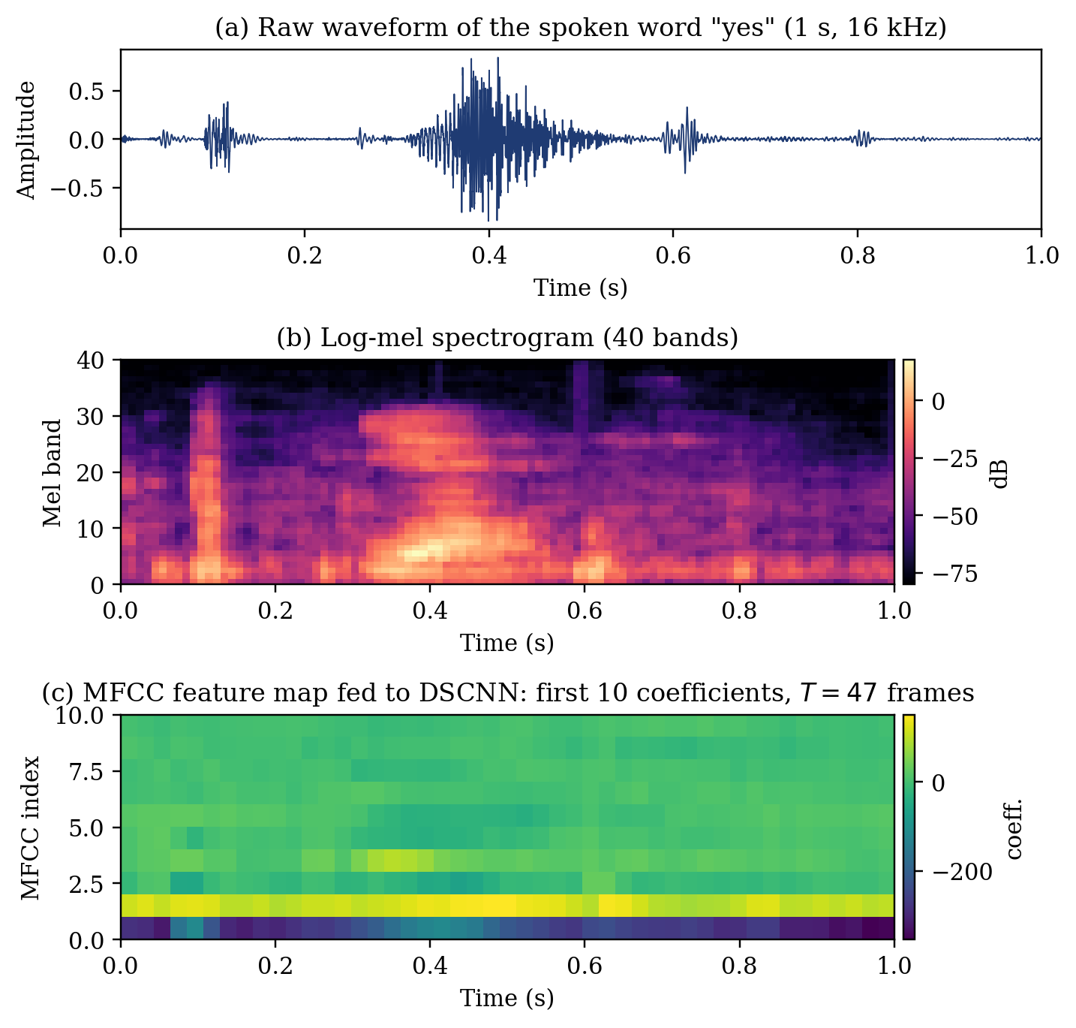
From sound to features, computed from a real Google Speech Commands recording of the word “yes”. (a) the 1 s, 16 kHz raw waveform; (b) the 40-band log-mel spectrogram; (c) the first 10 MFCC coefficients over $T=47$ frames — the tensor actually fed to the DSCNN encoder.
To build intuition for what the model sees, Figure 2 shows the log-mel spectrograms of six different command words. Each word has a characteristic time–frequency signature — the rising voiced segment of “yes”, the plosive burst of “stop”, the nasal onset of “no” — and it is this structure, not the raw waveform, that the encoder learns to compare. Figure 3 makes the mel front-end concrete: (a) the 40 overlapping triangular filters, densely packed at low frequencies; and (b) the Hz-to-mel warping of Equation [eq:mel].
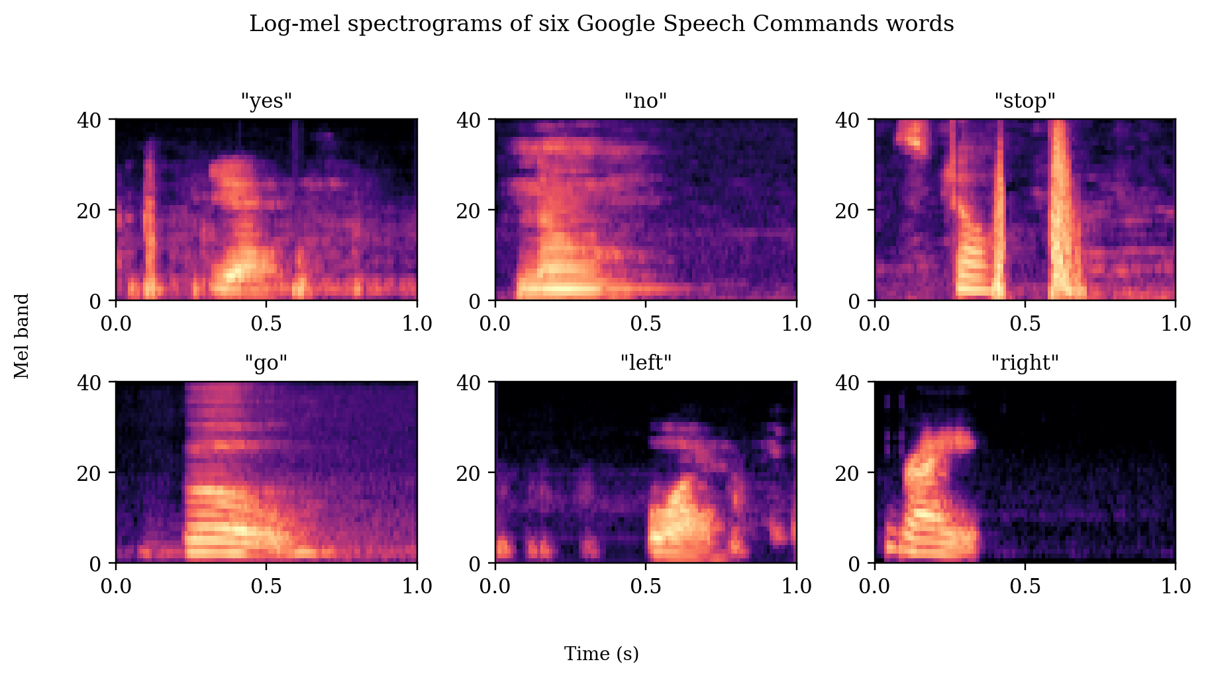
Log-mel spectrograms of six Google Speech Commands words (real data). Different words occupy visibly different time–frequency patterns, which is what makes metric learning in this space effective.
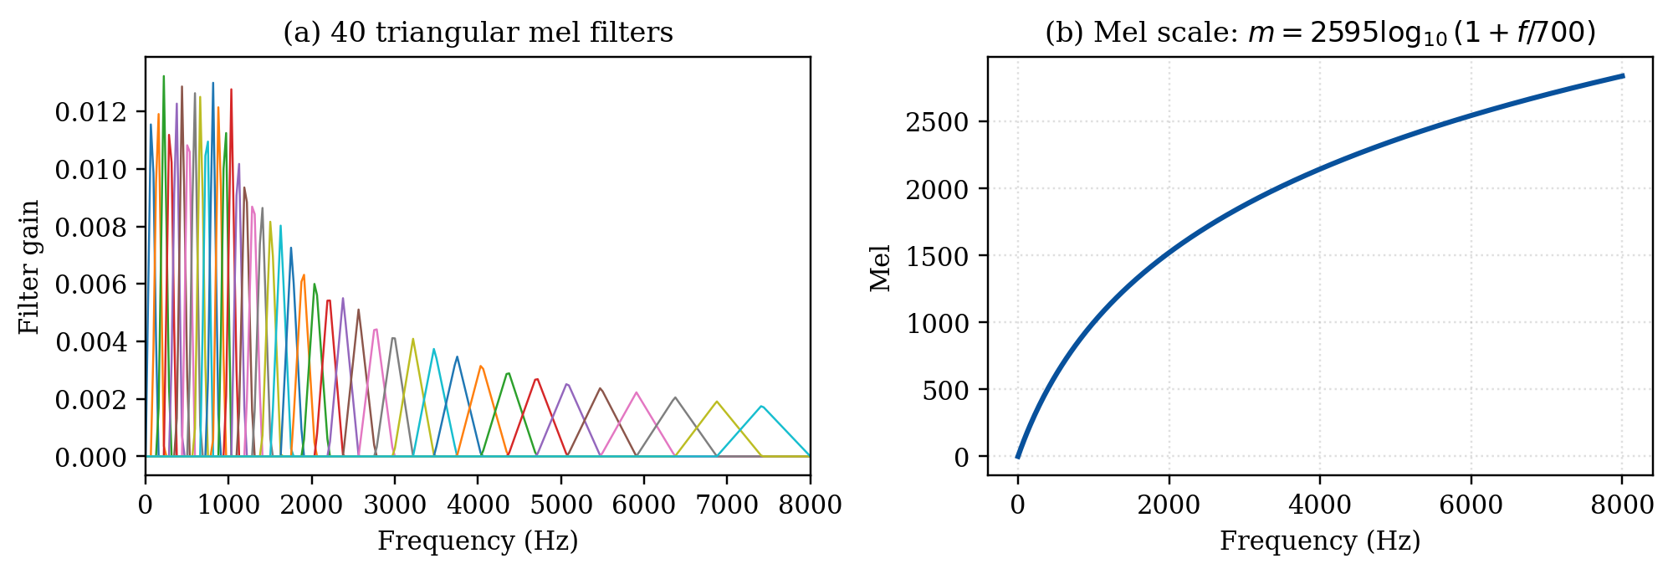
The mel front-end. (a) the 40-channel triangular mel filterbank used in this work; (b) the perceptual Hz$→$mel warping curve.

1.4 Related work

1.4.0.1 Small-footprint and open-set KWS.
Small-footprint KWS was popularised by depthwise-separable convolutional networks (DS-CNN) and later refined by broadcasted-residual networks (BC-ResNet) , both trading accuracy against parameter count for microcontroller deployment. These are closed-set classifiers and cannot, by design, abstain on unknown inputs. The open-set requirement — accepting known keywords while rejecting everything else — is what separates a laboratory accuracy number from a deployable wake-word engine.

1.4.0.2 Few-shot and metric learning.
To support arbitrary vocabularies we cast KWS as metric learning: the network learns an embedding space in which utterances of the same word are close and utterances of different words are far apart. Prototypical networks represent each class by the mean of its few support embeddings and classify queries by nearest prototype; triplet embeddings optimise relative distances directly. The Generalized End-to-End (GE2E) loss , originally proposed for speaker verification, builds centroids inside each training batch exactly as deployment builds prototypes, making it a natural fit for few-shot KWS.

1.4.0.3 Angular-margin classification, rejection, and self-supervision.
ArcFace and its sub-center variant SCAF learn highly discriminative embeddings for face recognition with thousands of identities by enforcing an angular margin. A natural question — which this thesis answers negatively at extreme scale — is whether the same machinery transfers to tens of thousands of word classes. For the open-set decision itself, OpenMax fits Weibull tails to per-class activations, and energy scores offer a calibration-free alternative; we adapt both to operate on prototype distances and compare them with a plain nearest-class-mean threshold. Finally, self-supervised speech models such as Wav2Vec 2.0 provide powerful representations; we use a frozen Wav2Vec 2.0 only as a distillation teacher, keeping the deployed student tiny.

1.5 Contributions
- A reproducible, dependency-light few-shot open-set KWS framework with two compact encoders, three feature front-ends, four metric objectives, and four open-set rejection heads, all sharing a common prototype interface.
- A 16-configuration factorial screen on full-vocabulary MSWC that isolates the contribution of each design axis with paired deltas; PCEN and GE2E emerge as the two robust wins.
- A scale analysis showing (a) accuracy saturation near $∼$2 M training clips and (b) the failure mode of Sub-center ArcFace at $37$k classes, with a gradient-magnitude explanation and a practical fix.
- A knowledge-distillation study showing that a cosine objective against a frozen Wav2Vec 2.0 teacher matches GE2E accuracy with roughly half the training data.
- A complete cross-corpus evaluation under a strict 10-shot protocol (100 runs), plus a CPU streaming pipeline and an offline web demonstrator.

2 Objectives

2.0.0.1 Scientific objective.
The objective of this internship is to design, implement, and rigorously evaluate a retraining-free, open-set keyword-spotting system that learns a single transferable embedding and supports arbitrary user-defined vocabularies from a few enrolment examples. The strategy is to (i) train one compact encoder on a large word vocabulary with a deployment-matched metric objective, and (ii) measure, through a controlled factorial study, which feature front-end, encoder backbone, and metric-learning objective generalise best across corpora and how they behave as the training vocabulary scales.

2.0.0.2 Concrete objectives.
- Build a compact, dependency-light encoder that runs offline on modest hardware ($∼$0.1–0.4 M parameters).
- Identify, through a controlled factorial study, which front-end, backbone, and objective generalise best across corpora.
- Characterise how design choices behave as the training vocabulary scales from tens to tens of thousands of words.
- Deliver an honest open-set evaluation (DET/AUC/EER/ACC@FAR) under a strict, reproducible protocol, plus a working streaming demonstrator.

2.0.0.3 Desired outcomes.
The system is expected to (i) recognise a user’s own keyword set enrolled from $≤10$ examples per word without any retraining; (ii) reject out-of-vocabulary speech and silence with a controllable false-accept rate; (iii) generalise across recording conditions, demonstrated by training on one corpus (MSWC) and testing on a different one (GSC); and (iv) remain small enough for offline, on-device use.

2.0.0.4 Research questions.
The experiments are organised around four questions, which structure the results in Section 4:
Train all $2×2×4=16$ combinations of {DSCNN-L, EdgeSpot-Full} $×$ {MFCC, PCEN} $×$ {Triplet, SCAF, GE2E, SCAF$+$GE2E} and isolate each axis with paired deltas.
Fixing the best front-end and loss, sweep the per-word cap $\{20,50,220,620\}$ and grow the vocabulary from 31 to $37,387$ words, watching for both saturation and failure.
Compare GE2E against the cosine-KD objective at matched data caps.
Consolidate the strongest configurations per data regime and identify the best overall and best compact operating points.

3 Materials and Methods
At a high level (Figure 4) the method has two phases that share a single, frozen encoder. In the training phase the encoder is optimised once on MSWC with a metric objective. In the deployment phase the user enrols a few examples per keyword to form prototypes, and queries are recognised by nearest-prototype distance with an explicit open-set threshold — the encoder is never retrained.
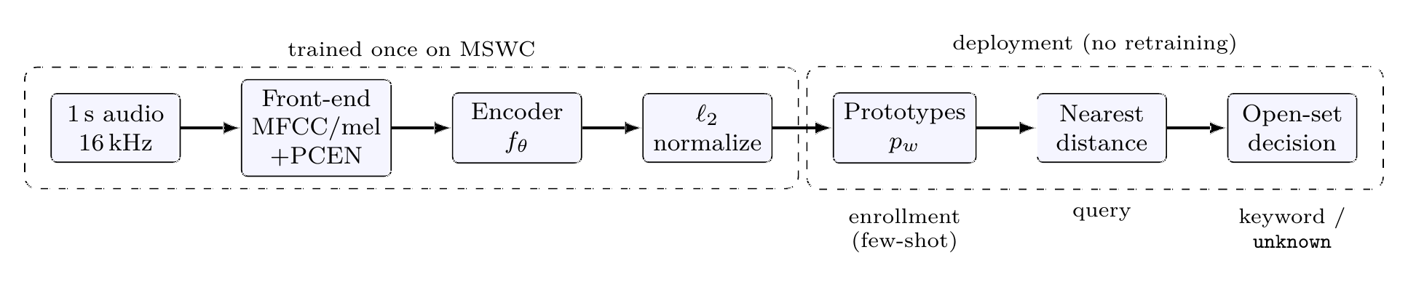
End-to-end few-shot open-set KWS pipeline. The encoder is trained once on MSWC; at deployment, user keywords become prototypes and queries are classified by nearest-prototype distance with an open-set threshold.

3.1 Problem formulation
Let $f_{θ}:R^{T×F}​→​R^{d}$ be an encoder mapping a one-second representation to a unit-norm embedding. The prototype of a keyword $w$ is the mean of its $k$ support embeddings,
$$p_{w} = \frac{1}{k}\sum_{i=1}^{k}{f_{θ}}​\left(x_{i}^{(w)}\right).$$
A query $x$ is assigned to the nearest prototype, with open-set score equal to the negated minimum distance,
$$\hat{w}(x)=arg\min_{w}d​\left(f_{θ}(x),p_{w}\right), s(x)=−​\min_{w}d​\left(f_{θ}(x),p_{w}\right),$$
and accepted as $\hat{w}(x)$ iff $s(x)≥τ$, otherwise labelled unknown. Figure 5 visualises the learned space: running the best trained encoder on real GSC recordings and projecting embeddings to two dimensions, each known command forms a tight, well-separated cluster around its prototype (stars), while out-of-vocabulary words (grey crosses) fall in the gaps — exactly the geometry that makes nearest-prototype matching with distance thresholding work for open-set rejection.
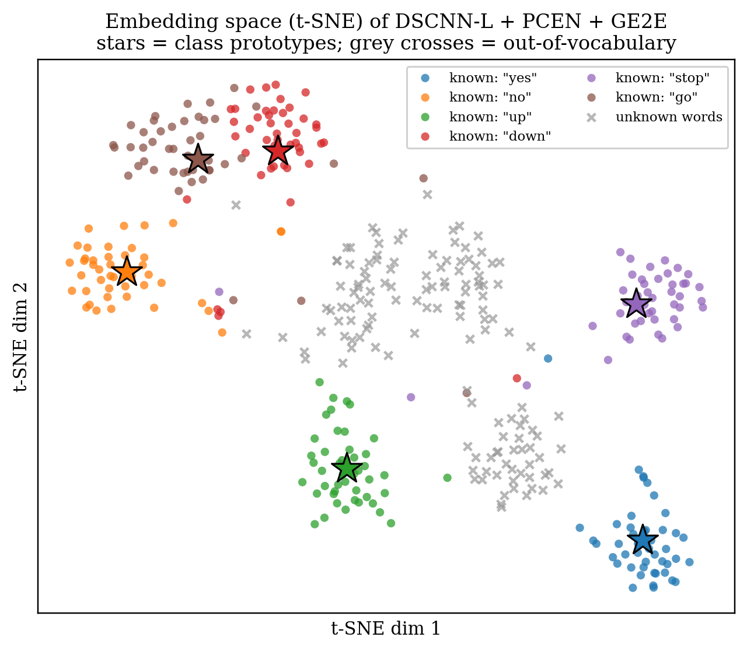
t-SNE projection of embeddings from the trained DSCNN-L + PCEN + GE2E model on real GSC audio. Coloured points are six known commands, stars are their prototypes, grey crosses are out-of-vocabulary words.

3.2 Datasets and training protocol
Training corpus (MSWC English). We train on the English subset of the Multilingual Spoken Words Corpus , which after filtering for $≥$ a minimum number of clips contains $37,387$ training words (and 763 validation words), drawn from a metadata pool of $∼$38,150 words and $∼$6.6 M clips. To study scale we form caps of $\{20,50,220,620\}$ clips per word — roughly $\{0.53,0.94,2.05,2.99\}$ M training clips — and two reduced regimes: a Top-500 legacy split (450 train / 50 val words) and an MLCommons micro-set (31 keywords) used only for pipeline validation and architecture screening. The three vocabulary regimes span more than three orders of magnitude (Figure 6); this range is what makes the scale effects in Section 4 observable.
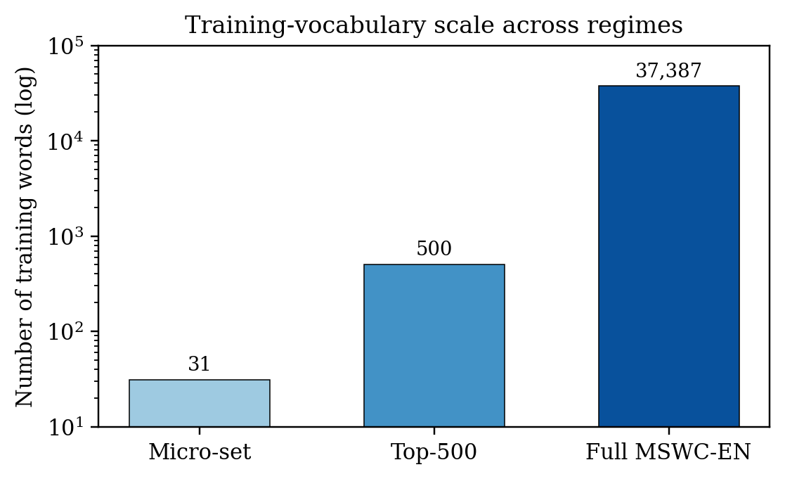
Training-vocabulary size for the three regimes (log scale). The micro-set is used only for screening; full MSWC English is the headline regime.
Episodic sampling and augmentation. Episodes draw 30 classes $×$ 20 utterances (only classes with $≥20$ clips are eligible). Online augmentation mixes DEMAND background noise (probability 0.5, SNR sampled in $[0,10]$ dB) and applies SpecAugment (one frequency mask of width 6, one time mask of width 8); gain perturbation ($±6$ dB) and time-shift ($≤100$ ms) are applied with probability 0.5. Figure 7 illustrates these augmentations on a real recording.
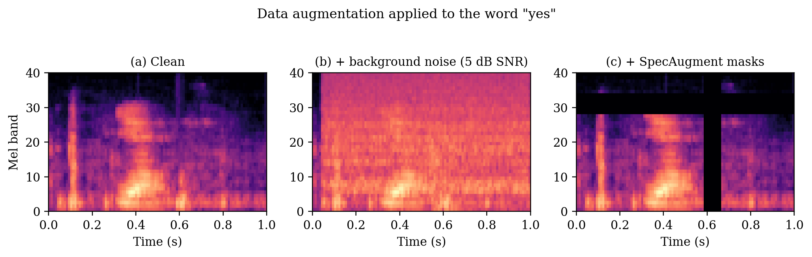
Training-time augmentation on the word “yes” (real data): (a) clean log-mel; (b) $+$ real background noise at 5 dB SNR; (c) $+$ SpecAugment frequency and time masks.
Evaluation corpus (GSC v2). We evaluate cross-corpus on Google Speech Commands v2 . Enrolment (support) samples are drawn from the official validation_list.txt; query samples from testing_list.txt (“test”) or the remaining files (“dev”), preventing leakage. A synthetic _silence_ class is generated from random one-second crops of _background_noise_, with disjoint crops for support and query.
Open-set protocol. The headline protocol partitions GSC’s 35 words into 11 positive classes — the ten command words {yes, no, up, down, left, right, on, off, stop, go} plus _silence_ — and 25 negative (unknown) spoken words. Each run enrols $k=10$ shots per positive word, computes prototypes, and scores up to 50 query samples per word (a fixed-seed subsample). We report the mean$±$std over 100 randomised runs; randomness comes from enrolment-shot selection. “test100” denotes 100 runs on the test split, “dev30” denotes 30 runs on the dev split.

3.3 Feature front-ends
All audio is mono, 16 kHz, and trimmed/zero-padded to exactly one second ($16,000$ samples). We support two spectral parameterisations (Table 1).
Feature front-end configurations.
 | MFCC | Log-mel
Sample rate | 16 kHz, mono, 1 s
FFT size | 1024 | 512
Window / hop | 40/20 ms | 25/10 ms
center | False | True
Mel bands | 40 | 40
Output coeffs. | 10 (first DCT) | 40 (mel)
Tensor shape | $(1,47,10)$ | $(1,40,101)$
Trainable PCEN | optional | optional
MFCC (DSCNN front-end). We compute 40 Mel-frequency cepstral coefficients with a 1024-point FFT, 640-sample (40 ms) Hann window, 320-sample (20 ms) hop, and center=False; the Mel filterbank uses Slaney scale and Slaney area normalisation, and the log is taken as $10\log_{10}(⋅)$ followed by an orthonormal DCT-II. We retain only the first 10 coefficients and transpose to a tensor of shape $(1,47,10)$, where $T=47=⌊(16000−1024)/320⌋+1$.
Log-mel (EdgeSpot front-end). We use 40 Mel bands with a 512-point FFT, 400-sample (25 ms) window, 160-sample (10 ms) hop, and center=True, producing $(1,40,101)$. The log compression is delegated to the PCEN layer.
Trainable PCEN. Per-channel energy normalisation applies a causal first-order IIR smoother $M_{t}=(1−s)M_{t−1}+sE_{t}$ followed by adaptive gain and dynamic-range compression,
$$\text{PCEN}(E_{t})=(\frac{E_{t}}{(ϵ+M_{t})^{α}}+δ)^{r}−δ^{r},$$
with learnable $α,δ,r,s$ (initialised to $0.96,2.0,0.5,0.04$; $ϵ={10}^{−6}$). PCEN replaces the static log and adapts to channel statistics during training.

3.4 Encoders
DSCNN-L. A depthwise-separable CNN: an initial $\text{Conv}(1→276,10×4,\text{stride }2×1)$ with TensorFlow-style asymmetric “same” padding, followed by five depthwise separable blocks (276 channels, $3×3$ kernels; the first strides $2×2$). All but the last block use BatchNorm$+$ReLU; the last uses an affine-free LayerNorm. A global average pool yields the embedding directly, so the embedding dimension equals the channel width, $d=276$ (no final linear projection). DSCNN-L has $≈0.413$ M parameters (Figure 8).
EdgeSpot-Full ($τ=4$). A width-scaled edge encoder on the $(1,40,101)$ mel/PCEN input. A $5×5$ stride-$(2,1)$ stem feeds four stages of fused-temporal and broadcasted-residual “lite” blocks with increasing temporal dilation $(1,2,4,8)$; a depthwise frequency-collapse block averages over frequency to a $(C,T)$ sequence; a depthwise positional convolution and a single-head temporal self-attention block ($d=64$) model long-range temporal structure; a depthwise temporal head and global pooling produce a 64-dimensional embedding. EdgeSpot-Full $τ=4$ has $≈0.131$ M parameters, $∼$3.2$×$ smaller than DSCNN-L (Figure 9).
Encoder comparison. $ℓ_{2}$-normalisation is applied outside the encoder so all losses and the deployment classifier operate on the hypersphere.
Encoder | Front-end | $d$ | Params
DSCNN-L | MFCC / mel($+$PCEN) | 276 | 0.413 M
EdgeSpot-Full $τ=4$ | mel($+$PCEN) | 64 | 0.131 M
EdgeSpot-Lite | mel($+$PCEN) | 64 | $<0.131$ M
BC-ResNet-FS $τ=4$ | mel($+$PCEN) | 64 | $∼$0.1 M
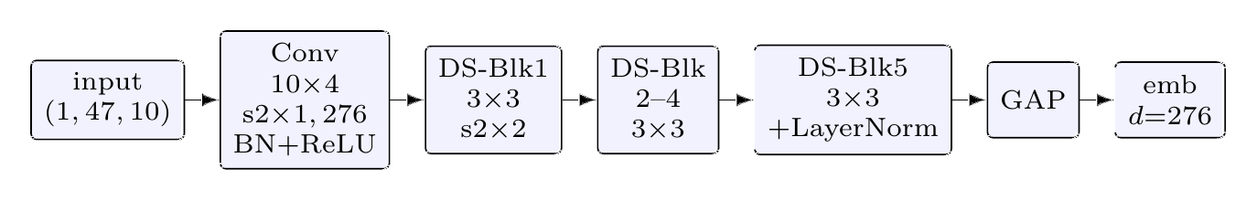
DSCNN-L encoder: depthwise-separable CNN, $≈$0.41 M parameters. The embedding equals the final channel width (276); no linear projection.
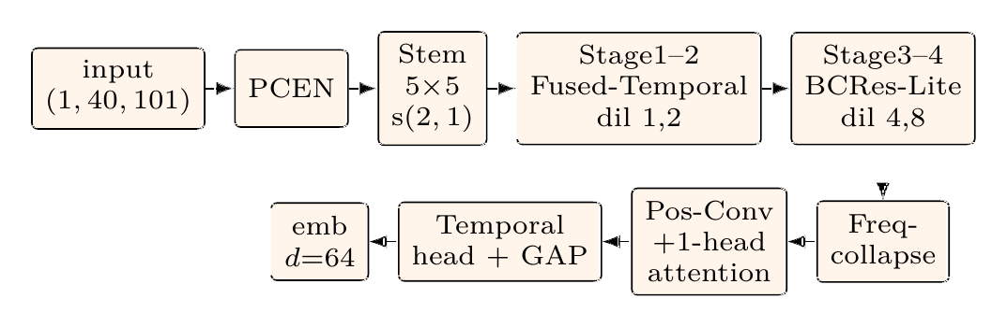
EdgeSpot-Full ($τ=4$) encoder: mel/PCEN front-end, fused-temporal and broadcasted-residual blocks with growing dilation, frequency collapse, and a single-head temporal self-attention stage, $≈$0.13 M parameters.

3.5 Metric-learning objectives
All objectives are trained episodically: each episode samples 30 classes with 20 utterances each (600 embeddings/episode).
Triplet. Semi-hard triplet loss with Euclidean distance, $L=\frac{1}{N}∑max(0,d(a,p)−d(a,n)+m)$, with hardest-positive and FaceNet semi-hard negative mining.
Sub-center ArcFace (SCAF). An angular-margin softmax with $K=3$ sub-centers per class. With normalised weights, the per-class logit is the max cosine over its sub-centers, $cosθ_{c}=\max_{j≤K}w_{c,j}^{⊤}z$; the additive margin $m=0.5$ is applied to the target class and logits are scaled by $s=30$ before cross-entropy.
GE2E (centroid). Generalised end-to-end loss that mirrors deployment: within an episode each class is split into support/query; the centroid is the $ℓ_{2}$-normalised support mean and queries are classified by scaled cosine similarity to all centroids, optimised by cross-entropy. GE2E directly optimises the enrol-then-match objective of Equations [eq:proto]–[eq:score].
Cosine knowledge distillation (KD). We distil from a frozen Wav2Vec 2.0-base teacher (hidden layer 16, mean-pooled, projected to $d=64$). The distillation loss is a pure embedding-cosine term,
LKD=1−1Ni​cos​fθ(xi), gteacher(xi),
with no temperature/soft-label term. Teacher embeddings are precomputed offline and looked up by file path during training.
Hybrid combinations. We form weighted sums (e.g. scaf_ge2e, kd_ge2e). A crucial implementation detail (and a key empirical finding, Section 4) is the SCAF weight: under KD it is set to $5×{10}^{−5}$ while GE2E/KD weights are 1.0, preventing the high-magnitude angular-margin classification loss from dominating the centroid/cosine terms.
Optimisation. Unless noted, training uses Adam (learning rate ${10}^{−3}$, weight decay ${10}^{−4}$), gradient clipping at $5.0$, a cosine-annealing-with-warm-restarts schedule ($T_{0}=10$, $T_{\text{mult}}=2$, $η_{min}={10}^{−5}$), and a fixed seed (42) with cuDNN determinism.

3.6 Open-set rejection heads
All heads share the prototype interface and differ only in the rejection score; the predicted keyword is always the argmin-distance class (Equation [eq:score]). (i) Nearest-class-mean (NCM, “Direct $ℓ_{2}$”) — our default — rejects when the minimum prototype distance exceeds a threshold. (ii) OpenMax fits a Weibull tail to support-to-prototype distances and uses $1−CDF$ as the membership score. (iii) Energy treats $−d_{i}$ as logits and uses the free energy E(x)=Tlogi​exp(−di/T) as the acceptance score. (iv) Calibrated thresholds ($μ+2σ$ of support distances) drive per-word confusion analysis.

3.7 Evaluation methodology
We treat the open-set problem as binary keyword-vs-non-keyword detection augmented by a multiclass identity track, and build all metrics on the ROC.
- AUC: area under the ROC of the open-set scores; threshold-free.
- EER: equal-error rate, the operating point minimising $|\text{FAR}−\text{FRR}|$, reported as $(\text{FAR}+\text{FRR})/2$.
- FRR@FAR: false-reject rate at the largest threshold whose false-accept rate does not exceed the target (1% or 5%).
- Open-set ACC@FAR: the headline accuracy. A known query is correct iff it is accepted ($s≥τ_{\text{FAR}}$) and the argmin label is correct; an unknown query is correct iff it is rejected. Reported at FAR $∈\{1\%,5\%\}$.
- Keyword ACC: closed-set nearest-prototype accuracy over known queries only (ignores rejection).
- F1: binary keyword-vs-unknown F1 at the EER threshold.
Interpretation caveat. AUC and EER are threshold-free, whereas ACC@FAR and FRR@FAR use a threshold derived from the evaluation ROC (an oracle operating point), not transferred from a held-out calibration split. We therefore treat ACC@FAR as a comparison metric across systems under matched conditions, and report AUC/EER/F1 jointly so that degenerate operating points are visible: a system that rejects nearly everything scores high open-set ACC against many negatives while missing all positives, and such cases are exposed by $\text{FRR}→100\%$ and $\text{F1}→0$.

3.8 Deployment: streaming and demonstrator
Beyond the core encoder, the system includes a CPU streaming pipeline and an offline web demonstrator. Streaming performs sliding-window detection (1 s window) gated by Silero Voice Activity Detection (VAD): only windows that VAD marks as speech are embedded and matched, reducing computation and false activations on silence. A backend-agnostic decision state machine (Appendix A) stabilises raw candidates into clean events using majority-vote smoothing over a short window, a top-2 margin check, and a cooldown to suppress duplicate firings. The streaming server decouples audio ingestion from inference (a non-blocking receiver feeds a single-inference-at-a-time consumer on a fixed cadence), which bounds end-to-end detection latency under load without changing the detection arithmetic. Optional modules — a spectral-gating denoiser and an ECAPA-TDNN speaker-verification gate — follow the same fail-open, runtime-toggle pattern.

4 Results and Discussion
All numbers are mean$±$std over the 10-shot open-set protocol (100 runs on GSC test, denoted test100). Higher is better for ACC/AUC/F1/Keyword-ACC; lower is better for EER/FRR.

4.1 Training dynamics
Figure 10 shows the real training trajectory of the Microset anchor model (EdgeSpot-Full + SCAF+GE2E), read directly from saved TensorBoard logs. The loss decreases smoothly from $∼$15.5 to $∼$1.3, the validation AUC rises to and stabilises near $98\%$, and the GSC-dev open-set accuracy plateaus around $85\%$ — a healthy, non-overfitting trajectory. The contrasting collapse behaviour at full $37$k-class vocabulary is discussed in Section 4.3.
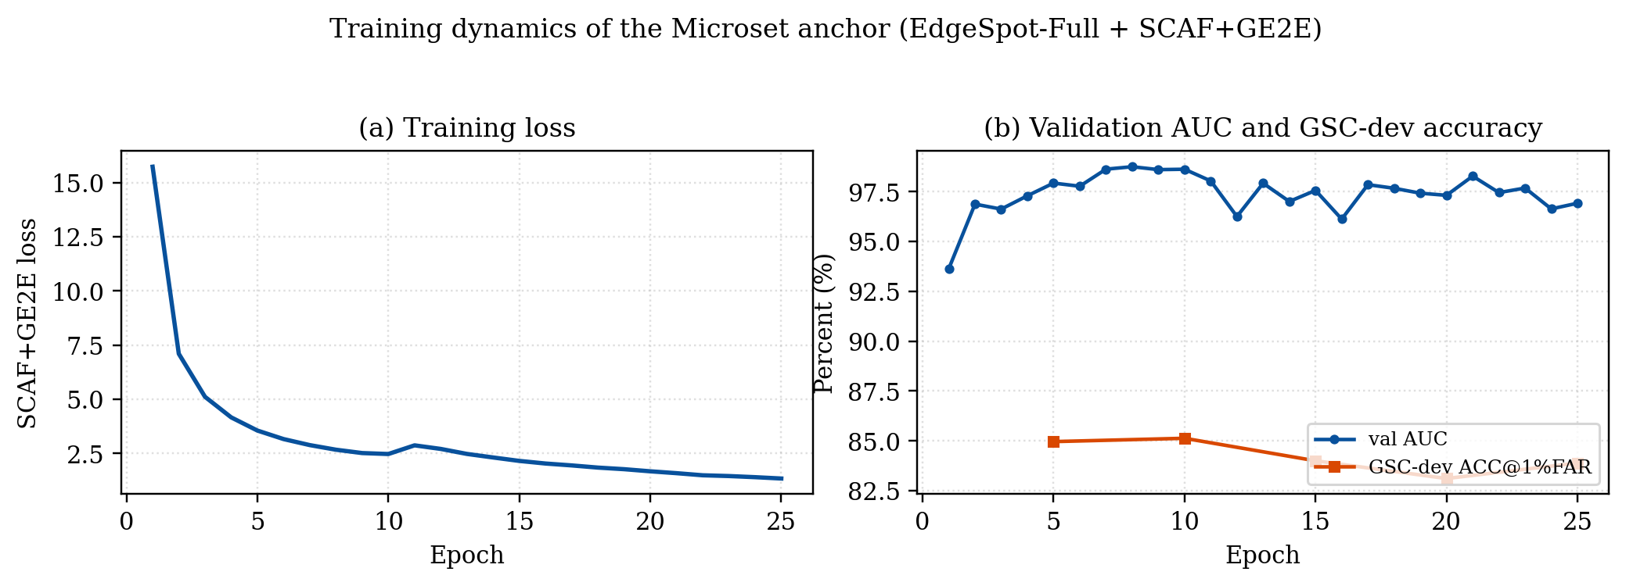
Real training dynamics of the Microset anchor (EdgeSpot-Full + SCAF+GE2E), from local TensorBoard logs: (a) training loss; (b) validation AUC and GSC-dev ACC@1%FAR over epochs.

4.2 Q1: Which design axis matters
Table 3 reports the full 16-configuration screen on full-vocabulary MSWC (cap-620), and Figure 11 ranks the configurations visually. Two findings are immediate: PCEN-based pipelines occupy the top of the ranking, and the centroid GE2E loss is the best objective for every backbone. The classification objective SCAF (and the SCAF$+$GE2E hybrid at full weight) collapses at this scale — analysed in Section 4.3.
Full 16-configuration screen on full-vocabulary MSWC (cap-620), GSC test100 @ 1% FAR. “coll.” marks degenerate collapse (AUC$=$50, F1$=$0, FRR$=$100%). Best in bold.
Enc. | Feat. | Loss | ACC$​_{1\%}$ | AUC | EER | F1
DSCNN | MFCC | Triplet | 71.52 | 75.55 | 31.41 | 57.17
DSCNN | MFCC | SCAF | 70.08 | 55.04 | 46.41 | 41.38
DSCNN | MFCC | GE2E | 77.08 | 86.46 | 21.95 | 68.50
DSCNN | MFCC | SCAF+GE2E | 69.04 | 47.78 | 52.15 | 35.93
DSCNN | PCEN | Triplet | 79.98 | 90.65 | 17.57 | 74.14
DSCNN | PCEN | SCAF | 69.44 | 50.00 | 50.00 | coll.
DSCNN | PCEN | GE2E | 82.34 | 92.42 | 14.89 | 77.75
DSCNN | PCEN | SCAF+GE2E | 69.44 | 50.00 | 50.00 | coll.
Edge | MFCC | Triplet | 69.63 | 52.84 | 48.05 | 39.79
Edge | MFCC | SCAF | 69.44 | 50.00 | 50.00 | coll.
Edge | MFCC | GE2E | 70.76 | 65.30 | 39.05 | 48.82
Edge | MFCC | SCAF+GE2E | 69.67 | 50.88 | 50.39 | 37.57
Edge | PCEN | Triplet | 79.58 | 89.85 | 18.22 | 73.29
Edge | PCEN | SCAF | 69.44 | 50.00 | 50.00 | coll.
Edge | PCEN | GE2E | 79.98 | 87.23 | 20.23 | 70.68
Edge | PCEN | SCAF+GE2E | 69.44 | 50.00 | 50.00 | coll.
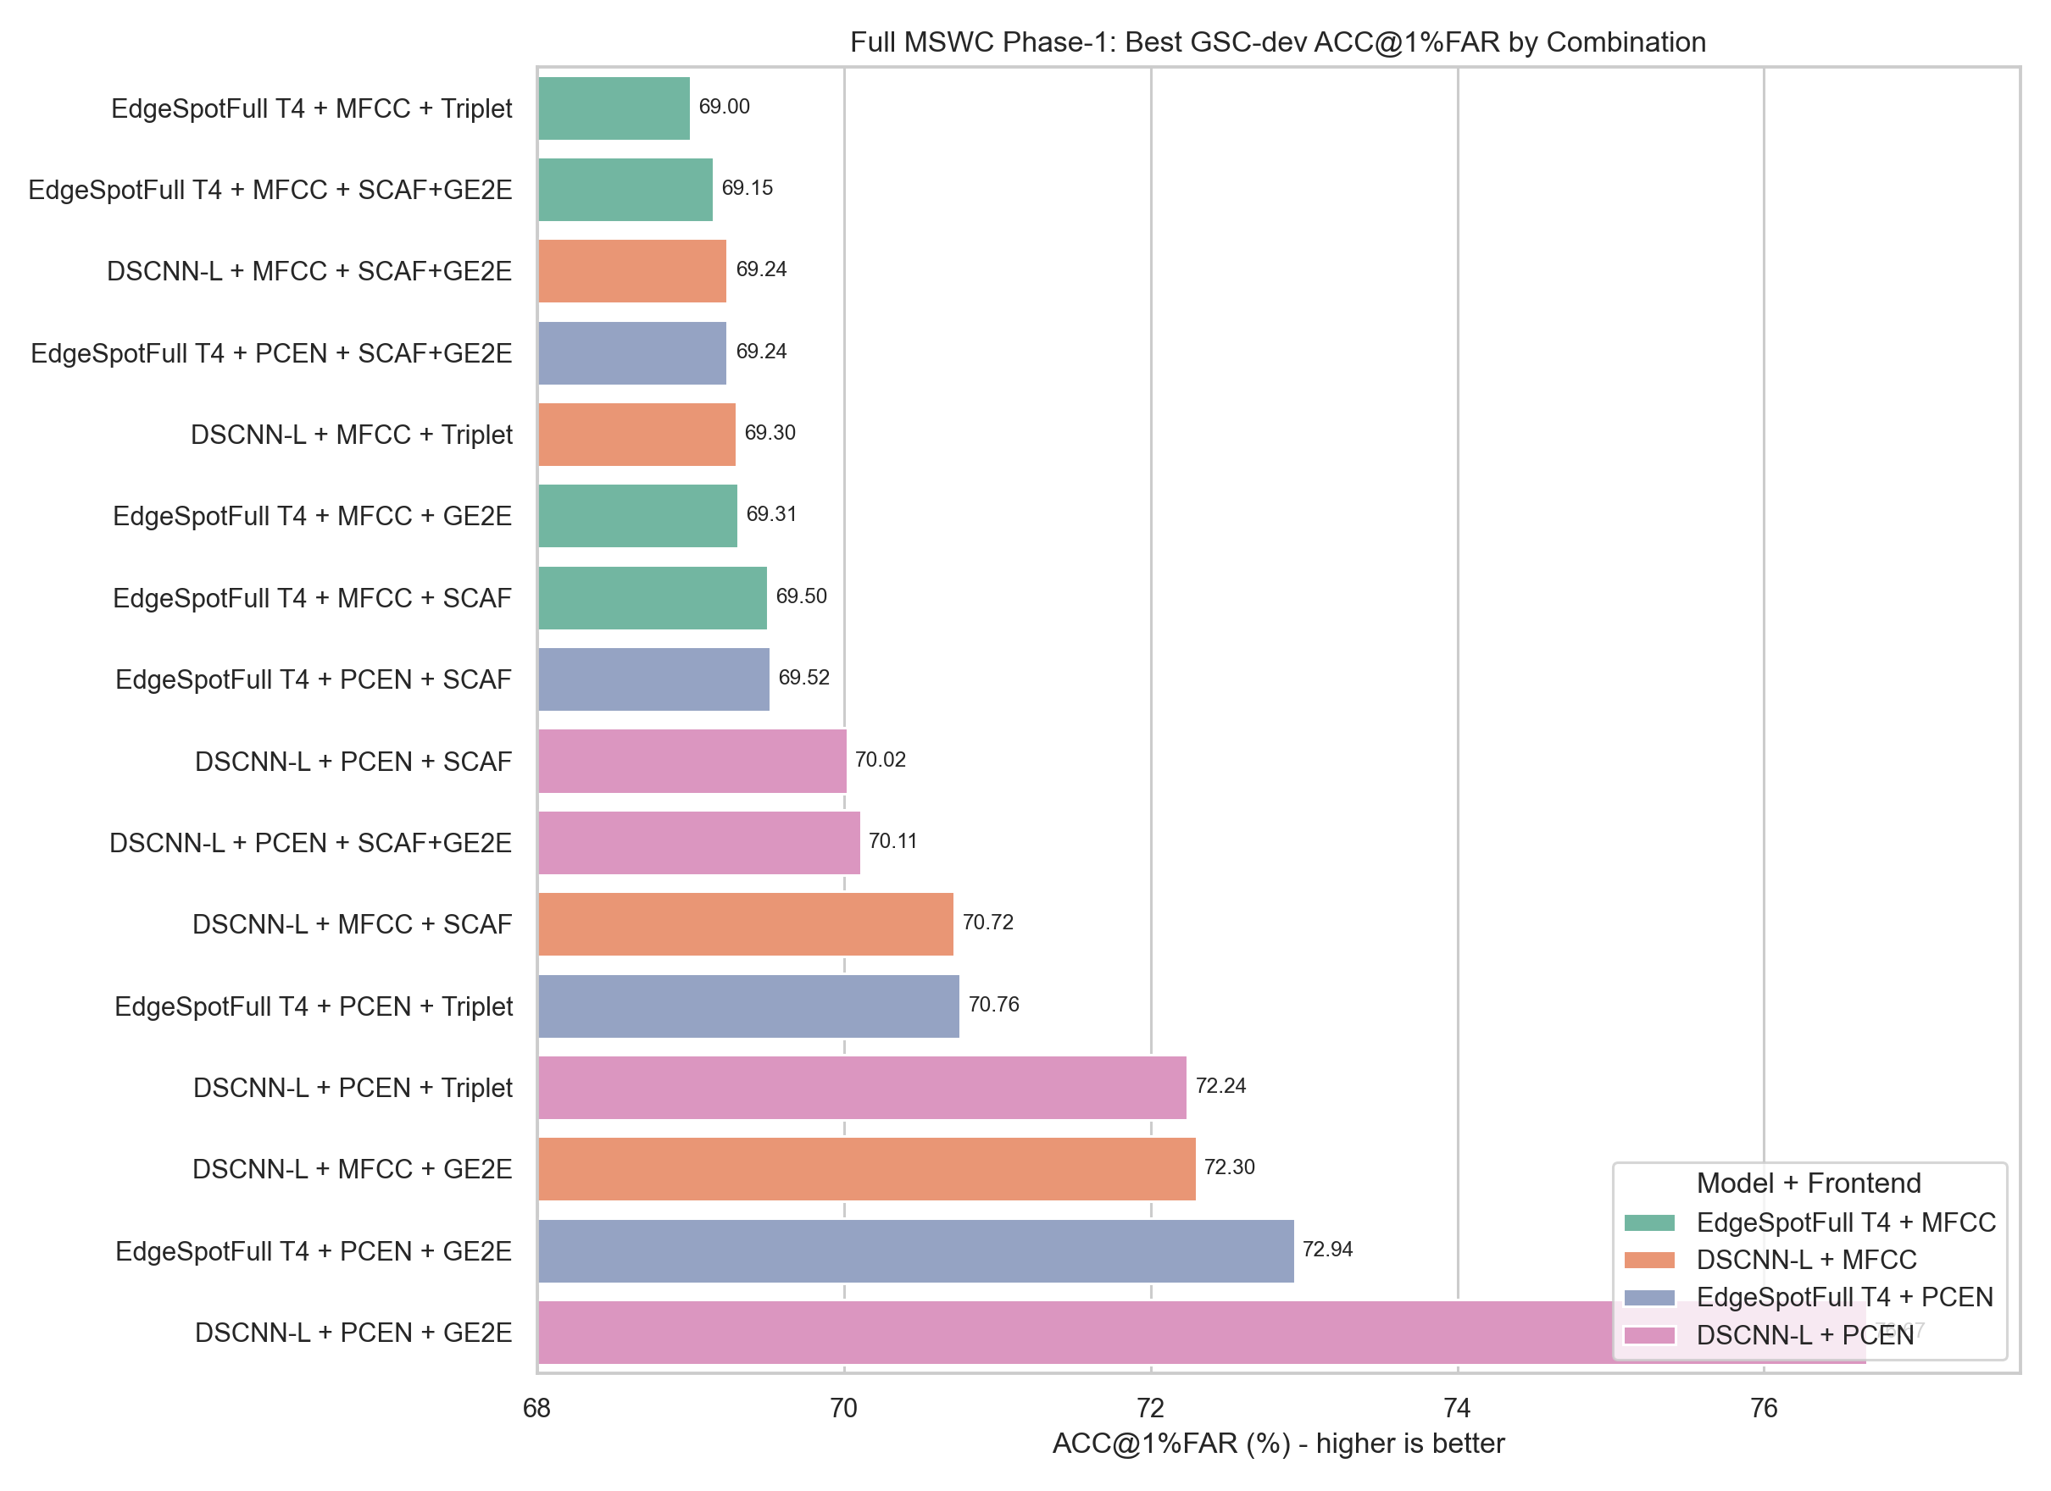
Configurations ranked by GSC ACC@1%FAR (phase-1 screen on full MSWC). PCEN$+$GE2E pipelines lead; colour encodes backbone$×$front-end.

4.2.0.1 Paired effect deltas.
Isolating each axis (Table 4, Figure 12) shows two robust wins. PCEN improves every backbone — most dramatically the edge encoder ($+9.22$ ACC, $+21.86$ F1) — and GE2E consistently beats triplet. The front-end therefore carries proportionally more of the representational burden when the backbone is small.
Paired effect deltas (percentage points), full-vocabulary MSWC, GSC test100 @ 1% FAR. Positive favours the first option.
Contrast (others fixed) | $Δ$ACC$​_{1\%}$ | $Δ$AUC | $Δ$F1
PCEN $−$ MFCC (DSCNN, GE2E) | +5.26 | +5.96 | +9.25
PCEN $−$ MFCC (Edge, GE2E) | +9.22 | +21.93 | +21.86
GE2E $−$ Triplet (DSCNN, PCEN) | +2.36 | +1.77 | +3.61
DSCNN $−$ Edge (PCEN, GE2E) | +2.36 | +5.19 | +7.07
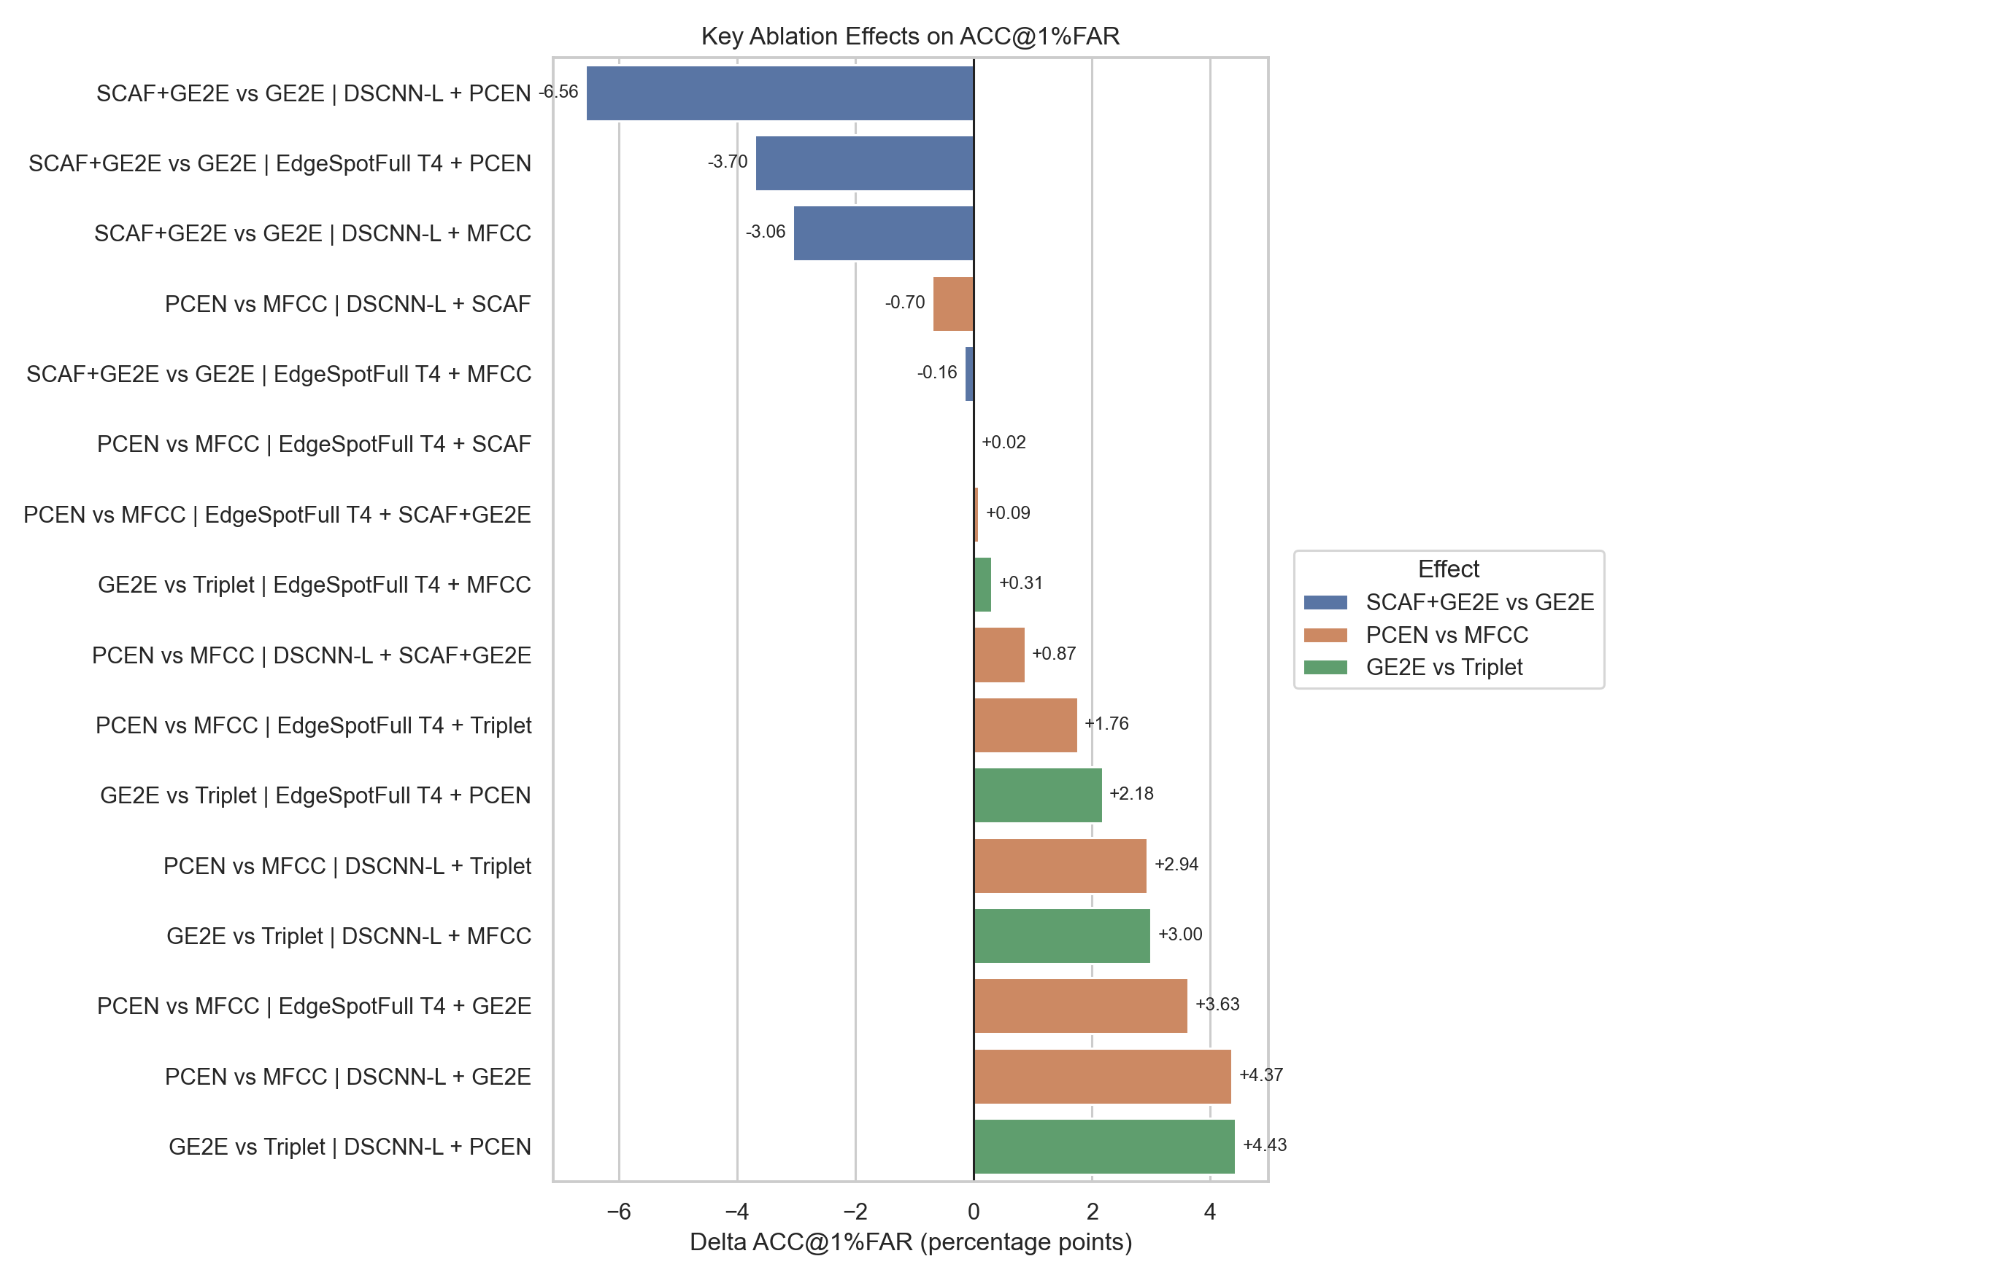
Key paired effect deltas. PCEN and GE2E are the two consistent improvements across backbones.

4.3 Q2: Scale — saturation and the SCAF collapse

4.3.0.1 Accuracy saturates near 2 M clips.
Figure 13 and Table 5 sweep the per-word cap for the best front-end/loss (PCEN$+$GE2E). There is a large jump between cap-50 and cap-220 ($+3.55$ ACC for DSCNN, $+3.79$ for EdgeSpot at 5% FAR) and a flat region from cap-220 to cap-620. Accuracy is effectively data-saturated at $∼$2 M training clips: beyond this point, more clips of the same words yield negligible cross-corpus gains.
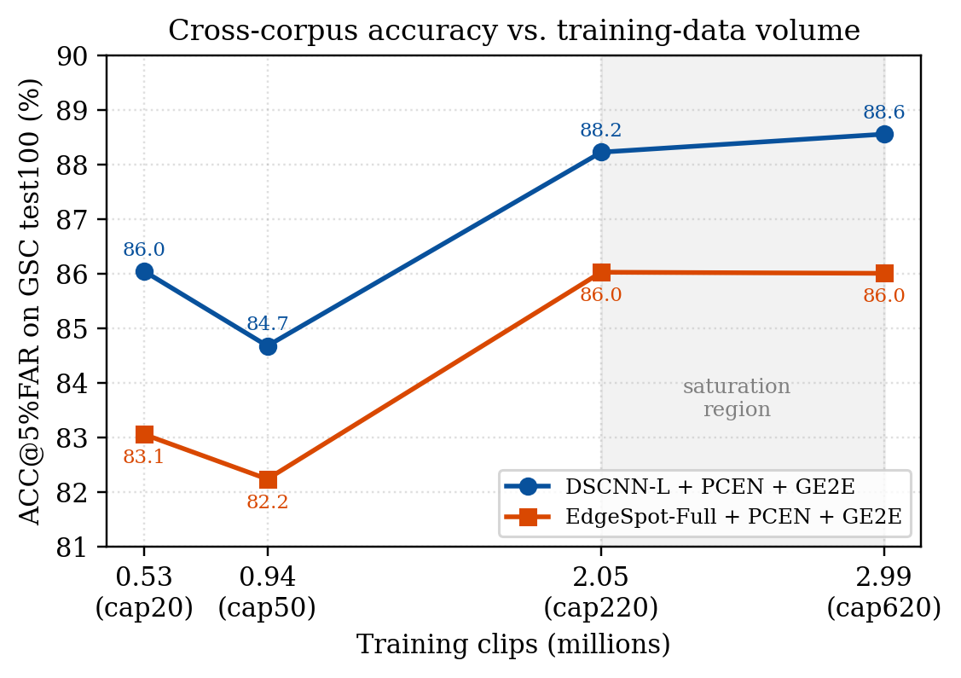
Cross-corpus accuracy vs. training-data volume (per-word caps). Performance saturates near $∼$2 M clips (shaded).
Data-scale sweep (PCEN$+$GE2E), GSC test100. ACC at 5% FAR.
Encoder | Cap | ACC$​_{5\%}$ | AUC | EER | F1
DSCNN-L | 20 | 86.05 | 91.57 | 16.25 | 75.90
 | 50 | 84.68 | 90.45 | 17.42 | 74.34
 | 220 | 88.23 | 93.87 | 12.78 | 80.67
 | 620 | 88.56 | 94.04 | 12.53 | 81.02
EdgeSpot | 20 | 83.06 | 87.22 | 20.40 | 70.46
 | 50 | 82.24 | 87.74 | 20.19 | 70.73
 | 220 | 86.03 | 91.31 | 16.47 | 75.61
 | 620 | 86.01 | 91.34 | 16.64 | 75.38

4.3.0.2 The SCAF collapse at 37k classes.
The most striking result of the scale study is a qualitative failure. On the 31-class micro-set and the $∼$500-class Top-500 split, SCAF and SCAF$+$GE2E are excellent (AUC $≈95$). However, on the full $37,387$-class vocabulary with the default SCAF weight of 1.0, training collapses from epoch 2: validation AUC pins at 0.5000, the in-episode GE2E accuracy falls to $≈0.033$ ($≈1/30$, chance), and the GSC metrics become degenerate (AUC 50, F1 0, FRR$=$100%, keyword ACC 9.09%). The mechanism is a gradient-magnitude imbalance: the sub-center ArcFace logit scale ($s=30$) multiplied across $∼$$3.7×{10}^{4}$ classes produces a classification gradient that dwarfs the centroid/cosine terms, driving all embeddings to a trivial solution. The same hybrid does not collapse under KD, where the SCAF weight is $5×{10}^{−5}$. Practical remedies we verify are: (i) reduce the SCAF weight to $∼$$5×{10}^{−5}$, (ii) warm up the margin/scale, or (iii) drop the classification term and use GE2E or KD. This is a cautionary result: angular-margin classification losses that are state-of-the-art at ${10}^{2}$–${10}^{3}$ classes do not transfer naively to ${10}^{4}$-class word embedding.

4.4 Q3: Knowledge distillation trades teacher knowledge for data
Table 6 distils a frozen Wav2Vec 2.0 teacher into the compact EdgeSpot student. At cap-50, KD improves every metric over GE2E ($+3.60$ ACC@1%FAR, $−4.78$ EER, $+6.31$ F1) and, strikingly, KD at cap-50 matches GE2E at cap-220 — the same accuracy with roughly half the training clips. KD also saturates early, indicating that the teacher injects most of its useful inductive bias from limited data.
Knowledge distillation vs. GE2E (EdgeSpot student), GSC test100.
Cap | Loss | ACC$​_{1\%}$ | ACC$​_{5\%}$ | EER | F1
50 | GE2E | 77.14 | 82.24 | 20.19 | 70.73
50 | KD | 80.74 | 85.82 | 15.41 | 77.04
220 | GE2E | – | 86.03 | 16.47 | 75.61
220 | KD | 80.82 | 85.90 | 15.36 | 77.10

4.5 Q4: Best deployable systems
Table 7 consolidates the strongest configurations per data regime, and Figures 14–15 visualise the headline operating point. Three points stand out:
- Best overall: DSCNN-L$+$PCEN$+$GE2E (cap-620) reaches $86.36±1.29$ ACC@1%FAR and $89.93±0.65$ at 5% FAR, with AUC 95.21, EER 11.32, F1 82.73, keyword ACC 92.92%.
- Best compact: EdgeSpot-Full$+$PCEN$+$GE2E (cap-620, ep300 composite) reaches $82.87±1.22$ ACC@1%FAR at 0.131 M parameters — within $∼$3.5 points of the best system at one third the size, and competitive with (slightly above the mean of) the EdgeSpot-4 literature reference ($∼$82% ACC@1%FAR, $∼$128k params).
- Best small-vocabulary: on the reduced Top-500 split, the EdgeSpot$+$PCEN$+$SCAF$+$GE2E hybrid is the strongest compact model ($85.62±1.04$ ACC@1%FAR, AUC 95.34), confirming the hybrid is excellent when the class count is small enough not to trigger the collapse.
Consolidated best systems across data regimes (GSC test100, 10-shot, 100 runs). “coll.”$=$ degenerate collapse.
Regime | Encoder | Loss | Params | ACC$​_{1\%}$ | ACC$​_{5\%}$ | AUC | EER | F1 | KW
Micro (31) | EdgeSpot | SCAF+GE2E | 0.131M | 84.61 | 86.12 | 95.61 | 11.54 | 82.41 | 77.66
Top-500 | EdgeSpot | SCAF+GE2E ep13 | 0.131M | 85.62 | 88.79 | 95.34 | 11.51 | 82.45 | 90.44
Top-500 | DSCNN-L | GE2E | 0.413M | 81.55 | 86.56 | 93.17 | 14.00 | 78.97 | 88.62
Full cap20 | DSCNN-L | GE2E | 0.413M | 82.10 | 86.05 | 91.57 | 16.25 | 75.90 | 88.90
Full cap220 | DSCNN-L | GE2E | 0.413M | – | 88.23 | 93.87 | 12.78 | 80.67 | 89.82
Full cap620 | DSCNN-L | GE2E ep300 | 0.413M | 86.36 | 89.93 | 95.21 | 11.32 | 82.73 | 92.92
Full cap620 | EdgeSpot | GE2E ep300 | 0.131M | 82.87 | 86.76 | 92.41 | 14.82 | 77.85 | 87.29
Full cap50 | EdgeSpot | KD | 0.131M | 80.74 | 85.82 | 91.19 | 15.41 | 77.04 | 87.95
Full cap220 | EdgeSpot | SCAF+GE2E | 0.131M | coll. | coll. | 50.00 | 50.00 | coll. | 9.09
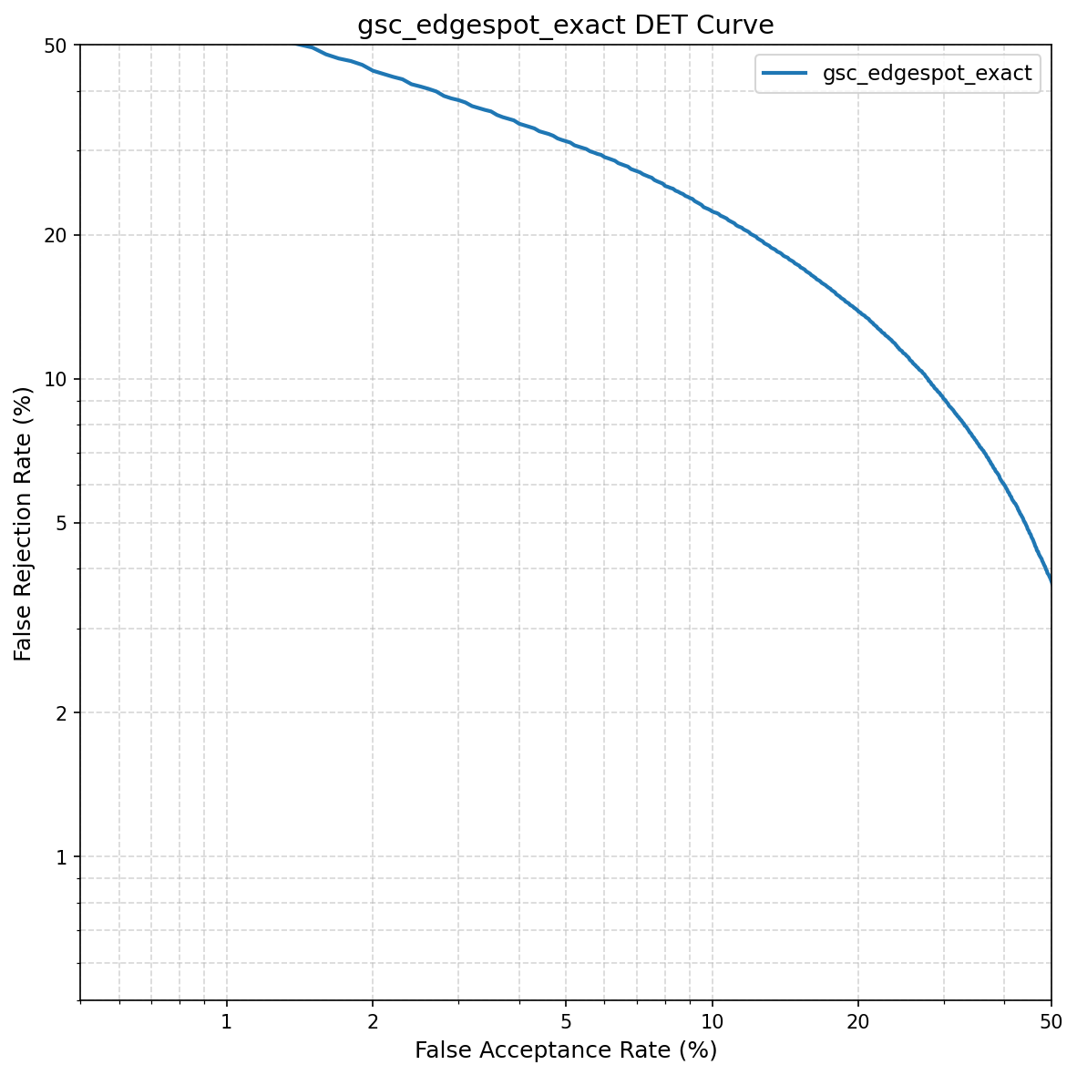
Detection-error-tradeoff (DET) curve of the best overall system (DSCNN-L$+$PCEN$+$GE2E).
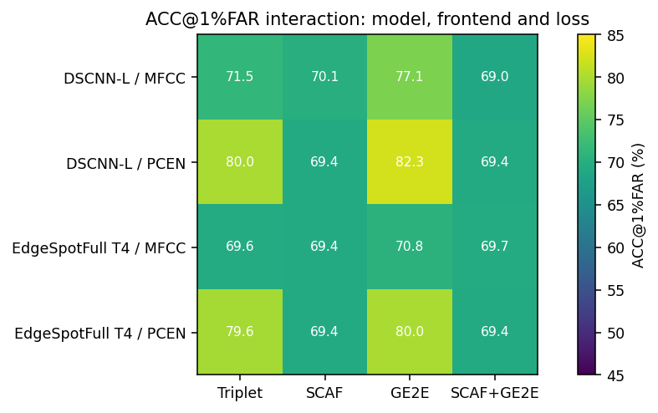
ACC@1%FAR heat map over the cap-620 configurations.

4.5.0.1 Accuracy vs. model size.
Figure 16 places the systems on the accuracy–size plane. DSCNN-L leads on accuracy; EdgeSpot-Full reaches a competitive point at one third the parameters; KD lifts the compact model further at low data.
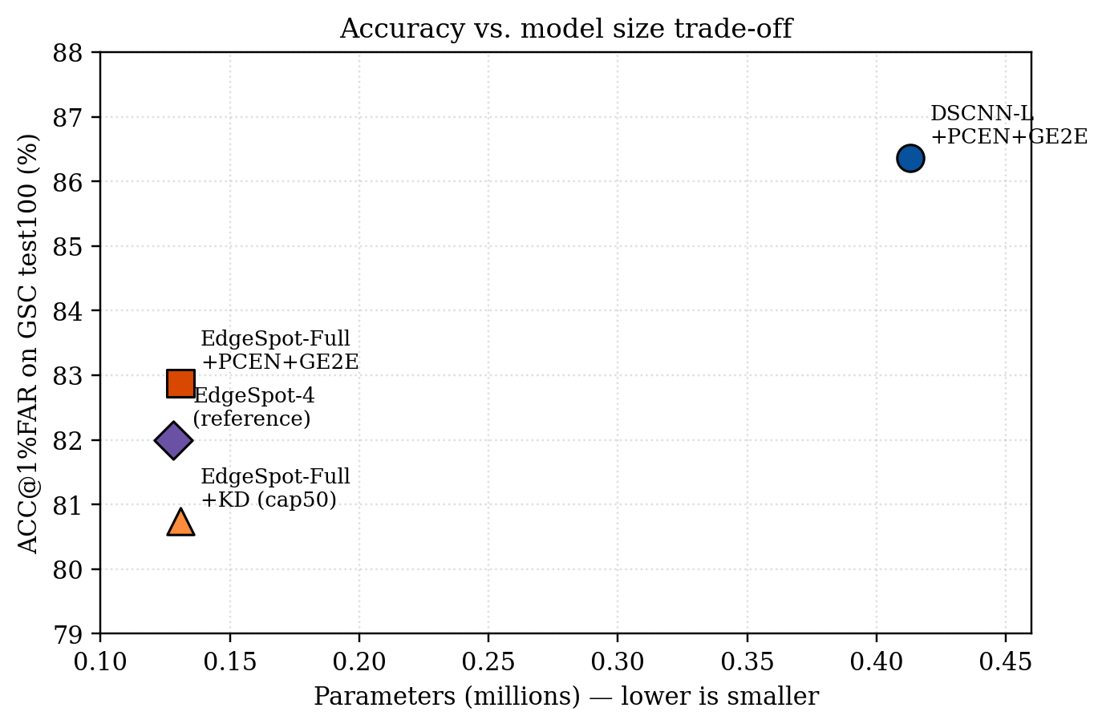
Accuracy vs. model size. The compact EdgeSpot-Full sits within a few points of the larger DSCNN-L at one third the parameters.

4.6 Inference on long audio
To verify the system end-to-end — not only on isolated test clips — we enrol prototypes for 17 keywords (10 shots each from GSC) and run nearest-prototype inference over a real, continuously spoken multi-word recording. Figure 17 overlays the predicted keyword and its prototype distance on the waveform for the first 16 spoken segments. The model correctly identifies $15/16$ segments ($≈$94%); the single error (“sheila”, a long, rare name) also has the largest prototype distance — exactly the signal the open-set threshold uses to flag low-confidence detections. Figure 18 shows the front-end$×$loss interaction: the PCEN$+$GE2E cell dominates, while classification-only cells degrade at full vocabulary scale.
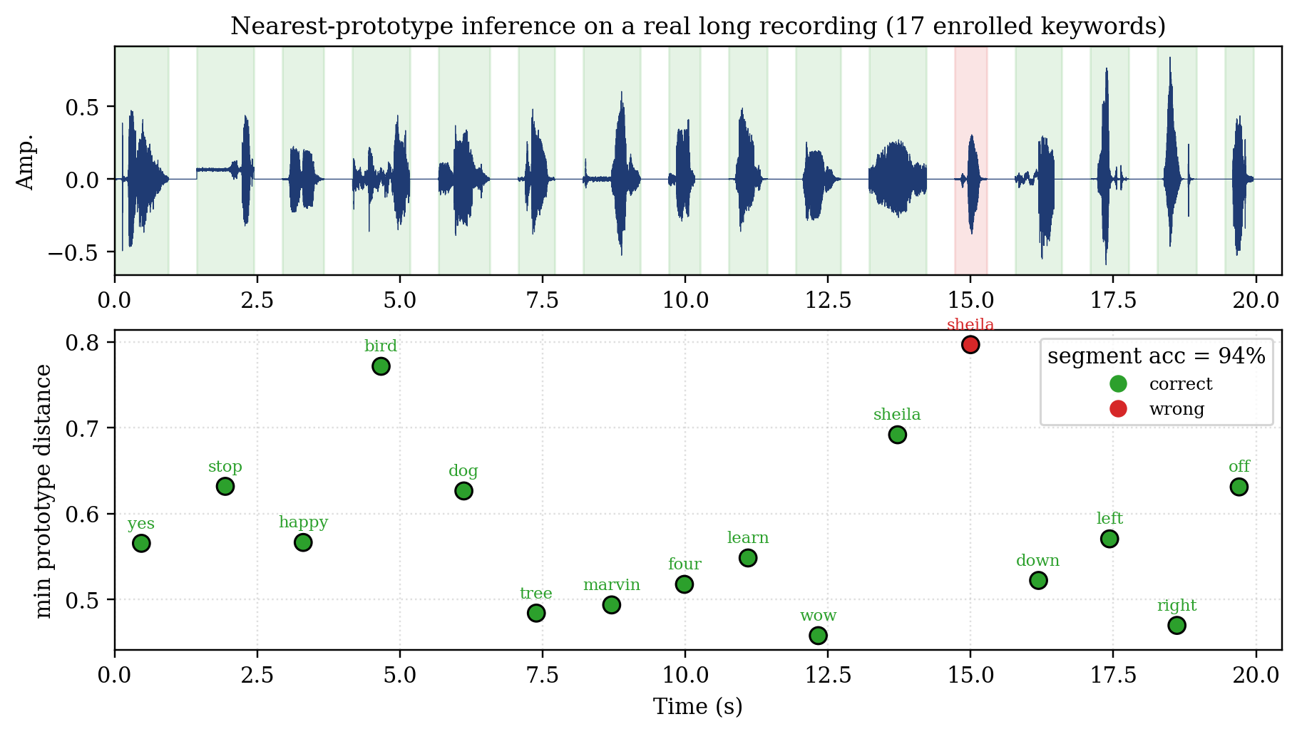
Nearest-prototype inference on a real long recording. Top: waveform with per-segment correct (green) / wrong (red) shading. Bottom: minimum prototype distance and predicted keyword per segment.
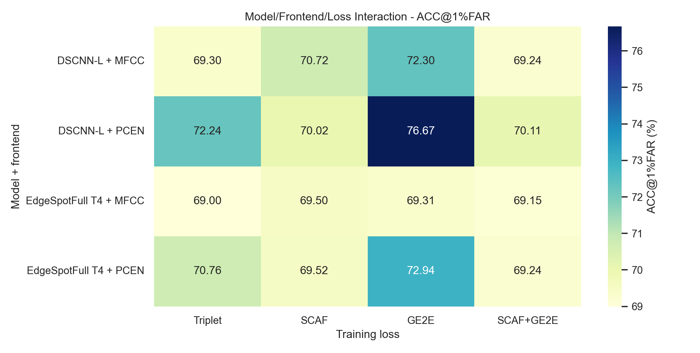
Front-end $×$ loss interaction (ACC@1%FAR). The PCEN$+$GE2E cell dominates; classification-only cells degrade at full vocabulary scale.

4.6.0.1 Reproducibility note on data regimes.
Within full-vocabulary results, three cap-620 runs use different episode budgets (a 40-epoch fixed screen, a 1000-episode saturation run, and a 300-episode composite-selection development run). They must not be conflated; each table row is drawn from a single consistent run, with the budget stated where it matters.

5 Conclusion and Perspective

5.1 Current status
This thesis set out to build a keyword-spotting system that escapes the two structural limits of classical wake-word engines — a frozen vocabulary and the inability to abstain — and to understand, rather than merely report, what makes such a system work as the training vocabulary grows. We delivered a complete, reproducible, dependency-light pipeline: two compact encoders (DSCNN-L at $≈$0.41 M and EdgeSpot-Full at $≈$0.13 M parameters), three feature front-ends, four metric-learning objectives, four open-set rejection heads, a CPU streaming engine, and an offline web demonstrator. Every system is trained on MSWC English and evaluated cross-corpus on GSC v2 under a single strict 10-shot protocol with 100 randomised runs, so the numbers compare fairly.
The headline outcome is that few-shot open-set KWS is viable and even strong at true vocabulary scale: training once on $37,387$ words, the best configuration (DSCNN-L $+$ PCEN $+$ GE2E) reaches $86.36\%$ open-set accuracy at a strict $1\%$ false-accept rate and $95.21$ AUC on a corpus it was never trained on, while a three-times-smaller edge model (EdgeSpot-Full $+$ PCEN $+$ GE2E) stays within a few points at $82.87\%$. A user can define an arbitrary keyword set from ten examples per word, with no retraining, and the system can decline to answer on unknown speech and silence.

5.2 What is good, what is weak

5.2.0.1 What works.
Three findings are robust and transferable. (1) The trainable PCEN front-end is the most reliable single improvement, and it helps the smaller encoder most — a useful lever precisely where the parameter budget is tightest. (2) The centroid GE2E objective, which optimises the same enrol-then-match computation used at deployment, consistently beats both triplet and classification objectives for open-set generalisation. (3) A frozen Wav2Vec 2.0 teacher distilled with a simple cosine loss lets the compact model reach GE2E-level accuracy with roughly half the data.

5.2.0.2 What is weak.
The clearest negative result is the collapse of the sub-center ArcFace (SCAF) classification objective at ${10}^{4}$-class scale: a loss that is excellent on tens to hundreds of classes drives the embedding to a trivial solution on tens of thousands of classes unless its weight is cut by four orders of magnitude. Two further limitations bound the present claims. First, the ACC@FAR/FRR@FAR operating points are read from the evaluation ROC (an oracle threshold) rather than transferred from an independent calibration split; we mitigate this by always co-reporting threshold-free AUC/EER/F1, but a calibrated, deployment-time threshold study is still owed. Second, enrolment is fixed at $k=10$ shots and the streaming latency figures are design budgets, not measured field benchmarks, and there is no quantitative denoising ablation.

5.3 Future work
Four directions follow directly from the limitations above. (1) $k$-shot sensitivity: sweep $k∈\{1,3,5,10\}$ to chart the accuracy-vs-enrolment-effort curve, which is the metric end users actually feel. (2) Calibrated thresholds: learn or transfer the open-set threshold from a held-out split and report deployment-realistic ACC@FAR, closing the oracle gap. (3) On-device benchmark: measure end-to-end latency, false-alarms-per-hour, and miss-rate on target hardware, plus an SNR-sweep denoising ablation. (4) Stabilising classification at scale: margin/scale warm-up, curriculum, or sub-center pruning to recover the discriminative power of angular-margin losses without the collapse.
In summary, the thesis demonstrates a deployable, retraining-free, open-set keyword spotter and, just as importantly, a clear empirical map of which design choices help, where they saturate, and where they fail as the problem scales.
99
Y. Zhang, N. Suda, L. Lai, and V. Chandra, “Hello edge: Keyword spotting on microcontrollers,” arXiv:1711.07128, 2017. B. Kim, S. Chang, J. Lee, and D. Sung, “Broadcasted residual learning for efficient keyword spotting,” Interspeech, 2021. J. Snell, K. Swersky, and R. Zemel, “Prototypical networks for few-shot learning,” NeurIPS, 2017. F. Schroff, D. Kalenichenko, and J. Philbin, “FaceNet: A unified embedding for face recognition and clustering,” CVPR, 2015. L. Wan, Q. Wang, A. Papir, and I. L. Moreno, “Generalized end-to-end loss for speaker verification,” ICASSP, 2018. J. Deng, J. Guo, N. Xue, and S. Zafeiriou, “ArcFace: Additive angular margin loss for deep face recognition,” CVPR, 2019. J. Deng, J. Guo, T. Liu, M. Gong, and S. Zafeiriou, “Sub-center ArcFace: Boosting face recognition by large-scale noisy web faces,” ECCV, 2020. A. Bendale and T. E. Boult, “Towards open set deep networks,” CVPR, 2016. W. Liu, X. Wang, J. Owens, and Y. Li, “Energy-based out-of-distribution detection,” NeurIPS, 2020. Y. Wang, P. Getreuer, T. Hughes, R. F. Lyon, and R. A. Saurous, “Trainable frontend for robust and far-field keyword spotting,” ICASSP, 2017. A. Baevski, H. Zhou, A. Mohamed, and M. Auli, “wav2vec 2.0: A framework for self-supervised learning of speech representations,” NeurIPS, 2020. M. Mazumder et al., “Multilingual Spoken Words Corpus,” NeurIPS Datasets and Benchmarks, 2021. P. Warden, “Speech Commands: A dataset for limited-vocabulary speech recognition,” arXiv:1804.03209, 2018.

6 Streaming decision state machine
The streaming detector stabilises raw per-window candidates into clean events with majority-vote smoothing, a top-2 margin check, and a cooldown:
- Maintain a short ring buffer of recent candidates and the timestamp $t_{\text{last}}$ of the last emitted event.
- For each candidate $c$ with span $[t_{s},t_{e}]$: if $t_{s}−t_{\text{last}}<C$ (cooldown), emit cooldown and continue.
- If $c$ is not detected, or its keyword is unknown, or its top-2 margin $<m_{min}$: clear the buffer, emit rejected, and continue.
- Otherwise push $c$ and let $k^{⋆}$ be the majority keyword in the buffer.
- If $\text{votes}(k^{⋆})≥V$: pick the highest-confidence candidate of $k^{⋆}$, set $t_{\text{last}}$ to its end, clear the buffer, and emit detected$(k^{⋆})$; else emit scoring.
The server runs ingestion and inference as a non-blocking producer/consumer pair with at most one inference in flight, so detection latency stays bounded to about one process cycle even when the model cannot keep up with the realtime chunk rate.

7 Reproducibility summary
- Audio: 16 kHz mono, 1 s windows; MFCC $(1,47,10)$ or log-mel $(1,40,101)$; optional trainable PCEN.
- Episodes: 30 classes $×$ 20 utterances; DEMAND noise ($p=0.5$, SNR $[0,10]$ dB) $+$ SpecAugment $+$ gain/time-shift.
- Optimisation: Adam (${10}^{−3}$, weight decay ${10}^{−4}$), grad-clip $5.0$, cosine-annealing warm restarts, seed 42, cuDNN deterministic.
- Evaluation: GSC v2, 10-shot, 11 positive / 25 unknown classes, 100 runs (test100); metrics ACC@{1,5}%FAR, AUC, EER, FRR@FAR, keyword ACC, F1.
- Best checkpoints: DSCNN-L$+$PCEN$+$GE2E (best overall) and EdgeSpot-Full $τ=4$ $+$PCEN$+$GE2E (best compact), cap-620, ep300 composite selection by mean(ACC@1%FAR, AUC, F1) on GSC-dev.

