**Ho Chi Minh University of Technology and Education**

**High Quality Training Faculty**



**FINAL REPORT OF TECHNICAL ENGLISH 2**

**RESEARCH, DESIGN AND IMPLEMENTATION**

**OF AN AUTOMATIC SLIDING DOOR**

**FOR CUSTOMER IN SUPERMARKETS**

**USING PIR SENSOR AND DC MOTOR**

**Instructor:** Mr. PHAM BACH DUONG

Team AD:  HUYNH QUOC AN – 19146107

       DO QUOC DUONG – 19146111

Ho Chi Minh City, December 11, 2021

# ACKNOWLEDGEMENTS

Automatic doors for architectural use have become popular since the late 1950s. Today, there are more than two million automatic doors operating in Japan. Automatic doors not only offer convenience to users but also various benefits such as energy saving, security, and hygiene.

Since automatic doors can be opened without the use of hands, they offer convenience to everyone even with baggage in both hands or carrying a cart. Automatic doors are widely used at high traffic places like commercial buildings, hotels and public facilities to show care and good customer service.

Automatic doors provide excellent customer service by allowing everyone enters easily, regardless of their ages or physical capabilities. In Japan, automatic doors for multi-purpose toilets are highly recommended at public facilities such like stations and city offices.

Automatic doors effectively contribute to energy saving and reduce annual heating and cooling costs. Doors open only when activated and automatically close so to eliminate the doors being left open. They also prevent air-conditioning from escaping and outside air and dust from entering.

The hands-free operation of automatic doors offers an optimal solution to hospitals and food factories where sanitation is essential. Automatic door with air-tight function can also prevent the entry of dust and dirt by increasing the air pressure of the room, which is suitable for operating rooms and other controlled environments.

# ABSTRACT

Coronavirus (COVID-19) is affecting thousands of people around the world. The World Health Organization (WHO) has reminded all countries and communities that the spread of this virus can be considerably slowed down or even stopped if strict containment and control measures are applied.

Automatic doors that avoid the spread of the pandemic:

Many people are pushing entrance doors with their hands when they are manual. But they are unsure how to open the door when you have to pull on it to exit to enter the premises. Thanks to places with automatic doors, this is no longer a problem because there is no possibility of contagion from the hands.

Automatic doors are becoming essential at present in hospitals and health centers, as they completely isolate the inside of the rooms. These are hermetic doors that provide the utmost safety in quarantine conditions. Nowadays, when many patients have to suffer the effects of the illness in isolation, they are of great use and importance for health centers.

Likewise, in warehouses working with products where there is a great loading and unloading activity, automatic doors are fundamental. They provide agility, great operability, and the best hygiene conditions. At times where we must be strict with regard to distances and the use of materials, they provide comfort and safety.

Once this pandemic is over, it would be a good idea to analyses where automatic doors might be of benefit (in most places and buildings, including public transport), for the common good of all society. Not only to avoid a new epidemic, but also for hygiene against the common cold and flu.

Therefore, our group decide to make a project of the automatic sliding door for customer in supermarkets based on our know league.

**TABLE OF CONTENTS**

ACKNOWLEDGEMENTS 2

ABSTRACT 3

LIST OF FIGURES 5

LIST OF TABLES 5

Chapter 3: DESIGN AND IMPLEMENTATION 6

3.1. Block Diagram 6

3.1.1. Block Listing 6

3.1.2. Connection 6

3.2. OPERATIONAL DESCRIPTION 6

3.3. MECHANICAL DESIGN 7

3.3.1. Calculation and Selection 7

3.3.2. Draft Drawing 9

3.3.3. CAD Drawing 10

3.3.4. Part List 12

3.3.5. Implementation 14

3.4. Electrical Design 15

3.4.1. Block Diagram 15

3.4.2. Wiring 16

3.5. Control Design 16

Chapter 4: EXPERIMENTS AND DESIGN ANALYSIS 18

4.1. DESIGN EXPERIMENTS 18

4.1.1. Needs 18

4.1.2. Metrics 18

4.1.3. Needs – Metrics Correlation 19

4.1.4. Product specification 19

4.1.5. Method of experiment 21

4.2. OPERATION EXPERIMENTS 23

4.2.1. Static test 23

4.2.2. Dynamic test: 24

4.3. ANALYSIS 27

4.4. Conclusion 29

# LIST OF FIGURES

Figure 3.1: The block diagram of the automatic sliding door 6

Figure 3.2: The DC motor 775 – 80W (12V-24V) 9

Figure 3.3: The front draft drawing of the automatic sliding door 9

Figure 3.4: The back draft drawing of the automatic sliding door 10

Figure 3.4: The front CAD drawing of the automatic sliding door 10

Figure 3.5: The back CAD drawing of the automatic sliding door 11

Figure 3.6: The explosion view of CAD drawing of the automatic sliding door 11

Figure 3.7: The implementation model of the automatic sliding door 14

Figure 3.8: The implementation model of the automatic sliding door 14

Figure 3.9: The electrical connection of the automatic sliding door system 15

Figure 3.10: The wiring connection of the automatic sliding door system 16

Figure 3.11: Flowchart of the operation of the automatic door system 17

Figure 4.1: Measured speed of motor according to 20 times of test 27

Figure 4.2: Measured operating time according to 20 times of test 28

Figure 4.3: Measured position response accuracy according to 20 times of test 28

Figure 4.4: Measured time response according to 20 times of test 29

# LIST OF TABLES

Table 1. Established metrics and units 18

Table 2. Link metrics to needs 19

Table 3. Assign margins and ideal value 19

Table 4. Specification list 21

Table 5 Methods of experiment and sampling rate 21

Table 6 Type of test 22

Table 7 Static test 23

Table 8 Power consumption data collection 24

Table 9 Speed of motor data collection 25

Table 10 Operating time data collection 25

Table 11 Position response accuracy data collection 26

Table 12 Time response data collection 27

# Chapter 3: DESIGN AND IMPLEMENTATION

## 3.1. Block Diagram

### 3.1.1. Block Listing

* Power supply: to provide electrical power for system.
* PIR sensor: sense the incoming signal from customer.
* Motor driver: open and close the door.
* Arduino: control the activity of the motor driver.
* Limit switches: determine the position of the door.
* DC motor: control the movement of the door.
* Sliding door**:** for easy opening and closing.

### 3.1.2. Connection

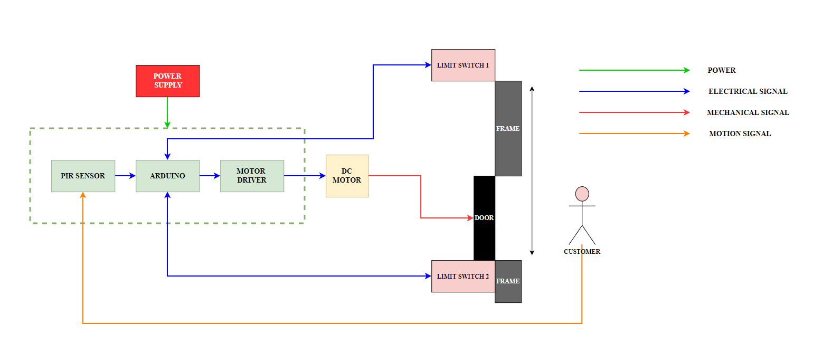

Figure 3.1: The block diagram of the automatic sliding door

## 3.2. OPERATIONAL DESCRIPTION

Automatic door is a very useful equipment for ever building. In common every automatic door uses infrared sensor which can sense human’s body heat and motion. Our automatic door is using a **PIR sensor**, an **Arduino uno**, a **motor driver**, a **DC motor**, two **limit switches**, and a **sliding door**. At first the PIR sensor will senses the signal from the customers, then it will transmit the signal to the Arduino. The Arduino will receive the signal than transmit the command to the motor driver which will control the motor to open or close the door. We also add 2 limit switches, which can help the door not to be athwart. All of this process is supplied by a **Power supply**.

## 3.3. MECHANICAL DESIGN

### 3.3.1. Calculation and Selection

#### 3.3.1.1. Selecting frame material:

There are a lot of type of material we can use to make an automatic door frame such as iron, **alloy steel**, copper, etc. We decide to use **alloy aluminum** for making frame because it has some advantages:

* Alloy aluminum: The main frame of the automatic door is made from aluminum because this material ensures mechanical properties, meeting processing capability, light weight.
* It is very easy to manufacture.
* Easy to find in the market with the suitable price.

#### **3.3.1.2. Calculation**

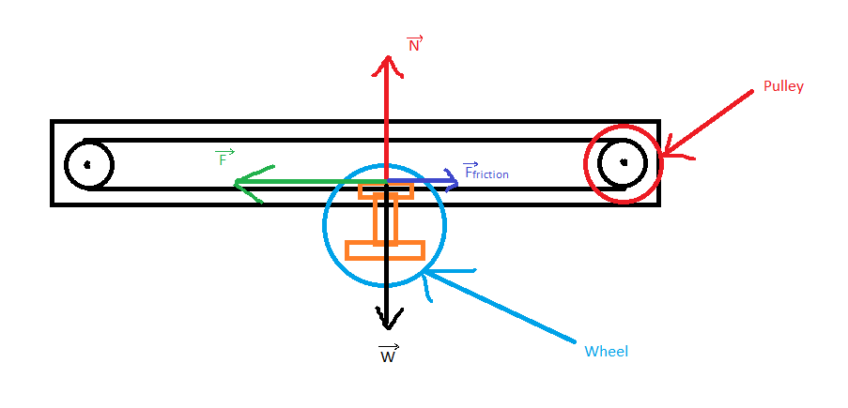

P1: The motor power (W)

F1: The force exerting on the wheel (N)

From equation (1) and (2), we have:

ω: The angular velocity (rad/s)

v: The instant velocity = 0.6 (m/s)

r: The radius of the driving pulley = 2.7 (cm) = 0.027 (m)

b: resistance coefficient = 1.7 x 10-3

rB: The radius of the wheel = 1.8 (cm)

m: The weight of the door and another component = 20 (kg)

g: gravitational acceleration = 9.81 (m/s2)

P2: The power for the motor to accelerate (W)

F2: The acceleration force (N)

From equation (4) and v = 0.6 (m/s), we have:

s: The traveling distance (m)

vfinal: The final velocity (m/s)

vinitial: The initial velocity = 0 (m/s)

a: The acceleration of motor (m/s2)

m: The weight of the door and another component = 20 (kg)

v: The instant velocity = 0.6 (m/s)

P3: The power against the friction (W)

F3: The force against the friction (N)

T = F2 = 6.857 (N)

From equation (6) and v = 0.6 (m/s), we have:

From equation (3), (5) and (7), we have:

P: The power to controller the automatic sliding door (W)

T: The belt tension (N)

µ: The coefficient of friction between the belt and pulley = 0.42

v: The instant velocity = 0.6 (m/s)

In conclusion, the following motor meets the requirements:

We choose the DC motor model 775 – 80W (12V-24V)

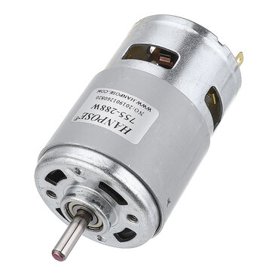

Figure 3.2: The DC motor 775 – 80W (12V-24V)

### 3.3.2. Draft Drawing

We make a draft drawing for the door to generate ideas and to have an overall operation before making a CAD drawing.

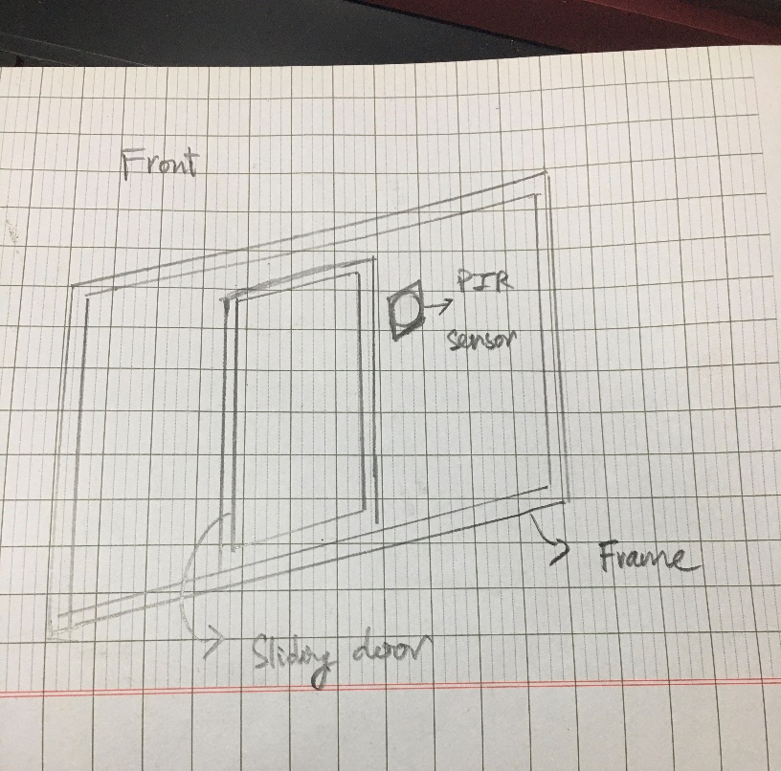

Figure 3.3: The front draft drawing of the automatic sliding door

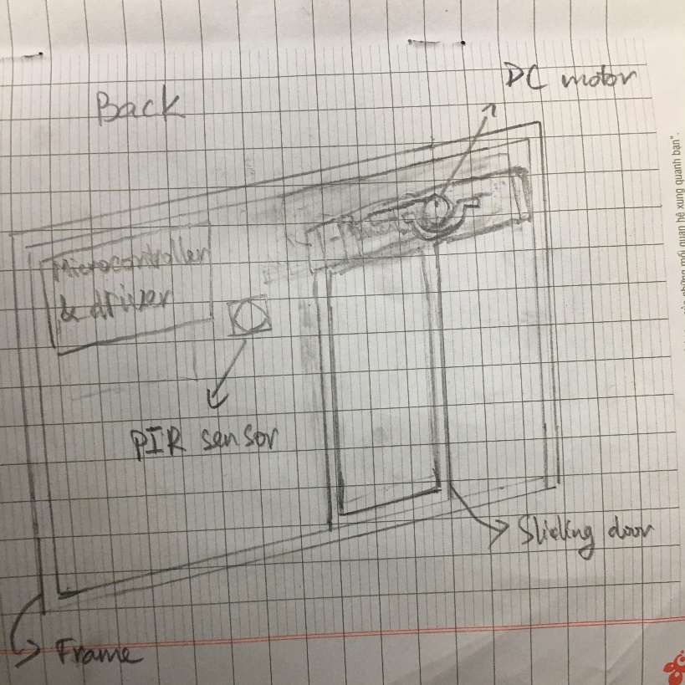

Figure 3.4: The back draft drawing of the automatic sliding door

### 3.3.3. CAD Drawing

As illustrated in the following figures below, the materials making up the door frame are alloy aluminum and steel. Moreover, all components are assembled by bolts and nuts.

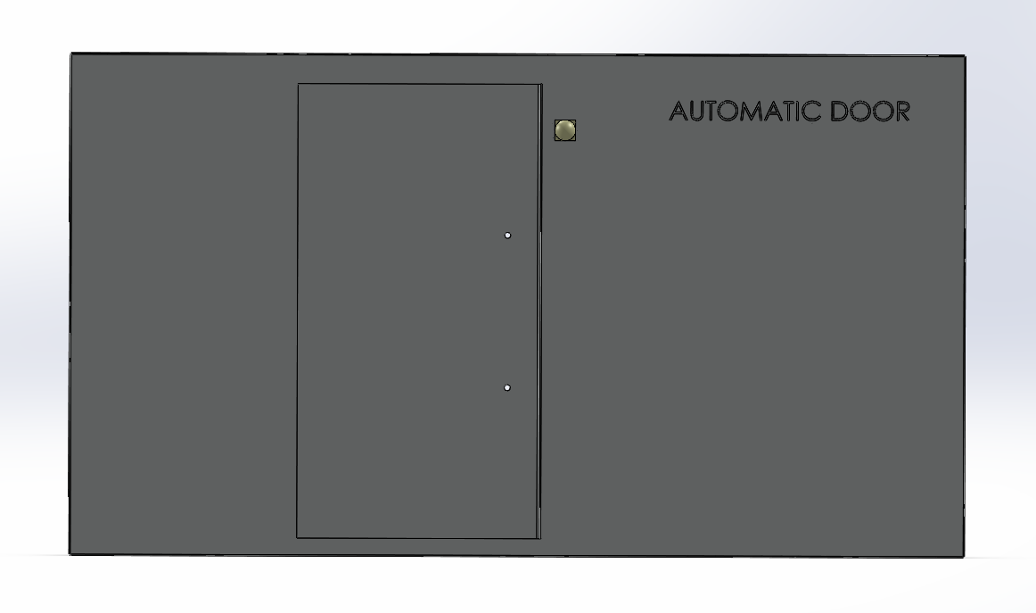

Figure 3.4: The front CAD drawing of the automatic sliding door

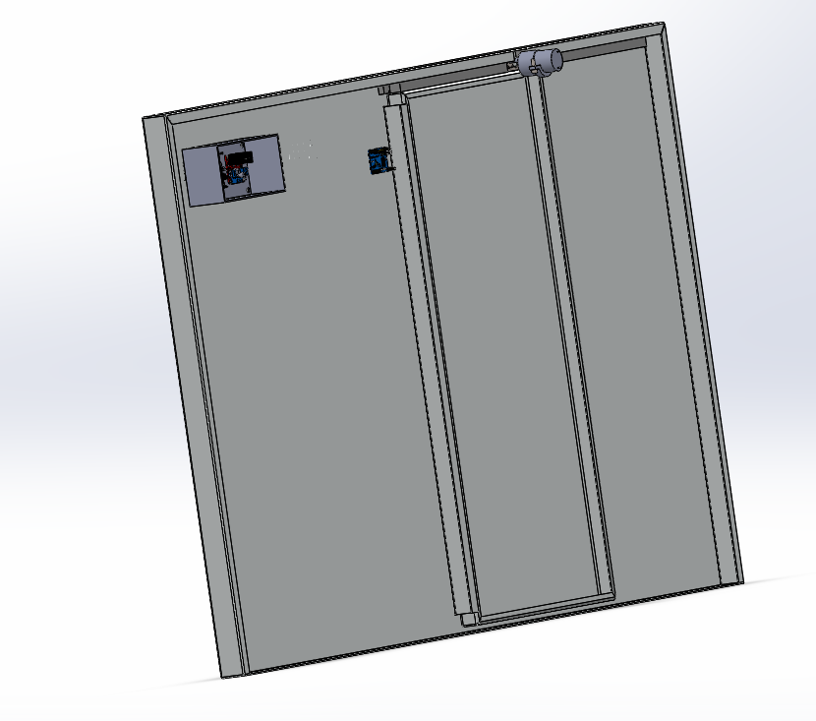

Figure 3.5: The back CAD drawing of the automatic sliding door

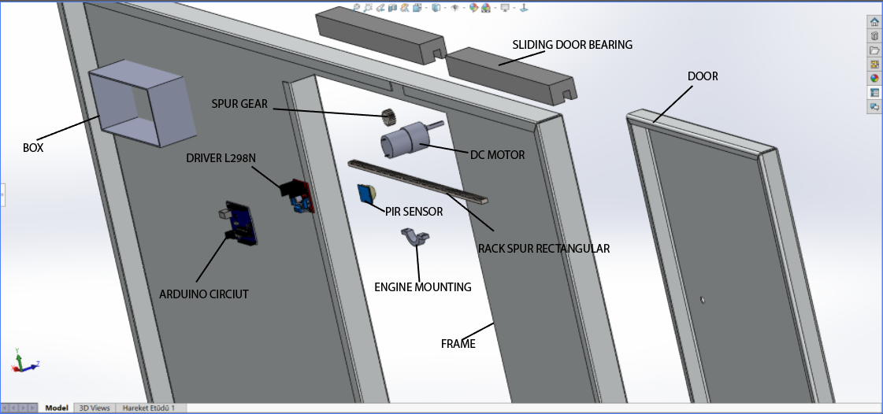

Figure 3.6: The explosion view of CAD drawing of the automatic sliding door

### 3.3.4. Part List

|  |  |  |  |  |
| --- | --- | --- | --- | --- |
| **No.** | **Type of component** | **Figure** | **Model** | **Quantity** |
| 1 | Microcontroller |  | Arduino Uno | 1 |
| 2 | Infrared sensor | HC-SR501 motion sensor module | PIR sensor | 1 |
| 3 | Beam sensor | IR Break Beam Sensor (5mm LEDs) – Pimoroni | IR Beam sensor | 2 |
| 4 | Motor driver |  | L298N Motor driver | 1 |
| 5 | DC Motor |  | DC motor 775 | 1 |
| 6 | Limit switch |  | OMRON SS-5GL | 2 |
| 7 | Sliding door |  | Alloy aluminum sliding door | 1 |
| 8 | Frame |  | Alloy aluminum frame | 1 |
| 9 | Gear |  | Steel spur gear | 1 |
| 10 | Rack spur |  | Steel rack spur | 1 |
| 11 | Sliding door bearing |  | Steel sliding door bearing | 2 |
| 12 | Engine fastening ring |  | Steel engine fastening ring | 1 |

### 3.3.5. Implementation

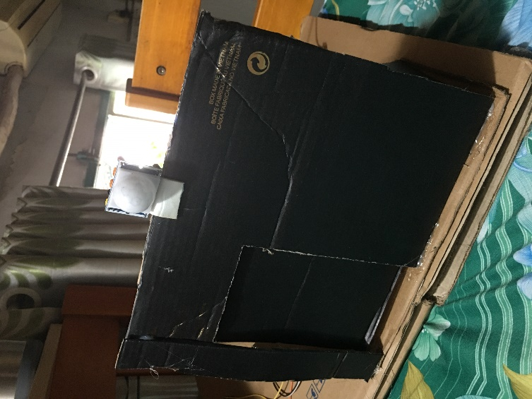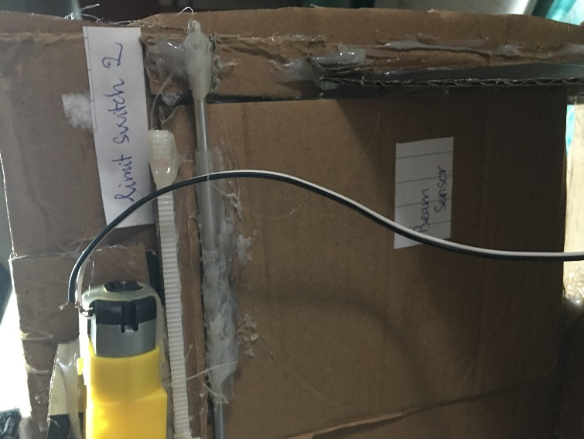

Figure 3.7: The implementation model of the automatic sliding door

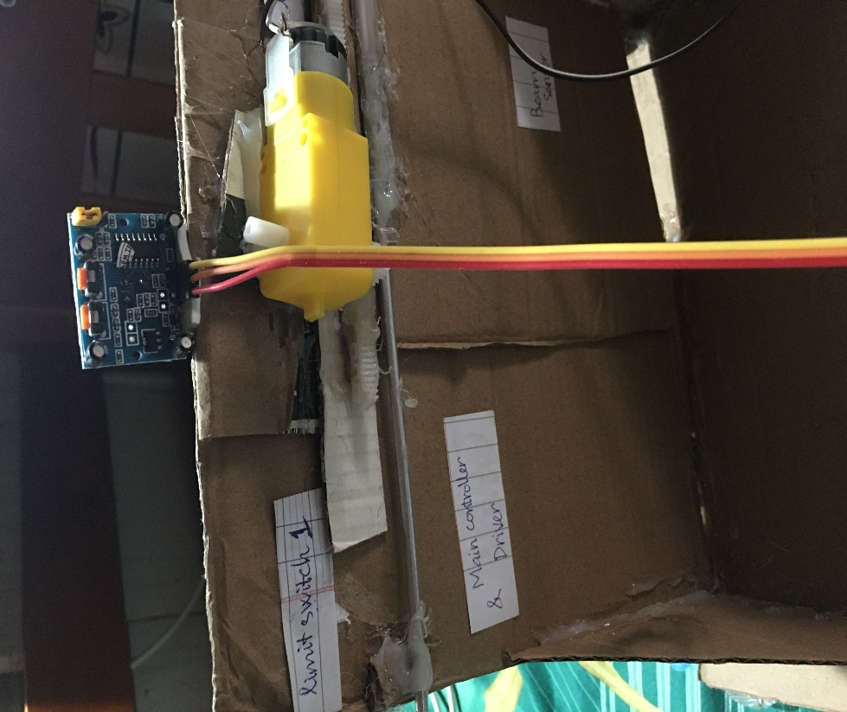

Figure 3.8: The implementation model of the automatic sliding door

## 3.4. Electrical Design

### 3.4.1. Block Diagram

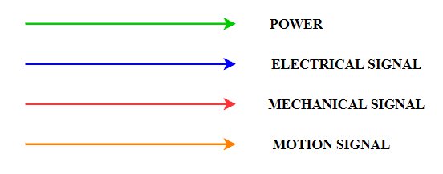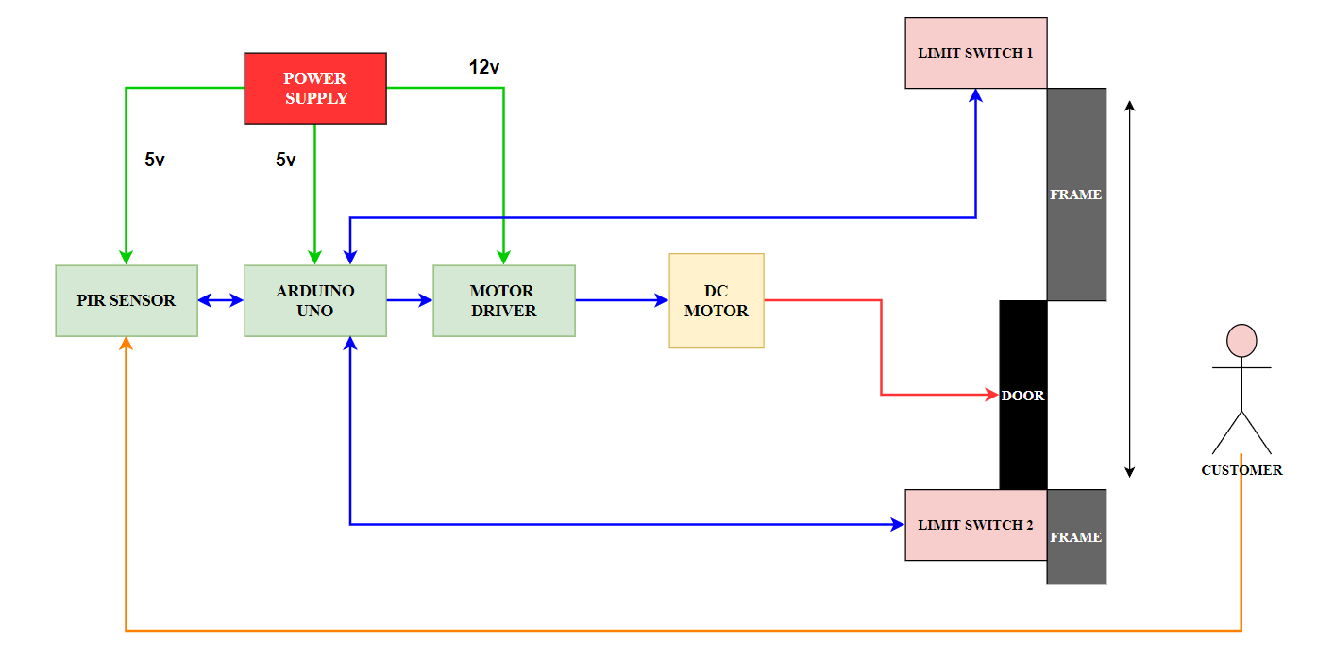

Figure 3.9: The electrical connection of the automatic sliding door system

Electrical block diagram explanation: The power supply will power the Arduino Uno, the PIR sensor, and the motor driver. The Arduino Uno will activate and receive the signal from the PIR sensor through the conditions set on the code and send a feedback signal for analysis and comparison to control the motor driver to provide pulses for the DC motor to operate. motion. The limit switches send the signal to the Arduino Uno to stop the door in the correct position.

### 3.4.2. Wiring

The below figure illustrates the wiring diagram that need to be followed when building an Automatic Sliding Door.

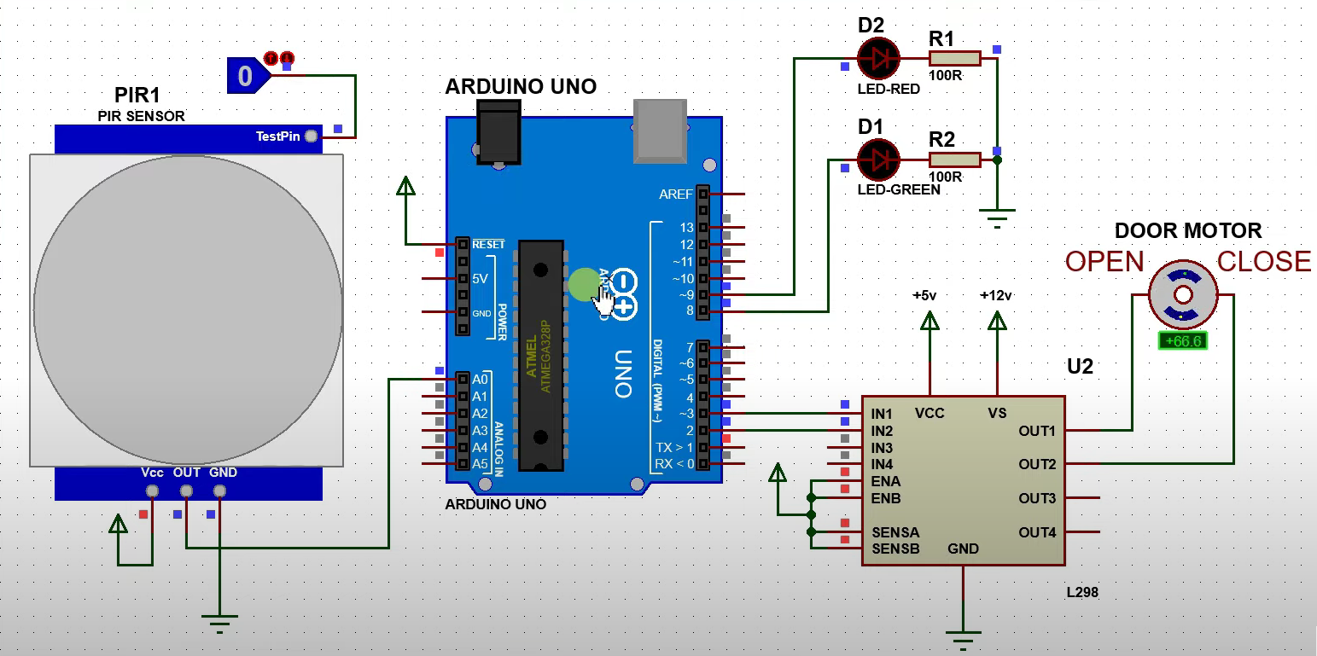

Figure 3.10: The wiring connection of the automatic sliding door system

## 3.5. Control Design

**Flow Chart Explanation**

The PIR sensor scans the area in front of the door for customer movement. If not, continue scanning. Otherwise, the sensor sends a signal to the microcontroller to control the motor driver. The motor driver then sends a pulse to the DC motor to open the door. When the door hits the first limit switch, the door stops, waits for about 5 seconds, and it starts closing when the door hits the second limit switch the door will stop, which is the end of the open / close cycle.

**Flow Chart:**

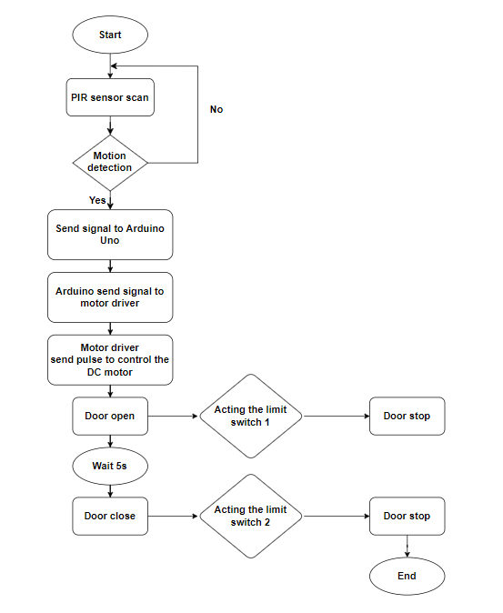

Figure 3.11: Flowchart of the operation of the automatic door system

# Chapter 4: EXPERIMENTS AND DESIGN ANALYSIS

## 4.1. DESIGN EXPERIMENTS

### 4.1.1. Needs

By making survey from 100 students from Ho Chi Minh city University of Technology and Education (HCMUTE), we have selected 6 needs that are most voted for an automatic sliding door:

**N1.** I want an auto-door which is **safe** for users

**N2.** I want a **quick respond** auto-door

**N3.** I want a **durable** auto-door

**N4.** I want an auto-door which has a **medium mass**

**N5.** I want an auto-door that has **a suitable price**

**N6.** I want a **high accurate operation** auto-door

### 4.1.2. Metrics

We have chosen 7 metrics that meet the requirements above.

Table 1. Established metrics and units

|  |  |  |  |  |
| --- | --- | --- | --- | --- |
| **No** | **Needs** | **Metrics** | **Imp** | **Unit** |
| M1 | 1,2,6 | Sensor types | 4 | (list) |
| M2 | 1,2 | Speed of motor | 3 | (m/s) |
| M3 | 3,5 | Operating time | 4 | (opening/closing cycles per hours) |
| M4 | 3,4 | Body weight | 3 | (kg) |
| M5 | 3,4,5 | Price | 3 | (VND) |
| M6 | 1,2,5,6 | Accuracy | 5 | (Percent - %) |
| M7 | 2,6 | Response time | 4 | (Second - s) |

**Important rate: From 1 to 5 (maximum).**

### 4.1.3. Needs – Metrics Correlation

Table 2. Link metrics to needs

|  |  |  |  |  |  |  |  |
| --- | --- | --- | --- | --- | --- | --- | --- |
| **Needs** | **Metrics** | | | | | | |
| **M1** | **M2** | **M3** | **M4** | **M5** | **M6** | **M7** |
| **N1** | I | I |  | I |  | I |  |
| **N2** | I | D |  | I |  | D | D |
| **N3** |  |  | D | I | I |  |  |
| **N4** |  |  |  | D | I |  |  |
| **N5** |  |  | I |  | D | I |  |
| **N6** | I |  |  |  |  | I | I |

I - Indirect measure

D - Direct measure

### 4.1.4. Product specification

Table 3. Assign margins and ideal value

|  |  |  |  |  |  |  |
| --- | --- | --- | --- | --- | --- | --- |
| **SPECIFICATION OF PRODUCT** | | | | | | |
| **No** | **Specification name** | **IMP** | **Unit** | **Ideal value** | **Marginal Value** | **Group** |
| **1** | Sensor types | 4 | list |  |  | BASIC |
| **2** | Speed of motor | 3 | m/s | 5 m/s | 6.5 m/s  3 m/s | BASIC |
| **3** | Operating time | 4 | total opening/closing cycles per hour | 560 | 470 | BASIC |
| **4** | Body weight | 3 | kg | 30kg | 35kg  27kg | BASIC |
| **5** | Accuracy | 5 | % | 100% | 95% | BASIC |
| **6** | Response time | 4 | s | 0.2s | 0.5s | BASIC |
| **7** | Supply voltage | 3 | V | 12V | + 0.5V | BASIC |
| **8** | Power consumption | 3 | W | 80W | 85W  60W | BASIC |
| **9** | Length | 2 | m | 3m | 3.4m  2.8m | BASIC |
| **10** | Width | 2 | mm | 120mm | 145mm  118mm | BASIC |
| **11** | Height | 2 | m | 2.5m | 2.7m  2.4m | BASIC |
| **12** | Display screen | 3 | list |  |  | ADDITIONAL |
| **13** | Upgrade material | 4 | list |  |  | ADVANCED |
| **14** | Safety lock | 4 | list |  |  | ADVANCED |

*BASIC is all static measurable Metrics, functions that typical product should have.*

*ADVANCED is all static measurable metrics, functions that improve the product performances and cost more than 10%.*

*ADDTIONAL is all static measurable metrics, functions that add value to the product but not making the product cost higher than 10%*

Table 4. Specification list

|  |  |  |
| --- | --- | --- |
| **No** | **Specification name** | **List** |
| 1 | Frame material | + Aluminum frame  + Steel frame  + Wood |
| 2 | Safety lock | + Hafele EL9000  + YALE YDR 414 |
| 3 | Sensor types | + PIR sensor  + Beam sensor |
| 4 | Display screen | + LCD green  + LCD blue  + LCD red |

### 4.1.5. Method of experiment

Table 5 Methods of experiment and sampling rate

|  |  |  |  |  |
| --- | --- | --- | --- | --- |
| **NO** | **Specification name** | **Unit** | **Method description** | **Sampling rate** |
| 1 | Sensor types | list | Compare to the list of sensors | 1 |
| 2 | Speed of motor | m/s | Measure the distance traveled by the door using the formula v=s/t. | 10-20 |
| 3 | Operating time | total opening/closing cycles per hour | Count the total number of opening and closing times in an hour. | 10-20 |
| 4 | Body weight | kg | Using scale to measure the mass | 1 |
| 5 | Accuracy | % | Measure the number of times the automatic sliding door is out of range. | 10-20 |
| 6 | Response time | s | Statistic and calculate many times when the response time is slow | 10-20 |
| 7 | Supply voltage | V | Using VOM to measure the voltage | 1 |
| 8 | Power consumption | W | Using VOM to measure the (V) voltage and the amperage (A) based on the formula P = V*A | 1 |
| 9 | Length | m | Using ruler to measure the length | 1 |
| 10 | Width | mm | Using ruler to measure the width | 1 |
| 11 | Height | m | Using ruler to measure the height | 1 |
| 12 | Display screen | list | Compare to the list of display screen | 1 |
| 13 | Upgrade material | list | Compare to the list of upgraded materials | 1 |
| 14 | Safety lock | list | Compare to the list of safety lock | 1 |

Table 6 Type of test

|  |  |  |  |  |
| --- | --- | --- | --- | --- |
| **NO** | **Specification name** | **Unit** | **Type of test** | |
| **Dynamic** | **Static** |
| 1 | Sensor types | List |  | x |
| 2 | Speed of motor | m/s | X |  |
| 3 | Operating time | total opening/closing cycles per hour | x |  |
| 4 | Body weight | Kg |  | x |
| 5 | Accuracy | % | x |  |
| 6 | Response time | s | x |  |
| 7 | Supply voltage | V | x |  |
| 8 | Power consumption | W | x |  |
| 9 | Length | m |  | x |
| 10 | Width | mm |  | x |
| 11 | Height | m |  | x |
| 12 | Display screen | list |  | x |
| 13 | Upgrade material | list |  | x |
| 14 | Safety lock | list |  | x |

## 4.2. OPERATION EXPERIMENTS

### 4.2.1. Static test

To make sure that the electrical design and control design work smoothly under any condition, we need to check the mechanical design carefully because it affects directly to the stability of the machine and the output quality. In mechanical design, we carry out 2 different test which are body weight, dimension.

#### 4.2.1.1. Mechanical Design (Body weight, dimension)

Table 7 Static test

|  |  |  |  |  |  |  |
| --- | --- | --- | --- | --- | --- | --- |
| **NO** | **Specification name** | **Ideal value** | **Ideal value**  **1/15** | **Marginal Value** | **Actual Value** | **Result (%)** |
| 1 | Body weight | 30kg | 2kg | 2.333kg  1.8kg | 250 g | 12.5% |
| 2 | Length | 3m | 200mm | 226.6m  186.6m | 223 mm | 83.5% |
| 3 | Width | 120 mm | 8mm | 9.6mm  7.86mm | 2 mm | 25% |
| 4 | Height | 2.5 m | 166.6mm | 180m  1.6m | 201 mm | 79.35% |
| 5 | Sensor types |  |  |  |  | 100% |
| 6 | Display screen |  |  |  |  | 100% |
| 7 | Upgrade material |  |  |  |  | 100% |
| 8 | Safety lock |  |  |  |  | 100% |

#### 4.2.1.2. Electrical Design (Power supply)

When we ensure that the mechanical design works properly, we move on to electrical design experiments. This part provides power to the whole machine. If the power source is stable, the machine will work properly, otherwise, if the power source fluctuates, it will cause the voltage drop on the electrical system which cause the instability of the controller, and fail of reading sensor signal. Moreover, if the controller runs in fluctuated voltage, the controller may be damaged.

### 4.2.2. Dynamic test:

#### 4.2.2.1. Free load test (Power consumption)

Table 8 Power consumption data collection

|  |  |  |  |  |  |  |
| --- | --- | --- | --- | --- | --- | --- |
| **NO** | **Specification name** | **Ideal value** | **Ideal value**  **1/15** | **Marginal Value** | **Actual Value** | **Result (%)** |
| 1 | Supply voltage of motor | 12V |  | + 0.5V | 12 V | 100% |
| 2 | Current of motor | 3A | 0.2 A | + 0.3 A | 0.22 A | 90% |
| 3 | Supply voltage of microcontroller | 5V |  | + 0.5V | 4.8 V | 96% |
| 4 | Current of microcontroller | 2A | 0.13 A | + 0.5 A | 0.114 A | 87.69% |
| 5 | Power consumption | 80W | 3.05 W |  | 3.21 W | 96.81% |

#### 4.2.2.2. Full load test (speed of motor, operating time, accuracy, response time)

Table 9 Speed of motor data collection

|  |  |  |  |  |  |  |  |
| --- | --- | --- | --- | --- | --- | --- | --- |
| **SPEED OF MOTOR** | | | | | | | |
| **Ideal value** | **Marginal value** | **Test no** | **Measure value** | **Result**  **(%)** | **Test no** | **Measure value** | **Result**  **(%)** |
| v = 5 m/s  (v/15 = 33.3 cm/s) | v = 43.3 cm/s  v = 20 cm/s | 1 | 20.454545 | 61.36% | 11 | 27.272727 | 81.82% |
| 2 | 27.272727 | 81.82% | 12 | 27.272727 | 81.82% |
| 3 | 45 | 65% | 13 | 22.5 | 67.5% |
| 4 | 27.272727 | 81.82% | 14 | 27.272727 | 81.82% |
| 5 | 45 | 65% | 15 | 27.272727 | 81.82% |
| 6 | 33.333333 | 100% | 16 | 25.714286 | 77.14% |
| 7 | 27.272727 | 81.82% | 17 | 20.454545 | 61.36% |
| 8 | 19.565217 | 58.7% | 18 | 31.034483 | 93.1% |
| 9 | 33.333333 | 100% | 19 | 23.684211 | 71.05% |
| 10 | 23.076923 | 69.23% | 20 | 20.454545 | 61.36% |
| **Average** | v = 27.7257 (cm/s) | | | | Percentage = 76.18% | | |

Table 10 Operating time data collection

|  |  |  |  |  |  |  |  |
| --- | --- | --- | --- | --- | --- | --- | --- |
| **OPERATING TIME** | | | | | | | |
| **Ideal value** | **Marginal value** | **Test no** | **Measure value** | **Result**  **(%)** | **Test no** | **Measure value** | **Result**  **(%)** |
| 560 opening/closing cycles per hour | 470  opening/closing cycles per hour | 1 | 543 | 96.96% | 11 | 535 | 95.54% |
| 2 | 558 | 99.64% | 12 | 550 | 98.21% |
| 3 | 550 | 98.21% | 13 | 553 | 98.75% |
| 4 | 541 | 96.61% | 14 | 557 | 99.46% |
| 5 | 538 | 96.07% | 15 | 557 | 99.46% |
| 6 | 546 | 97.5% | 16 | 556 | 99.29% |
| 7 | 547 | 97.68% | 17 | 549 | 98.04% |
| 8 | 558 | 99.64% | 18 | 541 | 96.61% |
| 9 | 572 | 97.86% | 19 | 570 | 98.21% |
| 10 | 557 | 99.46% | 20 | 562 | 99.64% |
| **Average** | 552 opening/closing cycles per hour | | | | Percentage = 98.14% | | |

Table 11 Position response accuracy data collection

|  |  |  |  |  |  |  |  |  |
| --- | --- | --- | --- | --- | --- | --- | --- | --- |
| **ACCURACY** | | | | | | | | |
| **Ideal value** | **Marginal value** | **Test no** | **Measure value** | **Result**  **(%)** | | **Test no** | **Measure value** | **Result**  **(%)** |
| 100%  (s = 9cm) | 95% | 1 | 9.04 | 96% | | 11 | 9 | 100% |
| 2 | 9.25 | 75% | | 12 | 8.97 | 97% |
| 3 | 9.15 | 85% | | 13 | 9 | 100% |
| 4 | 9.04 | 96% | | 14 | 9.25 | 75% |
| 5 | 9.05 | 95% | | 15 | 9.05 | 95% |
| 6 | 9 | 100% | | 16 | 9.11 | 89% |
| 7 | 9 | 100% | | 17 | 9.03 | 97% |
| 8 | 8.85 | 85% | | 18 | 8.98 | 98% |
| 9 | 9.2 | 80% | | 19 | 8.89 | 89% |
| 10 | 9.02 | 98% | | 20 | 9 | 100% |
| **Average** | s = 9.044 (cm) | | | | Percentage = 92.5% | | | |

Table 12 Time response data collection

|  |  |  |  |  |  |  |  |  |
| --- | --- | --- | --- | --- | --- | --- | --- | --- |
| **TIME RESPONSE** | | | | | | | | |
| **Ideal value** | **Marginal value** | **Test no** | **Measure value** | **Result**  **(%)** | | **Test no** | **Measure value** | **Result**  **(%)** |
| 0.2s | 0.5s | 1 | 0.44 | 45.45% | | 11 | 0.33 | 60.61% |
| 2 | 0.33 | 60.61% | | 12 | 0.33 | 60.61% |
| 3 | 0.2 | 100% | | 13 | 0.4s | 50 |
| 4 | 0.33 | 60.61% | | 14 | 0.33 | 60.61% |
| 5 | 0.2 | 100% | | 15 | 0.33 | 60.61% |
| 6 | 0.27 | 74.07% | | 16 | 0.35 | 57.14% |
| 7 | 0.33 | 60.61% | | 17 | 0.44 | 45.45% |
| 8 | 0.46 | 43.48% | | 18 | 0.29 | 68.97% |
| 9 | 0.27 | 74.07% | | 19 | 0.38 | 52.63% |
| 10 | 0.39 | 51.28% | | 20 | 0.44 | 45.45% |
| **Average** | 0.342 s | | | | Percentage = 61.61% | | | |

## 4.3. ANALYSIS

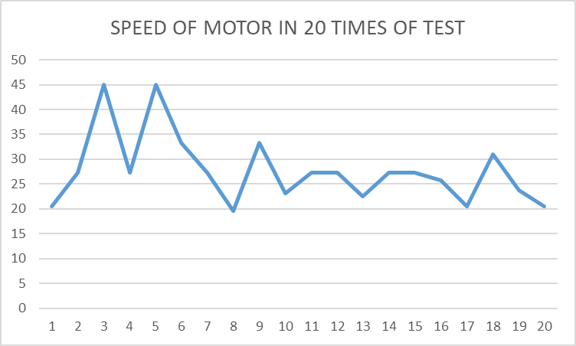

Figure 4.1: Measured speed of motor according to 20 times of test

The line graph shows the measured speed of motor according to 20 times of test. Most of the measured values are in the range of 25 cm/s to 30 cm/s. The method of the speed of motor test is measuring the distance traveled by the door using the formula v=s/t. The measured speed gets the highest result percentage at 100% at the 6th and 9th test which are both 33.33 cm/s. The measured speed gets the lowest result percentage at 58.7% at the 8th test which is 19.57 cm/s.

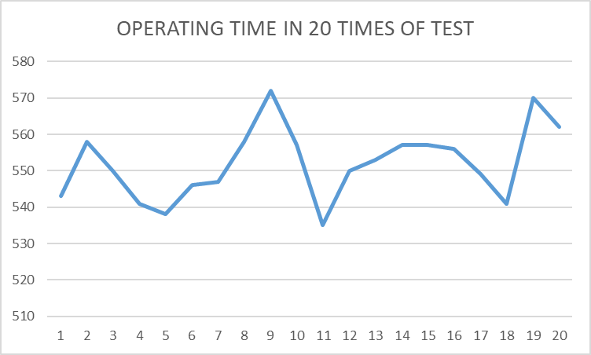

Figure 4.2: Measured operating time according to 20 times of test

The line graph shows the measured operating time according to 20 times of test. Most of the measured values are in the range of 550 to 560 cycles per hour. The method of operating time test is counting the total number of opening and closing times in an hour. The measured operating time gets the highest result percentage at 99.64% at the 2nd,6th and 9th test which are both 558 cycles per hour. The measured speed gets the lowest result percentage at 95.54% at the 11th test which is 535 cycles per hour.

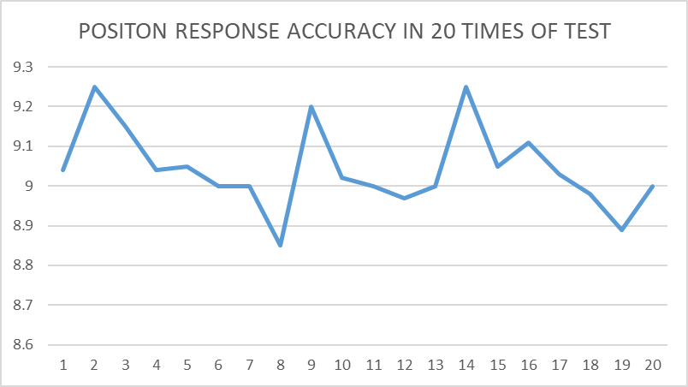

Figure 4.3: Measured position response accuracy according to 20 times of test

The line graph shows the measured position response accuracy according to 20 times of test. Most of the measured values are in the range of 9 to 9.15 cm. The method of position response accuracy test is measuring the number of times the automatic sliding door is out of range. The measured position response accuracy gets the highest result percentage at 100% at the 6th, 7th 11th and 13th test which are both 9 cm. The measured speed gets the lowest result percentage at 75% at the 2nd test which is 9.25 cm.

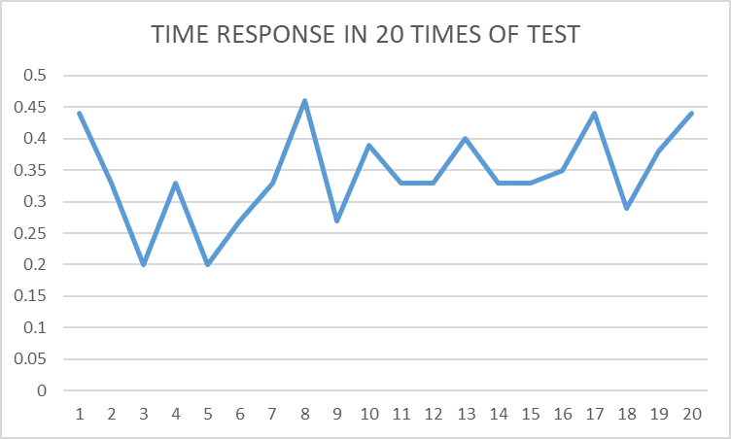

Figure 4.4: Measured time response according to 20 times of test

The line graph shows the measured time response according to 20 times of test. Most of the measured values are in the range of 0.27 to 0.33 s. The method of time response test is measuring many times when the response time is slow. The measured time response gets the highest result percentage at 100% at the 3rd and 5th test which are both 0.2 s. The measured speed gets the lowest result percentage at 43.45% at the 8th test which is 0.46 s. It is noticeable that it takes 1 minutes for the system to be stable.

## 4.4. Conclusion

It can be clearly seen from the synthesized results table above that all the tested values are in allowable range with “quite-good” result, 75% in static tests and 88.84% in dynamic test.

Static tests: most of the result reach more 75% of ideal value except for body weight and width dimension. Body weight and width dimension do not have many effects on result.

Dynamic tests: Power supply’s voltage determine the stable in the operation of the micro-controller and the precise of feedback values of the color sensor. But thanks to the built-in voltage regulator in the micro-controller board that small fluctuation in supply voltage won’t cause any considerable effects. There is 1 issue that cause the imperfect in the result of dynamic tests. When starting, it takes about 1 minute to stabilize the system.

Overall, all the tested specifications satisfy the pre-set desired values at 85%. The machine needs to be improved to increase the accuracy rate of position response accuracy. Moreover, main controller and mechanism should be modified to improve the quality of output of the automatic sliding door.