|  |  |  |  |  |  |  |  |  |  |  |  |  |
| --- | --- | --- | --- | --- | --- | --- | --- | --- | --- | --- | --- | --- |
|  | | **ADVANCED PROGRAMMING + DBMS** | | | | | | | |  | | |
|  | | | | | | | | | | | | |
|  | MID-SEMESTER ASSESSMENT CARD | | | | | | | | | |  | |
|  | | | | | | | | | | | | |
| TEAM 15 | | | | | | AMRITA VISHWA VIDYAPEETHAM, CHENNAI | | | | | | |
|  | | | | | | | | | | | | |
|  | | | | | | | | | | | | |
| AMRITA SCHOOL OF ENGINEERING COIMBATORE Reviews | Address | Phone Number |  Courses  TEAM MEMBERS  **ANIKET MISHRA**  CH.EN.U4CYS20004  **JYOTHIKA NAMBIAR**  CH.EN.U4CYS20032  **KADIYALA RISHIKESH**  CH.EN.U4CYS20033  **SHRADDHA CHOPRA**  CH.EN.U4CYS20068 | | |  |  | SUBMITTED TO  **DR. V MURALIDARAN**  Assistant Professor  Department of Computer Science and Engineering  **DR. RAGUPATHY P**  Assistant Professor  Department of Computer Science and Engineering | |  | | ADVANCED PROGRAMMING  DATABASE MANAGEMENT SYSTEMS | | |
|  | |  | SUBMITED ON  18TH DECEMBER, 2021  BY **TEAM 15**  **CYBER SECURITY**  ODD SEMESTER  2ND YEAR |  | | |
| USING THE SOFTWARE | |  |

|  |  |
| --- | --- |
| **MID-SEMESTER ASSESSMENT CARD** **ADVANCED PROGRAMMING** **+**  **DATABASE MANAGEMENT SYSTEMS** | **TABLE CHOSEN:**  The name of our project is **MID-SEMESTER ASSESSMENT CARD**. blueprint of a Report card or Assessment Card but based on all the data and information that we collected from our mid-semester marksheet for Advanced Programming and Database and Management systems. It is similar to a report card but we have tweaked it a little by adding in various parameters of comparison and reasoning such as printing the ranks of all the students whose viva was taken by a particular faculty member or the option to see which student has scored the most in the chosen subject.  **MOTIVATION FOR CHOOSING THE TOPIC:**  We wanted to incorporate database management systems and programming in such a way that it can be useful in a realistic scenario.  While we were choosing our topic, it was the time when we were being presented with our midsemester marks. With a class strength of 87, it is quite difficult to manage the huge amount of data that is presented to us in the form of marks. We thought of blending these two ideas together in such a way that it can be helpful to those trying to compare or check.  We thought of making a report card system that would help students find out potentially what their ranks in class are, how well they have performed in viva and under which faculty their marks were the highest. This project was made keeping in mind the real-time and real-world use of database systems and programming languages.  **APPROACH FOR SOLVING THE PROBLEM:**  This project is an amalgam of database systems and programming so methods of incorporating them together was our first plan of action.  Using a mind-map we first broke down the project to its various components, mentioning all of its parameters and attributes. We then found ways in which every aspect can be made user friendly from data collection to date presentation.  Most of our planning went into assuring that both the frontend and backend were in sync with one another. |

|  |  |
| --- | --- |
| **MID-SEMESTER ASSESSMENT CARD** **ADVANCED PROGRAMMING** **+**  **DATABASE MANAGEMENT SYSTEMS** | **ANY DIFFICULTIES FACED (AND HOW WE SOLVED THEM):**  Choosing between the two programming languages was quite a task at first. On one hand we had C++ which was familiar and easy to use and on the other hand we had Python which was advanced, came with a lot of elaborate in-built functions and is easier to connect with backend. In the end, sophistication won against familiarity and ended up choosing Python as our programming language.  During execution we realized that there were quite many glitches in connecting frontend and backend but with the help of a few YouTube videos and help from our faculty members we managed to resolve that.  We also found it slightly laborious to create every single one of the 19 cases one by one but on the suggestion of one of our team members we managed to combine a lot of them together and reduce redundancy and time of execution.  In the middle of our coding, we realized that if there were multiple top scorers for a subject, our code was only printing the one with the smallest roll number. The code and backend weren’t supporting multiple answers and to solve this we had to learn many new database commands and implement it.  **NEW THINGS WE LEARNT THROUGH THIS PROJECT:**  We learnt how to work with backend and frontend simultaneously. We got to practice all the theory and knowledge we had acquired this semester in a more realistic and practical way. Python wasn’t our strongest forte before this project but after having worked on this code, we are much more familiarized and comfortable with using it.  **IMPLEMENTATION DETAILS:**  For our project, we implemented Python and SQL using the software - Visual Studio Code and MySQL. We mainly used commands from TCL, DML and DCL under SQL.  In our code, we have started off by prompting the user to choose among the multiple options given to manipulate the students’ marks information. On choosing one of the criterions, they are taken to the function that handles that particular option. There are many sub-parts to each option, thus giving the user a variety of alternatives to work with.  We have allowed the user to store, access, delete and manipulate students’ mark’s data, to retrieve the highest scorer in each subject, and the ranks according to a particular viva teacher. |

DATABASE DESIGN

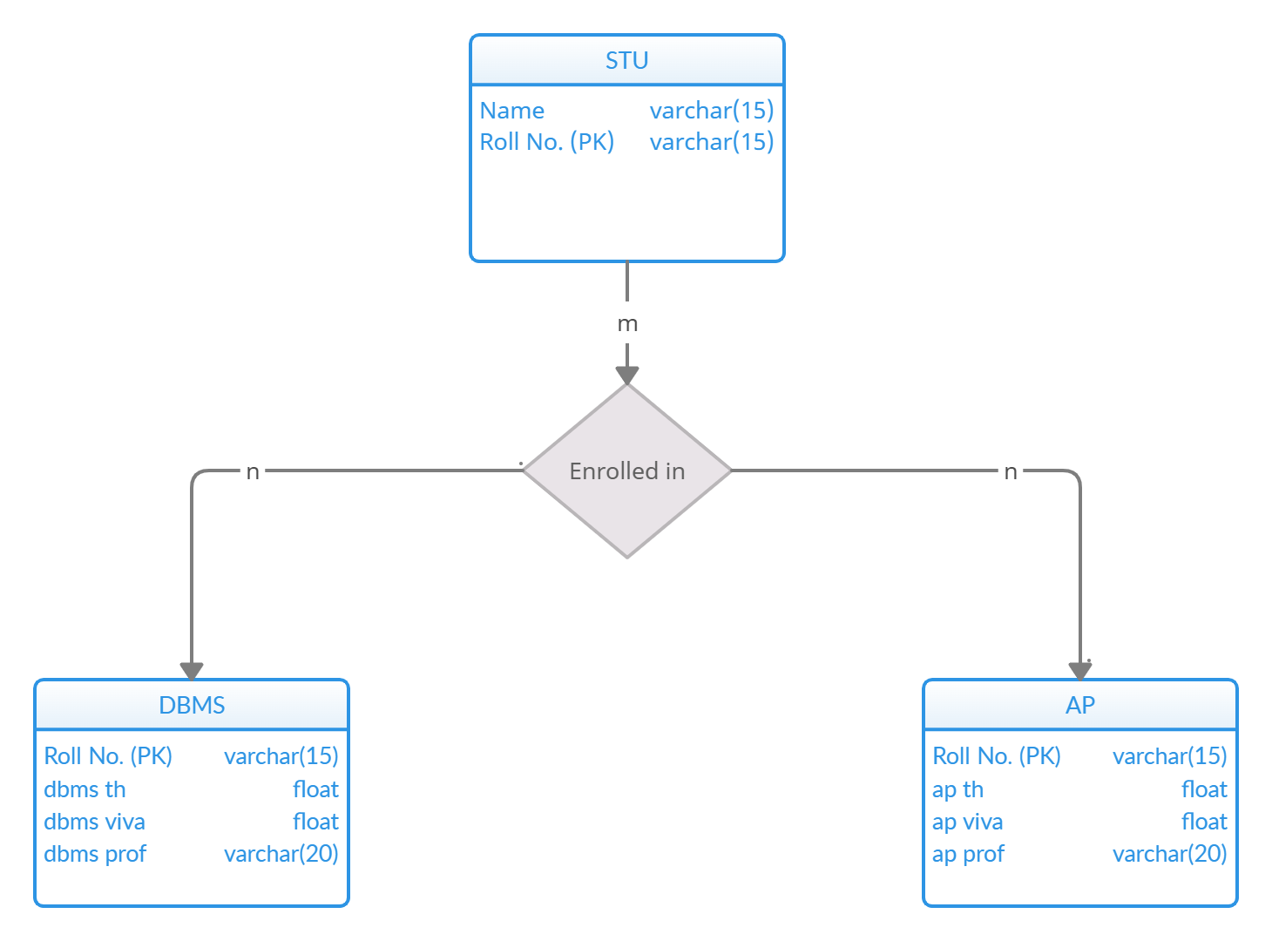

**TABLE DESCRIPTION**

|  |  |
| --- | --- |
| AP Table | |
| Roll no. | varchar |
| ap th | float |
| ap viva | float |
| ap prof | varchar |

|  |  |
| --- | --- |
| STU Table | |
| Roll no. | varchar |
| Name | varchar |

|  |  |
| --- | --- |
| DBMS Table | |
| Roll no. | varchar |
| dbms th | float |
| dbms viva | float |
| dbms prof | varchar |

ENTITY RELATIONSHIP

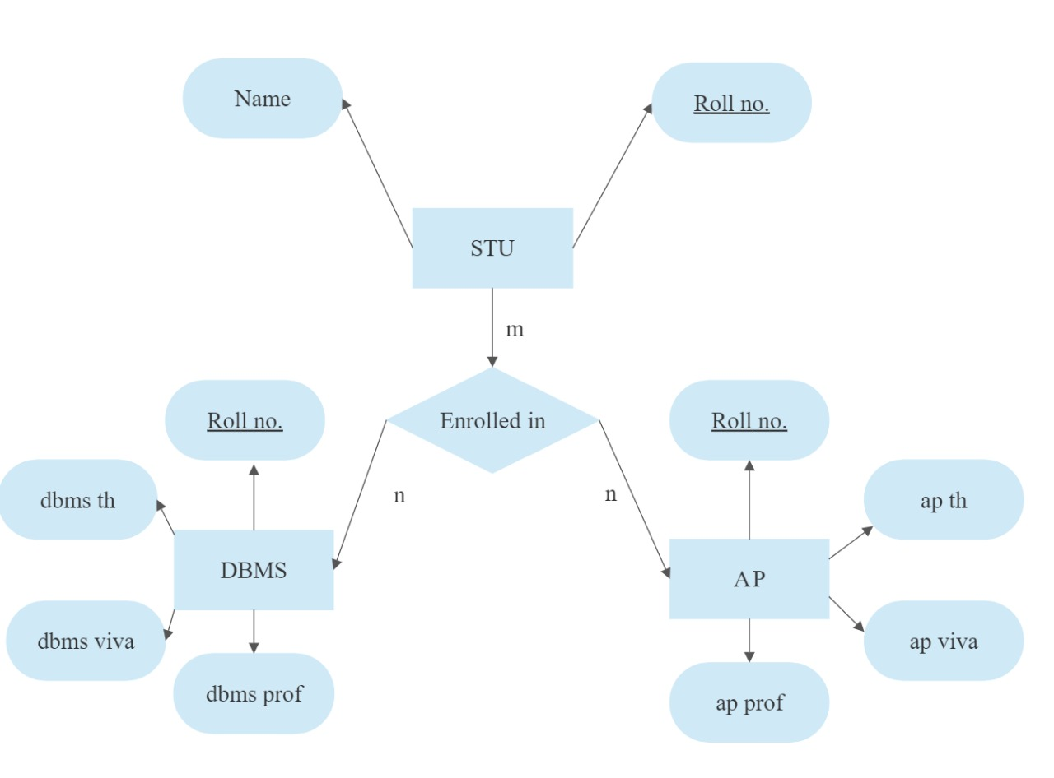

SYMBOL MEANING

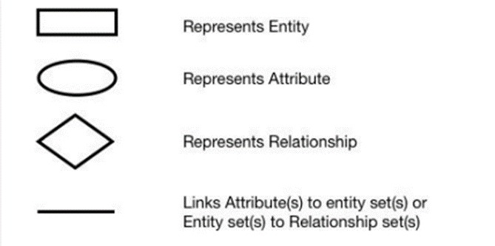 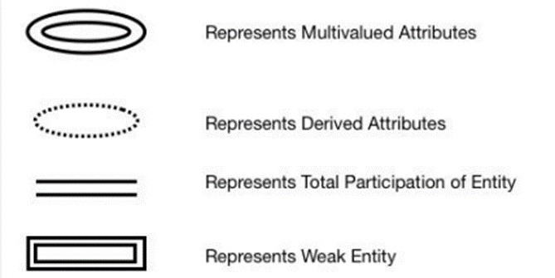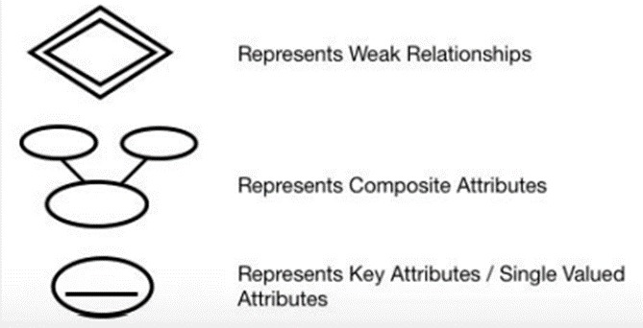

REFERENCES

* <https://stackoverflow.com/questions/39149243/how-do-i-connect-to-a-sql-server-database-with-python>
* <https://www.tutorialspoint.com/python/python_database_access.htm>
* <https://www.w3schools.in/python-tutorial/database-connection/>
* <https://creately.com/diagram-type/database-design>
* <https://github.com/topics/dbms?l=python>
* <https://cloud.smartdraw.com/editor.aspx?templateId=da34e096-b9cb-4d56-a0ce-d9bdef138714&flags=128#depoId=31723575&credID=-36858967>
* <https://stackoverflow.com/questions/2655748/writing-a-dbms-in-python>
* <https://www.codewithc.com/pharmacy-management-system-c-mysql/#google_vignette>
* <https://docs.python.org/3/library/sqlite3.html>
* <https://www.freecodecamp.org/news/connect-python-with-sql/>