Министерство цифрового развития, связи и массовых коммуникаций
Ордена Трудового Красного Знамени федеральное государственное бюджетное
образовательное учреждение высшего образования
«Московский технический университет связи и информатики»

Кафедра Математической кибернетики и информационных технологий

Отчёт по лабораторной работе № 3
«Методы поиска подстроки в строке»
по дисциплине «Структуры и алгоритмы обработки данных»

Выполнил: студент группы БВТ1902
Голованов Константин Сергеевич

Москва
2021
Задание
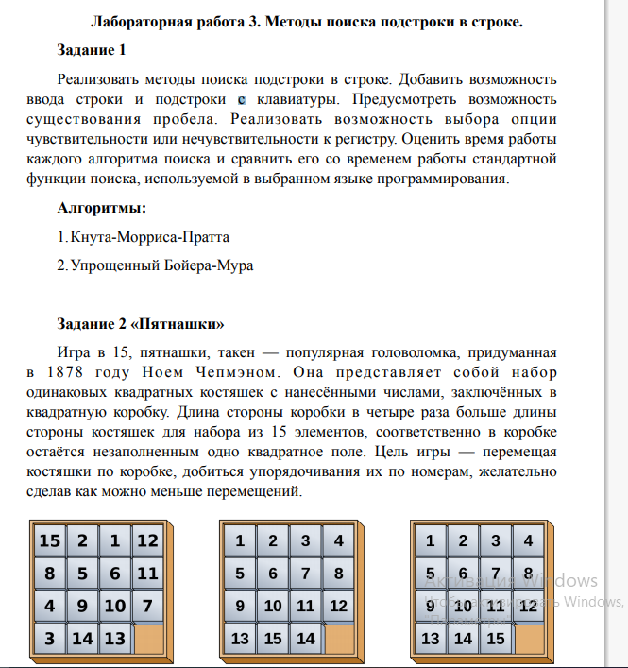
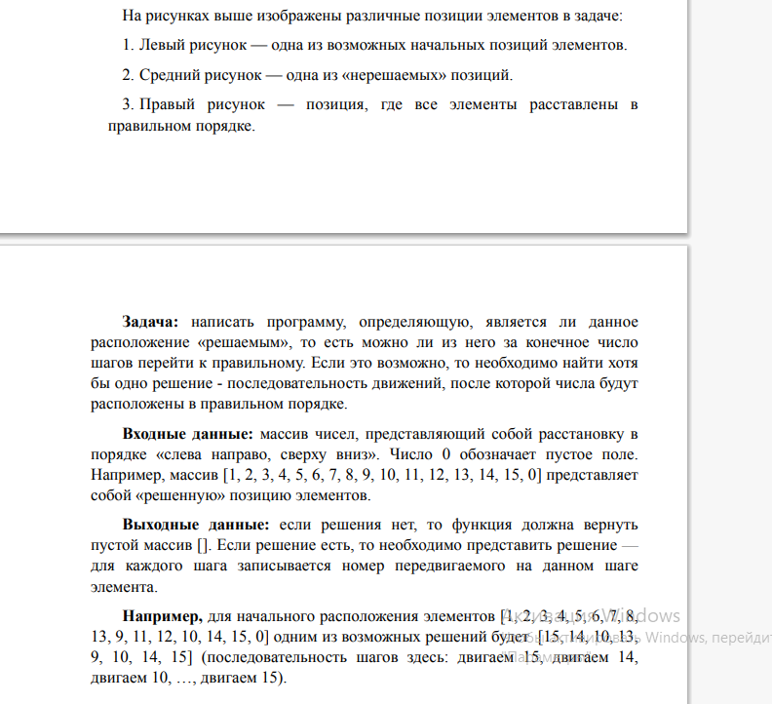

Код программы

Задание 1

def prefix_function (S) :
n = len(S)
res = []
res.append(0)
for i in range (1, n):
k = res[i-1]
while k > 0 and S[i] != S[k]:
k = res[k-1]
if S[i] == S[k]:
k += 1
res.append(k)
return res
s = "aabcaabcd"
sub = "cd"
S = sub + "#" + s
l = prefix_function(S)
l2 = []
for i in range (len(l)):
if l[i] == len(sub):
l2.append(i-2*len(sub) + 1)
print(l2)
S = "Алгоритм поиска строки Бойера — Мура — алгоритм общего назначения."
sub = "Мур"
def createD(sub):
d = {}
i = len(sub)-2
while i >= 0:
l = list(d.keys())
if l.count(sub[i]) > 0:
i -= 1
continue
d[sub[i]] = len(sub)-i-1
i -= 1
l = list(d.keys())
if l.count(sub[len(sub)-1]) == 0:
d[sub[len(sub)-1]] = len(sub)
l = 0
return d
def boyerMurSearch(s, sub):
d = createD(sub)
l = list(d.keys())
i = 0
while True:
for j in range(len(sub)-1, -1, -1):
if j == len(sub) - 1:
if s[i + j] != sub[j]:
if s[i+j] not in l:
i += len(sub)
else:
i += d[s[i+j]]
break
else:
if s[i + j] != sub[j]:
i+= d[sub[j]]
break
if j == 0:
return i
print(boyerMurSearch(S, sub))

Задание 2
import random
closed = []
class LinkedList:
path = ""
def __init__(self, data):
self.next = None
self.data = data
def getParent(self):
return self.cameFrom
def solve(self):
n = self
if n.data.couldBeSolved() == 1:
print("Решения нет")
return
while n.data.solved() == False:
n.data.pprint()
n.next = LinkedList(n.data.childState())
n = n.next
n.data.pprint()
def append(self, val):
end = LinkedList(val)
n = self
while n.next:
n = n.next
n.next = end
def list(self):
l = []
n = self
while n.next:
l.append(n.data)
n = n.next
l.append(n.data)
return l
class State:
def __init__(self, currentList, cameFrom):
self.currentList = currentList
self.cameFrom = cameFrom
def Matrix(self):
A = [0] * 4
for i in range(4):
A[i] = [0] * 4
n = 0
for i in range (4):
for g in range(4):
A[i][g] = self.currentList[n]
n += 1
return A
def couldBeSolved(self):
inv = 0
for i in range(16):
if self.currentList[i] != None:
for j in range (i):
if self.currentList[j] != None:
if self.currentList[j] > self.currentList[i]:
inv += 1
str, sto = self.null_peace()
str += 1
return (str+inv) % 2
def null_peace(self): #метод находит пустой элемент
currentMatrix = self.Matrix()
for i in range(4):
for j in range(4):
if currentMatrix[i][j] == None :
currentMatrix = 0
return i, j
def childState(self):
r, el = self.null_peace()
#directs = ["U", "D", "L", "R"]
#directs.remove(self.cameFrom)
child = []
if r != 0 and self.cameFrom != "U":
newL = []
for i in range (16):
newL.append(self.currentList[i])
if self.currentList[i] == None:
a, b = self.currentList[i-4], self.currentList[i]
newL[i-4], newL[i] = b, a
Upper = State(newL, "D")
if closed.count(Upper.currentList) == 0:
child.append(Upper)
if Upper.solved():
LinkedList.path += "U"
return Upper
if r != 3 and self.cameFrom != "D":
newL = []
for i in range (16):
newL.append(self.currentList[i])
if self.currentList[i-4] == None:
a, b = self.currentList[i-4], self.currentList[i]
newL[i-4], newL[i] = b, a
Lower = State(newL, "U")
if closed.count(Lower.currentList) == 0:
child.append(Lower)
if Lower.solved():
LinkedList.path += "D"
return Lower
if el != 0 and self.cameFrom != "L":
newL = []
for i in range (16):
newL.append(self.currentList[i])
if self.currentList[i] == None:
a, b = self.currentList[i-1], self.currentList[i]
newL[i-1], newL[i] = b, a
Left = State(newL, "R")
if closed.count(Left.currentList) == 0:
child.append(Left)
if Left.solved():
LinkedList.path += "L"
return Left
if el != 3 and self.cameFrom != "R":
newL = []
for i in range(16):
newL.append(self.currentList[i])
if self.currentList[i-1] == None:
a, b = self.currentList[i - 1], self.currentList[i]
newL[i - 1], newL[i] = b, a
Right = State(newL, "L")
if closed.count(Right.currentList) == 0:
child.append(Right)
if Right.solved():
LinkedList.path += "R"
return Right
if (len(child)) == 0:
while True:
k = random.randint(0,3)
if k == 0:
if r != 0 and self.cameFrom != "U":
return Upper
continue
if k == 1:
if r != 3 and self.cameFrom != "D":
return Lower
continue
if k == 2:
if el != 0 and self.cameFrom != "L":
return Left
continue
if k == 3:
if el != 3 and self.cameFrom != "R":
return Right
continue
for i in range(len(child)):
k = child[i].h()
if i == 0:
minH = k
else:
if k < minH:
closed.append(self.currentList)
return child[i]
closed.append(self.currentList)
return child[0]
def h(self):
return (self.manhDist() + self.linConflict())
def manhDist(self):
A = self.Matrix()
distance = 0
for i in range(4):
for j in range(4):
if A[i][j] != None:
x, y = divmod(A[i][j] - 1, 4)
distance += abs(x - i) + abs(y - j)
return distance
def linConflict(self):
currentMatrix = self.Matrix()
conflict = 0
for i in range(4):
for j in range(3):
if currentMatrix[i][j] != None and currentMatrix[i][j + 1] != None:
if currentMatrix[i][j] > currentMatrix[i][j + 1]:
conflict += 2
return conflict
def pprint(self):
currentMatrix = self.Matrix()
for row in currentMatrix:
print(row)
print()
currentMatrix = 0
def solved(self):
return ''.join(map(str, self.currentList)) == '123456789101112131415None'
pyatnashki = [[1, 2, 3, 4], [5, 6, 7, 8], [13, 9, 11, 12], [10, 14, 15, None]]
pyatnashkiList = []
for i in range(4):
for j in range(4):
pyatnashkiList.append(pyatnashki[i][j])
StartState = State(pyatnashkiList, None)
Puzzle = LinkedList(StartState)
Puzzle.solve()

Вывод
В ходе выполнения лабораторной работы, мной были получены навыки реализации различных алгоритмов поиска подстроки в строке, а также алгоритма A*.

