TECHNICAL DESIGN SPECIFICATION


TIMER IP DESIGN SPECIFICATION
Prepared by: Huynh Minh An
Contact & Portfolio:
- Email: anhuynh14122004@gmail.com
- Linkedln:
- GitHub:

Contents
LIST OF TABLES 3
LIST OF FIGURES 4
1.Overview 4
1.1. Introduction 4
1.2. Main features 5
1.3. Block diagram 6
1.4. Interface signals 7
2.Register Specification 8
2.1. Register Summary 8
2.2. Timer Control Register (TCR) 8
2.3. Timer Data Register 0 (TDR0) 9
2.4. Timer Data Register 1 (TDR1) 9
2.5. Timer Compare Register 0 (TCMP0) 9
2.6. Timer Compare Register 1 (TCMP1) 10
2.7. Timer Interrupt Enable Register (TIER) 10
2.8. Timer Interrupt Status Register (TISR) 11
2.9. Timer Halt Control Register (THCSR) 11
3. Functional Description 12
3.1. APB slave 12
3.2. Register 15
3.2.1. Timer Control Register 15
3.2.2 Timer Data and Compare Registers (TDR0, TDR1, TCMP0, TCMP1) 16
3.2.3. Timer Interrupt Enable Register (TIER) 20
3.2.4. Timer Interrupt Status Register (TISR) 20
3.2.5. Timer Halt Control Register (THCSR) 21
3.3. Counter Control 22
3.5. Counter 23
3.6. Interrupt 24
4. History 25
5. Check List 25
6. Testcases 25
7. Coverage 26

LIST OF TABLES
Table 1: Interface signals of timer IP 6
Table 2: Register Summary 6
Table 3. Timer Control Register (TCR) 7

LIST OF FIGURES
Figure 1 Block diagram of Timer IP 7
Figure 2 Read Transfer and Write Transfer With Wait State 13
Figure 3 Logic Diagram APB Slave 14
Figure 4 Logic Diagram TCR 15
Figure 5 Logic diagram TDR0 16
Figure 6 Logic Diagram TDR1 17
Figure 7 Logic Diagram TCMP0 18
Figure 8 Logic Diagram TCMP1 19
Figure 9 Logic Diagram TIER 20
Figure 10 Logic Diagram TISR 20
Figure 11 Logic Diagram THCSR 21
Figure 12 Logic Diagram Counter Control 22
Figure 13 Logic Diagram Counter 23
Figure 14 Logic Diagram Interrupt 24
Figure 15 Summary Report 28

1.Overview

1.1. Introduction
A Timer is a fundamental logic block within embedded systems and System-on-Chips (SoCs). It is primarily utilized for measuring time intervals, generating delays, producing periodic signals, or triggering events at predefined cycles . This specific Timer Intellectual Property (IP) core is engineered to provide a robust 64-bit counting solution, ensuring high performance, scalability, and seamless integration into modern architectures.
Unlike a basic counter, this Timer IP is fully compliant with the AMBA APB3 standard interface, providing a 32-bit data bus with byte-access capabilities (pstrb) and a dedicated error-handling mechanism (pslverr) . The core architecture encompasses several advanced hardware features:
- Programmable Prescaler: Supports dynamic clock division with factors ranging from 1 to 256.
- Interrupt Generation: Utilizes a precise 64-bit compare-match mechanism to trigger system interrupts.
- Debug/Halt Mode: Allows the CPU to issue cycle-accurate halt requests to freeze the counter during system debugging.
- Hardware Protection: Incorporates built-in safety logic to prevent invalid configurations or prescaler modifications while the timer is actively counting, thereby ensuring system stability.
Typical Applications of the Timer IP include:
- Generating periodic interrupts for task scheduling in Real-Time Operating Systems (RTOS).
- Measuring system execution time and latency.
- Periodically triggering events in control systems.
- Serving as a clock divider source for other hardware modules.
- Generating timeouts for error detection in communication protocols .

1.2. Main features
The Timer IP core is highly configurable and provides the following key hardware features:
- 64-bit Synchronous Up-Counter:
  - Implements a precise up-counting mechanism.
  - Automatically performs a synchronous reset to zero when the timer_en signal is deasserted.
- Programmable Prescaler (Clock Divider):
  - Supports dynamic counting speed adjustment with division factors ranging from 1 to 256.
  - Provides a bypass mode (div_en) to enable or disable the clock divider dynamically.
- Compare-Match Interrupt Generation:
  - Continuously evaluates the 64-bit counter value against a programmable target compare register.
  - Generates a precise interrupt request upon a match, equipped with software-configurable interrupt enable and clear capabilities.
- Advanced Debug & Halt Mechanism:
  - Allows the host CPU or debugger to issue a cycle-accurate halt request to freeze the counter.
  - Features a hardware acknowledgment status (halt_ack) to indicate that the timer has safely stopped.
- Hardware Error Protection:
  - Incorporates built-in safety logic to prevent modifications to the prescaler value or state while the timer is actively counting.
  - Rejects invalid prescaler configurations to prevent unpredictable system behavior.
  - Triggers an immediate error response (pslverr) upon detecting any access violations.
- AMBA APB3 Compliant Interface:
  - Fully supports the standard APB3 protocol for all control and status register read/write transactions.
  - Includes full byte-access support via write strobes (pstrb).
  - Implements appropriate wait states (pready) and invalid access handling.

1.3. Block diagram
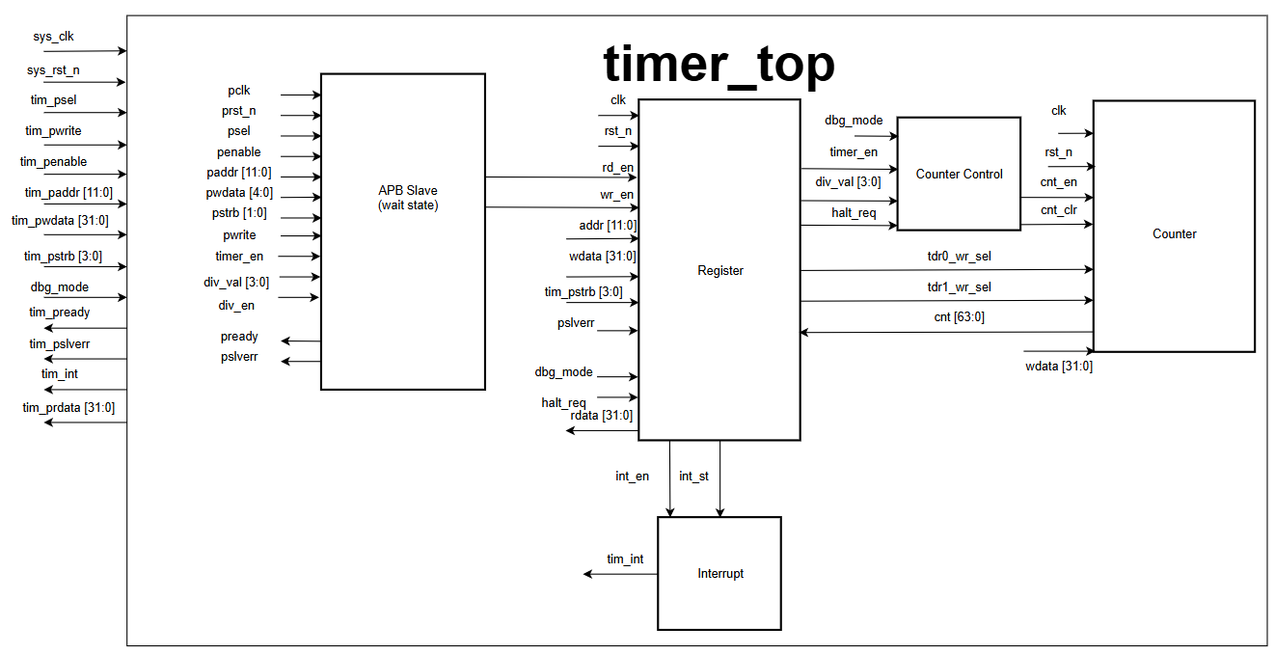
Figure 1 Block diagram of Timer IP
The Timer IP architecture is partitioned into several interconnected functional sub-modules:
- APB Slave Interface: Acts as the communication bridge between the system bus and the internal IP logic . It receives and decodes incoming APB signals (pclk, psel, pwrite, penable, paddr, pwdata, pstrb) to target specific internal registers . This block strictly manages the read/write sequences, supports byte-level access via pstrb, and drives the output responses including read data (prdata), wait-state acknowledgment (pready), and error flags (pslverr) .
- Register Block: Houses all memory-mapped configuration and status registers (TCR, TDR0, TDR1, TCMP0, TCMP1, TIER, TISR, THCSR) . It stores the user's software configuration and continuously drives internal control signals to the Counter and Control modules .
- Counter Control: The core logic engine responsible for regulating the timing of the counter. It generates the count enable pulse (cnt_en) based on the prescaler configuration (div_val and div_en) . Additionally, it processes debug/halt requests to precisely freeze the counter and issues the synchronous clear signal (cnt_clr) .
- 64-bit Counter: The primary up-counting mechanism, logically constructed from a lower 32-bit register (TDR0) and an upper 32-bit register (TDR1) . It increments its value according to the configured speed whenever the cnt_en pulse is active, and synchronously resets to 0 upon receiving the cnt_clr signal (or when timer_en transitions from High to Low) .
- Interrupt Logic: A dedicated comparison block that continuously evaluates the current 64-bit counter value against the programmed target value . It asserts the hardware interrupt signal (tim_int) when a perfect match occurs, provided that the interrupt functionality is globally enabled (int_en = 1) .

1.4. Interface signals
Table 1: Interface signals of timer IP
Signal name | Width | Direction | Description
sys_clk | 1 | Input | System clock for the Timer IP.
sys_rst_n | 1 | Input | Active-low reset signal.
tim_psel | 1 | Input | APB select signal for accessing the Timer IP.
tim_pwrite | 1 | Input | APB write control (1 = write, 0 = read).
tim_penable | 1 | Input | APB enable signal during the access phase.
tim_paddr[11:0] | 12 | Input | Register address for APB access.
tim_pwdata[31:0] | 32 | Input | Write data from the APB master.
tim_prdata[31:0] | 32 | Output | Read data returned to the APB master.
tim_pstrb[3:0] | 4 | Input | Byte_enable signals for APB write.
tim_pready | 1 | Output | Indicates transfer completion (1 = ready).
tim_pslverr | 1 | Output | APB error signals for invalid access.
tim_int | 1 | Output | Timer interrupt output
dbg_mode | 1 | Input | Enable debug mode for halt control

2.Register Specification

2.1. Register Summary
Table 2: Register Summary
Offset | Abbreviation | Register name
0x00 | TCR | Timer Control Register
0x04 | TDR0 | Timer Data Register 0
0x08 | TDR1 | Timer Data Register 1
0x0C | TCMP0 | Timer Compare Register 0
0x10 | TCMP1 | Timer Compare Register 1
0x14 | TIER | Timer Interrupt Enable Register
0x18 | TISR | Timer Interrupt Status Register
0x1C | THCSR | Timer Halt Control Register
Others | Reserved

2.2. Timer Control Register (TCR)
Offset address: 0x00
Reset value: 0x0000_0100
31 | 30 | 29 | 28 | 27 | 26 | 25 | 24 | 23 | 22 | 21 | 20 | 19 | 18 | 17 | 16
Reserved

15 | 14 | 13 | 12 | 11 | 10 | 9 | 8 | 7 | 6 | 5 | 4 | 3 | 2 | 1 | 0
Reserved |  |  |  | DIV_VAL[3:0] |  |  |  | Reserved |  |  |  |  |  | DIV_  EN | TIM_  EN
 |  |  |  | rw |  |  |  |  |  |  |  |  |  | rw | rw

Table 3. Timer Control Register (TCR)
Bit | Name | Type | Default value | Description
31:12 | Reserved |  | 20’h0 | Reserved
11:8 | DIV_VAL[3:0] | RW | 4’b0001 | Counter control mode setting couting speed:  - 4’b0000: Speed is not devided  - 4’b0001: Speed is devided by 2 (default)  - 4’b0010: Speed is devided by 4  - 4’b0011: Speed is devided by 8  - 4’b0100: Speed is devided by 16  - 4’b0101: Speed is devided by 32  - 4’b0110: Speed is devided by 64  - 4’b0111: Speed is devided by 128  - 4’b1000: Speed is devided by 256  - Other: Reserved, div_val not change
7:2 | Reserved | RO | 6’b0 | Reserved
1 | DIV_EN | RW | 1’b0 | Counter control mode enable (0: Disable, Speed is default, 1: Enable, Speed is controlled based on div_val)
0 | TIM_EN | RW | 1’b0 | Timer enable (0: Not count, 1: Counting)

2.3. Timer Data Register 0 (TDR0)
Offset address: 0x04
Reset value: 0x0000_0000
31 | 30 | 29 | 28 | 27 | 26 | 25 | 24 | 23 | 22 | 21 | 20 | 19 | 18 | ……………… |  | 0
TDR0
 |  |  |  |  |  |  |  | rw
Table 4. Timer Data Register 0 (TDR0)
Bit | Name | Type | Default value | Description
31:0 | TDR0 | RW | 32’h0000_0000 | Lower 32 bit of 64 bit counter.

2.4. Timer Data Register 1 (TDR1)
Offset address: 0x08
Reset value: 0x0000_0000
31 | 30 | 29 | 28 | 27 | 26 | 25 | 24 | 23 | 22 | 21 | 20 | 19 | 18 | ……………… |  | 0
TDR1
 |  |  |  |  |  |  |  | rw
Table 5. Timer Data Register 1 (TDR1)
Bit | Name | Type | Default value | Description
31:0 | TDR1 | RW | 32’h0000_0000 | Upper 32 bit of 64 bit counter.

2.5. Timer Compare Register 0 (TCMP0)
Offset address: 0x0C
Reset value: 0xFFFF_FFFF

31 | 30 | 29 | 28 | 27 | 26 | 25 | 24 | 23 | 22 | 21 | 20 | 19 | 18 | ……………… | 0
TCMP0
 |  |  |  |  |  |  |  | rw
Table 6. Timer Compare Register 0 (TCMP0)
Bit | Name | Type | Default value | Description
31:0 | TCMP0 | RW | 32’hFFFF_FFFF | Lower 32 bit of 64 bit compare value.

2.6. Timer Compare Register 1 (TCMP1)
Offset address: 0x10
Reset value: 0xFFFF_FFFF

31 | 30 | 29 | 28 | 27 | 26 | 25 | 24 | 23 | 22 | 21 | 20 | 19 | 18 | ……………… | 0
TCMP1
 |  |  |  |  |  |  |  | rw
Table 7. Timer Compare Register 1 (TCMP1)
Bit | Name | Type | Default value | Description
31:0 | TCMP1 | RW | 32’hFFFF_FFFF | Upper 32 bit of 64 bit compare value.

2.7. Timer Interrupt Enable Register (TIER)
Offset address: 0x14
Reset value: 0x0000_0000

31 | 30 | 29 | 28 | 27 | 26 | 25 | 24 | 23 | 22 | 21 | 20 | 19 | 18 | 17 | 16
Reserved

15 | 14 | 13 | 12 | 11 | 10 | 9 | 8 | 7 | 6 | 5 | 4 | 3 | 2 | 1 | 0
Reserved |  |  |  |  |  |  |  |  |  |  |  |  |  |  | Int_en
rw

Table 8. Timer Interrupt Enable (TIER)
Bit | Name | Type | Default value | Description
31:1 | Reserved |  | 20’h0 | Reserved
0 | Int_en | RW | 1’b0 | Timer interrupt enable (0: Timer interrupt is disabled, 1: Timer interrupt is enable).  When this bit is 0, no timer interrupt is output  When this bit is 1, timer interrupt pending bit can be output.  Clearing this bit to 0 while interrupt is asserting will mask the interrupt to 0 but does not affect the interrupt pending bit

2.8. Timer Interrupt Status Register (TISR)
Offset address: 0x18
Reset value: 0x0000_0000

31 | 30 | 29 | 28 | 27 | 26 | 25 | 24 | 23 | 22 | 21 | 20 | 19 | 18 | 17 | 16
Reserved

15 | 14 | 13 | 12 | 11 | 10 | 9 | 8 | 7 | 6 | 5 | 4 | 3 | 2 | 1 | 0
Reserved |  |  |  |  |  |  |  |  |  |  |  |  |  |  | Int_st
R1WC

Table 9. Timer Interrupt Status Register (TISR)
Bit | Name | Type | Default value | Description
31:1 | Reserved |  | 20’h0 | Reserved
0 | Int_st | R1WC | 1’b0 | Timer interrupt trigger condition status bit (  0: the interrupt trigger condition does not occur.  1: the interrupt trigger condition occurred.)  Write behavior:  Write 1 when this bit is 1 to clear it to 0.  Write 0 when this bit is 1 → no effect.  Write to this bit when it is 0 → no effect.

2.9. Timer Halt Control Register (THCSR)
Offset address: 0x1C
Reset value: 0x0000_0000

31 | 30 | 29 | 28 | 27 | 26 | 25 | 24 | 23 | 22 | 21 | 20 | 19 | 18 | 17 | 16
Reserved

15 | 14 | 13 | 12 | 11 | 10 | 9 | 8 | 7 | 6 | 5 | 4 | 3 | 2 | 1 | 0
Reserved |  |  |  |  |  |  |  |  |  |  |  |  |  | Halt_ack | Halt_req
rw

Table 10. Timer Interrupt Status Register (TISR)
Bit | Name | Type | Default value | Description
31:1 | Reserved |  | 20’h0 | Reserved
1 | Halt_ack | RO | 1’b0 | Indicates whether the timer is currently halted (0: Timer is NOT halted, 1: Timer is halted)
0 | Halt_req | RW | 1’b0 | Controls whether a halt request is issued to the timer (0: No halt request, 1: Timer is requested to halt)

3. Functional Description

3.1. APB slave
The APB Slave acts as the primary communication interface, enabling the host CPU or bus master to configure and monitor the Timer IP. This module receives the address, data, and control signals from the system bus and returns the corresponding read data or transaction status. It strictly complies with the AMBA APB3 protocol, operating synchronously with the system clock (pclk).
Key characteristics of the APB Slave interface:
- 12-bit address bus (paddr) for targeting internal registers.
- 32-bit data bus (pwdata, prdata) supporting byte-level access via write strobes (pstrb).
- Wait-state insertion via the pready signal to synchronize data transfers.
- Access violation reporting via the pslverr signal.
To ensure safe synchronization with internal processing speeds, the slave deliberately inserts exactly one wait state for every read and write transaction.

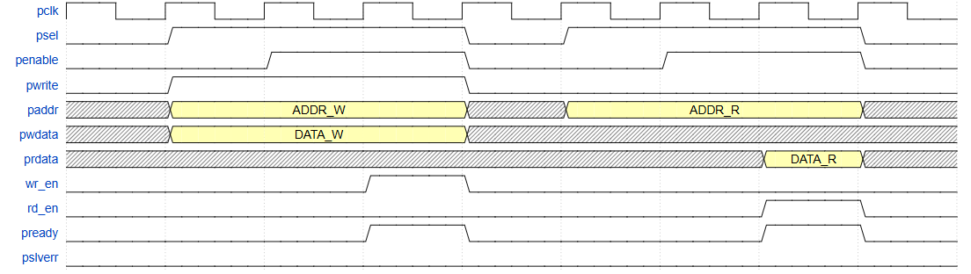
Figure 2 Read Transfer and Write Transfer With Wait State

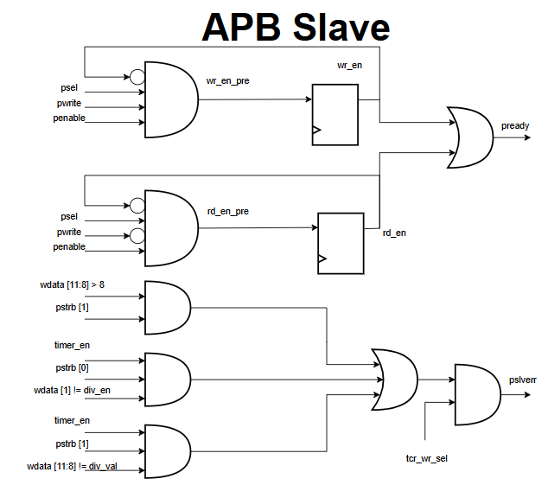
Figure 3 Logic Diagram APB Slave
The logic architecture of the APB Slave is partitioned into two main functional blocks:
- Wait-State Generation (pready) To ensure safe synchronization with internal processing speeds, the slave deliberately inserts exactly one wait state for every read and write transaction:
  - This mechanism utilizes two dedicated flip-flops to delay the internal write-enable (wr_en) and read-enable (rd_en) signals.
  - During a write sequence, the pre-write signal (wr_en_pre) is only active when psel = 1, penable = 1, and pwrite = 1. This signal propagates through a flip-flop, creating a one-cycle delay for the actual wr_en.
  - Consequently, the pready signal (which is the logical OR of the delayed wr_en and rd_en) does not assert immediately upon penable going high, but accurately waits for one clock cycle to complete the handshake.
- Error Handling Mechanism (pslverr) This block implements combinational logic to immediately detect data violations or invalid access attempts. The pslverr signal is asserted, rejecting the transaction, if a write access is targeted at the Timer Control Register (tcr_wr_sel is active) under any of the following illegal conditions:
  - Invalid Configuration: Attempting to write an out-of-range prescaler value (e.g., wdata[11:8] > 8 while pstrb is active).
  - State Violation 1: Attempting to toggle the divider enable bit (div_en) while the Timer is actively counting (timer_en = 1).
  - State Violation 2: Attempting to modify the clock division value (div_val) while the Timer is actively counting.

3.2. Register

3.2.1. Timer Control Register (TCR)
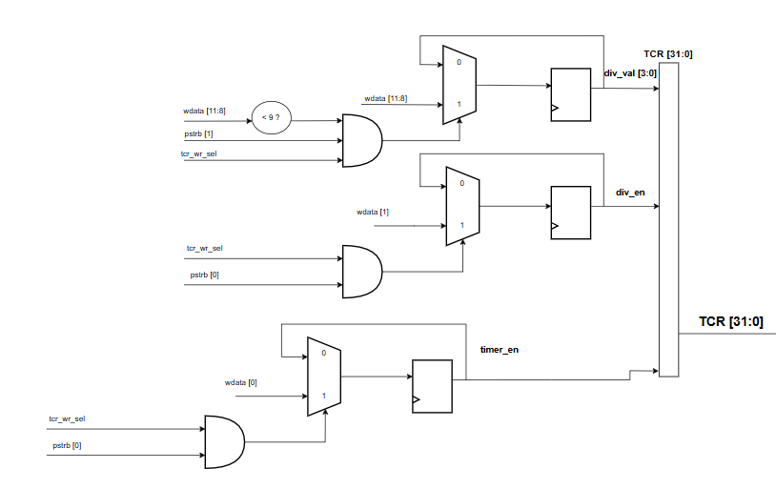
Figure 4 Logic Diagram TCR
The TCR manages core parameters including the clock divider value (div_val), divider enable flag (div_en), and timer enable flag (timer_en). The logic is partitioned into two data paths:Mạch hoạt động dựa trên hai luồng dữ liệu chính:
- Write Path: Uses multiplexers and D-Flip-Flops to update states, strictly controlled by the tcr_wr_sel signal and byte-enable strobes (pstrb). Crucially, a hardware protection comparator is implemented before the register input: it ensures that wdata[11:8] < 9 before updating the div_val, actively preventing invalid prescaler configurations.
- Read Path: The current states of the register bits are routed through a read-address decoder multiplexer. Data is driven to the rdata bus only when the rd_en signal is active, ensuring read stability.

3.2.2 Timer Data and Compare Registers (TDR0, TDR1, TCMP0, TCMP1)
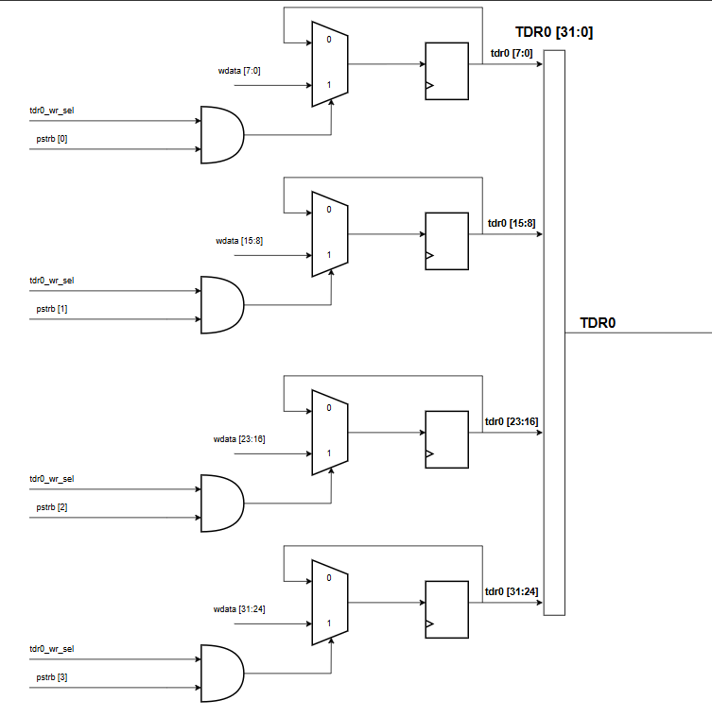
Figure 5 Logic diagram TDR0
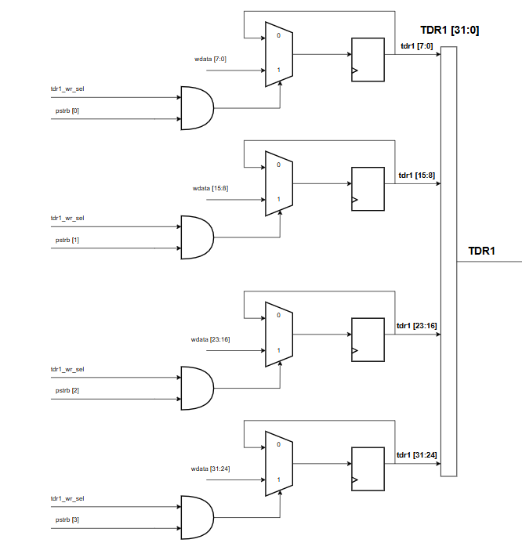
Figure 6 Logic Diagram TDR1
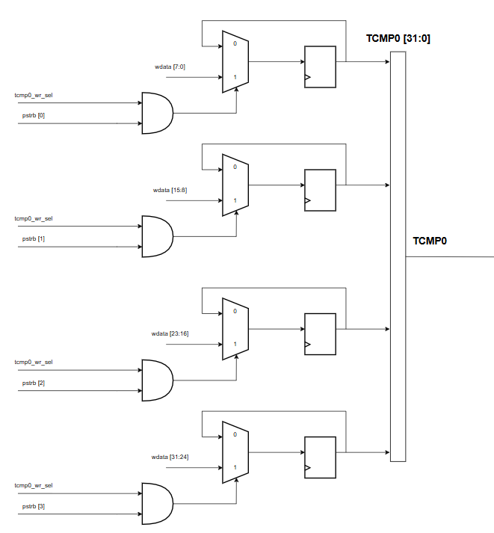
Figure 7 Logic Diagram TCMP0
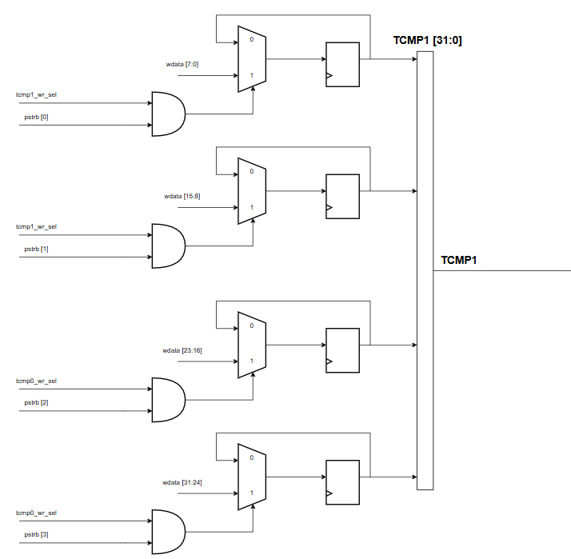
Figure 8 Logic Diagram TCMP1
These four 32-bit registers form the 64-bit current counting value (cnt) and the 64-bit target compare value (tcmp). The architecture of these registers relies on standard 32-bit D-Flip-Flop arrays. Their write-enable signals are individually decoded from the APB interface address, allowing the software to configure the 64-bit values via two consecutive 32-bit write transactions.

3.2.3. Timer Interrupt Enable Register (TIER)
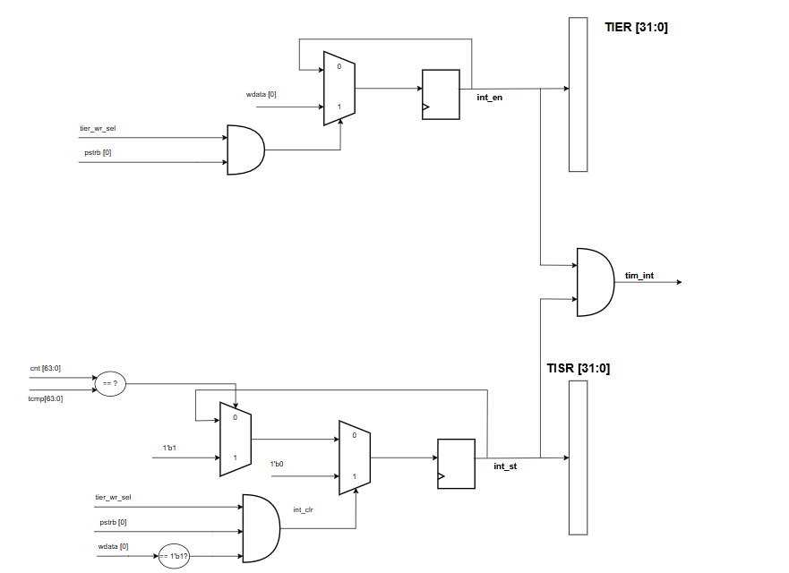
Figure 9 Logic Diagram TIER
The TIER module stores the interrupt enable bit (int_en). The circuit employs a single Flip-Flop to maintain this state. It selectively updates its value from wdata only upon receiving a valid write request (when tier_wr_sel AND pstrb are simultaneously active). This bit acts as a physical hardware gate, deciding whether the internal interrupt event is propagated to the host CPU.

3.2.4. Timer Interrupt Status Register (TISR)
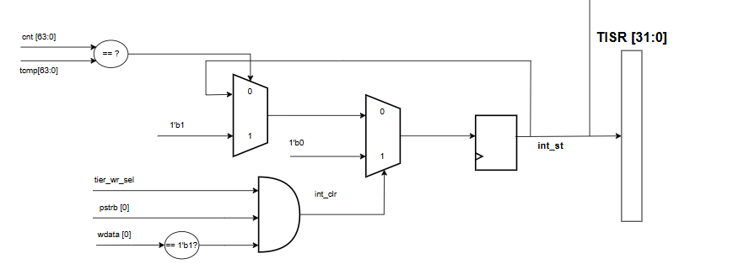
Figure 10 Logic Diagram TISR
The TISR manages the interrupt status flag (int_st), operating via a rigorous hardware-software handshake mechanism:
- Hardware Set: The flag automatically asserts to '1' the exact moment the internal comparator detects a match (cnt == tcmp).
- Software Clear (Write-1-to-Clear): To acknowledge and clear this flag, the software must write a '1' to this bit. This operation triggers the internal int_clr signal, which directs the multiplexer to forcefully reset the Flip-Flop state to '0'. Writing a '0' has no effect, preventing accidental clearances.

3.2.5. Timer Halt Control Register (THCSR)

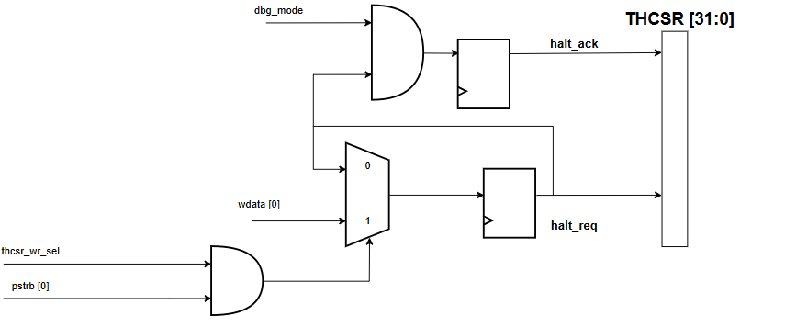
Figure 11 Logic Diagram THCSR
The THCSR logic handles the debug/halt capabilities via two dedicated signals:
- halt_req (Halt Request): A software-driven control bit. A valid write operation stores the stop request in a Flip-Flop.
- halt_ack (Halt Acknowledge): A read-only status feedback bit. This signal asserts to '1' only when a halt request is pending (halt_req = 1) AND the system is externally configured to be in debug mode (dbg_mode = 1).

3.3. Counter Control
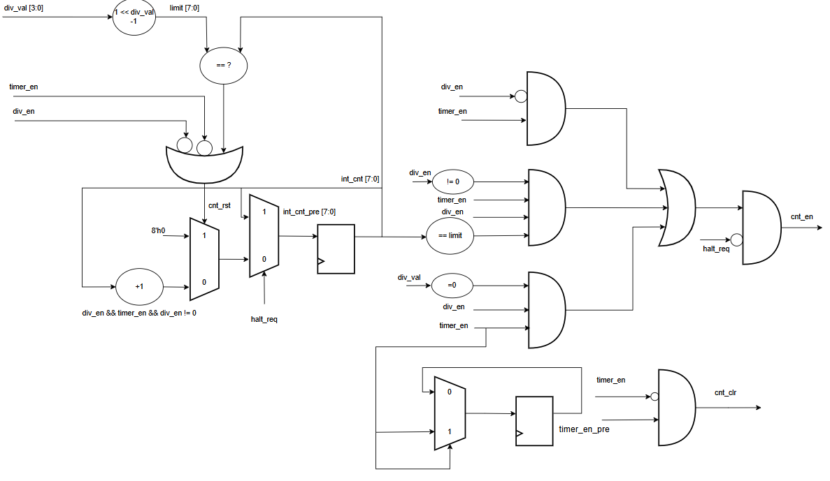
Figure 12 Logic Diagram Counter Control
The Counter Control module serves as the primary timing engine for the Timer IP. It governs the pace and lifecycle of the main 64-bit counter by driving two critical control signals: the count enable pulse (cnt_en) and the synchronous clear pulse (cnt_clr).
Prescaler & Count Enable Generation (cnt_en) The system employs a dedicated internal counter (int_cnt) acting as a hardware prescaler. This prescaler continuously compares its current value against a dynamically calculated limit derived from the user-configured division value (div_val). The cnt_en pulse is strictly asserted to '1' under any of the following conditions :
- Bypass Mode: The clock divider is explicitly disabled (div_en = 0), allowing the main counter to increment at the full system clock speed.
- Match Event: The prescaler reaches its configured limit (int_cnt == limit).
- Zero Division: The division value is configured to zero.
Synchronous Clear Mechanism (cnt_clr) To guarantee deterministic behavior across operational cycles, the control block incorporates a falling-edge detection circuit monitoring the timer_en signal . Whenever the timer is disabled (transitioning from '1' to '0'), the edge detector generates a single, cycle-accurate cnt_clr pulse. This mechanism ensures that the 64-bit counter is cleanly flushed and strictly ready to start from zero upon the next activation cycle .

3.4. Counter
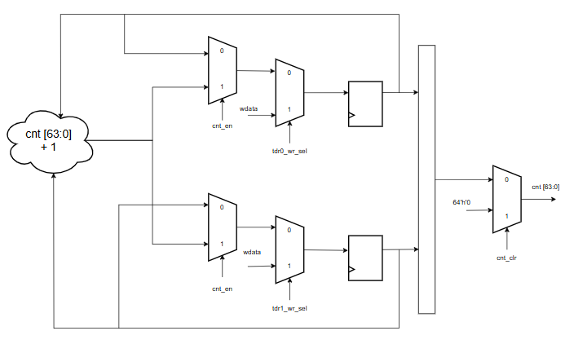
Figure 13 Logic Diagram Counter

The Counter block operates as a precise 64-bit synchronous up-counter, logically constructed by concatenating two 32-bit registers: TDR0 for the lower 32 bits and TDR1 for the upper 32 bits . This datapath functions entirely under the coordination of control signals generated by the internal Counter Control module . The architecture of the counter relies on two primary hardware routing mechanisms:
- Count Enable Datapath (cnt_en): The cnt_en signal actively controls the primary input multiplexers (MUX) of the counter . When cnt_en is asserted (High), the MUX selects the adder branch to increment the current counter value (cnt + 1) . If cnt_en is deasserted, the MUX selects the feedback branch, allowing the counter to seamlessly hold its current state without consuming dynamic power for toggling .
  - Synchronous Clear Datapath (cnt_clr): The cnt_clr signal is routed to the final overriding MUX of the counter block . Whenever the control block issues this cycle-accurate pulse (e.g., upon timer initialization or state transitions), it immediately forces the entire 64-bit register value to 64'h0 . This overriding mechanism guarantees that the next counting cycle consistently starts from a clean zero state, preventing unpredictable behavior.

3.5. Interrupt
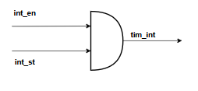
Figure 14 Logic Diagram Interrupt
This logic diagram illustrates the final stage of the interrupt generation mechanism. The module utilizes a logical AND gate to strictly govern the hardware interrupt output signal (tim_int). The tim_int signal is asserted (driven to High) to alert the host CPU only when the following two conditions are simultaneously met :
- Interrupt Event Occurrence (int_st): The internal 64-bit counter reaches the programmed compare value (TCMP), which hardware automatically detects and sets the pending status flag (int_st = 1) .
- Interrupt Enablement (int_en): The interrupt generation feature is explicitly authorized by the software via the enable bit in the TIER register (int_en = 1) .
This final gating mechanism ensures that the IP securely propagates interrupt requests to the system only when a valid match event occurs and the software configuration explicitly permits it . Once asserted, the interrupt signal remains active until the host CPU explicitly acknowledges and clears it by writing a '1' to the int_st bit (Write-1-to-Clear mechanism) or actively disables the int_en bit .

4. History
Date | Version | Description | Author
12/11/2025 | 1.0 | IP Timer | Minh An

5. Check List
This section outlines the high-level sign-off criteria for the Timer IP, ensuring that the design strictly adheres to industry RTL coding guidelines, AMBA APB3 protocol specifications, and advanced verification requirements.
To guarantee the robustness of the hardware, a comprehensive checklist was executed. From an RTL perspective, the design is fully synchronous with no unintended latches, applies an active-low asynchronous reset (sys_rst_n), and strictly follows safe assignment practices. Regarding the system interface, the IP fully complies with the AMBA APB3 standard. It successfully supports byte-level accesses via pstrb, consistently generates exactly one wait state (pready) for all data transfers, and features advanced hardware protection by asserting error signals (pslverr) upon detecting invalid on-the-fly configurations.
Finally, the verification environment confirms that all functional requirements, including the cycle-accurate advanced debug/halt mode, operate flawlessly. Most notably, the testbench successfully achieves 100% code coverage across all critical metrics (Statement, Branch, Expression, Condition, and Toggle). For the fully detailed test plan and comprehensive checklist, please refer to Appendix A at the end of this document (or visit the project's GitHub repository).

6. Testcases
The verification of the Timer IP is conducted using a mix of directed and constrained-random tests to ensure complete functional correctness and protocol compliance. The comprehensive test plan is categorized into five main suites:
- Register Tests: Verifies default reset values, read/write access, and precise byte-level operations using the pstrb signal for all APB registers .
- Counter & Prescaler Tests: Validates normal counting operations, programmable clock division scaling (from div-1 to div-256), and 32-bit boundary wrap-around conditions .
- Error Handling Tests: Ensures the hardware protection logic correctly asserts the pslverr signal when invalid configurations (e.g., modifying div_val or div_en while the timer is running) are applied on-the-fly .
- Interrupt Tests: Validates interrupt trigger generation on compare-match events, masking capabilities, and the exact Write-1-to-Clear (W1C) acknowledgment mechanism .
- Halt/Debug Tests: Confirms that the counter cycle-accurately freezes when a halt request (halt_req) is issued, exclusively when the system operates in debug mode (dbg_mode = 1) .

7. Coverage
To rigorously evaluate the completeness of the verification environment, code coverage metrics were extracted and analyzed. The testbench successfully achieved 100% coverage across all critical metrics, satisfying the project requirements:
- Statement Coverage: Ensuring all lines of the RTL code were executed.
- Branch & Condition Coverage: Verifying all logical branches and APB protection conditions were fully exercised.
- Expression & Toggle Coverage: Confirming all bit-level transitions and combinational expressions operated correctly under various scenarios.
The achievement of 100% code coverage signifies that there are no unverified design holes within the Timer IP. For detailed coverage extraction logs and reports, please refer to Appendix B at the end of this document.

Appendix A: Detailed Verification Plan and Testcases
This appendix contains the detailed test sequences and sign-off criteria for all verification suites executed on the Timer IP.
A.1 APB Register Access Suite
A.2 Counter and Prescaler Suite
A.3 Error Handling Suite
A.4 Interrupt Suite
A.5 Halt and Debug Suite

