Polar bonds self-ordering and negative thermal expansion

Yuriy Poplavko
National Technical University of Ukraine “Igor Sikorsky Kyiv Polytechnic Institute”
Kiev, Ukraine
ypoplavko@gmail.com

Уважаемый Юрий Михайлович, я прочитал полный текст Вашей статьи который Вы мне присылали (“Polar bonds self-ordering and negative thermal expansion”). Интерес не пропал (и не пропадёт), так что хочу Вас попросить выслать мне дополнительную литературу для дальнейшего освоения этой темы. А что касается того что я не задаю никаких вопросов (пока что) после прочтения этой публикации, то это из-за того что я думаю что я всё понял (ну это я так думаю) )

Abstract—Thermal expansion coefficient, reflecting the peculiarities of crystal inter-atomic bonds, in most of crystals increases with temperature rise. The negative value of this coefficient, seen in the polar crystals in a certain temperature interval, correlates to the configurational entropy, which in opposed to vibrational entropy increases as pressure grows. Negative coefficient of thermal expansion testifies to dynamic self-ordering of polar bonds in crystals, and is seen not only in the piezoelectrics, but also in the semiconductors (like Si) that might be due to ordering of the virtual hexagonal polar phase.

Keywords—hermal expansion, configurational entropy, piezoelectric, internal polarity, semiconductors

Introduction
The coefficient of thermal expansion describes the change in relative dimensions of solids with temperature growing, and it is important characteristic of interatomic bonds features. The polar dielectric possess peculiar structures arising due to different electronegativity of their constituent atoms. The peculiarities of complex interatomic bonds in polar crystals are manifested precisely during their deformation under the scalar action, such as the uniform change in temperature. On the contrary, the gradient (vector) and tensor type of actions affect the symmetry of crystal response, when the strain x_{ij} occurs due to mechanical stress tensor (x_{ij} = s_{ijkl}X_{kl}) or to vector type actions of electrical or magnetic fields (x_{ij} = d_{ijk}E_{k}, x_{ij} = ς_{ijkl}H_{k}), where s_{ijkl} is the elastic compliance, d_{ijk} is the piezoelectric module and ς_{ijk} is the magnetostriction [1]. In all these cases, the symmetry of response includes not only a symmetry of studied material but also the symmetry of acting force (this is the Curie principle). So they can only indirectly characterize the nature of interatomic bonds of a crystal. In the same time, the thermal deformation of a crystal and especially its temperature dependence provides the defining contribution to the understanding of internal polarity physical nature, which is important in the development of technologies for microelectronic materials.

Therefore, the features of inter-atomic interactions, which are of special importance for polar crystals, are better revealed under the scalar (homogeneous) influences on crystal, such as the uniform change of temperature δT or the hydrostatic change of pressure δp: x_{ij} = α_{ij}δT and x_{ij} = ξ_{ij}δp, where α_{ij} is the coefficient of thermal expansion and ξ_{ij} is the compressibility factor (both are the second rank tensors relating to each other). However, the tensor nature of these parameters needs separate consideration for the crystals of different symmetry. That is why, in what follows, only the scalar parameters of the volumetric thermal expansion α_{V} and the volumetric compressibility ξ_{V} = K (the all-round compression module) will be considered.

Physical Nature of Thermal Expansion
The volumetric coefficient of thermal expansion is the relative change of a volume when body is heating/cooling by one degree of temperature at constant pressure p, defining as α_{V} = (1/V)⋅(∂V/∂T)_{p}. Its connection with the tensor α_{ij} can be presented by the sum of diagonal matrix elements α_{V} ≈ α₁ + α₂ + α₃. In various solids, it lies in wide range of α = +(1–50)×10^{–6} K^{–1} and is inversely proportional to the melting temperature of a crystal: α_{V} ~ Т_{melt}^{–1}, since the stronger the inter-atomic bonds the more difficult to change and wreck them, so the thermal expansion of crystal the smaller the greater crystal melting point.

The binding energy between atoms is characterized by the Debye temperature θ_{D}, and, according to Lindemann relation, the melting temperature is Т_{m} ~ θ_{D}². So a connecting expression follows for the thermal expansion coefficient and Debye temperature: α_{V} ~ θ_{D}^{–2}, from which one can make a conclusion that the coefficient α is awaited to be positive quantity [2].

The change in crystal size during heating or cooling is due to the difference in the laws of atoms attraction and repulsion, when the neighboring atoms or ions are displaced from their equilibrium position due to thermal vibrations of atoms. An example of typical α(T) dependence is shown in Fig. 1a for the MgO crystal: such dependence is seen in the vast majority of solids: the coefficient α first increases with temperature rise by a cubic law (α ~ T³) but then goes to the saturation area, repeating the specific heat capacity change with temperature.

Therefore, the root cause of thermal expansion is the difference in interatomic forces of attraction and repulsion. The energy of atoms interaction, Fig. 1b, consists of the attraction (negative) and repulsion (positive) components.

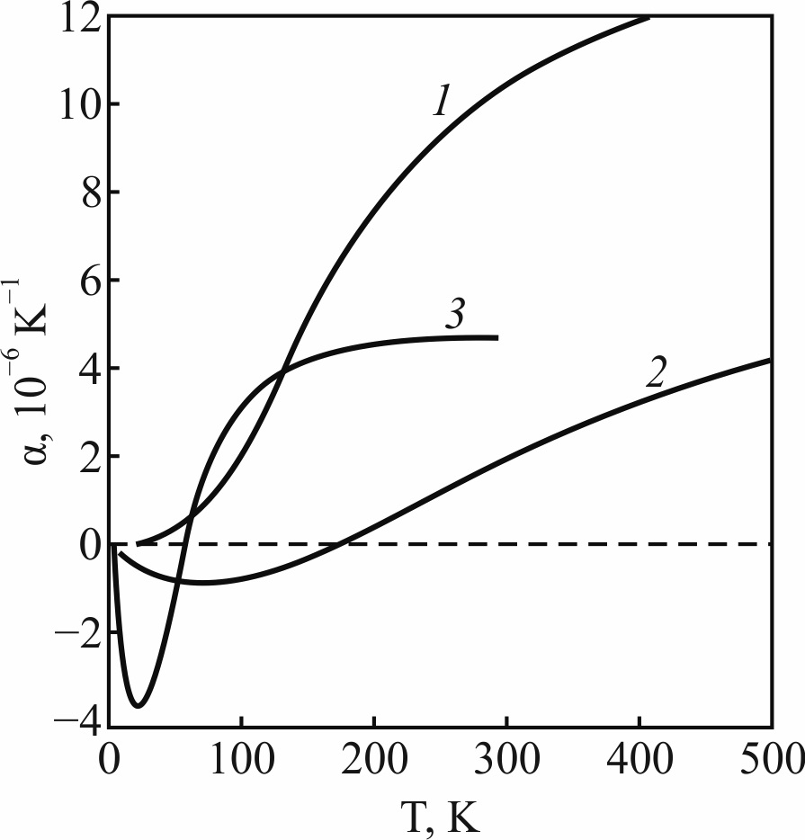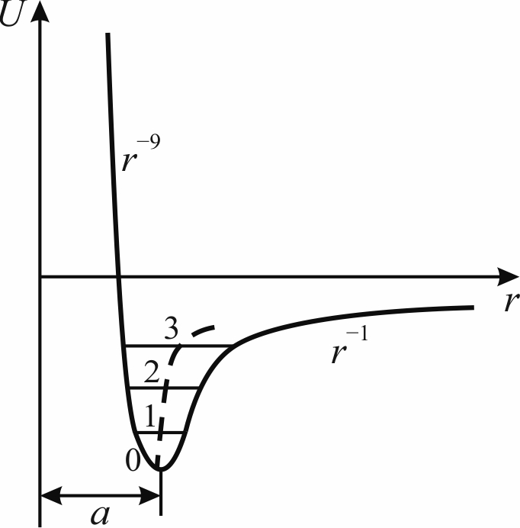

a b

Fig. 1. Thermal expansion: a – α(T) dependence in crystals MgO (1), ZnO (2) and HgTe (3); b – energy dependence on inter-atomic distance r, increase in amplitude of ions oscillations shown by lines 0-1-2-3; lattice parameter changing a+x is shown by dotted line

When the distance between the interacting particles changes, these components vary in different ways: the repulsive force operates at very short distance, as their potential energy very fast decreases with interatomic distance: U(r) ~ r^{–10} due to the overlap of electronic shells. Conversely, the attraction forces operate at much longer interatomic distance: for ionic bonding U(r) ~ r^{–1} and for covalent bonds U(r) ~ r^{–3} (both in this and in other case coefficient α(T) > 0). Quite other dependence of attraction energy arises in case of the mixed ionic-covalent polar bonds (which is a possible reason for α(T) > 0).

In any case, the total energy as a function of interatomic distance shows the asymmetric minimum, Fig. 1b. At the lowest temperature, the bottom of potential well can be approximated by the symmetric parabola, so that when temperature changes near absolute zero, the interatomic distance is constant: r = a (lattice parameter). This explains why the coefficient of thermal expansion for quite various solids near zero temperature tends to zero. However, when the amplitude of thermal vibrations increases, the average distance between atoms (shown by dotted line) increases: this is an obvious reason of thermal expansion. The levels of different energy are shown in Fig. 1b by the horizontal lines 1-2-3: with the increase in amplitude of thermal vibrations (starting from 0), the displacement of vibrating atoms to the left becomes less than their displacement to the right. As a result, time-averaged (middle) equilibrium position of atom (a+x), shown by the dashed line in Fig. 1b, shifts to the right, and this effect becomes the stronger the higher the vibrational energy of atoms.

In this reasoning, a special moment is the concept of time-averaged displacement of vibrating atoms, which actually determines the temperature dependence of thermal expansion coefficient. According to above description, the physical meaning of thermal expansion coefficient is "the reciprocal of a slope of the curve, which expresses the dependence of binding energy on the interatomic distance (a+x) at a point corresponding to the time-average position of an atom: dU(a+x)/d(a+x) ~ 1/α". In other words, the α(T) dependence is determined by the middle profile of U(r) dependence of crystal.

Below Debye temperature, thermal vibrations intensity changes nonlinearly, at that, the α(T) change is proportional to specific heat C(T) growing with the increase of phonons number and their energy. This dependence is fulfilled in the most crystals of chemical elements, and in simple compositions, for example, in the halide salts and oxides. At that, the increase of thermal expansion coefficient with temperature rise corresponds to the Grüneisen law, which establishes the similar temperature dependence of heat capacity C_{V} and thermal expansion: α = γ⋅C_{V}/3K. In this equation of state for rigid body, γ is the Grüneisen constant (the measure of anharmonicity of interatomic forces) and K is the volumetric compressibility.

It is important to note the close correlation between the thermal expansion α and the compressibility K: both of them show the peculiarities of crystal strain induced by the uniform action. The relationship α_{V} ⇔ K is due to the fact that both of them are the result of scalar effects on a crystal, and, therefore, the reaction of crystal – its deformation – is associated only with intrinsic elastic properties of a crystal, reflecting the features of its interatomic bonds. Therefore, it is not surprising that in future discussion, relating to the negative thermal expansion coefficient, this property is compared with compressibility, characterizing hydrostatic compression correspondingly to configurational entropy.

In contrast to absolute majority of crystals, in the polar crystal their volume V(T) changes unusually with the rise of temperature, and the reason of this is the unusual U(r) dependence of attraction energy, arising due to hybridization of ionic-covalent bonds (it leads to specific middle energy profile in the interatomic distances). Therefore, first a slight increase of the V(T) occurs in region of quantum vibrations of crystal, but then the cubic growth of α(T), seen for most crystals, in some temperature range is inhibited, so that α(T) crosses the zero line and becomes negative. The reason is that the increase of phonons concentration and their energy leads to more dense and more rigid structure insofar as the thermal energy contributes to the dynamic ordering of polar bonds. This effect may resemble the formation of polarons, when the phonons promote the dynamic nanoregions of polarization around the charge carriers, reducing their mobility hundreds of times. But further, as temperature increases, the same but much more intensive thermal movement destroys the polar environment of the charge carriers, and their mobility increases dramatically.

With the support of thermal motion, the polar bonds become self-ordering; as a result, the rigidity of polar crystal increases leading even to some compression, so usual for non polar crystals increase in the volume with increasing temperature is inhibited. But this effect cannot continue when a significant increase in temperature goes on, since the thermal energy begins to destroy a weakly stable ordering of polar bonds; in this way, the α(T) dependence returns to its traditional cubic law, repeatedly crossing zero line. In this case, in a certain temperature interval, the coefficient of thermal "expansion" shows a more or less deep minimum. It can be seen in Fig. 1a that polar crystals (the hexagonal ZnO of wurtzite symmetry 6m and the cubic polar HgTe crystal of 43m sphalerite structure) shows the α(T) dependence in negative region. Note that at lowest temperatures any negative α_{V} is impossible, since the inevitable quantum oscillations violate any ordering of the polar bonds in the crystal lattice (as, for example, in the virtual ferroelectrics KTaO₃ and SrTiO₃).
- Minimal value of thermal expansion coefficient (α_{min}), its value (α₃₀₀) at temperature near 300 K, and temperature at which α_{min} occurs in different polar crystals [3]
Crystal | α_{min}⋅10^{–6} K^{–1} | T_{α min} | α₃₀₀⋅10^{–6} K^{–1}
HgTe | –3.8 | 25 | 4.8
InSb | –1.4 | 27 | 5.1
ZnO | –1.2 | 75 | 5.5
InAs | –0.9 | 35 | -
InP | –0.5 | 45 | 4.8
H₂O | –5.8 | 40 | -

Table 1 gives experimental data as to temperature minimum of α in the polar substances. In most cases, the α_{min} is about 20% of its value in the saturation region. The low-temperature properties of the ice are also given in Table 1, but the arrangement of the polar bonds in H₂O crystal is substantially different. Note that the fused quartz also belongs to the substances with a negative value ​​of thermal expansion coefficient seen at low temperatures: at temperature of 35 K the α_{min} = – 9⋅10^{–6} K^{–1} that is 1.5 times bigger than the α₃₀₀ = + 6⋅10^{–6} K^{–1}. So it can be concluded that the negative value of α(T) is a general property of polar substances with a small coordination number (with an open structure), characterizing by the tetrahedral arrangement of atoms: in them, the ordering of polar-sensitive bonds is much easier. In contrast, in the structures of tight packing of atoms, the thermal expansion is usually positive.

Thermal Expansion Thermodynamics
Subsequent reasoning is based on the concept of Gibbs function, using isobaric-isothermal thermodynamic potential G, the value of which, changing during the thermodynamic process, is equal to the change in the internal energy of system. The Gibbs energy shows what part of the total internal energy of system can be used in the transformations (or obtained as a result of them) under given conditions, and makes it possible to establish the fundamental possibility of changes, occurring under given conditions. Mathematically, this is thermodynamic potential of form: G = U + pV – TS, where U is the internal energy, p is the pressure, V is the volume, T is the absolute temperature, and S is the entropy. The minimum of Gibbs potential corresponds to the stable equilibrium of thermodynamic system at fixed temperature, pressure and number of particles. To describe the system with constant number of particles, it is important to express the differential of Gibbs energy:

dG = – SdT + Vdp

Volumetric thermal expansion coefficient is defined as the relative change of volume with temperature at constant pressure: α = (∂V/∂T)_{p}/V. At that, the change in volume can be expressed through the Gibbs potential and pressure at constant temperature: V = (∂G/∂p)_{T}, and obtain following expressions:
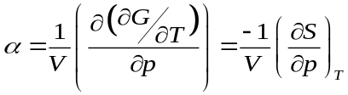
In the almost all solids, their volume increases with increasing temperature, and α > 0. The resulting expression means that the higher the pressure the lower the entropy, and this correlation corresponds to usually observed thermal expansion in solids. Nevertheless, in the dynamically ordering systems, for example, in the polar crystals, there is a certain temperature range, in which the coefficient α < 0 that means the entropy increase with increasing pressure.

This requires some expansion of the entropy concept: it is the property difficult to explain, since the entropy cannot be measured directly like T, V or p. Formally, the entropy characterizes an inaccessibility of a part of thermal energy for its conversion into a work; that is, it is a measure of the portion of heat energy that is not available to do useful work. Moreover, the entropy is interpreted as the degree of the disorder in a system, arising from microscopic dynamic phenomena, which are consistent with the macroscopic quantities (p, V, T), characterizing the system. At that, the entropy establishes a connection between the macro- and micro- states. It is believed that particular arrangement of particles, which are characterizing by average quantities, is the macrostate, while the individual arrangement, defining the properties of each particle, is the microstate. Entropy is related to the number of ways, in which the microstate can rearrange itself without affecting macrostate. At that, for microstates, for example, for a system of many particles, it is possible to specify coordinates and velocities of all particles. It's obvious that macroscopic state is described using macroscopic parameters, for example p, V, T.

In connection with the discussion of dynamic ordering in the polar crystals, a conditional division of entropy into the "vibrational" and "configurational" becomes relevant. The vibrational entropy can be thought of as the number of microstates, through which the thermal energy is distributed between particles. The higher the temperature, the greater the vibrational entropy, but with increasing pressure it becomes smaller, since the binding energy of particles increases. Consequently, with pressure increase, vibrational entropy decreases. The configurational entropy is that part of the entropy of a system, which is due to the different positions of some parts of a system, which are applicable to all possible configurations in a system. This entropy characterizes the number of ways, in which the groups of atoms can be distributed in a space. With increasing pressure, the possibility of partial ordering of dynamic nanoscale clusters becomes limited, and the mutual chaos increases. Thus, a distinctive feature of the configurational entropy is its growth with pressure increase [4].

Some convincing examples, showing direct relationship of negative expansion coefficient and structural self-ordering may be given. Barium titanate, while cooling, passes from its non-polar into the polar phase at temperature T_{C} = 130 º C. During phase transition from disordered phase into the ordered phase the volume of ferroelectrics increases (Fig. 2a, curves 1 and 2) while the configurational entropy decreases due to suppression of polar fluctuations below T_{C}. At that, applied hydrostatic pressure can squeeze out the polar phase, leading to the disordered phase (the negative α(T), i.e., the thermostriction, is well known property of the ferromagnets also).

On the contrary, the antiferroelectrics (like antiferro-magnets) become denser below their phase transition (Fig. 2a, curves 3 and 4) which is characterized by the α(T) maximum. The reason is the vanishing of crystal soft mode frequency near the boundary of Brillouin zone with the multiplication of lattice parameter. The possibility of the reducing of antipolar phase volume in comparison with the polar phase is simplistic shown in Fig. 2b by the two-dimensional model of the mixed ionic-covalent bonds. For technical applications of this phenomenon, it is important that applied electrical field can reversibly switch the antipolar state to the polar one and vice versa, which leads to the huge electromechanical effect and the large electrocaloric effect.

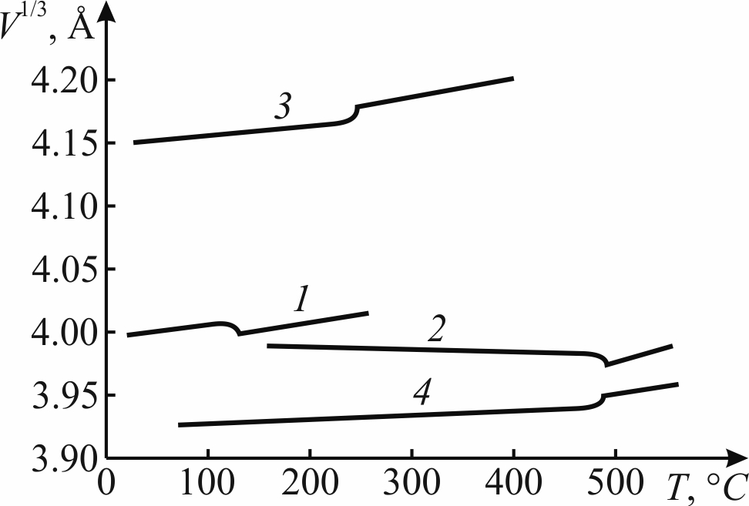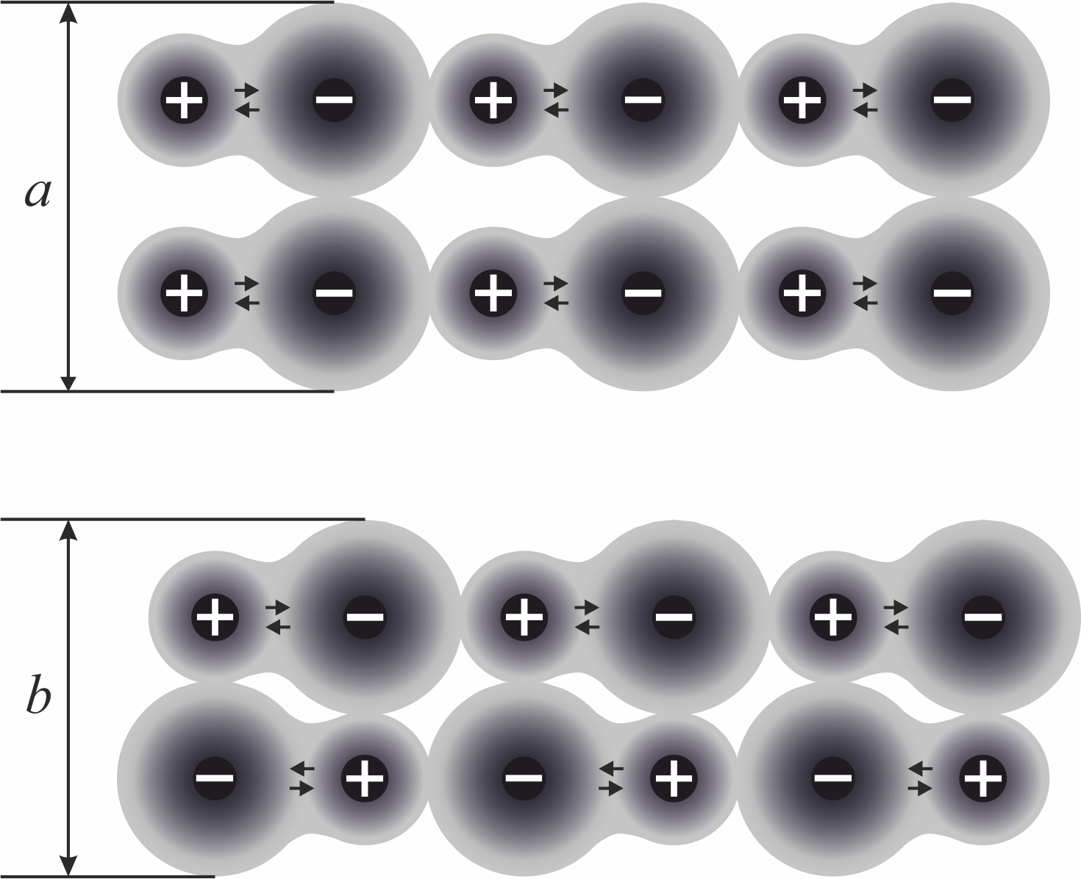

(A) (B)

Fig. 2. Thermal expansion temperature dependence: A – cubic root of unit cell volume in ferroelectrics BaTiO₃ (1), PbTiO₃ (2) and antiferroelectrics PbZrO₃ (3), NaNbO₃ (4); B – model of polar and anti-polar ordering, it is seen that a > b

Negative Thermal Expansion Coefficient in Semicoductors
Those semiconductors that have polar structure also exhibit the negative coefficient of thermal expansion. For example, the Group III–V compounds have sphalerite structure being the piezoelectrics, while the Group II–VI semiconductors with wurtzite structure are the pyroelectrics. It is important to note that all of them belong to the direct-gap semiconductors, while the non-polar semiconductors of a diamond structure are the indirect-gap crystals. At low temperatures in semiconductors, where the negative α(T) is observed, the concentration of free charge carriers is very low, so that they cannot screen possible polar fluctuations in such structures. Thus, the negative coefficient of thermal expansion, observed exactly at low temperatures, should be considered as a phenomenon due to electrical polarization.
From the standpoint of lattice dynamics, the negative value of α(Т) corresponds to a such phonon spectrum, which leads to the negative Grüneisen constant. These singularities are due to the acoustic vibrational mode; so in polar crystals the branch of transverse acoustic oscillations, when approaching the boundary of Brillouin zone, bends downward, Fig. 3a. Therefore, this branch can be represented by two parts: the Debye-type mode in the beginning of a spectrum and the Einstein-type mode at its end; exactly the last part of TA branch near the boundary of Brillouin zone corresponds to the negative α(T) [5]. In connection with foregoing, the low-temperature minimum of α(T) is not surprising. When temperature decreases, the activity of thermal motion lowers, so the tendency of polar bonds to the self-ordering manifests, demonstrating negative α(T). But with the post-cooling to a very low temperature, the inescapable quantum oscillations in the crystal lattice prevent further self-ordering of fluctuating polarity.
However, negative α(T) in the atomic semiconductors, Fig. 3b, at the first sight, is the unexpected phenomenon. As is shown, negative α(T) is due to change in configurational entropy. Obviously, that it is desirable to indicate, which kind of ordering process is possible in the crystals of diamond type. Here it is assuming that the main reason of the negative α(T) in the germanium and silicon is the fluctuations in partial ordering of the virtual hexagonal polar phase, arising when double covalent bond mix with single bond.

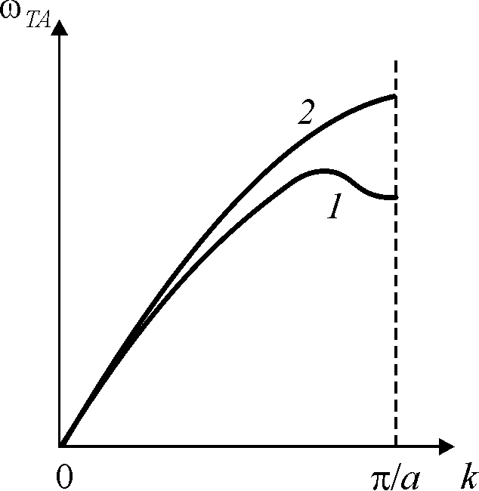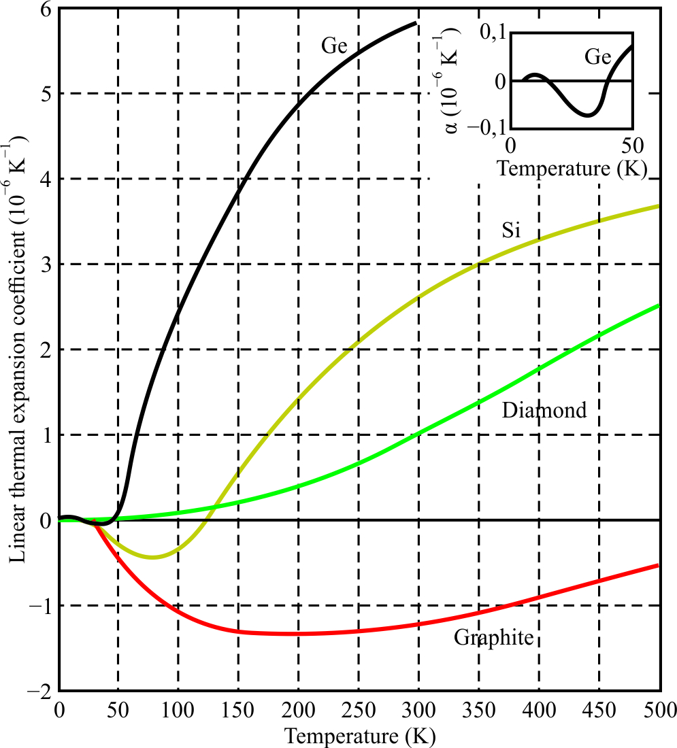
a b

Fig. 3. Phonons spectrum for: a – transverse mode (TA) in polar GaAs crystal (1) and in non-polar NaCl crystal (2); b – α(T) dependence in semiconductors Ge (1), Si (2), С-diamond (3) and C-graphite (4)

This assumption is based on the fact of the hexagonal diamond existence: initially it was discovered in meteorites [1] but later is synthesized in laboratory [4]. Obtained in a peculiar technologic condition, the hexagonal phase remains stable only in the super hard and super stable diamond, observing throughout temperature interval. However, in Si and Ge, the hexagonal phase, apparently, can exist only in a form of weak polar fluctuations in the [111] type directions. It is pertinent to note that the direction of natural growth of these crystals from their melt is also the [111] direction; moreover, these crystals can float in their own melt (like ice in the water), which indicates the decrease in their density during crystallization (the same property is observed, for example, in the GaAs, which is a polar crystal of sphalerite symmetry). The motif of hexagonal structure, which can exist in the one kind of diamonds but possibly weakly fluctuating in the Si and Ge, is clearly realized in graphite, the cellular plane of which is characterized by the negative expansion coefficient with temperature minimum at 180 K.

Conclusions
In polar crystals, the increase in volume with temperature rise (the thermal expansion, usual for solids), at low temperatures slows down, since the increase in the intensity of thermal motion stimulates the self-ordering of polar bonds, increasing the rigidity of their structure and even leading to small compression. But next, with the significant increase in temperature, a more intense thermal movement violates this ordering, and, therefore, the volume of crystal continues to increase again, as in the ordinary crystals. In this case, the coefficient of thermal expansion α_{V} in polar crystals at low temperatures changes its sign twice, forming a region of negative α_{V}. Its extended minimum means that initially (when a noticeable thermal motion appears) the polar bonds gradually acquire their partial ordering: in this case, the stronger the interatomic bonds, the lower the thermal expansion coefficient, up to its negative value. The polar structures in some crystals arise due to the structural compensation of the electronegativity of different neighboring atoms. A negative value of α_{V}(T) corresponds to a particular case, when the entropy grows with increasing pressure, which is characteristic of configurational entropy: the region of negative expansion coefficient corresponds to the processes of self-ordering of polar bonds. Since the minimum α_{V}(T) of polar crystals is explained by the ordering of polar bonds, the proposed concept is extending to some semiconductors. In them, it can be assumed that the polar tendencies, fluctuating in their structures, become consolidated at low temperatures.

References
- C. Kittel, Introduction to solid state physics, 5th ed. New York: John Willey, 1976.
- S. I. Novikova, Thermal expansion of solids. Moscow: Nauka, 1974.
- W. Martienssen and H. Warlimont, Eds., Handbook of Condensed Matter and Materials Data. Berlin: Spinger, 2005.
- Z. K. Liu, Y. Wang and S. L. Shang, "Origin of negative thermal expansion phenomenon in solids", Scripta Mater, 65, 664, 2011.
[5] Yu. M. Poplavko. Dielectric spectroscopy of electronic materials.
Applied physics of dielectrics. ELSEVIAR, 2021.

