Negative thermal expansion: nature and
application

Mnatsakanov Anton
National Technical University of Ukraine “Igor Sikorsky Kyiv Polytechnic Institute”
Kiev, Ukraine
antonnm1412@gmail.com

Abstract—Negative thermal expansion (NTE) is an uncommon physical and chemical phenomenon in which some materials shrink when heated rather than expand like most other materials. Per the last few years there has been significant development in the field of materials NTE. This opened up a new field of composites for the creation of which use NTE materials as thermal expansion joints.

Keywords—thermal expansion, negative thermal expansion, expansion in solids, ...

Introduction
Some materials, when the temperature rises, do not demonstrate expansion, but, on the contrary, contraction, that is, they have a negative coefficient of thermal expansion α (which at lower temperatures is typical for any polar crystal). For some substances, this manifests itself in a rather narrow temperature range, such as, for example, as the best known material with NTE is water at 0 ... 4 ◦С this property is also present in other substances and materials, for example fluoride scandium (ScF3), zirconium tungstate (ZrW2O8), some CFRPs, the range is very wide. This behavior is also demonstrated by ordinary rubber. At ultra-low temperatures, quartz, silicon and a number of other materials behave in a similar way.

Thermal expansion of solids
Any book on solid state physics says that
anharmonicity of lattice vibrations causes thermal
extension [7]. Anharmonicity means that the bonds that bind atoms together in a lattice pattern are not entirely, but simply obey Hooke's law. Atoms can't get through
very close to each other due to Pauli's exclusion
principle. Therefore, the potential energy of atomic bonds
as a function of the interatomic distance ▲r diverges when ▲r approaches zero (Figure 1.1)[9]. Due to this asymmetry
potential well, excursions to large interatomic distances
lighter than shorter interatomic distances. Hence,
the average interatomic distance increases simultaneously with temperature increase. Thermal expansion caused by the
natural law is apparently a destiny of solids.

The coefficient of linear thermal expansion α is expressed
as

α = (γ C_{debye}) / 3K V (1)

assuming that the variation in the frequency of lattice
vibration due to anharmonicity is proportional to minute
changes in the volume V . Here, γ is Grüneisen’s parameter,
C_{debye} is Debye specific heat and K is the bulk modulus.
For simplicity, let us consider an isotropic material. In
that case, the coefficient of volume thermal expansion
β = (1/V₀)(dV /dT ) (V₀: volume at reference temperature T₀ ) is simply related to α as β = 3α. γ represents how the Debye temperature θ, which dominates the lattice vibration, depends on volume, which is defined as

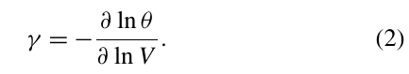

Elastic properties can be expressed in terms
Young's modulus E, shear modulus G, and Poisson's ratio ν.
For isotropic materials, the independent constants are reduced to up to two: K = E / [3 (1 - 2ν)] and G = E / [2 (1 + ν)]. Concerning inorganic materials, Poisson's ratio ν weakly depends on materials and in most cases can be considered as a constant in the range 0.2-0.3. Therefore we can calculate G and K of E, which is often easier to measure.

Usually γ and K are weakly dependent on temperature,
and thus α shows almost the same temperature
dependence on Cdebye:

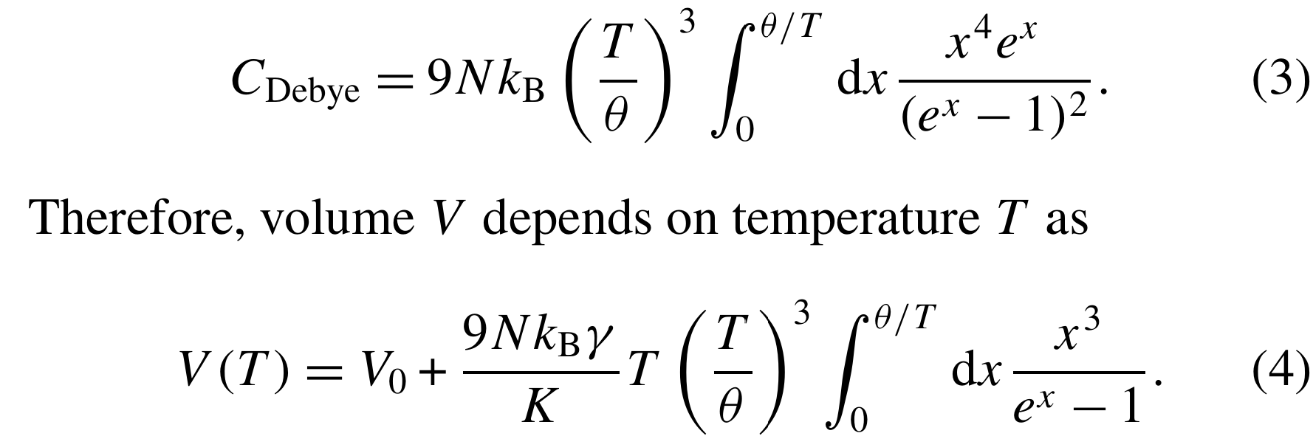
Equation (4) gives a theoretical description of the thermal
extensions. It is used to fit the experimental thermal expansion with the refinement of the corresponding parameter θ, when γ and K are set. It is also useful for estimating the ideal phonon contribution to thermal expansion in a magnetic metal (see. section 3.3). Functions approximating the integral in the equation (4) for convenience of analysis are available in
literature [8].

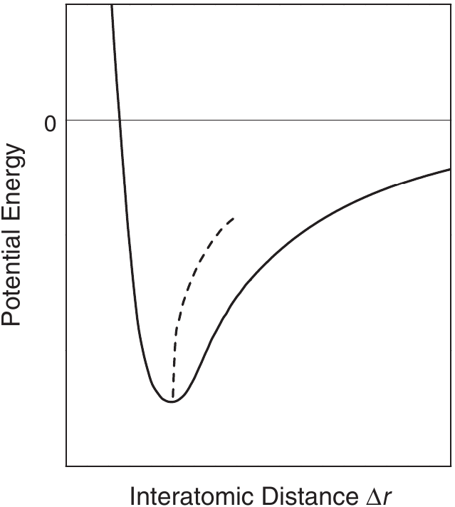

Figure 1.1. Potential energy (solid line) for a typical chemical bond as a function of interatomic distance ▲r . The dashed line represents the average interatomic distance.

The energy of interaction of atoms, Fig. 1.15B, consists of attraction (negative) and repulsive (positive) components. When the distance between interacting particles changes, these components change in different ways. The repulsive force acts at a very short distance, because their potential energy very quickly decreases with the distance between particles r as r ⁻ ⁸ - r ⁻ ¹² (the nature of this force is such that the electron shells of neighboring atoms or ions can only slightly penetrate each other) ...
Conversely, the forces of attraction act at a fairly large distance, since their energy varies with the interatomic distance approximately as r ⁻ ¹-r ⁻ ⁶, depending on the nature of the attraction (i.e., on the type of atomic bonds: ionic, covalent, or mixing of molecules) …

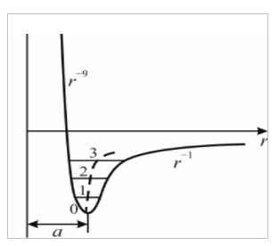
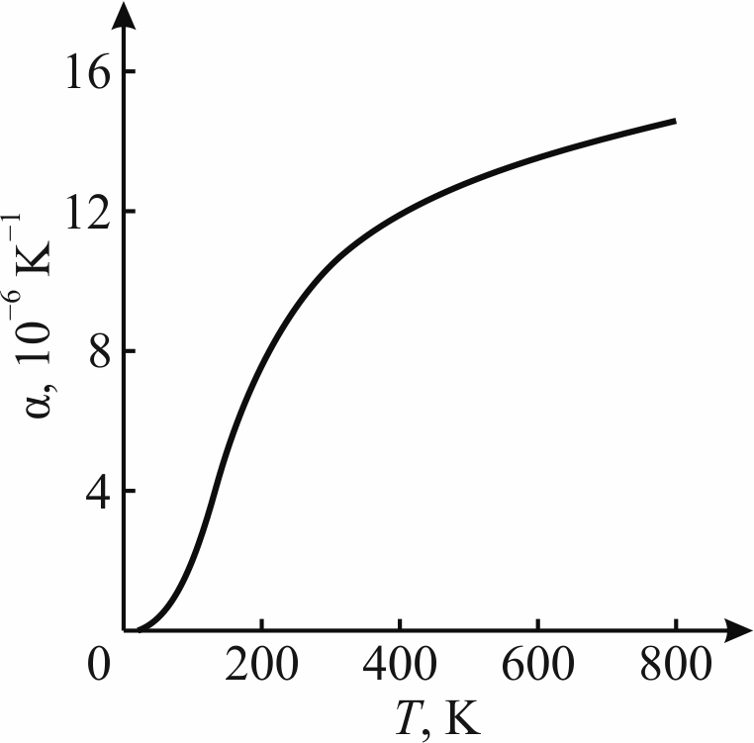

А В

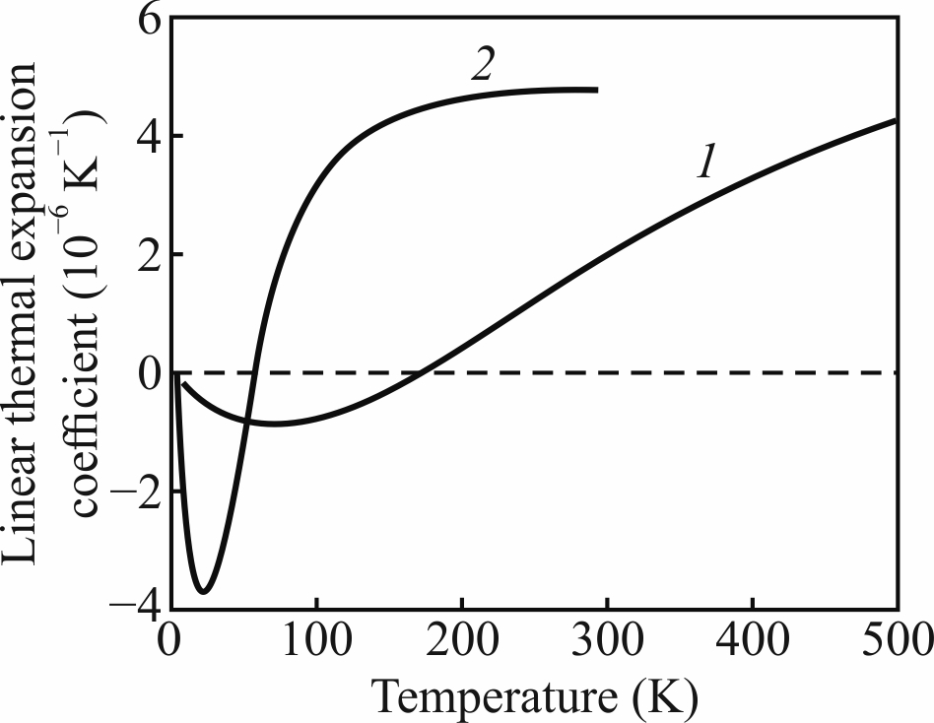

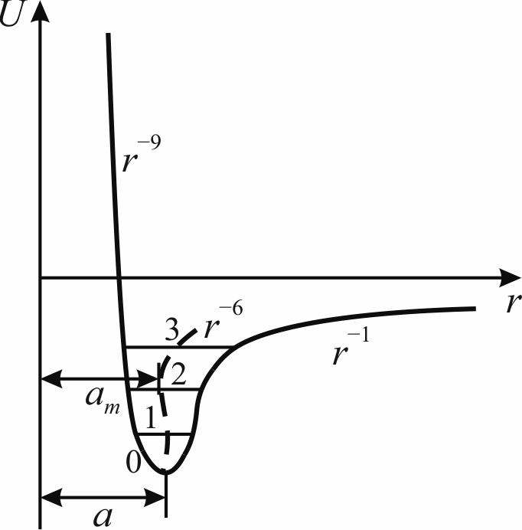
С В

Fig. 1.15. Thermal expansion in different crystals: A – typical temperature dependence of expansion coefficient with example MgO; B – typical thermal expansion approximate explanation: increase in amplitude of ions oscillations as temperature rise shown by horizontals 0-1-2-3 leads to the gradual increase of lattice constant a shown by dotted line (in fact, roughly shown situation develops only in the narrow interval of interatomic distance r, very deep near the bottom of energy minimum); C – thermal expansion in the polar crystals with examples ZnO (1) and HgTe (2); D –symbolic explanation of negative thermal expansion; in fact, shown situation develops deeply, near the very bottom of energy minimum.Е

At the lowest temperature, the bottom of the potential well can be approximated by a symmetric parabola, so that when the temperature changes near absolute zero, there is no noticeable change in the crystal size: r = a. This explains why the coefficient of thermal expansion for completely different solids tends to zero in the region of absolute zero, Fig. 1.15A [3]. However, as mentioned earlier, with an increase in the amplitude of thermal vibrations, the average distance between atoms (shown by the dotted line) increases: this is the obvious reason for thermal expansion. The different energy levels are shown in Fig. 1.15B [3] horizontal lines 1-2-3: how much the amplitude of thermal fluctuations increases, starting from zero; in this case, the displacement of the vibrating atoms to the left becomes less than their displacement to the right. As a result, the time-averaged equilibrium position of the atom (a + x), shown by the dashed line in Fig. 1.15B [3], is shifted to the right, and this effect is stronger, the higher the vibrational energy of the atom. In this reasoning, a special moment is the concept of the time-averaged displacement of vibrating atoms <x>, which actually determines the temperature dependence of the expansion coefficient. According to this description, the physical meaning of the coefficient of thermal expansion *) can be described as
the reciprocal of the slope of the curve, which expresses the dependence of the binding energy on the interatomic distance (a + x) at the point corresponding to the time-average position of the atom: dU (a + x) / d (a + x) ~ 1 / α.

Negative Thermal expansion

Thermal expansion is a fundamental property of solids.
However, although rare, some materials shrink when heated under constant pressure. These are materials with negative thermal expansion (NTE). In fact, NTE cannot be explained by the normal circuit described above and is the subject of research in itself. This is also of great practical importance, since it allows djustment of the thermal expansion of the material up to some specific value, usually zero, by forming composites. Typical low expansion material is Fe-36Ni Invar[9], which in physics is closely related to magnetic metals.

Applications
Some materials which undergo NTE have a range of potential engineering, photonic, electronic, and structural applications. For example, if one were to mix a negative thermal expansion material with material which expands on heating (typical, normal materials), it is possible to use it as a thermal expansion compensator what might allow for forming composites with tailored or even close to zero thermal expansion. Combining a material with positive heat expansion and a material with negative heat expansion can allow to regulate the thermal expansion of composites or even to obtain compositions with warm expansion close to zero, ie with increasing body temperature will not change its size. The change in the object will not occur because the negative and positive thermal expansion will compensate for the other to some extent when the temperature changes. Adjusting the total coefficient of thermal expansion (CTE) to certain values can be achieved by changing the volume fractions of different materials involved in the thermal expansion of the composition.

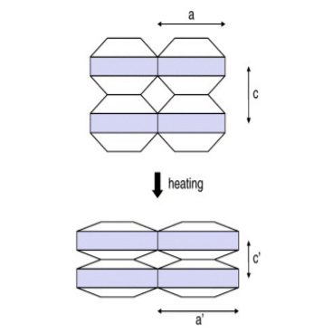

Fig. 1. Schematic of anisotropic thermal expansion in the silicates. As the shaded layers undergo thermal expansion, they are pulled closer together in the direction perpendicular to the layers, which causes significant thermal contraction in this direction.

A practically important group of negativeor low-expansion materials is formed by differ2 ent materials (silicates) of various kinds such as LiAlSiO4 (β-eucryptite) 6 , Li2Al2SinO4+2n (βspodumenes) 4 and Mg2Al4Si5O18 (cordierite) 2 . Such silicates are sometimes distinguished from other NTE materials having flexible bonds 5 . Here, they are grouped together, emphasizing their common features that non-expansive covalent bonds and thermally excited lattice deformation consuming open spaces play an essential role in NTE. These material contain twodimensional sheets composed of ionic bonds such as Li–O and Mg–O; the sheets are connected by strong covalent bonds such as Al–O and Si–O. Because the ionic bonds lengthen with increasing temperature, expansion occurs in two dimensions within the sheets. Due to the rigidity of the covalent bonds, the sheets are forcibly pulled closer together, as shown schematically in Fig.2. Consequently, significant NTE appears in one direction to the perpendicular to thermal-expansive sheets (Fig.1). Although volume thermal expansion can be either positive or negative in this mechanism, many materials show net negative (although not large) volume thermal expansion. Large anisotropy in the thermal expansion restricts the practical use of these materials. For example, their performance as thermal-expansion compensators depends strongly on their morphology.

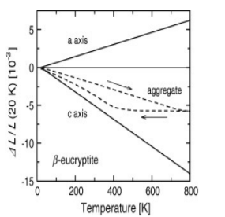

Fig. 2. Axial and aggregate thermal expansion of β-eucryptite 6 .

Materials with near-zero CTE, i.e. constant characteristics over a large temperature range, are most widely used in precision instruments, since any change in one or another parameter leads to errors and undesirable deviations. But also in everyday life, materials with a CTE close to zero are required. Vitrified ceramic cooktops, such as Ceran cooktops, have to withstand high temperature gradients and rapid temperature changes during cooking, as only certain parts of the cooking surface get hot, while other parts remain close to ambient temperature. Generally, due to their brittleness, temperature gradients in glass can lead to cracks. However, the glass ceramic used in hobs consists of several different layers, some of which have positive and others negative thermal expansion. The expansion of the different phases compensates each other and the volume of the ceramic does not change much with temperature and cracking is avoided.Materials with near-zero CTE, i.e. constant characteristics over a large temperature range, are most widely used in precision instruments, since any change in one or another parameter leads to errors and undesirable deviations. But also in everyday life, materials with a CTE close to zero are required. Vitrified ceramic cooktops, such as Ceran cooktops, have to withstand high temperature gradients and rapid temperature changes during cooking, as only certain parts of the cooking surface get hot, while other parts remain close to ambient temperature. Generally, due to their brittleness, temperature gradients in glass can lead to cracks. However, the glass ceramic used in hobs consists of several different layers, some of which have positive and others negative thermal expansion.

The expansion of the different phases compensates each other and the volume of the ceramic does not change much with temperature and cracking is avoided. In everyday life, an example of the need for materials with controlled thermal expansion is dental fillings. If the fillings have a tendency to expand by an amount different from the expansion of the teeth, e.g. when drinking hot or cold, this can cause toothache, which can be very uncomfortable. However, if dental restorations are made of composite material containing a mixture of materials with positive and negative thermal expansion, the overall expansion can be exactly matched to the expansion of the tooth enamel.

Conclusions
...

References

- Chu C N, Saka N. and Suh N P. Mater. Sci. Eng. 1987;95:303. doi: 10.1016/0025- 5416(87)90523-4.
- Milberg M E. and Blair H D. J. Am. Ceram. Soc. 1977;60:372. doi: 10.1111/jace.1977.60.issue-7-8.
- Yu. M. Poplavko. Polar bonds self-ordering and negative thermal expansion. Kiev, Ukraine, 2021.
- Ostertag W, Fischer G R. and Williams J P. J. Am. Ceram. Soc. 1968;51:651. doi: 10.1111/jace.1968.51.issue-11.
- Sleight A W. Inorg. Chem. 1998;37:2854. doi: 10.1021/ic980253h.
- Gillery F H. and Bush E A. J. Am. Ceram. Soc. 1959;42:175. doi: 10.1111/jace.1959.42.issue-4.
- Dove, Martin T; Fang, Hong (2016-06-01). "Negative thermal expansion and associated anomalous physical properties: review of the lattice dynamics theoretical foundation".
- Sayetat F, Fertey P and Kessler M 1998 J. Appl. Cryst. 31 121
- Koshi Takenaka (2012) Negative thermal expansion materials: technological key for control of thermal expansion, Science and Technology of Advanced Materials, 13:1, 013001, DOI: 10.1088/1468-6996/13/1/013001

