Wireframe Mockup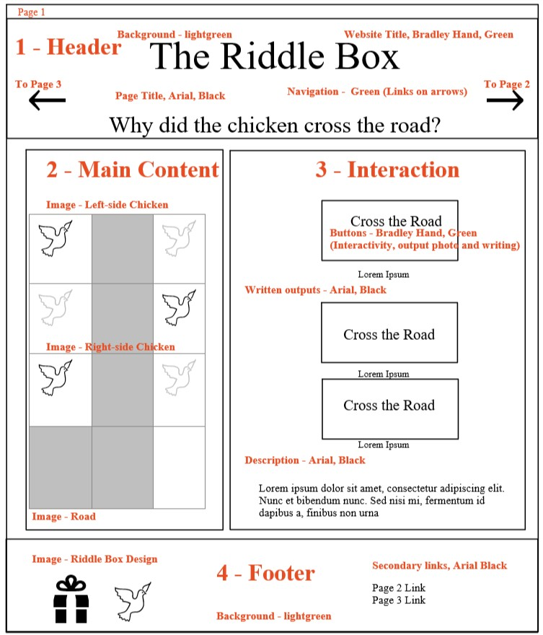

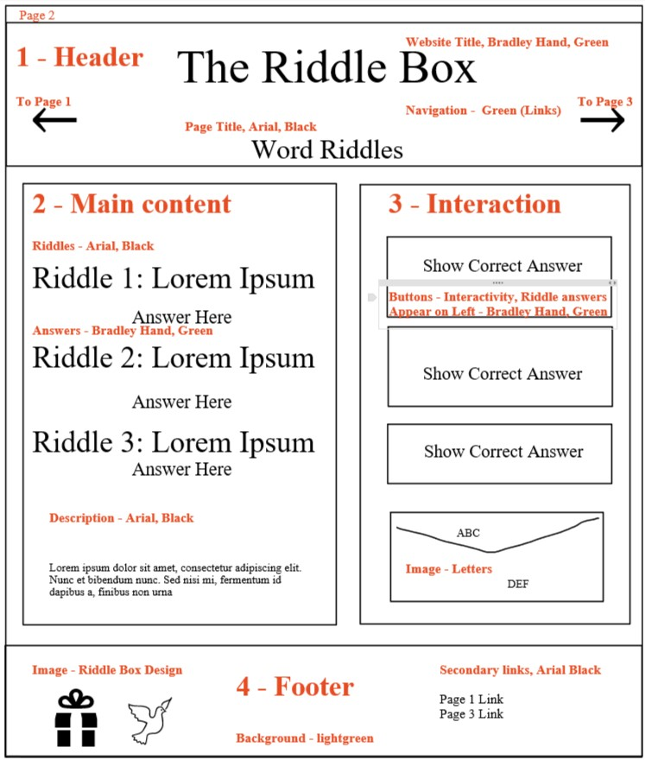

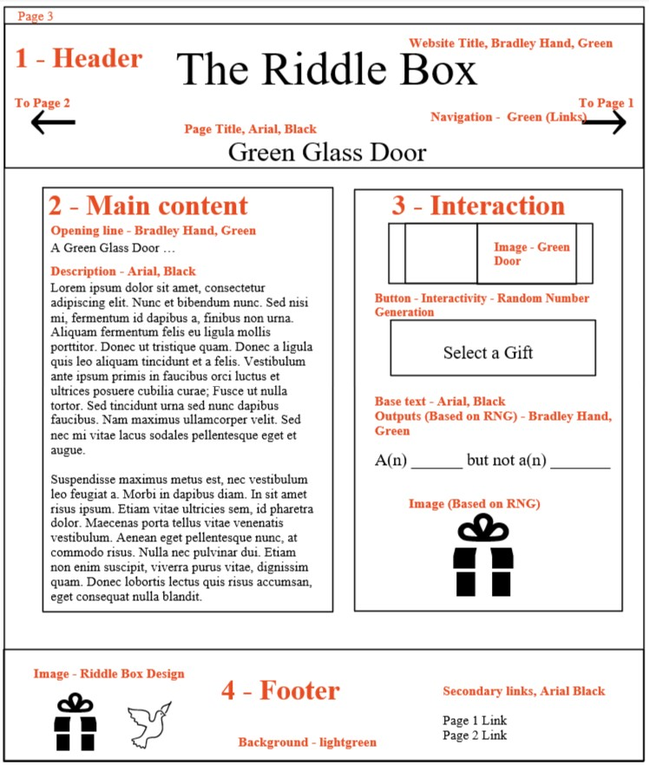

Site Design Explanation

In designing this site, creating cohesive, user-friendly and well-organized webpages was a priority. I chose to implement a monochromatic colour scheme, so that there would be a sense of unity within individual webpages and across the website as a whole. Specifically, I used shades of green throughout the website. Green is a vibrant and energetic colour, so it aligns well with the feelings of lightheartedness and fun which I hoped to impart through the site content.

While selecting and applying the colours for my webpages, I wanted to ensure that I maintained contrast between elements so that the monochromatic scheme improved the user experience rather than hindering it. It was important for every piece of content information to be distinct from the other information on the page as well as from the background. To achieve this, I used a mix of light and dark shades of green. Dark greens were primarily used for important elements, such as the website title, outputs, and interactive buttons, and I selected lighter greens for background elements. Then, to add balance to the website colours, I interspersed medium shades of green into the images. I sourced the images from Canva and intentionally selected clipart rather than photos, so that I could modify each individual colour and ensure that it was cohesive with the website. To maximize the contrast within the webpages, I then opted to use simple black text for larger sections of writing instead of using green for these content pieces. I believe this will improve the user experience by reducing eye strain and making the site more compatible with electronic screen readers.

To further unify the website, I looked for opportunities to use repetition in my work. Each webpage utilizes a similar structure, with identical headers and footers apart from the specific links referenced. While the body of each website contains different content, repetition is also present there – with general content primarily positioned on the left-hand side of the webpages and more interactive elements positioned on the right-hand side. This ties together the website, giving users a general understanding of what to expect as they navigate through the pages. For individual pages, meanwhile, I combined repetition of elements with layout choices, grouping similar items together to further achieve that sense of unity. For example, images on the first page are vertically stacked such that elements within an image line up with those of previous and subsequent images, and the second page has questions, buttons, and outputs visually grouped together according to the riddle they pertain to.

The omission of certain elements further contributed to the organization of the website. I wanted to avoid overcluttering the web pages, so I considered ways to represent each riddle without unnecessarily increasing the amount of content on the website. This was best accomplished on the third page. Rather than including all ten photos on the page at once, I decided to only display one at a time. This enabled me to better space out the existing content, improving the site layout, and it also made it easier to discern which content was changing with the webpage interactivity.