**RTL EXERCISE #2**

**LEAST FREQUENTLY USED ALGORITHM**

**Supporter: Nguyen Dinh Minh Nhat**

**Trainee: Tran Hong An**

**ID: 1792**

# REVISIONS

|  |  |  |  |  |  |
| --- | --- | --- | --- | --- | --- |
| Version | Modification | | | Author | Review by |
| Page | Details | Reason |
| 00.01 14/10/2016 | ― | New creation | ― | An Tran |  |
| 00.02 23/10/2016 | 2, 3, 6-16 | Edit the revisions and content. Add the Block diagrams and detail design. Add the timing chart and test cases. | ― | An Tran |  |
|  |  |  |  |  |  |
|  |  |  |  |  |  |
|  |  |  |  |  |  |
|  |  |  |  |  |  |
|  |  |  |  |  |  |

# CONTENTS

REVISIONS 2

CONTENTS 3

LIST OF FIGURES 3

LIST OF TABLES 3

1. SYSTEM DESCRIPTION 4

2. ARCHITECHTURE 6

3. BLOCK DIAGRAM 7

4. DETAIL DESIGN 8

4.1. find_min_buf 8

4.2. control_access_time 9

5. TIMING CHART DIAGRAM 11

6. TEST CASES 15

# LIST OF FIGURES

Figure 1. Basic operation of buffers 4

Figure 2. LFU management table 5

Figure 3. Block diagram of architecture 6

Figure 4. Block diagram of lfu_finder module 7

Figure 5. Block diagram of find_min_buf block 8

Figure 6. Block diagram of control_access_time block 9

Figure 7. Timing chart when rst_n is ACTIVE 11

Figure 8. Timing chart when rst_n and num_buf_req is off 12

Figure 9. Timing chart when rst_n is off and the new_buf_req is active 13

Figure 10. Timing chart when a buffer's access time = 2'b11 and all buffers’ access time = 2'b11 14

# LIST OF TABLES

Table 1. IF table of architecture 6

Table 1. IF Table of top module 7

Table 3. IF Table of the find_min_buf block 8

Table 2. IF Table of the control_access_time block 9

# SYSTEM DESCRIPTION

Create a module that finds out the Least Frequently Used entry in the four entries specified below.

The target data are accessible only through data buffers named: #0 buffer, #1 buffer, #2 buffer, and #3 buffer. The following figure shows that data a1 using #1 buffer, a3 using #2 buffer, a6 using #0 buffer, and a9 using #3 buffer. Now, if data a2 is requested, one of the buffers must be replaced for a2. To select the buffer to be replaced for the new request, apply LFU strategy.

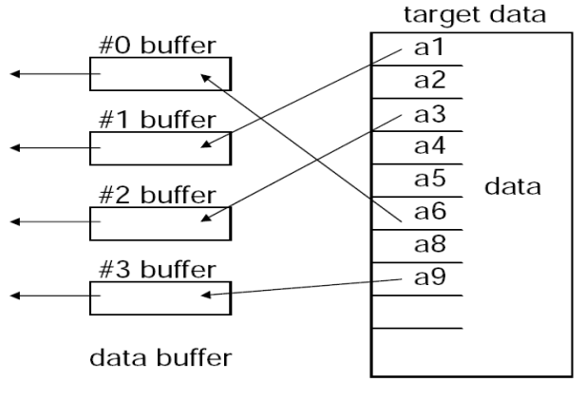

Figure 1. Basic operation of buffers

* Objective: Suppose the target data are randomly accessed, create a module which can output the buffer number to be replaced based on LFU algorithm.

The following figure shows the LFU management rule. If ref_buf_numbr =2 means that data in cache #2 buffer is referenced. If buf_num_replc = 1 means cache #1 buffer shall be replaced (saved back to external memory and shall be filled in with new data).

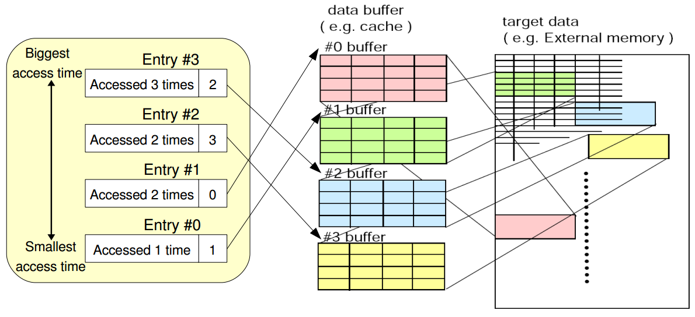

Figure 2. LFU management table

In case where two or more buffers have the same minimum access time, the default replacement order is #0 -> #1 -> #2 -> #3. That means the buffer with lowest ID is replaced first. The access time of newly filled buffer is 1.

# ARCHITECHTURE

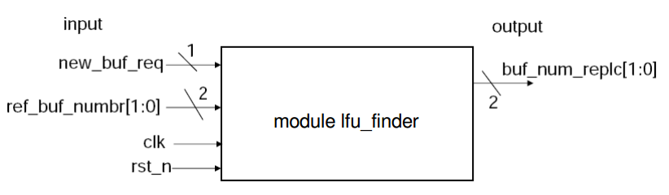

Figure 3. Block diagram of architecture

Table 1. IF table of architecture

|  |  |  |  |  |
| --- | --- | --- | --- | --- |
| **No.** | **Port** | **I/O** | **Mode** | **Description** |
| 1 | clk | I | Rising edge | Clock signal |
| 2 | rst_n | I | Falling edge | Reset signal |
| 3 | new_buf_req | I | Data | 0 if no need to replace a buffer. 1 if a buffer must be replaced. |
| 4 | ref_buf_numbr[1:0] | I | Data | The number of the buffer accessed. This signal is valid only when new_buf_req = 0. |
| 5 | buf_num_replc[1:0] | O | Data | The number of the buffer to be replaced. This signal is valid only during a clock cycle right after new_buf_req is set to 1. |

Note 1: The buffer defined by this signal must be treated to be accessed 1 time.

Note 2: After reset, the access time of buffers shall be reset to 1 and the buf_num_replc will be reset to 2’b00.

Note 3: In actual usage, the LFU algorithm is only applicable after all entries are filled up.

# BLOCK DIAGRAM

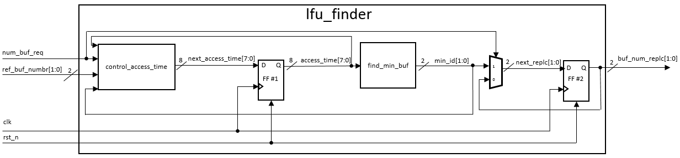

Figure 4. Block diagram of lfu_finder module

Table 2. IF Table of top module

|  |  |  |  |  |
| --- | --- | --- | --- | --- |
| **No.** | **Port** | **I/O** | **Mode** | **Description** |
| 1 | clk | I | Rising edge | Clock signal |
| 2 | rst_n | I | Active low | Reset signal |
| 3 | new_buf_req | I | Control signal | 0 if no need to replace a buffer. 1 if a buffer must be replaced. |
| 4 | ref_buf_numbr[1:0] | I | Data | The number of the buffer accessed. This signal is valid only when new_buf_req = 0. |
| 5 | buf_num_replc[1:0] | O | Data | The number of the buffer to be replaced. This signal is valid only during a clock cycle right after new_buf_req is set to 1. |
| 6 | next_access_time[7:0] | - | Data | The next cycle access time. |
| 7 | access_time[7:0] | - | Data | The current access time. |
| 8 | min_id[1:0] | - | Data | The id of the buffer which has the minimum access time. |
| 9 | next_replc[1:0] | - | Data | The next cycle buf_num_replc. |

Description

* The control_access_time block uses 4 inputs “min_buf_req”, “ref_buf_numbr”, “access_time” and “min_id” to provide the next_access_time.
* The find_min_buf block is used to provide the buffer with minimum access time or the lowest order buffer if there are 2 or more buffer having the same number of access time.
* The mux is used to select the “min_id” buffer for the “buf_num_replc” when there is a request for new buffer or keep the same value.
* The FF #1 is used to return the access_time value to calculate for the next_access_time. When reset is active, the access_time = 8’b01010101.
* The FF #2 is used to return the current buf_num_replc to keep this value for the next cycle if the new_buf_req is not 0.

# DETAIL DESIGN

* 1. **find_min_buf**
  2. **control_access_time**

## 4.1. find_min_buf

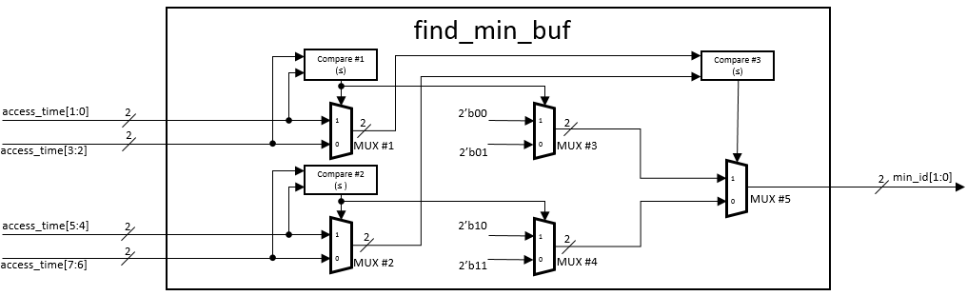

Figure 5. Block diagram of find_min_buf block

Table 3. IF Table of the find_min_buf block

|  |  |  |  |  |
| --- | --- | --- | --- | --- |
| **No.** | **Port** | **I/O** | **Mode** | **Description** |
| 1 | access_time[7:0] | I | Data | Each 2 bit represent the number of access time for each buffer. access_time[1:0] for buffer #0, access_time[3:2] for buffer #1; access_time[5:4] for buffer #2 and access_time[7:6] for buffer #3. |
| 2 | min_id[1:0] | O | Data | The id of the buffer which has the minimum access time. |

Description:

* The Compare #1 is used to find the smaller access time between buffer #0 and buffer #1. Its output is used to control MUX #1 and MUX #3. The same for the Compare #2, MUX #2 and MUX #4.
* The Compare #3 is used to find the smaller access time between MUX #1 and MUX #2. The output is used to control the MUX #5.
* The output MUX #1 and MUX #2 is the smaller access time between the buffer #0 and #1, #2 and #3 respectively.
* The output MUX #3 and MUX #4 is the id of the buffer having smaller access time between the buffer #0 and #1, #2 and #3 respectively.
* The output MUX #5 is the id of the buffer having minimum access time.

## 4.2. control_access_time

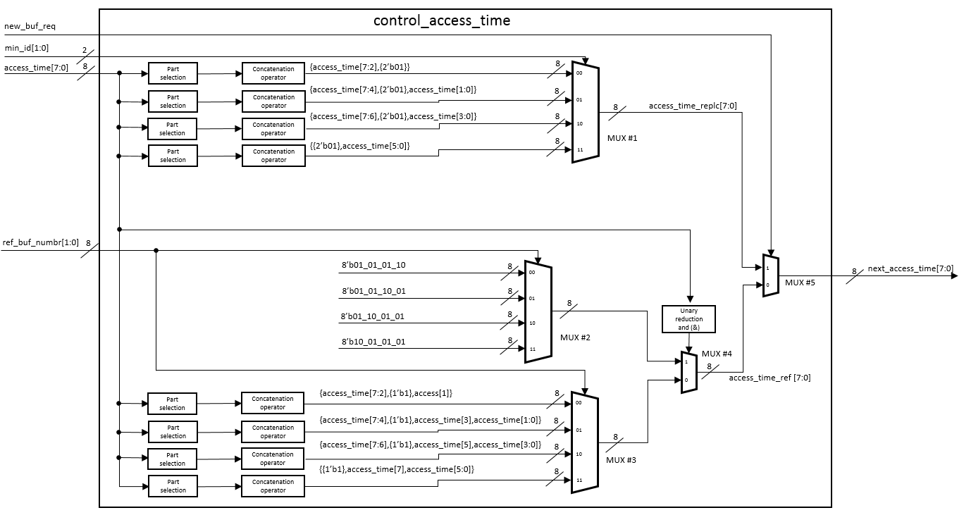

Figure 6. Block diagram of control_access_time block

Table 4. IF Table of the control_access_time block

|  |  |  |  |  |
| --- | --- | --- | --- | --- |
| **No.** | **Port** | **I/O** | **Mode** | **Description** |
| 1 | new_buf_req | I | Control signal | 0 if no need to replace a buffer. 1 if a buffer must be replaced. |
| 2 | min_id[1:0] | I | Data | The id of the buffer which has the minimum access time. |
| 3 | access_time[7:0] | I | Data | Each 2 bit represent the number of access time for each buffer. access_time[1:0] for buffer #0, access_time[3:2] for buffer #1; access_time[5:4] for buffer #2 and access_time[7:6] for buffer #3. |
| 4 | ref_buf_numbr[1:0] | I | Data | The number of the buffer accessed. This signal is valid only when new_buf_req = 0. |
| 5 | next_access_time[7:0] | O | Data | The next cycle value of access_time |
| 6 | access_time_replc[7:0] | - | Data | Access time when a buffer is requested |
| 7 | access_time_ref[7:0] | - | Data | Access time when a buffer is referenced and new_buf_req = 0. |

Description

* The Mux #1‘s output is the access_time in case of the new_buf_req = 1. The requested buffer’s access time is set to 2’b01 while the others do not change.
* The Mux #2’s output is the access_time in case of the access time of 4 buffers is all 2’b11 and a buffer is referenced.
* The Mux #3’s output is the access_time in case of the access time of 4 buffers is not all 2’b11 and a buffer is referenced.
* The “Unary reduction and (&)” is used to AND 8 bit of the access_time. If the access_time = 8’hff, the output will be 1’b1 or 1’b0 for other cases. The output is used to choose between access_time from Mux #2 and Mux #3.
* The Mux #5 is used to choose between the access time when the new_buf_req is 1 or 0.

# TIMING CHART DIAGRAM

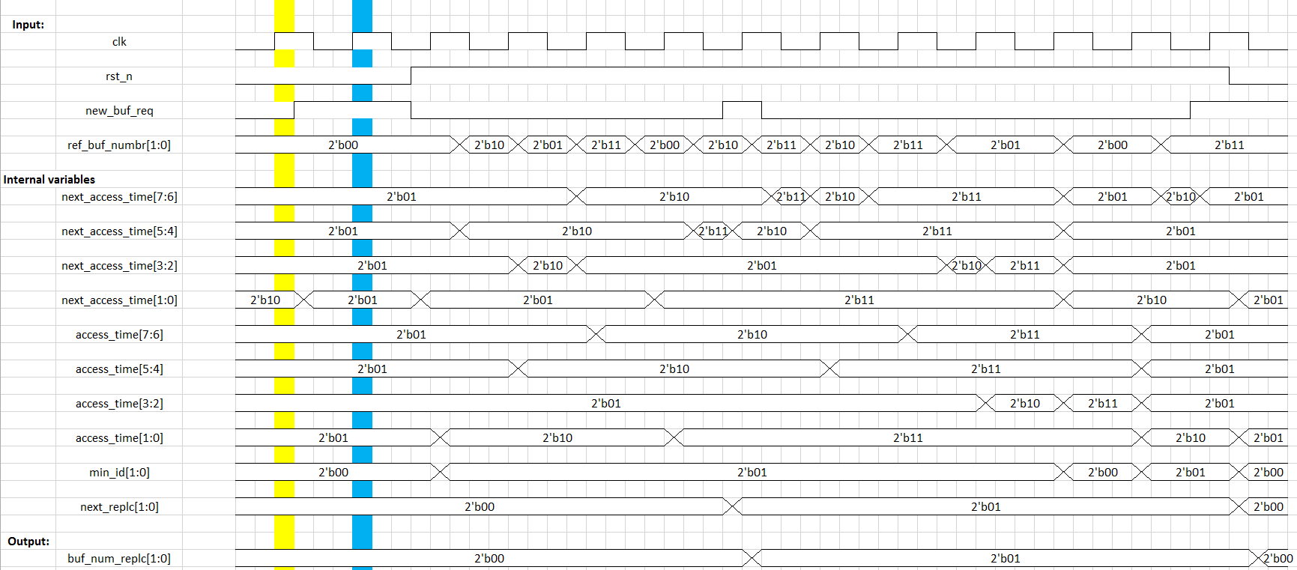

Figure 7. Timing chart when rst_n is ACTIVE

Yellow line:

* rst_n is ACTIVE ( = 0) 🡺Initial values: access_time = 8’b01010101, buf_num_replc = 2’b00.
* next_access_time = 2’b01010110 but the acces_time won’t change the value (rst_n is active).

Blue line:

* rst_n is ACTIVE ( = 0) 🡺 Initial values: access_time = 8’b01010101, buf_num_replc = 2’b00.
* buf_num_req = 1 🡺 buf_num_replc = 2’b00 (not change) and next_access_time = 8’h55.

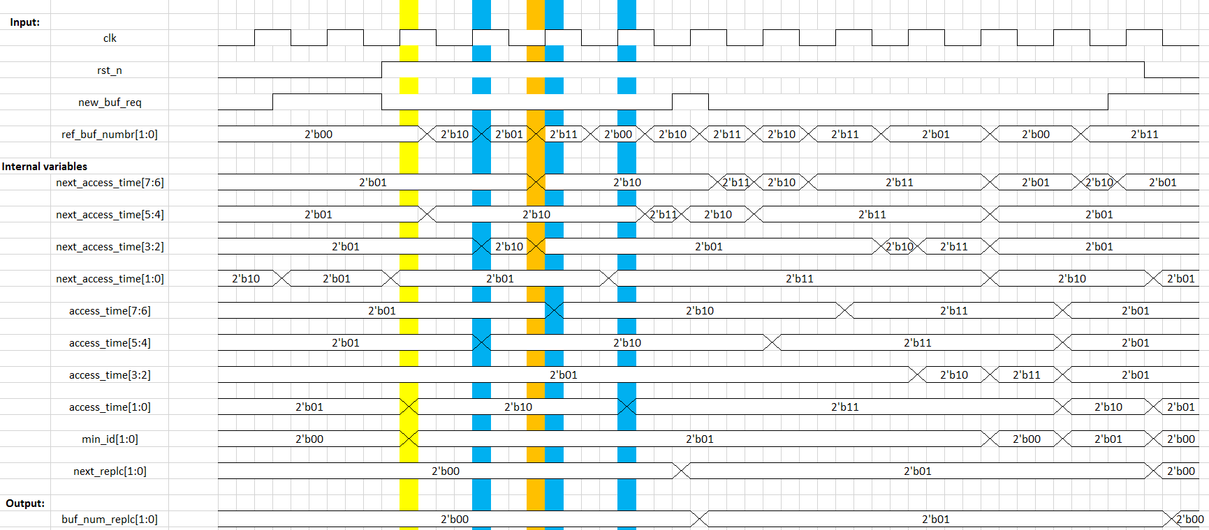

Figure 8. Timing chart when rst_n and num_buf_req is off

Yellow line:

* next_accesss_time increased based on the ref_buf_numbr.
  + ref_buf_numbr = 2’b00 🡺next_access_time[1:0] = 2’b10.
* access_time get the value of next_access_time (8’b01010110).
* The min_id changed according to the change of access_time (from 2’b00 to 2’b01)

Blue lines:

* next_access_time changed according to the ref_buf_numbr.
* access_time get the values of next_access_time

Orange line:

* ref_buf_numbr change value after the clock rise and before the next clock rise.
* The next_access_time[3:2] change to 2’b01 (from 2’b10) since the access_time[3:2] = 2’b01.
* Only the change of next_access_time[7:6] effect the access_time

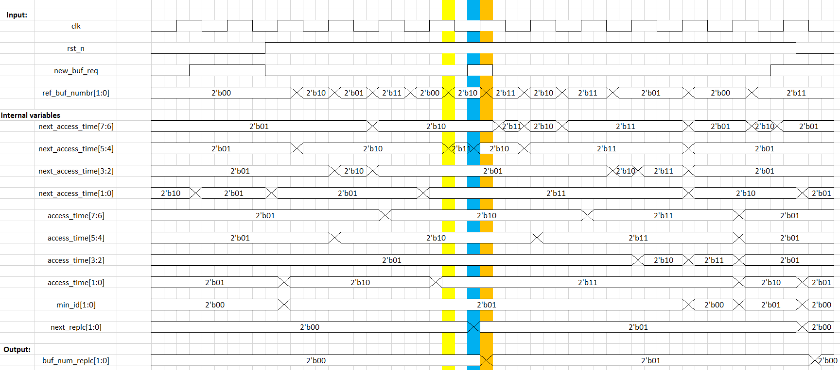

Figure 9. Timing chart when rst_n is off and the new_buf_req is active

Yellow line:

* next_accesss_time increased based on the ref_buf_numbr.

Blue line:

* new_buf_req is active🡺the next_access_time forget the above increment and change according to the min_id.
  + min_id = 2’b01 🡺the next_access_time[3:2] = 2’b01, other bit keep the same value of the access_time.
* next_replc changed according to the min_id.

Orange line:

* buf_num_replc change according to next_replc (from 2’b00 to 2’b01)

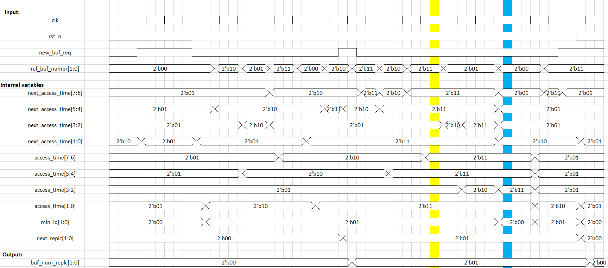

Figure 10. Timing chart when a buffer's access time = 2'b11 and all buffers’ access time = 2'b11

Yellow line:

* access_time[7:6] = 2’b11, ref_buf_numbr = 2’b11 🡺next_access_time[7:6] keep its value (2’b11).

Blue line:

* access_time = 8’hff, ref_buf_numbr = 2’b00 🡺next_access_time = 6’b01010110
* min_id = 2’b00 when access_time = 8’hff.

# TEST CASES

|  |  |  |
| --- | --- | --- |
| **No.** | **Test items** | **Expected** |
| * **When rst_n is active, change value of new_buf_req:** | | |
| 1 | rst_n = 1'b0 new_buf_req = 1'b0 ref_buf_numbr = 2'bxx | access_time = 8'h55 buf_num_replc = 2'b00 |
| 2 | rst_n = 1'b0 new_buf_req = 1'b1 ref_buf_numbr = 2'bxx | access_time = 8'h55 buf_num_replc = 2'b00 |
| * **When rst_n is off and new_buf_req is on:** | | |
| 3 | rst_n = 1'b1 new_buf_req = 1'b1 ref_buf_numbr = 2'b00 | access_time = 8'h55 buf_num_replc = 2'b00 |
| * **When new_buf_req is off. Operating normally:** | | |
| 4 | rst_n = 1'b1 new_buf_req = 1'b0 ref_buf_numbr = 2'b00 | access_time = 8'h56 buf_num_replc = 2'b00 |
| 5 | rst_n = 1'b1 new_buf_req = 1'b0 ref_buf_numbr = 2'b00 | access_time = 8'h57 buf_num_replc = 2'b00 |
| 6 | rst_n = 1'b1 new_buf_req = 1'b0 ref_buf_numbr = 2'b01 | access_time = 8'h5B buf_num_replc = 2'b00 |
| 7 | rst_n = 1'b1 new_buf_req = 1'b0 ref_buf_numbr = 2'b01 | access_time = 8'h5F buf_num_replc = 2'b00 |
| 8 | rst_n = 1'b1 new_buf_req = 1'b0 ref_buf_numbr = 2'b10 | access_time = 8'h6F buf_num_replc = 2'b00 |
| 9 | rst_n = 1'b1 new_buf_req = 1'b0 ref_buf_numbr = 2'b11 | access_time = 8'hAF buf_num_replc = 2'b00 |
| * **When access_time is not 8’hff and new_buf_req is on:** | | |
| 10 | rst_n = 1'b1 new_buf_req = 1'b1 ref_buf_numbr = 2'b11 | access_time = 8'h9F buf_num_replc = 2'b10 |
| * **When new_buf_req is off, increase the access_time to 8’hff** | | |
| 11 | rst_n = 1'b1 new_buf_req = 1'b0 ref_buf_numbr = 2'b11 | access_time = 8'hDF buf_num_replc = 2'b10 |
| 12 | rst_n = 1'b1 new_buf_req = 1'b0 ref_buf_numbr = 2'b11 | access_time = 8'hDF buf_num_replc = 2'b10 |
| 13 | rst_n = 1'b1 new_buf_req = 1'b0 ref_buf_numbr = 2'b10 | access_time = 8'hEF buf_num_replc = 2'b10 |
| 14 | rst_n = 1'b1 new_buf_req = 1'b0 ref_buf_numbr = 2'b10 | access_time = 8'hFF buf_num_replc = 2'b10 |
| * **When access_time = 8’hff and new_buf_req is on:** | | |
| 15 | rst_n = 1'b1 new_buf_req = 1'b1 ref_buf_numbr = 2'b10 | access_time = 8'hFD buf_num_replc = 2'b00 |
| * **When the new_buf_req is off. Check the access_time increment when a buffer’s access time is 2’b11 and referenced.** | | |
| 16 | rst_n = 1'b1 new_buf_req = 1'b0 ref_buf_numbr = 2'b01 | access_time = 8'hFD buf_num_replc = 2'b00 |
| * **When the new_buf_req is off. Check the access_time increment when all four buffers’ access time are 2’b11 and referenced.** | | |
| 17 | rst_n = 1'b1 new_buf_req = 1'b0 ref_buf_numbr = 2'b00 | access_time = 8'hFE buf_num_replc = 2'b00 |
| 18 | rst_n = 1'b1 new_buf_req = 1'b0 ref_buf_numbr = 2'b00 | access_time = 8'hFF buf_num_replc = 2'b00 |
| 19 | rst_n = 1'b1 new_buf_req = 1'b0 ref_buf_numbr = 2'b00 | access_time = 8'h56 buf_num_replc = 2'b00 |