AnVIL 101
October 02, 2026
Table of Contents

About this Book
Welcome to AnVIL 101! This book is part of a collection of resources for the Genomic Data Science Analysis, Visualization, and Informatics Lab-space (AnVIL) of the National Human Genome Research Institute (NHGRI). Learn more about AnVIL by visiting https://anvilproject.org or reading the article in Cell Genomics.
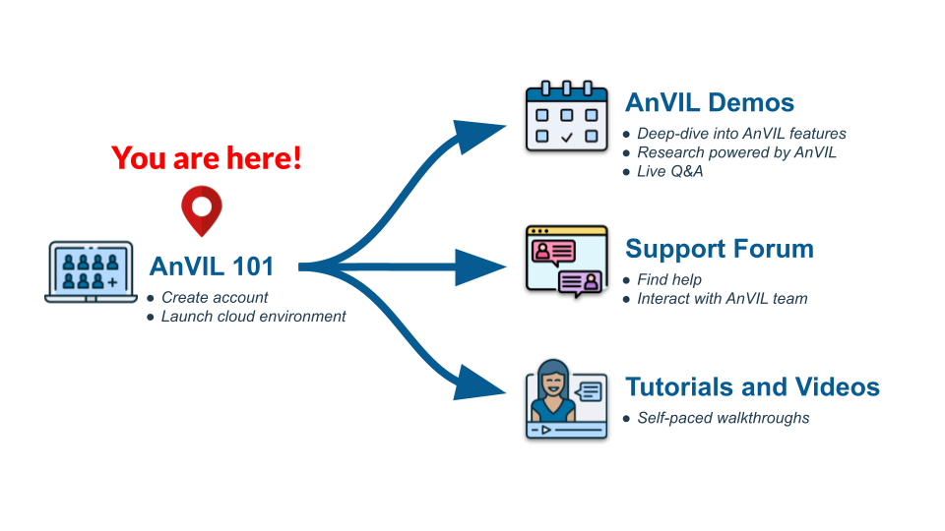
This book is a companion to the virtual AnVIL101 workshop, containing a walkthrough of the material. You can work through this book on your own, or you can:
- Join us for an upcoming workshop
- Watch a recording of a past workshop

Who is AnVIL 101 for?
AnVIL 101 gives a brief tour of the AnVIL ecosystem and walks through the basics of setting up a compute environment on AnVIL. If you have never used AnVIL before, this is a great place to start!
If you have previously set up your AnVIL account and started up an interactive computing environment (Jupyter, RStudio, or Galaxy), then you may be more interested in other materials, such as our monthly virtual AnVIL Demos which dive deeper into how people use AnVIL for research. Check out the AnVIL Training website to learn more about other training opportunities.
This book walks you through the basics of using AnVIL, which requires you to have an active Billing Project to pay for the computing resources that you use. If you join us for a live AnVIL 101 virtual workshop, we will take care of the Billing Project for you.
The beginning chapters, which give an overview of AnVIL, can be done without an AnVIL account or Billing Project.

Skills Level
Genetics
Novice: no genetics knowledge needed
Programming skills
Novice: no programming experience needed

AnVIL Training
Please check out training.anvilproject.org for additional learning opportunities and related resources.

1 Student Guide

1.1 Activity One
Many of the AnVIL books that are designed for teaching a class or workshop contain information aimed at the instructor.
You might want to create a “student guide” that contains a different subset of Rmd files from your book, or renders to a different output format (e.g. word document). You can specify the output and Rmd files that will be used for the student guide using the _output.yml and _bookdown.yml files in the student-guide directory.
By default, repositories based on AnVIL_Template create a docx file containing this chapter as an example. Once you have adjusted student-guide/bookdown.yml to include the chapters you want in your student guide, you can link to it by replacing {repo-name} in the following URL:
https://github.com/jhudsl/{repo-name}/raw/main/student-guide/docs/Student_Guide.docx
When someone clicks this link, they will download the docx file. For example, here is the link for the student guide from AnVIL_Template:
https://github.com/jhudsl/AnVIL_Template/raw/main/student-guide/docs/Student_Guide.docx

1.2 Activity Two
Steps of the guide could go here.

About the Authors
These credits are based on our course contributors table guidelines.

Credits | Names
Pedagogy
Lead Content Instructor(s) | FirstName LastName
Lecturer(s) (include chapter name/link in parentheses if only for specific chapters) - make new line if more than one chapter involved | Delivered the course in some way - video or audio
Content Author(s) (include chapter name/link in parentheses if only for specific chapters) - make new line if more than one chapter involved | If any other authors besides lead instructor
Content Contributor(s) (include section name/link in parentheses) - make new line if more than one section involved | Wrote less than a chapter AnVIL instructions: Katherine Cox, Ava Hoffman, Elizabeth Humphries
Content Editor(s)/Reviewer(s) | Checked your content
Content Director(s) | Helped guide the content direction
Content Consultants (include chapter name/link in parentheses or word “General”) - make new line if more than one chapter involved | Gave high level advice on content AnVIL instructions: Allie Cliffe
Acknowledgments | Gave small assistance to content but not to the level of consulting
Production
Content Publisher(s) | Helped with publishing platform
Content Publishing Reviewer(s) | Reviewed overall content and aesthetics on publishing platform
Technical
Course Publishing Engineer(s) | Helped with the code for the technical aspects related to the specific course generation
Template Publishing Engineers | Candace Savonen, Carrie Wright
Publishing Maintenance Engineer | Candace Savonen
Technical Publishing Stylists | Carrie Wright, Candace Savonen
Package Developers (ottrpal) | John Muschelli, Candace Savonen, Carrie Wright
Art and Design
Illustrator(s) | Created graphics for the course
Figure Artist(s) | Created figures/plots for course
Videographer(s) | Filmed videos
Videography Editor(s) | Edited film
Audiographer(s) | Recorded audio
Audiography Editor(s) | Edited audio recordings
Funding
Funder(s) | Institution/individual who funded course including grant number
Funding Staff | Staff members who help with funding

## ─ Session info ───────────────────────────────────────────────────────────────
## setting value
## version R version 4.3.2 (2023-10-31)
## os Ubuntu 22.04.4 LTS
## system x86_64, linux-gnu
## ui X11
## language (EN)
## collate en_US.UTF-8
## ctype en_US.UTF-8
## tz Etc/UTC
## date 2026-10-02
## pandoc 3.1.1 @ /usr/local/bin/ (via rmarkdown)
##
## ─ Packages ───────────────────────────────────────────────────────────────────
## package * version date (UTC) lib source
## bookdown 0.46 2025-12-05 [1] CRAN (R 4.3.2)
## cachem 1.0.8 2023-05-01 [1] RSPM (R 4.3.0)
## cli 3.6.5 2025-04-23 [1] CRAN (R 4.3.2)
## devtools 2.4.5 2022-10-11 [1] RSPM (R 4.3.0)
## digest 0.6.34 2024-01-11 [1] RSPM (R 4.3.0)
## ellipsis 0.3.2 2021-04-29 [1] RSPM (R 4.3.0)
## evaluate 1.0.5 2025-08-27 [1] CRAN (R 4.3.2)
## fastmap 1.1.1 2023-02-24 [1] RSPM (R 4.3.0)
## fs 1.6.3 2023-07-20 [1] RSPM (R 4.3.0)
## glue 1.7.0 2024-01-09 [1] RSPM (R 4.3.0)
## htmltools 0.5.7 2023-11-03 [1] RSPM (R 4.3.0)
## htmlwidgets 1.6.4 2023-12-06 [1] RSPM (R 4.3.0)
## httpuv 1.6.14 2024-01-26 [1] RSPM (R 4.3.0)
## knitr 1.50 2025-03-16 [1] CRAN (R 4.3.2)
## later 1.3.2 2023-12-06 [1] RSPM (R 4.3.0)
## lifecycle 1.0.4 2023-11-07 [1] RSPM (R 4.3.0)
## magrittr 2.0.3 2022-03-30 [1] RSPM (R 4.3.0)
## memoise 2.0.1 2021-11-26 [1] RSPM (R 4.3.0)
## mime 0.12 2021-09-28 [1] RSPM (R 4.3.0)
## miniUI 0.1.1.1 2018-05-18 [1] RSPM (R 4.3.0)
## pkgbuild 1.4.3 2023-12-10 [1] RSPM (R 4.3.0)
## pkgload 1.4.1 2025-09-23 [1] CRAN (R 4.3.2)
## profvis 0.3.8 2023-05-02 [1] RSPM (R 4.3.0)
## promises 1.2.1 2023-08-10 [1] RSPM (R 4.3.0)
## purrr 1.0.2 2023-08-10 [1] RSPM (R 4.3.0)
## R6 2.6.1 2025-02-15 [1] CRAN (R 4.3.2)
## Rcpp 1.0.12 2024-01-09 [1] RSPM (R 4.3.0)
## remotes 2.4.2.1 2023-07-18 [1] RSPM (R 4.3.0)
## rlang 1.1.6 2025-04-11 [1] CRAN (R 4.3.2)
## rmarkdown 2.25 2023-09-18 [1] RSPM (R 4.3.0)
## sessioninfo 1.2.2 2021-12-06 [1] RSPM (R 4.3.0)
## shiny 1.8.0 2023-11-17 [1] RSPM (R 4.3.0)
## stringi 1.8.3 2023-12-11 [1] RSPM (R 4.3.0)
## stringr 1.5.1 2023-11-14 [1] RSPM (R 4.3.0)
## urlchecker 1.0.1 2021-11-30 [1] RSPM (R 4.3.0)
## usethis 2.2.3 2024-02-19 [1] RSPM (R 4.3.0)
## vctrs 0.6.5 2023-12-01 [1] RSPM (R 4.3.0)
## xfun 0.55 2025-12-16 [1] CRAN (R 4.3.2)
## xtable 1.8-4 2019-04-21 [1] RSPM (R 4.3.0)
## yaml 2.3.12 2025-12-10 [1] CRAN (R 4.3.2)
##
## [1] /usr/local/lib/R/site-library
## [2] /usr/local/lib/R/library
##
## ──────────────────────────────────────────────────────────────────────────────

2 References

