Git URL: https://github.com/NigDra/Workshop1

Git Concepts

**Creating a local repository**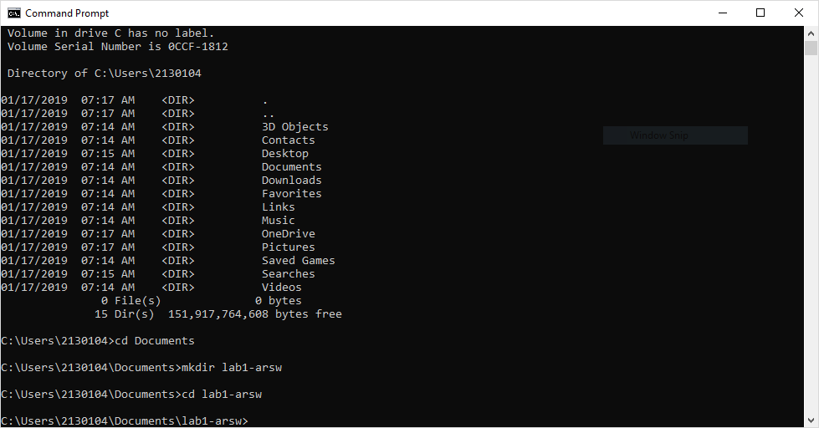

**Let's code**

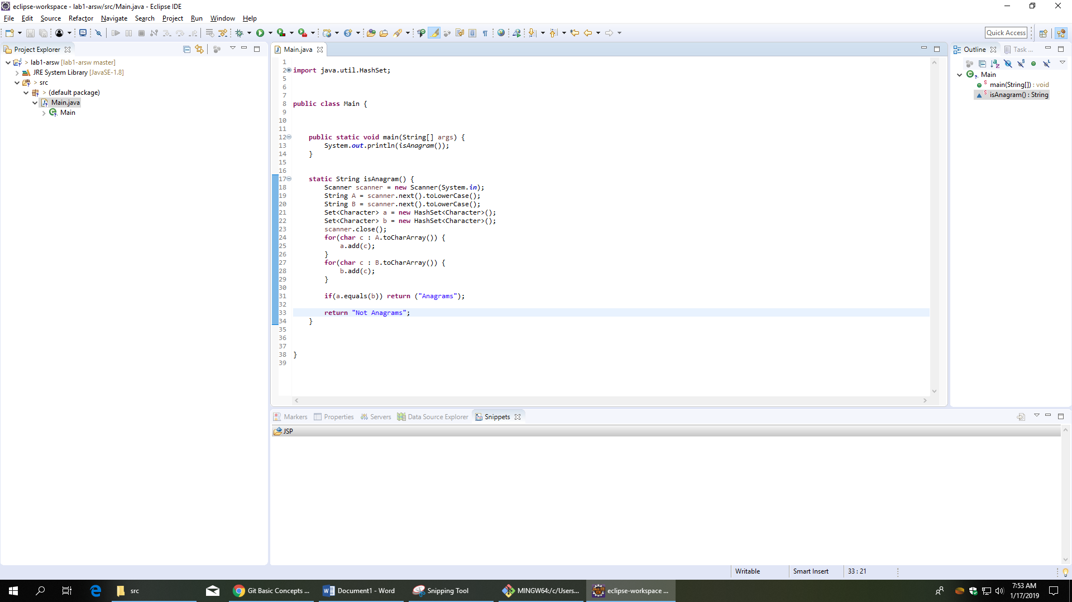

**Preserving our changes**

Use the following command

git add .

Answer: What is the purpose of this command?

It’s used to create a newer version of the repository in the local machine with the new changes made.

Use the command line to type the command showed below

git commit -m "Message"

Answer : Why we used it?

For when the git repository is updated, this version has this message shown where the changes were made.

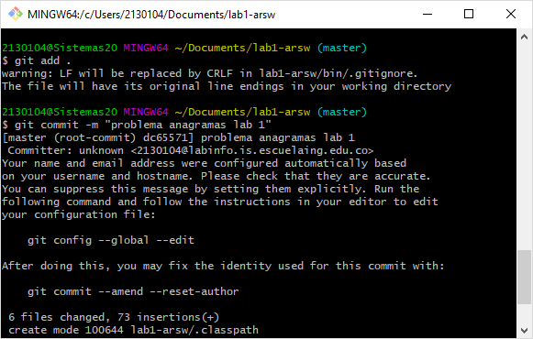

## Using Github

## Go to [github](https://github.com/)​

Create a new repository on github and name it workshop1

Copy the url of your remote repository, in order to link it with our local repository that was created previously

Use the following command to link the remote repository with the local one.

git remote add origin <server>

## Using the push command

Using the command line, type the command below

git push origin master

Answer: What is the purpose of the this command?

Is for updating the online repository with the changes made in the local and that were registered with the git add .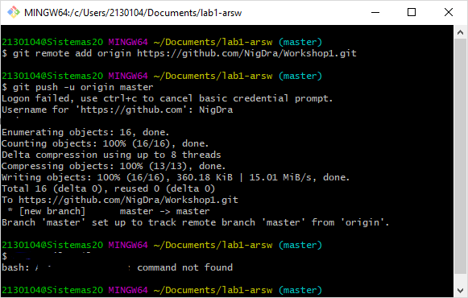

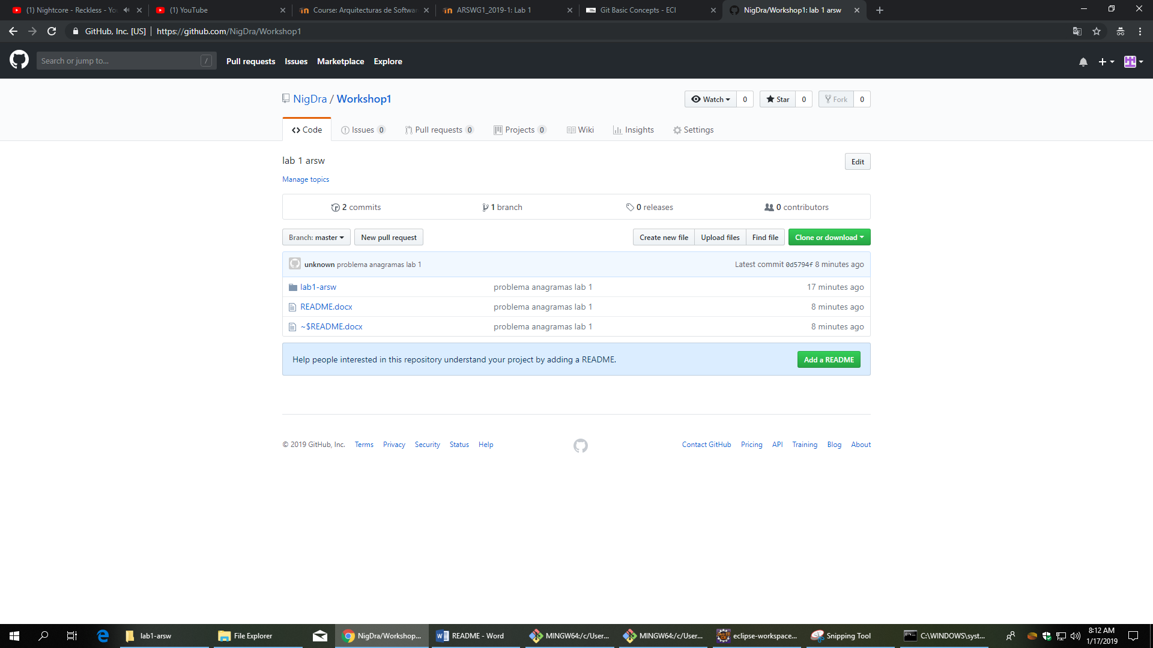

## Let's code

​

The challenge here is to read n lines of input until you reach EOF, then number and print all lines of content.

**Hint:** Java's Scanner.hasNext() method is helpful for this problem.

**Input Format**

Read some unknown n lines of input from stdin(System.in) until you reach EOF; each line of input contains a non-empty String.

**Output Format**

For each line, print the line number, followed by a single space, and then the line content received as input.

**Sample Input**

Hello world

I am a file

Read me until end-of-file.

**Sample Output**

1 Hello world

2 I am a file

3 Read me until end-of-file.

taken from <https://www.hackerrank.com/challenges/java-end-of-file/problem>​

Preserve the changes using your partner's github account.

Take a screenshot of the commit report in the github account and include it in the report

## 

## Using pull command

Use the first github account to type this command

git pull origin master

Answer: What that command does?

It downloads the latest version of the repository in git

Include the report on github repository using the commands you have learned

Maven concepts

## Tasks

* Create a new maven project using the command mvn archetype:generate -B -DgroupId=edu.eci -DartifactId=file-spy, take screenshots.
* What do means the -B option in the command?
* What do means the -D option in the command?
* What do means the groupId, artifactId properties in the command?
* Describe the content of the directory that has been created.
* Create the folders src/main/resources` and `src/test/resources

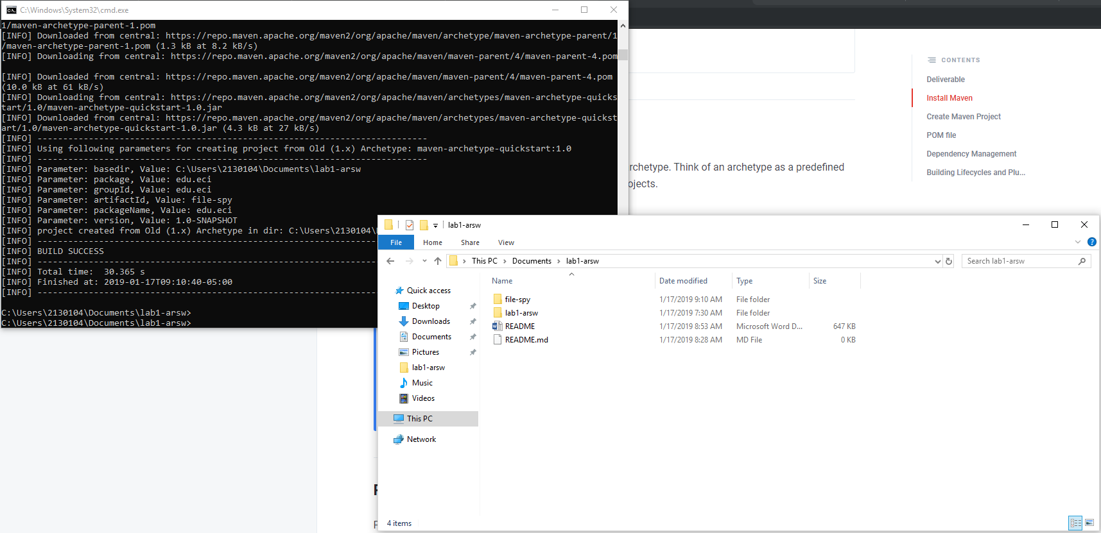

# Building Lifecycles and Plugins

Maven is based on the idea of a build lifecycle which refers to the process of assembling and distributing an artifact like a JAR file. Maven ships with three lifecycles and you can think of them in terms of distributing an application.

Now within lifecycle, there are phases. For examples, some of the phases that make up the default build lifecycle are the compile, test, package, and install phases.

## Task:

* The three principal Maven lifecycles are clean, default and site. Describe each one.
  + Clean: remove all files generated by the previous build
  + Default: validate that the project is correct and all necessary information is available then runs the project.
  + Site: generate all the project documentation.
* Using the terminal execute the command mvn compile. Take the output screenshot. What is this command using for? What are transitive dependencies?

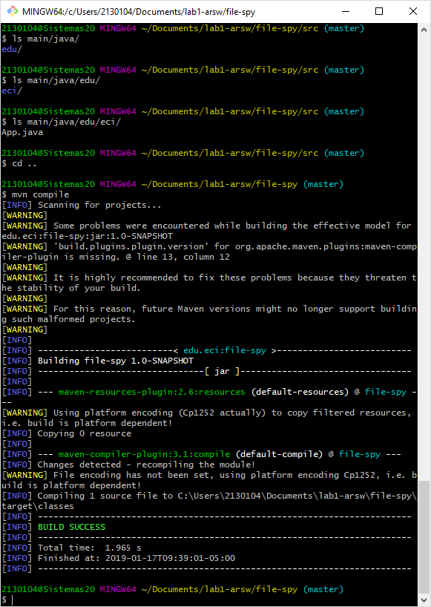

This command is used to compile the project and check that everything is ok.

* Using the terminal execute the command mvn package. Take the output screenshot. What is this command using for?

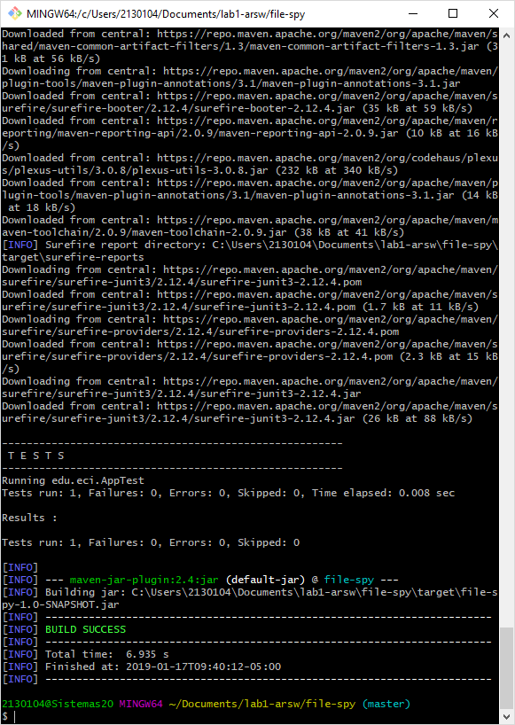

This commands compacts the project in in a distributed format, such as JAR files.

* Using the terminal execute the command mvn install. Take the output screenshot. What is this command using for?
* 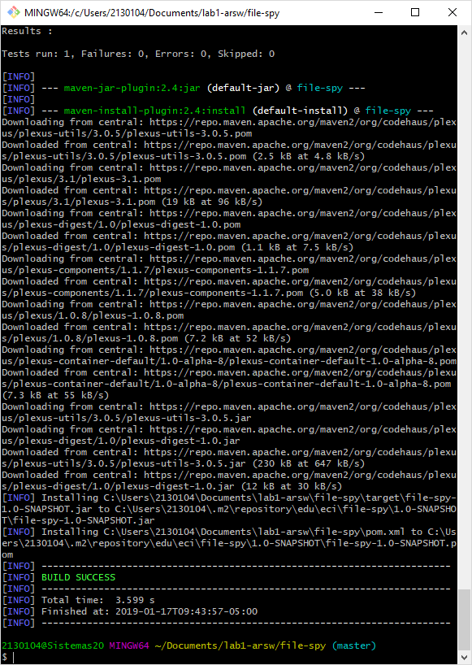

This command is used to “install” the project in the local machine so other projects can use it.

* Generate a new maven project in other folder using the maven command line tools, this project should has as groupId "edu.eci" and as artifactId "another-maven-project". Take the output screenshot.

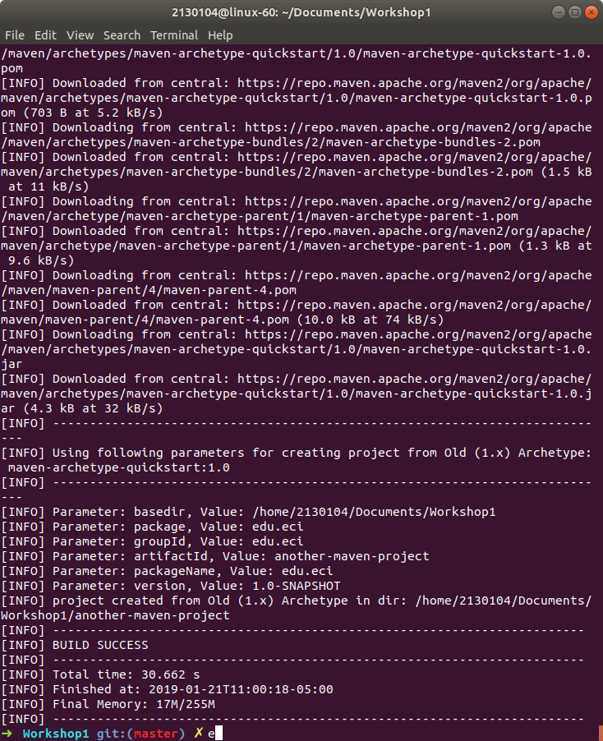

Replace the code of the App.java class with the following code and do all the necessary steps to compile the code.

package edu.eci;

​

import edu.eci.FileSpy;

​

public class App

{

public static void main( String[] args )throws Exception

{

FileSpy.main(args);

}

}

All the commands showed here such as mvn compile, mvn install, mvn package, they all come from plugins. And even if you didn't have to explicitly add a plugin to your pom file, a Maven plugin provides developers a way to attach their own tasks called goals to phases. So we have lifecycles, phases, and goals putting it all together, here's how they're related.

Each Maven builds lifecycle such as the default lifecycle has specific phases associated with it. Think of these phases as categories of tasks that need to be performed. We've talked about some of these already such as compile, test, and package. Now at these phases are like categories of tasks, the actual tasks in Maven are called goals, these goals are provided by plugins. In other words, plugins bind goals to phases. These specific plugins are shipped with Maven but you can also use third party plugins and even develop your own. Speaking of plugins and goals, let's run a goal from the exact plugin short for execute.

## Task:

* Use the following command to execute the file-spy application mvn exec:java -Dexec.mainClass="edu.eci.FileSpy". Take the output screenshot.

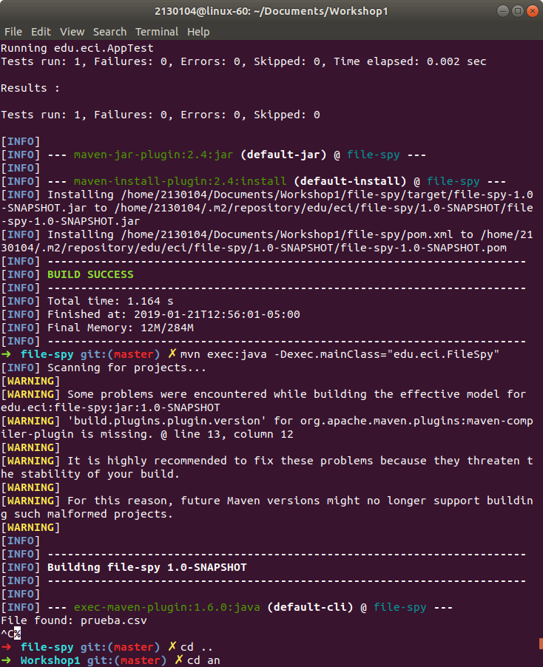

* But this time you should knew that the application detect events in a folder when you add new files and print on the screen all the files with the text/csv extension. Test the application using the examples files. Take the output screenshot.