A Ground-Low-Altitude Mobility Manager for Service Reconfiguration under Disruptions
An Xu¹, Chengbo Zhang² and Yunfei Yin¹*
¹ School of Transportation Science and Engineering, Harbin Institute of Technology, Harbin 150090, China
² Department of Civil Engineering, McGill University, Montreal, QC H3A 0C3, Canada
* Corresponding author: yunfeiyin@hit.edu.cn
Abstract. Low-altitude transport can bypass a disrupted road, but a faster trip does not always mean better service recovery. An aircraft may already serve another task, and a replacement route may arrive after the deadline. We propose a Ground-Low-Altitude Mobility Manager that links joint ground-air observations to feasible service interventions. A shared candidate interface reports travel time, resource constraints and the incumbent service that each intervention would interrupt. We compare ground-only, air-first, fixed-objective heuristic and large language model policies in SUMO-BlueSky experiments on three urban road networks. Across 10,960 primary runs, the value of air support depends on surviving alternatives and the time available to use them. In Suzhou, the heuristic and language model both reduce missed emergency deadlines from 33.33% to 16.67%, but leave 0.058 and 0.133 damaged incumbent services per run. Under air failures, all affected coordinated runs establish a replacement path, yet many still finish late. Sparse observations and delayed execution can also exhaust the service margin. These findings support selective air deployment guided by deadline needs and existing service commitments, rather than emergency travel time alone.
Keywords: Transport Resilience · Ground-Air Coordination · Service Reconfiguration · Disruption Management

1 Introduction
A road disruption can leave an urgent medical delivery with a usable route but too little time to reach its destination. An aircraft offers another route, yet assigning it may interrupt a service already in progress. The transport question is therefore not simply whether air is faster. It is when air support protects a deadline, what other service it displaces, and whether the intervention can still be executed in time.
Transport resilience concerns the loss and recovery of system performance [1]. Multimodal recovery can pool replacement resources, as in Resilience as a Service [2]. Dynamic routing revises assignments as conditions change [3], while truck-drone planning coordinates ground and air movements [4]. Recent work also considers uncertain truck travel times and soft time windows [5]. These studies show why resource availability and synchronization matter. Our focus is the service decision after a disruption, when air resources may themselves fail and existing commitments must be reconsidered.
Language models provide one possible supervisor. SayCan connects language choices to executable capabilities [6], and LLMLight studies language-based traffic signal control [7]. However, access to information does not ensure that a model uses it effectively [8]. A transport comparison must therefore separate the benefit of adding an air alternative from the benefit of the policy that selects it.
We develop a Ground-Low-Altitude Mobility Manager with a common interface for feasible interventions and a separate execution check. The study asks three questions: when does air support reduce missed deadlines; how much incumbent service does it displace; and when do observation or execution delays remove the benefit? Its contribution is a service-management framework and evidence on these trade-offs. The comparison includes a transparent heuristic, so improvements over ground-only operation are not attributed automatically to the language model.

2 Managing Disrupted Services
The Manager observes the road network, aircraft, landing sites, missions and active disturbances in one study area. Each mission has a release time, deadline, priority and permitted transport modes. Each aircraft has a role, assignment, position, endurance and commandability state. Decisions are triggered by new or interrupted missions, with additional 30 s polling while services need attention. Figure 1 shows the decision cycle.
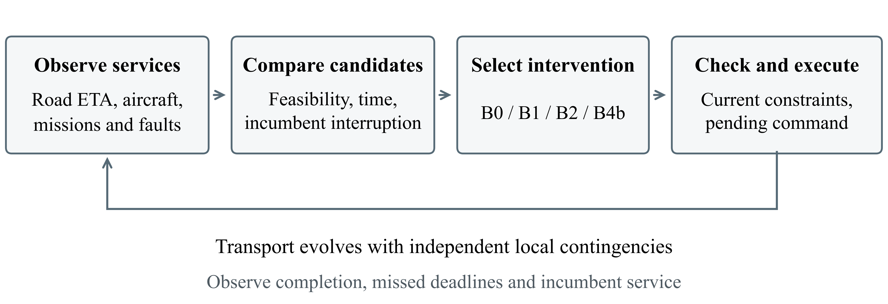
Fig. 1. The Manager links shared service facts to policy selection and execution. A replacement must remain feasible when issued; transport completion is observed separately.

2.1 Feasible Interventions and Remaining Time
A deterministic generator lists compatible air and ground candidates. For each, it gives the estimated remaining duration, feasibility or rejection reason, endurance information and any incumbent service to be interrupted. Reassignment requires a reassignable incumbent with strictly lower priority. Command-link loss, unavailable landing sites and modeled operating restrictions can exclude air candidates. Ground fallback is available when the mission permits it and a corridor travel-time estimate exists.
For a mission m with deadline $d_{m}$, candidate c has estimated remaining duration ${η̂}_{c}$ at decision time t. With an execution wait $δ$, its estimated service margin is
$σ_{m}(c,t) = d_{m} − t − δ − {η̂}_{c}$ (1)
A negative margin means the candidate is not predicted to meet the deadline. A nonnegative margin is not a guarantee because travel times are approximate and conditions may change. The executor checks the selected action against the current state before issuing it. An identical pending command keeps its original due time; a changed command replaces it. Local aircraft contingencies operate independently. Thus, selecting a feasible route, issuing a replacement and completing the service are distinct events.

2.2 Policies under a Common Service Contract
B0 uses ground fallback for the target emergency; background air services remain. B1 selects the feasible air candidate with the shortest estimated duration and uses ground only if no air candidate remains. B2 compares both modes using a fixed score for duration, lateness, preemption and low endurance. B4b uses a large language model to choose from the shared candidate information. All policies use the same feasibility and execution rules.
B2 first selects an actionable mission by priority, then minimizes
$\begin{aligned}J(c) = {η̂}_{c} + 10 max(0, t + {η̂}_{c} − d_{m}) \\ + I_{p}(κ + 30) + 10ρ\end{aligned}$ (2)
Here $I_{p}$ indicates preemption and $κ$ is 20, 40, 80 or 100,000 for a LOW, NORMAL, HIGH or CRITICAL incumbent. The endurance penalty $ρ$ counts whether the remaining margin falls below 120 s and 60 s. Ground has neither penalty. The fixed weights express seconds-equivalent service preferences; B2 is a one-step heuristic, not a network-wide optimum.
B4b uses the archived deepseek-v4-pro backend identifier, temperature 0, JSON output and an 8,192-token output limit. Its candidate table contains no B2 score or recommended choice. An additional policy, B4a, removes the explicit candidate section but retains raw assignments, priorities, positions and ground ETA. This ablation tests derived information support, not formatting alone. Recorded backend errors and retries remain in the analyzed cohort.

3 Experimental Design
SUMO [9] supplies ground traffic estimates and BlueSky [10] simulates aircraft motion. OpenStreetMap networks [11] represent approximately 3.2 km × 3.2 km areas in Suzhou (A), Amsterdam (B) and Edmonton (C). A has a meshed urban network. B has a dense network but a barrier-constrained reference corridor. C has more dead ends and higher sampled route circuity. Facilities, air services and disturbances are modeled. Each site has two medical UAVs, one logistics UAV and one passenger eVTOL, with role-based compatibility.
Ground fallback uses a SUMO corridor ETA timer rather than a separately dispatched road vehicle. The model does not track payload custody or physical transfers between carriers. Inference wall-clock time does not advance the transport simulation. These choices allow controlled comparisons of supervisory service decisions, but they limit claims about physical deployment.
Table 1 summarizes the experiment panels. E1 releases a blood-transport mission at 300 s, with a 180 s CRITICAL or 300 s HIGH service window. E2 gives the primary mission a 180 s window and tests command-link loss, navigation degradation, traffic-management degradation, landing closure, unknown-aircraft intrusion and flyaway. Fault times are adapted to each site's flight phase. E3 combines failures and competing emergencies; its levels change both disturbance and demand. E4 separately varies observation intervals, execution waiting and inert input records.
Table 1. Experiment design. Primary cells use 20 matched seeds.
Panel | Main variation | Sites | Primary runs
E1 | Road disruption, urgency, workload | A–C | 2,880
E2 | 16 failure/context combinations | A–C | 3,840
E3 | 12 compound service scenarios | A–C | 2,880
E4A | Observation interval: 10–300 s | A | 400
E4B | Execution wait: 0–60 s | A | 560
E4C | Aircraft records: 5–50; active: 4 | A | 400
Total: 10,960 primary runs, plus 180 B4a ablation runs (six E1 scenarios per site, ten seeds).
Policies are paired by scenario and seed (20240601–20240620). Seed blocks retain dependence across the fixed scenario panel. We report mean differences and 95% t intervals over 20 seed aggregates; the E1 ablation uses ten seeds. Continuous tests use paired seed aggregates, with a signed-rank fallback for constant nonzero differences. Binary tests swap policy labels for whole seed blocks. Holm adjustment retains the original comparison families [12]. Intervals describe initialization uncertainty within these panels, not uncertainty over all urban disruptions.
A service is late if it completes after its deadline; completion exactly at the deadline is timely. Incumbent damage counts non-primary missions left interrupted, needing replanning, cancelled or failed at the horizon. It is a final-state count, not physical damage or total interruption duration. E2 restoration is conditional on an air chain actually being affected; deadline rates use all runs. E3 weights late or unresolved services by priority. A late CRITICAL mission costs 240 configured loss units and a late HIGH mission costs 135. These are fixed penalties, not monetary values or charges per second. All 4,320 E3 task instances due by the horizon had completed.

4 Results

4.1 Air Support Reduces Lateness but Can Displace Service
Selective air support improves emergency outcomes in E1 (Fig. 2). At A, B2 and B4b halve missed deadlines from 33.33% under B0 to 16.67%. Their mean completion times are close: 147.62 and 146.63 s. Their incumbent consequences differ more: B2 leaves 0.058 damaged services per run, compared with 0.133 for B4b and 0.500 for air-first B1. Emergency speed alone therefore gives an incomplete ranking of the policies.
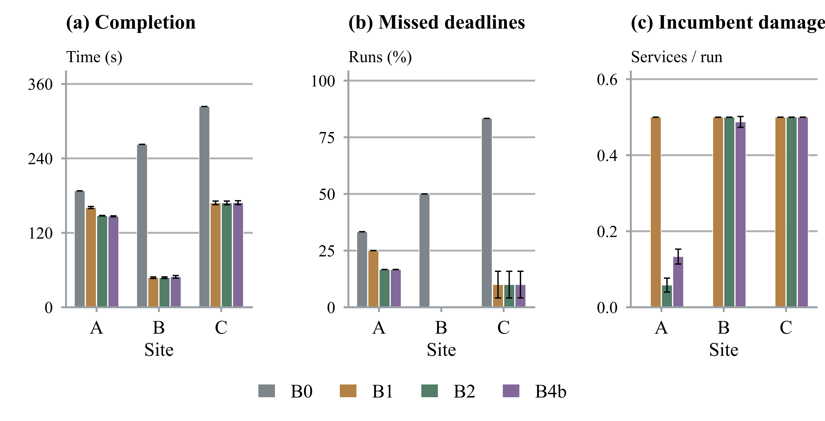
Fig. 2. E1 emergency outcomes and incumbent cost across sites A–C. Each site-policy cell has 240 runs. Error bars show 95% intervals over 20 seed blocks; zero-width intervals indicate no variation in the fixed-panel seed means.
One Suzhou scenario makes the trade-off clear. With high road disruption, HIGH urgency and busy medical aircraft, ground remains timely. B2 keeps the emergency on the road in all 20 runs. B4b preempts an occupied aircraft in 12 and uses ground in eight. Relative to B2, it saves 11.95 s on average (95% CI −17.33 to −6.57 s; adjusted p = 0.0021) but adds 0.600 damaged incumbent services per run. Both policies meet every emergency deadline. The extra speed is obtained by interrupting another service, not by rescuing an otherwise late emergency.
At B and C, the coordinated policies have the same deadline rates: 0% and 10%, compared with B0's 50% and 83.33%. Here, access to a useful alternative explains much of the gain. More complex selection adds little to the observed deadline outcome.
Explicit candidate information also changes choices. At A, B4b improves on B4a by 13.567 s in completion duration (95% CI −15.978 to −11.155) and 0.383 damaged services per run (−0.441 to −0.326). Air intervention falls by 38.333 percentage points; all three differences pass Holm adjustment. No endpoint passes adjustment at B, and all differences are zero at C. The benefit of information support is strongest where the service trade-off leaves room for different choices.

4.2 Restoring a Path Is Not the Same as Meeting a Deadline
In E2, every actually affected coordinated run establishes an executable replacement path. Nevertheless, late completion remains common (Table 2). Under B4b, deadline violations reach 39.06%, 37.50% and 62.81% at A, B and C. Recovery decisions restore access to transport; they do not remove the travel time still needed to finish the service.
Table 2. E2 restoration counts and all-run deadline violations. Each row uses 320 runs. B1 and B2 have identical entries.
Site | Policy | Restored / affected | Late, all runs (%)
A | B0 | N/A | 100.00
A | B1 / B2 | 200 / 200 | 37.50
A | B4b | 191 / 191 | 39.06
B | B0 | N/A | 100.00
B | B1 / B2 | 200 / 200 | 37.50
B | B4b | 199 / 199 | 37.50
C | B0 | N/A | 100.00
C | B1 / B2 | 200 / 200 | 62.50
C | B4b | 201 / 201 | 62.81
At A, B4b takes 4.525 s longer than B2 (95% CI 2.412–6.638; adjusted p = 0.0031). The conditional recovery-time difference does not pass correction. Completion differences at B and C also do not pass correction. Because earlier assignments change fault exposure, conditional recovery denominators differ by policy. B0 has no affected air chain, so its restoration rate is undefined.
The remaining margin is also sensitive to omitted handling time. At B, 80 affected but timely replacements per coordinated policy have only 19 s left. Adding an assumed 30 s transfer delay would make them late. This is an offline sensitivity with recorded trajectories held fixed, not a new closed-loop experiment. It shows why path-restoration rates alone can overstate practical recovery.

4.3 Compound Loss Depends on Surviving Alternatives
In E3, coordinated support reduces aggregate priority-weighted loss. At A, the mean falls from 240 under B0 to 100 under B1/B2 and 102.125 under B4b. At B and C, coordinated policies share means of 127.5 and 227.5, versus 307.5 under B0. Yet the gain is not universal: all policies retain loss 240 in A's L2 panel, and C benefits only in L3. A surviving route helps only if it can protect the relevant service deadline.
B4b does not significantly reduce weighted loss relative to B1 or B2 in the recorded compound comparison families. At A, coordinated policies even take longer on the primary mission on average than B0, while reducing system loss. This apparent tension reflects which priority-weighted services miss their deadlines. The fastest mean primary trip is not necessarily the best system outcome.

4.4 Observation and Execution Consume the Service Margin
In E4, B2 and B4b have identical completion times as observation intervals increase. Their mean duration rises from 140 s at a 10 s interval to 180 s at 60 s, 240 s at 120 s and 482 s at 300 s. All runs are timely through the 60 s arm and late in the two longer arms. Sparse snapshots delay discovery of both the mission and the fault. An event injected after a snapshot is absent even if their timestamps show the same simulation second.
Execution waiting has a related but different effect. At waits of 0–30 s, coordinated completion rises from 120 to 150 s and remains timely. At a 60 s wait, a fault replaces the pending B2/B4b air command with ground fallback, which completes in 302 s. Corrected B0 completes in 242 s because its unchanged pending command keeps its original due time. Thus, the loss comes from command replacement and timing, rather than simply adding 60 s to the original trip.
Adding inert aircraft records increases B4b input from 3,982 to 20,594 tokens per logged call. All 100 runs remain timely and no illegal or nonexistent resource is selected. The active fleet stays at four aircraft, so this result concerns input burden, not large-fleet coordination. Full timing curves, command sequences and input statistics are in the supplement.

5 Implications and Conclusions
The experiments suggest three priorities for disruption management. First, compare air support with the remaining ground deadline margin. When ground remains timely, preemption buys speed at another service's expense. Second, judge recovery by completed services and missed deadlines, alongside restored paths. Third, design observation and execution rules around the time left to act. A useful plan can lose its value before it is issued.
These conclusions apply to the modeled service panels. Road geometry, facility placement, flight distance and fault timing vary together, so the site comparison does not identify a causal effect of morphology. The four-aircraft fleet, ground ETA timer, omitted payload transfer and one recorded language-model configuration limit generalization. Physical deployment and superiority over optimized network-wide dispatch remain untested. Future work should model task-specific road vehicles and carrier transfers, allowing handling delays to change later decisions.
The Manager makes the transport trade-off explicit: feasible air capacity must be matched to deadline need, incumbent commitments and execution timing. In these experiments, selective coordination can halve emergency lateness, but the language model does not consistently outperform the fixed heuristic. The main opportunity is service-aware use of surviving ground-air alternatives before the remaining margin expires.
Supplementary material. Extended figures, tables and 11,140 per-run metric records, with restored code and recovery limits, are available at:
https://github.com/AnXu-ITS/global-llm-mobility-reconfiguration/tree/itsac-restored-20261016/itsac/supplement

References
1. Mattsson, L.-G., Jenelius, E.: Vulnerability and resilience of transport systems—A discussion of recent research. Transportation Research Part A 81, 16–34 (2015). doi:10.1016/j.tra.2015.06.002
2. Jaber, S., Ameli, M., Mahdavi, S.M.H., Bhouri, N.: A methodological framework for Resilience as a Service (RaaS) in multimodal urban transportation networks. Sustainable Cities and Society 124, 106276 (2025). doi:10.1016/j.scs.2025.106276
3. Pillac, V., Gendreau, M., Guéret, C., Medaglia, A.L.: A review of dynamic vehicle routing problems. European Journal of Operational Research 225(1), 1–11 (2013). doi:10.1016/j.ejor.2012.08.015
4. Murray, C.C., Chu, A.G.: The flying sidekick traveling salesman problem: Optimization of drone-assisted parcel delivery. Transportation Research Part C 54, 86–109 (2015). doi:10.1016/j.trc.2015.03.005
5. Meng, S., Li, D., Liu, J., Chen, Y.: The multi-visit drone-assisted routing problem with soft time windows and stochastic truck travel times. Transportation Research Part B 190, 103101 (2024). doi:10.1016/j.trb.2024.103101
6. Ichter, B., et al.: Do As I Can, Not As I Say: Grounding Language in Robotic Affordances. In: Conference on Robot Learning, PMLR 205, pp. 287–318 (2023).
7. Lai, S., Xu, Z., Zhang, W., Liu, H., Xiong, H.: LLMLight: Large Language Models as Traffic Signal Control Agents. arXiv:2312.16044v5 (2024). doi:10.48550/arXiv.2312.16044
8. Liu, N.F., et al.: Lost in the Middle: How Language Models Use Long Contexts. Transactions of the Association for Computational Linguistics 12, 157–173 (2024). doi:10.1162/tacl_a_00638
9. Alvarez Lopez, P., et al.: Microscopic Traffic Simulation using SUMO. In: IEEE International Conference on Intelligent Transportation Systems, pp. 2575–2582 (2018). doi:10.1109/ITSC.2018.8569938
10. Hoekstra, J.M., Ellerbroek, J.: BlueSky ATC Simulator Project: An Open Data and Open Source Approach. In: 7th International Conference on Research in Air Transportation (2016).
11. Haklay, M., Weber, P.: OpenStreetMap: User-Generated Street Maps. IEEE Pervasive Computing 7(4), 12–18 (2008). doi:10.1109/MPRV.2008.80
12. Holm, S.: A Simple Sequentially Rejective Multiple Test Procedure. Scandinavian Journal of Statistics 6(2), 65–70 (1979).

