A Ground-Low-Altitude Mobility Manager for Service Reconfiguration under Disruptions
An Xu and Yunfei Yin*
School of Transportation Science and Engineering, Harbin Institute of Technology, Harbin 150090, China
* Corresponding author: yunfeiyin@hit.edu.cn
Abstract. Ground transport disruptions can prevent time-critical services from meeting deadlines. Low-altitude resources offer alternatives, but reassigning occupied aircraft may interrupt existing commitments. A feasible path or shorter transport duration therefore does not necessarily restore service. We investigate how to select executable recovery options while accounting for deadlines and incumbent services. The Ground-Low-Altitude Mobility Manager combines a shared candidate interface, replaceable supervisory policies and execution-time revalidation. Service-level SUMO–BlueSky simulation compares ground-only, air-first, fixed-objective heuristic and language-model policies across three road networks. Coordination reduces emergency deadline violations in some scenarios, yet faster air options can interrupt incumbent services even when ground transport remains timely. Under air failures, replacement paths can be restored without timely completion. Observation delays, command replacement and execution waiting further consume the remaining service margin. These findings show that effective ground–air recovery depends not only on available alternatives, but also on protecting existing service commitments and executing interventions before their value expires.
Keywords: Transport Resilience · Ground-Air Coordination · Service Reconfiguration · Disruption Management

1 Introduction
A road disruption can make an urgent delivery late even when another route is available. A low-altitude aircraft may offer a faster option, but it may already serve another task. Using it for the emergency can therefore interrupt an existing service. The main question is how to restore urgent deliveries on time while keeping the impact on other services small.
Transport resilience studies how transport systems lose and recover service [1]. Resilience as a Service coordinates multimodal replacement resources and ongoing services [2]. Dynamic routing adjusts routes when conditions change [3], while truck–drone studies focus on routing and synchronization [4,5]. This paper studies a related but different problem: how a supervisor chooses and executes a replacement after a road or air failure. The decision must consider deadlines and current service commitments. We compare simple rules, a fixed heuristic and a language-model supervisor [6,7], including how the supervisor uses candidate information [8].
We develop a Ground-Low-Altitude Mobility Manager for this task. The study makes three contributions: (1) a shared candidate interface with execution-time checks; (2) a comparison of ground-only, air-first, heuristic and language-model policies under common rules; and (3) simulation evidence from three road networks showing how available alternatives, existing services and execution delays affect recovery. We examine when air support is useful, why a replacement path may still arrive late and how the time left to act changes the result.

2 Managing Disrupted Services
The Manager links disruption, feasible alternatives, service-aware selection, executable intervention and outcomes (Fig. 1). Missions define release, deadline, priority and modes; aircraft define assignment, position, endurance and commandability. New or interrupted missions trigger decisions, with 30 s polling while attention is needed.
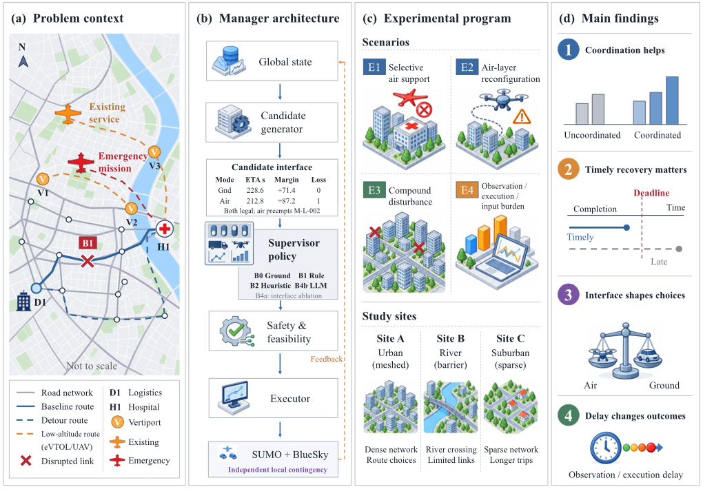
Fig. 1. Manager overview: (a) service network; (b) candidate interface and execution; (c) experiments and sites; (d) conceptual findings. Map B1 marks a disrupted link, distinct from policy B1. Symbols and bars are qualitative.

2.1 Candidate Facts and Execution
Candidates report ETA, legality or rejection reason, endurance and affected incumbents. ETA is estimated remaining completion duration. Air ETA uses great-circle waypoint distances from the current position, role-specific cruise speed and dispatch overhead. Preemption requires a reassignable, strictly lower-priority incumbent. Link loss, landing closure and restrictions can exclude air; ground requires permission and a corridor ETA.
For deadline $d_{m}$, estimated remaining duration ${\hat{η}}_{c}$, decision time t and execution wait $δ$, the estimated service margin is
$σ_{m}(c,t) = d_{m} - t - δ - {η̂}_{c}$ (1)
A nonnegative margin indicates predicted on-time completion. Candidate legality is checked against the specified constraints of the simulation model. Proposals are checked before issue or queuing; execution rechecks feasibility and the active command version. Identical pending commands keep their due times, while changed commands supersede them. Same-time events precede due commands, and local contingencies act independently. Proposal acceptance, command execution, path restoration and service completion are distinct.

2.2 Policies under a Common Contract
B0 restricts emergency support to ground, retaining background air services. B1 chooses the shortest-ETA legal air candidate, using ground only if none remains. B2 prioritizes actionable missions and ranks both modes. B4b uses an LLM with the same candidate facts. Feasibility and execution rules are shared; B0 comparisons also change available modes.
B2 minimizes
$\begin{aligned}J(c) = {η̂}_{c} + 10 max(0, t + {η̂}_{c} - d_{m}) \\ + I_{p}(κ + 30) + 10ρ\end{aligned}$ (2)
Here $I_{p}$ indicates preemption; $κ$ is 20, 40, 80 or 100,000 for LOW, NORMAL, HIGH or CRITICAL incumbents. The endurance penalty is $ρ = 1[b_{c} < 120] + 1[b_{c} < 60]$, where $b_{c}$ is remaining endurance margin in seconds, not deadline margin $σ_{m}$. Ground incurs neither penalty. B2 uses a fixed one-step score with seconds-equivalent penalties. Execution waiting enters Eq. (1), but not Eq. (2).
B4b uses the recorded deepseek-v4-pro API identifier, temperature 0, JSON output and an 8,192-token limit. Its input contains no B2 score or recommendation. B4a retains raw states, priorities, positions and ground ETA but removes derived candidate-level facts. The B4a–B4b comparison tests how this information changes supervisory decisions. Recorded API errors and retries are included in the analysis.

3 Experimental Design
SUMO [9] and BlueSky [10] simulate ground traffic and aircraft at 1 s steps. OpenStreetMap [11] supplies 3.2 km × 3.2 km networks in Suzhou (A), Amsterdam (B) and Edmonton (C): meshed, barrier-constrained and higher-circuity contexts (Fig. 2). Each has two medical UAVs, one logistics UAV and one passenger eVTOL. Facilities, workloads and faults are modeled, not operationally calibrated.
Completion duration is elapsed time since mission release; absolute completion time is the simulation timestamp. Ground execution recomputes SUMO corridor ETA for a completion timer, using proposed ETA if unavailable. No service vehicle, payload custody or physical transfer is tracked; backups may depart before interrupted carriers reach contingency sites. Inference wall-clock time does not advance simulation.
E1 crosses three disruption levels, two urgency levels and two workloads; emergencies arrive at 300 s with 180 s or 300 s slack. E2/E4 use 180 s. E2 covers 16 feasible fault-context combinations with site-specific flight-phase timing: link loss, navigation degradation, traffic-management degradation/outage, landing closure, unknown-aircraft intrusion and flyaway. Contexts span peripheral faults, interruption with air backup and loss of air alternatives; two infeasible combinations are excluded. E3 combines faults and emergencies (Fig. 5); E4 varies observation, waiting and input records (Table 1). Horizons are 900 s, or 1,200 s for multi-emergency E3.
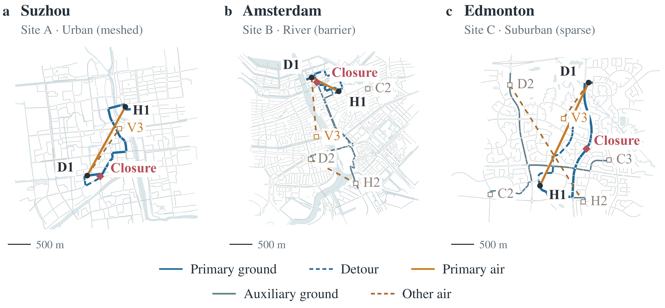
Fig. 2. Study networks at a common scale. D1/H1 are reference service endpoints; V3 is a backup landing site. Blue/orange denote ground/air connections. Road and water data: OpenStreetMap contributors; services and disruptions are modeled.
Table 1. Fixed experiment panels; each primary cell uses 20 paired seeds.
Panel | Main variation | Sites | Primary runs
E1 | Road disruption, urgency, workload | A–C | 2,880
E2 | 16 failure/context combinations | A–C | 3,840
E3 | 12 compound service scenarios | A–C | 2,880
E4A–C | Observation, waiting, input records | A | 1,360
Total: 10,960 primary runs; E4A/B/C: 400/560/400. B4a adds 180 runs (six E1 scenarios/site, ten seeds).
Shared seeds (20240601–20240620) control SUMO randomness, aircraft battery/endurance reductions (0–15%) and busy-aircraft initial route progress (5–40%). Fixed panels are averaged within seeds; 95% t intervals use 20 blocks (ten for B4a). Continuous tests use paired aggregates, with signed-rank fallback for constant nonzero differences; binary tests swap whole seed blocks. Holm adjustment retains recorded comparison families [12]. Intervals describe within-scenario initialization uncertainty.
Damaged incumbents are non-primary services ending interrupted, needing replanning, cancelled or failed, excluding physical damage and lateness; their 1,800 s deadlines exceed the horizons. Completion at the deadline is timely. E2 restoration conditions on affected chains; deadline rates use all runs. E3 system weighted loss sums priority weight × fixed task loss. CRITICAL, HIGH, NORMAL and LOW weights are 4, 3, 2 and 1. Task loss is delay cost for late completion, cancellation cost for cancelled, failed, interrupted, replanning or waiting states, and zero otherwise. CRITICAL/HIGH delay costs are 60/45; cancellation costs are 600/450. Late tasks thus cost 240/135 units. All 4,320 E3 tasks due within the horizon completed.

4 Results

4.1 Air Support and Incumbent Commitments
In E1 (Fig. 3), Suzhou’s deadline violations fall from B0’s 33.33% to 16.67% under B2 and B4b. Their completion durations average 147.62 and 146.63 s, but damaged incumbents average 0.058 and 0.133 per run; B1 leaves 0.500. Coordinated deadline rates are 0% in Amsterdam and 10% in Edmonton, versus B0’s 50% and 83.33%. Air availability helps; policy choice shapes incumbent losses.
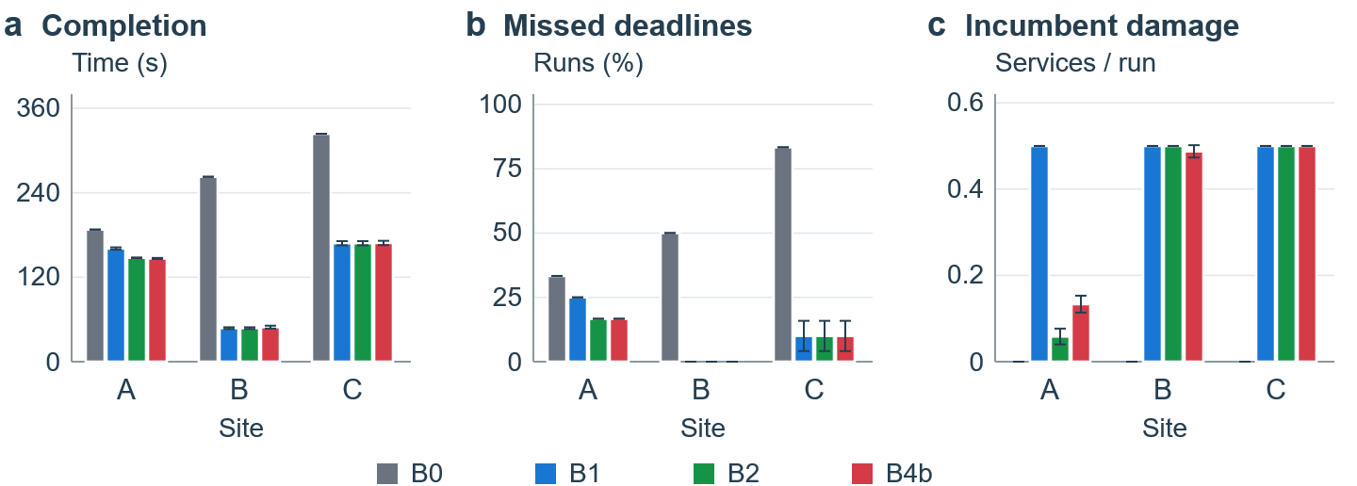
Fig. 3. E1 outcomes at Suzhou (A), Amsterdam (B) and Edmonton (C); 240 runs/site-policy. Bars show means and 95% intervals over 20 seed blocks. Zero-width intervals indicate constant fixed-panel seed means.
Candidate facts match across B1, B2 and B4b in 720 E1 first-decision states. Figure 4 isolates faster air requiring preemption despite timely ground options. In Suzhou, B2 chooses ground in all 20 states; B4b preempts in 12. B4b minus B2 gives −11.95 s in completion duration (95% CI −17.33 to −6.57; Holm-adjusted p = 0.0021) and +0.600 damaged incumbents/run; both meet every emergency deadline. At the other two sites, B2 also chooses air: its fixed weights do not always preserve incumbents.
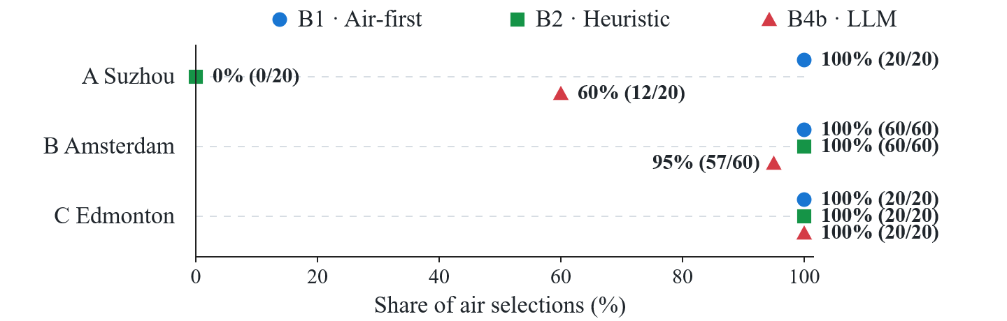
Fig. 4. Air selection shares in matched E1 first decisions: air is faster and preempts, while ground is predicted timely. Labels give counts; vertical offsets separate policies. These descriptive states are not independent samples or population rates.
Suzhou’s B4b-minus-B4a differences are −13.567 s in completion duration (95% CI −15.978 to −11.155), −0.383 damaged incumbents/run (−0.441 to −0.326) and −38.333 percentage points in air intervention; all are significant after Holm adjustment. The information-support effect is strongest in Suzhou. No contrast remains significant after Holm adjustment in Amsterdam, while the recorded differences are zero in Edmonton.

4.2 A Restored Path Can Still Finish Late
E2 separates restoration from timely recovery. All affected coordinated runs restore a path (Table 2). Timely completions among restored runs are 80/200 for each of B1 and B2 and 75/191 for B4b in Suzhou; 80/200 and 80/199, respectively, in Amsterdam; and zero for every policy in Edmonton. Policy choices alter exposure and affected denominators. These conditional counts differ from all-run deadline rates; B0 has no affected air chain.
Table 2. E2 restored/affected chains and all-run deadline violations (320 runs/site-policy). B0 is 100% late at all sites and has no affected air chain; B1/B2 coincide.
Site | B1/B2 restored | B4b restored | B1/B2 late (%) | B4b late (%)
A | 200 / 200 | 191 / 191 | 37.50 | 39.06
B | 200 / 200 | 199 / 199 | 37.50 | 37.50
C | 200 / 200 | 201 / 201 | 62.50 | 62.81
Suzhou’s B4b-minus-B2 completion-duration difference is +4.525 s (95% CI 2.412–6.638; Holm-adjusted p = 0.0031). Neither conditional recovery time nor completion contrasts in Amsterdam and Edmonton are significant after adjustment. Amsterdam’s 80 timely affected replacements per coordinated policy retain only 19 s; adding 30 s makes them late in trajectory-fixed sensitivity, which holds decisions fixed and does not validate physical transfer.

4.3 Compound Disturbances
E3 benefits require surviving, timely alternatives (Fig. 5). Suzhou’s loss falls from 240 under B0 to 100 under B1/B2 and 102.125 under B4b, despite longer primary completion. Other weighted deadlines matter. Suzhou gains nothing in L2; Edmonton gains only in L3. No B4b improvement over B1 or B2 is significant.
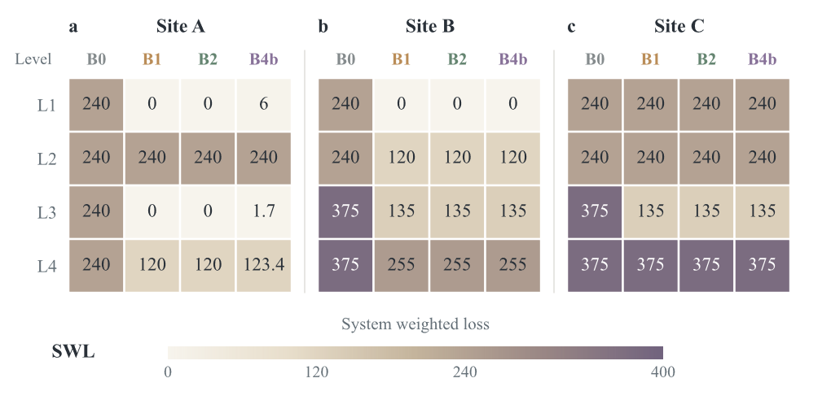
Fig. 5. Mean system weighted loss (SWL); lower is better. L1: one failure, one emergency; L2: two failures, one emergency; L3: one failure, two emergencies; L4: two or three failures, two emergencies. Each policy has 40 runs in L1/L4 and 80 in L2/L3. Levels vary both disturbance and demand; noninteger labels are rounded.

4.4 Observation and Execution Timing
In E4A, B2/B4b completion durations rise from 140 s with 10 s observations to 180, 240 and 482 s with 60, 120 and 300 s intervals: timely through 60 s, late thereafter. Sparse snapshots postpone visibility; events injected after a snapshot remain unseen even at the same timestamp.
E4B waits of 0–30 s raise coordinated completion duration from 120 to 150 s, still timely. With 60 s waiting, B2/B4b select air at 300 s; a fault at 360 s substitutes ground, executed at 420 s and completed at 602 s (302 s duration). Corrected B0 retains its command, executes at 360 s and completes at 542 s (242 s duration). The D60 case shows how replacing a pending command adds waiting and delays recovery.
E4C increases aircraft records from 5 to 50 while keeping four aircraft active; all 100 B4b runs remain timely despite the additional input.

5 Implications and Conclusions
The Manager provides a common interface for selecting and executing ground–air recovery actions. Our results show that air support can reduce emergency lateness, but a faster aircraft may interrupt an existing service. A restored path can still miss the deadline, and delayed observations or commands can reduce the benefit of recovery. Effective coordination therefore needs to consider available alternatives, existing service commitments and the time left for execution.
The evidence comes from fixed service-level simulations with ground ETA timers, no physical transfer, four active aircraft and one recorded model configuration. The sites differ in road geometry, facilities and fault timing, so their results describe combined operating settings. Future work should simulate individual ground vehicles and physical transfers within the decision loop.
Data availability. Saved per-run metrics support statistical recomputation. Missing complete historical raw trajectories cannot be recovered from the archive. Code and supplementary results:
GitHub: itsac-restored-20261016/itsac/supplement

References
- Mattsson, L.-G., Jenelius, E.: Vulnerability and resilience of transport systems – A discussion of recent research. Transp. Res. A 81, 16–34 (2015). doi:10.1016/j.tra.2015.06.002
- Jaber, S., Ameli, M., Mahdavi, S.M.H., Bhouri, N.: A methodological framework for Resilience as a Service (RaaS) in multimodal urban transportation networks. Sustain. Cities Soc. 124, 106276 (2025). doi:10.1016/j.scs.2025.106276
- Pillac, V., Gendreau, M., Guéret, C., Medaglia, A.L.: A review of dynamic vehicle routing problems. Eur. J. Oper. Res. 225(1), 1–11 (2013). doi:10.1016/j.ejor.2012.08.015
- Murray, C.C., Chu, A.G.: The flying sidekick traveling salesman problem: Optimization of drone-assisted parcel delivery. Transp. Res. C 54, 86–109 (2015). doi:10.1016/j.trc.2015.03.005
- Meng, S., Li, D., Liu, J., Chen, Y.: The multi-visit drone-assisted routing problem with soft time windows and stochastic truck travel times. Transp. Res. B 190, 103101 (2024). doi:10.1016/j.trb.2024.103101
- Ichter, B., et al.: Do As I Can, Not As I Say: Grounding Language in Robotic Affordances. In: Conference on Robot Learning, PMLR 205, pp. 287–318 (2023).
- Lai, S., Xu, Z., Zhang, W., Liu, H., Xiong, H.: LLMLight: Large Language Models as Traffic Signal Control Agents. In: KDD ’25, vol. 1, pp. 2335–2346. ACM (2025). doi:10.1145/3690624.3709379
- Liu, N.F., et al.: Lost in the Middle: How Language Models Use Long Contexts. Trans. Assoc. Comput. Linguist. 12, 157–173 (2024). doi:10.1162/tacl_a_00638
- Alvarez Lopez, P., et al.: Microscopic Traffic Simulation using SUMO. In: 21st IEEE ITSC, pp. 2575–2582 (2018). doi:10.1109/ITSC.2018.8569938
- Hoekstra, J.M., Ellerbroek, J.: BlueSky ATC Simulator Project: An Open Data and Open Source Approach. In: 7th International Conference on Research in Air Transportation (2016).
- Haklay, M., Weber, P.: OpenStreetMap: User-Generated Street Maps. IEEE Pervasive Computing 7(4), 12–18 (2008). doi:10.1109/MPRV.2008.80
- Holm, S.: A Simple Sequentially Rejective Multiple Test Procedure. Scand. J. Stat. 6(2), 65–70 (1979).

