Software Architecture & Design Specification
Smart Lab Equipment & Slot Reservation Portal
Document ID | SADS-SLP-01
Version | 1.0 (Mini-Project Part-1)
Author | Anagha N (PES1UG24CS058)
Format | IEEE Std 1016 (software design description) / ISO/IEC/IEEE 42010 (architecture description) structure
Inputs | SRS.md (SRS-SLP-01)
Part I | Architecture: §1–§7. Part II – Design: §8–§12

Status. This is a design for a system that is not yet implemented. Technology products are deliberately not named because Lab 1 did not choose any (SRS A-01). Where the SRS is silent, a labelled design decision (DD-xx) is made and listed in §12 for confirmation.

1. Introduction

1.1 Purpose and scope
Describe the structure of the portal and the detailed design needed to implement SRS-SLP-01: components and their responsibilities, how security requirements are realised, the HTTP API, the interaction of components in two key use cases, and error handling.

1.2 References
SRS (SRS.md), Test Plan (Test_Plan.md), Traceability (traceability/Requirements_Traceability.md), Lab 1 documents (see SRS §1.4).

1.3 Definitions
IDs follow the SRS: FR/NFR/SEC-REQ/UC. C-nn = architecture component, SD-nn = sequence diagram, DD-nn = design decision.

Part I – Architecture

2. Architectural Drivers
Driver | Source | Consequence for the architecture
No double booking, even under simultaneous requests | FR-001, NFR-003 | One authoritative store with transactional locking; all reservation writes in a single locked transaction.
Reservation processed in ≤ 200 ms | NFR-001 | Short transaction; no slow external call inside it (DD-04).
Role-restricted functions, session expiry | NFR-002, SEC-REQ-01/02 | Central authentication and authorization components that every request passes through.
Student-own-data access | SEC-REQ-03 | Ownership checks in the reservation logic.
Input validation | SEC-REQ-05 | Single validating entry point (API layer) plus parameterised data access.
Accountability | SEC-REQ-06 | Dedicated audit component.
External notification, failure-tolerant | FR-009, A-06 | Adapter component isolating the external system.
Calibration check as a distinct rule | FR-002, FR-008 | Separate component with one responsibility, reused by reservation.

3. Architecture Pattern
Selected pattern: layered client–server architecture (three tiers: web client / application server / relational database), with a service-oriented decomposition of the business layer.
Structure derived from the actual system:
- Users work through a browser portal → a client tier (C-01).
- All business rules (calibration, overlap, cut-off, penalty, RBAC) must be enforced centrally and cannot be trusted to the browser (NFR-002, SEC-REQ-05) → an application-server tier (C-02…C-10) exposing an HTTP/JSON API.
- NFR-001/NFR-003 explicitly call for database-level lock isolation, i.e. a transactional relational store that is the single source of truth → a data tier (C-11, C-12).
- Inside the server the layers are: API layer (entry, validation, security filter) → business services (reservation, calibration, inventory, return/penalty) → data access layer. Cross-cutting components (authentication, access control, audit, notification adapter) are separate so that each security requirement maps to one component.
Why not alternatives: MVC describes the internal structure of a UI application rather than the system-level split between browser, server and database, so it is not used as the system pattern (the web client may use it internally, which is not constrained here). Microservices would add distributed transactions that conflict with the single-transaction locking required by NFR-003, and the scale (one lab) does not justify it. Event-driven/publish-subscribe is not needed: the only asynchronous interaction is the one notification request (DD-04).

4. Component View

4.1 Component diagram

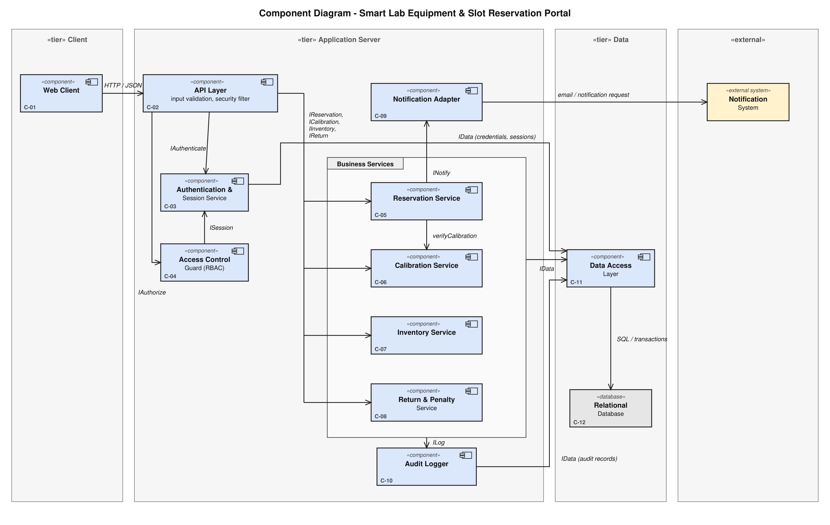
Figure 2 – UML Component Diagram (draw.io source: diagrams/component.drawio)

Dashed arrows are UML dependencies (the arrow points to the component that provides the interface). The Business Services package groups C-05…C-08; arrows crossing its border apply to the contained services as listed in the table.

4.2 Component descriptions
ID | Component | Responsibility | Provided interface / depends on | Related requirements
C-01 | Web Client | Browser UI for all use cases; shows role-specific menus; displays error messages; never enforces rules on its own. | Uses HTTP/JSON API of C-02. | UC-01…UC-08 UI; EIR-01; FR-001, FR-003, FR-007, FR-009 (display)
C-02 | API Layer | Single entry point: routes requests, runs the security filter (session present, not expired → C-03; role allowed → C-04), validates inputs, maps component results and exceptions to HTTP responses (§11). | Provides HTTP/JSON API (§9). Uses IAuthenticate (C-03), IAuthorize (C-04), IReservation, ICalibration, IInventory, IReturn. | SEC-REQ-04, SEC-REQ-05, NFR-001 (request handling), EIR-04
C-03 | Authentication & Session Service | Verifies credentials, issues a session token bound to user and role, tracks last activity and expires sessions after 30 min inactivity. | Provides IAuthenticate, ISession. Uses C-11 (credentials, sessions). | FR-006, NFR-002, SEC-REQ-02, SEC-REQ-04
C-04 | Access Control Guard (RBAC) | Decides whether the role in the session may call an operation (technician-only vs student-only). | Provides IAuthorize. Uses ISession (C-03). | NFR-002, SEC-REQ-01, SEC-REQ-03 (role part)
C-05 | Reservation Service | Availability query; reserve (duration, horizon, overlap, own-overlap); token generation; cancel (ownership, cut-off, release); own history. Runs the reservation transaction. | Provides IReservation. Uses ICalibration (C-06), INotify (C-09), IData (C-11). | FR-001, FR-003, FR-007, FR-010, NFR-001, NFR-003, SEC-REQ-03; UC-02…UC-05, UC-10
C-06 | Calibration Service | Verifies calibration status (UC-09) and updates it (UC-07). | Provides ICalibration. Uses IData, ILog. | FR-002, FR-008, SEC-REQ-06
C-07 | Inventory Service | Add / update / remove equipment records; refuses removal with future Confirmed reservations (DD-06). | Provides IInventory. Uses IData, ILog. | FR-005, SEC-REQ-05, SEC-REQ-06
C-08 | Return & Penalty Service | Records returns, computes the late-return flag (UC-12). | Provides IReturn. Uses IData, ILog. | FR-004, SEC-REQ-06
C-09 | Notification Adapter | Builds and submits the confirmation request to the external Notification System; logs failures without failing the reservation. | Provides INotify. Uses the Notification System. | FR-009, EIR-02, A-06
C-10 | Audit Logger | Writes audit records for privileged actions; also receives error log entries (§11.4). | Provides ILog. Uses IData (audit records). | SEC-REQ-06, SEC-OBJ-04
C-11 | Data Access Layer | All persistence; transactions and slot/row locks; parameterised statements only. | Provides IData. Uses C-12 over SQL. | NFR-001, NFR-003, SEC-REQ-05, EIR-03
C-12 | Relational Database | Stores users, sessions, equipment, reservations, audit records; provides transactions and locking. | SQL. | NFR-003, EIR-03
EXT | Notification System (external) | Delivers email / notification. Not part of the system. | Used by C-09. | FR-009

Every component has at least one related requirement; no requirement is without a component (§5).

5. Traceability: Requirements → Use Cases → Components → Design
Requirement | Use case | Components | Design elements | Tests
FR-001 | UC-02, UC-03, UC-10 | C-01, C-02, C-05, C-11, C-12 | SD-01; API GET /equipment/{id}/availability, POST /reservations; DD-01, DD-02 | TC-01–04, 17, 21
FR-002 | UC-03, UC-09 | C-05, C-06, C-11 | SD-01 (alt A1); 409 CALIBRATION_INVALID | TC-01, 05, 13
FR-003 | UC-04 | C-05, C-11 | API POST /reservations/{id}/cancel; DD-05 | TC-06, 07, 23
FR-004 | UC-06, UC-12 | C-08, C-10, C-11 | SD-02; API POST /reservations/{id}/return | TC-08, 09, 22
FR-005 | UC-08 | C-07, C-10, C-11 | API POST/PUT/DELETE /equipment; DD-06 | TC-10, 21, 22
FR-006 | UC-01 | C-03, C-11 | API POST /auth/login | TC-11, 19, 20
FR-007 | UC-05 | C-05, C-11 | API GET /reservations/me | TC-12
FR-008 | UC-07 | C-06, C-10, C-11 | API PUT /equipment/{id}/calibration | TC-13, 22
FR-009 | UC-11 | C-05, C-09 | SD-01; DD-04 | TC-14
FR-010 | UC-03 | C-05, C-11 | SD-01 (overlap check, both windows) | TC-15
NFR-001 | UC-03 | C-02, C-05, C-11 | DD-02, DD-04 | TC-16
NFR-002 | UC-06/07/08 | C-03, C-04, C-02 | SD-02 (security filter); §7 | TC-18, 19
NFR-003 | UC-03 | C-05, C-11, C-12 | DD-02; SD-01 | TC-17
SEC-REQ-01…06 | – | see §7 | see §7 | TC-11, 12, 18–23

6. Data View
Logical entities (technology-neutral):
Entity | Attributes | Notes
User | id, username, role (Student / Lab Technician), credential verifier | Credential verifier is not a plain-text password (SEC-REQ-04); algorithm is an implementation choice.
Session | token, userId, role, lastActivity | Valid while now − lastActivity ≤ 30 min (SEC-REQ-02).
Equipment | id, name, category, calibrationStatus (Valid / Expired / Pending), calibrationDueDate | FR-005, FR-008, A-02.
Reservation | id, studentId, equipmentId, slotStart, slotEnd, status (Confirmed / Cancelled / Returned), token (unique), createdAt, returnTimestamp, penaltyFlag | FR-001, 003, 004.
AuditRecord | id, userId, role, action, targetId, timestamp | SEC-REQ-06.

Relationships: a User (Student) has many Reservations; Equipment has many Reservations. Constraint: the database shall not allow two Confirmed reservations of the same equipment with overlapping slots (enforced by the locked transaction of DD-02; a database-level exclusion/uniqueness rule can be added as defence in depth if the chosen database supports it).

7. Security Architecture

7.1 Trust boundaries
Browser (untrusted) → API Layer (first trusted point: security filter and validation) → services → data. The Notification System is outside the boundary and receives only the confirmation data of FR-009. Nothing the browser sends (role, student id, times) is trusted: role and user id come from the server-side session, never from the request body.

7.2 Security requirement → control → mechanism → validation
Security objective | Requirement | Component(s) / control | Design mechanism | Validation
SEC-OBJ-01 | SEC-REQ-01 | C-04 Access Control Guard, invoked by C-02 for every operation | Static operation → allowed-roles table; technician-only: calibration, inventory, return, list-all-reservations; deny by default; 403 FORBIDDEN_ROLE. | TC-18
SEC-OBJ-01 | SEC-REQ-02 | C-03 | lastActivity updated on every valid request; request rejected if now − lastActivity > 30 min; 401 SESSION_EXPIRED. | TC-19
SEC-OBJ-01 | SEC-REQ-04 | C-03, C-02 security filter | Every endpoint except POST /auth/login requires a valid session token; login returns one generic error for unknown user and wrong password; credentials stored only as a verifier and excluded from logs (C-10 / §11.4). | TC-11, TC-20
SEC-OBJ-03 | SEC-REQ-03 | C-05 (+ C-04 for role) | Ownership check reservation.studentId == session.userId before read or cancel; 403 FORBIDDEN_RESOURCE with no reservation data in the body. History query is filtered by the session's user id, not by a client-supplied id. | TC-12, TC-23
SEC-OBJ-02 | SEC-REQ-05 | C-02 input validation; C-11 | Schema validation (type, format, range) before any service call; parameterised statements only in C-11; server-side horizon / duration rules. | TC-21
SEC-OBJ-04 | SEC-REQ-06 | C-10 | Services C-06, C-07, C-08 call ILog after a successful privileged action, recording user id, role, action, target, time (same transaction as the change, DD-07). | TC-22
SEC-OBJ-02 | NFR-003 (integrity) | C-05, C-11, C-12 | Locked transaction for reservation writes. | TC-17

Deployment assumption A-10 (HTTPS) protects session tokens in transit; it is a configuration dependency, not a component.

Part II – Design

8. Design Decisions
ID | Decision | Rationale / requirement | Needs confirmation?
DD-01 | A Reservation Token is a random, non-guessable identifier generated server-side and stored with a uniqueness constraint; it is bound to the reservation row (student, equipment, slot). Exact format/length is an implementation choice. | FR-001 "unique token bound to student, equipment, slot"; UC-10. | Format only
DD-02 | The reservation write is a single database transaction: lock the student row and then the equipment row (fixed order, avoids deadlock) → re-read calibration status → check overlap for equipment window and student window → insert → commit. Concurrent requests for the same equipment are serialised by the lock. | NFR-003, NFR-001, FR-010 | No
DD-03 | Times are compared in one server time base; the slot window is [slotStart, slotEnd), so back-to-back slots do not overlap. | FR-001, TC-04 | Yes (A-05)
DD-04 | The request to the Notification System is submitted after the transaction commits and a failure never rolls back the reservation; it is logged. | A-06, NFR-001 (no external call inside the timed path or the lock) | Yes (A-06)
DD-05 | Cancel: allowed when now ≤ slotStart − 60 min; sets status Cancelled; the slot is free immediately on commit (well inside the 5 s of FR-003). | FR-003, A-04 | Yes (A-04)
DD-06 | Removing equipment with future Confirmed reservations is rejected (409 EQUIPMENT_HAS_ACTIVE_RESERVATIONS). | FR-005, A-07 | Yes (A-07)
DD-07 | Audit records are written in the same transaction as the privileged change, so a change without audit record cannot be committed. | SEC-REQ-06 | No
DD-08 | Role and user id are taken from the server-side session, never from request parameters. | SEC-REQ-01/03 | No

9. API Design
The portal exposes an HTTP/JSON API consumed by its own web client (C-01). Base path /api/v1. Content type application/json. All endpoints except POST /auth/login require header Authorization: Bearer <session token> (SEC-REQ-04). Timestamps are ISO-8601. Role column: S = Student, T = Lab Technician.

9.1 Endpoint catalogue
# | Method & path | Purpose | Role | Use case | Requirement
1 | POST /auth/login | Authenticate, create session | public | UC-01 | FR-006
2 | GET /equipment?category=&calibrationStatus= | List equipment with calibration status | S, T | UC-02 | FR-001
3 | GET /equipment/{id}/availability?from=&to= | Reserved / free slots of one item | S, T | UC-02 | FR-001
4 | POST /equipment | Add equipment | T | UC-08 | FR-005
5 | PUT /equipment/{id} | Update equipment | T | UC-08 | FR-005
6 | DELETE /equipment/{id} | Remove equipment | T | UC-08 | FR-005
7 | PUT /equipment/{id}/calibration | Set calibration status | T | UC-07 | FR-008
8 | POST /reservations | Reserve a slot | S | UC-03 | FR-001, 002, 009, 010
9 | GET /reservations/me | Own reservation history | S | UC-05 | FR-007
10 | GET /reservations/{id} | One reservation (owner or technician) | S (owner), T | UC-05 | FR-007, SEC-REQ-03
11 | POST /reservations/{id}/cancel | Cancel own reservation | S (owner) | UC-04 | FR-003
12 | GET /reservations?status=Confirmed | List reservations to process returns | T | UC-06 | FR-004
13 | POST /reservations/{id}/return | Record return, set penalty flag | T | UC-06, UC-12 | FR-004

No other API exists; endpoint 12 is a design addition so that a technician can select "the reserved item" of UC-06.

9.2 Details of the main endpoints
1. POST /auth/login – Request { "username": "string", "password": "string" }. Success 200 { "token": "…", "role": "Student|Lab Technician", "expiresAfterIdleMinutes": 30 }. Errors: 400 VALIDATION_ERROR (missing field), 401 INVALID_CREDENTIALS (same body for unknown user and wrong password). Not authenticated by design.
2. GET /equipment – Success 200 { "items": [ { "id": 1, "name": "…", "category": "…", "calibrationStatus": "Valid", "calibrationDueDate": "2026-12-31" } ] }. Errors: 401, 400 (unknown filter value).
3. GET /equipment/{id}/availability – Success 200 { "equipmentId": 1, "reserved": [ {"start": "…", "end": "…"} ] }. Errors: 401, 404 EQUIPMENT_NOT_FOUND, 400.
4–6. Equipment maintenance (T) – POST /equipment body { "name", "category", "calibrationDueDate" } → 201 with the record; PUT /equipment/{id} same body → 200; DELETE /equipment/{id} → 200. Errors: 401, 403 FORBIDDEN_ROLE, 404, 422/400 validation, 409 EQUIPMENT_HAS_ACTIVE_RESERVATIONS (delete only).
7. PUT /equipment/{id}/calibration – Request { "status": "Valid|Expired|Pending" } → 200 updated record. Errors: 401, 403, 404, 422 INVALID_CALIBRATION_STATUS.
8. POST /reservations – Request { "equipmentId": 1, "start": "2026-10-02T10:00:00", "durationMinutes": 90 }. Student id comes from the session (DD-08). Success 201 { "reservationId": 17, "token": "…", "equipmentId": 1, "start": "…", "end": "…", "status": "Confirmed" }. Errors:
HTTP | Code | Condition
400 | VALIDATION_ERROR | missing / non-numeric / malformed field
422 | DURATION_EXCEEDS_LIMIT | duration > 120 min (or ≤ 0 → VALIDATION_ERROR)
422 | START_OUT_OF_RANGE | start in the past or later than now + 7 days
401 / 403 | AUTHENTICATION_REQUIRED, SESSION_EXPIRED, FORBIDDEN_ROLE | filter
404 | EQUIPMENT_NOT_FOUND | unknown equipment
409 | CALIBRATION_INVALID | status Expired / Pending; body carries the FR-002 message and alternatives
409 | SLOT_CONFLICT | overlap on equipment; body carries nextAvailableSlots
409 | STUDENT_SLOT_CONFLICT | student has an overlapping reservation (FR-010)

9. GET /reservations/me – Success 200 { "items": [ { "id", "equipment", "start", "end", "status", "token", "penaltyFlag" } ] } (only the caller's records). Errors: 401, 403.
10. GET /reservations/{id} – Success 200 one item. Errors: 401, 403 FORBIDDEN_RESOURCE (student, not owner), 404 RESERVATION_NOT_FOUND.
11. POST /reservations/{id}/cancel – No body. Success 200 { "reservationId", "status": "Cancelled" }. Errors: 401, 403 FORBIDDEN_RESOURCE, 404, 409 CANCELLATION_WINDOW_CLOSED (less than 60 min to start), 409 INVALID_RESERVATION_STATE (already Cancelled / Returned).
12. GET /reservations?status=Confirmed – Success 200 list (all students) for technicians. Errors: 401, 403.
13. POST /reservations/{id}/return – No body; technician id from the session. Success 200 { "reservationId", "status": "Returned", "returnTimestamp": "…", "penaltyFlag": true|false }. Errors: 401, 403 FORBIDDEN_ROLE, 400 (malformed id), 404 RESERVATION_NOT_FOUND, 409 INVALID_RESERVATION_STATE.

9.3 Common error body
{ "error": { "code": "SLOT_CONFLICT", "message": "Human-readable text", "details": { } } }
message is safe to show to the user; details carries structured data (alternatives, next slots, field errors). No stack traces or internal identifiers are returned.

10. Sequence Diagrams
The two sequence diagrams model use cases UC-03 (the core use case specified in Lab 1) and UC-06 (the technician-side use case that exercises RBAC, the extend relationship and auditing).

10.1 SD-01 – UC-03 Reserve Equipment Slot
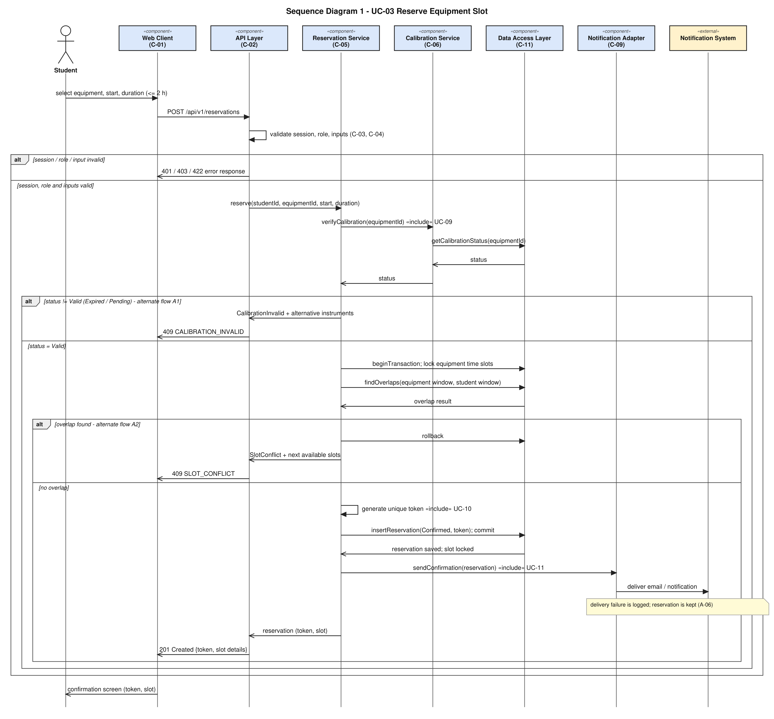
Figure 3 – Sequence Diagram 1: Reserve Equipment Slot (draw.io source: diagrams/sequence-01.drawio)
Covers: FR-001, FR-002, FR-009, FR-010, NFR-001, NFR-003; alternate flows A1 (calibration), A2 (conflict), A3 (invalid session/input); the «include» use cases UC-09, UC-10, UC-11. Steps 4–5 of the Lab 1 flow (calibration, overlap) appear in the same order. The overlap check and the insert happen inside one locked transaction (DD-02). The request to the Notification System is submitted after commit (DD-04).

10.2 SD-02 – UC-06 Return Equipment
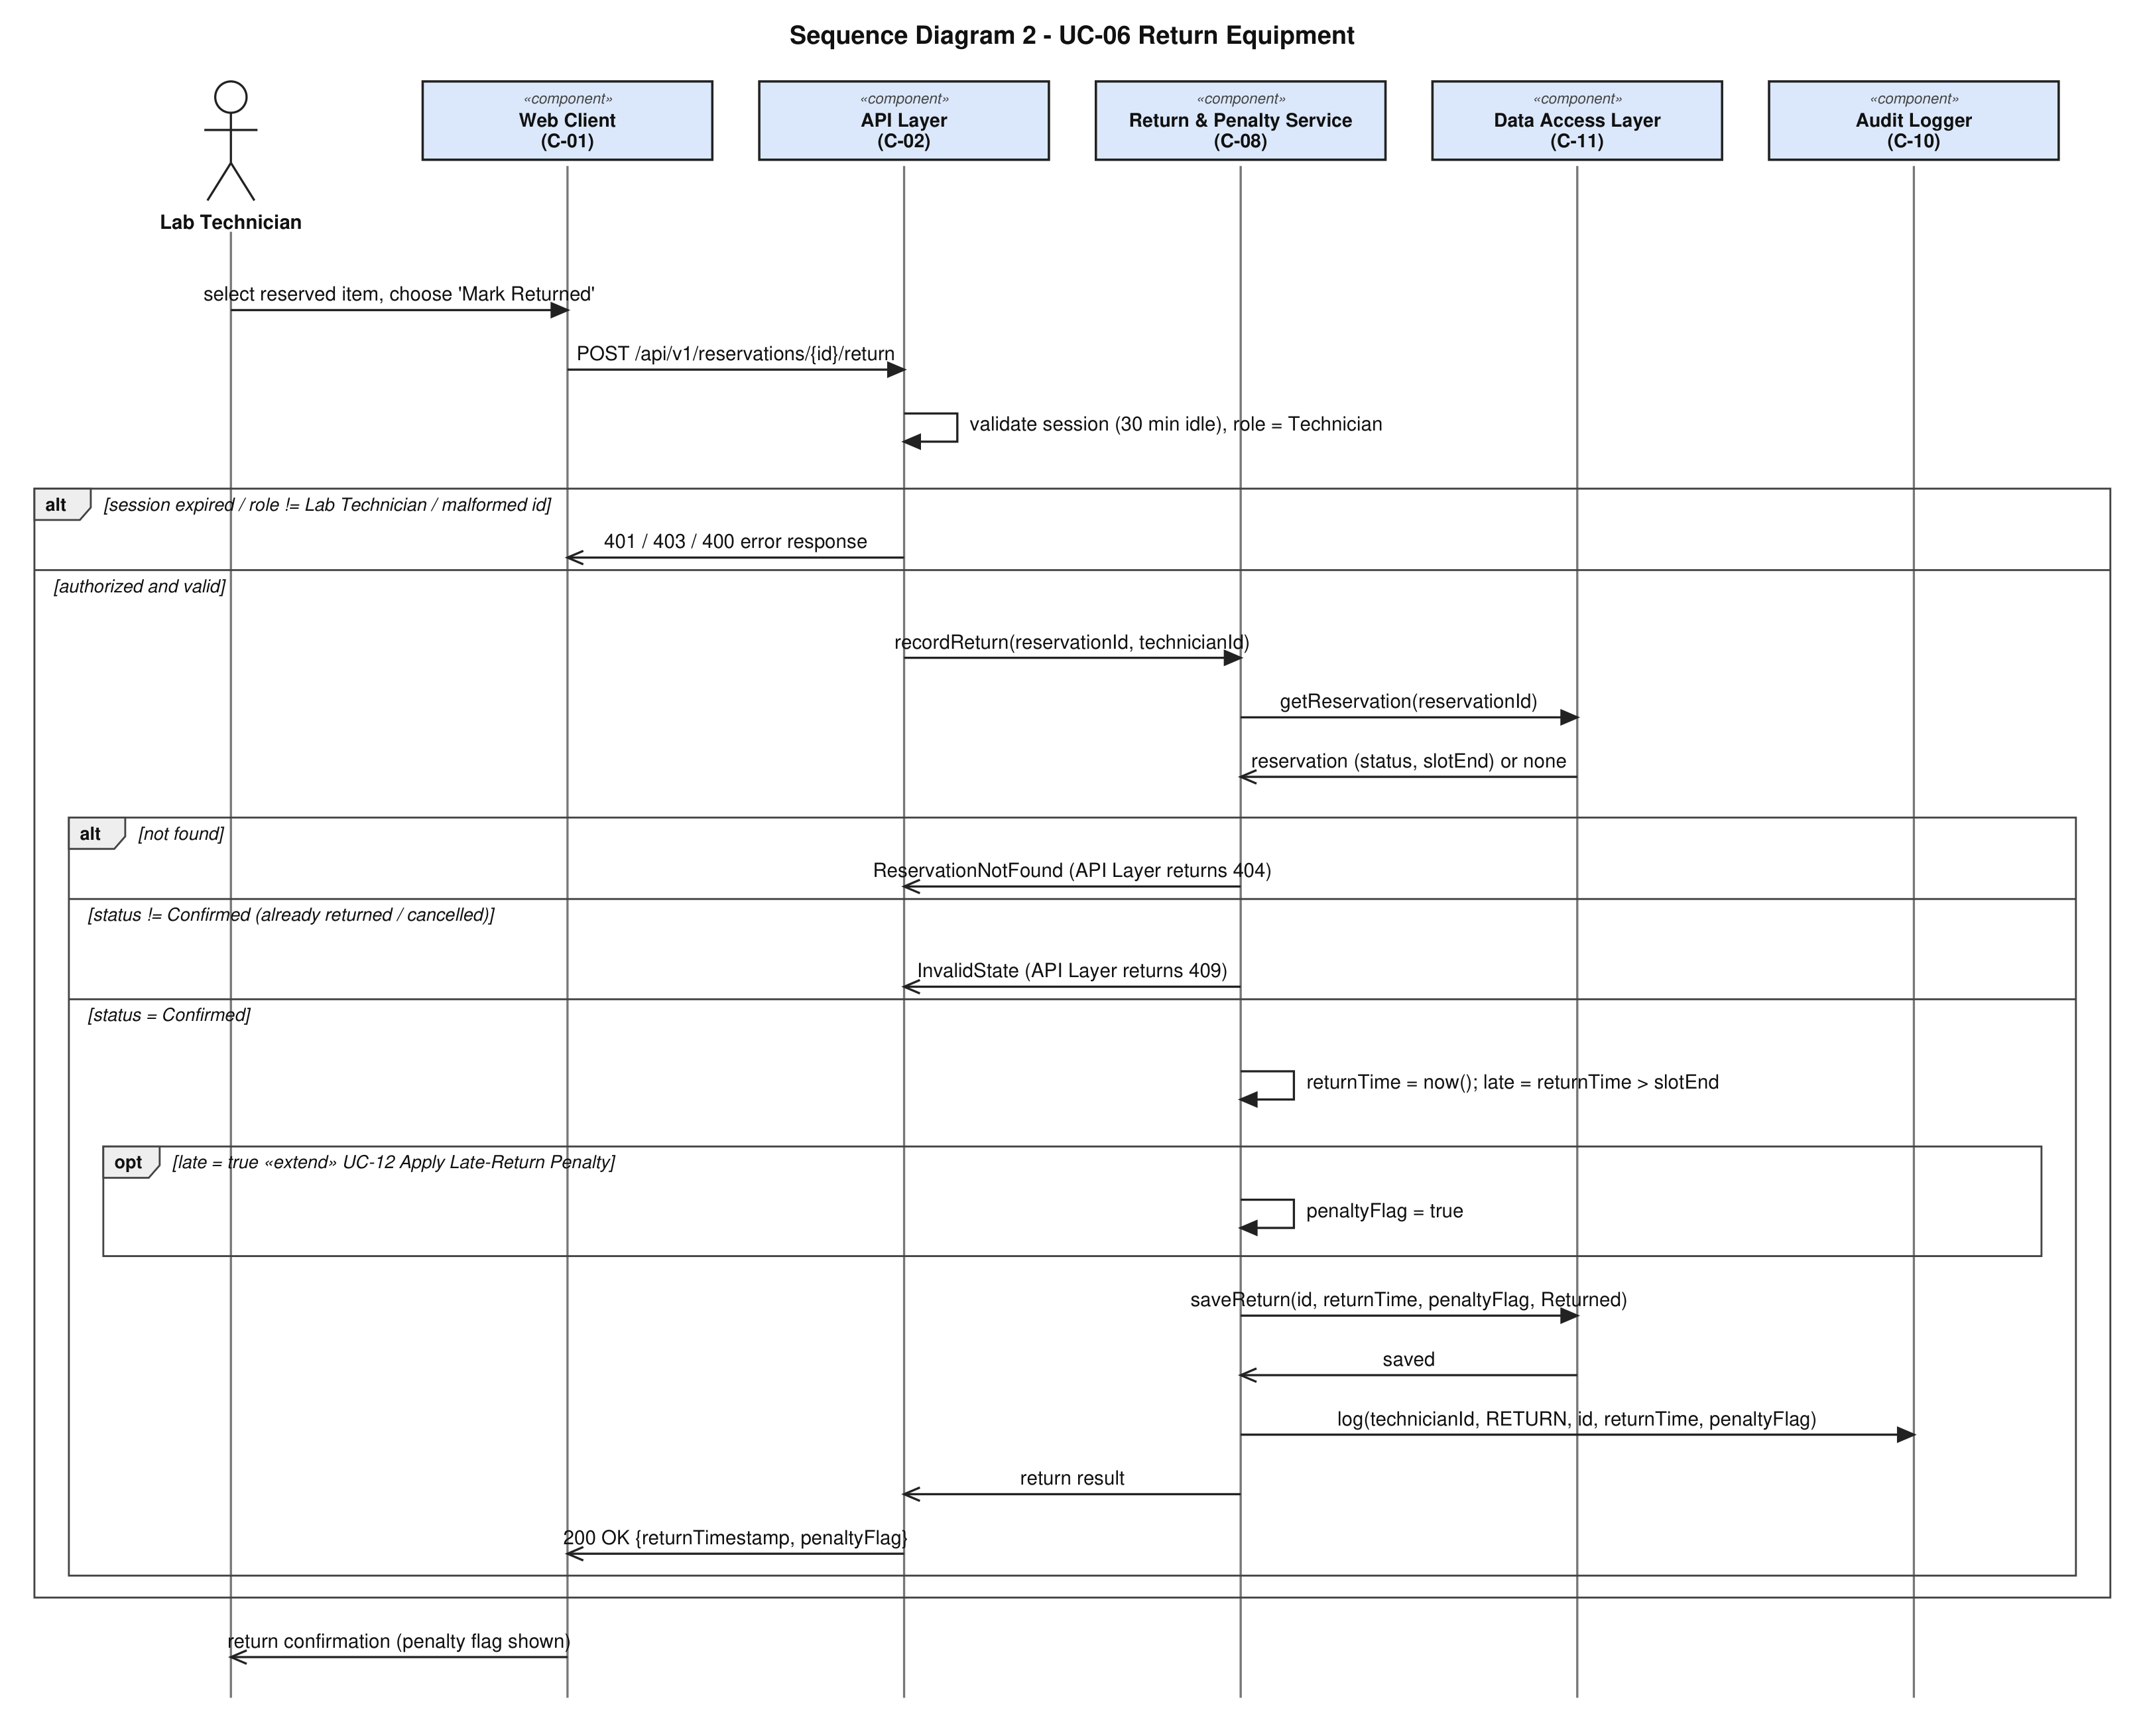
Figure 4 – Sequence Diagram 2: Return Equipment (draw.io source: diagrams/sequence-02.drawio)
Covers: FR-004, NFR-002, SEC-REQ-01, SEC-REQ-02, SEC-REQ-06; the «extend» use case UC-12 appears as the opt fragment taken only when returnTime > slotEnd. The security filter rejects expired sessions (401) and non-technician roles (403) before the service is called.

11. Error Handling

11.1 Principles
- Validate early (API Layer) and fail with a precise code; never let invalid input reach the data layer (SEC-REQ-05).
- A failed request changes no data: reservation, cancellation, return and inventory operations run in one transaction that is rolled back on any failure (FR-001 postcondition "no reservation record is created").
- Messages for users are specific enough to act on but never reveal internals, other users' data, or whether a username exists.
- The same error body format is used everywhere (§9.3).

11.2 Error categories
Category | Examples | HTTP | User-facing behaviour | System behaviour
Invalid input | non-numeric id, duration ≤ 0, missing field, bad status value | 400 / 422 | Field-level message; form stays filled | No state change; logged at INFO with request id
Business-rule violation | duration > 120, start > 7 d, overlap, student overlap, cancel inside cut-off, invalid state | 422 / 409 | Message from SRS (e.g. FR-002 wording); alternatives or next slots shown | Transaction rolled back; INFO log
Calibration not valid | Expired / Pending | 409 CALIBRATION_INVALID | "This equipment is currently unavailable for booking — calibration required." + alternative instruments | No reservation created
Missing data | unknown equipment or reservation id; no alternatives available | 404 or empty list | "Not found" message; empty-list message in UI | None
Authentication failure | no / malformed token, expired session, wrong credentials | 401 | Redirect to login; generic "invalid credentials" text | Log with source and time; never log the password
Authorization failure | Student calls technician function; access to another student's reservation | 403 | "You are not allowed to perform this action." | Log WARN (user id, endpoint); no data changed or disclosed
Resource unavailable | database down or lock wait too long | 503 SERVICE_UNAVAILABLE | "Service temporarily unavailable, please retry." | Transaction rolled back; ERROR log; no partial reservation. (Lock-wait limit is an implementation setting, not specified by the SRS.)
External system failure | Notification System unreachable | none (request succeeds) | Reservation confirmed; on-screen confirmation still shown | Failure logged by C-09; reservation kept (A-06). No retry policy is specified.
Unexpected error | unhandled exception | 500 INTERNAL_ERROR | Generic message with a request id | Transaction rolled back; ERROR log with stack trace (server side only)

11.3 Concurrency errors
When two requests compete for a slot, the one that loses the lock re-checks and receives 409 SLOT_CONFLICT – not a 500 (TC-17).

11.4 Logging strategy
- Audit log (C-10): privileged successful actions (SEC-REQ-06). Persistent, in the database.
- Application log: timestamp, request id, user id (if any), endpoint, outcome / error code. Never contains passwords, tokens or full request bodies.
- Authentication failures and authorization failures are logged; log retention and rotation are not specified by Lab 1.

12. Open Issues and Items Needing Confirmation
ID | Item | Where used
A-02 | Calibration status is a stored field; due date does not auto-expire it. | FR-002, FR-008, DD
A-03 | Peak load for NFR-001 (20 concurrent requests used for testing only). | TC-16
A-04, A-05 | Cancel cut-off inclusive; whole-minute slots, no minimum duration. | DD-03, DD-05
A-06 | Notification failure keeps the reservation. | DD-04, TC-14
A-07 | Equipment with future reservations cannot be removed. | DD-06
A-10 | HTTPS in deployment; password-verifier algorithm not chosen. | §7
– | Technology stack, hosting, and Notification System protocol not chosen. | whole document

