LABORATOR 2 CSI
Grupa 10216
Corcodel Ana-Maria

P1 generarea cheilor RSA
#include <iostream>
#include <cstdlib>
#include <ctime>

using namespace std;

int gcd(int a, int b)
{
while (b != 0)
{
int r = b;
b = a % b;
a = r;
}
return a;
}

int modInverse(int e, int z)
{
for (int d = 2; d < z; d++)
if ((e * d) % z == 1)
return d;
return -1;
}

int main()
{
srand(time(NULL));

int primes[] = { 3,5,7,11,13,17,19,23,29,31 };
int size = 10;

int p = primes[rand() % size];
int q;

do
{
q = primes[rand() % size];
} while (q == p);

int n = p * q;
int z = (p - 1) * (q - 1);

int e;

do
{
e = rand() % z;
} while (e <= 1 || gcd(e, z) != 1);

int d = modInverse(e, z);

cout << "===== GENERARE CHEI RSA =====" << endl;

cout << "p = " << p << endl;
cout << "q = " << q << endl;

cout << "n = p*q = " << n << endl;

cout << "z = (p-1)*(q-1) = " << z << endl;

cout << "e (cheie publica) = " << e << endl;

cout << "d (cheie privata) = " << d << endl;

return 0;
}
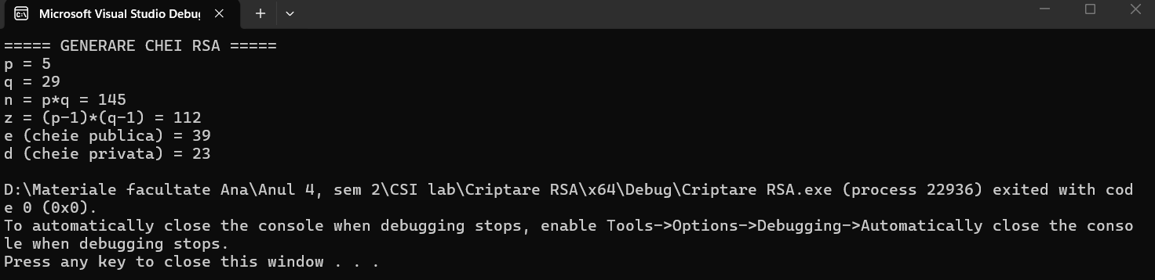

P2 Criptare
#include <iostream>
using namespace std;

long long modExp(long long baza, long long exp, long long mod)
{
long long rezultat = 1;

for (int i = 0; i < exp; i++)
{
rezultat = (rezultat * baza) % mod;
}

return rezultat;
}

int main()
{
long long n, e;
int mesaj;

cout << "===== CRIPTARE RSA =====" << endl;

cout << "Introdu n: ";
cin >> n;

cout << "Introdu e: ";
cin >> e;

cout << "Introdu mesaj (numar < n): ";
cin >> mesaj;

long long criptat = modExp(mesaj, e, n);

cout << "Mesaj criptat: " << criptat << endl;

return 0;
}
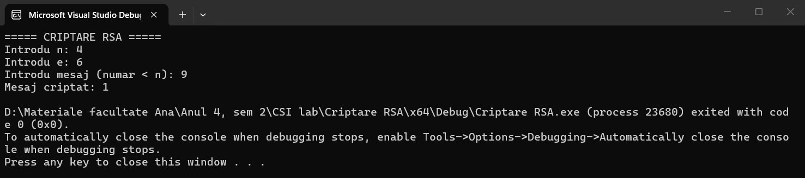

P3 Decriptare
#include <iostream>
using namespace std;

long long modExp(long long baza, long long exp, long long mod)
{
long long rezultat = 1;

for (int i = 0; i < exp; i++)
{
rezultat = (rezultat * baza) % mod;
}

return rezultat;
}

int main()
{
long long n, d;
long long criptat;

cout << "===== DECRIPTARE RSA =====" << endl;

cout << "Introdu n: ";
cin >> n;

cout << "Introdu d: ";
cin >> d;

cout << "Introdu mesajul criptat: ";
cin >> criptat;

long long mesaj = modExp(criptat, d, n);

cout << "Mesaj decriptat: " << mesaj << endl;

return 0;
}
