Business Template

sUBWAY (METRO)

Contents
1 Business Description 3
1.1 Business background 3
1.2 Problems. Current Situation 3
1.3 The benefits of implementing a database. Project Vision 3
2 Model description 3
2.1 Definitions & Acronyms 3
2.2 Logical Scheme 3
2.3 Objects 3

Business Description

Business background
The Metro system is a critical urban public transportation network, transporting thousands of passengers daily. Operational efficiency depends on accurate, centralized data covering subway lines, stations, train schedules, ticketing, promotions, maintenance, assets, and workforce management.

Problems. Current Situation
Operational data is currently scattered across spreadsheets and manual records, leading to:
- Difficulty tracking real-time train schedules, arrivals, and departures
- Inefficient maintenance tracking for trains, tracks, tunnels, and assets
- Poor visibility into ticket sales, passenger flow, and revenue
- Data redundancy, inconsistencies, and errors across departments

the Benefits of implementing a database. Project Vision
A Centralized Metro Database will:
- Consolidate all data on lines, stations, schedules, trains, and assets
- Enable accurate, real-time maintenance and asset lifecycle tracking
- Provide comprehensive reporting on ticket sales, promotions, and line performance
- Support data-driven decisions for scheduling, staffing, infrastructure investment, and optimization

Model description

Definitions & Acronyms
PK – Primary Key
FK – Foreign Key
INT – Integer
DECIMAL – Decimal Number
DATE – Date (YYYY-MM-DD)
VARCHAR - Variable-length string (max n characters)
TIME – Time (HH:MM:SS)
DATETIME – Date and Time
TEXT – Long text field

Logical Scheme
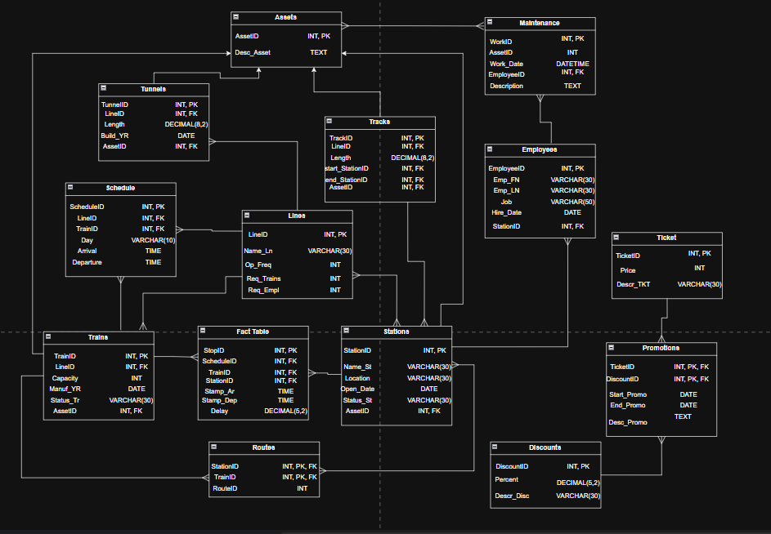

Objects

“Lines” Table - Stores information about subway lines
“Trains” Table - Contains details of individual trains
“Employees” Table – Holds employee data
“Stations” Table – Holds subway stations data
“Routes” Table - Sequence of stations per line
“Schedule” Table – Holds daily/periodic train schedules data
“Tracks” Table – Holds data on track segments between stations
“Tunnels” Table – Stores data on tunnel infrastructure
“Assets” Table - Stores physical assets data
“Maintenance” Table – Holds data on maintenance activities
“Ticket” Table – Stores ticket sales records
“Promotions” Table – Holds data on discount campaigns
“Discounts” – Stores applied discount rules
“Fact Table” Table – Holds aggregated performance data

Table Name | Field name | Field Description | Data Type
Lines | LineID | Unique line identifier, PK | INT
Lines | Name_Ln | Line name | VARCHAR(30)
Lines | Op_Freq | Operating frequency in minutes | INT
Lines | Req_Trains | Required number of trains | INT
Lines | Req_Empl | Required number of employees | INT
Trains | TrainID | Unique train identifier, PK | INT
Trains | LineID | References assigned Line | INT
Trains | Capacity | Passenger capacity | INT
Trains | Manuf_Year | Manufacturing year | DATE
Trains | Status_Tr | Operational status | VARCHAR(30)
Trains | AssetID | Asset identifier, FK | INT
Employees | EmployeeID | Unique employee identifier, PK | INT
Employees | Emp_FN | First name | VARCHAR(30)
Employees | Emp_LN | Last Name | VARCHAR(30)
Employees | Job | Job Description | VARCHAR(50)
Employees | Hire_Date | Hire Date | DATE
Employees | Station | References assigned Station, FK | INT
Stations | StationID | Unique station identifier, PK | INT
Stations | Name_St | Station Name | VARCHAR(30)
Stations | Location | Location Name | VARCHAR(30)
Stations | Status_St | Operational status | VARCHAR(30)
Stations | Open_Date | Opening date | DATE
Stations | AssetID | Asset identifier, FK | INT
Routes | StationID | References Station, PK, FK | INT
Routes | TrainID | References Trains, PK, FK | INT
Routes | RouteID | Sequence of Stations | INT
Schedule | ScheduleID | References Schedule_Lines, PK | INT
Schedule | LineID | References Lines, FK | INT
Schedule | TrainID | References Trains, FK | INT
Schedule | Day | Day of the Schedule | VARCHAR(10)
Schedule | Arrival | Arrival Time | TIME
Schedule | Departure | Departure Time | TIME
Tracks | TrackID | Unique track identifier, PK | INT
Tracks | LineID | References Lines, FK | INT
Tracks | Length | Track length | DECIMAL(8,2)
Tracks | Start_StationID | References start station of the track, FK | INT
Tracks | End_StationID | References end station of the track, FK | INT
Tracks | AssetID | Asset identifier, FK | INT
Tunnels | TunnelID | Unique tunnel identifier, PK | INT
Tunnels | LineID | References Lines, FK | INT
Tunnels | Length | Track length | DECIMAL(8,2)
Tunnels | Build_YR | The date tunnel was built | DATE
Tunnels | AssetID | Asset identifier, FK | INT
Assets | AssetID | Unique asset identifier, PK | INT
Assets | Desc_Asset | Asset Description | TEXT
Maintenance | WorkID | Unique maintenance work identifier, PK | INT
Maintenance | AssetID | References asset, FK | INT
Maintenance | Work_Date | Finishing date of maintenance | DATE
Maintenance | EmployeeID | Refrences assigned employee, FK | INT
Maintenance | Description | Describes maintenance work | TEXT
Ticket | TicketID | Unique ticket identifier, PK | INT
Ticket | Price | Ticket Price | INT
Ticket | Descr_TKT | Ticket description | VARCHAR(30)
Promotions | TicketID | References tickets, FK, PK | INT
Promotions | DiscountID | References Discounts, FK, PK | INT
Promotions | Start_Promo | Promotion start | DATE
Promotions | End_Promo | Promotion end | DATE
Promotions | Desc_Promo | Promotion desciption | TEXT
Discounts | DiscountID | Unique discount identifier, PK | INT
Discounts | Percent | Discount percent | DECIMAL(5,2)
Discounts | Descr_Disc | Discount Description | VARCHAR(30)
Fact Table | StopID | Unique stop identifier, PK | INT
Fact Table | ScheduleID | References schedules, FK | INT
Fact Table | TrainID | References trains, FK | INT
Fact Table | StationID | References stations, FK | INT
Fact Table | Stamp_Ar | Arrival Timestamp | TIME
Fact Table | Stamp_Dep | Departure Timestamp | TIME
Fact Table | Delay | Delay from schedule | DECIMAL(5,2)

Table Relationships:
Relationship | Type | Description
Lines → Routes | 1:N | One line has multiple route segments
Stations → Routes | N:N | Stations appear in multiple routes
Lines → Schedule | 1:N | One line has multiple schedules
Trains → Schedule | 1:N | One train follows multiple schedules
Stations → Schedule | N:N | Stations are stops in multiple schedules
Assets → Trains / Tracks / Tunnels | 1:N | Assets represent physical items
Assets → Maintenance | 1:N | One asset has multiple maintenance records
Employees → Maintenance | 1:N | One employee performs multiple maintenance tasks
Employees → Stations | 1:N | One station has multiple assigned employees
Ticket → Promotions | 1:N | One ticket type can have multiple promotions
Promotions → Discounts | 1:N | One promotion applies multiple discount rules
Fact Table → Schedule, Trains, Lines | N:1 | Fact table aggregates schedule and train performance

