Business Template

SUBWAYs

Contents
1 Business Description 3
1.1 Business background 3
1.2 Problems. Current Situation 3
1.3 The benefits of implementing a database. Project Vision 3
2 Model description 3
2.1 Definitions & Acronyms 3
2.2 Logical Scheme 3
2.3 Objects 3

Business Description

Business background
The subject area is the management and operation of a Subway (metro) system, a critical public transportation service. The metro management requires detailed information across key operational and infrastructure areas to maintain efficient, safe, and profitable services.

Problems. Current Situation
Without a centralized database, critical information such as train scheduling, infrastructure maintenance history (tunnels, tracks, trains, stations), and commercial data (tickets, discounts, promotions) is likely fragmented. This leads to difficulties in accurately tracking train arrival/departure times, scheduling maintenance based on asset history, and calculating true revenue.

the Benefits of implementing a database. Project Vision
The vision is to implement a third normal form (3NF) database that provides a unified, reliable source of truth for all metro operations. This implementation will allow management to: gain detailed insights into stations, lines, routes, and schedules; optimize resource allocation by tracking the required number of trains and employees; and ensure safety by tracking the upkeep and repair history of infrastructure.

Model description

Definitions & Acronyms
PK - Primary Key (Uniquely identifies a record)
FK - Foreign Key (Links to a Primary Key in another table)
INT – Integer Data Type
DATA – Data Data Type
TIME – Time Data Type
Varchar – Variable Character Data Type
DECIMAL –
DATETIME – Datetime Data Type

Logical Scheme
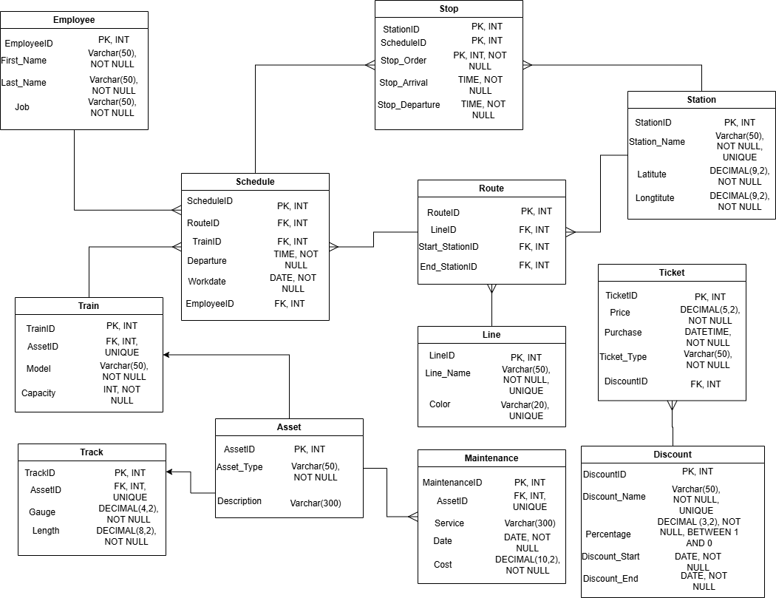

Objects

Table Name | Field name | Field Description | Data Type
Asset | Asset_ID | Unique identifier for any physical item | INT,PK
 | Asset_Type | Type of asset (e.g., 'Train', 'Track', 'Tunnel', 'Station') | VARCHAR(50),NOT NULL
 | Description | General description of the asset | VARCHAR(300)
Train | Train_ID | Unique identifier for the train vehicle | INT,PK
 | Asset_ID | Links to the physical asset record | INT,FK (Asset), UNIQUE
 | Model | Manufacturer's model name | VARCHAR(50),NOT NULL
 | Capacity | Train Capacity | INT, NOT NULL
Track | Track_ID | Unique identifier for a segment of track | INT,PK
 | Asset_ID | Links to the physical asset record | INT,FK (Asset), UNIQUE
 | Length | Physical length of the track segment | DECIMAL(8,2),NOT NULL
 | Gauge | Gauge of the track | DECIMAL(4,2),NOT NULL
Maintenance | Maintenance_ID | Unique identifier for a maintenance job/record | INT,PK
 | Asset_ID | Links to the physical asset record | INT,FK (Asset), UNIQUE
 | Date | Date the maintenance was performed | DATE,NOT NULL
 | Service | Description of the maintenance | VARCHAR(300)
 | Cost | Cost of the maintenance | DECIMAL(10,2), NOT NULL
Line | Line_ID | Unique identifier for the line | INT,PK
 | Line_Name | Full name of the subway line | VARCHAR(50),NOT NULL, UNIQUE
 | Color | Color of the line of the map | VARCHAR(20), UNIQUE
Station | Station_ID | Unique ID for the physical station location | INT,PK
 | Station_Name | Official name of the station | VARCHAR(50),NOT NULL, UNIQUE
 | Latitute | Latitude on the map | DECIMAL(9,2),NOT NULL
 | Longtitute | Longtitute on the map | DECIMAL(9,2),NOT NULL
Route | Route_ID | Unique identifier for a specific defined travel path | INT,PK
 | Line_ID | The line this route belongs to | INT,FK (Line)
 | Start_Station_ID | The station where the route begins | INT,FK (Station)
 | End_Station_ID | The station where the route ends | INT,FK (Station)
Schedule | Schedule_ID | Unique identifier for a specific timed run | INT,PK
 | Route_ID | The route definition used for this run | INT,FK (Route)
 | Train_ID | The train assigned to this run | INT,FK (Train)
 | Employee_ID | The operator/driver assigned to this run (required employee) | INT,FK (Employee)
 | Departure | Time of departure | TIME, NOT NULL
 | Workdate | Date of the schedule | DATE, NOT NULL
Stop | Station_ID | Station where the stop occurs | INT,PK/FK (Station)
 | Schedule_ID | The schedule the stop belongs to | INT,PK/FK (Schedule)
 | Stop_Order | The sequence of the stop within the schedule | INT, PK, NOT NULL
 | Stop_Arrival | Train arrival time for this specific station (train arrival/departure times) | TIME,NOT NULL
 | Stop_Departure | Train departure time for this specific station (train arrival/departure times) | TIME,NOT NULL
Employee | Employee_ID | Unique identifier for an employee | INT,PK
 | Job | The employee's role (e.g., 'Driver', 'Conductor') | VARCHAR(50), NOT NULL
 | First_Name | Employee first name | VARCHAR(50), NOT NULL
 | Lat_Name | Employee last name | VARCHAR(50), NOT NULL
Ticket | Ticket_ID | Unique identifier for a purchased ticket | INT,PK
 | Price | Final purchase price of the ticket | DECIMAL(5,2),NOT NULL
 | Ticket_Type | Type of ticket (e.g., 'Single Ride', 'Day Pass') | VARCHAR(50),NOT NULL
 | Purchase | Time of purchase | DATETIME, NOT NULL
 | DiscountID | Discount which is applied | INT, FK
Discount | Discount_ID | Unique identifier for a discount type | INT,PK
 | Percentage | The discount rate (e.g., 0.15 for 15%) | DECIMAL(3,2),NOT NULL
 | Discount_Name | Name of the discount | VARCHAR(50),NOT NULL
 | Discount_Start | Start of discount period | DATE, NOT NULL
 | Discount_End | End of discount period | DATE, NOT NULL

Comments on Table Relationships:
  - The Stop bridge table resolves the Many-to-Many relationship between Station and Schedule.
  - It contains the composite Primary Key (Station_ID, Schedule_ID, Stop_Order) to uniquely define the exact stop sequence, and it holds the critical data on train arrival and departure times for each station stop.
  - Asset has a 1-to-1 relationship with Train and Track (enforced by a UNIQUE FK), specializing in the general asset type.
  - Asset has a 1-to-Many relationship with Maintenance to track all upkeep and repair history for any infrastructure item.
  - Line (1) and Route (N), Route (1) and Schedule (N), Train (1) and Schedule (N), and Employee (1) and Schedule (N). These links track the required hierarchy and ensure every scheduled run is associated with one route, one train, and one assigned employee.

Example with data

TrainID | AssetID | Model | Capacity
2001 | 101 | TZB767 | 1200
2023 | 107 | SZG657 | 1250

AssetID | Asset_Type | Description
101 | Train | Metro Car: Series 7000
104 | Track | Segment A-B, Blue Line

TrackID | AssetID | Gauge | Length
30089 | 104 | 56.6 | 1500.00
30076 | 123 | 43.5 | 1250.00

MaintenanceID | AssetID | Date | Cost | Service
456 | 104 | 2025-10-20 | 4500.00 | Routine electrical inspection
476 | 123 | 2025-12-20 | 1200.00 | Rail welding and alignment check

LineID | Line_Name | Color
879 | First Line | Red
899 | Saburtalo Line | Green

StationID | Station_Name | Latitute | Logtitute
65 | State University | 56.6987 | -87.6534
68 | Medical University | 43.5067 | -98.6512

RouteID | LineID | Start_Station | End_Station
546 | 879 | 65 | 657
512 | 899 | 68 | 632

EmployeeID | First_Name | Last_Name | Job
987 | Fiona | Stiles | Driver
943 | Nick | Schwebber | Driver

ScheduleID | RouteID | TrainID | EmployeeID | Departure | Workday
756 | 546 | 2001 | 934 | 06:00:00 | 2025-11-01
712 | 546 | 2023 | 912 | 06:15:00 | 2025-11-01

StationID | ScheduleID | Stop_Order | Stop_Arrival | Stop_Departure
65 | 756 | 1 | 06:00:00 | 06:00:00
68 | 712 | 2 | 06:15:00 | 06:15:00

TicketID | Price | Purchase | Ticket_Type | DiscountID
T234 | 2.65 | 2025-11-01 05:45:00 | One-Way | 06:00:00
T214 | 13.45 | 2025-11-01 01:45:00 | 24HR | 06:15:00

DiscountID | Discount_Name | Percentage | Discount_Start | Discount_End
D12 | Weekend Special | 0.20 | 2025-11-01 | 2026-06-01
D18 | Student Special | 0.10 | 2025-11-01 | 2026-11-01

