**First, What is Flexbox?**



When you're building a house, you need a blueprint. In the same way, we need a blueprint when we're making websites. And Flexbox is the blueprint.

The Flexbox model allows us to**layout the content**of our website. Not only that, it helps us create the structuresneeded for creating **responsive websites**for multiple devices.

**Flexbox Architecture**

So how does Flexbox architecture work? The flex-items [Contents] are distributed along the main axis and cross axis. And, depending on the flex-direction property, the layout position changes between rows and columns.

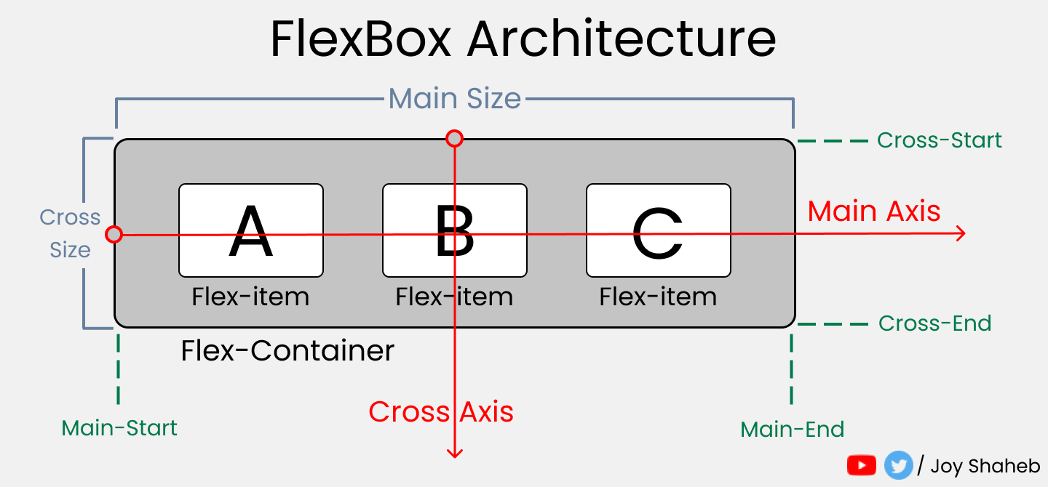

**Flexbox Chart**

This chart contains every possible property and value you can use when you're working with Flexbox. You can reference it while doing your projects and experiment with different values.

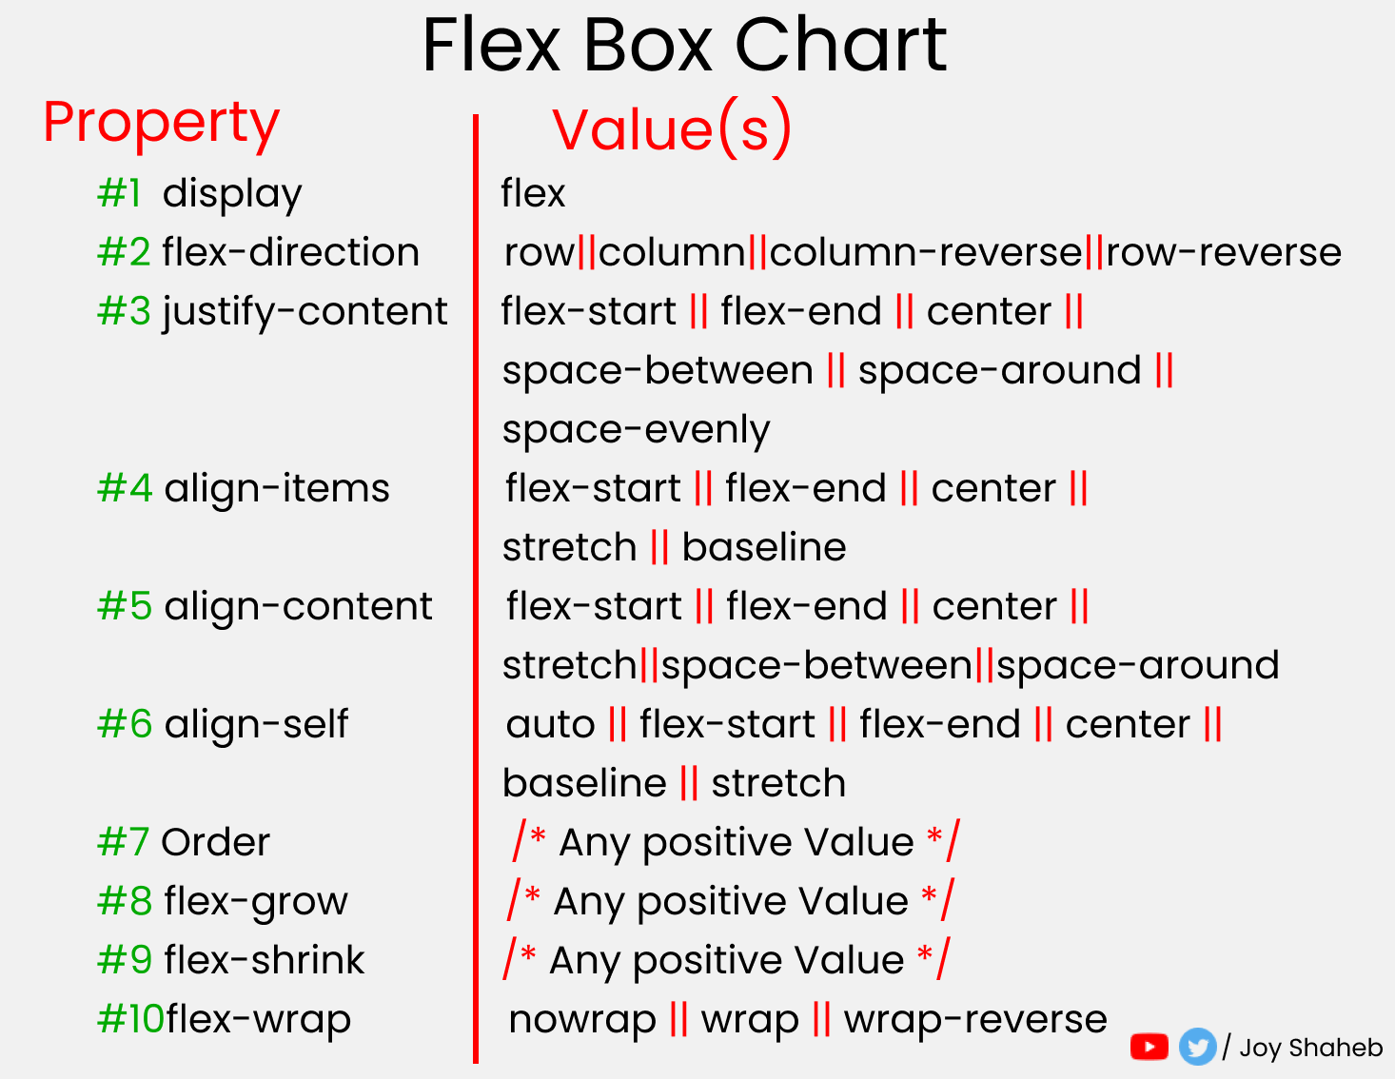

**But Wait....**



Before starting, you need to understand the relationship between parent and child classes.

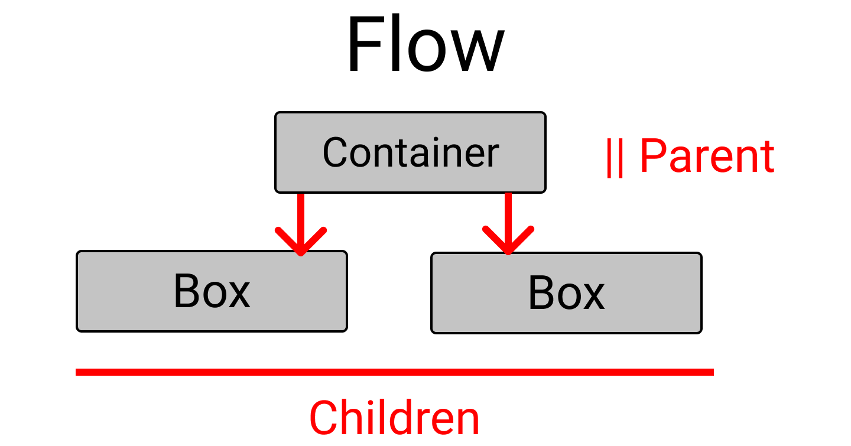

Flexbox works on the **parent class**, not on the child classes.

Here, the .container class is the **parent** and our .box-* classes are our **children**.

So, apply the display: flex inside the .container class. And place the letters at the center of the box like this:

.container{

display : flex;

height : 100vh;

// To place some gap between boxes

gap : 25px;

}

[class ^="box-"]{

// Code from previous step are here

// Placing text at center

display : flex;

justify-content : center;

align-items : center;

}

And...we're all set! Let's start coding.

**flex-direction property**

This property allows us to set the direction and orientation in which our flex-items should be distributed inside the flex-container.

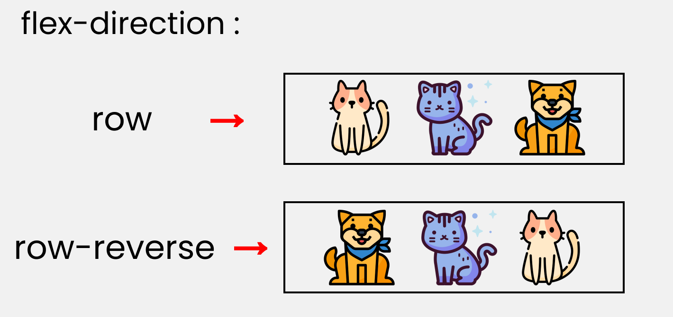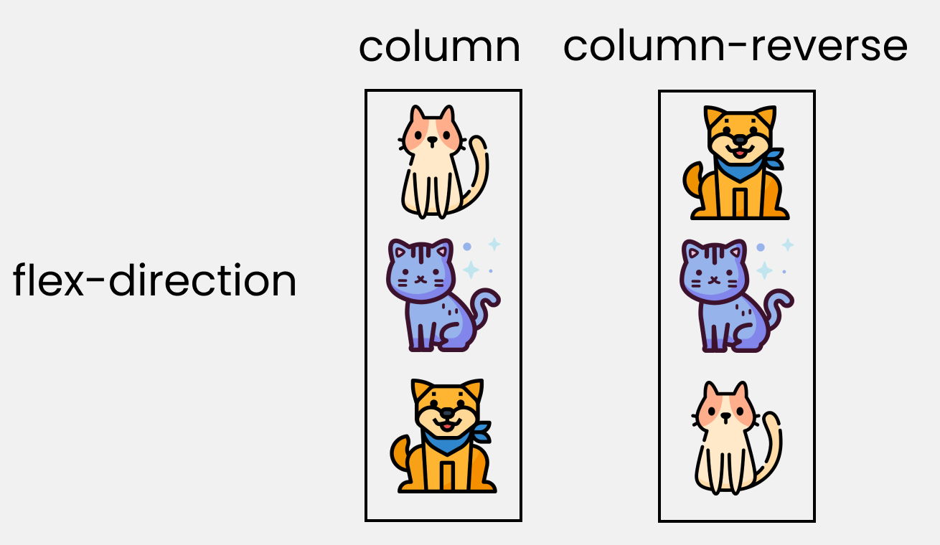

To recreate these results, let's write these lines in our CSS:

**Please note** that we'll write them inside the .container class.

.container{

//code from setup stage are here

// Change the value 👇 here to see results

flex-direction : row;

}

**justify-content property**

This property arranges flex-items along the **MAIN AXIS** inside the flex-container.

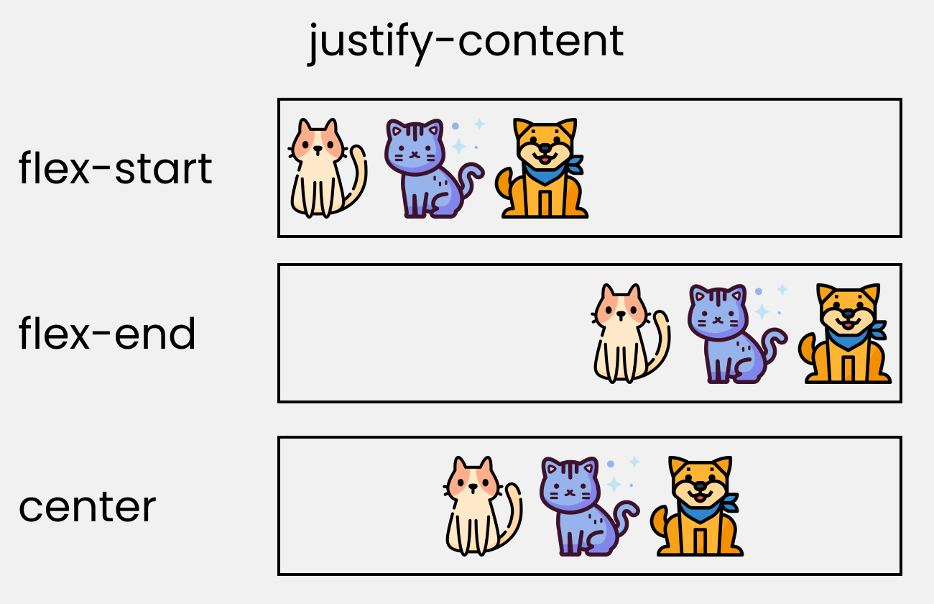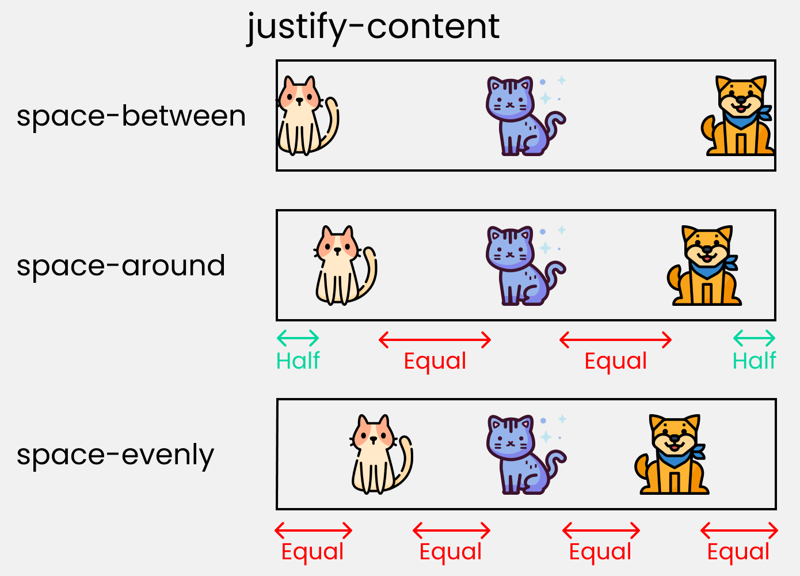

To recreate these results, write these lines in your CSS:

.container{

//code from setup stage are here

// Change the value 👇 here to see results

justify-content: flex-start;

}

**align-content property**

This property arranges flex-items along the **CROSS AXIS** inside the flex-container. This is similar to **justify-content**.

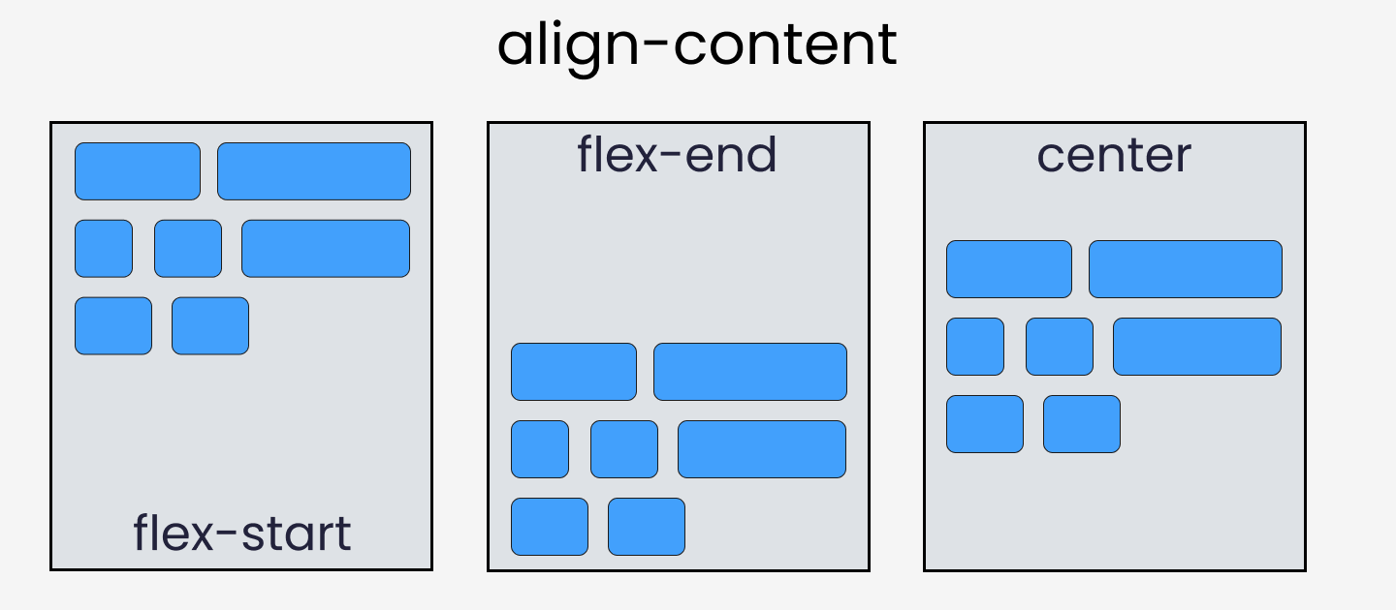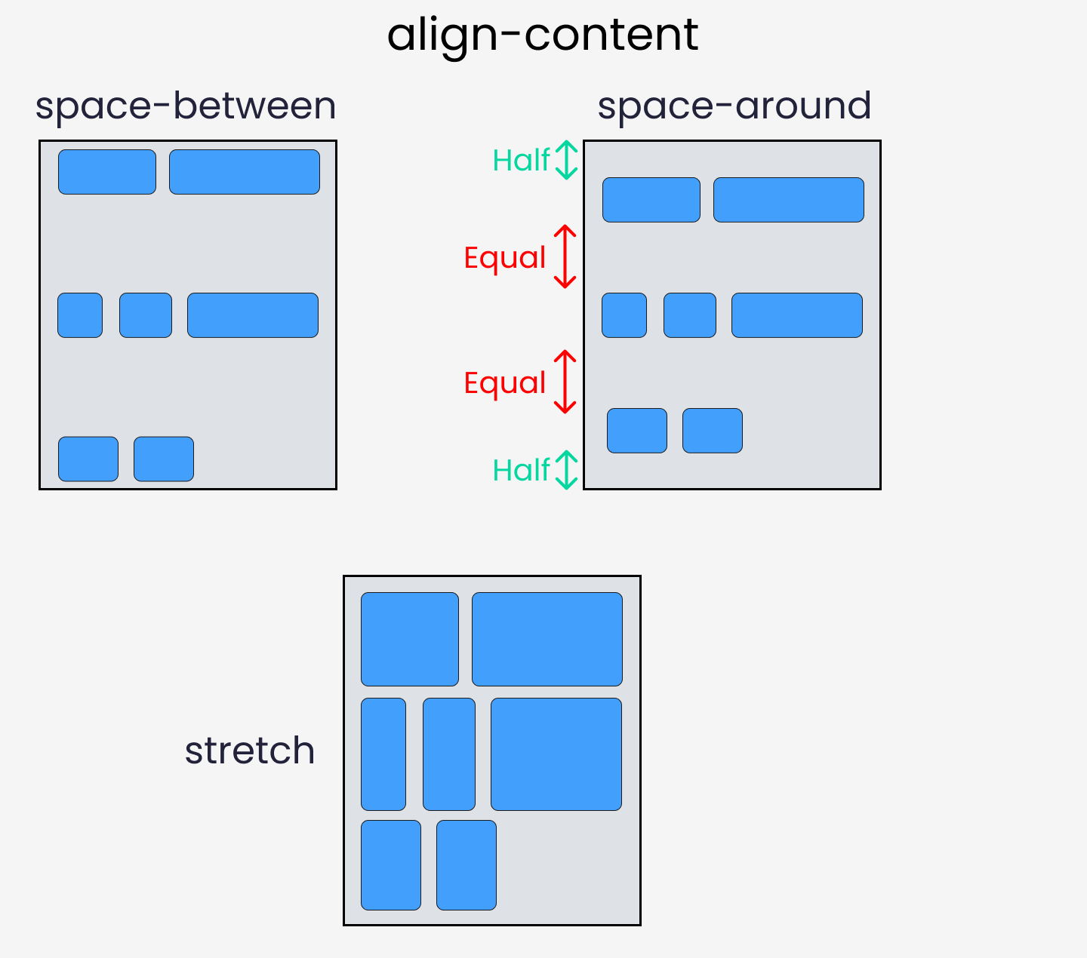

Please note that without the **flex-wrap** property, this property doesn't work. Here's a demo:

.container{

// Change the value 👇 here to see results

align-content: center;

// without this line, align-content won't work

flex-wrap: wrap;

}

**align-items property**

This property distributes Flex-items along the **Cross Axis**.

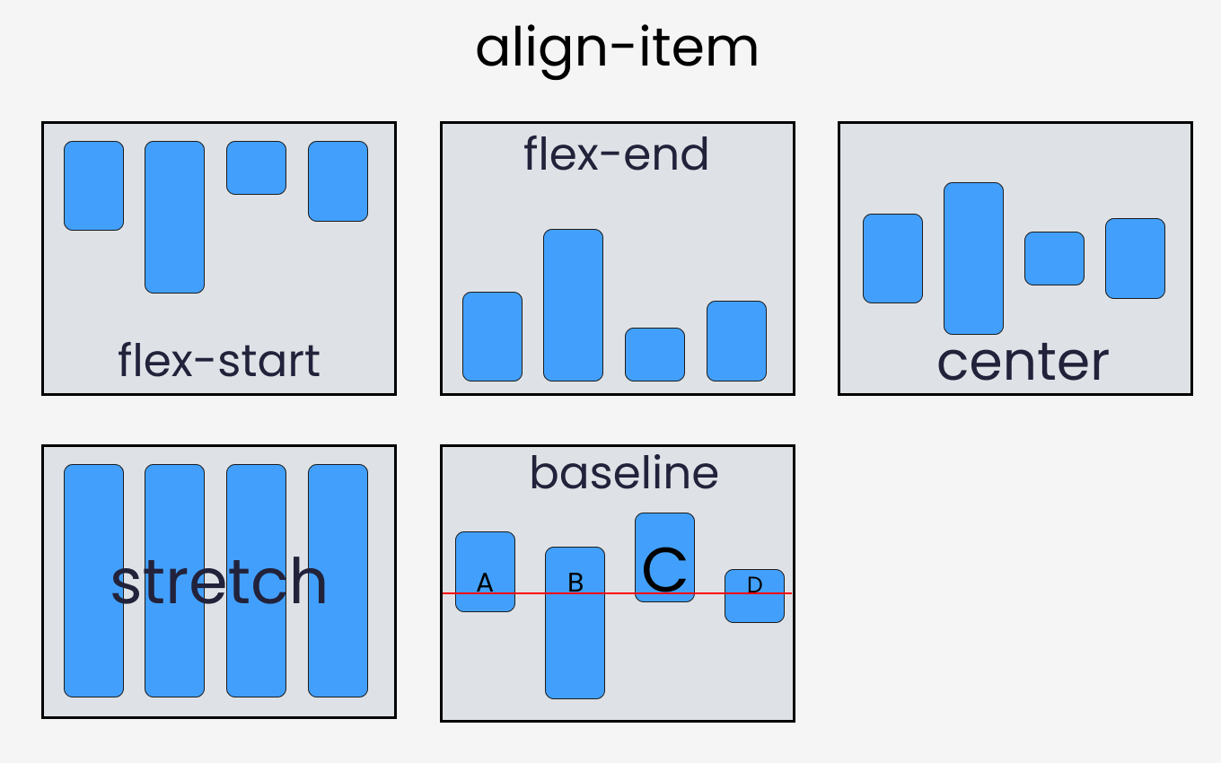

To recreate these results, let's write the following code in CSS:

.container{

//code from setup stage are here

// Change the value 👇 here to see results

align-items: flex-end;

}

**align-self property**

This property works on the child classes. It positions the selected item along the **Cross Axis**.

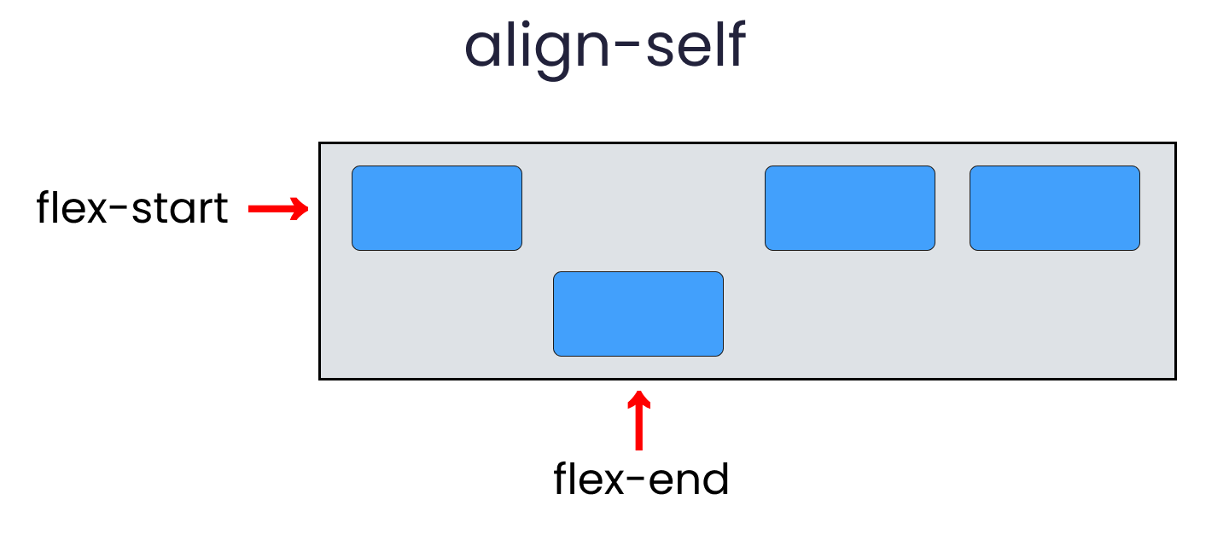

In total we have 6 values:

* flex-start
* flex-end
* center
* baseline
* stretch
* auto

To recreate the results, select any .box-* and write the following code:

.box-2{

// Change the value 👇 here to see results

align-self : center;

}

**flex - grow | shrink | wrap | basis properties**

The properties we'll discuss now will work when we resize the window. Let's dive right in.

**flex-grow**

This property grows the size of a flex-item based on the width of the flex-container.

**flex-shrink**

This property helps a flex item shrink based on the width of the flex-container. It's the opposite of flex-grow.

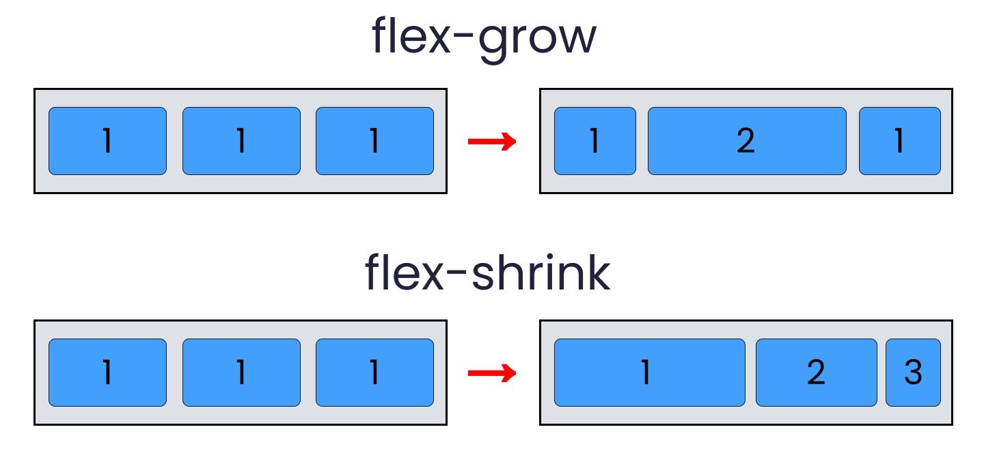

To achieve these results, follow me.

**Please note** that flex-grow and flex-shrink work on child classes. So, we will target all our boxes like this:

.box-1{

flex-grow: 1;

}

.box-2{

flex-grow: 5;

}

.box-1{

flex-grow: 1;

}

Resize the window and you'll see the results.

To duplicate the result of flex-shrink, write the following code:

**Please note** that you need to delete the flex-wrap property first, otherwise it won't work.

.box-1{

flex-shrink: 1;

}

.box-2{

flex-shrink: 5;

}

.box-1{

flex-shrink: 1;

}

Now, resize the window and you'll see the results.

**flex-wrap**

This property helps you set the number of flex-items you want in a line or row.

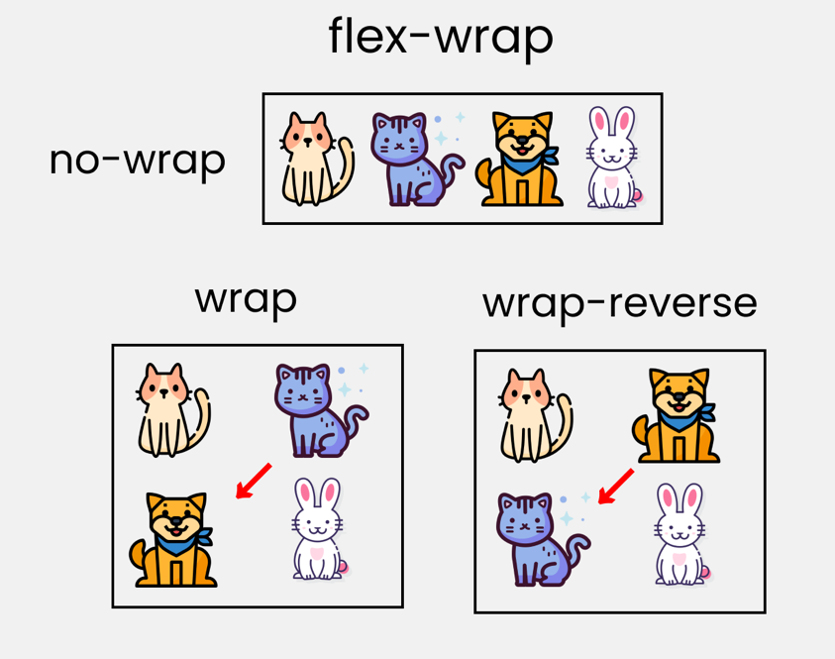

This works on the .container parent class. So, write the following code:

.container{

//other codes are here

// Change value 👇 here to see results

flex-wrap : wrap;

**flex-basis**

This is similar to adding width to a flex-item, but only more flexible. flex-basis: 10em, for example, will set the initial size of a flex-item to 10em. Its final size will be based on the available space, flex-grow, and flex-shrink.

**Shorthand Flexbox Properties**

**flex shorthand**

This is the shorthand for the **flex-grow**, **flex-shrink** and **flex-basis** properties combined.

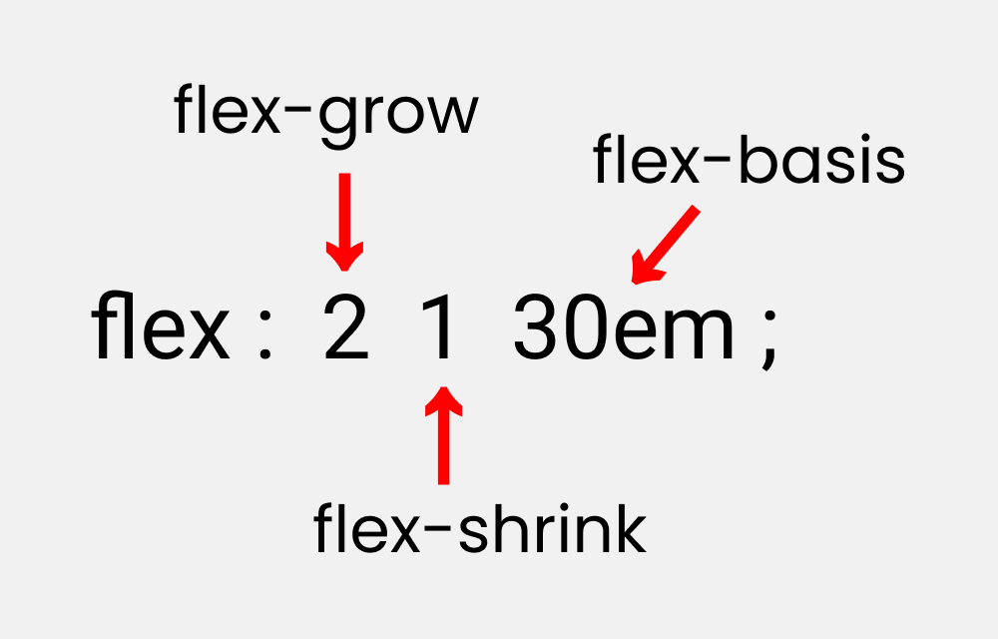

You can try this by writing the following code:

**Please note**that it only works on the child classes:

.box-2{

flex : 2 1 30em;

}

**flex-flow**

This is the shorthand for the **flex-direction** and **flex-wrap**properties:

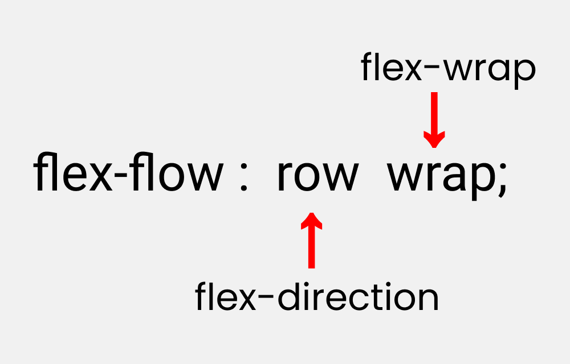

You can try this by writing the following code:

**Please note** that it only works on the parent class.

.container{

flex-flow : row wrap;

}

**place-content**

This is the shorthand for the justify-content and align-content properties:

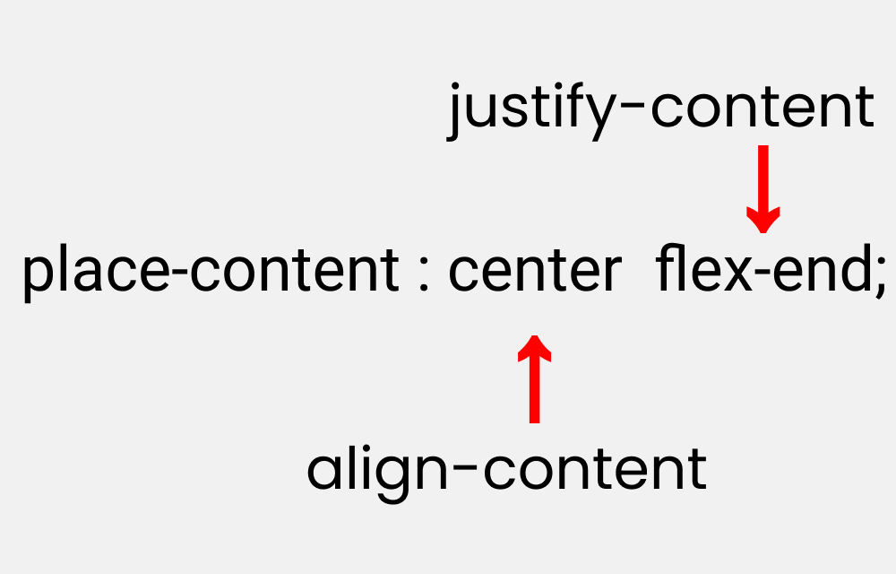

Let's duplicate the results:

**Please note**that it works on the parent class.

.container{

place-content : center flex-end;

}